`— title: “Film Sales Analysis” author: “Reza Fabiola” date: “2025-12-09” output: docx_document —

Introduction

Dataset obtained from real world business of medical equipments distributor. Data has been anonymized and approved for public use. Data is cleaned to remove any irrelevant data.

Setting up my environment
library(tidyverse)
library(tidyr)
library(ggplot2)
library(janitor)
library(readr)
library(dplyr)
library(lubridate)
library(knitr)
library(ggrepel)

Load the dataset
film_sales <- read_csv("film_sales_cleaned.csv")

Setting up and inserting parameters

* Products arrive within 15 days after order is placed

* Target Service Level is 95%
lead_time_days <- 15 # Days it took for shipment to arrive at the door
service_level <- 0.95 # Means service level of 95%
z_score <- qnorm(service_level) # The corresponding z value from normal distribution
days_per_month <- 365.25 / 12 # Average days per month

Processing the data

Calculate monthly demand
month_map <- c(Jan = 1, Feb = 2, Mar = 3, Apr = 4, May = 5, Jun = 6,
Jul = 7, Aug = 8, Sep = 9, Oct = 10, Nov = 11, Dec = 12)
avg_monthly_demand_df <- film_sales %>%
mutate(
date = make_date(year, month_map[month], 1)
) %>%
group_by(date, film_size) %>%
summarise(
monthly_qty = sum(qty),
.groups = 'drop'
) %>%
group_by(film_size) %>%
summarize(
average_monthly_demand = mean(monthly_qty),
.groups = 'drop'
)

Calculate ROP and SS
demand_daily_stats <- film_sales %>%
mutate(
date = make_date(year, month_map[month], 1)
) %>%
# 1. Calculate Monthly Demand per Film Size
group_by(film_size, date) %>%
summarise(
monthly_qty = sum(qty),
.groups = 'drop_last' # Drop 'date', keep 'film_size' grouped
) %>%
# The data is now grouped ONLY by film_size. The next summarize will work across all months.
# 2. Calculate Demand Statistics (Mean and SD across months)
summarize(
n_months = n(),
mu_monthly = mean(monthly_qty, na.rm = TRUE),
sigma_monthly = ifelse(
n_months > 1,
sd(monthly_qty, na.rm = TRUE),
0
),
.groups = 'drop'
) %>%
# 3. Convert to Daily Statistics
mutate(
mu_daily = mu_monthly / days_per_month,
sigma_daily = if_else(
sigma_monthly == 0,
0,
sigma_monthly / sqrt(days_per_month)
)
)
final_inventory_metrics <- demand_daily_stats %>%
mutate(
ss = z_score * sigma_daily * sqrt(lead_time_days)
) %>%
mutate(
rop = (mu_daily * lead_time_days) + ss
) %>%
select(
`Film Size` = film_size,
`Avg Daily Demand (μ)` = mu_daily,
`Safety Stock (SS)` = ss,
`Reorder Point (ROP)` = rop
) %>%
mutate(across(c(`Safety Stock (SS)`, `Reorder Point (ROP)`), ~ round(.x, 0))) %>%
mutate(`Avg Daily Demand (μ)` = round(`Avg Daily Demand (μ)`, 2))
knitr::kable(final_inventory_metrics)
Film Size | Avg Daily Demand (μ) | Safety Stock (SS) | Reorder Point (ROP)
Large | 1.16 | 14 | 32
Medium | 1.05 | 16 | 32
Small | 1.68 | 39 | 64

Inventory Optimization Analysis (Reorder Point)
This analysis determines the critical stock levels required to meet 95% of customer demand while accounting for the 15-day time it takes for new stock to arrive.

1. Inventory Strategy Dashboard

Analysis
The table below shows the calculated Reorder Point (ROP) and Safety Stock (SS) for each film size. 1. Reorder Point (ROP): The precise inventory level that triggers a new purchase order. When stock falls to this number, we must order immediately. 2. Safety Stock (SS): The extra buffer inventory held specifically to guard against unexpected spikes in customer demand or delays in delivery.

Key Inventory Metrics (Lead Time: 15 Days, Service Level: 95%)
- **Highest Priority: Small film has the highest average daily demand and consequently requires the highest ROP, meaning it must be managed most actively.
- **Highest Risk/Volatility: Small film requires the largest Safety Stock. This indicates its demand is the most unpredictable, making the safety buffer crucial to prevent stockouts.
- **Lowest Priority: Medium film has the lowest overall demand and risk, requiring the least inventory commitment.

Recommendation
- Implement ROP Immediately: Inform the calculated Reorder Point values to the warehouse manager. Consider shifting inventory control from reactive management to a predictive, automated process
- Focus on Safety Stock: Pay close attention to the Small film’s Safety Stock. This buffer represents the minimum stock we must maintain at all times to absorb market shocks and keep our 95% service promise to customers.
- Optimize Purchasing: The 15-day ROP is designed to cover demand only during the short lead time. We should explore opportunities with suppliers to reduce the lead time further, as this will directly decrease the required ROP and Safety Stock, freeing up working capital.

10 biggest customer
top_10_customers_df <- film_sales %>%
group_by(cust_id) %>%
summarise(total_qty = sum(qty)) %>%
arrange(desc(total_qty)) %>%
head(10)
ggplot(top_10_customers_df, aes(x = reorder(cust_id, total_qty), y = total_qty)) +
geom_bar(stat = "identity", fill = "steelblue") +
labs(
title = "Top 10 Customers by Total Film Quantity Purchased",
x = "Customer ID",
y = "Total Quantity (Units)"
) +
coord_flip() +
theme_minimal()
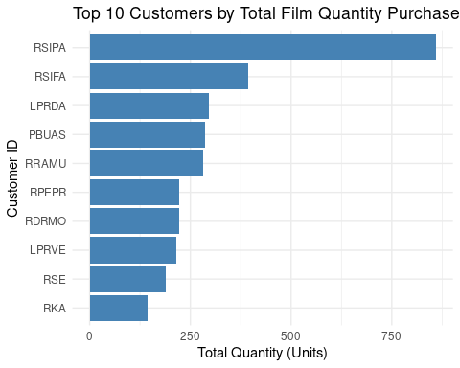

Creating Heatmap of Customer’s Purchase
customer_demand_time_series <- film_sales %>%
mutate(
month_num = case_match(month,
"Jan" ~ 1, "Feb" ~ 2, "Mar" ~ 3, "Apr" ~ 4,
"May" ~ 5, "Jun" ~ 6, "Jul" ~ 7, "Aug" ~ 8,
"Sep" ~ 9, "Oct" ~ 10, "Nov" ~ 11, "Dec" ~ 12
),
date = make_date(year, month_num, 1)
) %>%
group_by(cust_id, date) %>%
summarise(
monthly_qty = sum(qty),
.groups = 'drop'
)
ggplot(customer_demand_time_series, aes(x = date, y = cust_id, fill = monthly_qty)) +
geom_tile(color = "white", linewidth = 0.2) +
scale_fill_viridis_c(name = "Monthly Quantity", direction = -1) +
labs(
title = "Customer Order Stability and Anomaly Analysis (Monthly Quantity)",
x = "Month",
y = "Customer ID"
) +
scale_x_date(date_breaks = "6 months", date_labels = "%Y-%m") +
theme_minimal() +
theme(
axis.text.x = element_text(angle = 45, hjust = 1, size = 8),
axis.text.y = element_text(size = 5),
plot.title = element_text(hjust = 0.5),
axis.ticks.y = element_blank()
)
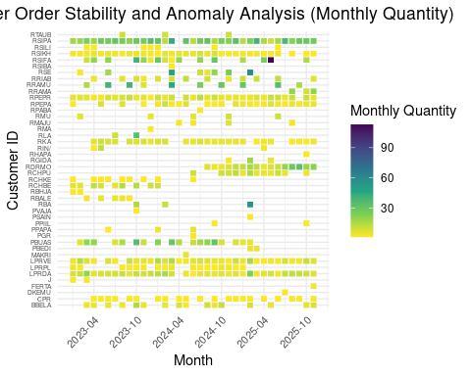 # Customer Order Stability and Anomaly Analysis
The heatmap visualizes customer behavior with Month of Purchase (X-axis), and Customer ID (Y-axis). The map showing regularities of each customer’s order. The fuller the map the regular the order.

1. Most Stable All Time
Most stable customers placed order regularly, indicated by a full map, with darker colors indicating higher order quantity per month. With the map we can isolate most stable customers such as RSIPA, RSIKH, RPEPR, LPRVE, LPRDA

Analysis
- How They Look on the Heatmap: They are identified by having the fullest map (stable).
- Implications: They represent the stable revenue generator and needed to be maintained.

2. Irregular Customer
Some customers placed irregular order, indicated by map with empty slots, the more empty it is the more irregular. With the map we can spot irregular customers such as RBA, PVAJA, RSE and more.

Analysis
- How They Look on the Heatmap: They are identified by having the empty map (irregular).
- Implications: They represent the irregular customer purchase, making it necessary to prepare more safety stock and increases inventory costs.
By looking at the heatmap data, and understand the irregularity, we should look at average purchase interval of the customers and highlight the long purchase interval customers.

Analyzing Average Purchase Interval
# Calculate the count of unique purchase dates per customer
customer_purchase_count <- film_sales %>%
mutate(
date = make_date(year, month_map[month], 1)
) %>%
group_by(cust_id) %>%
summarise(
n_purchases = n_distinct(date),
.groups = 'drop'
) %>%
filter(n_purchases >= 3)
# Calculate the time between consecutive purchases (Inter-Purchase Interval)
customer_follow_up_analysis <- film_sales %>%
mutate(
date = make_date(year, month_map[month], 1)
) %>%
# Filter to include only customers with at least 3 distinct purchase dates
semi_join(customer_purchase_count, by = "cust_id") %>%
# Group by customer and purchase date to get one row per purchase month
group_by(cust_id, date) %>%
summarise(
.groups = 'drop_last'
) %>%
# Calculate the time difference between consecutive purchase dates
mutate(
time_since_last_purchase_days = as.numeric(c(NA, diff(date)), units = "days")
) %>%
ungroup() %>%
filter(!is.na(time_since_last_purchase_days))
# Calculate Average IPI and Last Purchase Date
follow_up_metrics <- customer_follow_up_analysis %>%
group_by(cust_id) %>%
summarise(
average_ipi_days = mean(time_since_last_purchase_days),
.groups = 'drop'
)
last_purchase_dates <- film_sales %>%
mutate(
date = make_date(year, month_map[month], 1)
) %>%
group_by(cust_id) %>%
summarise(
last_purchase_date = max(date),
.groups = 'drop'
)
# Combine metrics and predict next follow-up date (3 days before predicted purchase)
final_follow_up_table <- follow_up_metrics %>%
inner_join(last_purchase_dates, by = "cust_id") %>%
mutate(
predicted_next_purchase_date = last_purchase_date + days(round(average_ipi_days, 0)),
follow_up_date = predicted_next_purchase_date - days(3)
) %>%
select(
`Customer ID` = cust_id,
`Last Purchase Date` = last_purchase_date,
`Average Purchase Interval (Days)` = average_ipi_days,
`Predicted Follow Up Date` = follow_up_date
) %>%
mutate(
`Average Purchase Interval (Days)` = round(`Average Purchase Interval (Days)`, 0)
)

Purchase Intervals 2023 - 2025
plot_data <- final_follow_up_table %>%
mutate(
highlight_flag = ifelse(`Average Purchase Interval (Days)` > 60, "Follow-up Priority (> 60 Days)", "Standard Interval")
)
ggplot(plot_data, aes(x = reorder(`Customer ID`, `Average Purchase Interval (Days)`), y = `Average Purchase Interval (Days)`, fill = highlight_flag)) +
geom_bar(stat = "identity") +
scale_fill_manual(
values = c("Follow-up Priority (> 60 Days)" = "darkred", "Standard Interval" = "skyblue"),
name = "Follow-up Group"
) +
labs(
title = "Average Purchase Interval by Customer ID 2023 - 2025",
x = "Customer ID",
y = "Average Purchase Interval (Days)"
) +
coord_flip() +
theme_minimal() +
theme(legend.position = "bottom")
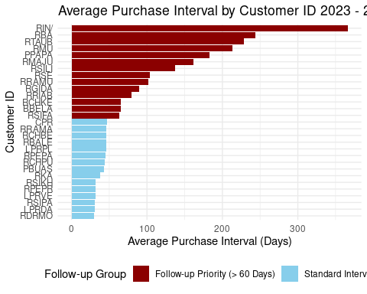

Purchase Intervals 2023 - 2025
sales_2025_onwards <- film_sales %>%
mutate(
date = make_date(year, month_map[month], 1)
) %>%
filter(date >= as.Date("2025-01-01"))
customer_purchase_count_2025 <- sales_2025_onwards %>%
group_by(cust_id) %>%
summarise(
n_purchases = n_distinct(date),
.groups = 'drop'
) %>%
filter(n_purchases >= 2)
customer_follow_up_analysis_2025 <- sales_2025_onwards %>%
semi_join(customer_purchase_count_2025, by = "cust_id") %>%
group_by(cust_id, date) %>%
summarise(
.groups = 'drop_last'
) %>%
mutate(
time_since_last_purchase_days = as.numeric(c(NA, diff(date)), units = "days")
) %>%
ungroup() %>%
filter(!is.na(time_since_last_purchase_days))
final_follow_up_table_2025 <- customer_follow_up_analysis_2025 %>%
group_by(cust_id) %>%
summarise(
`Average Purchase Interval (Days)` = mean(time_since_last_purchase_days),
.groups = 'drop'
) %>%
mutate(
`Average Purchase Interval (Days)` = round(`Average Purchase Interval (Days)`, 0)
) %>%
select(
`Customer ID` = cust_id,
`Average Purchase Interval (Days)`
)
plot_data_2025 <- final_follow_up_table_2025 %>%
mutate(
highlight_flag = ifelse(`Average Purchase Interval (Days)` > 60, "Follow-up Priority (> 60 Days)", "Standard Interval")
)
ggplot(plot_data_2025, aes(x = reorder(`Customer ID`, `Average Purchase Interval (Days)`), y = `Average Purchase Interval (Days)`, fill = highlight_flag)) +
geom_bar(stat = "identity") +
scale_fill_manual(
values = c("Follow-up Priority (> 60 Days)" = "darkred", "Standard Interval" = "skyblue"),
name = "Follow-up Group"
) +
labs(
title = "2025 Average Purchase Interval by Customer ID",
x = "Customer ID",
y = "Average Purchase Interval (Days)"
) +
coord_flip() +
theme_minimal() +
theme(legend.position = "bottom")
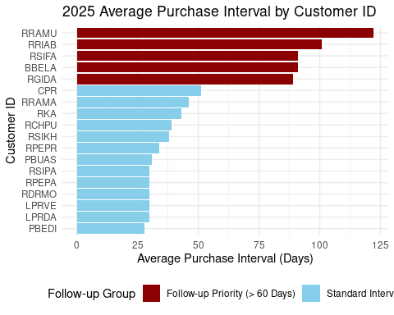
- Average data from 2023 to 2025 may have caused some customer purchase interval length highly exaggerated due to some customers have only just purchasing from the company in 2025. Therefore it is more relevant to count the average purchase interval in year 2025 only

Recency, Frequency and Quantity Analysis
analysis_date <- film_sales %>%
mutate(date = make_date(year, month_map[month], 1)) %>%
summarise(max_date = max(date)) %>%
pull(max_date) + days(1)
rfq_data <- film_sales %>%
mutate(date = make_date(year, month_map[month], 1)) %>%
group_by(cust_id) %>%
summarise(
Recency = as.numeric(analysis_date - max(date), units = "days"),
Frequency = n_distinct(date),
Quantity = sum(qty),
.groups = 'drop'
)
top_5_valuable <- rfq_data %>%
arrange(desc(Quantity)) %>%
head(5) %>%
mutate(segment = "Most Valuable")
top_5_stable <- rfq_data %>%
arrange(desc(Frequency)) %>%
head(5) %>%
mutate(segment = "Most Stable")
top_5_churned <- rfq_data %>%
arrange(desc(Recency)) %>%
head(5) %>%
mutate(segment = "Churned")
focus_customers <- bind_rows(top_5_valuable, top_5_stable, top_5_churned) %>%
group_by(cust_id, Recency, Frequency, Quantity) %>%
summarise(
label_text = paste(unique(segment), collapse = " & "),
.groups = 'drop'
)
plot_data <- rfq_data %>%
left_join(focus_customers, by = c("cust_id", "Recency", "Frequency", "Quantity")) %>%
mutate(
label_text = ifelse(is.na(label_text), "", label_text)
)
ggplot(plot_data, aes(x = Recency, y = Frequency, size = Quantity, color = Quantity)) +
geom_point(alpha = 0.7) +
scale_size_continuous(range = c(2, 12)) +
scale_color_viridis_c(option = "D") +
geom_text_repel(
data = subset(plot_data, label_text != ""),
aes(label = paste(cust_id, label_text, sep = "\n")),
box.padding = 0.5,
point.padding = 0.5,
size = 3,
min.segment.length = 0,
segment.color = 'grey50'
) +
labs(
title = "Customer Segmentation: Recency vs. Frequency (RFM Analysis)",
x = "Recency (Days Since Last Purchase)",
y = "Frequency (Number of Unique Purchase Months)",
size = "Total Quantity",
color = "Total Quantity"
) +
theme_minimal() +
theme(
plot.title = element_text(hjust = 0.5, face = "bold"),
legend.position = "right"
)
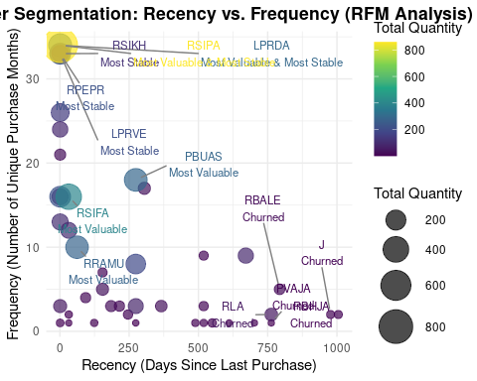 # Customer RFQ Segmentation Analysis
The scatterplot visualizes customer behavior with Recency (X-axis), Frequency (Y-axis), and Quantity (bubble size). Highlighting the top 5 customers in key segments allows for targeted strategy development.

1. Most Valuable Customers (Highest Quantity)
These are the 5 customers who have purchased the largest total quantity of film over the analysis period.

Analysis
- How They Look on the Plot: They are identified by having the largest bubble size (Quantity).
- Implications: They represent the largest portion of your sales volume and are critical to revenue.

Strategy Focus
- Retention is Critical: These customers must be prioritized for special service, loyalty programs, and relationship building.
- Up-selling/Cross-selling: Analyze the film sizes they are not buying and offer bundles.
- Monitor Recency and Frequency: Even highly valuable customers can churn. If their Recency increases (moves right) or Frequency drops (moves down), immediate follow-up is necessary.

2. Most Stable Customers (Highest Frequency)
These are the 5 customers who have made the most frequent purchases (highest number of unique purchase months).

Analysis
- How They Look on the Plot: They are positioned at the top of the Y-axis (high Frequency).
- Implications: These customers have established a strong buying pattern, indicating loyalty and stable demand.

Strategy Focus
- Automation: They are excellent candidates for subscription models or automated reorder reminders based on their average purchase interval.
- Efficiency: Analyze their logistics/delivery process to ensure maximum speed and minimum friction to maintain their high purchasing rate.
- Value Maximization: While frequent, focus on increasing their average order quantity if their total Quantity (bubble size) is not yet maxed out.

3. Churned Customers (Highest Recency)
These are the 5 customers who have the longest time period since their last purchase.

Analysis
- How They Look on the Plot: They are positioned furthest to the right on the X-axis (high Recency).
- Implications: These customers have stopped ordering entirely. They represent significant lost revenue potential.

Strategy Focus
- Win-back Campaigns: Initiate targeted follow-up communication. Offer aggressive discounts, personalized product recommendations, or surveys to understand why they left.
- Identify Root Cause: Compare their last purchase date to any business events (e.g., price increases, service changes) to diagnose the potential reason for the churn.
- De-prioritize if Low Value: If a customer is Churned (far right) and has low Frequency (low Y-axis) and small Quantity (small bubble), the cost of winning them back may not be worth the effort.

Conclusion
According to the findings, RSIPA and LPRDA is the most valuable customer with its stability and high volume order. There are also High volume but with stable order like RSIFA, and RRAMU but has long purchase interval. Initial data lacks some parameters like day of purchase, making it slightly complicated to calculate mu, and sigma daily needed to build ROP and SS calculation.

Note
The analysis was done using Rstudio cloud. The codes was aided by AI with human-in-loop approach to ensure accuracy.

Reference
- Nahmias, S. (2009). Production and operations analysis (6th ed.). McGraw-Hill/Irwin.
- Taylor, B. W. (2019). Introduction to management science (13th ed.). Pearson Education.

