Role-Based Access Control (RBAC)

Overview
This section defines Tri-State's approach to Role-Based Access Control in Splunk. It establishes a layered model that maps directly to Splunk's native RBAC primitives, separates concerns to support audit and reuse, and aligns access decisions with the data classification and index naming standards defined elsewhere in this document.
The intent of the model is to make every access decision traceable to a documented business need, to limit the blast radius of any single role assignment, to isolate sensitive capabilities behind explicit governance, and to keep the catalog of roles small enough to remain comprehensible as the deployment grows.

Mapping to Splunk primitives
Splunk RBAC has exactly one object type: the role. A role is defined as a [role_<name>] stanza in authorize.conf and contains some combination of allowed indexes, capabilities, search-runtime constraints, and imported roles. Splunk does not natively distinguish between business-facing roles and underlying permission bundles — that distinction is a governance overlay introduced by this strategy.
Within this model, both rl_* (Business Roles) and pr_* (Privilege Bundles) are Splunk roles. The relationship between them — a Business Role composed of multiple Privilege Bundles — is implemented through Splunk's importRoles attribute. Splunk evaluates a user's effective permissions as the union of all roles in their assigned set and the roles those import, with quota attributes evaluated as the maximum across the set. This behavior is foundational to the model and is the reason bundles can be composed freely without permission loss.

Conceptual model
Tri-State organizes Splunk roles into two layers:
- Business Roles (rl_*) are the roles assigned to users via their IdP group membership. A Business Role contains no permissions of its own; it is purely a composition of Privilege Bundles via importRoles. The name of a Business Role reflects a business function and access tier (for example, rl_ot_engineer, rl_cyber_security, rl_soc_t1).
- Privilege Bundles (pr_*) are reusable, single-concern roles that grant one specific kind of access. Bundles are composed into Business Roles and are not assigned directly to users. The bundle name reflects the type and scope of access it grants.
Privilege Bundles are organized into four categories, each governing one dimension of access:
Category | Purpose | Splunk attributes used
pr_data_* | Defines which indexes a user can search | srchIndexesAllowed, srchIndexesDefault, optionally srchFilter
pr_search_* | Defines the search-runtime envelope and search-execution capabilities | search, rtsearch, schedule_search, srchTimeWin, srchJobsQuota, rtSrchJobsQuota, srchDiskQuota, srchMaxTime
pr_feat_* | Grants capabilities supporting specific user activities | Splunk capabilities (excluding search-execution capabilities, which live in pr_search_*)
pr_workspace_* | Grants access to a curated set of Splunk apps and dashboards | App-access grants in each app's metadata/local.meta file

A bundle in one category must not contain attributes belonging to another category. A pr_data_* bundle defines index access only and contains no capabilities. A pr_workspace_* bundle is an empty role stanza whose access is granted through app metadata. This separation is what makes bundles composable: any data bundle can be combined with any search bundle, any feature bundle, and any workspace bundle to produce a Business Role tailored to a specific population.
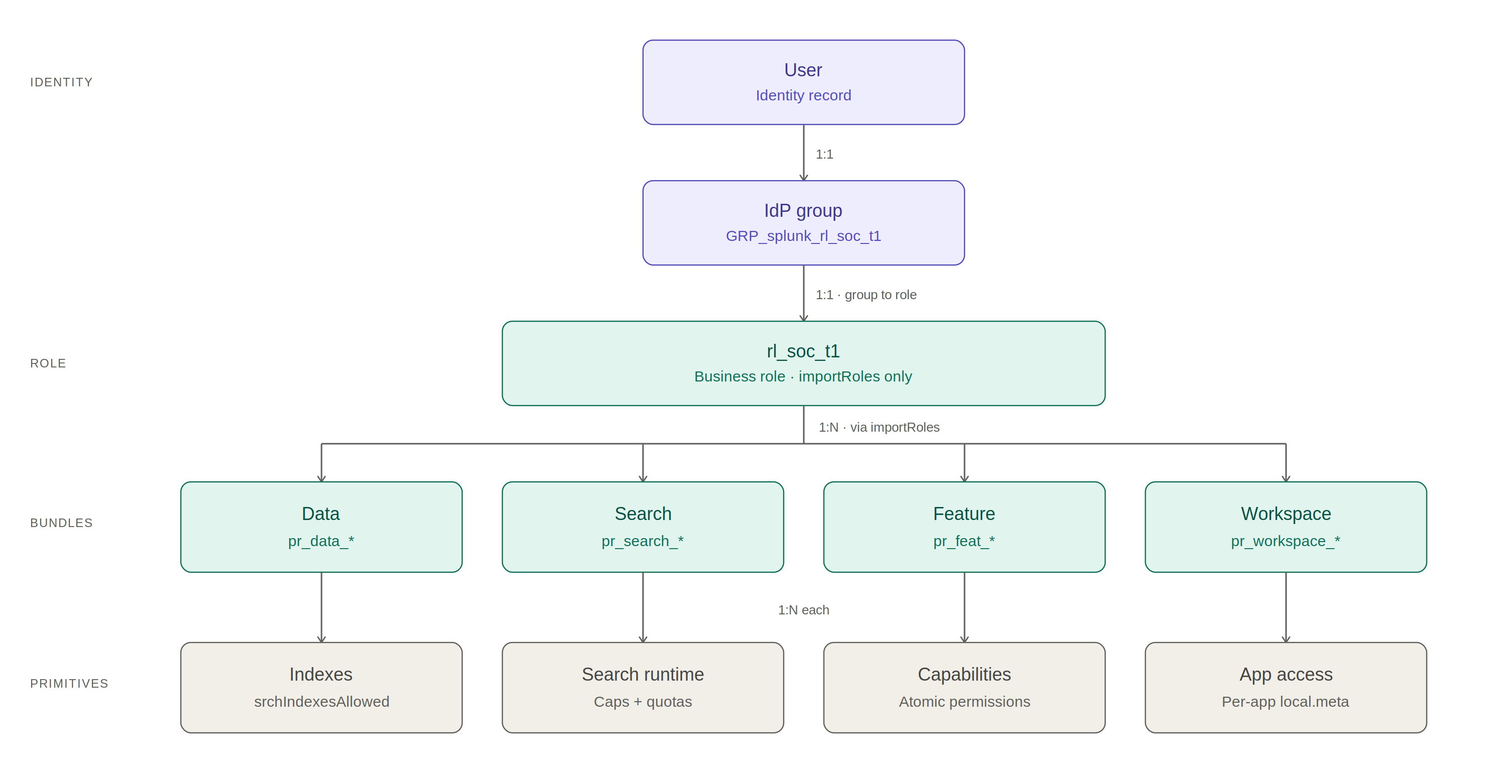
Figure 1: Layered control mapping from user identity through to Splunk's atomic permission primitives. Each layer maps to a distinct configuration concern; the rl_/pr_ split is a governance overlay above Splunk's native role primitive.

Composition convention: one Business Role per user
Splunk natively supports assigning multiple roles to a single user, with permissions evaluated as the union across all assigned roles. Tri-State chooses to constrain this: each user is assigned exactly one rl_* Business Role. Variations in access between user populations are expressed by creating distinct Business Roles with different importRoles compositions, rather than by stacking multiple roles on a single user.
This convention is enforced through IdP group membership policy and through compliance monitoring rather than through any Splunk-platform constraint. The reasons for adopting it:
- Audit clarity. Answering “what can this user do?” requires inspecting exactly one role chain.
- Composability. Every permission combination is expressed as an explicit, named Business Role, making the catalog of compositions enumerable.
- Blast-radius control. A change to a Business Role affects exactly the population intended; a change to a shared bundle is reviewed under that lens.
The trade-off is a larger number of Business Roles than would exist under multi-role assignment. This cost is accepted as the price of audit clarity.

IdP group to role mapping
User membership in Business Roles is driven entirely by the corporate Identity Provider. Splunk does not hold the source of truth for identity, except for a small number of named break-glass local accounts (see “Local accounts” below).
The mapping convention:
- Each Business Role has exactly one corresponding IdP group, named GRP_splunk_<rl_role_name>.
- The [roleMap_SAML] (or equivalent LDAP) stanza in authentication.conf contains exactly one role on the right side of each mapping line, and that role is always an rl_* Business Role.
- Direct assignment of pr_* Privilege Bundles to IdP groups is prohibited.
This convention is the technical enforcement point for the one-role-per-user rule.

Capabilities
Splunk capabilities are the atomic permission units checked at runtime by Splunk's code. They are not user-defined; Splunk ships a fixed catalog of approximately 180 capabilities, extended by capabilities registered by installed apps (Enterprise Security, ITSI, third-party apps) via [capability::<name>] stanzas in their own authorize.conf files.
Capabilities are granted to users exclusively through Privilege Bundles, never directly on Business Roles. The placement rule:
- Search-execution capabilities (search, rtsearch, schedule_search) live in pr_search_* bundles, where they sit alongside the runtime envelope they govern.
- All other capabilities live in pr_feat_* bundles, organized by the user activity they support.
- pr_data_* and pr_workspace_* bundles never contain capabilities.

Sensitive capability tier
A defined subset of Splunk capabilities is classified as sensitive. These capabilities grant privilege escalation, data destruction, credential access, or platform-wide configuration change, and require stricter governance than routine capabilities. The sensitive tier includes, at minimum:
- edit_user, edit_roles_grantable — user and role administration
- edit_tokens_all, list_storage_passwords — credential and token access
- edit_search_server, edit_indexer_cluster — platform configuration
- delete_by_keyword — data destruction
- run_collect — arbitrary index writes
- edit_indexes, edit_indexes_allinternal, clean_indexes — index modification
Sensitive capabilities are isolated in dedicated pr_feat_admin_* bundles. No routine bundle contains a sensitive capability. The governance requirements applying to any role chain that includes a sensitive bundle:
- Time-bounded assignment, with a maximum standing duration to be defined by the Platform team
- Dual approval for assignment
- Mandatory session logging to _audit
- Quarterly recertification of membership

Capability changes across Splunk releases
Splunk introduces new capabilities and occasionally renames or splits existing ones across major releases. App upgrades (Enterprise Security, ITSI) also expand the capability catalog. Each Splunk or major-app upgrade triggers a defined capability triage process:
- Run a baseline capability inventory before the upgrade.
- Run the same inventory after the upgrade and diff against the baseline.
- For each new or changed capability: assign it to the appropriate pr_feat_* bundle (or create a new bundle if no existing one fits), or determine that it should not be granted to any role.
- Update the deployment app and deploy through the standard change-management process.
This process ensures that capability additions do not silently expand what existing roles grant.

Built-in roles
Splunk ships built-in roles (admin, power, user, can_delete). Tri-State's policy regarding these roles:
- Built-in roles are not modified.
- Built-in roles are not used as components of pr_* bundles or rl_* Business Roles, except for explicitly-named research or service-account roles documented as deliberate exceptions.
- The pr_feat_baseline bundle serves as the maintained equivalent of the user baseline within this model, containing capabilities every authenticated Splunk user in the Tri-State environment should hold.
- The Splunk admin role is used only by named platform administrators and is governed under the sensitive capability tier.

Workspace bundles
Workspace bundles (pr_workspace_*) are the one category that differs structurally from the others. The pr_workspace_* role stanza in authorize.conf is intentionally empty: it grants no capabilities, no indexes, and no quotas. Its purpose is to be a named role handle that other files can reference.
The actual app access is granted in each app's metadata/local.meta file, which references the workspace role by name. For example:
# In etc/shcluster/apps/tristate_ot_workspace/metadata/local.meta
[]
access = read : [ pr_workspace_ot ], write : [ rl_platform_admin ]
export = system
[views]
access = read : [ pr_workspace_ot ], write : [ pr_workspace_ot ]
A workspace bundle is therefore a two-file construct: the empty role stanza in the central tristate_rbac app, and the access grants in each app belonging to the workspace. A complete workspace deployment requires both halves; either alone produces a half-implemented workspace where users have a role they cannot use, or apps that no role can reach.
The default landing application (the app a user sees first on login) is set in etc/users/<username>/user-prefs/local/user-prefs.conf. Splunk does not offer a role-level default-app attribute. Default landing apps are provisioned by automation on first login based on the user's rl_* Business Role, mapping each Business Role to its primary workspace app.

Authoritative configuration paths
All RBAC definitions are deployed through a dedicated Splunk app, tristate_rbac, distributed via the search head cluster deployer or manually. The suggested authoritative paths:
Configuration | Authoritative path
Role and bundle definitions | etc/shcluster/apps/tristate_rbac/local/authorize.conf
IdP group to role mapping | etc/shcluster/apps/tristate_rbac/local/authentication.conf
RBAC app access control | etc/shcluster/apps/tristate_rbac/metadata/local.meta
Workspace app access grants | etc/shcluster/apps/tristate_<workspace>/metadata/local.meta (per workspace)
Indexes referenced by pr_data_* | etc/manager-apps/<index_app>/local/indexes.conf (deployed via indexer cluster manager)
Default landing app per user | etc/users/<username>/user-prefs/local/user-prefs.conf (provisioned by automation)

Production modifications to RBAC made through the Splunk Web UI are prohibited. UI changes are written to etc/system/local/authorize.conf on the search head where the change was made — a path that is per-member, not under version control, and not synchronized across the cluster. Write access to the tristate_rbac app is restricted to platform administrators via the app's own local.meta, providing technical enforcement of this policy.
A standing audit query detects drift between the deployment app and etc/system/local/ on any search head, alerting on any role or capability assignment outside the authoritative path.

Bundle catalog sizing
The model should be designed to remain compact and abstracted. Suggested target counts per category:
Category | Target count | Sized by
pr_data_* | 8–12 bundles | Data classification × domain matrix
pr_search_* | 3–4 bundles | Distinct runtime envelopes
pr_feat_* | 6–10 bundles | User activities recognized by the governance model
pr_workspace_* | 3–6 bundles | Distinct app landing experiences

Growth beyond these targets is permitted but requires justification under the following tests:
- Necessity test. A new bundle is justified only when it represents a genuinely distinct access boundary: at least one role needs it, and at least one role must not have it.
- Reuse test. A bundle used by exactly one Business Role is not a bundle; those grants belong directly in the Business Role's stanza, marked as a deliberate exception.
- Composition test. Before adding a bundle, attempt to satisfy the requirement by composing existing bundles into a new Business Role. New Business Roles are cheap; new bundles are not.

Local accounts
A small number of named local accounts are maintained for break-glass scenarios — typically two named platform administrators with sealed credentials managed by the Security team. Local accounts bypass SAML authentication and are not subject to the IdP-driven role assignment process.
Policy for local accounts:
- The local account roster is documented and reviewed quarterly.
- Each local account login is audited and alerted on.
- Credentials are stored in the Tri-State PAM system, sealed, and rotated on a defined schedule.
- Service accounts are not created as local accounts; service identities are managed through the IdP wherever the integration permits.

Service accounts
Splunk service accounts (used by integrations, forwarders authenticating with credentials, scheduled API consumers, and similar) are governed by the same role model as human users. Each service account is assigned exactly one Business Role, named with the convention rl_svc_<purpose> (for example, rl_svc_siem_ingest). Service-account Business Roles compose from the same Privilege Bundle catalog as human roles, with the following additional discipline:
- The pr_search_constrained bundle (narrow runtime envelope, no scheduling, no real-time) is the default for service accounts unless a wider envelope is justified.
- Service accounts are scoped to the minimum data, capability, and workspace bundles required for their function.
- Service account credentials are managed in the Tri-State secrets management platform.
- Service account activity is logged to _audit and reviewed quarterly.

Compliance monitoring
The integrity of the RBAC model is verified through a defined set of saved searches running against _audit, _internal, and the /services/authorization/roles REST endpoint. The standing detections:
Detection | Question it answers
Multi-role assignment | Are any users assigned more than one rl_* role?
Direct bundle assignment | Are any users or IdP groups directly assigned a pr_* Privilege Bundle?
Sensitive capability sprawl | Is any sensitive capability granted by a role outside its designated pr_feat_admin_* bundle?
Destructive capability check | Does any role grant delete_by_keyword, edit_indexes, or other destructive capabilities outside the explicit allow-list?
Configuration drift | Does etc/system/local/authorize.conf on any search head contain stanzas outside the authoritative deployment app?
Sensitive role chain membership | Who currently holds, or has recently been granted, membership in a role chain that includes a sensitive bundle?
Capability catalog change | Have any capabilities been added, removed, or renamed since the last baseline?

Detection output is routed to the Platform team for triage. Recurring violations are treated as policy gaps requiring strategy revision, not as incidents to suppress.

Change management
RBAC changes follow the standard Tri-State Splunk change-management process with the following additional requirements specific to this section:
- All changes to authorize.conf and authentication.conf are made via pull request against the tristate_rbac repository, never directly through Splunk Web.
- Pull requests require review by at least one platform administrator not party to the change.
- Changes affecting sensitive bundles or the [roleMap_SAML] stanza require additional review by the Security team.
- Every RBAC change is tested in the non-production Splunk environment with a representative set of test users before production deployment.
- A defined rollback procedure exists for each category of change. The rollback procedure is exercised at least annually as part of platform disaster-recovery testing.
- The deployment app version in app.conf is incremented on every change, providing a versioned audit trail in combination with the repository history.

Glossary
Term | Definition
Business Role (rl_*) | A Splunk role assigned to users via IdP group membership, composed entirely of Privilege Bundles via importRoles. Contains no permissions of its own.
Privilege Bundle (pr_*) | A reusable, single-concern Splunk role granting one specific kind of access. Not assigned directly to users.
Capability | A Splunk-defined atomic permission unit checked by Splunk's code at runtime. Approximately 180 capabilities exist, extended by installed apps.
Sensitive Capability | A capability classified by Tri-State as requiring stricter governance due to its potential for privilege escalation, data destruction, credential access, or platform-wide impact.
Workspace | The curated set of Splunk apps and dashboards a user population interacts with. Implemented as a pr_workspace_* role handle plus app-level metadata grants.
IdP Group | A group defined in Tri-State's Identity Provider, mapped one-to-one to a Business Role via SAML or LDAP role mapping.
Effective Permission Set | The union of all permissions a user receives through their assigned role and all roles imported transitively. Computed by Splunk at search time.

