RESEARCH ARTICLE
A Comparative Study of Process Synchronization Algorithms
Monitor · Semaphore · Peterson · Dekker · Readers–Writers

ARTICLE INFORMATION
Field | Details
Title | Comparison of Monitor, Semaphore, Peterson, Dekker and Readers–Writers
Author | Zeynab Rezaii
Course | Embedding Systems / Concurrent Programming
Supervisor | Majid Shamshirgaran
University / Department | Eshragh Univesity
Language | English
Date | November 2026
Keywords | synchronization, critical section, mutual exclusion, semaphore, monitor

Contents: pseudocode · flowcharts · charts · comparison tables · simulation of Readers–Writers policies

Table of Contents
1. Introduction and Problem Definition 3
2. Evaluation Criteria 4
3. Dekker's Algorithm 4
4. Peterson's Algorithm 6
5. Semaphores 8
6. Monitors 9
7. The Readers–Writers Problem 11
8. Comprehensive Comparison Tables 16
9. Comparison Charts 19
10. Algorithm Selection Guide 21
11. Conclusion 22
12. References 22

Note: figures, flowcharts and pseudocode use English identifiers.

Abstract
Synchronization of concurrent processes is one of the most fundamental problems in operating systems and parallel programming. This article studies and compares five classic solutions: Dekker's algorithm, Peterson's algorithm, semaphores, monitors and the Readers–Writers problem. For each approach we give pseudocode, a flowchart, an analysis of the three correctness requirements (mutual exclusion, progress and bounded waiting) and evaluation charts. Comprehensive comparison tables cover parameters such as waiting type, starvation, deadlock, scalability, hardware requirements and efficiency. A discrete-event simulation additionally measures the behaviour of three Readers–Writers policies under different loads. Finally, a guide for choosing a suitable algorithm is provided.
Keywords: synchronization, critical section, mutual exclusion, busy waiting, semaphore, monitor, Peterson, Dekker, readers–writers.

1 Introduction and Problem Definition

1.1 The critical-section problem
When several processes (or threads) access shared data concurrently, the result depends on the exact interleaving of their instructions. This situation is called a race condition. The part of a program that touches the shared resource is the critical section. Every process is modelled as four parts: an entry section, the critical section, an exit section and a remainder section.
Pseudocode 1 — General structure of a process
do {
entry section // request permission to enter
critical section // access the shared resource
exit section // announce that we have left
remainder section // private work
} while (true);

1.2 Three correctness requirements
A correct solution must satisfy three requirements simultaneously. Mutual exclusion: at most one process is inside the critical section at any time. Progress: if the critical section is free and some processes want to enter, the decision about who enters cannot be postponed indefinitely, and only the requesting processes take part in it. Bounded waiting: between a request to enter and its grant, the number of times other processes enter first is bounded, so no starvation occurs. The standard assumptions are: the relative speeds of processes are unknown, a process stays in the critical section for a finite time, and reading or writing a single variable is atomic.

1.3 Roadmap and historical context
The five approaches fall into three levels of abstraction. Dekker and Peterson are pure-software solutions for two processes that use busy waiting. A semaphore is a primitive supported by the operating system or hardware, and a monitor is a language-level construct that provides mutual exclusion automatically. Readers–Writers is a classic coordination problem solved with semaphores or monitors. Figure 1 shows when these approaches appeared.
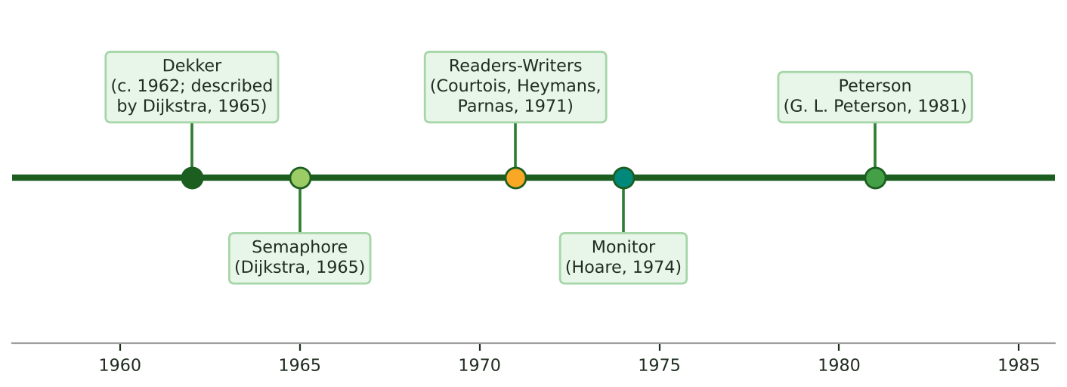
Figure 1: Chronology of the synchronization approaches

2 Evaluation Criteria
For a fair comparison all approaches are evaluated against the same fixed set of parameters. Table 1 defines each parameter in both languages; the same definitions are used in the following sections.
Table 1: Evaluation parameters
Parameter | Definition
Mutual exclusion | At most one process in the critical section at a time.
Progress | The decision to enter is never postponed forever.
Bounded waiting | Upper bound on how often others enter first.
Starvation | A process that never gets its turn.
Deadlock | Processes waiting for each other forever.
Waiting type | Busy waiting (spinning on the CPU) or blocking (sleeping).
Scalability | Behaviour as the number of processes grows.
Hardware / OS support | Which atomic or OS support is required.
Memory overhead | Number of shared variables and queues needed.
Complexity and proof | Difficulty of implementation and correctness proof.
CPU efficiency | Whether processor time is wasted while waiting.

Besides the qualitative parameters above, two countable structural indicators are extracted from the pseudocode of this article: the number of shared synchronization variables and the number of entry/exit statements. For Readers–Writers, performance indicators (average and maximum waiting time) come from a simulation. The radar scores in Section 9 are the author's qualitative assessment based on the analysis, not empirical measurements.

3 Dekker's Algorithm

3.1 Overview
Dekker's algorithm is the first correct software solution to the mutual-exclusion problem for two processes. It was devised by the Dutch mathematician Th. J. Dekker around 1962 and described by Dijkstra in 1965 in “Cooperating Sequential Processes”. It needs only atomic reads and writes of shared variables; no special hardware instruction such as Test-and-Set is required.

3.2 Idea of the algorithm
Each process Pi announces its intention to enter by raising its flag flag[i]. If the rival's flag is also raised, there is contention and the variable turn decides whose turn it is. The process that does not hold the turn lowers its flag temporarily, waits until it is its turn, and then raises the flag again. On exit, the process hands the turn to the rival and lowers its flag. This “polite back-off” prevents deadlock; a naive version using only flag can deadlock, and a version using only turn forces the processes to alternate strictly.

3.3 Pseudocode
Pseudocode 2 — Dekker's algorithm (process Pi, j = 1 - i)
shared: boolean flag[2] = {false, false}; int turn = 0;

do {
flag[i] = true; // I want to enter
while (flag[j]) { // rival also wants to enter
if (turn == j) { // rival has priority
flag[i] = false; // back off
while (turn == j) ; // busy wait for my turn
flag[i] = true; // try again
}
}
/* ------- CRITICAL SECTION ------- */
turn = j; // give priority to rival
flag[i] = false; // I am done
/* ------- REMAINDER SECTION ------ */
} while (true);

3.4 Flowchart
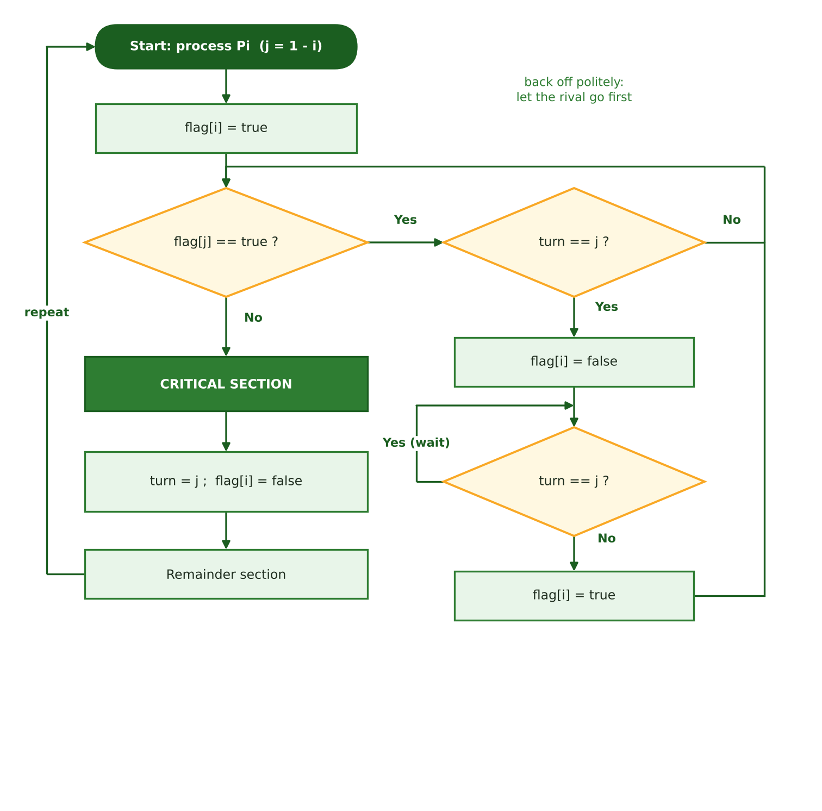
Figure 2: Flowchart of Dekker's algorithm for process Pi

3.5 Analysis
Mutual exclusion: a process that sees flag[j] lowered already has its own flag raised, so the rival either stays in its wait loop or backs off after seeing that flag. Progress: turn always gives priority to exactly one of the two processes, and under contention the holder proceeds without waiting. Bounded waiting: on exit the turn is handed to the rival, so each process lets the rival enter ahead of it at most once.
- Strengths: fully correct for two processes; no special atomic instruction; all three requirements hold.
- Weaknesses: busy waiting wastes CPU; intricate logic and hard proof; only two processes (Dijkstra's N-process generalization needs 2N+1 variables); fails on modern processors without memory barriers.

4 Peterson's Algorithm

4.1 Overview and idea
In 1981 Gary L. Peterson published a much simpler solution than Dekker's. Each process first announces its need with flag[i] = true and then “gives the turn away” to its rival (turn = j). It waits only if the rival also wants to enter and the turn belongs to the rival. Because both processes write turn and the last writer loses, only one of them can pass the test.

4.2 Pseudocode
Pseudocode 3 — Peterson's algorithm (process Pi, j = 1 - i)
shared: boolean flag[2] = {false, false}; int turn;

do {
flag[i] = true; // I am interested
turn = j; // let the rival go first
while (flag[j] && turn == j) ; // busy wait
/* ------- CRITICAL SECTION ------- */
flag[i] = false; // exit section
/* ------- REMAINDER SECTION ------ */
} while (true);

Pseudocode 4 — Generalization to N processes (filter lock)
shared: int level[N] = {-1,...,-1}; int victim[N];

lock(i):
for (L = 0; L < N - 1; L++) { // N-1 filtering levels
level[i] = L; // I reached level L
victim[L] = i; // I am the last arrival
while (exists k != i : level[k] >= L && victim[L] == i) ;
}
/* ------- CRITICAL SECTION ------- */
unlock(i):
level[i] = -1;

4.3 Flowchart and execution trace
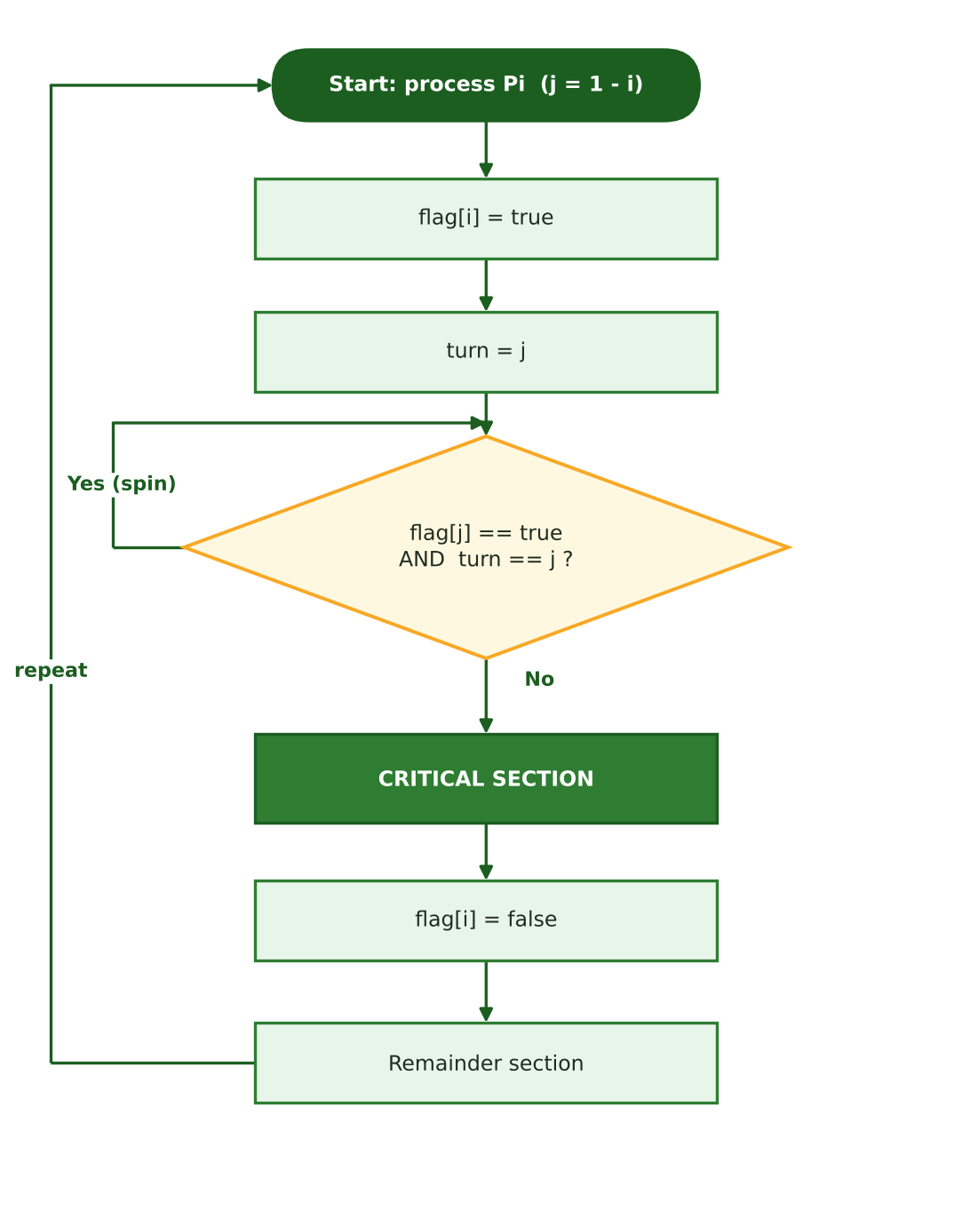
Figure 3: Flowchart of Peterson's algorithm for process Pi
Figure 4 shows one possible interleaving of the two processes. Both raise their flags and write turn; since P1 is the last writer of turn (final value 0), P0 passes the test and enters, while P1 busy-waits until P0 leaves.
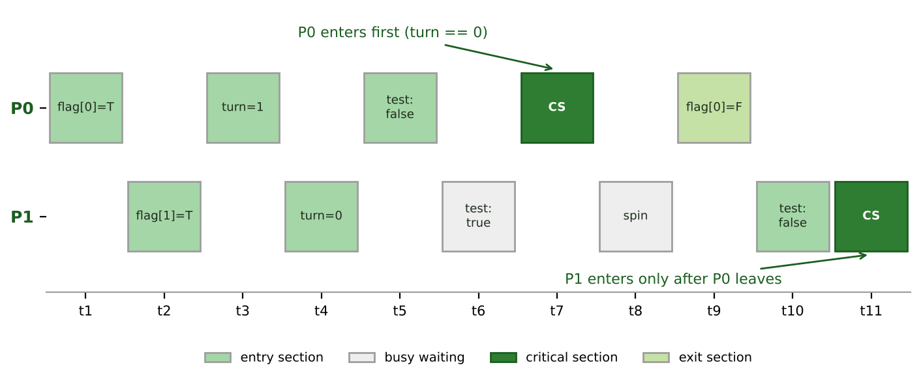
Figure 4: Timing trace of one possible execution of Peterson's algorithm

4.4 Correctness argument and analysis
Short proof of mutual exclusion: assume P0 passes the entry test before P1. At that moment either flag[1] was lowered (then P1 later writes turn = 0, and because P0 does not change turn until it exits and flag[0] is raised, P1 stays blocked), or turn = 0 already held (P1 had written it earlier, and that same state keeps P1 blocked). In both cases P1 cannot enter simultaneously. Progress and bounded waiting: the process that wrote turn last waits, and the rival lowers its flag on exit, so each process enters at most once after the rival.
- Strengths: very short and provable; all three requirements hold; generalizes to N processes via the filter lock.
- Weaknesses: busy waiting; the filter lock needs O(N) entry cost and 2N-1 memory cells; on modern hardware it fails without memory fences or sequentially consistent atomics because stores may be reordered after later loads (store buffers).

5 Semaphores

5.1 Overview
Semaphores were introduced by Dijkstra in 1965. A semaphore is an integer variable S that can be changed only through two atomic operations, wait(S) (also P) and signal(S) (also V). A binary semaphore (mutex) holds only 0 or 1 and is used for mutual exclusion; a counting semaphore can hold any non-negative value and records the number of free instances of a resource. Semaphores have three main uses: mutual exclusion (initial value 1), event ordering (initial value 0) and resource counting (initial value equal to the capacity).

5.2 Pseudocode
Pseudocode 5a — Busy-waiting semaphore
wait(S): while (S <= 0) ; // spin until positive
S--;
signal(S): S++;

Pseudocode 5b — Blocking semaphore (no busy waiting)
typedef struct { int value; queue list; } semaphore;

wait(S): S.value--;
if (S.value < 0) { add this process to S.list; block(); }
signal(S): S.value++;
if (S.value <= 0) { remove a process P from S.list; wakeup(P); }

Pseudocode 6 — Mutual exclusion with a binary semaphore
semaphore mutex = 1;

do {
wait(mutex); // entry section
/* ------- CRITICAL SECTION ------- */
signal(mutex); // exit section
/* ------- REMAINDER SECTION ------ */
} while (true);

Pseudocode 7 — Bounded buffer (producer-consumer) with three semaphores
semaphore mutex = 1, empty = N, full = 0;

Producer: Consumer:
do { do {
produce(item); wait(full);
wait(empty); wait(mutex);
wait(mutex); item = remove();
insert(item); signal(mutex);
signal(mutex); signal(empty);
signal(full); consume(item);
} while (true); } while (true);

5.3 Flowchart
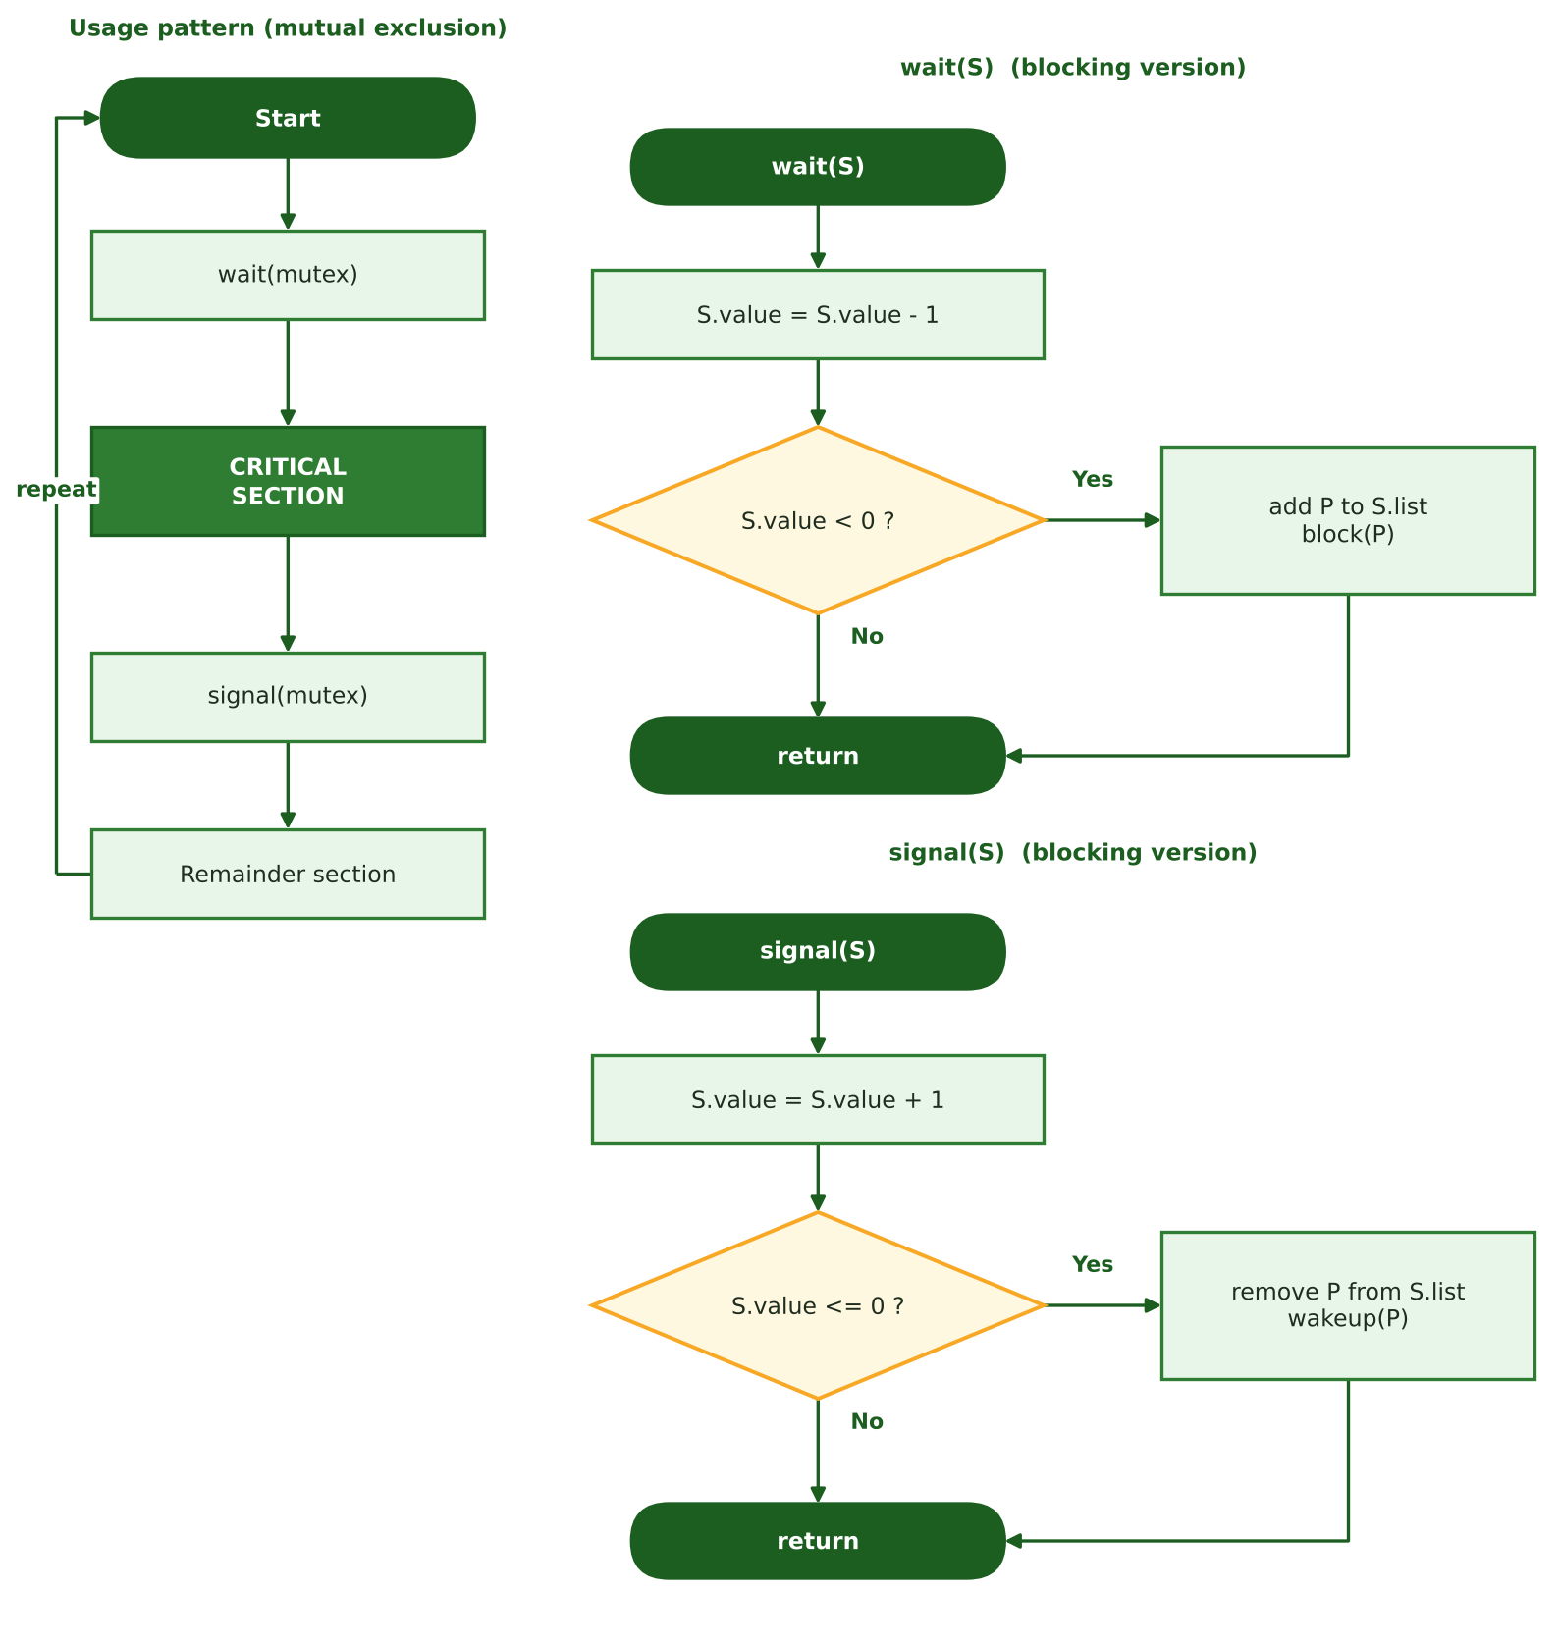
Figure 5: Usage pattern of a semaphore and the blocking implementation of wait and signal

5.4 Analysis
Correctness: because wait and signal are atomic (implemented with interrupt disabling, a spinlock or a Test-and-Set instruction) and the semaphore value cannot be decremented simultaneously by two processes, mutual exclusion holds. Bounded waiting depends on the queue policy: it holds for a strong semaphore (FIFO queue) but starvation is possible with a weak semaphore (arbitrary wake-up). In the blocking version a waiting process consumes no CPU.
- Hazards: deadlock from a wrong ordering (e.g. swapping wait(empty) and wait(mutex) in the producer), forgetting signal, and priority inversion, famously seen in the Mars Pathfinder mission in 1997.
- Strengths: scales to N processes, no busy waiting (blocking version), flexible for ordering and resource counting. Main weakness: low level and error-prone, since mutual exclusion relies on programmer discipline rather than language structure.

6 Monitors

6.1 Overview
Monitors were proposed by C. A. R. Hoare in 1974 (and independently by Per Brinch Hansen) to overcome the problems of semaphores. A monitor is a language-level construct that encapsulates shared data together with the procedures that access it and allows only one process to be active inside it at a time; mutual exclusion is guaranteed by the compiler or runtime. Waiting for a condition uses condition variables with the operations wait() and signal(). c.wait() releases the monitor lock and puts the process to sleep on the condition queue; c.signal() wakes up one waiting process.

6.2 Signalling semantics
There are two main styles. In the Hoare style (signal-and-wait) the signalling process hands the monitor to the woken process immediately, so the condition is guaranteed to hold when it resumes and an if is sufficient. In the Mesa style (signal-and-continue) the signaller keeps running and the woken process must re-acquire the lock; since the condition may have changed in between, the test must be repeated inside a while loop. Java, pthreads and most modern languages follow the Mesa style.

6.3 Pseudocode
Pseudocode 8 — Bounded buffer implemented as a monitor (Mesa semantics)
monitor BoundedBuffer {
item buffer[N]; int count = 0, in = 0, out = 0;
condition notFull, notEmpty;

procedure put(item x) {
while (count == N) notFull.wait(); // wait until space exists
buffer[in] = x; in = (in + 1) % N; count++;
notEmpty.signal(); // wake one consumer
}
procedure item get() {
while (count == 0) notEmpty.wait(); // wait until data exists
x = buffer[out]; out = (out + 1) % N; count--;
notFull.signal(); // wake one producer
return x;
}
}

6.4 Flowchart
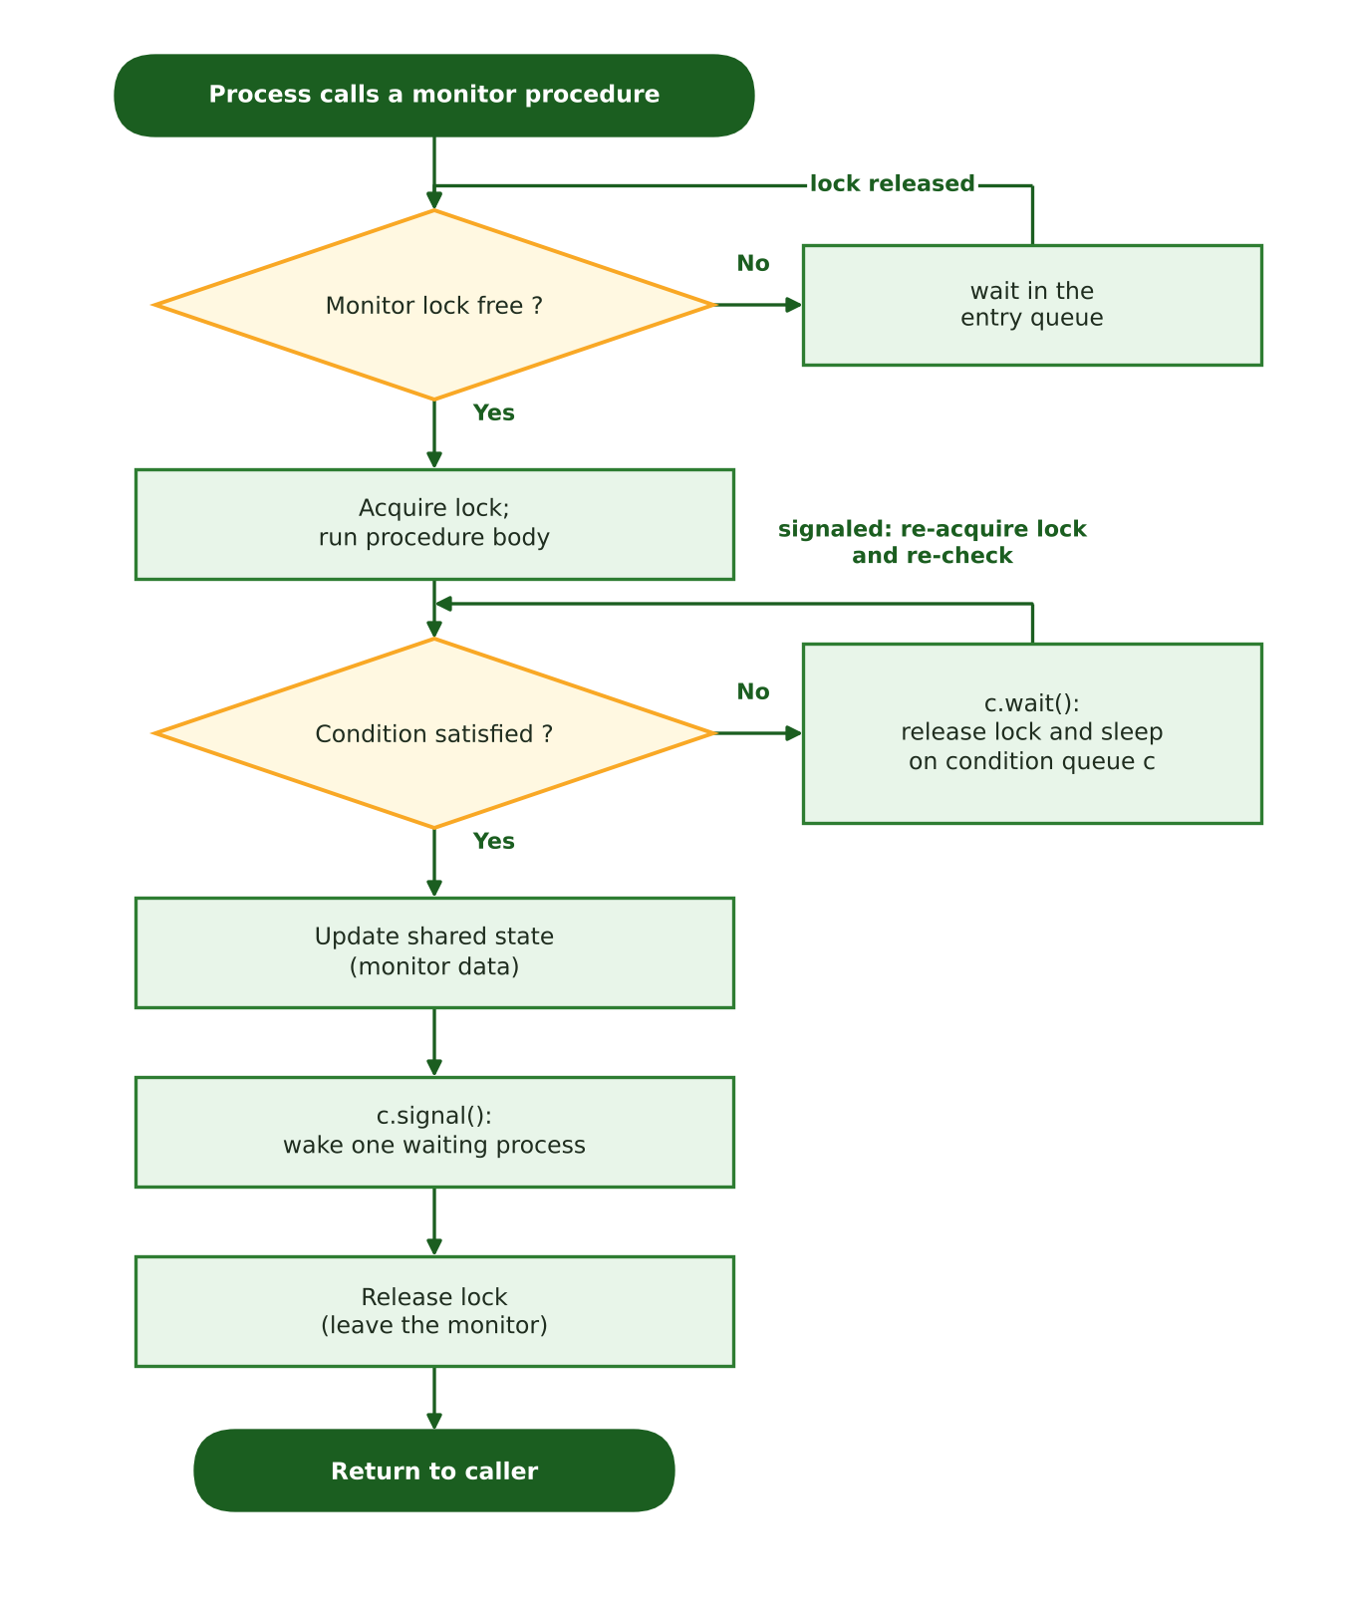
Figure 6: Flowchart of entering a monitor, waiting on a condition variable and leaving

6.5 Analysis
Correctness: mutual exclusion is inherent and automatic, and the programmer cannot forget the entry or exit operations. Progress: because wait() releases the lock, other processes can proceed. Bounded waiting depends on the policy of the entry and condition queues (FIFO queues guarantee it). Waiting is blocking and consumes no CPU. Typical problems: nested-monitor lockout, lost wake-ups when if is used instead of while under Mesa semantics, and dependence on language support.
- Strengths: high level, safer than semaphores, data encapsulation, scalable, no busy waiting. Implementations: synchronized/wait/notify in Java, mutex + cond_var in pthreads, Monitor in C#.

7 The Readers–Writers Problem

7.1 Problem statement
The Readers–Writers problem was posed by Courtois, Heymans and Parnas in 1971. A shared resource (for example a database or a file) can be read by several readers at the same time, but a writer needs exclusive access. The rules: writers must not overlap with writers or readers, while readers do not conflict with each other. Three variants are defined by priority: reader priority (first problem), writer priority (second problem) and starvation-free / fair (third problem).

7.2 Pseudocode of the three solutions
Pseudocode 9 — First problem: reader priority (semaphores)
semaphore mutex = 1, wrt = 1; int readcount = 0;

Reader: Writer:
wait(mutex); wait(wrt);
readcount++; /* WRITING */
if (readcount == 1) wait(wrt); signal(wrt);
signal(mutex);
/* READING */
wait(mutex);
readcount--;
if (readcount == 0) signal(wrt);
signal(mutex);

Pseudocode 10 — Second problem: writer priority (semaphores)
semaphore rmutex = 1, wmutex = 1, wrt = 1, readTry = 1;
int readcount = 0, writecount = 0;

Reader: Writer:
wait(readTry); wait(wmutex);
wait(rmutex); writecount++;
readcount++; if (writecount == 1) wait(readTry);
if (readcount == 1) wait(wrt); signal(wmutex);
signal(rmutex); wait(wrt);
signal(readTry); /* WRITING */
/* READING */ signal(wrt);
wait(rmutex); wait(wmutex);
readcount--; writecount--;
if (readcount == 0) signal(wrt); if (writecount == 0) signal(readTry);
signal(rmutex); signal(wmutex);

Pseudocode 11 — Third problem: fair solution (strong FIFO semaphore "order")
semaphore mutex = 1, wrt = 1, order = 1; int readcount = 0;

Reader: Writer:
wait(order); wait(order);
wait(mutex); wait(wrt);
readcount++; signal(order);
if (readcount == 1) wait(wrt); /* WRITING */
signal(mutex); signal(wrt);
signal(order);
/* READING */
wait(mutex);
readcount--;
if (readcount == 0) signal(wrt);
signal(mutex);

Pseudocode 12 — Writer-priority solution as a monitor (Mesa semantics)
monitor ReadersWriters {
int activeReaders = 0, waitingWriters = 0; boolean writing = false;
condition okRead, okWrite;

procedure beginRead() {
while (writing || waitingWriters > 0) okRead.wait();
activeReaders++;
}
procedure endRead() {
activeReaders--;
if (activeReaders == 0) okWrite.signal();
}
procedure beginWrite() {
waitingWriters++;
while (writing || activeReaders > 0) okWrite.wait();
waitingWriters--; writing = true;
}
procedure endWrite() {
writing = false;
if (waitingWriters > 0) okWrite.signal(); else okRead.broadcast();
}
}

7.3 Flowchart (first problem)
The first reader keeps writers out with wait(wrt) and the last reader releases the resource with signal(wrt). The variable readcount is protected by mutex.
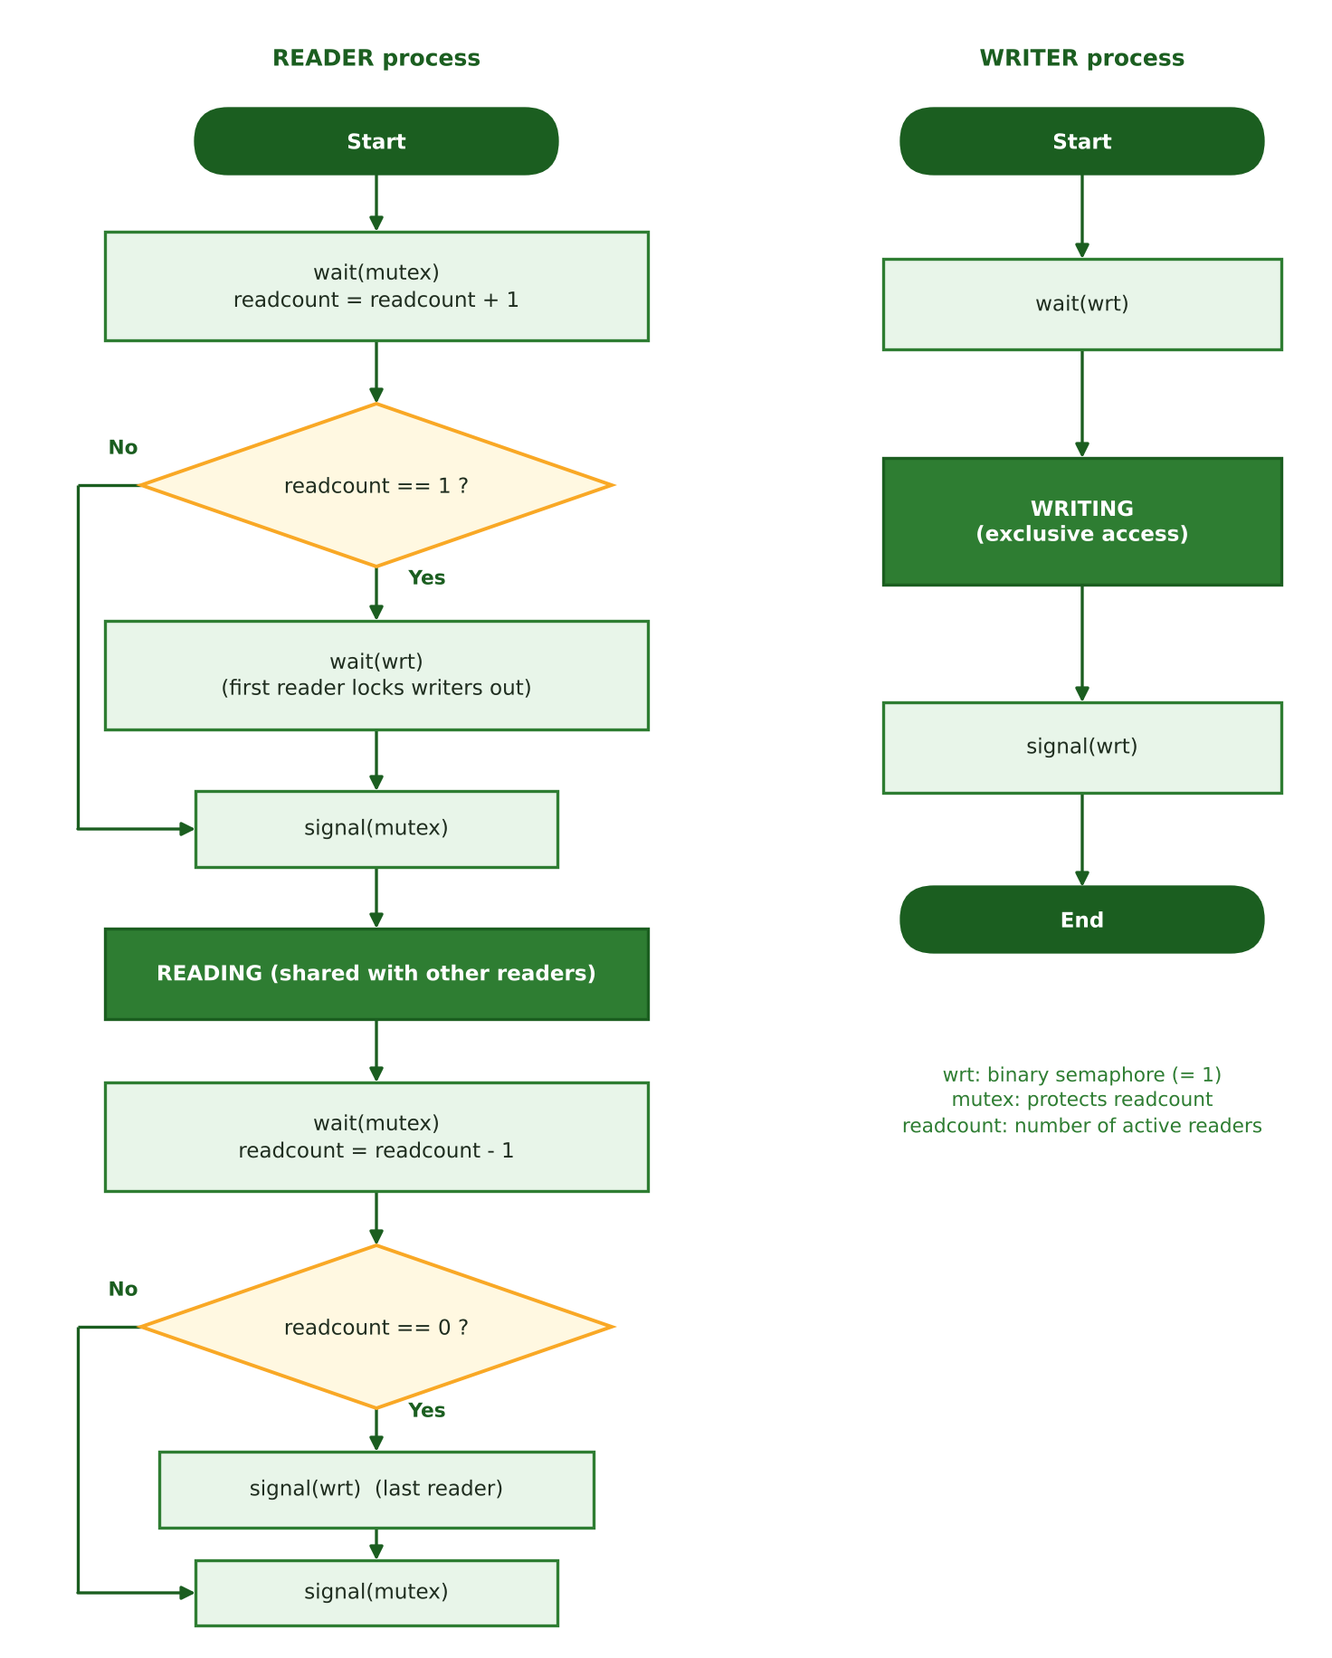
Figure 7: Flowchart of the reader and writer processes in the first-problem solution

7.4 Comparison of the three variants
Table 2: Comparison of the three Readers–Writers variants
Property | Reader priority | Writer priority | Fair (FIFO)
Writer starvation | Possible | No | No
Reader starvation | No | Possible | No
Reader concurrency | Maximal | Reduced | Medium
Bounded waiting | No | No | Yes
Semaphores used | 2 + readcount | 4 + 2 counters | 3 + readcount
Best suited for | Read-mostly data | Fresh-data critical systems | General purpose

7.5 Simulation of the three policies
To measure the difference between the three variants in practice, a discrete-event simulation was written. Assumptions: readers and writers arrive as Poisson processes; the writer arrival rate is 0.15 per time unit while the reader arrival rate varies from 0.5 to 4; read and write durations are exponential with means 1.0 and 1.5; the horizon is 30,000 time units and results are averaged over three random seeds. Requests still waiting at the end are counted with their current waiting time so that starvation is not hidden. The results are specific to this model; absolute values change with the workload.
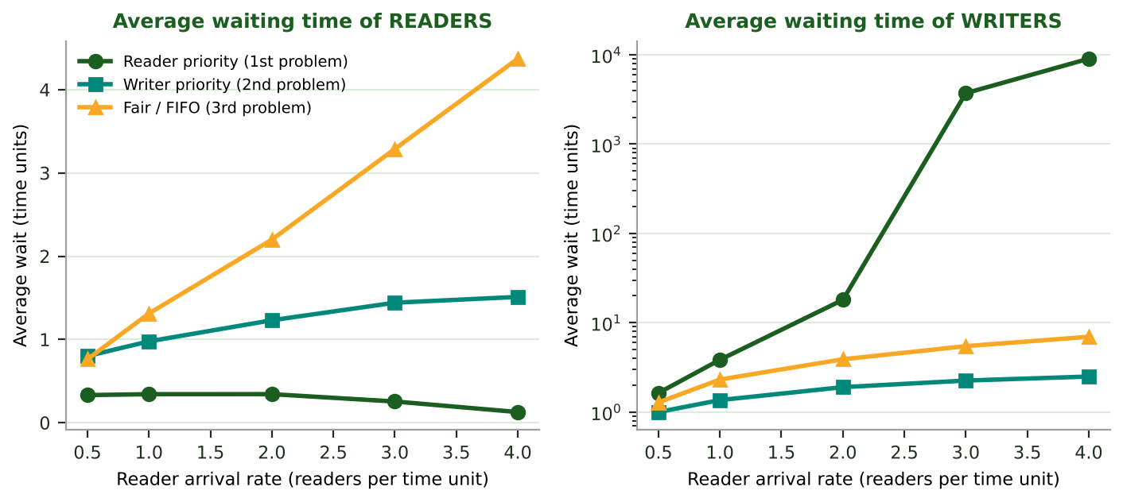
Figure 8: Average waiting time of readers and writers (writer axis is logarithmic)
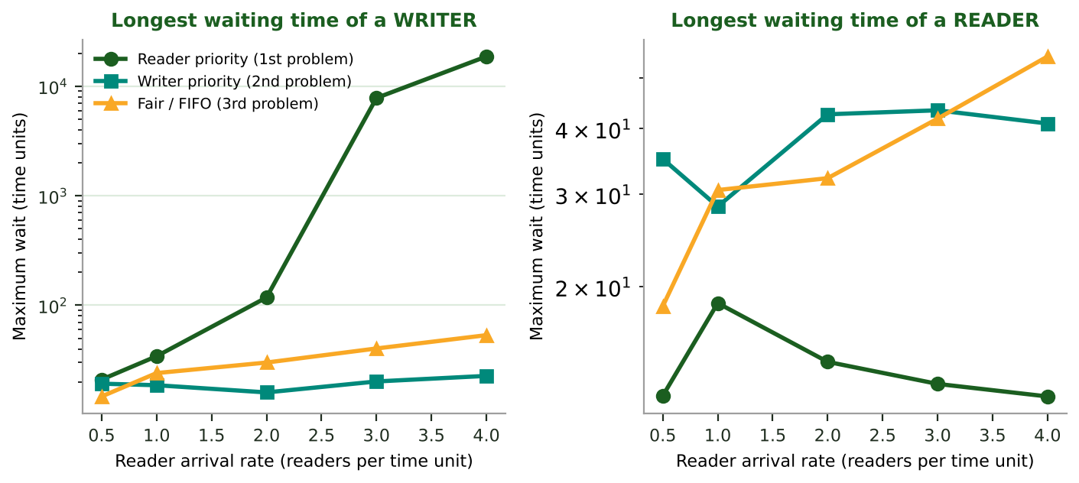
Figure 9: Maximum waiting time of a writer and of a reader (logarithmic axes)
Interpretation: at a reader arrival rate of 4, the average writer wait under reader priority is about 9,000 time units (effectively starvation, bounded only by the simulation length), versus about 2.5 under writer priority and about 7 under the fair policy. Conversely, a reader waits only about 0.13 units under reader priority, about 1.5 under writer priority and about 4.4 under the fair policy. Fairness is therefore paid for with a higher average reader wait, but it gives a bound on the waiting of both groups.

7.6 Analysis
- Mutual exclusion: the writer is separated from everyone else by wrt; readers deliberately share. Progress: holds in all variants. Bounded waiting: only in the third variant.
- Cost: maintaining readcount and at least two semaphores; the second variant needs more semaphores and more complexity. In practice ready-made reader–writer locks (such as pthread_rwlock or ReentrantReadWriteLock) are used.

8 Comprehensive Comparison Tables
In this section the five approaches are compared in three tables using all parameters of Section 2: general characteristics, correctness and safety, and performance and practice.
Table 3: General characteristics
Property / Parameter | Dekker | Peterson | Semaphore | Monitor | Readers–Writers
Author and year | Th. J. Dekker, c. 1962 (Dijkstra, 1965) | G. L. Peterson, 1981 | Dijkstra, 1965 | Hoare / Brinch Hansen, 1974 | Courtois et al., 1971
Type and level | Software algorithm | Software algorithm | OS / hardware primitive | Language-level construct | Coordination problem (semaphores or monitors)
Processes supported | 2 (N via generalization) | 2 (N with filter lock) | N | N | N readers + M writers
Hardware / OS support | Atomic read/write + memory fences | Atomic read/write + memory fences | Atomic instruction or OS support | Language / runtime support | Semaphores or monitors
Shared variables (2 processes) | 3 (flag[2], turn) | 3 (flag[2], turn) | 1 semaphore (+ kernel queue) | 1 implicit lock + conditions | 3 (mutex, wrt, readcount)
Entry + exit statements | 9 | 4 | 2 | 2 (implicit) | 8 reader / 2 writer
Implementation complexity | High | Low | Low | Medium | Medium–High
Difficulty of proof | Hard | Easy | Medium | Easy (encapsulation) | Medium

Table 4: Correctness and safety (bounded waiting, progress, …)
Property / Parameter | Dekker | Peterson | Semaphore | Monitor | Readers–Writers
Mutual exclusion | Guaranteed | Guaranteed | Guaranteed (binary semaphore) | Guaranteed and automatic | Writer vs. all; readers share
Progress | Holds | Holds | Holds | Holds | Holds
Bounded waiting | Holds (at most 1 turn) | Holds (at most 1 turn) | Depends on queue (strong: yes, weak: no) | Depends on queue policy | Only the fair variant
Starvation | None | None | Possible (weak semaphore) | Possible (unfair signalling) | Possible (variants 1, 2)
Deadlock | None (due to back-off) | None | Possible (wrong ordering) | Possible (nested monitors) | Possible if misused
Fairness | Turn-based | Turn-based | FIFO if strong | FIFO with fair queues | Variant dependent
Memory-model issue | Needs memory fences | Needs memory fences | None (handled by OS / library) | None | None
Priority-inversion risk | High (spinning) | High (spinning) | Present | Present | Present

Table 5: Performance and practice
Property / Parameter | Dekker | Peterson | Semaphore | Monitor | Readers–Writers
Waiting type | Busy waiting | Busy waiting | Blocking (busy in simple version) | Blocking | Blocking
CPU efficiency | Poor | Poor | Good | Good | Good
Scalability | Poor (2 processes) | Poor (filter O(N)) | Excellent | Excellent | Good
Memory growth with N | 2N + 1 | 2N - 1 | Constant O(1) | Constant O(1) | Constant O(1)
Context-switch overhead | None | None | Yes (when blocking) | Yes (on wait) | Yes
Typical applications | Teaching, historical | Teaching, systems without atomic ops | OS kernels, producer–consumer | Java, C#, pthreads (mutex + cond) | Databases, file systems, caches
Main weakness | Busy wait, intricacy | Busy wait, memory reordering | Error-prone, priority inversion | Language dependent, nested lockout | Starvation in variants 1, 2

9 Comparison Charts

9.1 Qualitative radar chart
Figure 10 shows seven criteria on a scale of 1 to 5, where 5 is best. The scores are the author's qualitative assessment based on the analysis of the previous sections (for example, “CPU efficiency” is 1 for busy-waiting methods and 4 for blocking methods) and are not empirical measurements.
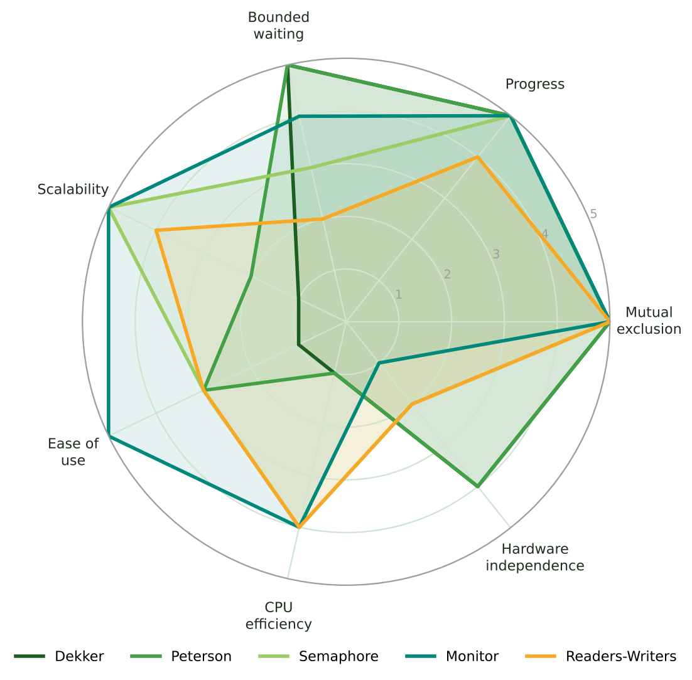
Figure 10: Radar chart for the qualitative comparison of the five approaches
Table 6: Qualitative scores (1 to 5, higher is better)
Criterion | Dekker | Peterson | Semaphore | Monitor | Readers–Writers
Mutual exclusion | 5 | 5 | 5 | 5 | 5
Progress | 5 | 5 | 5 | 5 | 4
Bounded waiting | 5 | 5 | 3 | 4 | 2
Scalability | 1 | 2 | 5 | 5 | 4
Ease of use | 1 | 3 | 3 | 5 | 3
CPU efficiency | 1 | 1 | 4 | 4 | 4
Hardware independence | 4 | 4 | 2 | 1 | 2

9.2 Structural metrics
Figure 11 shows two countable indicators derived from the pseudocode of this article. Semaphores and monitors have the shortest entry/exit protocol; Dekker is the longest with 9 statements. For the monitor the implicit lock is counted as one variable and condition variables are not counted.
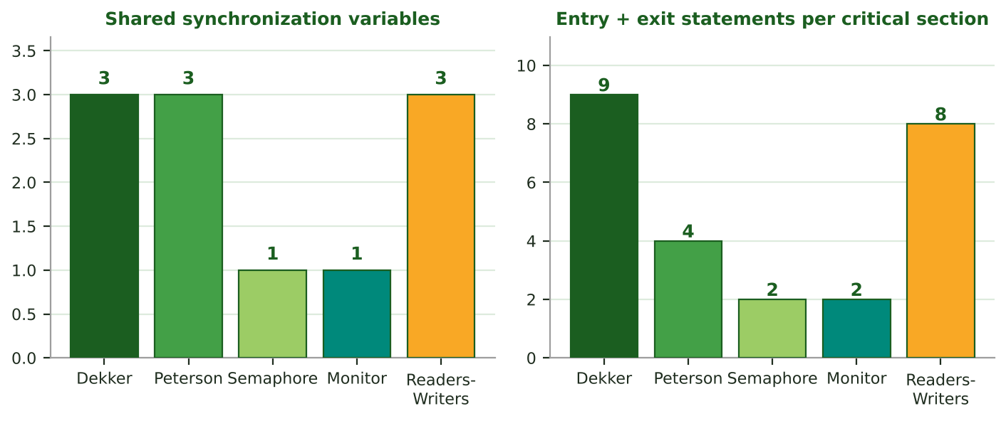
Figure 11: Number of shared variables and entry/exit statements

9.3 Memory growth with the number of processes
Figure 12 shows that the N-process software methods (Dijkstra's generalization of Dekker with 2N+1 cells and Peterson's filter lock with 2N-1 cells) grow shared memory linearly, whereas a semaphore or monitor lock always has one shared variable (the wait queues are kept by the kernel).
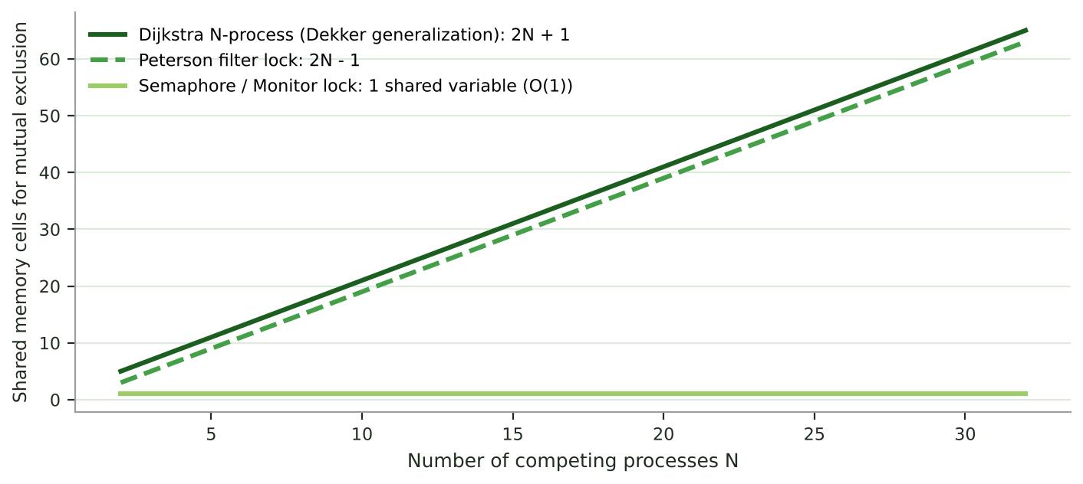
Figure 12: Shared memory cells versus number of processes

10 Algorithm Selection Guide
Figure 13 is a simple decision tree for choosing a suitable approach. In practice a modern programmer almost never uses Dekker or Peterson directly; they are mainly valuable for understanding the principles and for environments without atomic-operation support.
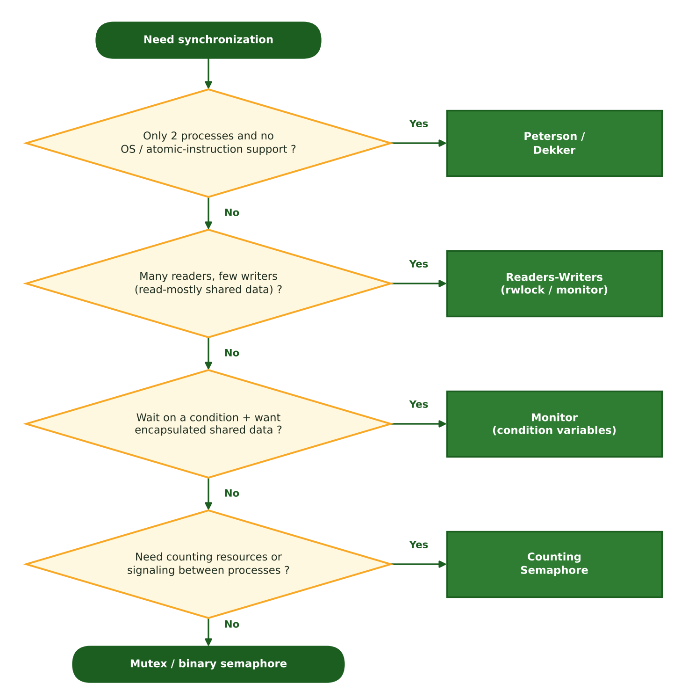
Figure 13: Decision tree for choosing a synchronization method
Table 7: Scenario and recommended method
Scenario | Recommended | Reason
OS course, proving correctness | Peterson | Short and provable
Microcontroller without atomic ops | Peterson (with fences) | Needs only reads/writes
Protecting a data structure | mutex / monitor | Simple, safe, blocking
Producer–consumer | Counting semaphore or monitor | Capacity counting and ordering
Read-mostly database | Readers–Writers | Reader concurrency
Starvation must be avoided | Fair FIFO solution | Bounded waiting

11 Conclusion
This article compared five classic synchronization solutions with pseudocode, flowcharts, charts and comprehensive tables. Dekker and Peterson show that mutual exclusion is possible with plain reads and writes, but busy waiting, the two-process limit and sensitivity to the memory model restrict their practical use; Peterson is preferable to Dekker because of its simplicity. The semaphore is a general and scalable tool, but error-prone. The monitor, with encapsulation and automatic mutual exclusion, is the safest and most widely used high-level tool. Readers–Writers shows that the choice of priority policy is a direct trade-off between throughput and fairness: the simulation showed that reader priority can starve writers under heavy load, writer priority keeps reader waiting moderate, and the fair policy bounds the waiting of both groups at the cost of a higher average.
Future work: comparison with locks built on hardware instructions (Test-and-Set, Compare-and-Swap), Lamport's Bakery algorithm and lock-free structures, as well as empirical measurements on real hardware.

12 References
[1] E. W. Dijkstra, “Cooperating Sequential Processes”, EWD123, 1965; in F. Genuys (ed.), Programming Languages, Academic Press, 1968, pp. 43–112.
[2] G. L. Peterson, “Myths About the Mutual Exclusion Problem”, Information Processing Letters, 12(3), 1981, pp. 115–116.
[3] C. A. R. Hoare, “Monitors: An Operating System Structuring Concept”, Communications of the ACM, 17(10), 1974, pp. 549–557.
[4] P. J. Courtois, F. Heymans, D. L. Parnas, “Concurrent Control with Readers and Writers”, Communications of the ACM, 14(10), 1971, pp. 667–668.
[5] P. Brinch Hansen, Operating System Principles, Prentice Hall, 1973.
[6] A. Silberschatz, P. B. Galvin, G. Gagne, Operating System Concepts, Wiley (multiple editions).
[7] A. S. Tanenbaum, H. Bos, Modern Operating Systems, Pearson (multiple editions).
[8] M. Herlihy, N. Shavit, The Art of Multiprocessor Programming, Morgan Kaufmann.
[9] A. B. Downey, The Little Book of Semaphores, Green Tea Press.

