|  |
| --- |
| **Reza Karbasi** |
| **Robotic AI Engineer** |
| [arzkarbasi@gmail.com](mailto:arzkarbasi@gmail.com)  [LinkedIn](https://www.linkedin.com/in/reza-karbasi-270791133/)  [Reza Karbasi](https://github.com/rezakarbasi)  [Portfolio](https://rezakarbasi.github.io/) Tehran, Iran |

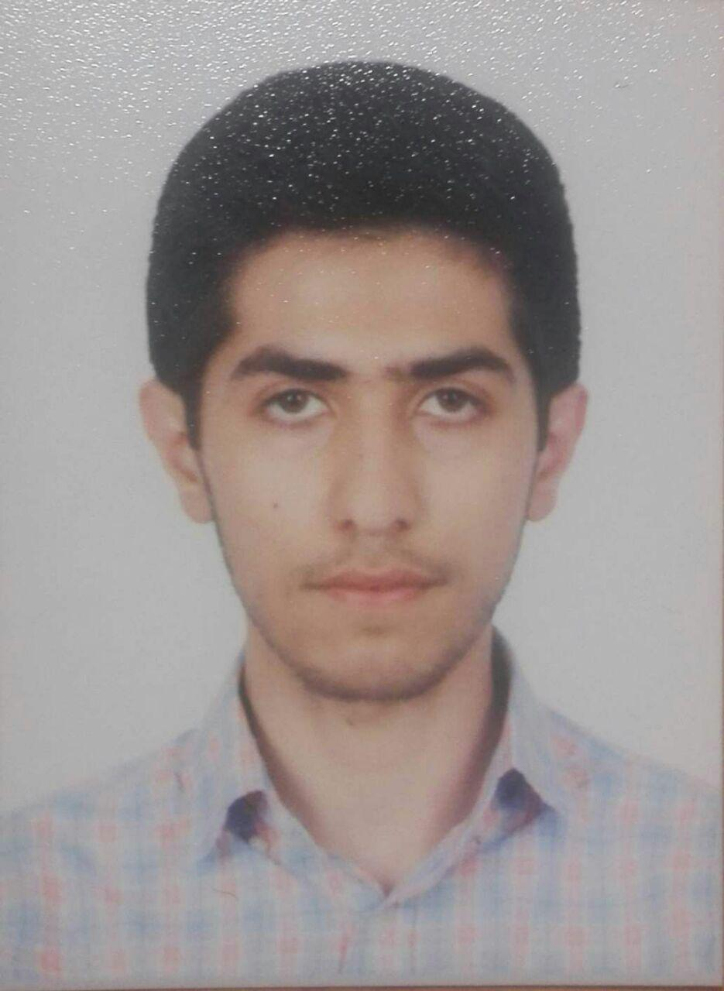

# Summary

* AI Software Engineer with 4+ years experience in autonomous driving perception. Master’s in AI and Robotics. Skilled in C++, Python, ROS, PyTorch. Experienced in computer vision, object detection, multi-object tracking, and sensor fusion. Contributed to open source like  [DeepFace](https://github.com/serengil/deepface). Adept at collaborating in multidisciplinary teams.

# Work Experience

|  |  |
| --- | --- |
| **Automotive Software Engineer** | [*SoftwareMotion*](https://sw-motion.tech/) |
| *04/2023 - Now* | *Remote, China* |
|  |  |

* + Made a **CI/CD** pipeline in **Gitlab** with **GTest** for the Autosar-based codebase, reducing on-field testing through automated unit and integration tests by 30%
  + Built a **PyQT** visualization software for AEB and ACC systems, integrating BEV plots to drastically reduce debugging time. Processed MF4 and CAN signals (BLF, DBC) to expedite vehicle issue diagnosis.
  + Evaluated and integrated advanced path planning solutions, such as lattice-based and  [Apollo](https://github.com/ApolloAuto/apollo)’s EM planner. Also, developed obstacle avoidance algorithms with **DP** and **A\*** techniques, validated through a custom Python-based simulator.

|  |  |
| --- | --- |
| **Machine Learning Engineer** | [*Hara AI Company*](https://hara.ai/) |
| *06/2022 - 03/2023* | *Tehran, Iran* |
|  |  |

* + Leveraged Google’s  [YamNet](https://www.tensorflow.org/hub/tutorials/yamnet) within the TensorFlow framework to automate the categorization of audio files by gender and age, fine-tuning the model on the company’s labeled dataset. Introduced a custom loss function that balances precision and recall, achieving an average precision of 0.55 and an average recall of 0.51 across various categories.
  + Building a filter for detecting operator interruptions and poor voice quality using VAD algorithms.
  + Deployed **MLflow** to facilitate experiment tracking.
  + Conducted an in-depth assessment and visualization of the company’s Speech-to-Text (**STT**) models under varied real-world conditions (such as noise and reverbation) to pinpoint vulnerabilities.

|  |  |
| --- | --- |
| **AI Engineer** | *Iran’s National Elites Foundation* |
| *10/2022 - 12/2023* | *Tehran, Iran* |
|  |  |

* Leading a team, we developed a microservice-based platform for a vehicle monitoring, focusing on a graph-based path planning module. By implementing advanced algorithms like Dynamic Programming and A*, we enhanced navigation precision and system responsiveness, achieving a tenfold increase in processing speed over the initial version.

|  |  |
| --- | --- |
| **Designer of a Trader Bot** | *QDM* |
| *04/2019 - 01/2020* | *Tehran, Iran* |
|  |  |

* Engineered a Metatrader trading bot with a technical strategy, incorporating a **Deep Q Network** in **PyTorch**. Utilized a socket connection for data streaming and applied the algorithm on historical data spanning 2007-2019 in Metatrader. Documented a version on this  [Medium blog](https://medium.com/@a.rz.karbasi/enhancing-trading-performance-through-deep-q-network-hyper-parameter-tuning-7475e2f11a06) and this  [Github repo](https://github.com/rezakarbasi/RL-agent-trader).

|  |  |
| --- | --- |
| **Instructor** | [*Aras Academy*](https://aras.kntu.ac.ir/aras-academy/) |
| *06/2021 - 09/2021* | *Tehran, Iran* |
|  |  |

* Presented **an Introduction to Reinforcement Learning** at Aras Academy’s 2021 summer school, basing the syllabus on Sutton’s book, "Reinforcement Learning: An Introduction."

|  |  |
| --- | --- |
| **Embedded System Engineer** | [*Raiwan*](https://www.linkedin.com/company/raiwan/?originalSubdomain=ir) |
| *12/2017 - 06/2019* | *Tehran, Iran* |
|  |  |

* + Developed **Inner Hospital Communication** boards with **STM32 F1** microcontrollers, incorporating audio signal transportation via **RS485** protocol, and implemented audio recording and playback on digital boards. Enabled efficient real-time communication between nurses and patients, successfully deployed in over 2 hospitals.
  + Designed **Taxi Payment Device** frame via CNC and worked on the device’s **ESP32** integration.

|  |  |
| --- | --- |
| **Robotic Researcher** | [*KN2C Robotic Lab*](https://aras.kntu.ac.ir/kn2c/) |
| *05/2015 - 09/2017* | *Tehran, Iran* |
|  |  |

* + Led the electronics team in KN2C’s SSL, enhancing robot performance by designing, soldering, and maintaining Xmega and ST processor boards for motor control and precise **PID** calibration. Fostered collaboration with mechanical and software teams to integrate system improvements.
  + Boosted ball detection precision by implementing a **Kalman Filter** in **C++**, leveraging the Armadillo library.
  + Crafted a real-time GUI in C# using Visual Studio for simultaneous condition monitoring of all robots, enhancing strategic decision-making.

|  |  |
| --- | --- |
| **Teaching Assistant** |  |
| *I served as a Teaching Assistant in some courses:* |  |

* + **Deep Neural Networks**: *Spring 2022*, working with  [Dr. Reshad Hosseini](https://ece.ut.ac.ir/en/~reshad.hosseini)
  + **Reinforcement Learning**: *Fall 2021*, working with  [Prof. Majid Nili Ahmadabadi](https://ece.ut.ac.ir/en/~mnili)
  + **System Identification**: *Spring 2020*, working with  [Prof. Babak Nadjar Araabi](https://ece.ut.ac.ir/en/~araabi)
  + **Pattern Recognition**: *Fall 2022 , Fall 2019 , Fall 2017*, working with  [Prof. Hamid Abrishami Moghaddam](https://wp.kntu.ac.ir/moghaddam/index.html)

# Notable Projects

* Dockerized a **face recognition system** in videos using **Flask** and **deepface** library for identifying individuals by comparing faces with reference images, handling video processing, face embedding, matching, and output generation for applications like surveillance.  [Project link](https://github.com/rezakarbasi/facerecognition).
* Led the web crawling of the  [Soroush app](https://splus.ir/) for the Big Data Course’s final project, utilizing **Selenium** for data extraction and **Kafka** for transmission. Facilitated team collaboration for data analysis, with all contributions and code housed in our  [GitHub repository](https://github.com/rezakarbasi/BigDataCourse-FinalBS).
* Applied an image captioning application using **Resnet18** and **LSTM** models in **PyTorch**.
* Localized Anki robot in a **Gazebo** environment using **particle filter** and **EKF** algorithms.
* Led sentiment analysis of mobile phone reviews on Digikala for a Social Network course project, developing a metric to quantify device opinions. Spearheaded website crawling with **Selenium** and crafted the analysis network. Code available in  [this repository](https://github.com/rezakarbasi/Digikala-Spider).
* Implemented an Adaptive Neuro-Fuzzy Inference System (**ANFIS**) algorithm in **Pytorch** for EEG signal classification, facilitating video game control through brain activity.
* Developed a gym environment with a Deep RL **A3C** agent to optimize station power settings and maximize coverage area while minimizing conflicts.
* Conducted a comprehensive data analysis on surgical outcomes for various medical centers and procedures. Assessed performance, compared surgery types, and provided insights to enhance medical service quality.
* In this project, we aimed to implement the encoder part of a **transformer** network and use it for a translation application (English to Persian). This was one of the projects of the Deep Learning course.
* In this project, we aimed to predict accurate acceleration, velocity, and position values using GPS and an accelerometer. We implemented a **Kalman Filter** to filter the sensor values and estimate the device’s velocity. I used an **Arduino DUE** to collect the data and applied the filter in **MATLAB**. This project was the final assignment of the Instrumentation course.
* I implemented a Luenberger observer observer and an state feedback controller in **Matlab** for the modern control course.
* In this project, we aimed to implement a SegNet neural network for **semantic segmentation**. This was one of the projects of the Deep Learning course.

# Honors & Certificates

**The National University Entrance Exam for M.Sc. degree in AI:** Ranked 28th(top 0.2%)  
**National University Entrance Exams in Mathematics:** Ranked 888th(top 0.7%)  
**Iran Open RoboCup:** Ranked 5th in 2016’s Small Sized League (SSL)  
**Snake League:** Ranked 3rd in 2019’s Snake League in Nasir Cup  
**Certificate in Database Principles and SQL Server:**  [Link to the certificate](https://maktabkhooneh.org/certificates/MK-O1USZA/?print=True)  
**Certificate in Django Web Framework:**  [Link to the certificate](https://www.coursera.org/account/accomplishments/verify/ZZDP44XE9B4G)

# Skills

**Programming** Python(Advanced), C(Advanced), C++(Intermediate), Matlab(Intermediate), Java(Intermediate)

**Frameworks** Pytorch(Advanced), Tensorflow(Advanced), MLflow (Intermediate), ROS (Familiar), Simulink(Familiar)

**Libraries** Numpy, Pandas, Matplotlib, Plotly, Selenium, OpenCV

**Hardware** Keil, Stm32Cube, ARM, XMega, Arduino, Altium, Soldering

**Databases** SQL, InfluxDB, MongoDB

**Misc** Git, Linux, Docker, Software Testing, GTest , Bash Scripting, REST API, Confluence, Jira, Django

# Education

|  |  |
| --- | --- |
| **University of Tehran** | Tehran, Iran |
| *MS in Artificial Intelligence and Robotics;* ***GPA: 18.86/20*** | *Sep. 2019 - Jan. 2022* |

* + Thesis:  [An earthquake early warning system using smartphones as sensors](https://github.com/rezakarbasi/EEW_simulator)
  + Supervisors:  [Prof. Hadi Moradi](https://ece.ut.ac.ir/en/~moradih),  [Dr. Mahmoud Reza Hashemi](https://ece.ut.ac.ir/en/~rhashemi),  [Dr. Ali Moradi](https://profile.ut.ac.ir/en/~asmoradi)
  + Notable Courses: Deep Neural Network in Speech signals and Machine Vision, Reinforcement Learning, Big Data, Data Analysis, Artificial Intelligence

|  |  |
| --- | --- |
| **K. N. Toosi University of Technology** | Tehran, Iran |
| *BS in Electrical Engineering (major in Control Engineering);* ***GPA: 17.4/20*** | *Sep. 2014 - Jan. 2019* |

* + Thesis: Fault detection in gas turbine
  + Supervisor :  [Dr. Mahdi Aliyari](https://wp.kntu.ac.ir/aliyari/)
  + Notable Courses: Pattern Recognition, Digital Control, Signal and Systems

# References

[**Dr. Mahdi Aliyari-Shoorehdeli**](https://wp.kntu.ac.ir/aliyari/) Associate Professor, Control and Mechatronics Engineering, K. N. Toosi University of Technology, Tehran, Iran  
Email: aliyari@kntu.ac.ir  
 [**Dr. Reshad Hosseini**](https://ece.ut.ac.ir/en/~reshad.hosseini) Assistant Professor, Department of Electrical and Computer Engineering, Cofouder of Hara AI company, UT, Tehran, Iran  
Email: reshad.hosseini@ut.ac.ir  
 [**Dr. Hadi Moradi**](https://ece.ut.ac.ir/en/~moradih) Professor, Department of Electrical and Computer Engineering, UT, Tehran, Iran  
Email: moradih@ut.ac.ir  
 [**Dr. Ali Moradi**](https://profile.ut.ac.ir/en/~asmoradi) Associate Professor, Institute of Geophysics, UT, Tehran, Iran  
Email: asmoradi@ut.ac.ir  
 [**Dr. Hamid Abrishami Moghaddam**](https://wp.kntu.ac.ir/moghaddam/) Professor, Department of Electrical and Computer Engineering, K. N. Toosi University of Technology, Tehran, Iran  
Email: moghaddam@kntu.ac.ir  
 [**Dr. Hamid D. Taghirad**](https://aras.kntu.ac.ir/taghirad/) Professor, Department of Electrical and Computer Engineering, K. N. Toosi University of Technology, Tehran, Iran  
Email: taghirad@kntu.ac.ir