‏دوشنبه‏، 24‏ ژانويه‏ 2022

مدل اشاره شده در مقاله

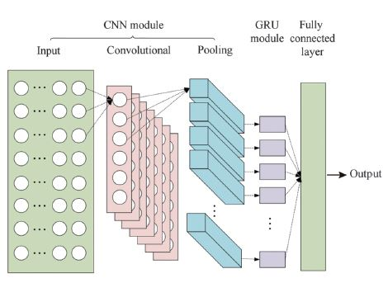

1. Convolutional
   1. 64 filters
   2. Kernel size 4
   3. ReLU activations
   4. Padding same
   5. 1 stride
2. Max pooling
   1. Size 1
3. Convolutional
   1. 64 filters
   2. Kernel size 4
   3. ReLU activations
   4. Padding same
   5. 1 stride
4. Max pooling
   1. Size 2
5. Flatten
6. GRU
   1. Neurons 40
   2. Tanh activations
   3. Sigmoid recurrent activations
7. Dense
   1. Neurons 1
   2. Linear activations

* Compile
  + Loss mean squared error
  + Optimizer Adam
  + ReduceLROnPlateau and early stopping
  + Maximum epoch 1000
  + Time step 5
  + Batch size 10
  + Drop out 0.1