First Step

Create Public Class to define parameter, there is a name consisting of 4 words so I made 4 parameters and 1 additional parameter for sorting

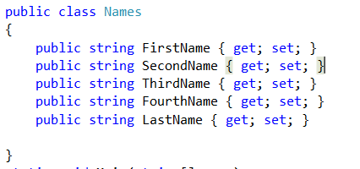

Second Step

create a function for uploading txtfile

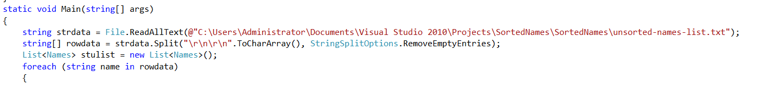

Third Step

word split based on the number of words per line

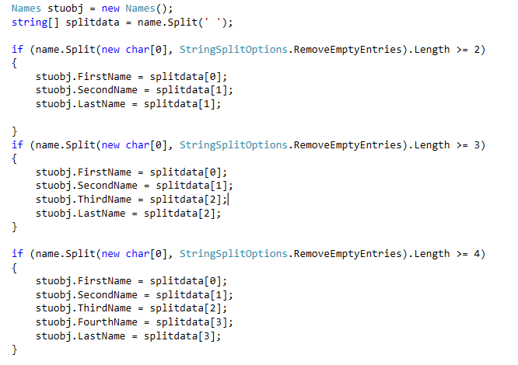

Fourth Step

create a sorting function based on lastname (last word) and firstname

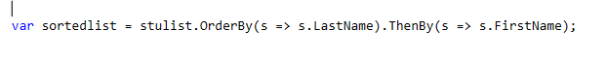

Fifth Step

create function display and write txtfile

