**Implementation of DBSCAN Algorithm in Python (Hasin Us Sami):**

Since our project focuses on detecting outliers in quasars, or in other way, data point that deviates from the normal behavior of quasars, a number of outlier detection algorithms has been studied. Among them, DBSCAN (Density-Based Spatial Clustering of Applications with Noise) has been chosen as one of the techniques for our project as it is one of the most efficient algorithms in detecting outliers.

Before applying self-implemented algorithm from scratch, DBSCAN built-in function in python has been experimented on the pre-processed dataset with 144582 data points and 21 features just to verify how much accurate this detection technique would be in the case of our quasar dataset. Optimum values for DBSCAN parameters have been chosen using trial and error method. After performing DBSCAN, Principal Component Analysis(PCA) function has been used to map the data points into 2D plane for the purpose of visualization.

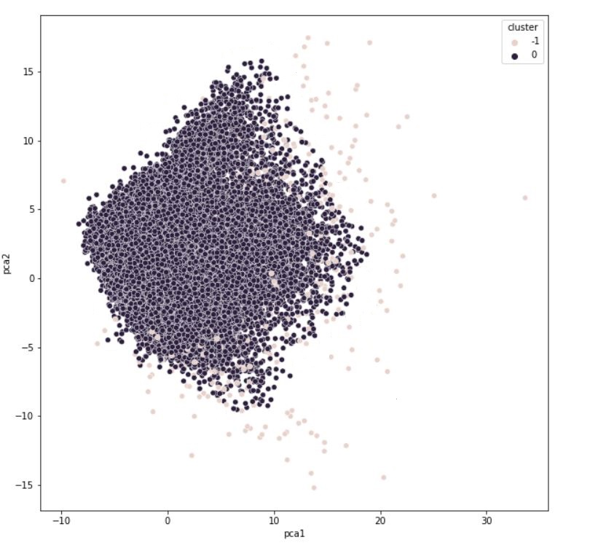

Figure: 2-D Visualization of the data points ( -1 circles are outliers)

The work is in progress and focus is on to further increase the accuracy. The algorithm has been implemented from scratch in python but unfortunately there are several errors observed in the code that has to be dealt with. The next step to do is- fix the errors and run the algorithm on our quasar dataset to detect outliers.