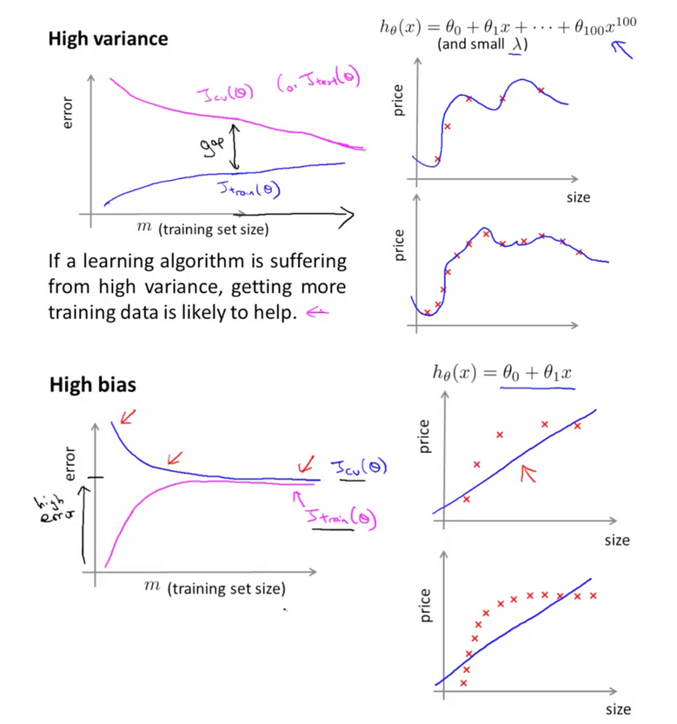

**High variance**

ho(x) = 10 + 012+...+0100x100

(and small 1)

-

Iculo)

(or I testla)

**error**

price

Itron (0)

size

price

m (training set size) If a learning algorithm is suffering from high variance, getting more training data is likely to help. 4

*he(x) = 0 + 012*

**High bias**

price

&

Sculo)

size

*m*

(training set size)

xxxxxx

price

++++

.

size