Q1: Why Python:
Python's widespread adoption in AI and machine learning stems from several key advantages:
- Simplicity and Readability:
Python's clear and concise syntax makes it easy to learn, write, and understand, reducing the cognitive load for developers and allowing them to focus on the complex logic of AI algorithms.
- Extensive Library Ecosystem:
Python boasts a rich collection of libraries and frameworks specifically designed for AI and ML, such as:
  - TensorFlow and PyTorch: For deep learning and neural network development.
  - Scikit-learn: For classical machine learning algorithms, data mining, and analysis.
  - NumPy and Pandas: For numerical computation, data manipulation, and analysis.
  - Matplotlib and Seaborn: For data visualization.
- Strong Community Support:
Python has a large and active community, providing extensive resources, tutorials, and support for developers working on AI projects. This fosters a collaborative environment where knowledge and solutions are readily available.
- Flexibility and Versatility:
Python is a multi-paradigm language, supporting procedural, object-oriented, and functional programming, which offers flexibility in designing and implementing AI solutions. It's also platform-independent, allowing code to run across various operating systems.
- Efficient Prototyping and Development:
Python's high-level nature and readily available libraries enable rapid prototyping and iteration, accelerating the development cycle for AI models.
- Interoperability:
Python can seamlessly integrate with other languages like C and C++, allowing developers to leverage optimized code for computationally intensive tasks, addressing potential performance concerns.

Quesiton2:
What is a pipeline:
An AI pipeline is a sequence of automated processes used to prepare data, train machine learning models, and deploy AI-powered applications. Also referred to as a machine learning pipeline or AI workflow, it manages the full lifecycle of AI development, from raw data ingestion to real-time prediction and monitoring.
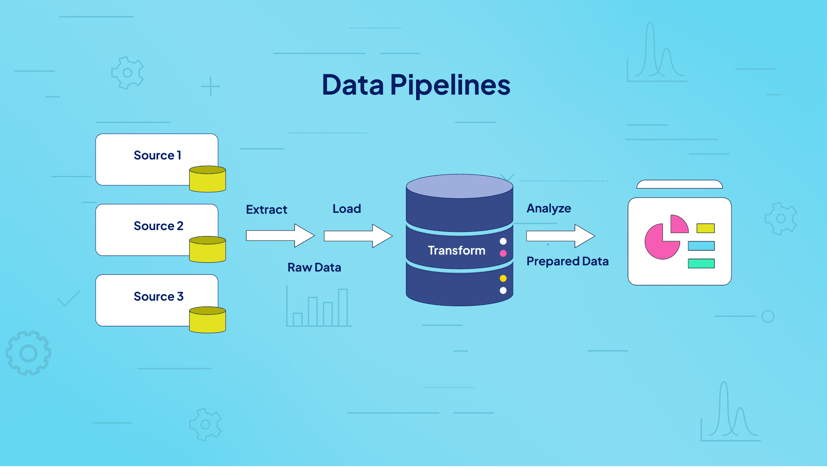

ELT or ETL : it’s abbreviation of extract , load and transformative it’s mean first step will extract the data from the source what ever data type could be and second step could be either load or transformative.

Q3:
Their ability to perform massive numbers of calculations simultaneously makes them well-suited for the computationally demanding tasks at the heart of AI. GPUs accelerate the training of AI models, enabling researchers and developers to iterate on models more quickly and unlock breakthroughs in AI capabilities.
GPUs were originally created for graphics rendering, but have evolved to play a crucial role in AI. To meet the intense computational demands of modern AI workloads, organizations are turning to a familiar but specialized resource—GPUs.
Unlike CPUs, which handle general-purpose tasks sequentially, GPUs are built for parallel processing. The GPU and its role in AI workloads have become increasingly important, as their architecture includes thousands of smaller cores designed to execute simultaneous operations—ideal for handling the matrix-heavy computations AI models require.

