برای ساخت اسلایدر باید اپی برای آن ساخت و مدل Slide را پیاده سازی کرد و درنهایت برای ساخت هر اسلاید ازش استفاده میکنیم

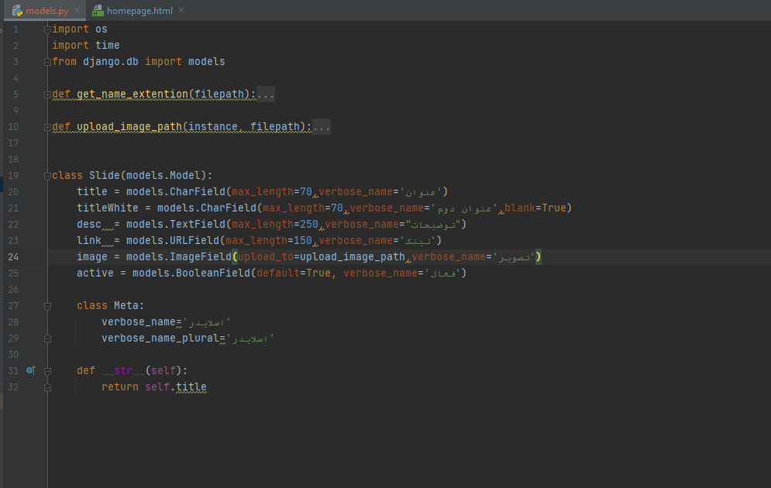**Model:**

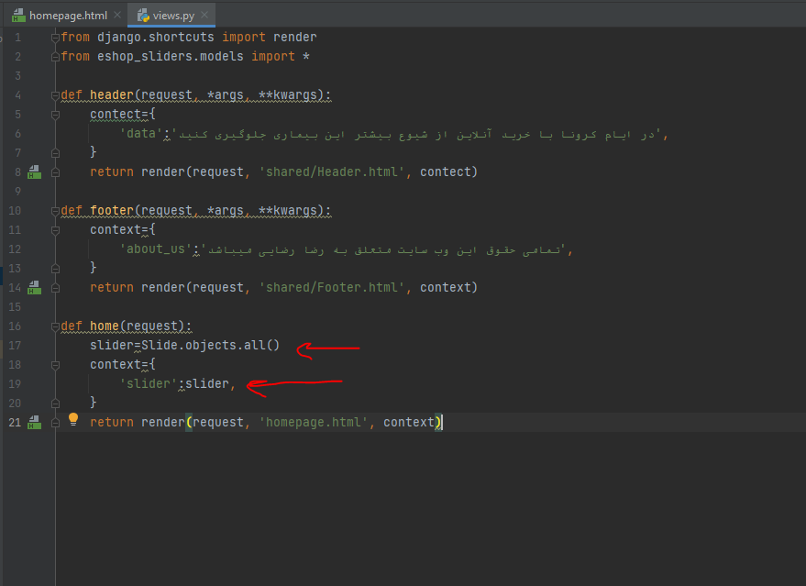**View: (in homepage or index page)**

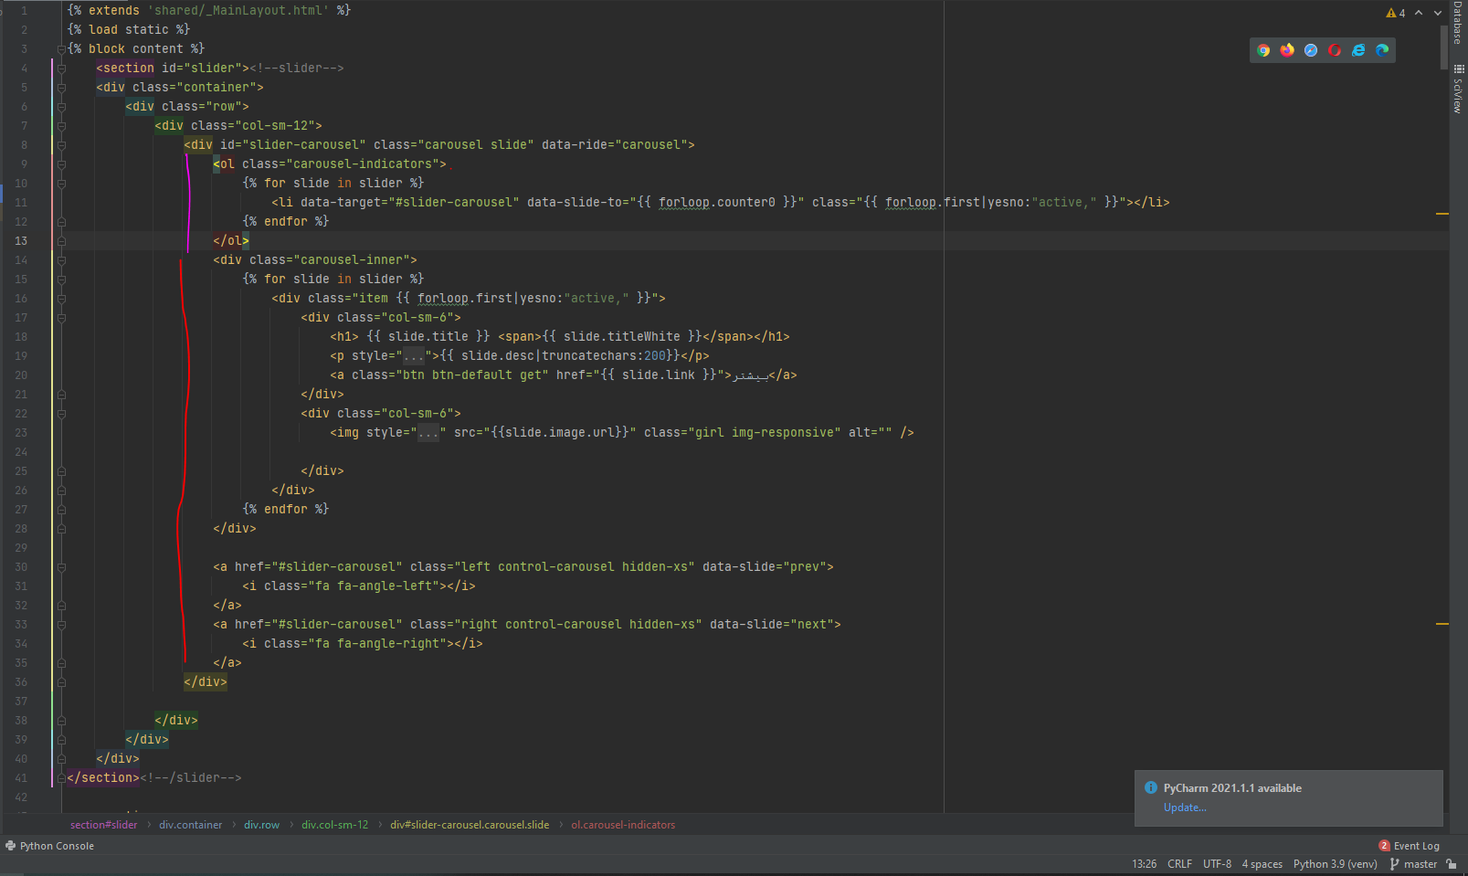**Template: (depended to html template kind)**

* If each slide has “active” class is shown it, else not displayed

- so should first slide has “active” class and other if turned page

be first and “active”.

+ for make this structure use jinja filters:

1. forloop.first -> give first object
2. …|yesno:”active,” -> give Boolean result of check condition And put answer in double quote depended result and separate by comma

* *the list of slide’s receive in view.py from backend.*