ورق پوسته

توسط:

استاد درس:



فهرست مطالب
عنوان صفحه
پروژه 1-........ 1
پروژه 2-......................................................................................................................................... 8

پروژه 1-
تمرین پروژه یک - مطلوب است محاسبه تابع خیز دریک ورق همسانکرد مستطیلی شکل که مطابق شكل زير بار کذاری شده است. همچنین مقدار عددی خیز بدست آمده به روش تحلیلی در زیر محل بارگذاری با روش اجزا محدود برای سه شدت بارگذاری مختلف متمرکز مورد مقایسه قرار کیرد. هر شدت باید دو برابر مرحله قبلی باشد. (P و2 Pو 4P) تمامی مقادیری كه در براى مسئله نياز هستند به اختيار دانشجو است (ضخامت، جنس، ابعاد ورق و محل و مقادير شدت باركذاری P و .... ) نتايج عددی و تحليلی بايد دريک جدول مقايسه وجمع بندی شوند.

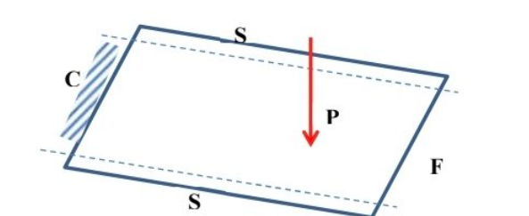

فرض روش لوی (Levy Method)
خیز ورق به صورت سری فوریه:
$$w\left(x , y\right)=\sum_{m=1}^{N}{Y_{m}}\left(x\right)\sin\left(\frac{mπy}{b}\right)$$

صلبیت خمشی ورق
$$D=\frac{Eh^{3}}{12\left(1-ν^{2}\right)}$$

بسط فوریه بار متمرکز
$$q_{m}\left(x\right)=\frac{2P}{b}\sin\left(\frac{mπy_{0}}{b}\right)δ\left(x-x_{0}\right)$$

معادله دیفرانسیل هر مود
با تعریف:
$$β_{m}=\frac{mπ}{b}$$
داریم:
$$Y_{m}^{''''}-2β_{m}^{2}Y_{m}^{''}+β_{m}^{4}Y_{m}=\frac{q_{m}\left(x\right)}{D}$$

پاسخ عمومی معادله
$$Y_{m}\left(x\right)=A_{1}cosh⁡\left(β_{m}x\right)+A_{2}xsinh⁡\left(β_{m}x\right)+A_{3}sinh⁡\left(β_{m}x\right)+A_{4}xcosh⁡\left(β_{m}x\right)$$

شرایط مرزی و پیوستگی
۱) لبه گیردار $\left(x=0\right)$
$$Y_{m}\left(0\right)=0 \\ Y_{m}^{'}\left(0\right)=0$$

۲) پیوستگی در محل بار $\left(x=x_{0}\right)$
$$Y_{I}\left(x_{0}\right)=Y_{II}\left(x_{0}\right) \\ Y_{I}^{'}\left(x_{0}\right)=Y_{II}^{'}\left(x_{0}\right) \\ Y_{I}^{''}\left(x_{0}\right)=Y_{II}^{''}\left(x_{0}\right)$$
شرط پرش نیروی برشی:
$$D\left[Y_{II}^{'''}\left(x_{0}\right)-Y_{I}^{'''}\left(x_{0}\right)\right]=\frac{2P}{b}\sin\left(\frac{mπy_{0}}{b}\right)$$

۳) لبه آزاد $\left(x=a\right)$
شرط گشتاور خمشی صفر:
$$Y_{m}^{''}\left(a\right)-νβ_{m}^{2}Y_{m}\left(a\right)=0$$
شرط نیروی برشی مؤثر صفر:
$$Y_{m}^{'''}\left(a\right)-\left(2-ν\right)β_{m}^{2}Y_{m}^{'}\left(a\right)=0$$

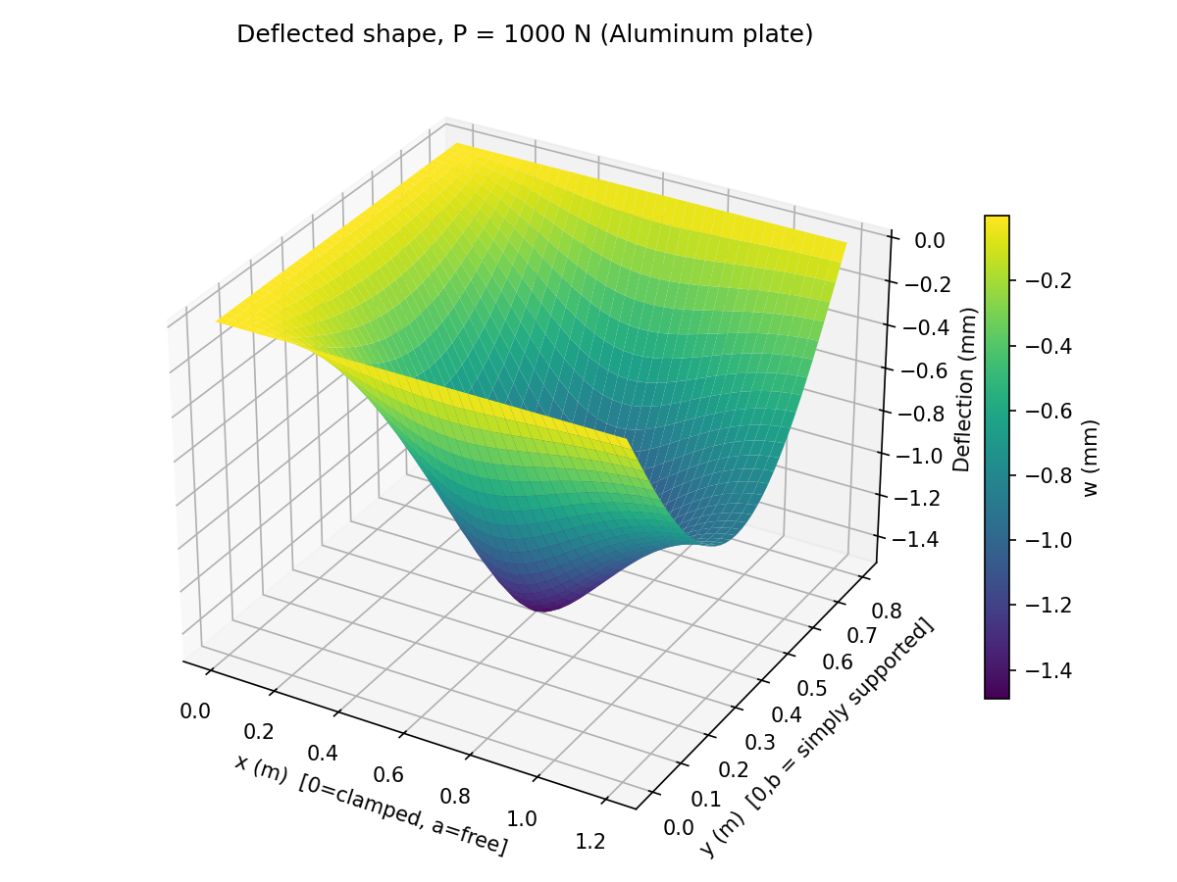
شکل خیز در پایتون

خروجی پایتون:
Plate: a = 1.2 m, b = 0.8 m, h = 10.0 mm
Flexural rigidity D = 6546.216 N.m
Load point: (x0, y0) = (0.6, 0.4) m

Convergence of w(x0,y0) [unit load, P=1 N] with number of Fourier terms:
n_modes = 5 w = 0.001480 mm
n_modes = 10 w = 0.001487 mm
n_modes = 15 w = 0.001489 mm
n_modes = 20 w = 0.001489 mm
n_modes = 25 w = 0.001490 mm
n_modes = 30 w = 0.001490 mm
n_modes = 35 w = 0.001490 mm
n_modes = 41 w = 0.001490 mm

Deflection under the point load - analytical (Levy method) vs FE:
Load_case P_N w_analytical_mm w_FE_mm diff_percent
1P 1000.0 1.490214 NaN NaN
2P 2000.0 2.980428 NaN NaN
4P 4000.0 5.960855 NaN NaN

کد پایتون:
"""
x = 0 : CLAMPED (C)
x = a : FREE (F)
y = 0 : SIMPLY SUPPORTED (S)
y = b : SIMPLY SUPPORTED (S)
"""

import numpy as np
import pandas as pd
import matplotlib.pyplot as plt
from mpl_toolkits.mplot3d import Axes3D
import mpmath as mp

mp.mp.dps = 300

a_plate = 1.2
b_plate = 0.8
h = 0.010

material = "Aluminum"
E = 70.0e9
nu = 0.33

x0 = a_plate / 2
y0 = b_plate / 2

P_base = 1000.0
load_cases = [1 * P_base, 2 * P_base, 4 * P_base]

n_modes = 41
grid_n = 41

D = E * h**3 / (12 * (1 - nu**2))
print(f"Material: {material} (E = {E/1e9:.1f} GPa, nu = {nu})")
print(f"Plate: a = {a_plate} m, b = {b_plate} m, h = {h*1000:.1f} mm")
print(f"Flexural rigidity D = {D:.3f} N.m")
print(f"Load point: (x0, y0) = ({x0}, {y0}) m\n")

def phi(x, beta):
c, s = mp.cosh(beta * x), mp.sinh(beta * x)
return [c, x * s, s, x * c]

def dphi(x, beta):
c, s = mp.cosh(beta * x), mp.sinh(beta * x)
return [beta * s, s + beta * x * c, beta * c, c + beta * x * s]

def d2phi(x, beta):
c, s = mp.cosh(beta * x), mp.sinh(beta * x)
return [beta**2 * c, 2*beta*c + beta**2*x*s, beta**2 * s, 2*beta*s + beta**2*x*c]

def d3phi(x, beta):
c, s = mp.cosh(beta * x), mp.sinh(beta * x)
return [beta**3 * s, 3*beta**2*s + beta**3*x*c, beta**3 * c, 3*beta**2*c + beta**3*x*s]

def solve_mode(m, a, b, x0, y0, nu, D):
beta = mp.pi * m / b
Fm = (2.0 / b) * mp.sin(m * mp.pi * y0 / b)

M = mp.zeros(8, 8)
rhs = mp.zeros(8, 1)

# Row 1: clamped, Y_I(0) = 0
row = phi(0, beta)
for j in range(4):
M[0, j] = row[j]

# Row 2: clamped, Y_I'(0) = 0
row = dphi(0, beta)
for j in range(4):
M[1, j] = row[j]

# Row 3: continuity of w at x0
rI, rII = phi(x0, beta), phi(x0, beta)
for j in range(4):
M[2, j] = rI[j]
M[2, 4 + j] = -rII[j]

# Row 4: continuity of w' at x0
rI, rII = dphi(x0, beta), dphi(x0, beta)
for j in range(4):
M[3, j] = rI[j]
M[3, 4 + j] = -rII[j]

# Row 5: continuity of w'' at x0
rI, rII = d2phi(x0, beta), d2phi(x0, beta)
for j in range(4):
M[4, j] = rI[j]
M[4, 4 + j] = -rII[j]

# Row 6: jump in w''' at x0 -> D*(Y_II''' - Y_I''') = Fm
rI, rII = d3phi(x0, beta), d3phi(x0, beta)
for j in range(4):
M[5, j] = -rI[j]
M[5, 4 + j] = rII[j]
rhs[5, 0] = Fm / D

# Row 7: free edge moment, Y_II''(a) - nu*beta^2*Y_II(a) = 0
r2, r0 = d2phi(a, beta), phi(a, beta)
for j in range(4):
M[6, 4 + j] = r2[j] - nu * beta**2 * r0[j]

# Row 8: free edge Kirchhoff shear, Y_II'''(a) - (2-nu)*beta^2*Y_II'(a) = 0
r3, r1 = d3phi(a, beta), dphi(a, beta)
for j in range(4):
M[7, 4 + j] = r3[j] - (2 - nu) * beta**2 * r1[j]

sol = mp.lu_solve(M, rhs)
A = [sol[i, 0] for i in range(4)]
B = [sol[4 + i, 0] for i in range(4)]
return beta, A, B

def Y_at(x, x0, beta, A, B):
"""Evaluate the (unit-load) Y_m(x) piecewise function."""
coeffs = A if x <= x0 else B
vals = phi(x, beta)
return sum(c * v for c, v in zip(coeffs, vals))

modes = [] # list of (m, beta, A, B)
for m in range(1, n_modes + 1):
beta, A, B = solve_mode(m, a_plate, b_plate, x0, y0, nu, D)
modes.append((m, beta, A, B))

def deflection_unit(x, y):
"""Unit-load (P=1 N) deflection w(x,y), summing all solved modes."""
total = mp.mpf(0)
for m, beta, A, B in modes:
total += Y_at(x, x0, beta, A, B) * mp.sin(beta * y)
return total

print("Convergence of w(x0,y0) [unit load, P=1 N] with number of Fourier terms:")
running = mp.mpf(0)
check_at = [5, 10, 15, 20, 25, 30, 35, 41]
k = 0
for i, (m, beta, A, B) in enumerate(modes, start=1):
running += Y_at(x0, x0, beta, A, B) * mp.sin(beta * y0)
if i in check_at:
print(f" n_modes = {i:3d} w = {float(running)*1000:.6f} mm")
w_unit_x0y0 = float(running) # deflection at the load point, per unit N of load
print()

results = []
for P in load_cases:
w_mm = w_unit_x0y0 * P * 1000.0 # convert m -> mm
results.append({
'Load_case': f"{P/P_base:.0f}P",
'P_N': P,
'w_analytical_mm': w_mm,
'w_FE_mm': np.nan, # <-- fill in from Abaqus at the same point
'diff_percent': np.nan,
})

df = pd.DataFrame(results)
print("Deflection under the point load - analytical (Levy method) vs FE:")
print(df.to_string(index=False))
df.to_csv('plate_deflection_results.csv', index=False)

-
xs = np.linspace(0, a_plate, grid_n)
ys = np.linspace(0, b_plate, grid_n)
W = np.zeros((grid_n, grid_n))

# reuse the pre-solved modes; evaluate Y_m at each grid x once per mode
for m, beta, A, B in modes:
Y_vals = np.array([float(Y_at(xv, x0, beta, A, B)) for xv in xs])
sin_vals = np.sin(float(beta) * ys)
W += np.outer(Y_vals, sin_vals)

W_mm = W * P_base * 1000.0 # deflection [mm] for the base load case P_base

Xg, Yg = np.meshgrid(xs, ys, indexing='ij')

fig = plt.figure(figsize=(8, 6))
ax = fig.add_subplot(111, projection='3d')
surf = ax.plot_surface(Xg, Yg, -W_mm, cmap='viridis', edgecolor='none')
# (plotted as -W so downward deflection visually points down)
ax.set_xlabel('x (m) [0=clamped, a=free]')
ax.set_ylabel('y (m) [0,b = simply supported]')
ax.set_zlabel('Deflection (mm)')
ax.set_title(f'Deflected shape, P = {P_base:.0f} N ({material} plate)')
fig.colorbar(surf, shrink=0.6, label='w (mm)')
fig.tight_layout()
fig.savefig('plate_deflected_shape.png', dpi=150)
plt.close(fig)

print(f"\nMax deflection on the plotted grid: {W_mm.max():.4f} mm "
f"(thickness = {h*1000:.1f} mm - check this stays small vs. thickness "
f"for thin-plate theory to remain valid)")

پروژه 2-
تمرین پروژه دو - مطلوب است تحلیل تنش غشایی که یک پوسته دوار که حاصل از دوران يک منحنی سهمی شکل است. پوسته صرفا تحت وزن خود قرار دارد و تحلیل غشایی را در محلی دور از لبه های تكیه کاهی برای تنشهای نصف النهاری و عرض از مبدا انجام دهید. نتایج را با روش عددی (نرم افزار اجزا محدود) در محل یکسان مقایسه کنید و در جدولی جمع بندی کنید. ( همه اطلاعات داده نشده در مسئله به اختیار دانشجوست)

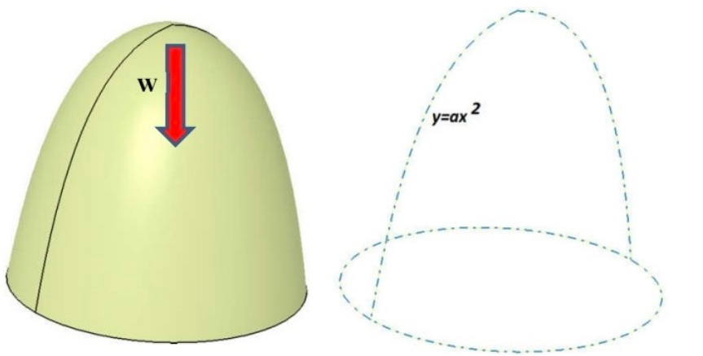

مدل‌سازی هندسه
معادله هندسه گنبد و شیب آن:
$$z=ar^{2} \\ \tan{ϕ}=2ar$$
روابط مثلثاتی:
$$\sin{ϕ}=\frac{2ar}{\sqrt{1+4a^{2}r^{2}}} \\ \cos{ϕ}=\frac{1}{\sqrt{1+4a^{2}r^{2}}}$$
شعاع انحنای نصف‌النهاری:
$$R_{1}=\frac{{\left(1+4a^{2}r^{2}\right)}^{3/2}}{2a}$$
شعاع انحنای محیطی:
$$R_{2}=\frac{r}{\sin{ϕ}}=\frac{\sqrt{1+4a^{2}r^{2}}}{2a}$$

مدل‌سازی بارگذاری (وزن خودی)
وزن کل بخش فوقانی پوسته تا شعاع $r$:
$$W\left(r\right)=\frac{πq_{0}}{6a^{2}}\left[{\left(1+4a^{2}r^{2}\right)}^{3/2}-1\right]$$

معادلات تعادل غشایی
نیروی نصف‌النهاری:
$$N_{ϕ}=-\frac{W\left(r\right)}{2πr\sin{ϕ}}$$
نیروی محیطی:
$$\frac{N_{ϕ}}{R_{1}}+\frac{N_{θ}}{R_{2}}=-q_{0}\cos{ϕ}$$
بنابراین:
$$N_{θ}=-R_{2}q_{0}\cos{ϕ}-N_{ϕ}\frac{R_{2}}{R_{1}}$$

مقادیر در تاج گنبد (Apex)
$$N_{ϕ}\left(0\right)=N_{θ}\left(0\right)=-\frac{q_{0}}{4a}$$

محاسبه تنش‌ها
$$σ_{ϕ}=\frac{N_{ϕ}}{t} \\ σ_{θ}=\frac{N_{θ}}{t}$$

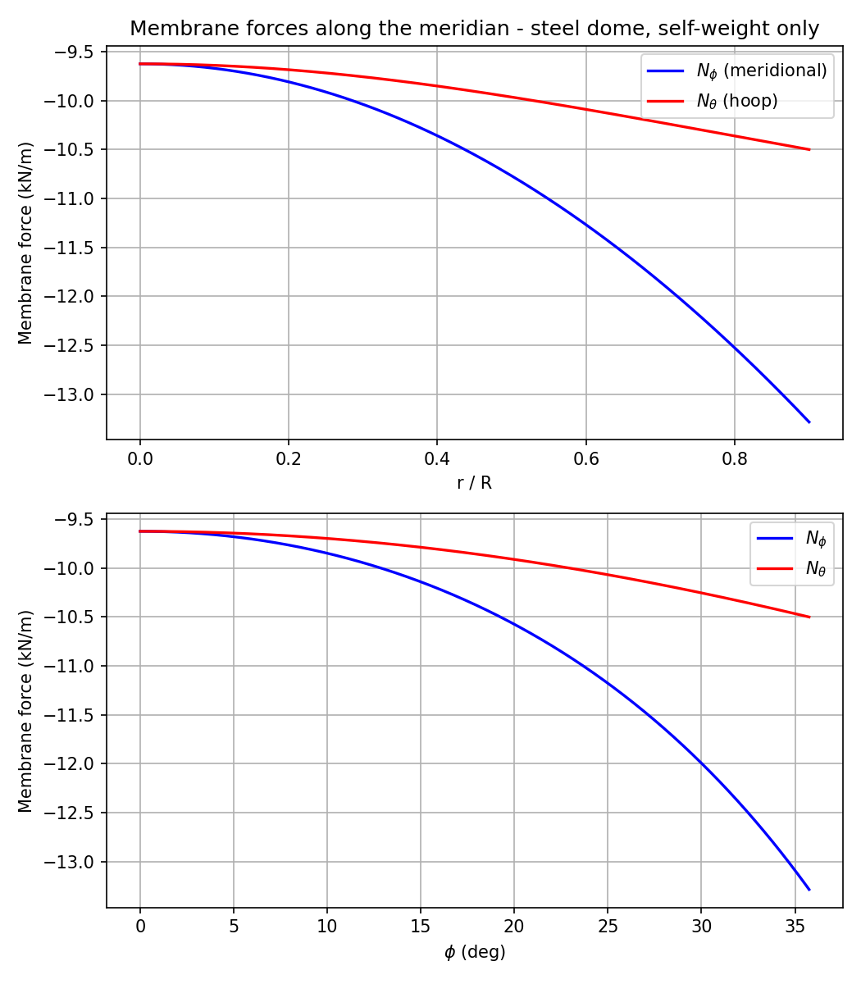
نمودار های ایجاد شده توسط پایتون

خروجی کد پایتون
Self-weight per area q0 = 1.5400 kN/m^2

Apex values (r=0): N_phi = N_theta = -9.6250 kN/m

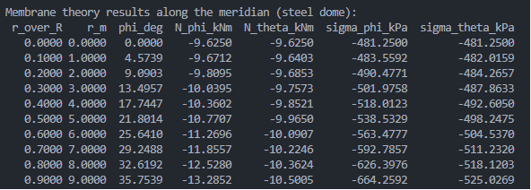
---Comparison point (away from support edge, r/R = 0.60) ---
r = 6.000 m , phi = 25.64 deg
N_phi (membrane theory) = -11.270 kN/m -> sigma_phi = -563.48 kPa
N_theta (membrane theory) = -10.091 kN/m -> sigma_theta = -504.54 kPa
کد پایتون:
"""

analytically for the meridian f(r) = a*r^2.

N_phi = - W(r) / (2*pi*r*sin(phi))
W(r) = total self-weight of the shell above the parallel at r

N_phi/R1 + N_theta/R2 = -Z , Z = q0*cos(phi)
N_theta = -R2*q0*cos(phi) - N_phi*(R2/R1)

"""

import numpy as np
import pandas as pd
import matplotlib.pyplot as plt

R = 10.0
H = 4.0
t = 0.02
gamma = 77.0
E = 200e6
nu = 0.30
r_edge_ratio = 0.90
r_eval_ratio = 0.60
n_pts = 500

a = H / R**2 # parabola coefficient: z = a*r^2
q0 = gamma * t # self-weight per unit AREA of the mid-surface

print(f"Parabola coefficient a = {a:.5f} (1/m)")
print(f"Self-weight per area q0 = {q0:.4f} kN/m^2\n")

def shell_geometry(r, a):
"""Return phi, sin(phi), cos(phi), R1, R2 for meridian f(r)=a*r^2."""
fp = 2 * a * r # f'(r) = tan(phi)
phi = np.arctan(fp)
sphi = fp / np.sqrt(1 + fp**2)
cphi = 1.0 / np.sqrt(1 + fp**2)
R1 = (1 + fp**2)**1.5 / (2 * a)
R2 = np.divide(r, sphi, out=np.zeros_like(r), where=sphi != 0)
return phi, sphi, cphi, R1, R2

def weight_above(r, a, q0):
"""W(r): closed-form self-weight of the shell above radius r."""
return (np.pi * q0 / (6 * a**2)) * ((1 + 4 * a**2 * r**2)**1.5 - 1)

def membrane_forces(r, a, q0):
"""N_phi, N_theta at radius r (r may be an array; r=0 handled below)."""
phi, sphi, cphi, R1, R2 = shell_geometry(r, a)
W = weight_above(r, a, q0)

denom = 2 * np.pi * r * sphi
N_phi = np.divide(-W, denom, out=np.zeros_like(r), where=denom != 0)
N_theta = -R2 * q0 * cphi - N_phi * (R2 / R1)
return phi, N_phi, N_theta, R1, R2

# analytic apex limit (r -> 0), used as the value at r=0 and as a sanity check
N_phi0 = -q0 / (4 * a)
N_theta0 = N_phi0 # N_phi = N_theta at the apex
print(f"Apex values (r=0): N_phi = N_theta = {N_phi0:.4f} kN/m\n")

r_min = 1e-4 * R # avoid the 0/0 singularity at the apex
r = np.linspace(r_min, r_edge_ratio * R, n_pts)

phi, N_phi, N_theta, R1, R2 = membrane_forces(r, a, q0)

sigma_phi = N_phi / t # [kN/m^2 = kPa]
sigma_theta = N_theta / t # [kN/m^2 = kPa]

fig, axes = plt.subplots(2, 1, figsize=(7, 8))

axes[0].plot(r / R, N_phi, 'b-', linewidth=1.6, label=r'$N_\phi$ (meridional)')
axes[0].plot(r / R, N_theta, 'r-', linewidth=1.6, label=r'$N_\theta$ (hoop)')
axes[0].set_xlabel('r / R')
axes[0].set_ylabel('Membrane force (kN/m)')
axes[0].set_title('Membrane forces along the meridian - steel dome, self-weight only')
axes[0].legend()
axes[0].grid(True)

axes[1].plot(np.degrees(phi), N_phi, 'b-', linewidth=1.6, label=r'$N_\phi$')
axes[1].plot(np.degrees(phi), N_theta, 'r-', linewidth=1.6, label=r'$N_\theta$')
axes[1].set_xlabel(r'$\phi$ (deg)')
axes[1].set_ylabel('Membrane force (kN/m)')
axes[1].legend()
axes[1].grid(True)

fig.tight_layout()
fig.savefig('membrane_forces_steel.png', dpi=150)
plt.close(fig)

ratios_report = np.arange(0, r_edge_ratio + 1e-9, 0.1)
r_report = ratios_report * R

phi_r, Nphi_r, Ntheta_r, R1_r, R2_r = membrane_forces(r_report, a, q0)

# overwrite the apex row (index 0, r=0) with the analytic limit
Nphi_r[0] = N_phi0
Ntheta_r[0] = N_theta0

sigphi_r = Nphi_r / t
sigtheta_r = Ntheta_r / t

df = pd.DataFrame({
'r_over_R': ratios_report,
'r_m': r_report,
'phi_deg': np.degrees(phi_r),
'N_phi_kNm': Nphi_r,
'N_theta_kNm': Ntheta_r,
'sigma_phi_kPa': sigphi_r,
'sigma_theta_kPa': sigtheta_r,
})

pd.set_option('display.float_format', lambda x: f'{x:0.4f}')
print("Membrane theory results along the meridian (steel dome):")
print(df.to_string(index=False))

df.to_csv('membrane_theory_results_steel.csv', index=False)

r_eval = r_eval_ratio * R
phi_eval, N_phi_eval, N_theta_eval, R1_eval, R2_eval = membrane_forces(
np.array([r_eval]), a, q0)
phi_eval = phi_eval[0]
N_phi_eval = N_phi_eval[0]
N_theta_eval = N_theta_eval[0]

sigma_phi_eval = N_phi_eval / t
sigma_theta_eval = N_theta_eval / t

print(f"\n--- Comparison point (away from support edge, r/R = {r_eval_ratio:.2f}) ---")
print(f"r = {r_eval:.3f} m , phi = {np.degrees(phi_eval):.2f} deg")
print(f"N_phi (membrane theory) = {N_phi_eval:8.3f} kN/m -> sigma_phi = {sigma_phi_eval:8.2f} kPa")
print(f"N_theta (membrane theory) = {N_theta_eval:8.3f} kN/m -> sigma_theta = {sigma_theta_eval:8.2f} kPa")

