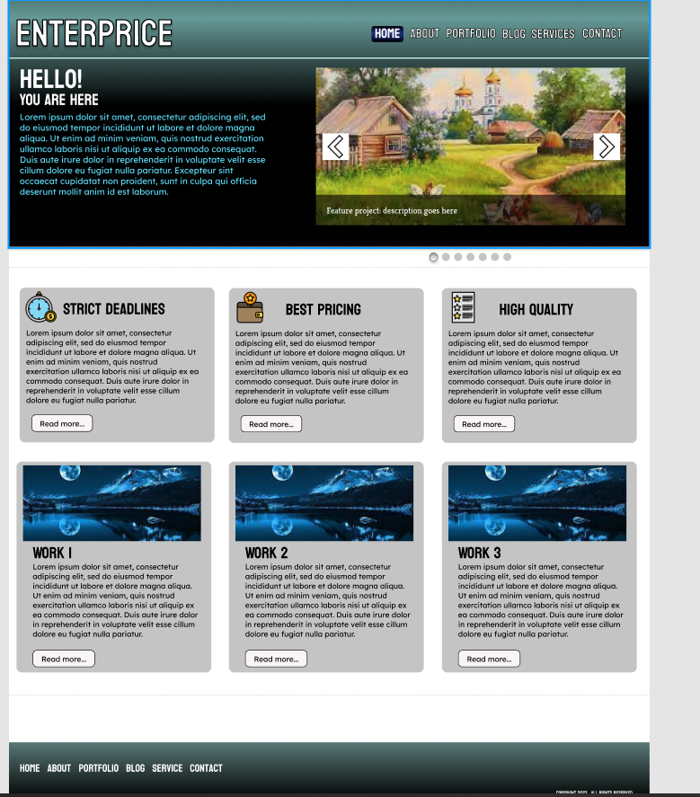

https://www.figma.com/file/LUzZrGegGPOOiAMGpdoOvj/Untitled?node-id=0%3A1