LOG-IN TEST CASES FOR CAS CONFIGURED WEB-SITE BY USING JMETER

REZART VELIAJ
LODZ UNIVERSITY
JUNE, 2010

Contents
1. Introduction 4
2. Test Plans 4
3. Login with Single User Data 4
3.1 Configuration 4
3.1.1Thread Group 4
3.1.2 HTTP Request Defaults 5
3.1.3 User Defined Variables 6
3.1.4 Simple Controller – Test Sequence 6
3.1.5 Login Request Defaults 7
3.1.6 Sampler 1: Request Login Form 7
3.1.7 Sampler 2: Login 8
3.1.8 Sampler 3: Log Out 9
3.1.9 Graph Results 10
3.1.10 View Results Tree 11
3.2 Results 11
4. Login with Multiple User Data 16
4.1 Configuration 16
4.1.1User Data Set 16
4.2 Results 17
5. Conclusion 19

Table of Figures
Figure 1 5
Figure 2 6
Figure 3 7
Figure 4 8
Figure 5 9
Figure 6 10
Figure 7 11
Figure 8 12
Figure 9 13
Figure 10 14
Figure 11 15
Figure 12 16
Figure 13 17
Figure 14 18
Figure 15 18
Figure 16 19

Introduction
CAS (Central Authentication Service) and JMeter are two recently introduced and emerging technologies in the IT field respectively for Central Authentication and Application Testing. CAS is a single-sign on protocol for the web, which main purpose is to allow a user to access multiple applications, while providing their credentials (username and password) only once. But also CAS refers to a software package, which implements this protocol. While JMeter is open source software, a 100% pure Java desktop application designed to load test functional behaviour and measure performance. The two Test Plans provided in this documentation will make use of JMeter to test the website with URL: https://usosweb.uni.lodz.pl which uses CAS for allowing the users to log in and view their personal data.

Test Plans
In order the test the functionality of logging in to the website: https://usosweb.uni.lodz.pl , two different tests were implemented. One of the tests takes the log in data only for one user, while the second one takes the log in parameters from a CSV file for more than one user.

Login with Single User Data
The first test case was implemented by using the data for only one single user. The log in data is provided as parameters before the log in takes place. In the following section, the whole configuration to obtain the desired results is provided.

3.1 Configuration
In order to implement the test case the following configuration parameters should be defined:
- Thread Group
- HTTP Request Defaults
- User Defined Variables
- Simple Controller
- HTTP Request Defaults
- Sampler 1: Request Login Form
- Sampler 2: Login
- Sampler 3: Log Out
- Graph Results
- View Results Tree

3.1.1Thread Group
The Thread Group element is the starting point of any test plan. All the controllers and samplers must be put under some Thread Group. The controls for a thread group allow the application tester to:

- Set the number of threads
- Set the ramp-up period
- Set the number of times to execute the test
The number of threads determines the number of users and therefore multiple threads are used to simulate multiple concurrent connections to the web server. In this case as one login user will be provided, the number of threads is set to 1.
The ramp-up period tells JMeter how long to take to "ramp-up" to the full number of threads chosen. If 10 threads are used, and the ramp-up period is 100 seconds, then JMeter will take 100 seconds to get all 10 threads up and running. Each thread will start 10 (100/10) seconds after the previous thread was begun. Ramp-up needs to be long enough to avoid too large a work-load at the start of a test, and short enough that the last threads start running before the first ones finish (unless one wants that to happen). As a rule of thumb Start with Ramp-up = number of threads and adjust up or down as needed. Therefore as the number of threads equals 1, the ramp-up period is chosen to be 1.
The number of times to execute the test determines the number of times; the test has to be executed. By default, the thread group is configured to loop once through its elements. The number of times to execute the test was chosen to be 1. The configuration of the Thread Group is displayed on the figure 1.
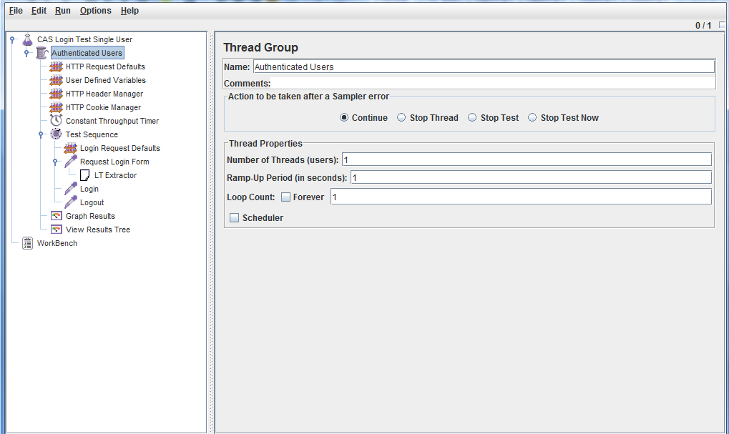
Figure 1

3.1.2 HTTP Request Defaults
This element lets you set default values that your HTTP Request controllers use. For example, if you are creating a Test Plan with many HTTP Request controllers and all of the requests are being sent to the same server, you could add a single HTTP Request Defaults element with the "Server Name or IP" field filled in. Then, when you add the many HTTP Request controllers, leave the "Server Name or IP" field empty. The controllers will inherit this field value from the HTTP Request Defaults element. This configuration elements id displayed on figure 2.
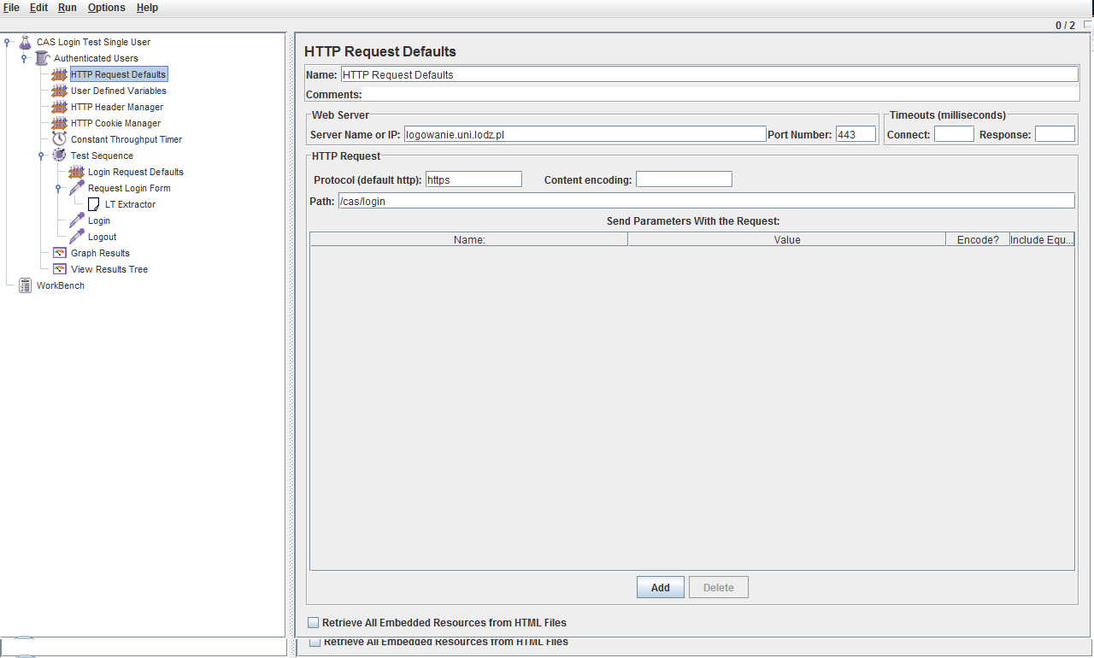
Figure 2
As it can be seen from the figure 2 the following parameters were provided:
- Server Name or IP: logowanie.uni.lodz.pl
- Port Number: 443
- Protocol [default http]: https
- Path: /cas/login

3.1.3 User Defined Variables
The User Defined Configuration element is different. It is processed at the start of a test, no matter where it is placed. For simplicity, it is suggested that the element is placed only at the start of a Thread Group. In this test case at the User Defined variables the username and password are defined.

3.1.4 Simple Controller – Test Sequence
JMeter has two types of Controllers: Samplers and Logical Controllers. These drive the processing of a test. Samplers tell JMeter to send requests to a server. For example, add an HTTP Request Sampler if you want JMeter to send an HTTP request. Logical Controllers let you customize the logic that JMeter uses to decide when to send requests. Logic Controllers can change the order of requests coming from their child elements. They can modify the requests themselves; cause JMeter to repeat requests, etc.
Test Sequence is a Logic Controller determines the order of the requests sent to the web server. In this case the order is: Request login Form, Login and Logout.

3.1.5 Login Request Defaults
This configuration element provides the configuration for two parameters: service and locale.

3.1.6 Sampler 1: Request Login Form
The configuration of the sampler “Request Login Form” is provided on Figure 3.
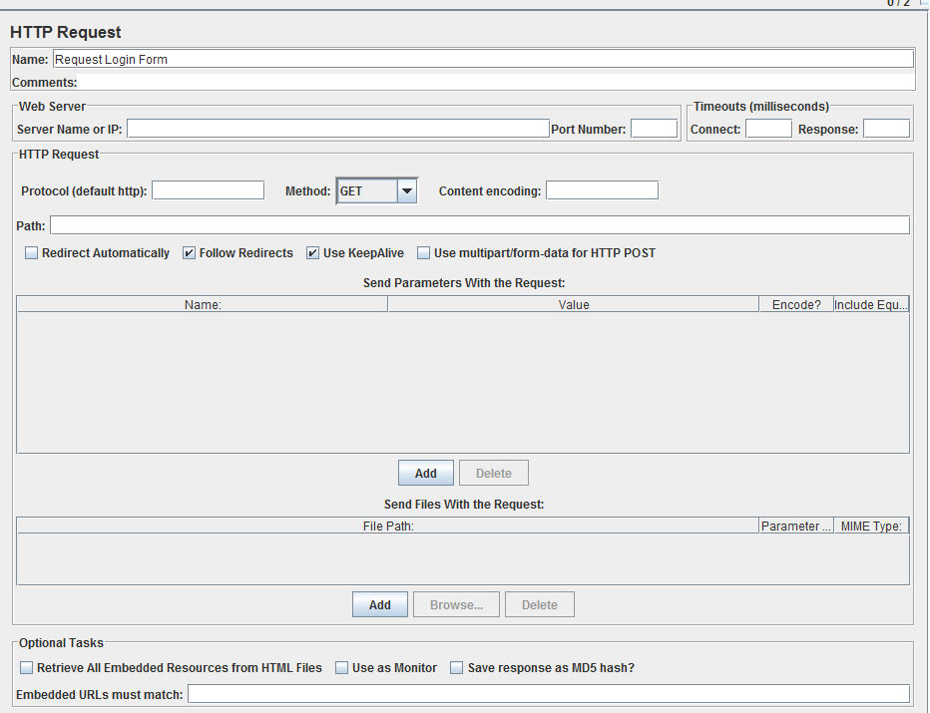
Figure 3
As it can be noticed from the figure 3, all the fields on this form are empty as the parameters containing the information for the IP, Port, Protocol and Path are obtained from the HTTP Request Defaults.
Under this sampler, there is a Regular Expression Extractor, which gets the information for Login Ticket (lt hidden field at the login form). The configuration for this element id displayed on the figure 4.
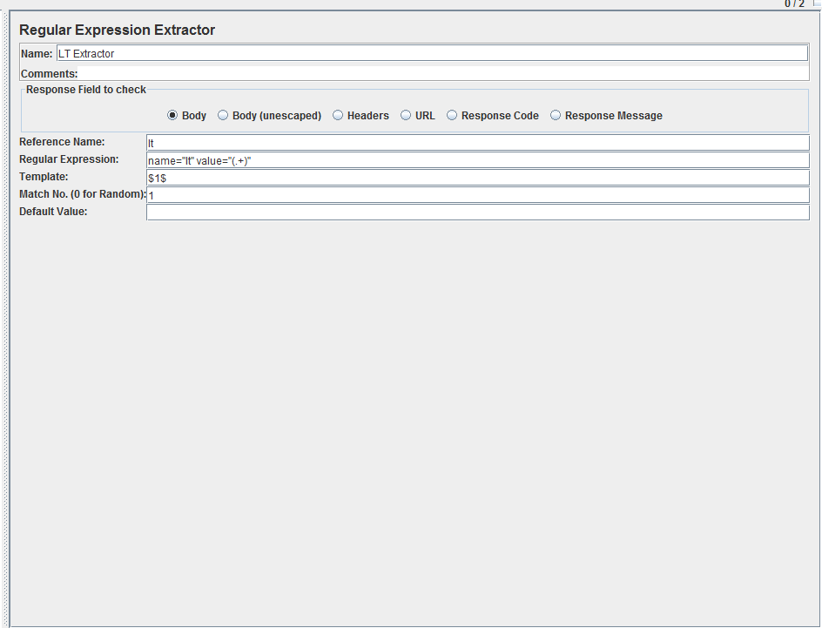
Figure 4

3.1.7 Sampler 2: Login
This sampler makes the request to the server for logging in by providing all the login information to the server. The configuration of this sampler is given on figure 5.
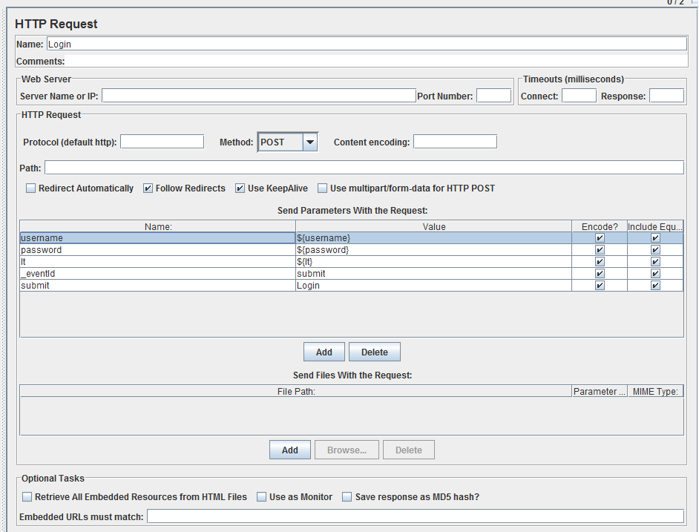
Figure 5
The parameters provided to this sampler are: username, password, lt, _eventld and submit. They will be sent to the server via POST method, in order to log in to the server.

3.1.8 Sampler 3: Log Out
This sampler makes the request to the server for logging out in by providing all the logout information. The configuration of this sampler is given on figure 6. The only parameter provided to this sampler is the path /cas/logout as it is different from the HTTP Request Defaults.
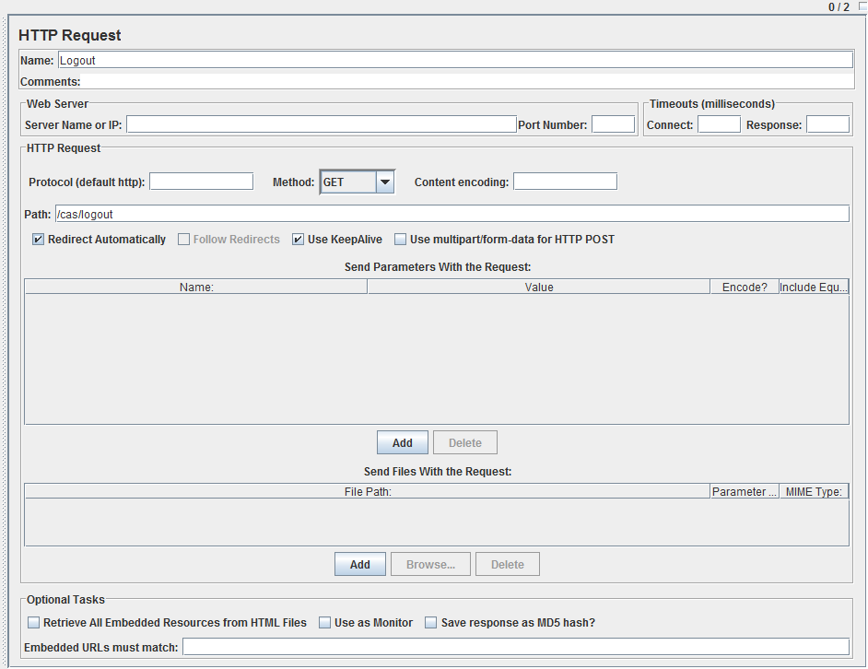
Figure 6

3.1.9 Graph Results
The Graph Results listener generates a simple graph that plots all sample times. Along the bottom of the graph, the current sample (black), the current average of all samples (blue), the current standard deviation (red), and the current throughput rate (green) are displayed in milliseconds. The throughput number represents the actual number of requests/minute the server handled. This calculation includes any delays you added to your test and JMeter's own internal processing time. The advantage of doing the calculation like this is that this number represents something real - your server in fact handled that many requests per minute, and you can increase the number of threads and/or decrease the delays to discover your server's maximum throughput. Whereas if you made calculations that factored out delays and JMeter's processing, it would be unclear what you could conclude from that number.
The results obtained from the Listener Graph Results are displayed on the figure 7.
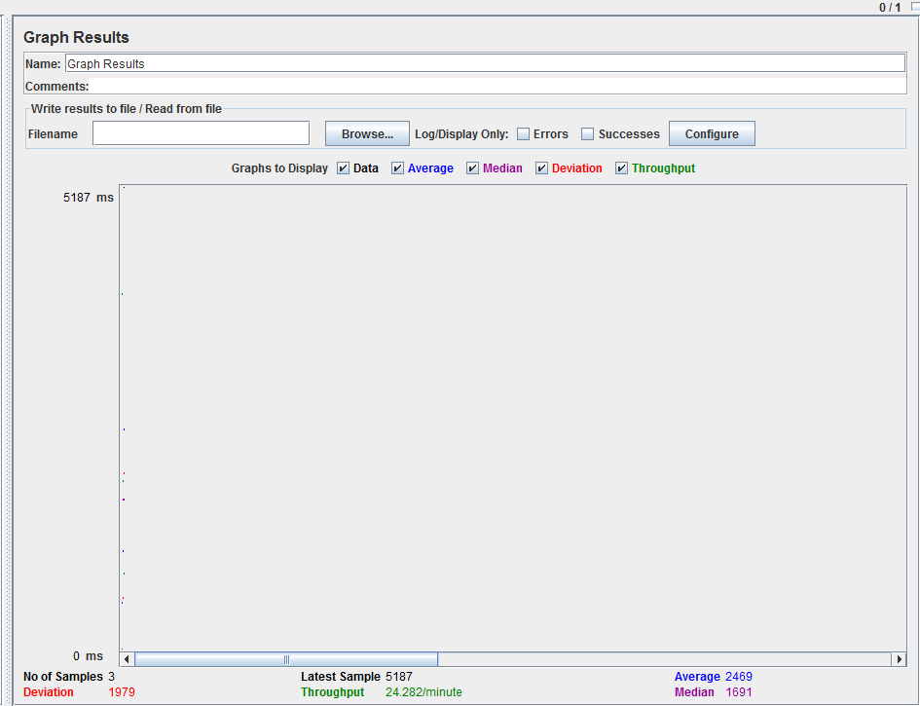
Figure 7

3.1.10 View Results Tree
Vies Results tree is a listener which allows the tester to view the outcome of the test in html, JSON, XML and Text formats. All the samplers are presented in a tree view and when the sampler has executed successful, it is displayed in green color.
The results obtained from the Samplers: Request Login Form, Login and Logout are revealed on the figures 8, 9, 10, 11 and 12.

3.2 Results
After running the test, the results displayed on the figures: 8, 9, 10, 11, and 12 were obtained from the Results Tree.

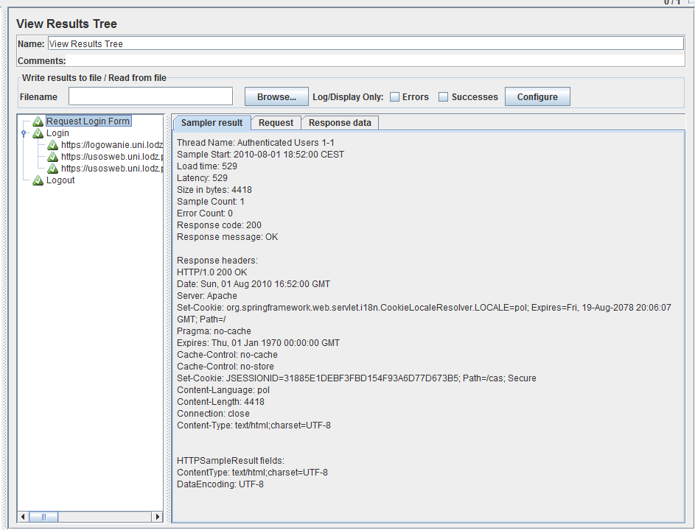
Figure 8

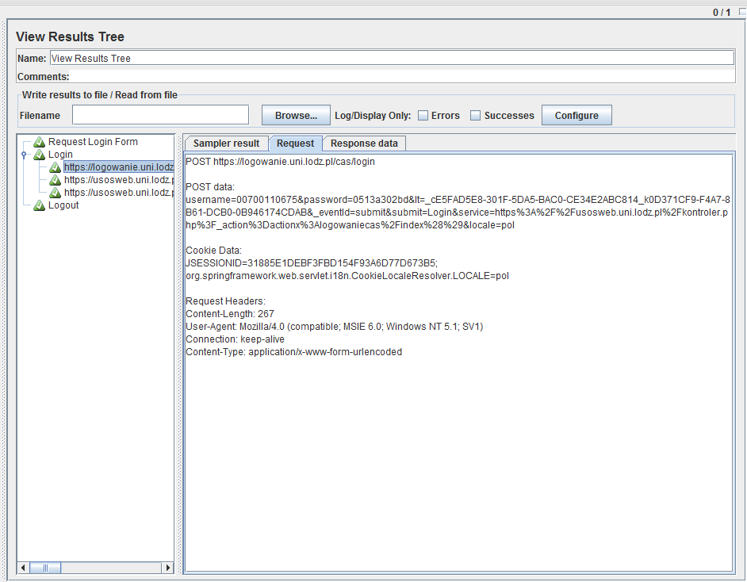
Figure 9

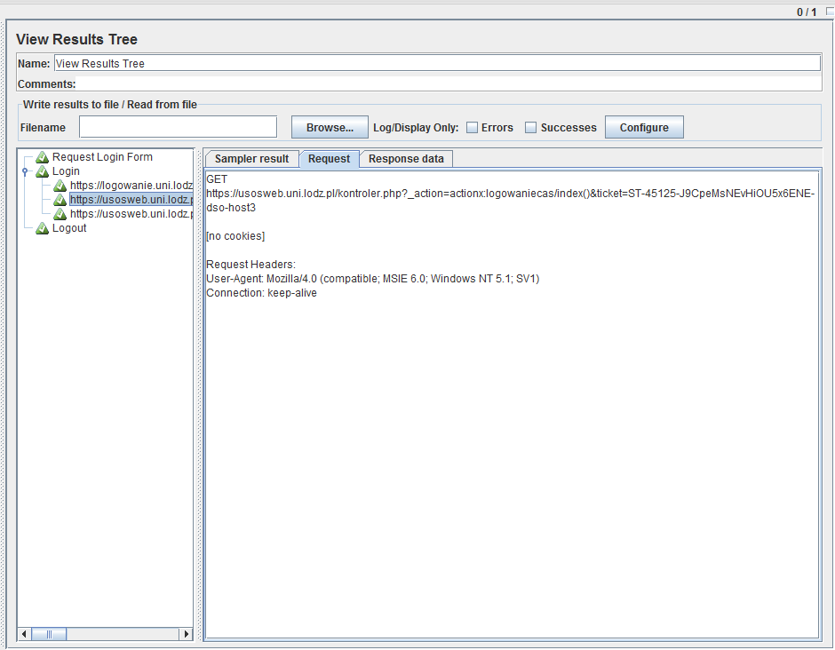
Figure 10
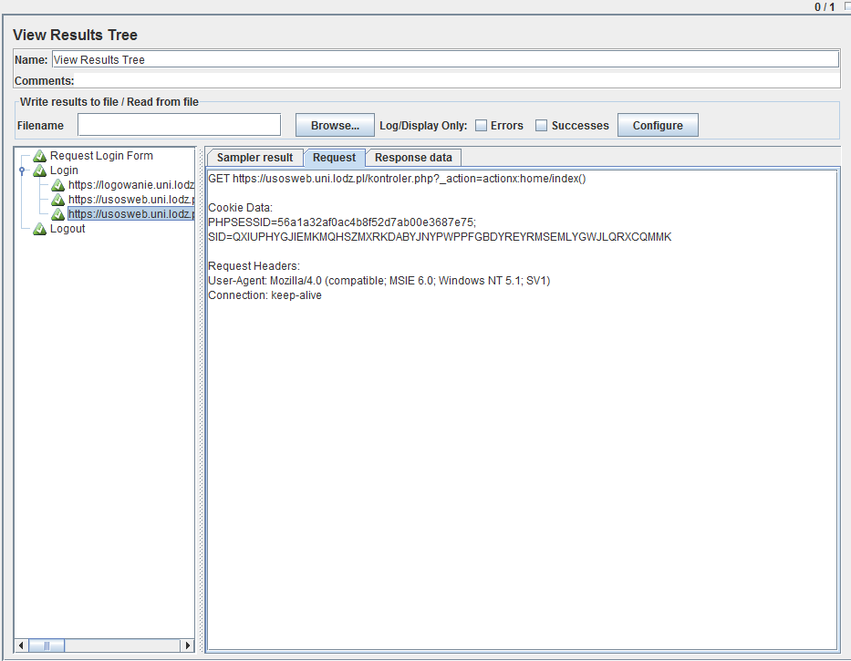
Figure 11

As it is displayed on the figures above 3 HTTP samplers have to take place for a successful login. The first one sends the parameters via POST method to login and after those parameters were checked to be correct on the web server, then it makes another request with the login ticket via GET method and in the end, after that results to be successful, it makes a request to navigate the site with the appropriate cookies: PHPSESSID and SID.
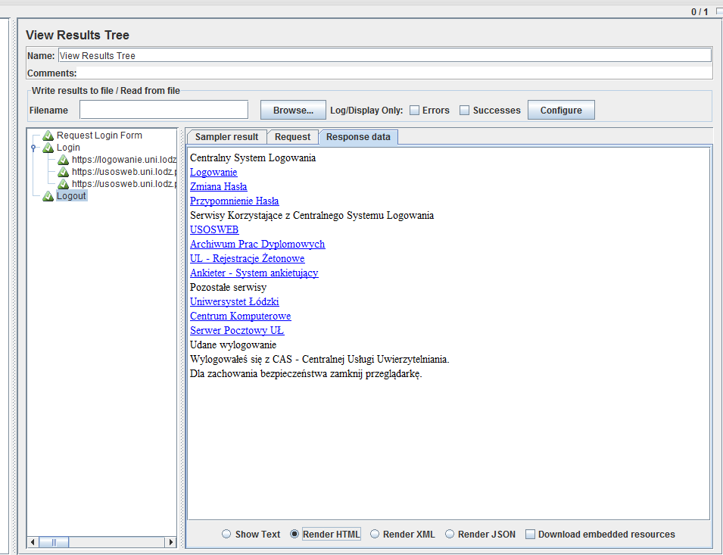
Figure 12
Figure 12 displays that the logout was successful.

Login with Multiple User Data
The second test was implemented by reading log-in parameters from a CSV file.

Configuration
All the configuration parameters were the same as in the previous test case, with the only difference that instead of getting the login user data from the User Defined Variables Configuration element, another configuration element was used such as User Data Set. Also the parameters in the Thread Group were changed to reflect the changes in the number of users.

4.1.1User Data Set
In order to provide the login information for more than one account, the usernames and passwords for all the accounts are placed in a CSV (comma delimited file) and read by JMeter. The following procedure was followed to test the web application for multiple logins:
- A text file was created containing the user names and passwords, separated by commas and was put this in the same directory as the test plan.
- A CSV Data Set Configuration was added element to the test plan and the variables username and password were named.
- The login name was replaced with ${username} and the password with ${password} on the appropriate samplers
The CSV Data Set element will read a new line for each thread. The configuration for the CSV data set configuration element is given on the figure below:
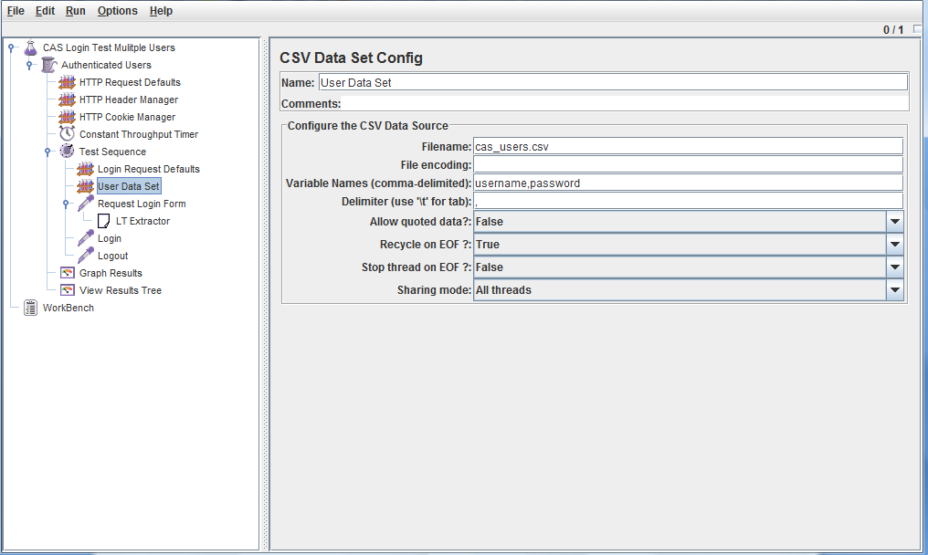
Figure 13
The parameters defined for this configuration element are: the Filename which contains the name and the path of the of the CSV file with the login account information and Variable Names (comma-delimited), which will contain respectively the username and the password read for each line from the CSV file. In this test as only the login data for one user was available, another login account in the CSV file was inserted with no correct information, but just for testing purposes.

4.2 Results
After running the test, the results displayed on the figure below were obtained:
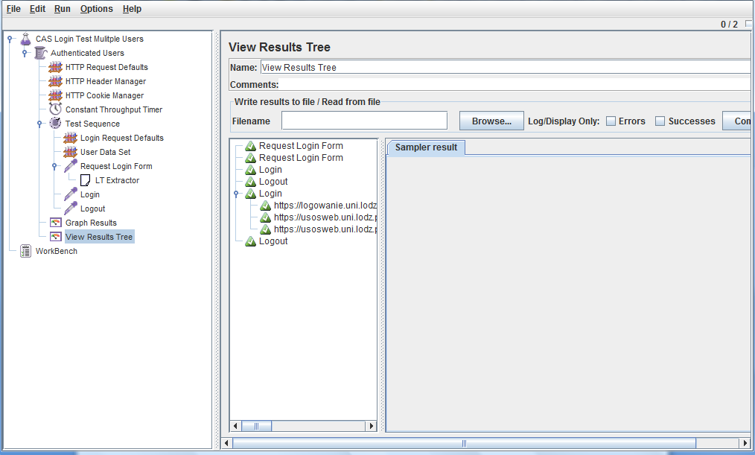
Figure 14

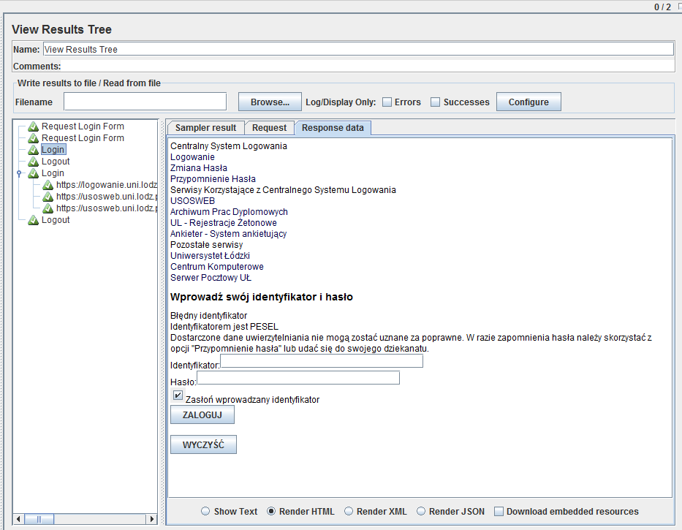
Figure 15
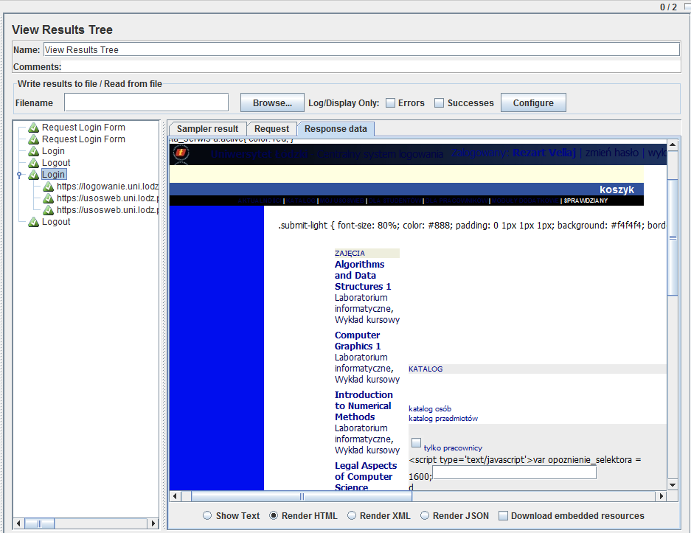
Figure 16
As it can be revealed from the figure above, the login test case has taken place twice, for two different accounts. For the account that did not contain the correct data, login was not successful, while for the one with the right information, the login has taken place successfully.

Conclusion
This document was a presentation of the two test case plans implemented in JMeter for testing a website that uses CAS. The configuration elements used for the two test case plans and the results obtained were revealed. The two test plans can serve as a starting point for implementing other tests using JMeter for web sites which make use of CAS technology.

