Nama : MOHAMMAD REZKI GOBEL

KELAS : 46-01

NIM : 6701220080

1. 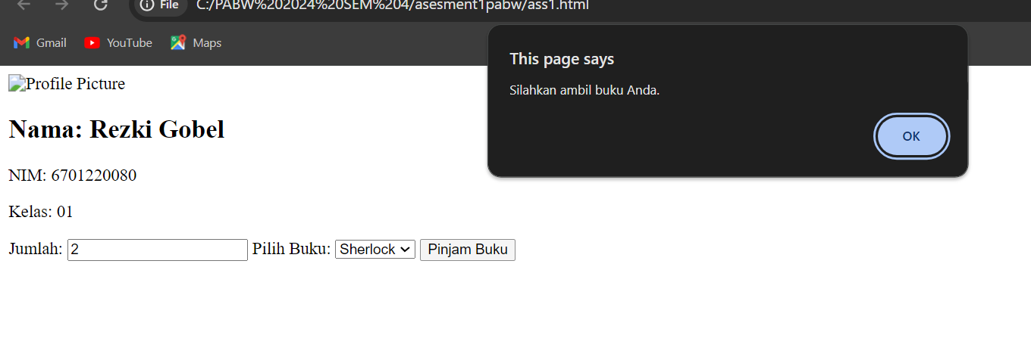
2. A screenshot of a computer

   Description automatically generated
3. A screenshot of a computer

   Description automatically generated
4. A screenshot of a computer

   Description automatically generated
5. A screenshot of a computer

   Description automatically generated
6. A screenshot of a computer

   Description automatically generated
7. A screen shot of a computer code

   Description automatically generated