Room Management System
Requirements Analysis Document
Version 1

CSCI 4711 Software Engineering
Spring 2023
Augusta University

Team Members

James Wilt
Charles Smith
Ian Roberson

Table of Contents
1 Introduction 3
1.1 Scope of system 3
2 requirements of system 4
2.1 FUNCTIONAL REQUIREMENTS 4
2.2 NON-FUNCTIONAL REQUIREMENTS 5
2.3 USE CASES 6
2.4 USE CASE DESCRIPTIONS 7
3 USER INTERFACE MOCKUPS 13
3.1 STARTUP/LOGIN 13
3.2 EMPLOYEE DASHBOARD 13
3.3 ADMIN DASHBOARD 14
3.4 RESERVE ROOM 14
3.5 CANCEL RESERVATION 15
3.6 LOGOUT 15

Introduction

Scope of system
The Room Management System (RMS) is a software tool for the reservation of rooms. It includes actors such as Employee who represent the users who reserve rooms, and Admin, the administrators who can executively cancel existing reservations.
The system supports both actors by logging and storing all the information pertaining to the reservations that are made via the system. This is stored via an internal database. The customers are able to interact with the system via the RMS Graphical User Interface.
The system includes functionality for verification and authorization of users, making room reservations, and canceling reservations. All changes to room statuses are logged in the internal database to ensure the most accurate status of the rooms are given to the actors utilizing the interface.

requirements of system

FUNCTIONAL REQUIREMENTS
- Startup: This functionality performs the initial configuration of the system including its database and user interface.
- Login – All users of the system must be verified as either an employee or an admin before they can use the Room Management System. This function verifies the user and grants them access to other functionality.
- ReserveRoom – Employees can choose what room to reserve via this function. The employee will be able to choose which building, room, date, and time to reserve.
- CancelReservation – This function lets admins cancel reservations made by employees. Admins will be able to see the building, room, date, and time along with which employee reserved them.
- Logout – This function allows users of the system to logout of their accounts when they have finished using the RMS. Following this function will be the login screen so different users can begin using the RMS.

NON-FUNCTIONAL REQUIREMENTS
      - Platform:
        - Target operating system is Microsoft Windows.
        - System is not web-based and should not utilize a web browser.
        - System should be implemented using the Java or C# programming language.
      - Security
        - All user input is validated for appropriateness and prevention of SQL injection attacks.
        - User passwords should not be stored as plaintext in the database.
      - Usability
        - System should implement a Graphical User Interface.

USE CASES

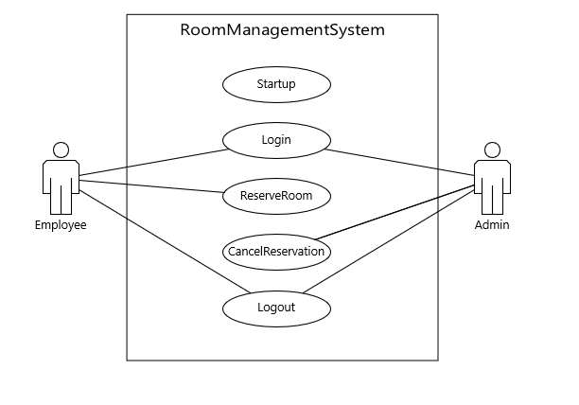
Figure 2.1: Use Case Diagarm

USE CASE DESCRIPTIONS

Use case name | Startup
Participating
actors
Precondition
Flow of events | - This use case is initiated when the application is launched.  - The RMS runs through its startup protocol, initializes the database and displays the GUI’s LoginMenu.
Post condition | The LoginMenu is displayed.
Security  requirements | The Users Password is not stored as plaintext in the database.
Figure 2.2: Startup

Use case name | Login
Participating  actors | Initiated by the Employee and Admin
Precondition
Flow of events | - The user enters their username and password to login to the RMS.  - RMS receives the input and verifies the username and password are valid and authenticates the user against the database. Username and password are valid, and RMS displays the appropriate menu for the user.
Post condition | The appropriate menu is displayed for the user
Security  requirements | Password should be obfuscated for the user.  User inputs should be verified against their specifications.  User inputs are validated to prevent SQL injection
Figure 2.3: Login: Authorized User

Use case name | Login
Participating  actors | Initiated by the Employee and Admin
Precondition
Flow of events | - The user enters their username and password to login to the RMS.  - RMS receives the input and verifies the username and password are valid and authenticates the user against the database. The username and password are invalid, and the GUI displays an error message.
Post condition | The LoginMenu is displayed for the user
Security  requirements | Password should be obfuscated for the user.  User inputs should be verified against their specifications.  User inputs are validated to prevent SQL injection
Figure 2.4: Login: Unauthorized User

Use case name | ReserveRoom
Participating  actors | Initiated by Employee
Precondition | Employee is logged into the system.
Flow of events | - This function is activated when a user logs in using an employee account.  - RMS presents the EmployeeDashboard for the employee to select a building and room to reserve.  - The Employee selects a building and room to reserve by pressing the “Reserve” button.  - RMS presents the ReserveRoom window for the employee to choose the date and time for the reservation.  - The Employee selects the desired date and time to reserve, and then presses the “Make Reservation” button.  - RMS updates the database according to which building, room, date and time selected and presents the EmployeeDashboard and returns the user to the appropriate menu.
Post condition | The database is updated with room reservation information.  The EmployeeDashboard is displayed
Security
requirements
Figure 2.5: ReserveRoom: Successful Reservation

Use case name | CancelReservation
Participating  actors | Admin
Precondition | Admin is logged into the system.
Flow of events | - This function is activated when a user logs in using an admin account.  - RMS presents the AdminDashboard for the admin to view the current reservations.  - Admin selects reservation to cancel using the “Cancel” button.  - RMS presents the CancelReservation menu with the details of what building, room, date and time were reserved by which employee.  - Admin confirms the room details and selects the “Cancel Reservation” button.  - RMS updates the database and displays the AdminDashboard.
Post condition | The database is updated.  The AdminDashboard is displayed.
Security
requirements
Figure 2.6: CancelReservation

Use case name | Logout
Participating  actors | Initiated by Employee or Admin
Precondition | User is logged into the system.
Flow of events | - This function is activated when a user selects the “logout” button from the appropriate menu.  - RMS presents the LogoutMenu with a message and a “Close” button.  - The user selects the Close button.  - RMS returns the LoginMenu for another user to login.
Post condition | The LoginMenu is displayed.
Security
requirements
Figure 2.7: Logout

USER INTERFACE MOCKUPS

STARTUP/LOGIN

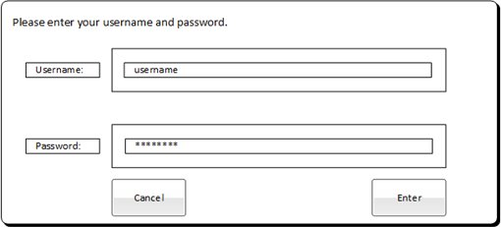
Figure 3.1: LoginMenu

EMPLOYEE DASHBOARD
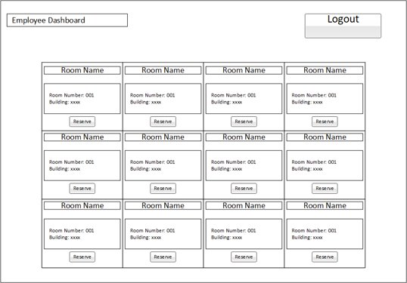
Figure 3.2: EmployeeDashboard

ADMIN DASHBOARD
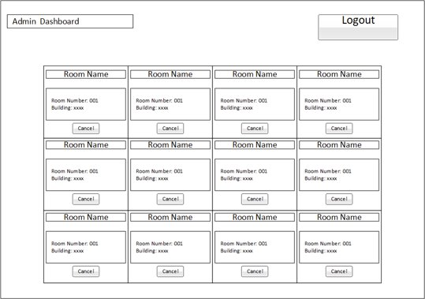
Figure 3.3: AdminDashboard

RESERVE ROOM
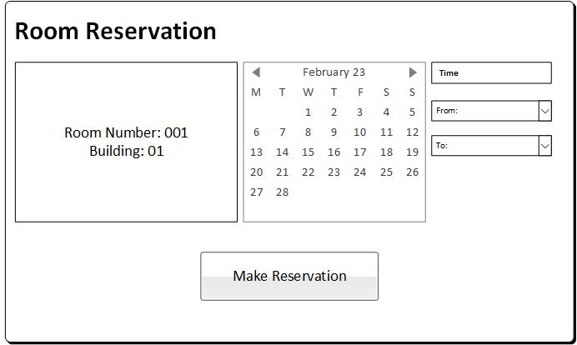
Figure 3.4: ReserveRoom Menu

CANCEL RESERVATION
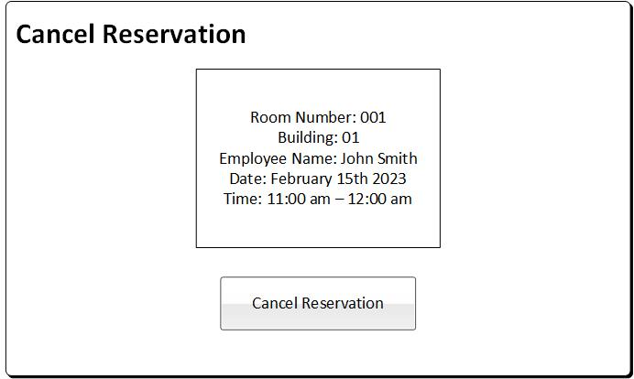
Figure 3.5: CancelReservation Menu

LOGOUT
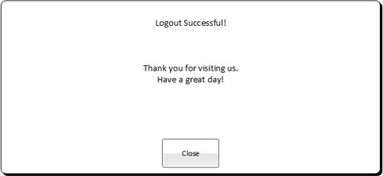
Figure 3.6: Logout Menu

