Module 5 Lab: Plotting Quality Metrics
Rezoan Ishteaque Hossain

Module 5 Lab: Plotting Quality Metrics
This lab examined the relationship between transcription speed and transcription quality for each transcriber. The assignment required loading the spreadsheet into R, normalizing the error counts to errors per 1,000 words, calculating the average seconds per word and average error rate for each transcriber, and comparing the results with two bar charts (Module 5 Assignment, n.d.). The spreadsheet data used in the lab came from the TranscriptionTimesWithError file (TranscriptionTimesWithError, n.d.).
To prepare the data, only the columns needed for the analysis were kept: Transcriber, Word Count, Seconds Per Word, and Errors. The error counts were then normalized with the formula Errors / (Word Count / 1,000) so that transcripts of different lengths could be compared fairly. After that step, the mean seconds per word and the mean errors per 1,000 words were calculated for each transcriber, and the two summaries were merged into a single comparison table.
Table 1
Average transcription speed and normalized error rate by transcriber
Transcriber | Average Seconds Per Word | Average Errors per 1,000 Words
Malcolm | 3.40 | 1.96
Srilaxmi | 3.60 | 0.98
Tanner | 4.00 | 2.54
Vanessa | 1.01 | 7.06
Wei | 4.40 | 1.42
Note. Error rate was normalized to errors per 1,000 words before the averages were calculated.
Table 1 shows that Vanessa had the fastest average speed at 1.01 seconds per word, but she also had the highest average error rate at 7.06 errors per 1,000 words. In contrast, Wei had the slowest average speed at 4.40 seconds per word while maintaining a much lower error rate of 1.42. Srilaxmi showed the lowest average error rate at 0.98 with a moderate speed of 3.60 seconds per word, suggesting the strongest balance between speed and accuracy in this data set.
Figure 1 provides the clearest comparison because the two measures are placed side by side for each transcriber. This makes it easier to compare how average speed and average error rate differ within the same person and across the full group. By contrast, the stacked bar chart in Figure 2 combines both measures into one bar, which makes it harder to judge the size of each value independently. For this reason, the side-by-side chart is the better visualization for the assignment.
The results suggest that speed alone does not indicate stronger performance. Vanessa's averages point to a clear tradeoff: she completed transcriptions much faster than the other transcribers, but the quality of her work was noticeably lower because her error rate was far above the rest of the group. Malcolm appeared fairly balanced, Tanner was slower with a somewhat higher error rate, and Wei was the slowest but still more accurate than Vanessa. Overall, the data suggest that the best performance in this set comes from balancing speed with accuracy rather than maximizing speed by itself.

Figure 1
Side-by-side bar chart comparing average transcription speed and average errors per 1,000 words by transcriber
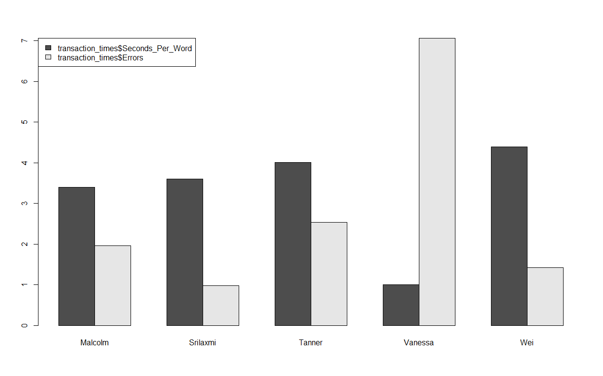
Note. The darker bars represent average seconds per word, and the lighter bars represent average errors per 1,000 words.

Figure 2
Stacked bar chart comparing average transcription speed and average errors per 1,000 words by transcriber
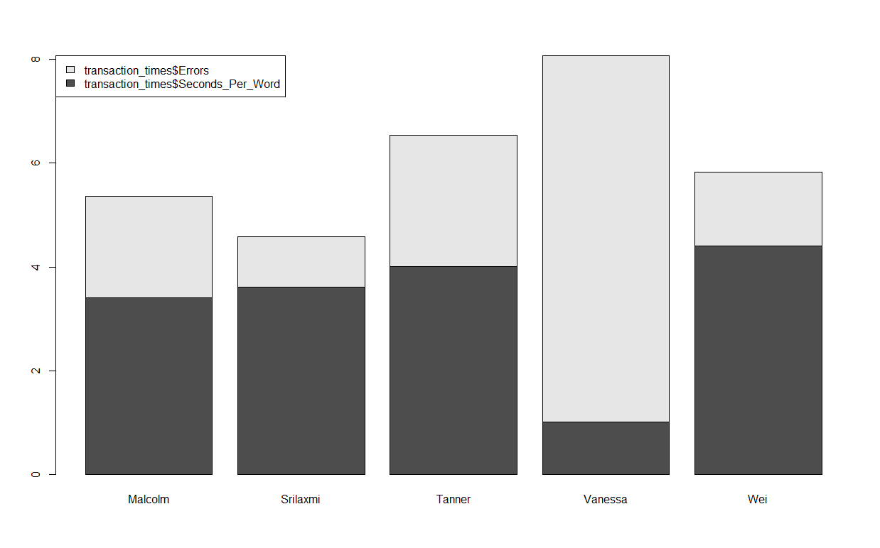
Note. The stacked format combines both measures within one bar, which makes precise comparison less clear than in Figure 1.

References
Module 5 Assignment. (n.d.). [R script]. Unpublished course material.
TranscriptionTimesWithError. (n.d.). [Data set]. Unpublished course material.

