Module 3 Lab – Chapter 4
Rezoan Ishteaque Hossain
IS 383 – Data Acquisition & Analysis
Chapter 4: Problem 2 and Problem 4

Problem 2: Combining Monthly Production Reports

Evidence
• I confirmed I was working in the correct folder and the three CSV files were available.
Screenshot: getwd() and list.files() showing the Chapter 4 files
• I loaded the Detroit, Albany, and Providence CSV files, added a Facility label, combined them, and checked the result.
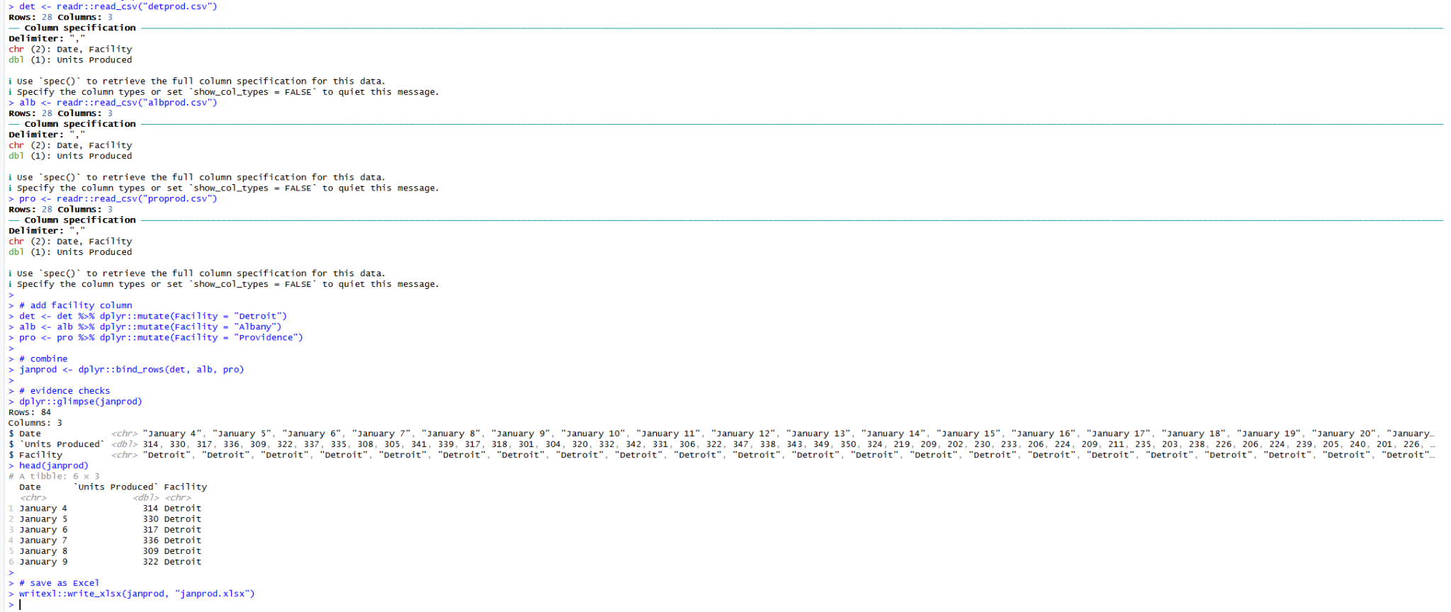
Screenshot: reading CSVs, combining rows, and checking janprod (glimpse + head)
• I saved the combined file as an Excel workbook (janprod.xlsx).
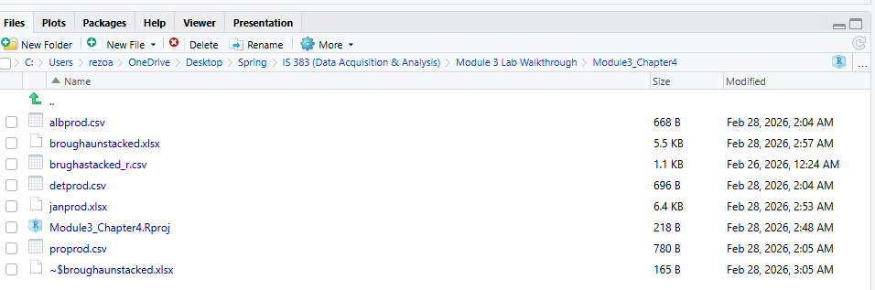
Screenshot: Files pane showing janprod.xlsx and broughaunstacked.xlsx

Analysis
I imported the three January production CSV files (Detroit, Albany, and Providence). I added a Facility column so each record keeps the correct site name. Then I combined the three datasets using bind_rows(). The combined dataset has 84 rows total (28 rows from each file), which shows the merge worked correctly.

Conclusion
I exported the combined January production data to Excel as janprod.xlsx.

Problem 4: Unstacking Marketing Research Data

Evidence
• I loaded the stacked dataset and converted Sales to numeric by removing the $ symbol.
• I unstacked the data into a wide format with Pretest and Posttest columns.
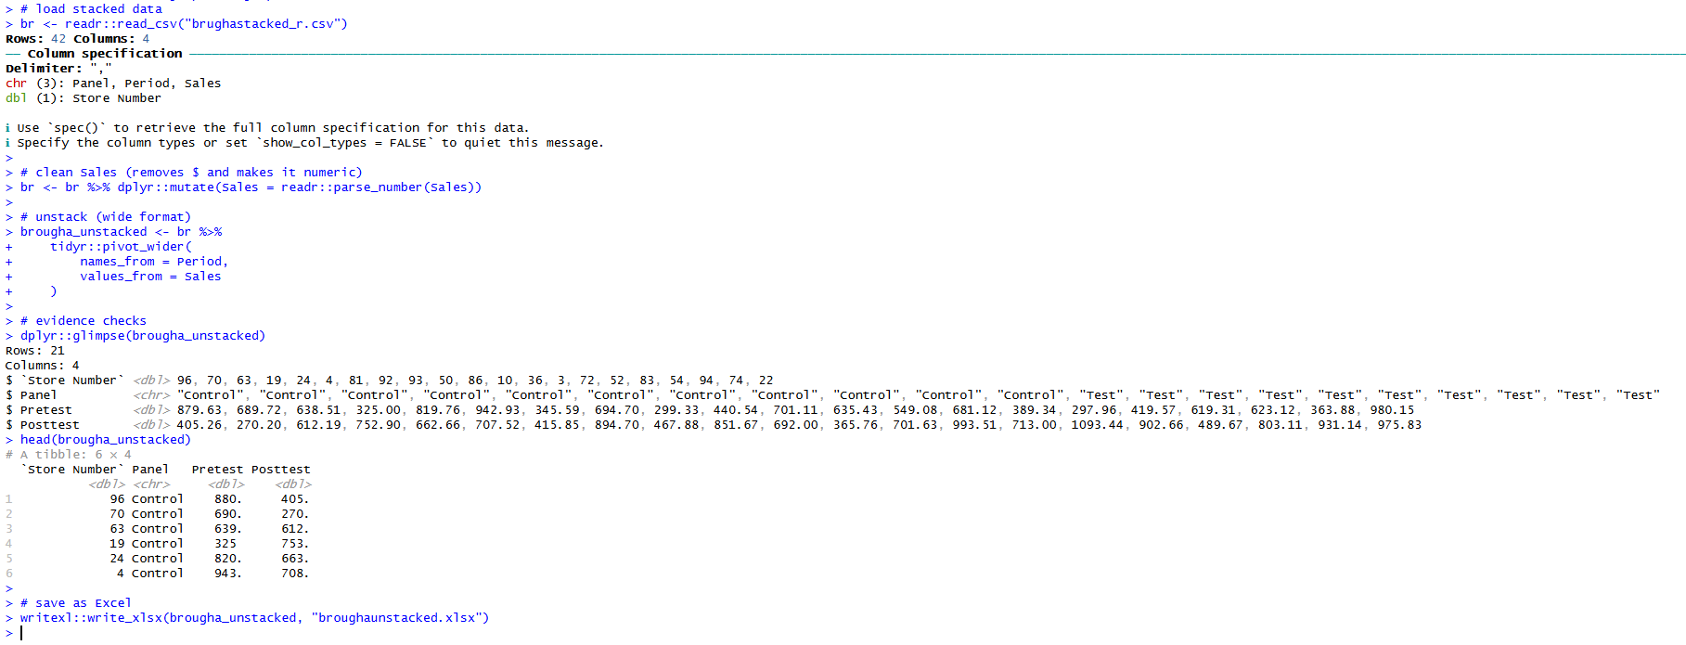
Screenshot: pivot_wider() results (Pretest + Posttest) with glimpse + head
• I saved the unstacked output as an Excel workbook (broughaunstacked.xlsx).
Screenshot: Files pane showing broughaunstacked.xlsx

Analysis
I loaded the stacked marketing research file (brughastacked_r.csv). The Sales values included a $ sign, so I cleaned Sales into a numeric field. Then I used pivot_wider() to convert the stacked Period column into separate columns. The final table has one row per store with Pretest and Posttest values.

Conclusion
I exported the unstacked marketing data to Excel as broughaunstacked.xlsx.

