Module 3 Lab – Chapter 6
Rezoan Ishteaque Hossain
IS 383 – Data Acquisition & Analysis
Chapter 6: Problem 18 and Problem 20

Setup Evidence (Chapter 6)

Evidence
• I installed/loaded the required Chapter 6 packages and confirmed the working folder contains the data files.
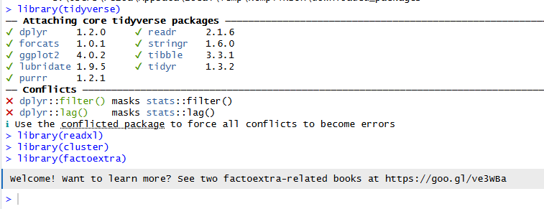
Screenshot: libraries loaded (tidyverse, readxl, cluster, factoextra)
Screenshot: getwd() and list.files() showing gatsby.xlsx and llemployees_r.csv

Problem 18: Distance to Centroid Calculation for Wine Clusters

Evidence
• I calculated the Euclidean distance from the new wine observation to each cluster centroid.
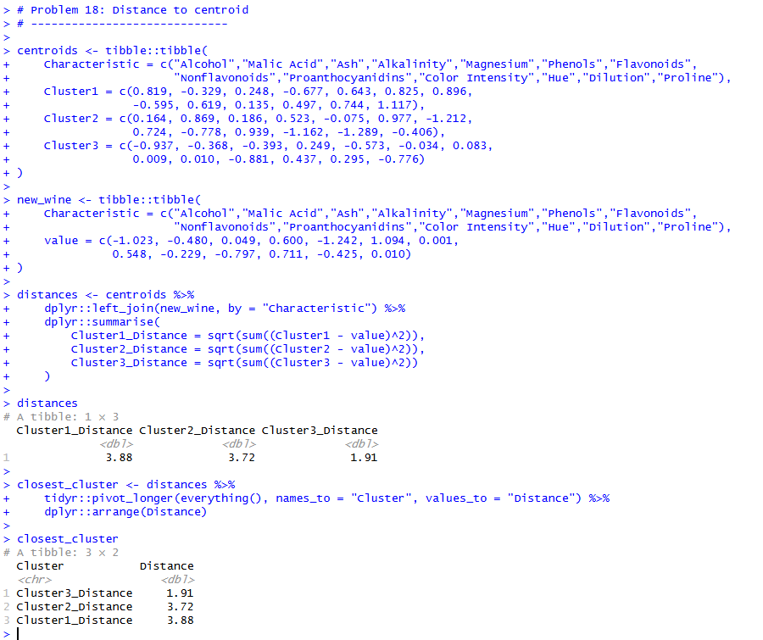
Screenshot: distances to Cluster 1/2/3 and the closest cluster result

Analysis
I compared the new wine observation to the three centroids using Euclidean distance. The distances were: Cluster 1 = 3.88, Cluster 2 = 3.72, and Cluster 3 = 1.91. Since Cluster 3 has the smallest distance, the new wine belongs to Cluster 3.

Conclusion
The new wine observation should be assigned to Cluster 3 (distance = 1.91).

Problem 20: Cluster Shapes for k-Means versus Single Linkage

Evidence
• I extracted Age and Performance Rating from EmpID and removed invalid ages (kept ages 18–70).
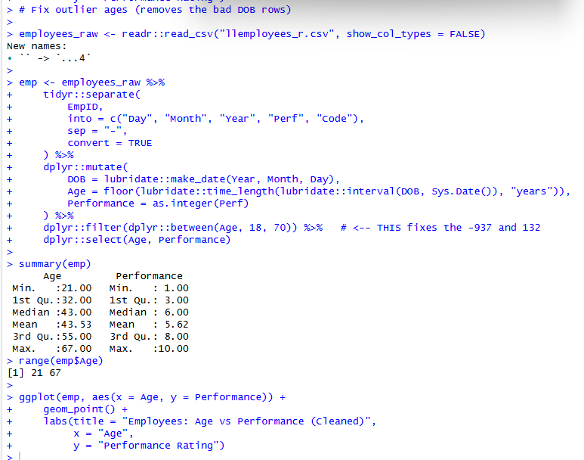
Screenshot: cleaned Age + Performance summary (Age range 21–67)
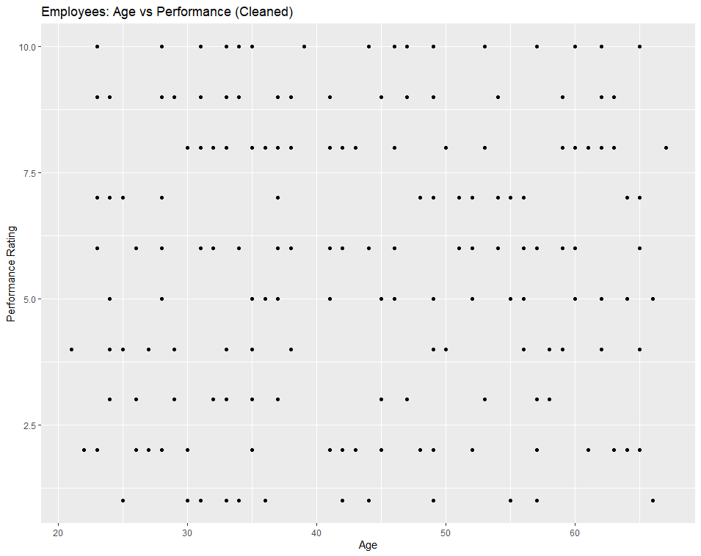
Screenshot: scatter plot (Age vs Performance) after cleaning
• I ran k-means clustering with k = 2 and plotted the clusters.
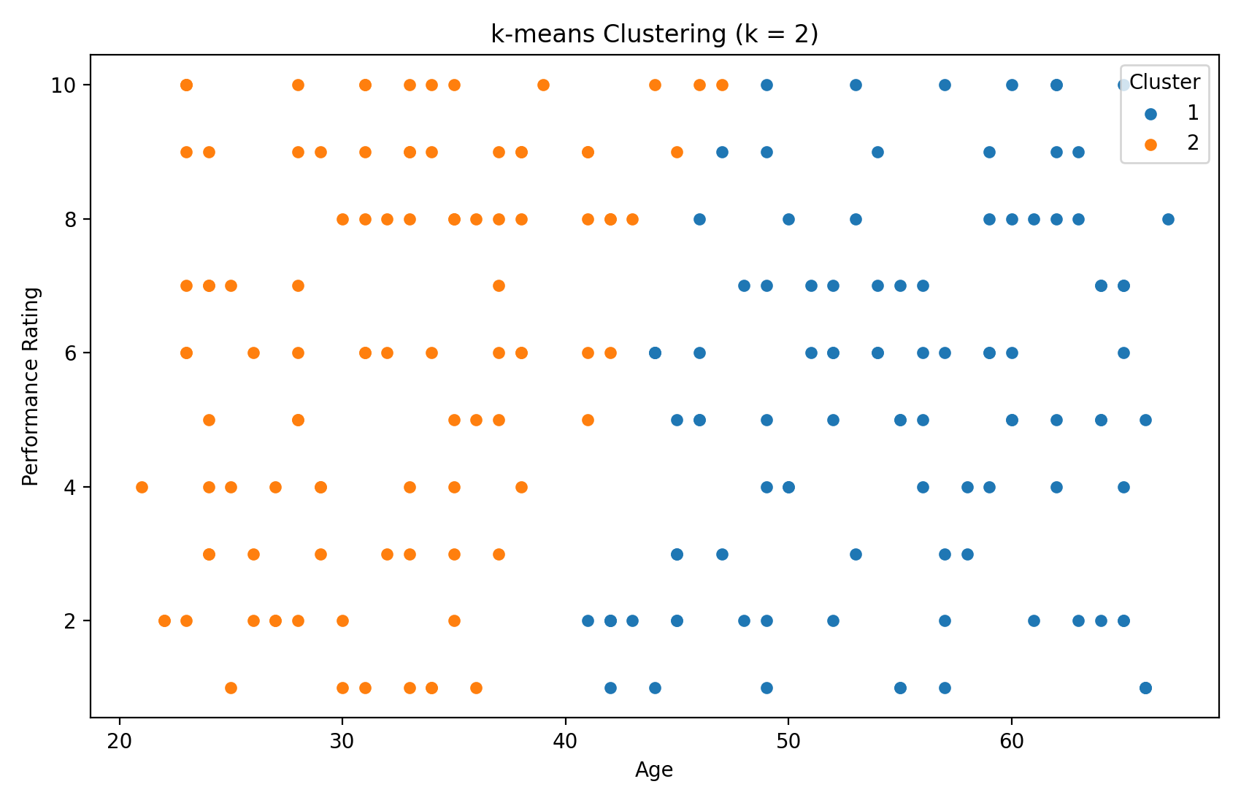
Plot: k-means clustering (k = 2) on Age and Performance (scaled)
• I ran single linkage hierarchical clustering (2 clusters) and compared the cluster shapes.
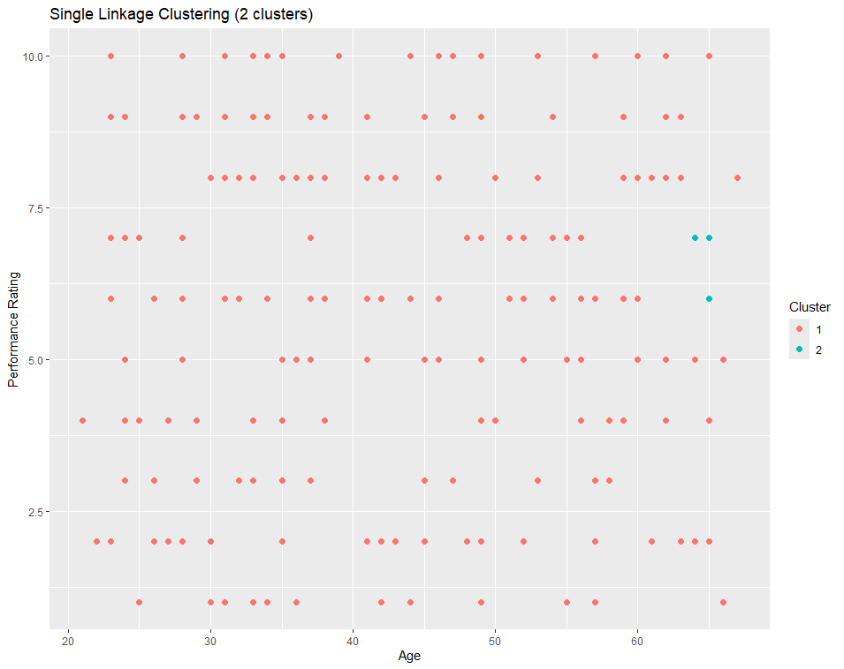
Screenshot: single linkage clustering (2 clusters)
• I also captured the cluster summary tables (size and averages).
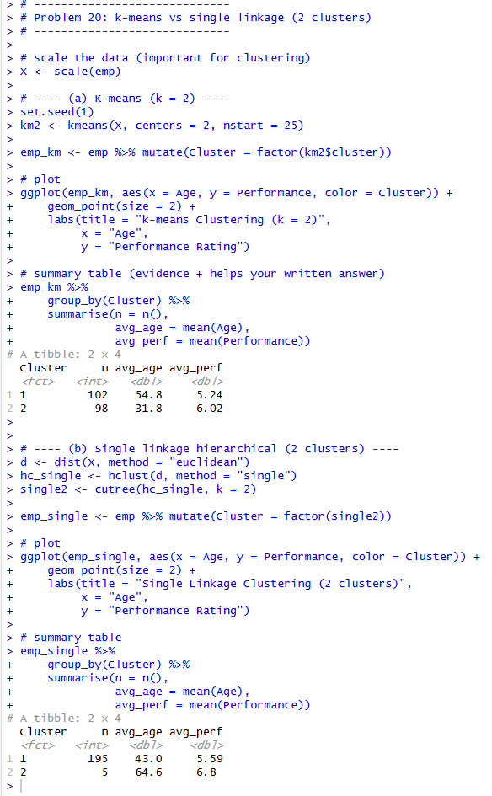
Screenshot: summary tables for k-means and single linkage clusters

Analysis
For k-means (k = 2), the clusters are fairly balanced and look more compact. The summary shows one cluster is older on average (~55 years) and the other is younger on average (~32 years), with slightly different average performance ratings. For single linkage, most points fall into one big cluster and a very small cluster is created (chaining effect). That means single linkage is more sensitive to outliers and does not form compact groups here.

Conclusion
k-means produces clearer and more useful clusters in this dataset. Single linkage creates one large cluster plus a tiny cluster, so the shapes are not as meaningful.

