Module 4 Lab Walkthrough
Chapter 5 Probability Problems Write-Up
Name: Rezoan Hossain

Introduction
This lab write-up answers Chapter 5 Problem 2, Problem 4, and Problem 8. For each problem, I included a screenshot of the table used as evidence, a short explanation of how the probability was found, and the final answer. The calculations were based directly on the values shown in the chapter tables.
Problem 2: Airline Performance Measures
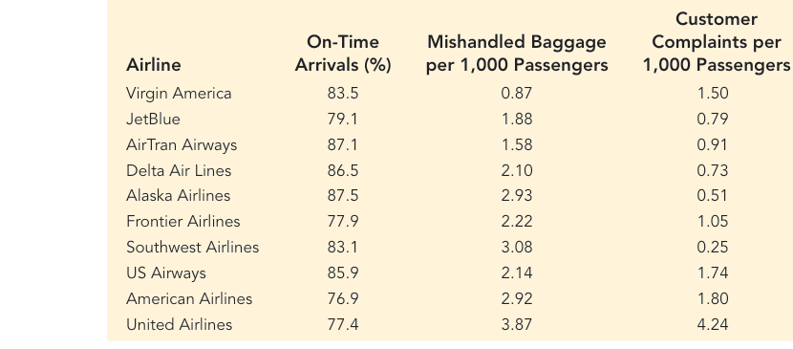
Figure 1. Airline performance table used for Problem 2.
Part a
The table shows that Delta Air Lines has an on-time arrival percentage of 86.5%. To write this as a probability, I changed the percent to a decimal. The probability that a randomly chosen Delta flight arrives on time is 0.865.
Part b
For this part, I counted the airlines with fewer than 2 mishandled baggage reports per 1,000 passengers. The qualifying airlines are Virgin America (0.87), JetBlue (1.88), and AirTran Airways (1.58). That makes 3 out of 10 airlines, so the probability is 3/10 = 0.30.
Part c
Next, I counted the airlines with more than 1 customer complaint per 1,000 passengers. The airlines are Virgin America (1.50), Frontier Airlines (1.05), US Airways (1.74), American Airlines (1.80), and United Airlines (4.24). That makes 5 out of 10 airlines, so the probability is 5/10 = 0.50.
Part d
AirTran Airways has an on-time arrival percentage of 87.1%. The probability that a flight does not arrive on time is the complement of arriving on time. So I calculated 1 - 0.871 = 0.129.
Problem 2 Conclusion
The results show that probability can be taken directly from a percentage, counted from a table, or found by using the complement rule. Among the ten airlines, 30% had fewer than 2 mishandled baggage reports, 50% had more than 1 customer complaint, and the probability that an AirTran flight is late is 0.129.
Problem 4: NCAA Basketball Championships
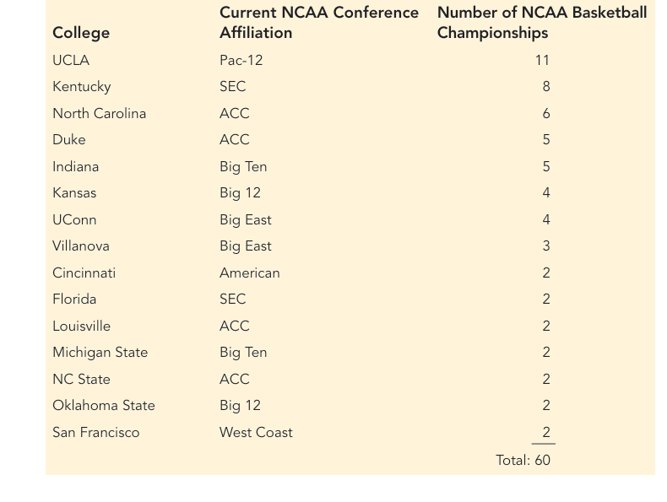
Figure 2. NCAA basketball championship table used for Problem 4.
Part a
UCLA won 11 of the 60 championships listed in the table. So the probability that the selected winner is from UCLA is 11/60, which is about 0.1833.
Part b
The Big Ten teams shown are Indiana and Michigan State. Indiana won 5 championships and Michigan State won 2, for a total of 7. Therefore, the probability that the selected winner is from the Big Ten is 7/60, or about 0.1167.
Part c
The ACC teams listed are North Carolina, Duke, Louisville, and NC State. Their championship totals are 6, 5, 2, and 2, which add to 15. Therefore, the probability that the selected winner is from the ACC is 15/60 = 0.25.
Part d
To find the probability that the selected winner is from either the Big Ten or the ACC, I added the two conference totals because no team belongs to both conferences in the table. The total is 7 + 15 = 22 championships. So the probability is 22/60, which is about 0.3667.
Problem 4 Conclusion
This problem used counting and simple probability. The ACC has the largest share among the groups asked about, and the combined probability for the Big Ten or the ACC is 22/60. This shows how totals from categories can be used to build probabilities from a frequency table.
Problem 8: Student Loans and College Degrees
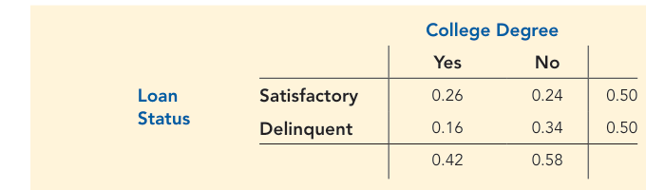
Figure 3. Joint probability table used for Problem 8.
Part a
The probability that a student with a student loan had received a college degree is the column total for "Yes." From the table, that value is 0.42.
Part b
The probability that a student with a student loan had not received a college degree is the column total for "No." From the table, that value is 0.58.
Part c
This part asks for a conditional probability: the probability of having a delinquent loan given that the student received a degree. I used the joint probability 0.16 and divided by the degree total 0.42. That gives 0.16/0.42 = 0.3810.
Part d
This is also a conditional probability. I used the joint probability for delinquent and no degree, which is 0.34, and divided by the total probability for no degree, which is 0.58. That gives 0.34/0.58 = 0.5862.
Part e
Students who left college without a degree are more likely to have a delinquent student loan. The delinquency probability is 0.5862 for students without a degree and 0.3810 for students with a degree. The difference is 0.2052, which means dropping out is associated with a noticeably higher chance of delinquent loan status.
Problem 8 Conclusion
The joint probability table shows that students without a degree have a higher risk of delinquent loan status. The conditional probabilities make that pattern clear: 0.5862 without a degree versus 0.3810 with a degree.
Overall Conclusion
Across all three problems, the same core ideas were used in different ways: direct probabilities from percentages, probabilities from counts, complements, and conditional probabilities from a joint table. The results show how probability helps describe practical situations such as airline service quality, sports outcomes, and student loan risk.

References
Cengage Learning. (2024). Chapter 5: Probability: An introduction to modeling uncertainty. Course textbook excerpt.

