Supplementary Information

What height is safe? An analysis of building destruction along the 207-km path of Nepal's 2026 flood
Nusrat Zahan Jarin¹, Obaidur Rahman², Rezwan Ahmed³
¹Department of Geography, University of California, Santa Barbara, CA, USA. ²Department of Geography, Oklahoma State University, Stillwater, OK, USA. ³Department of Geography and Environment, University of Dhaka, Dhaka, Bangladesh.
This file contains Supplementary Notes 1–6, Supplementary Tables 1–15, Supplementary Figs. 1–6 and Supplementary References. Every number is generated by the scripts that accompany the manuscript; table sources are named in each legend.

Supplementary Notes

Supplementary Note 1 | Sources, versions and provenance
The analysis combines two kinds of evidence (Supplementary Table 1). Event observations comprise the building-damage grading of HOT, CEMS and UNDP RAPIDA ^{1–3}, the UNOSAT flow extent ⁴, the propagation timeline ⁵ and official reports ^{6,7}. Pre-event context comprises the Copernicus GLO-30 elevation model ⁸, Sentinel-2 Level-2A imagery ^{9,10}, the Overture building stock and infrastructure ¹¹, GHS-BUILT-S settlement history ¹², WorldPop population ¹³ and geoBoundaries local levels ¹⁴. All sources were retrieved between 9 September and 20 October 2026; every download was logged with its URL, HTTP status, size and SHA-256 checksum.
Three limitations of access shaped the design. Gauge observations of the Department of Hydrology and Meteorology could not be retrieved because the public interface requires an application key, so stage rises were taken from the CHWRR report. HOT, UNDP and UNOSAT layers carry no product-specific redistribution licence; they are cited and archived for verification but should not be republished until permission is confirmed. Planet imagery is released for non-commercial use only and was not used.

Supplementary Note 2 | Harmonization of damage records and its sensitivity
Grades were mapped to a common ordinal scale: 0, no damage (HOT) or no record inside a graded area; 1, minor (HOT) or possibly damaged (CEMS); 2, major (HOT) or damaged (CEMS, UNDP); and 3, destroyed. Matching to the Overture stock (Methods) left 521 UNDP footprints, 363 HOT footprints and 631 CEMS points without a counterpart; they were retained as separate buildings so that the harmonized total of 5,781 damaged buildings (4,530 destroyed) includes every damage record (Supplementary Tables 3 and 4). The 5,781 damaged buildings used in the debris model are the same set.
HOT and CEMS agreed closely on destruction but not on lesser damage (Supplementary Table 4b). Of the 611 buildings that HOT classed as destroyed inside CEMS AOI01 and AOI02, 201 (33%) carried no CEMS record, whereas 97% of CEMS-destroyed buildings were destroyed in HOT; a building recorded as destroyed by either product was therefore treated as destroyed. Only 34% of the 367 UNOSAT-attributed records inside CEMS areas were also destroyed in CEMS, and these records are the only ones available north of the border (Supplementary Table 3).
Two checks retained from the first analysis address the quality of the HOT labels (Supplementary Fig. 6). Requiring a HOT confidence score of at least 0.75 retained 72% of records and removed almost all minor and major labels (minor 155 to 0; major 105 to 4) but only 21 of 677 destroyed labels, so the destruction labels on which the models rest are the most confident ones. Translating all HOT footprints by 5 m in each cardinal direction changed the number inside the UNOSAT extent by at most four buildings and the number of severely damaged buildings inside it by at most four.

Supplementary Note 3 | Model specification and diagnostics
The local models used the 1,050 HOT buildings with a damage label, of which 677 were destroyed. Height alone separated destroyed from other buildings with an AUC of 0.92 (odds ratio 0.50 per 10 m; height at 50% probability 66 m, 95% interval 57–100 m). In the multivariable models (Supplementary Table 6b), height, distance and hillslope angle are strongly correlated within this narrow reach, so their individual coefficients are less precise than the joint fit. Distance downstream and hillslope angle remained significant in both logistic models and building density in the model of major damage or destruction; in the ordinal model, all terms except valley width and footprint area were significant.
For the regional gradient-boosted model, out-of-fold predictions were well calibrated apart from slight overconfidence at the top of the range (Supplementary Fig. 3a): in the highest decile the mean predicted probability was 0.87 against an observed share of 0.79, and in the next decile 0.59 against 0.60. Partial dependence (Supplementary Fig. 3b–f) shows a sharp decline in the probability of destruction between about 10 and 35 m above the channel and a weaker decline with distance from the channel. Because partial dependence averages over the observed values of all other attributes, including distances of up to 1 km, its 50% contour lies below the reach-wise envelope, which is conditional on the buildings present in each reach; the contour is shown only to illustrate the downstream decline. Permutation importance (Supplementary Table 7b) attributes most of the skill to height above the channel.

Supplementary Note 4 | Height above the channel and the damage-calibrated height
Height above the channel is a relative elevation: it measures how far a building stands above the pre-event channel, not the depth of the flow. In the gorge it integrates water depth, run-up, superelevation and the collapse of undercut terraces; in the wider valley it approximates the stage reached by the flow more closely. The reach-wise height at 50% destruction is therefore a damage-calibrated envelope rather than a hydraulic quantity.
Reach estimates and their smoothing are listed in Supplementary Table 8. In three gorge reaches (marked †) the 50% height was poorly constrained, with a bootstrap interval wider than 60 m; there the 90th-percentile height of destroyed buildings was used when it was smaller. A three-reach running median within each contiguous graded segment then removed the influence of a few far up-slope destroyed records in the 31–36-km reach, whose 90th-percentile height (146 m) would otherwise have dominated the outer envelope. The pooled estimates for all buildings in each reach group (gorge 62 (95% CI 56–88) m; middle valley 21 (95% CI 19–24) m; lower valley 9 (95% CI 7–11) m) are consistent with the smoothed reach values. The damage-calibrated height correlated with the height of the UNOSAT flow-extent edge across 11 reaches (Spearman ρ = 0.97), negatively with the width of the valley floor and positively with the mean celerity of the wave front (Supplementary Fig. 4). Both relationships share a common downstream trend and are descriptive.
No uniform threshold matched the damage. A 20-m height threshold would have contained 54% of destroyed buildings in the graded corridor but only 16% in the gorge, against 87% in the lower valley, while including 4,232 undamaged buildings along the whole corridor (Supplementary Table 9).

Supplementary Note 5 | Sentinel-2 processing and corroboration
Sentinel-2 Level-2A scenes were read directly from the Earth Search cloud-optimized archive ¹⁰. All scenes used had the processing-baseline offset already removed by the archive (property earthsearch:boa_offset_applied), so reflectance was computed as the digital number × 10⁻⁴; the offset listed in the band metadata was applied only to scenes without this flag. Where an acquisition had been processed twice, only the later processing was used. Medians of clear-sky pixels (scene classes 4–7) were computed per MGRS tile at 20 m for 14 pre-event scenes (2025-10-11 to 2025-10-26) and 19 post-event scenes (2026-09-21 to 2026-10-18), and the tile with more clear observations was kept where tiles overlapped.
All four indices separated destroyed from other buildings (Supplementary Table 5 and Supplementary Fig. 2b). NDVI separated them with an AUC of 0.95 across all graded buildings and 0.94 against HOT labels; the median NDVI change was +0.04 for HOT buildings without damage and −0.33 for destroyed ones. A threshold on NDVI loss chosen without reference to the damage data (Otsu's method ¹⁵, ΔNDVI < −0.29) delineated 13.1 km² of disturbed ground within 1.5 km of the channel over the first 106 km; 83% of it lay inside the UNOSAT flow extent, which it covered to 56% (intersection over union 0.50). Differences from the UNOSAT extent arise where the flow left vegetation standing, where clouds or terrain shadow removed observations (Supplementary Fig. 2a) and where post-event landslides or construction changed the surface. At 20 m, a building pixel also contains gardens, fields and roads, so the indices corroborate the damage labels at the scale of a building's surroundings rather than grading roofs. The post-event window began on 21 September, a few weeks earlier in the season than the pre-event window, which probably explains the slightly positive median change for undamaged buildings; such a phenological difference cannot produce the grade-dependent contrast observed.

Supplementary Note 6 | Timing, exposure, infrastructure, debris and ranking
The propagation timeline (Supplementary Table 2) starts at the seismic onset of the failure (08:37:10 NPT) ^{16,17}. Gauge-loss times bound arrival from above, and the Kali Khola entry is a threshold crossing that was excluded from the interpolation. Lead times by local level are given in Supplementary Table 11.
Built-up surface grew fastest on the lowest ground in both the graded corridor and the ungraded corridor downstream (Supplementary Table 10). CEMS graded 73.0 km of road as destroyed, 4.8 km as damaged and 14.0 km as possibly damaged in its four areas of interest, and recorded 54 bridges as affected, of which 44 were destroyed (Supplementary Table 13a). 10 road records lacked geometry and were counted but not measured. Overture infrastructure inside the UNOSAT flow extent is listed as exposure in Supplementary Table 13b,c; it records presence before the event, not damage. ESA WorldCover 2021 ¹⁸ shows what the flow covered (Supplementary Table 15): tree cover, grassland and bare ground dominated above the border and in the gorge, whereas cropland (3.4 km²) and built-up land were concentrated in the Trishuli valley. The land-cover areas sum to 37.36 km², matching the area of the UNOSAT polygon (37.35 km²).
The debris estimate is most sensitive to the settlement factor applied to urban buildings (Supplementary Fig. 5a,b). The central estimate of 1.04 Mt uses UNDP's factors and therefore lies at the upper end of the Monte Carlo range, whose median is 0.75 Mt; without settlement factors the total is 0.53 Mt. The ranking of local levels was robust at the top and bottom but not in the middle (Supplementary Fig. 5c). In the casualty series (Supplementary Table 12) the number of missing people rose until mid-September and then fell, while the number of deaths continued to rise; the figures used here (to 3 October 2026) remain provisional. Published monetary estimates differ in scope (Supplementary Table 14) ^{3,7,19}.

Supplementary Tables
Supplementary Table 1 | Data sources. Datasets used in this study, with version, date, resolution, use and access. Retrieval logs with URLs, dates and SHA-256 checksums accompany the code.
Dataset | Provider and version | Date or epoch | Resolution or unit | Use in this study | Access and terms
HOT building-damage inventory and analysed area | Humanitarian OpenStreetMap Team; AI-assisted (fAIR) labels on OpenStreetMap footprints | Post-event imagery; acquisition times not published | 1,053 footprints; 13.9 km² analysed area | Damage labels (local models, harmonization) | HOT raw-data API; terms unconfirmed
CEMS EMSR927 grading | Copernicus EMS Rapid Mapping; AOI01, AOI02 first products; AOI03, AOI05 monitoring products (MONIT01) | Imagery 27 Aug–5 Sep 2026 | Building points; road lines; bridge points; not-analysed areas | Damage labels, graded domain, road and bridge damage | rapidmapping.emergency.copernicus.eu; © European Union
UNDP RAPIDA building debris layer | UNDP; records attributed to CEMS (2,311), SERTIT (48), UNOSAT (684) | StoryMap of 27 Aug, updated 2 Sep 2026 | 3,043 footprints with floors, site type, debris | Damage labels, debris model | UNDP NPL_debris service; terms unconfirmed
UNDP RAPIDA economic estimate and affected population | UNDP (CLIMADA-based) | Reference date 31 Aug 2026 | Local-level US$ and people | Monetary comparison; affected-people indicator | UNDP economic service; terms unconfirmed
UNOSAT flow extent FL20260826NPL | UNITAR/UNOSAT via UNESCO IHP-WINS | Imagery 26–27 Aug 2026 | 37.35 km² polygon in a 363 km² analysed area | Flow-edge heights, exposure | IHP-WINS dataset; redistribution terms unconfirmed
NDRRMA situation reports and consolidated update | Government of Nepal | 26 Aug–3 Oct 2026 | Deaths, missing, warning timeline | Casualties, alert times | ndrrma.gov.np
Rapid Damage and Needs Assessment (RDNA) | NDRRMA and National Planning Commission | 10 Sep 2026 | Affected buildings by local level; sector damage and needs | Comparison, ranking, monetary scope | ndrrma.gov.np
Propagation timeline and gauge records | Centre of Hydrology and Water Resources Research (CHWRR) | 26 Aug 2026 | Gauge-loss and threshold times; stage | Wave timing, stage rises | giwmscdnone.gov.np
Rapid Hazard Assessment NP3 | HiRISK | 28 Aug 2026 | Source coordinates and process interpretation | Start of the traced flow path | hirisk.org
Copernicus GLO-30 DEM | ESA/Airbus; tiles N27–N28, E084–E085 | Data acquired 2011–2015 | 30 m | Flow path, height above channel, slope, transects | AWS open data; Copernicus DEM licence
Sentinel-2 Level-2A | ESA Copernicus; Earth Search v1 cloud-optimized GeoTIFFs | 2025-10-11 to 2025-10-26 (14 scenes); 2026-09-21 to 2026-10-18 (19 scenes) | 10–20 m | Change indices, true-colour chips | Earth Search STAC; Copernicus Sentinel data terms
Overture Maps release 2026-09-23.1 | Overture Maps Foundation; buildings, transportation, base (infrastructure, water) | Release 23 Sep 2026 | Footprints, lines, points | Common building stock; infrastructure exposure | Amazon S3 (overturemaps-us-west-2); ODbL for OpenStreetMap-derived themes
GHS-BUILT-S R2023A | European Commission JRC | 1975–2020, 5-year epochs | 100 m | Built-up growth by height band | JRC open data; CC BY 4.0
WorldPop Global2 R2025A constrained counts | WorldPop, University of Southampton | 2015, 2020, 2026 | 100 m | Population in zones | data.worldpop.org; CC BY 4.0
geoBoundaries gbOpen NPL ADM3 | William & Mary geoLab (commit 9469f09) | Current release | Local-level polygons | Assignment to local levels | github.com/wmgeolab; CC BY-SA 4.0 (metadata)
Seismic onset of the failure | NRSC/ISRO; USGS event us7000tbwb | 26 Aug 2026, 08:37:10 NPT | Time | Time zero of the propagation timeline | Published sources ^{16,17}
Not used: DHM gauge observations | Department of Hydrology and Meteorology API | – | – | Requests returned HTTP 403 (application key required) | hydrology.gov.np
ESA WorldCover 2021 v200 | European Space Agency | 2021 | 10 m | Pre-event land cover in the flow extent | esa-worldcover.org; CC BY 4.0
Not used: Planet imagery catalogue | Planet | – | – | Inspected for reference only (CC BY-NC 4.0) | –

Note: "Terms unconfirmed" means that no product-specific licence was found; such layers are cited and archived for verification but not redistributed. OpenStreetMap data © OpenStreetMap contributors (ODbL).
Supplementary Table 2 | Propagation timeline of the flood wave. Distances are along the traced flow path. Mean celerity is the distance between consecutive arrival points divided by the time between them. Source: timing_wave_arrivals.csv.
Place | Distance (km) | Time (NPT) | Minutes after failure | Mean celerity from previous (m s⁻¹) | Used as arrival | Source
Source failure (seismic onset) | 0.0 | 08:37:10 | 0.0 | – | yes | NRSC/ISRO; USGS us7000tbwb
Rasuwagadhi (border) | 23.5 | 08:44:00 | 6.8 | 57.2 | yes | ICIMOD (22 km in 6 min 50 s); gauge lost 08:40, border hit 08:45 (CHWRR)
Syaphrubesi gauge lost | 36.5 | 08:50:00 | 12.8 | 36.2 | yes | CHWRR report, its table 2
Betrawati gauge lost | 69.9 | 09:20:00 | 42.8 | 18.6 | yes | CHWRR report, its table 2
Galchhi | 105.2 | 10:28:00 | 110.8 | 8.6 | yes | CHWRR report, its table 2
Phurke/Malekhu warning level | 127.0 | 11:26:00 | 168.8 | 6.3 | yes | CHWRR report, its table 2
Mugling | 169.9 | 13:00:00 | 262.8 | 7.6 | yes | CHWRR report, its table 2; HiRISK
Kali Khola danger level (threshold crossing, not arrival) | 173.0 | 14:14:00 | 336.8 | – | no (threshold crossing) | CHWRR report, its table 2
Devghat arrival | 206.8 | 15:20:00 | 402.8 | 4.4 | yes | CHWRR report, its table 2 (peak 16:00)

Note: Gauge-loss times are upper bounds on arrival. The Kali Khola time marks the crossing of the danger level and is not used as an arrival.
Supplementary Table 3 | Harmonized building damage by local level. Damaged includes possibly damaged, damaged and destroyed. Median distance is measured along the flow path for damaged buildings. CEMS residential and non-residential refer to the building type recorded by CEMS for affected buildings. Source: harmonised_by_municipality.csv.
Local level | Median distance (km) | Damaged (any grade) | Destroyed | Destroyed in ≥2 products | CEMS affected | CEMS residential | CEMS non-residential | HOT destroyed | UNDP destroyed
Outside Nepal (Gyirong, China) | 21.7 | 44 | 44 | 0 | 0 | 0 | 0 | 0 | 44
Gosaikunda | 28.1 | 1,366 | 1,040 | 560 | 847 | 605 | 109 | 668 | 509
Parbatikunda | 35.2 | 37 | 32 | 17 | 17 | 12 | 5 | 9 | 28
Uttargaya | 61.9 | 278 | 269 | 48 | 91 | 91 | 0 | 0 | 236
Kispang | 66.6 | 430 | 409 | 51 | 412 | 389 | 23 | 0 | 70
Bidur | 77.5 | 2,775 | 2,221 | 1,137 | 2,625 | 2,527 | 64 | 0 | 1,298
Belkotgadhi | 91.9 | 256 | 209 | 65 | 177 | 41 | 33 | 0 | 155
Tarakeshwor | 96.8 | 122 | 113 | 31 | 63 | 3 | 29 | 0 | 91
Galchhi | 107.5 | 353 | 127 | 3 | 333 | 61 | 101 | 0 | 23
Gajuri | 112.4 | 118 | 64 | 0 | 118 | 7 | 1 | 0 | 0
Siddhalek | 113.7 | 2 | 2 | 0 | 2 | 2 | 0 | 0 | 0
Total |  | 5,781 | 4,530 | 1,912 | 4,685 | 3,738 | 365 | 677 | 2,454

Note: Buildings outside Nepal are UNOSAT-attributed records in the UNDP layer, north of the border crossing at Rasuwagadhi. Local-level names follow the RDNA.
Supplementary Table 4 | Damage products and their agreement. a, Buildings assessed, damaged and destroyed by each product after one-to-one matching to the common stock. b, Cross-tabulation of HOT labels against the latest CEMS grade for the 867 buildings graded by both (Cohen's κ for destruction = 0.49). Sources: products_summary.csv, agreement_hot_cems.csv.
Product | Assessed | Damaged (any grade) | Destroyed
HOT (local, AI-assisted labels on OSM footprints) | 1,053 | 937 | 677
CEMS EMSR927 latest grading (photo-interpretation) | 17,299 | 4,685 | 3,571
UNDP RAPIDA: CEMS-attributed | – | 2,311 | 1,754
UNDP RAPIDA: SERTIT-attributed | – | 48 | 47
UNDP RAPIDA: UNOSAT-attributed | – | 684 | 653
Harmonized union (≥1 product) | – | 5,781 | 4,530
Destroyed in ≥2 products | – | – | 1,912

HOT label | No record | Possibly damaged | Damaged | Destroyed | Total
HOT no damage | 32 | 26 | 6 | 1 | 65
HOT minor | 74 | 23 | 19 | 2 | 118
HOT major | 36 | 20 | 8 | 9 | 73
HOT destroyed | 201 | 2 | 10 | 398 | 611

Supplementary Table 5 | Separation of destroyed buildings by Sentinel-2 change indices. Area under the receiver-operating-characteristic curve for post-minus-pre change averaged over 3 × 3 pixels (20 m) at each building. Source: s2_separability_auc.csv.
Index (post minus pre) | All graded: destroyed vs other (n = 23,189) | CEMS areas: destroyed vs no record (n = 21,898) | HOT: destroyed vs no damage (n = 763)
NDVI change | 0.948 | 0.952 | 0.936
NDWI change | 0.950 | 0.953 | 0.939
Visible brightness change | 0.941 | 0.944 | 0.938
Bare-soil index change | 0.902 | 0.911 | 0.872

Supplementary Table 6 | HOT damage by height above the channel and local models. a, Composition of HOT damage classes by band of height above the channel, with Wilson 95% confidence intervals for the share destroyed. b, Odds ratios (95% confidence intervals) from logistic models of destruction and of major damage or destruction and from a proportional-odds model of the four HOT classes, with standard errors clustered by 1-km reach (n = 1,050). Sources: terrain_local_rem_bins.csv, terrain_local_models.csv.
Height above channel (m) | Buildings | No damage (%) | Minor (%) | Major (%) | Destroyed (%, 95% CI)
−20 to 0 | 12 | 0 | 0 | 0 | 100 (76–100)
0 to 10 | 32 | 0 | 0 | 0 | 100 (89–100)
10 to 20 | 89 | 0 | 1 | 7 | 92 (85–96)
20 to 30 | 98 | 2 | 5 | 4 | 89 (81–94)
30 to 40 | 122 | 2 | 1 | 2 | 94 (89–97)
40 to 50 | 217 | 1 | 2 | 1 | 95 (92–97)
50 to 60 | 139 | 8 | 6 | 14 | 72 (64–79)
60 to 80 | 139 | 18 | 41 | 21 | 20 (14–28)
80 to 100 | 58 | 29 | 50 | 12 | 9 (4–19)
100 to 150 | 74 | 30 | 36 | 26 | 8 (4–17)
150 to 400 | 70 | 43 | 31 | 21 | 4 (1–12)

Term | Logistic: destroyed | Logistic: major or destroyed | Ordinal: four HOT classes
Height above channel (per 10 m) | 0.56 (0.28–1.13); P = 0.107 | 0.86 (0.74–1.00); P = 0.055 | 0.85 (0.79–0.92); P < 0.001
Distance to channel (log m) | 0.79 (0.09–6.53); P = 0.824 | 0.20 (0.04–1.10); P = 0.064 | 0.25 (0.13–0.47); P < 0.001
Distance downstream (per 10 km) | 0.23 (0.12–0.45); P < 0.001 | 0.26 (0.10–0.67); P = 0.005 | 0.36 (0.25–0.51); P < 0.001
Valley-floor width (per 100 m) | 0.55 (0.09–3.32); P = 0.511 | 0.74 (0.12–4.68); P = 0.747 | 0.71 (0.44–1.15); P = 0.163
Outer bank of bend | 2.06 (0.75–5.68); P = 0.163 | 2.13 (0.74–6.10); P = 0.159 | 1.53 (1.07–2.17); P = 0.019
Hillslope angle (per 10°) | 0.41 (0.19–0.88); P = 0.023 | 0.33 (0.15–0.74); P = 0.007 | 0.35 (0.27–0.44); P < 0.001
Footprint area (log m²) | 1.09 (0.74–1.61); P = 0.663 | 0.97 (0.79–1.18); P = 0.736 | 1.01 (0.84–1.21); P = 0.941
Buildings within 100 m (per 10) | 0.94 (0.87–1.01); P = 0.100 | 0.91 (0.85–0.97); P = 0.002 | 0.94 (0.90–0.99); P = 0.026
McFadden pseudo-R² | 0.50 | 0.37 | –

Supplementary Table 7 | Regional models of destruction. a, Performance under spatial cross-validation and transfer tests. b, Permutation importance of the gradient-boosted model (mean decrease in test-fold AUC over ten permutations). Sources: ml_performance.csv, ml_permutation_importance.csv.
Model | Validation | Buildings | Prevalence (%) | ROC AUC | PR AUC | Brier score
Gradient-boosted trees, nine attributes | Six folds grouped by 5-km reaches | 23,453 | 18.0 | 0.952 | 0.762 | 0.070
Logistic regression, nine attributes | Six folds grouped by 5-km reaches | 23,453 | 18.0 | 0.953 | 0.764 | 0.067
Logistic regression, height only | Six folds grouped by 5-km reaches | 23,453 | 18.0 | 0.857 | 0.522 | 0.109
Gradient-boosted trees, CEMS labels only | Four folds grouped by 5-km reaches, CEMS areas | 23,270 | 15.3 | 0.950 | 0.720 | 0.068
Gradient-boosted trees trained outside HOT reach, tested on HOT labels | Independent HOT labels | 1,050 | 64.5 | 0.890 | 0.921 | 0.266

Attribute | Mean decrease in AUC | Standard deviation across folds
Height above channel | 0.196 | 0.070
Distance to channel | 0.045 | 0.026
Distance downstream | 0.036 | 0.043
Channel gradient | 0.010 | 0.009
Footprint area (log) | 0.009 | 0.005
Hillslope angle | 0.004 | 0.005
Building density | 0.000 | 0.003
Valley-floor width | 0.000 | 0.003
Outer bank of bend | −0.001 | 0.001

Supplementary Table 8 | Damage-calibrated destructive height by reach. Height above the channel at which a logistic model of destruction reached 50% probability (block-bootstrap 95% interval), the 90th percentile height of destroyed buildings, the height of the UNOSAT flow-extent edge, valley-floor width, and the smoothed core and outer heights used for the danger zones. Source: terrain_envelope_by_reach.csv.
Reach (km) | Graded buildings | Destroyed | Height at 50% destruction (95% CI) (m) | 90th percentile, destroyed (m) | Flow-edge height, median (IQR) (m) | Valley-floor width <20 m (m) | Core height (m) | Outer height (m)
21–26 | 581 | 400 | 88.2 (unbounded)† | 59.9 | 71.1 (42–111) | 135 | 59.9 | 59.9
26–31 | 248 | 195 | 77.2 (30 to 113)† | 53.7 | 52.2 (34–77) | 105 | 59.9 | 59.9
31–36 | 151 | 51 | 66.3 (44 to 119)† | 146.0 | 49.6 (36–68) | 105 | 55.0 | 55.0
36–41 | 713 | 366 | 55.0 (53 to 68) | 54.5 | 59.5 (45–67) | 90 | 55.0 | 55.0
64–70 | 1,464 | 962 | 33.1 (28 to 39) | 29.7 | 31.0 (22–44) | 240 | 33.1 | 33.1
70–76 | 1,994 | 593 | 23.5 (21 to 26) | 25.2 | 24.8 (20–36) | 240 | 24.7 | 29.7
76–82 | 5,545 | 521 | 24.7 (21 to 26) | 29.9 | 27.4 (21–43) | 210 | 23.5 | 25.2
82–88 | 4,149 | 488 | 15.0 (13 to 17) | 23.0 | 19.9 (14–26) | 270 | 15.0 | 23.0
88–94 | 2,274 | 301 | 12.4 (11 to 14) | 21.3 | 14.8 (12–19) | 382 | 12.4 | 21.3
94–100 | 1,862 | 138 | 10.0 (7 to 13) | 20.9 | 14.0 (5–20) | 382 | 10.0 | 20.9
100–107 | 2,475 | 71 | 5.1 (0 to 9) | 20.5 | 13.2 (6–20) | 210 | 6.5 | 20.5
107–114 | 1,961 | 132 | 6.5 (1 to 10) | 19.9 | – | 225 | 6.5 | 19.9

Note: † Bootstrap interval wider than 60 m; the core height uses the smaller of the 50% height and the 90th percentile of destroyed buildings before smoothing. Downstream of 114 km the envelope is interpolated between stage rises of 9.1 m at Kali Khola (172 km) and 2.6 m at Devghat (206.8 km) ⁵.
Supplementary Table 9 | Share of destroyed buildings and undamaged stock below uniform height thresholds. Source: terrain_setback_thresholds.csv.
Height threshold (m) | Destroyed below, all graded (%) | Gorge, 21–41 km (%) | Middle valley, 64–89 km (%) | Lower valley, 89–114 km (%) | Undamaged buildings below, 0–207 km | of which 106–207 km
5 | 6 | 2 | 7 | 12 | 298 | 134
10 | 17 | 6 | 17 | 36 | 760 | 366
15 | 34 | 10 | 35 | 68 | 2,005 | 1,274
20 | 54 | 16 | 61 | 87 | 4,232 | 2,748
30 | 79 | 31 | 93 | 98 | 9,123 | 5,551
40 | 87 | 51 | 98 | 100 | 13,577 | 8,270
50 | 95 | 79 | 100 | 100 | 17,279 | 10,769
75 | 100 | 98 | 100 | 100 | 27,255 | 16,522
100 | 100 | 99 | 100 | 100 | 32,145 | 18,613

Supplementary Table 10 | Built-up surface and population by band of height above the channel. GHS-BUILT-S R2023A and WorldPop Global2 R2025A interpolated to the 30-m grid; bands are within 1 km of the traced channel. Source: exposure_growth_zones.csv.
Zone | Reach | Area (km²) | Built-up 1975 (ha) | Built-up 2000 (ha) | Built-up 2020 (ha) | Growth 1975–2020 (×) | Population 2015 | Population 2026
UNOSAT flow extent | 0–106 km | 37.4 | 3.5 | 18.3 | 43.7 | 12.4 | 6,292 | 6,753
<10 m above channel | 0–106 km | 12.3 | 0.7 | 3.0 | 11.8 | 16.7 | 1,505 | 1,626
<10 m above channel | 106–207 km | 15.3 | 0.7 | 2.5 | 9.4 | 12.6 | 1,624 | 1,755
10–20 m | 0–106 km | 7.0 | 1.5 | 8.1 | 20.2 | 13.4 | 2,756 | 2,950
10–20 m | 106–207 km | 7.5 | 2.5 | 8.6 | 23.5 | 9.4 | 3,571 | 3,831
20–40 m | 0–106 km | 13.0 | 4.9 | 18.2 | 41.9 | 8.6 | 6,652 | 7,109
20–40 m | 106–207 km | 13.8 | 3.8 | 18.5 | 60.5 | 16.0 | 9,671 | 10,382
40–80 m | 0–106 km | 22.2 | 10.1 | 32.4 | 78.9 | 7.8 | 15,339 | 16,399
40–80 m | 106–207 km | 31.0 | 16.6 | 37.5 | 105.5 | 6.4 | 20,399 | 21,852
≥80 m | 0–106 km | 144.8 | 14.4 | 51.4 | 110.9 | 7.7 | 21,998 | 23,530
≥80 m | 106–207 km | 118.9 | 12.4 | 22.8 | 105.4 | 8.5 | 23,444 | 25,208
All land within 1 km | 0–106 km | 199.3 | 31.6 | 113.2 | 263.7 | 8.3 | 48,251 | 51,614
All land within 1 km | 106–207 km | 186.6 | 36.0 | 89.7 | 304.3 | 8.5 | 58,709 | 63,028
All land within 2 km | 0–106 km | 392.0 | 56.4 | 184.2 | 423.7 | 7.5 | 77,282 | 82,592
All land within 2 km | 106–207 km | 356.4 | 75.9 | 183.8 | 526.9 | 6.9 | 105,368 | 112,714

Supplementary Table 11 | Warning lead time for destroyed buildings. a, Distribution of lead times under three alert scenarios for the 4,530 destroyed buildings. b, Median lead time by local level (negative values: the flood arrived before the alert). Sources: timing_lead_time_scenarios.csv, timing_lead_time_by_municipality.csv.
Alert scenario | Alert time (NPT) | Reached before alert (%) | ≥10 min (%) | ≥30 min (%) | ≥60 min (%) | Median lead time (min)
Seismic-triggered automatic alert (onset + 2 min) | 08:39 | 0.0 | 84.5 | 73.5 | 26.5 | 40.8
First official phone warnings (08:46–08:54) | 08:50 | 16.4 | 75.4 | 50.0 | 21.6 | 30.0
Mass SMS by DHM (09:15) | 09:15 | 28.8 | 41.0 | 23.8 | 4.9 | 5.0

Local level | Destroyed buildings | Median distance (km) | Seismic alert, 08:39 (min) | Phone warnings, 08:50 (min) | Mass SMS, 09:15 (min)
Outside Nepal (Gyirong, China) | 44 | 21.7 | 4 | −7 | −32
Gosaikunda | 1,040 | 26.2 | 6 | −5 | −30
Parbatikunda | 32 | 35.2 | 10 | −1 | −26
Uttargaya | 269 | 61.6 | 33 | 22 | −3
Kispang | 409 | 66.6 | 38 | 27 | 2
Bidur | 2,221 | 76.6 | 54 | 43 | 18
Belkotgadhi | 209 | 91.5 | 82 | 72 | 47
Tarakeshwor | 113 | 96.8 | 93 | 82 | 57
Galchhi | 127 | 107.5 | 115 | 104 | 79
Gajuri | 64 | 112.5 | 128 | 117 | 92
Siddhalek | 2 | 113.7 | 131 | 120 | 96

Supplementary Table 12 | Reported deaths and missing people in Nepal. Values as published at each date; some secondary compilations report official figures. Source: casualty_series.csv.
Date | Time (NPT) | Deaths | Missing | Source | Type
2026-08-27 | 08:15 | – | 826 | Nepal Police bulletin (via ADRC compilation) | secondary
2026-08-28 | 08:30 | 469 | 977 | NDRRMA SitRep #07 (via HiRISK RHA NP3 Table 1) | official via report
2026-08-30 | – | 734 | 2,498 | NDRRMA data as of 30 Aug (IFRC DREF MDRNP022) | official via IO
2026-08-31 | 09:00 | 903 | 4,247 | NDRRMA bulletin (OCHA Flash Update #4) | official via IO
2026-09-01 | 09:00 | 987 | 3,916 | NDRRMA SitRep (EN) #01 | official
2026-09-03 | 19:00 | 1,259 | 5,083 | NDRRMA (UN RC SitRep No. 6) | official via IO
2026-09-06 | 14:00 | 1,341 | 4,996 | MoFA daily update / NDRRMA via RSS | official
2026-09-08 | 18:00 | 1,358 | 5,326 | NDRRMA flash update | official
2026-09-10 | 18:00 | 1,377 | 5,130 | NDRRMA RDNA (official records) | official
2026-09-15 | 19:00 | 1,399 | 5,179 | NDRRMA SitRep (EN) #14 | official
2026-09-16 | – | 1,403 | 6,150 | NDRRMA (via Kantipur) | official via press
2026-09-19 | 19:00 | 1,411 | 5,875 | NDRRMA SitRep (EN) #18 | official
2026-09-21 | 19:00 | 1,451 | 5,745 | NDRRMA SitRep (EN) #20 | official
2026-09-23 | 19:00 | 1,453 | 5,644 | NDRRMA (UN RC SitRep No. 9) | official via IO
2026-09-26 | 19:00 | 1,453 | 5,285 | NDRRMA SitRep (EN) #26 / UN RC SitRep No. 10 | official
2026-10-03 | – | 1,455 | 5,285 | NDRRMA consolidated update 26 Aug–3 Oct 2026 | official

Supplementary Table 13 | Infrastructure. a, Road length and bridges graded by CEMS EMSR927 (latest product for each area of interest). b, Infrastructure assets mapped in Overture before the event inside the UNOSAT flow extent and on low ground near the channel. c, Overture road length inside the flow extent by class. Sources: infrastructure_cems_transport.csv, infrastructure_assets_in_extent.csv, infrastructure_roads_in_extent.csv.
Area of interest | Product | Roads destroyed (km) | Roads damaged (km) | Roads possibly damaged (km) | Roads, no visible damage (km) | Bridges destroyed | Bridges damaged | Bridges possibly damaged
AOI01 Syapru Besi | First grading | 6.2 | 0.0 | 1.5 | 3.9 | 5 | 0 | 0
AOI02 Timure | First grading | 9.5 | 0.0 | 0.2 | 0.0 | 1 | 0 | 0
AOI03 Bidur | Monitoring 1 | 41.1 | 0.1 | 8.6 | 82.3 | 24 | 0 | 2
AOI05 Phosretar | Monitoring 1 | 16.2 | 4.7 | 3.8 | 87.2 | 14 | 3 | 5
All | Latest | 73.0 | 4.8 | 14.0 | 173.4 | 44 | 3 | 7

Asset (Overture) | In UNOSAT flow extent | Within 500 m of channel and <20 m above it | In study window
Bridges | 47 | 95 | 1,754
Dams | 0 | 1 | 18
Power generators | 4 | 5 | 26
Power plants | 8 | 4 | 39
Transmission towers | 35 | 37 | 1,698
Substations | 4 | 4 | 47
Weirs | 1 | 1 | 10

Road class (Overture) | Length in UNOSAT flow extent (km)
Unclassified | 36.6
Track | 18.9
Path | 15.8
Primary | 9.2
Residential | 5.6
Trunk | 4.5
Service | 3.8
Footway | 2.9
Tertiary | 2.0
Secondary | 0.1
Total | 99.4

Supplementary Table 14 | Published monetary estimates. Values are reported as published; this study did not recompute monetary losses. Source: loss_estimates.csv.
Estimate | Scope | US$ million | Range (US$ million) | Reference date | Source
UNDP RAPIDA (CLIMADA) direct building damage | Buildings (modelled) | 169.5 | 119–220 | 2026-08-31 | UNDP economic FeatureServer (this study's aggregation)
RDNA private buildings and household assets | Private housing (damage) | 421.7 | – | 2026-09-10 | NDRRMA/NPC RDNA Table 9
RDNA energy sector damage | Energy (damage) | 889.2 | – | 2026-09-10 | NDRRMA/NPC RDNA
World Bank GRADE direct physical damage | All physical assets (damage) | 1,661.0 | – | 2026-09-01 | World Bank/GFDRR GRADE (via Nepal Development Update)
RDNA physical damage | All sectors (damage) | 1,812.0 | – | 2026-09-10 | NDRRMA/NPC RDNA
RDNA total effects (damage + losses) | All sectors (effects) | 2,695.3 | – | 2026-09-10 | NDRRMA/NPC RDNA
RDNA recovery and reconstruction needs | All sectors (needs) | 4,775.0 | – | 2026-09-10 | NDRRMA/NPC RDNA

Supplementary Table 15 | Pre-event land cover inside the UNOSAT flow extent. Area (km²) of ESA WorldCover 2021 classes inside the mapped flow extent by reach of the traced flow path; pixel areas are computed on the WGS 84 ellipsoid. Source: landcover_flow_extent.csv.
Land cover (2021) | 0–21 km (source to border) | 21–41 km (gorge) | 41–64 km | 64–89 km (middle valley) | 89–106 km (lower valley) | All reaches
Tree cover | 6.06 | 2.17 | 1.79 | 1.90 | 0.36 | 12.27
Grassland | 3.73 | 1.01 | 1.13 | 1.01 | 0.66 | 7.55
Bare or sparse vegetation | 4.41 | 1.25 | 0.41 | 0.38 | 0.66 | 7.11
Permanent water | 0.42 | 0.36 | 0.92 | 1.53 | 1.28 | 4.51
Cropland | 0.00 | 0.00 | 0.05 | 1.96 | 1.37 | 3.38
Snow and ice | 1.29 | 0.00 | 0.00 | 0.00 | 0.00 | 1.29
Built-up | 0.00 | 0.32 | 0.09 | 0.56 | 0.05 | 1.03
Moss and lichen | 0.23 | 0.00 | 0.00 | 0.00 | 0.00 | 0.23
Total | 16.14 | 5.11 | 4.39 | 7.34 | 4.38 | 37.36

Supplementary Figures
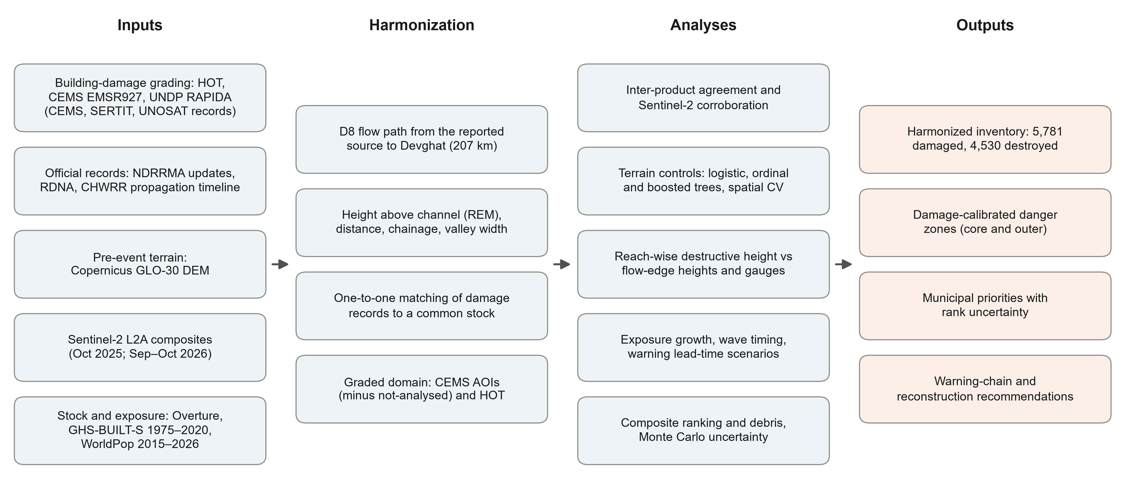
Supplementary Fig. 1 | Workflow. Inputs, harmonization steps, analyses and outputs. All steps are scripted and rebuilt from the archived inputs by a single command.
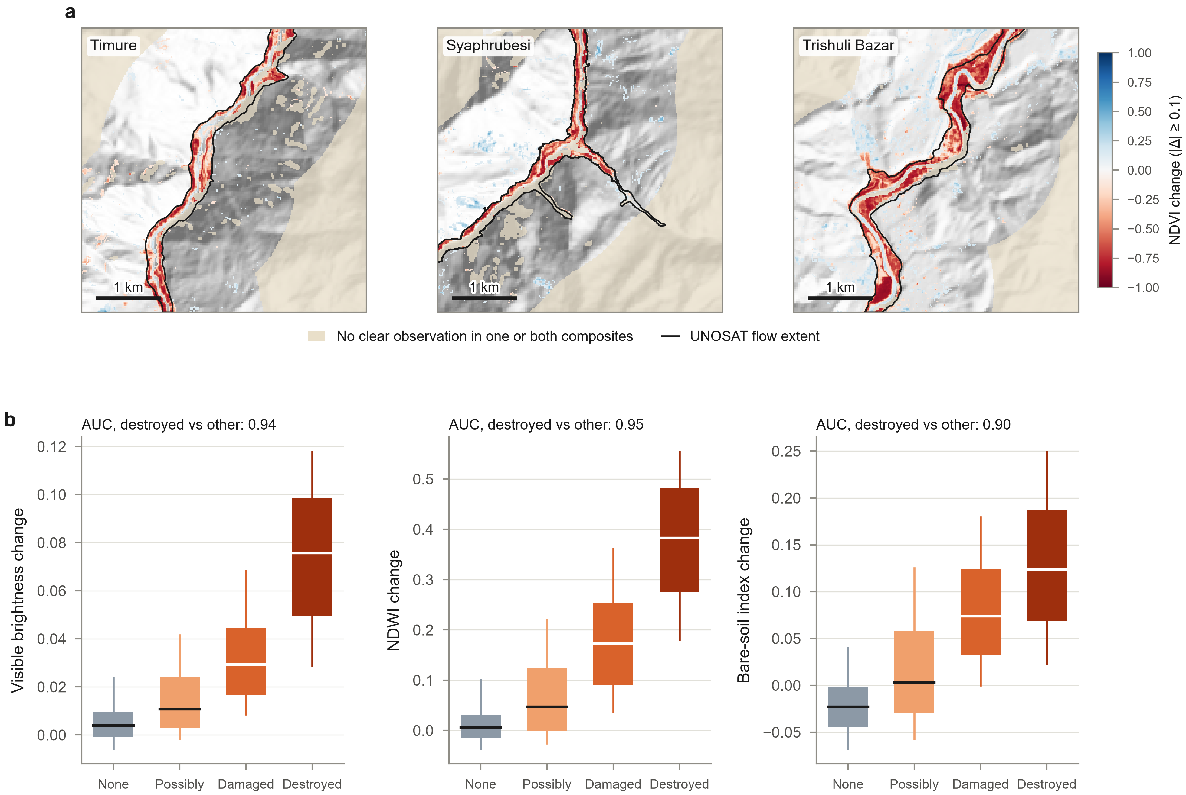
Supplementary Fig. 2 | Sentinel-2 change at building locations. a, Change in NDVI between clear-sky median composites of October 2025 and 21 September–18 October 2026 around Timure, Syaphrubesi and Trishuli Bazar; changes smaller than 0.1 in magnitude are transparent, areas without a clear observation in either composite are tinted, and the black line is the UNOSAT flow extent. b, Change in visible brightness, NDWI and the bare-soil index at building locations by harmonized damage grade (boxes, interquartile range; whiskers, 10th–90th percentiles; line, median), with the AUC for separating destroyed from other buildings. Contains modified Copernicus Sentinel data (2025, 2026).
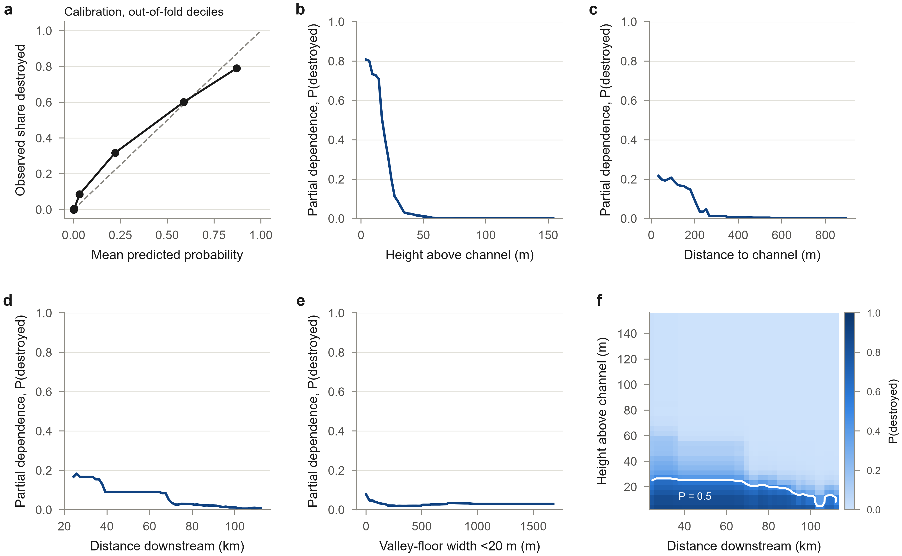
Supplementary Fig. 3 | Diagnostics of the regional gradient-boosted model. a, Calibration of out-of-fold predicted probabilities (deciles) under six-fold cross-validation grouped by 5-km reaches; dashed line, perfect calibration. b–e, Partial dependence of the probability of destruction on height above the channel, distance to the channel, distance downstream and valley-floor width. f, Two-way partial dependence on height above the channel and distance downstream, with the 50% contour. Partial dependence was computed on the log-odds scale and is shown after logistic transformation; it averages over the observed values of the other attributes (Supplementary Note 3).
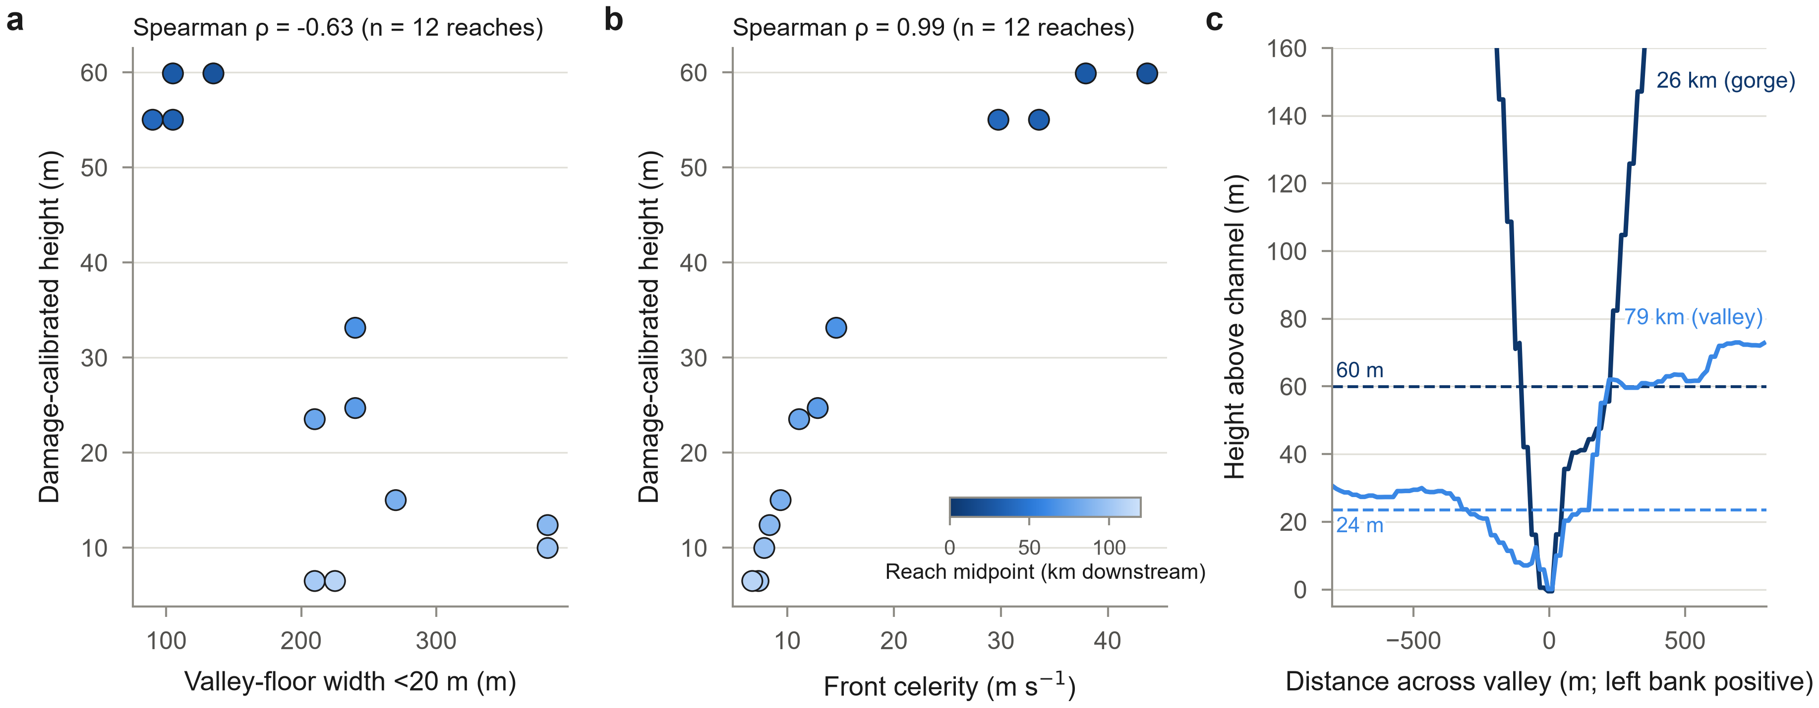
Supplementary Fig. 4 | The damage-calibrated height in relation to valley form and wave speed. a, Core damage-calibrated height of each graded reach against the median width of valley floor less than 20 m above the channel. b, The same height against the mean celerity of the wave front interpolated to the reach midpoint. Colours show distance downstream. c, Cross-sections of height above the channel perpendicular to the flow path in the gorge (26 km) and the valley (79 km), with the damage-calibrated heights of the two reaches (dashed lines).
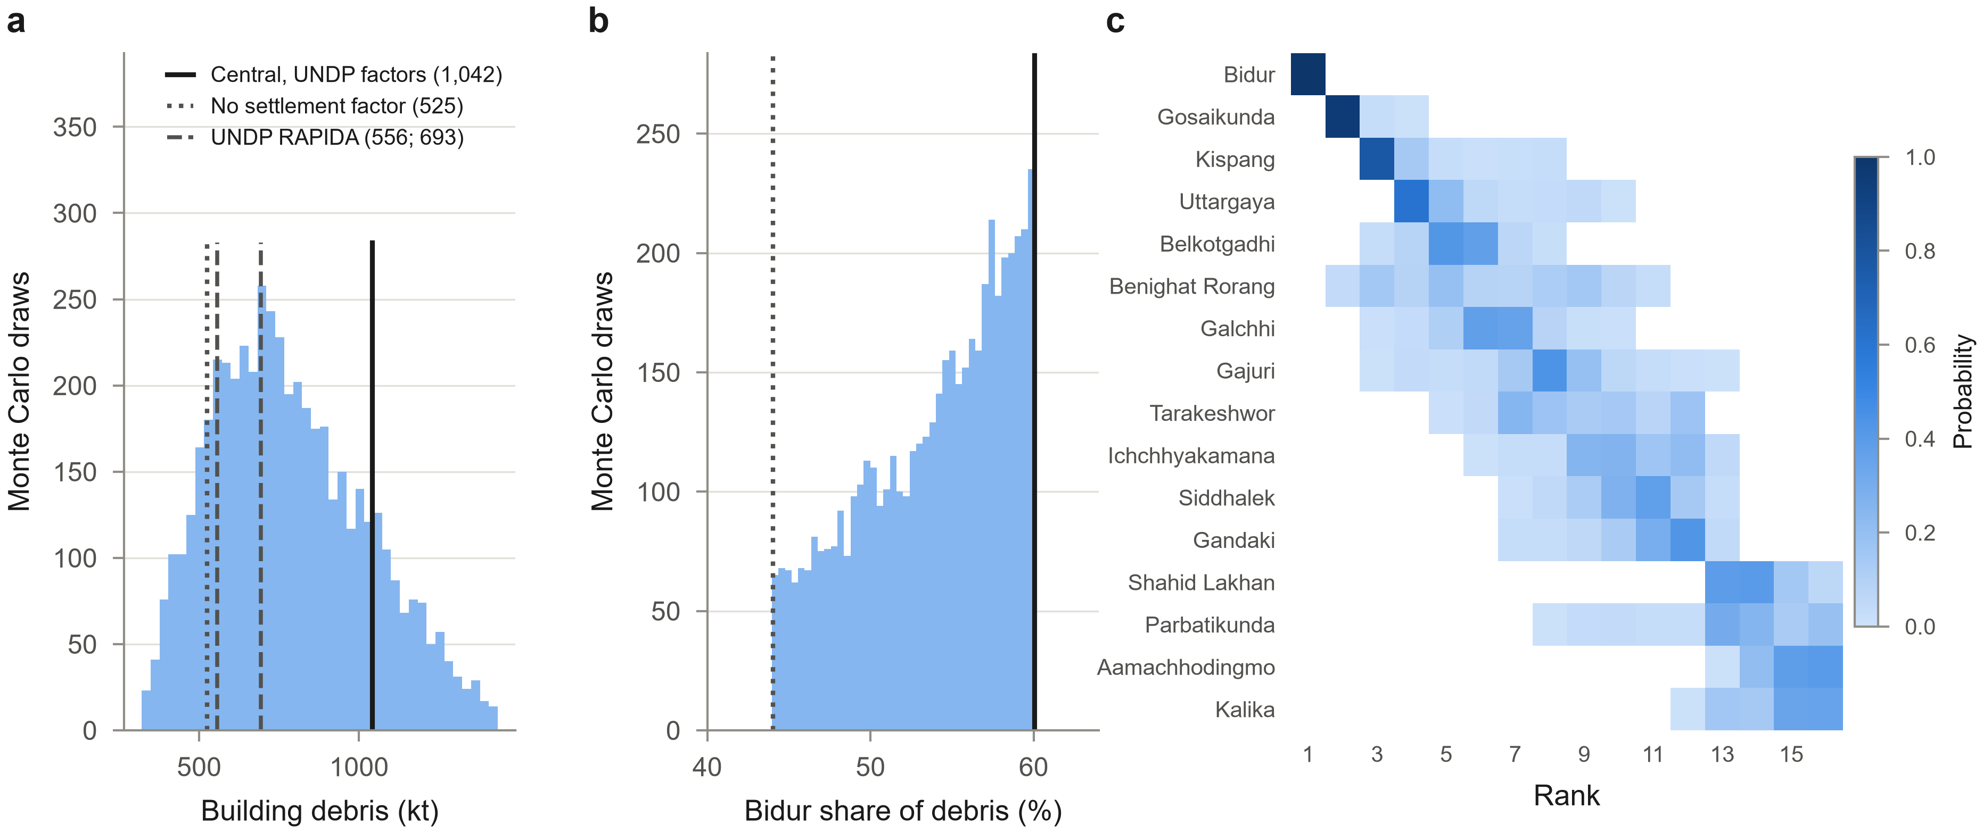
Supplementary Fig. 5 | Uncertainty in debris and priorities. a, Building debris in 5,000 Monte Carlo draws with grade coefficients scaled between 0.6 and 1.4 and the urban settlement factor between 1 and 3, compared with the central estimate using UNDP's factors (solid), the estimate without settlement factors (dotted) and the UNDP RAPIDA totals for the CEMS/SERTIT records and for all records (dashed). b, Share of debris in Bidur in the same draws; lines as in a. c, Probability of each rank of the composite priority index across 20,000 draws of weights, normalization and aggregation; local levels are ordered by median rank and probabilities below 0.5% are blank.
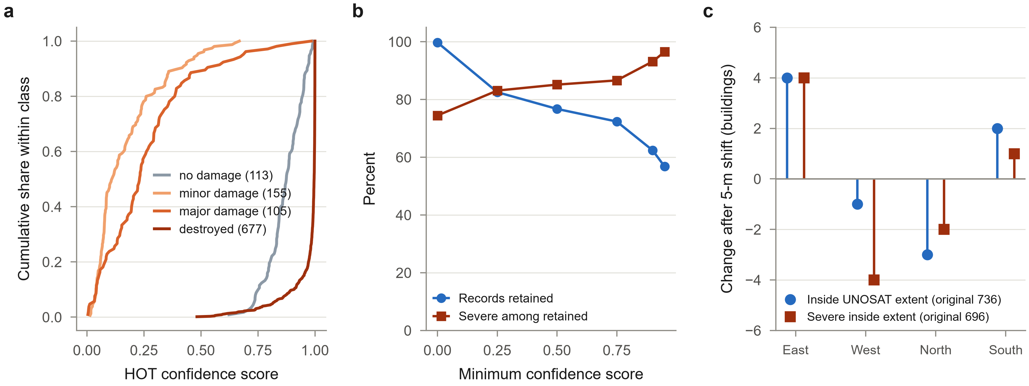
Supplementary Fig. 6 | Checks on the HOT inventory. a, Cumulative distributions of HOT confidence scores by damage class (number of buildings in brackets). b, Share of records retained and share of severe damage (major or destroyed) among retained records as the minimum confidence score increases. c, Change in the number of HOT buildings inside the UNOSAT flow extent, and of severely damaged buildings inside it, when all footprints are translated by 5 m in each direction.

Supplementary References
1. Humanitarian OpenStreetMap Team (HOT). Nepal flood building damage inventory and analysed-area polygon (fAIR-assisted labels on OpenStreetMap footprints). HOT raw-data API (retrieved 9 September 2026) (2026). https://production-raw-data-api.s3.amazonaws.com/ISO3/NPL/buildings/hot_flood_npl_buildings_damage_overview.html
2. Copernicus Emergency Management Service (European Commission JRC). EMSR927: Flood in Nepal - flood and mass movement damage grading, Syapru Besi and Timure, Rasuwa District (27 August 2026). Copernicus EMS Rapid Mapping (dataset; re-published with DOI via UNESCO IHP-WINS) (2026). https://doi.org/10.63253/bkdj361r
3. United Nations Development Programme (UNDP). RAPIDA assessment of the floods in Nepal (StoryMap and feature services for building debris, economic estimate, exposure and affected population). UNDP GeoSMART (retrieved 9 September 2026) (2026). https://geosmart.undp.org/arcgis/apps/storymaps/stories/7450cd01c584424f8a10ccfc166b167a
4. UNOSAT (UNITAR). Satellite-detected mudflow and rockflow extent in Rasuwa and Nuwakot Districts, Bagmati Province, Nepal (26-27 August 2026). UNOSAT products 4257/4258 (dataset; re-published with DOI via UNESCO IHP-WINS) (2026). https://doi.org/10.63253/1y26ihdq
5. Centre of Hydrology and Water Resources Research (CHWRR), Water and Energy Commission Secretariat. Assessment Report II: Rasuwa–Bhote Koshi Flood Event, 2026 (2083). Government of Nepal, Kathmandu (13 September 2026) (2026). https://giwmscdnone.gov.np/media/pdf_upload/1_Situation_Report_Bhotekoshi%20Flood_2026_CHWRR_hnmns6o.pdf
6. National Disaster Risk Reduction and Management Authority (NDRRMA). Bhotekoshi–Trishuli Flood: Search, Rescue and Relief Update (26 August–3 October 2026). NDRRMA, Government of Nepal, Kathmandu (2026). https://ndrrma.gov.np/mediafiles/publications/Bhotekoshi-Trishuli_Flood_Update_From_August_26_2026_to_October_3_2026.pdf
7. Government of Nepal, National Disaster Risk Reduction and Management Authority & National Planning Commission. Rapid Damage and Needs Assessment (RDNA): Rasuwa–Bhotekoshi Flood 2026. NDRRMA, Kathmandu (2026). https://ndrrma.gov.np/mediafiles/rasuwa/Rapid_Damage_and_Needs_Assessment_RDNA_Rasuwa-Bhotekoshi_Flood_2026.pdf
8. European Space Agency & Airbus. Copernicus DEM. ESA (dataset) (2022). https://doi.org/10.5270/ESA-c5d3d65
9. Drusch, M. et al. Sentinel-2: ESA's Optical High-Resolution Mission for GMES Operational Services. Remote Sensing of Environment 120, 25–36 (2012). https://doi.org/10.1016/j.rse.2011.11.026
10. Element 84. Earth Search STAC API: Sentinel-2 Level-2A cloud-optimised GeoTIFFs (collection sentinel-2-l2a). Amazon Web Services Open Data Registry (accessed 19–20 October 2026) (2026). https://earth-search.aws.element84.com/v1
11. Overture Maps Foundation. Overture Maps buildings theme (open map data release). Overture Maps Foundation (dataset) (2026). https://overturemaps.org/
12. Pesaresi, M. GHS-BUILT-S R2023A - GHS built-up surface grid, derived from Sentinel2 composite and Landsat, multitemporal (1975-2030). European Commission, Joint Research Centre (dataset) (2023). https://doi.org/10.2905/9F06F36F-4B11-47EC-ABB0-4F8B7B1D72EA
13. WorldPop. Global2 constrained population counts, 2015–2030, 100 m (release R2025A): Nepal. WorldPop, University of Southampton (dataset) (2025). https://data.worldpop.org/GIS/Population/Global_2015_2030/R2025A/
14. Runfola, D. et al. geoBoundaries: a global database of political administrative boundaries. PLOS ONE 15, e0231866 (2020). https://doi.org/10.1371/journal.pone.0231866
15. Otsu, N. A threshold selection method from gray-level histograms. IEEE Transactions on Systems, Man, and Cybernetics 9, 62–66 (1979). https://doi.org/10.1109/TSMC.1979.4310076
16. Roy, P. et al. 26 August 2026 rock–ice avalanche in Nepal: rapid assessment of the cascading disaster using satellite data. Journal of the Indian Society of Remote Sensing (2026). https://doi.org/10.1007/s12524-026-02611-x
17. Slaughter, S. et al. 2026 Nepal Debris Avalanche and Flash Flood. U.S. Geological Survey, Landslide Hazards Program (web page, 27-28 Aug 2026) (2026). https://www.usgs.gov/programs/landslide-hazards/science/2026-nepal-debris-avalanche-and-flash-flood
18. Zanaga, D. et al. ESA WorldCover 10 m 2021 v200. Zenodo (dataset) (2022). https://doi.org/10.5281/zenodo.7254221
19. World Bank & Global Facility for Disaster Reduction and Recovery (GFDRR). Global Rapid Post-Disaster Damage Estimation (GRADE) Report: Rasuwa Flash Flood, Nepal. World Bank Report No. 215321 (Washington, DC) (2026). http://documents.worldbank.org/curated/en/099217209292624461

