"University Alumni Website"

Project Report

Submitted in partial fulfillment of the requirements for the degree of

Masters of Engineering

by

Declaration

We declare that this written submission represents our ideas in our own words and where oth-ers ideas or words have been included, We have adequately cited and referenced the original sources. We also declare that we have adhered to all principles of academic honesty and in-tegrity and have not misrepresented or fabricated or falsified any idea/data/fact/source in our submission. We understand that any violation of the above will be cause for disciplinary action by the Institute and can also evoke penal action from the sources which have thus not been properly cited or from whom proper permission has not been taken when needed.

Abstract

Tittle: University Alumni Website

Alumni portals is providing common platform for every institute. Owing to the need to have all the Alumni (already passed out students) must be connected to the Institute,resulted in shar-ing their experiences , views , ideas, guidance , motivations and strategies. The objective of Alumni portal application is to allow old and new students of the college to communicate with each other. This allows students to know about each other and their current activities. This portal highlights the feature of communication, which will enable the current students to have interaction with the alumni of the college for getting various updates on current indusrty trends, Internship opportunity, sponsored projects and various referral opening in the corporate world. This portal will serve the cause of integrating all the stakeholders of Institute such as

- Alumni, College students , Faculties to avail the guidance and knowledge sharing on various domains. In this project we proposed the Dynamic Architectural design of the Alumni portal, which enable the two way communication between all stakeholders.

Chapter 1

Project Overview

1.1 Introduction

We are formulating the best alumni web portal which will facilitate effective communication platform through online chatting, profile viewing and personal messaging within three stake-holders of the institute viz- College , College students , Alumni.

This portal will be providing direct contact of the alumni with the students as well as the staff members. The desired query of the existing students will be answered faster.This keeps the students updated with the current updates and demands of the industrial market.The students neither posting nor chatting can also silently be updated with the ongoings in the college as well as the market.

This portal highlights the feature of communication, which will enable the current students to have interaction with the alumni of the college for getting various updates on current indusrty trends, Internship opportunity, sponsored projects and various referral opening in the corporate world [3]. This portal will serve the cause of integrating all the stakeholders of Institute such as

- Alumni, College students , Faculties to avail the guidance and knowledge sharing on various domains. In this project we proposed the Dynamic Architectural design of the Alumni portal, which enable the two way communication between all stakeholders.

1.1.1 Motivation

Although our college website is quite attractive but it lacks with the feature of com-munication with the alumnus.

This creates a problem for the current students in terms of guidance , internships , industrial knowledge.

It also lacks the instant solution to the problem which are related to education and

1

1.2. Proposed System Architecture

career.

It does not provide any idea about the news and current ststus of jobs in different companies and industry.

1.2 Proposed System Architecture

This proposed system architecture consits of three layers in which user interface acts as a mid-dleware.The user can interact with the sysytem with the help of user interface.
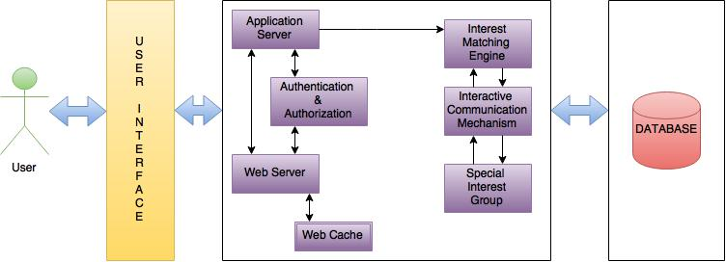

Figure 1.1: System Architecture

The explanation of the above architecture is as follows:

User first interacts with the system through the web address of alumni portal (alumni.aiktc.org)

Dynamic Architecture: It consists of Application server which is used to facilitate the appli-cation management in term of interest matching area,Interactive communication mechanism and Special interest group that is connected to the web application and indirectly to the web cache.After login of the students their user name and password are authenticated by the authen-tication module.The authentication module first verify from the web application and then give the access to the user.

Interest matching Area: Based upon the question rise from both the side (Students/Expertise/Alumni Students)about their interest area it shows list of expertise in particular area and user will able to know as per the requirement.

Database:Database is used for storing the details fetched from the different modules of the websites by the Phpmyadmin.

2

Chapter 1. Project Overview

1.2.1 Formulation of Problem With using Technology

Now a days the education became one of the desired need of the pepole,bt unfurtunatly what if the student is sincere bt unaware about the current market status and the market requirement.

This is the major problem with the students that they are unable to get more and more infor-mation about the sorrunding "Whats going on..?" The Problem occured with the students at the time of career guidance,Project title selection,Internships,Domain related queries,any query related to the syllabus or something which is very new concept for them ect.

Because of the lack of knowledge the student decides with their own ways may wrong or right.if luckily they got the desired goal then no issue bt imagin what if they have selected something very wrong.After the wrong choice the thing which has been done is only the wastege of time. Always remmber "Your golden advice can save others precious times."

The proposed architecture, by making use of Phpcode, offers a solution to those problems.. Problem can be solve by reducing the distance between the students with their alumni and the faculties so that they can get the correct guidance or the advice and can utilise their time in best way.

The implmented Alumni Portal will provide the features like chat,post,department wise chat and be able to connect with all the alumni students and the faculties also.

1.3 Organization of the Project

The remaining part of the project is organized as follows.

Chapter 2 presents a review of related work.

Chapter 3 introduces the Software and Hardware Requirement of the project.

Chapter 4 proposes the Project Design of the Project . It represent the architectural design, front end design and database design of the project.

Chapter 5 introduces the system model and some basic assumptions and Dependencies of our work.

Chapter 6 presents the Results and Test cases related work.

Chapter 7 Described the time management and time utilization during the Project implementa-tion.

Chapter 8 Described the Workload distribution.

3

1.3. Organization of the Project

Chapter 9 provides some concluding remarks and directions of our future work.

4

Chapter 2

Literature Review

2.1 Harvard Alumni-(www.alumni.harvard.edu)

Front page of this portal shows the features like login tab so that the alumnus can login easily , ways to connect for connecting the junior and the pass out students ,make gift for various occasions like birthdays or anything else [4].

With that Harvard provides Features News for surrounding informations , Lecture details which describes the schedule , events and the Notice are displayed on home page itself with the present event [4].

Also gives the Donor Initiative Chance for the scenario when the alumni student he/she feels that they can help the college in terms of donation so that will be possible with this [4].

With all this we have observe the unique feature that , it provides the clubbed video on the home page and this thing makes the whole portal very much attractive [4].

2.2 IIT Kanpur Alumni-(www.alumni.iitkanpur.edu)

IIT has Gallery with many images , Lectures details with specific day and time , con-tacts which shows whom all are connected with this portal, woman alumni convention as separate for the woman only on the Home page [5].

Features are Gallery present on the home page , visit for guide allocations is given so that the junior student can get the solution or the advice for their difficulties [5].

Notice with highlighted form is shown for better visualization . also gives the Donor

5

2.3. Alumni Princeton University-(www.alumni.princeton.edu)

Initiative Chance [5].

IIT Kanpur shows information events about present on every page where the current events are highlighted also there is a separate women alumni convention and that is the unique feature [5].

2.3 Alumni Princeton University-(www.alumni.princeton.edu)

This portal has different things in their front page like Calendar for the current and the in coming occasions and in order to get about their own informations there is a tab i.e. âœAbout usâ [6].

This portal is provides the features that is same as the IIT KANPUR like Gallery present on the home page , visit for guide allocations is given so that the junior student can get the solution or the advice for their difficulties [6].

But the different thing is that this portal provides the scholar ship in terms of donor ini-tiative for the collage requirement purpose [6].

Providing the unique feature like the alumnus are categorized on the basis of regions communities of networks so that the students who belongs to the same area will get listed together [6].

2.4 ITMB Alumni Association -(www.alumni.itmb.edu)

In the home page this portal shows the search tab for searching the alumni student whether he/she is connected in the portal or not [7].

provides the similar features like all portals HARVARD ALUMNI PORTAL , IIT KAN-PUR, Alumni Princeton University [7].

The notice are present in the higlighted form not only for the better visualization but also for making the portal active [7].

Also provided Donor initaitive for college [7].

And the unique feature which makes ITMB Alumni Association more unique is the search tab wich is shown on every page [7].

6

Chapter 2. Literature Review

2.5 UCLA Alumni -(www.alumni.ucla.edu)

The UCLA Alumni Portal’s home page layout is very much atractive , shows the similar features like all the portal wich we have disscused yet [8].

But unfortunatly there is no notice section because of that the portal not shows any sour-roundig informations [8].

And also the donor initiative is present in the form of scholarship but the basic concept is same [8].

Here the alumnus are connected by the social networks which reduce the distance between the pass out and the junior students and that makes the portal unique as compare to the other portals [8].

2.6 Commonly Identified Weaknesses

Majority of the alumni portals do not provide the feature of direct communication of the students with the alumnus although the institute remains in direct contact with the alumni.

And also the conservation is hidden or not displayed from the other student who all are connected with that particular portal.

No chat rooms specific to topic/ interest / domain. No direct registration.

2.7 How to Overcome the Weaknesses

Proposed method to overcome on shortfalls includes following features:

Provided Special intrest group(sig) chat rooms. Personal in private chatting.
Access of contact details on request. Auto registration of all students.

7

2.8. Technological Review

Passed out students are promoted as alumni automatically upon complition of their course.

2.8 Technological Review

2.8.1 PHP

For implementing the project, we are making use of php language as the main language. PHP is a server-side scripting language designed for web development but also used as a general-purpose programming language.PHP code can be embedded into HTML code, or it can be used in combination with various web template systems, web content management system and web frameworks.

2.8.2 Javascript

JavaScript is a high-level, dynamic, untyped, and interpreted programming language.It has been standardized in the ECMAScript language specification.Alongside HTML and CSS, it is one of the three essential technologies of World Wide Web content production; the majority of websites employ it and it is supported by all modern Web browsers without plug-ins.

JavaScript is also used in environments that are not Web-based, such as PDF documents, site-specific browsers, and desktop widgets. Newer and faster JavaScript virtual machines (VMs) and platforms built upon them have also increased the popularity of JavaScript for server-side Web applications.

2.8.3 HTML/CSS

HyperText Markup Language, commonly referred to as HTML, is the standard markup lan-guage used to create web pages. Along with CSS, and JavaScript, HTML is a cornerstone technology used to create web pages, as well as to create user interfaces for mobile and web applications. Web browsers can read HTML files and render them into visible or audible web pages. HTML describes the structure of a website semantically and, before the advent of Cas-cading Style Sheets (CSS), included cues for the presentation or appearance of the document (web page), making it a markup language, rather than a programming language.

8

Chapter 2. Literature Review

2.8.4 Mysql

MySQL is an open-source relational database management system (RDBMS) and the most widely used open-source clientâ“server model RDBMS.MySQL is a popular choice of database for use in web applications, and is a central component of the widely used LAMP open-source web application software stack (and other "AMP" stacks).

2.8.5 AJAX

Ajax is a set of web development techniques using many web technologies on the client-side to create asynchronous Web applications. With Ajax, web applications can send data to and retrieve from a server asynchronously (in the background) without interfering with the display and behavior of the existing page. Ajax is not a technology, but a group of technologies. HTML and CSS can be used in combination to mark up and style information. The DOM is accessed with JavaScript to dynamically display â“ and allow the user to interact with â“ the information presented. JavaScript and the XMLHttpRequest object provide a method for exchanging data asynchronously between browser and server to avoid full page reloads.

9

Chapter 3

Requirement Analysis

3.1 Platform Requirement :

3.1.1 Supportive Operating Systems :

The supported Operating Systems for client include:

Windows xp onwards Linux any flavour.

Windows and Linux are two of the operating systems that will support comparative website. Since Linux is an open source operating system, This system which is will use in this project is developed on the Linux platform but is made compatible with windows too.The comparative website will be tested on both Linux and windows.

The supported Operating Systems for server include: The supported Operating Systems For server include Linux. Linux is used as server operating system. For web server we are using apache 2.0

3.2 Software Requirement :

The Software Requirements in this project include:

Apache

PhpMyAdmin

10

Chapter 3. Requirement Analysis

Internet Explorer, Mozilla FireFox, Google Chrome etc

3.3 Hardware Requirement :

3.3.1 Hardware Required For Project Development:

1 GB Ram.

40 GB Hard Disk Minimum. Intel Core

11

Chapter 4

Project Design

4.1 Design Approach

Design is the first step in the development phase for any techniques and principles for the purpose of defining a device, a process or system in sufficient detail to permit its physical real-ization. Once the software requirements have been analyzed and specified the software design involves three technical activities design, coding, implementation and testing that are required to build and verify the software. The design activities are of main importance in this phase, be-cause in this activity, decisions ultimately affecting the success of the software implementation and its ease of maintenance are made. These decisions have the final bearing upon reliability and maintainability of the system. Design is the only way to accurately translate the customer requirements into finished software or a system. Design is the place where quality is fostered in development. Software design is a process through which requirements are translated into a representation of software. Software design is conducted in two steps. Preliminary design is concerned with the transformation of requirements into data.

4.2 Software Architectural Designs

Our system is follow the three tier architecture .

First tier: The GUI(Graphical User Interface) in our project deals with the interface for the user where the user can fire a query and gets the desired answers from the alumni. The GUI provides a platform for the user to communicate with the database.

Second tier: The middle tier is the block where the actual processing of our project is done. This block connects the GUI to the database i.e. It acts as a connector as well as communicator which connects the database and helps in transfer of data between the GUI and the database. It’s main function is to take the input in terms of queries or viiews of the user and give it to the database.

12

Chapter 4. Project Design

Third tier: Database tier is the tier used for the storage of data.This tier contains all the data that is needed for the processing of the whole project.The data about the alumni including their name , adress, designation and other related information is stored.The querying process gets completed by obtaining the data from the data collection -database.Other Dynamic features are fetched from the database.
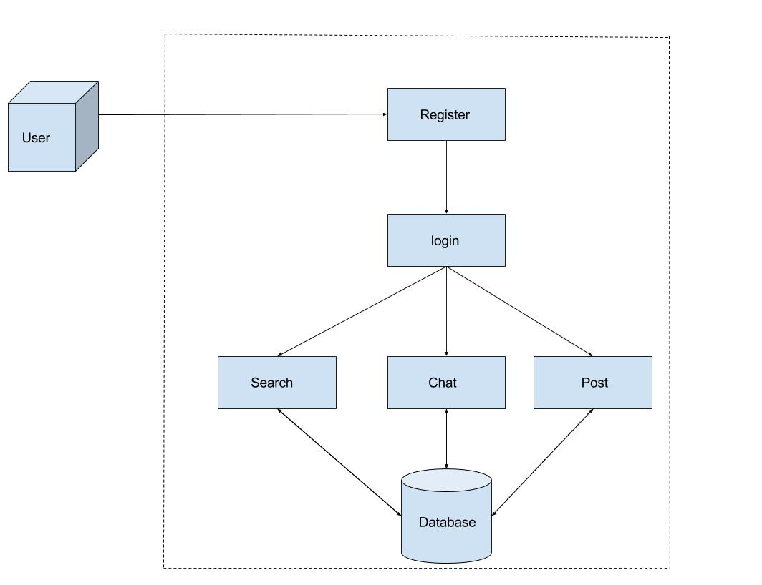

Figure 4.1: Software Architecture Design

13

4.2. Software Architectural Designs

4.2.1 Front End Designs

HyperText Markup Language, commonly referred to as HTML, is the standard markup lan-guage used to create web pages. Along with CSS, and JavaScript, HTML is a cornerstone technology used to create web pages, as well as to create user interfaces for mobile and web applications. Web browsers can read HTML files and render them into visible or audible web pages. HTML describes the structure of a website semantically and, before the advent of Cas-cading Style Sheets (CSS), included cues for the presentation or appearance of the document (web page), making it a markup language, rather than a programming language.

Figure 4.2: Front End Design

4.2.2 Component Diagram
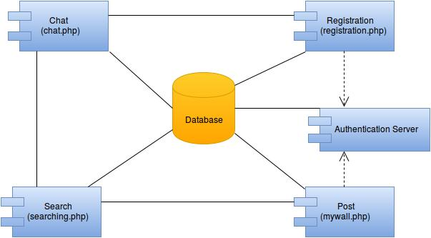

Figure 4.3: Component Diagram of College Alumni Portal

14

Chapter 4. Project Design

4.2.3 Deployment Diagram
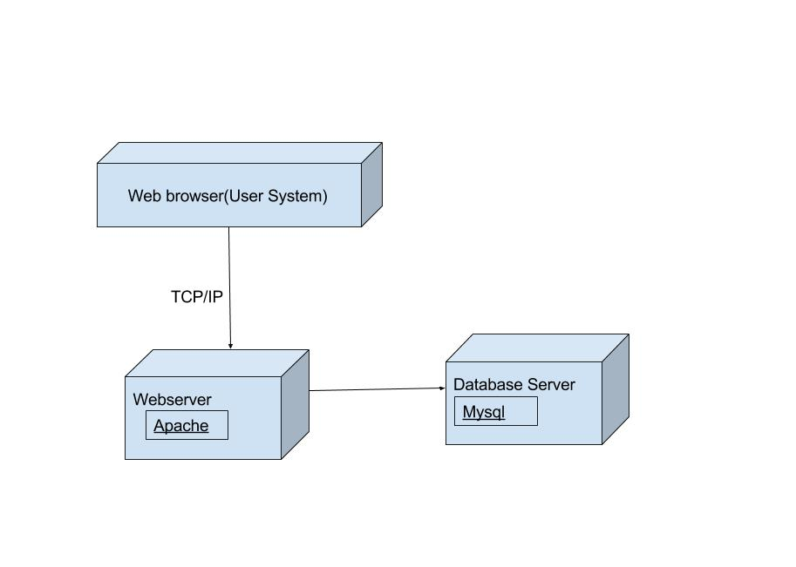

Figure 4.4: Deployment Diagram of College Alumni Portal

15

4.3. Database Design

4.3 Database Design

4.3.1 E-R Diagram

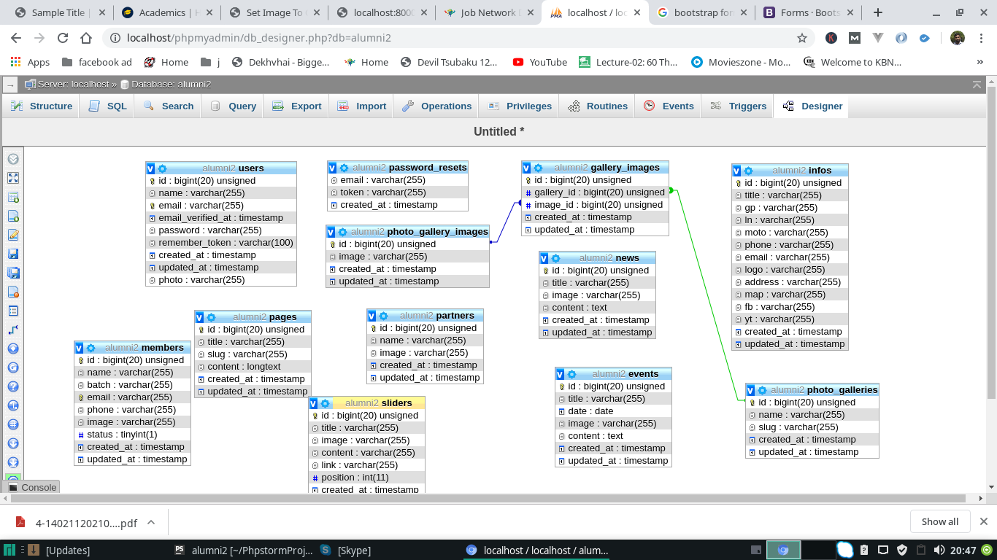

Figure 4.5: E-R Diagram of College Alumni Portal

16

Chapter 4. Project Design

4.4 Work-flow Design

4.4.1 Data Flow Diagram
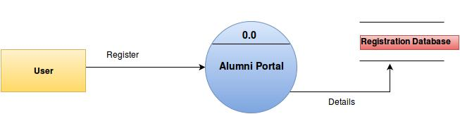

Figure 4.6: Level 0 DFD of College Alumni Portal
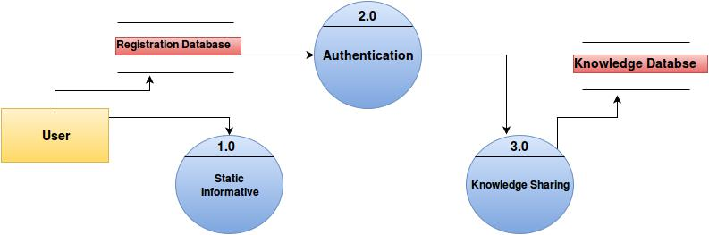

Figure 4.7: Level 1 DFD of College Alumni Portal
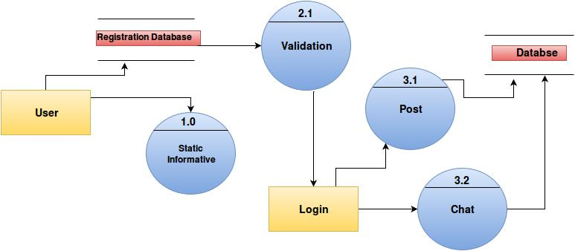

Figure 4.8: Level 2 DFD of College Alumni Portal

17

Chapter 5

Implementation Details

5.1 Assumptions And Dependencies

5.1.1 Assumptions

The assumption is made that alumni and the students can coomunicate with each other via this portal.Alumni or the pass out candidates working in certain reputed IT industries can post any vacancies regarding any job or any kind of interships opportunities.They can also post their experinces and views about companies and projects.They can also share their expereinces as a fresher and later for reaching the current designation.They can share the ongoing and upcoming demands of the market.

The existing students as well the alumni can communicate with each other via chat system. The queries from either side can be fired and the person having a knowlegde (a bit or more) can reply to the person.This way all the members on the portal will be benifited.The portal also helps Alumni to view the upcoming events in the college.

18

Chapter 5. Implementation Details

5.2 Implementation Methodologies

1. Interactive communication:

This portal will be providing different chatrooms for different departments such as Me-chanical Dept ,Computer Department ,EXTC Department etc. and also provides different discussion rooms for certain purposes such as disccusion room for different languages such as java,C,C++,C etc.
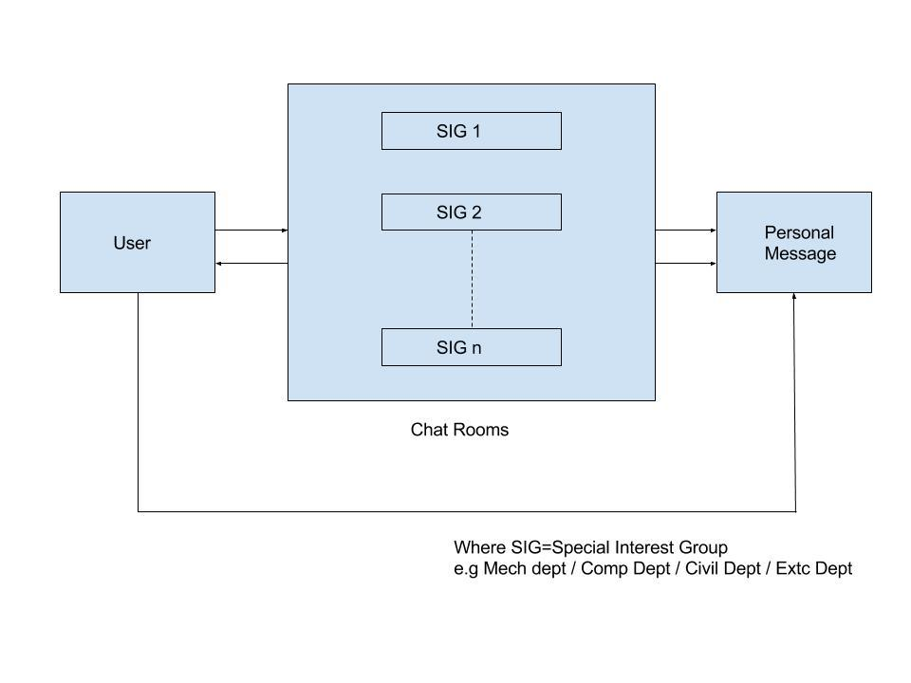

Figure 5.2: Interactive Communication

19

5.3. Detailed Analysis and Description of Project

- Auto promotion:

Auto promotion of an existing students into a new role i.e. of an alumni. For e.g. Student admitted in 2012 will become alumni in June 2016.

Pseudocode for auto promotion (of regular student)

if student course is equal to 4 years and month june then

convert the status of user from student to alumni else

keep the user in current state

Pseudocode for handling the conversion (of the failure student to an alumni)

if user has drop year

then

send e-mail to verify the status user selects YES then keep the user in current state

else

convert the status of current user to an alumni.

5.3 Detailed Analysis and Description of Project

Registration Module: In this module, the user can register onto the portal.The gui is made attractive with the help of css. Javascript is used for validating the input feilds that will be feeded by the user.

Chat Module: The chat module is made with the help of Php. The users can chat with each other for their benifit.The users can see the registered members online and accordingly chat with them.

Post module: The post module allows the users to post to what’s on their mind.Sharing and exchanging of veiws and ideas will be done here.Enquiries and doubts on jobs ,internships can be well clarified.The post can be posted department wise or may be posted to all the departments as per the requirement or the wish of the user.The posts can be liked by the users and if someone has a answer for the query or some views regarding the ongoing topic it may be done with the hepl of reply.

User Search: Whenever user searches for the alumnis in the search bar, the database is queried in order to retrieve the accurate results.

20

Chapter 5. Implementation Details

5.3.1 Usecase
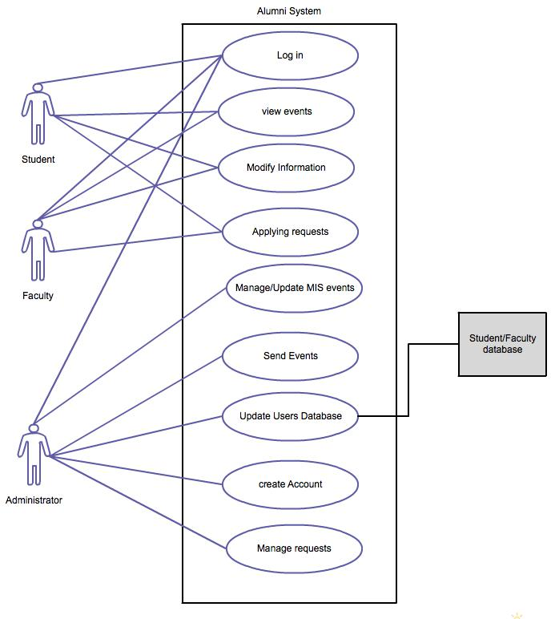

Figure 5.3: Usecase Diagram

21

 | 5.4. Class Diagram
Title: | College Alumni Portal
Description: | College Alumni Portal provides a way for alumni student to
 | communicate with the existing student and get the advice or
 | suggetions.
Primary | Student
Actor:
Preconditions: | Student visit the Website
Post condi- | Student register their self.
tions:
Main | 1. login with the username and password.
Success | 1. login with the username and password.
Scenario: | 2. chat with the registered students.
 | 3. Search already registered students.
 | 4. post any message to specific deparment or all.
Frequency | User can use any number of time
of Use:
System Re- | Normal No Specific Requirement
quirement:
Trigger: | A phpmyadmin, Which Fetches the information from dif-
 | ferent webpages Periodically & stores that information in
 | the database
 | Table 5.1: Usecase Report

Chapter 6

Results and Discussion

6.1 Test cases and Result

We have tested our web application by considering following test cases:

6.1.1 Unit Testing

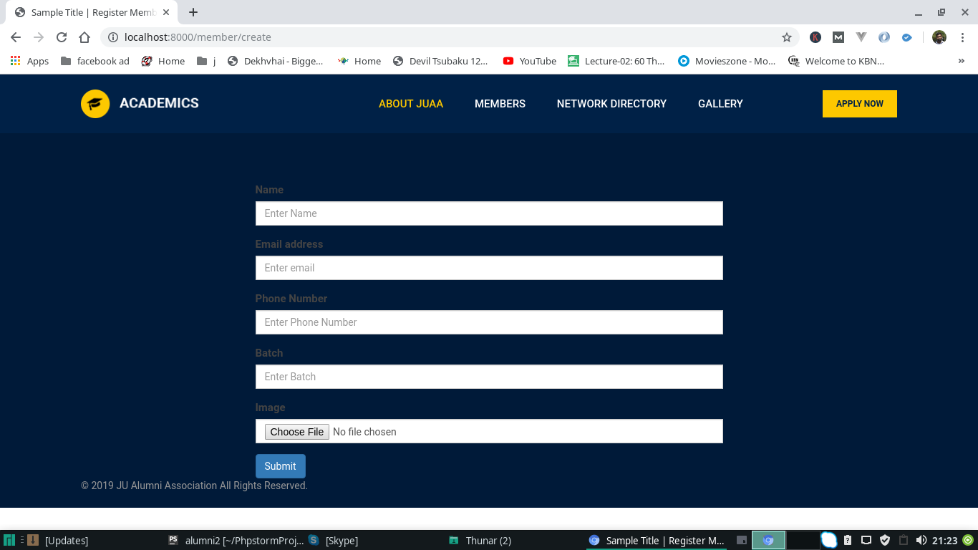
In Registration module users will have to register and will get their username and password in order to be active on the portal.The value of the feilds provided in the registration form are getting stored in the database. In Chat module the users can able to see users who are online and hence can chat with them.

Figure 6.1: Registration
Chapter 6. Results and Discussion

6.1.2 Functional Testing

We have tested our web application on the server by integrating all the units of our project. In this testing we focus on the output is as per requirement or not.

In post system the user can post on the portal.The message will be displayed to the user accord-ing to his choice.If the user wants to post the message groupwise or department wise the user can do that by selecting the type of post he wants to.

Under chat module the registered user can chat with others sucessfully.The messages are getting delievered to the one who has been targeted for the delivery.The user will also be able to view the last seen of the other members

Chapter 7

Task Distribution

8.1 Distribution of Workload

8.1.1 Scheduled Working Activities

Activity | Time | Comment
 | Period
Requirement Gathering | 07 Days | Requirement gathering has took
 |  | placed through searching on in-
 |  | ternet and taking the ideas, shar-
 |  | ing the views among group
 |  | members.
Planning | 40 Days | Planing has done by Reviewing
 |  | of literature of IEEE papers and
 |  | by taking the walkthrough.
Design | 45 Days | Designing has done by creat-
 |  | ing UML diagram, By creating
 |  | Charts,
Implementation | 95 Days | Implementation has done First
 |  | creating the backend and then
 |  | front end module by module.
Testing | 10 Days | Testing has done by perfoming
 |  | unit testing, alpha & Beta Test-
 |  | ing, integrated testing and sys-
 |  | tem testing.
Deployment | 05 Days | Deployment has done by in-
 |  | stalling project on the server.

Table 8.1: Scheduled Working Activities

Chapter 8

Conclusion and Future Scope

9.1 Conclusion

Alumni Portal for any college website is very important.It has been setup to increase interaction, knowledge sharing and networking among the alumni students and also focuses on bringing together alumni students of college And the primary goal of this report is to connect the alumni students with the college and existing college students with the help of alumni web portal where they can have communication with existing students and college.

9.2 Future Scope

In order to ease the work , an Android app can also be built. To add certain social networking features such as of LinkedIn. To involve companies to avail the services of this platform.

Bibliography

- Campus Portals: Supportive Mechanisms for University Communication, Collaboration, and Organizational Change David L. Eisler, Provost Weber State University

- Security Mechanism in Alumni Portal Department of Information Technology, Xavier In-stitute of Engineering, Mahim (W), Mumbai, India Vikrant Pawar , Sagar Date, Suraj Iyer , Chhaya Narvekar

- Cecilia A. Mercado and Gerry Paul C. GenoveTowards Overcoming Limitations of Com-munity Web Portals: a Classmates Example DERI (Digital Enterprise Research Institute), Uni-versity of Innsbruck, Austria, and National University of Ireland at Galway, Ireland Anna V. Zhdanova

- "Harvard Alumni" [online]. Available: http://www.alumni.harvard.edu

- "IIT Kanpur Alumni" [online]. Available: http://www.iitkalumni.org

- "Alumni Princeton University" [online]. Available: http://www.alumni.princeton.edu

- "ITMB Alumni Association" [online]. Available: http://www.alumni.itmb.edu

- "UCLA Alumni" [Online]. Available: http://www.alumni.ucla.edu

Chapter 9

Appendix I

10.1 What is PHP?

PHP is a server-side scripting language designed for web development but also used as a general-purpose programming language. Originally created by Rasmus Lerdorf in 1994,the PHP reference implementation is now produced by The PHP Group.PHP originally stood for Personal Home Page,but it now stands for the recursive backronym PHP: Hypertext Prepro-cessor.In terms of keywords and language syntax, PHP is similar to the C style syntax. if conditions, for and while loops, and function returns are similar in syntax to languages such as C, C++, C, Java and Perl.

10.2 What is Javascript?

JavaScript is a high-level, dynamic, untyped, and interpreted programming language.It has been standardized in the ECMAScript language specification.Alongside HTML and CSS, it is one of the three essential technologies of World Wide Web content production; the majority of websites employ it and it is supported by all modern Web browsers without plug-ins. JavaScript is prototype-based with first-class functions, making it a multi-paradigm language, supporting object-oriented,imperative, and functional programming styles.

On the client side, JavaScript has been traditionally implemented as an interpreted language, but more recent browsers perform just-in-time compilation. It is also used in game development, the creation of desktop and mobile applications, and server-side network programming with runtime environments such as Node.js.
Chapter 10. Appendix I

10.3 What is Ajax?

Ajax is a set of web development techniques using many web technologies on the client-side to create asynchronous Web applications. With Ajax, web applications can send data to and retrieve from a server asynchronously (in the background) without interfering with the display and behavior of the existing page. Ajax is not a technology, but a group of technologies. HTML and CSS can be used in combination to mark up and style information. The DOM is accessed with JavaScript to dynamically display â“ and allow the user to interact with â“ the information presented. JavaScript and the XMLHttpRequest object provide a method for exchanging data asynchronously between browser and server to avoid full page reloads.

ACKNOWLEDGMENT

