**1. Introduction**

**1.1 Purpose**

This SRS describes the software functional and nonfunctional requirements for SERIESIFY 1.0.

SERIESIFY allows users to save their favorite TV Series into a watch list. SERIESIFY also helps user to get recommendation to watch more TV Series that they might be interested in, with the help of Machine Learning. Users are also able to register with their Google account. It is also available on android with similar features like the web-based application.

**1.2     Intended Audience and Reading Suggestions**

This document is intended for the members of the project team and course instructor.

**1.3 Product Scope**

SERIESIFY is a web-based application that allows the users to add, remove TV series to their watch list. Users can also get recommendations about other TV series that they might be interested to watch. There will also be android application that will allow the users to do similar things like the web application.

**1.4 Risk Definition**

They are mostly an issue if there is any bug in the system, which I will try to minimize.

**2. Overall Description**

**2.1 User Classes and Charactertics**

SERIESIFY is a follow-on member of a product family of TV Series. People love to watch TV Series and they want to list all the TV Series they watched and want to watch. SERIESIFY helps them do that.

**2.2     Product Functions**

* Registration
* Login
* Search Series
* Add TV Series to watch list.
* Remove TV Series from watch list.
* Get TV Series Recommendation

**2.4     Operating Environment**

The software will operate on the following:

* Any OS with a browser.
* Android.

**2.5     Design and Implementation Constraints**

* Users must have active internet connection.
* Users must be registered to use the main functionality of the software.
* Users should have JavaScript enabled on their browser.

**2.7     Assumptions and Dependencies**

**Assumption**: Users have JavaScript enabled on their browser and have active internet.

**Dependency**: SERIESIFY depends on 3rd part APIs to function properly. All the APIs are list on 3.3 Software Interfaces Section.

**3.     Requirements**

**3.1     User Interfaces**

All the User Interface Screen Mockups are included in Expanded Use Case Diagram.

**3.2     Hardware Interfaces**

Not applicable.

**3.3     Software Interfaces**

SERIESIFY needs to use APIs to get all the information about the TV Series. These will be used to get search result and more information about specific series.

APIs that will be used are:

* [OMDB API](http://www.omdbapi.com/)
* [TV Maze API](http://www.tvmaze.com/api)
* [TheMovieDB API](https://www.themoviedb.org/documentation/api)

**3.4     Communications Interfaces**

Active internet connection and JavaScript Enabled in browser is required to use SERIESIFY. REST API will be used to GET, POST data.

**4. System Features**

**4.1 Functional Requirements**

**4.1.1 Registration**

Use Case Name: Registration

Actor: User

Brief Overview: Actor visits the web page and system respond with web page. Actor clicks on registration option to register, Actor enters their email, name and password for registration.

Type: Primary

**Typical Course of Events/Action**

|  |  |
| --- | --- |
| **Actor Actions** | **System Responses** |
| 1)      Actor goes to the web page. | 2)      System responds with the web page. |
| 3)      Actor clicks on the registration option. | 4)      System responds with the registration page. |
| 5)      Actor enters their email, username, and password. | 6)      System stores it to the database site. |
| 7)      Finally actor clicks on registration button to complete the registration. | 8)      System completes the actor process. |

**Alternative Course Of Events/Action**

5.1)Email, Username /Password missing. Re-Prompt with error message “Email, Username and/or Password missing”

5.2) Username and Password already registered. Re-prompt with error message “This Username and/or Password is already registered”

**Screen Mockup of Registration Page**

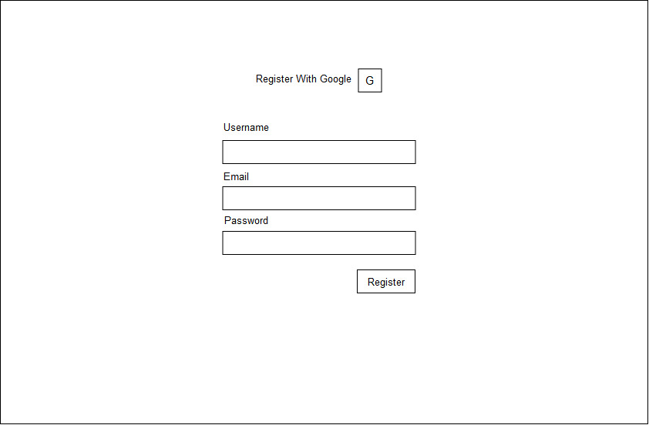

**4.1.2 Login**

Use Case Name: Login

Actor: User

Brief Overview: Actor visits the login page and system responds with the Login page. Actor needs to login to use all the features of the software. Actor enters their username and password to Login.

Type: Primary

**Typical Course of Events/Action**

|  |  |
| --- | --- |
| **Actor Actions** | **System Responses** |
| 1)      Actor goes to the web page. | 2)      System responds with the web page. |
| 3)      Actor clicks on the Login option from the menu. | 4)      System responds with the Login page. |
| 5)      Actor enters username and password in corresponding fields and presses login or the return key. | 6)      System authenticates the user (with the DB ) & redirects to Homepage of the website. |

**Alternative Course Of Events/Action**

6.1) If one had not create an account before then re-prompt with error message “You have to register first”

6.2) If anyone just click on login without entering the name and password re-prompt with error message “You have to enter the name and password”

6.3) If the name or password was incorrect re-prompt with error message “You have entered the wrong name/password”

**Screen Mockup of Login Page**

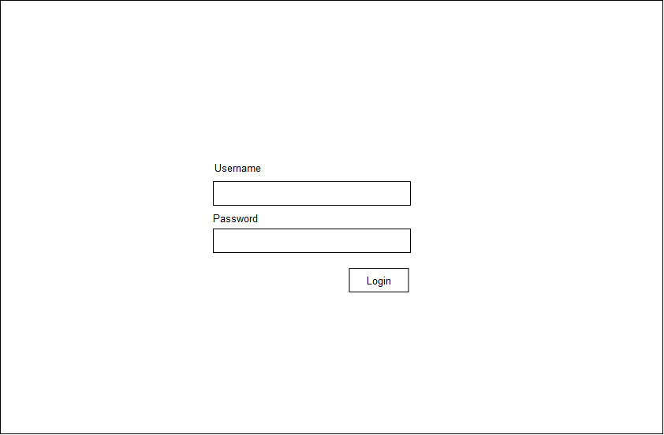

**4.2 Use Case Diagram**

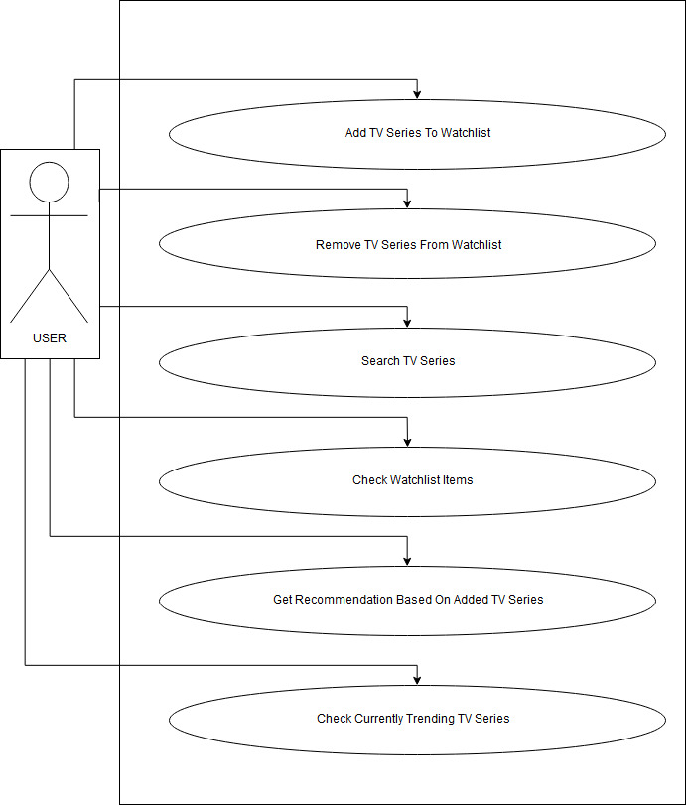

**4.3 Expanded Use Case Diagrams**

**4.3.1 Search TV Series**

Use Case Name: Add TV Series To Watch list

Actor: User

Brief Overview: Actor Searches for their desired TV Series and System responds with the Search Result Page. Actor clicks on Add button to add it to their watch list. System Saves the series in the Actor’s watch list.

Type: Primary

**Typical Course of Events/Action**

|  |  |
| --- | --- |
| **Actor Actions** | **System Responses** |
| 1)      Actor goes to the login URL | 2)      System responds with the login page. |
| 3)      Actor enters username and password in corresponding fields and presses login or the return key. | 4)      System authenticates the user (with the DB ) & redirects to Homepage of the website. |
| 5)      Actor inputs their desired TV Series name in the Search field and presses the return key. | 6)      System responds with Search Results Page. |

**Alternative Course of Events/Action**

3.1)Username and/or Password missing. Re-prompt with error message “Username and/or Password missing”

4.1)Wrong Username and/or Password. Re-prompt with error message “Wrong Username and/or Password”

6.1) System does not return any search result.

**Screen Mockup of Search Result Page**

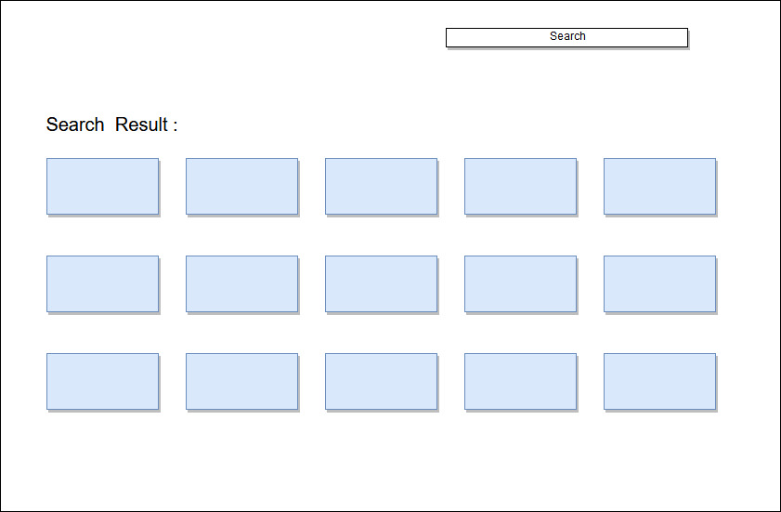

**4.3.2 Add TV Series To Watchlist**

Use Case Name : Add TV Series To Watchlist

Actor : User

Brief Overview : Actor Searches for their desired TV Series and System responds with the Search Result Page. Actor clicks on Add button to add it to their watchlist. System Saves the series in the Actor’s watchlist.

Type : Primary

**Typical Course of Events/Action**

|  |  |
| --- | --- |
| **Actor Actions** | **System Responses** |
| 1)      Actor goes to the login URL | 2)      System responds with the login page. |
| 3)      Actor enters username and password in corresponding fields and presses login or the return key. | 4)      System authenticates the user (with the DB) & redirects to Homepage of the website. |
| 5)      Actor inputs their desired TV Series name in the Search field and presses the return key. | 6)      System responds with Search Results Page. |
| 7)      Actor clicks “Add Button” to add the corresponding Series to the watch list. | 8)      System adds the series to the watch list. |

**Alternative Course Of Events/Action**

3.1)Username and/or Password missing. Re-prompt with error message “Username and/or Password missing”

4.1)Wrong Username and/or Password. Re-prompt with error message “Wrong Username and/or Password”

6.1) System does not return any search result.

8.1) The series is not added to the watch list.

**Screen Mockup**



**4.3.3 Remove TV Series From Watch list**

Use Case Name: Remove TV Series To Watch list

Actor: User

Brief Overview: Actor clicks on watch list and System responds with the Watch list Page. Actor clicks on Remove button beside any series to remove the series from their watch list. System removes the series from the Actor’s watch list.

Type: Primary

**Typical Course of Events/Action**

|  |  |
| --- | --- |
| **Actor Actions** | **System Responses** |
| 1)      Actor goes to the login URL | 2)      System responds with the login page. |
| 3)      Actor enters username and password in corresponding fields and presses login or the return key. | 4)      System authenticates the user (with the DB) & redirects to Homepage of the website. |
| 5)      Actor clicks on “Watch list” on the navigation bar. | 6)      System responds with Watch list Page. |
| 7)      Actor clicks on "Remove" beside the Series. | 8)      System removes the series from the withiest and database. |

**Alternative Course Of Events/Action**

3.1)Username and/or Password missing. Re-prompt with error message “Username and/or Password missing”

4.1)Wrong Username and/or Password. Re-prompt with error message “Wrong Username and/or Password”

6.1)System does not show anything on the watch list page because actor did not add anything yet.

**Screen Mockup of Watch list Page**



**4.3.4 Browse Watch list Items**

Use Case Name: Browse Watch list Items

Actor: User

Brief Overview: Actor clicks on Watch list on the navigation bar from any page and the system responds with the Watch list page. This page contains the entire TV Series actor added to their watch list.

Type: Primary

**Typical Course of Events/Action**

|  |  |
| --- | --- |
| **Actor Actions** | **System Responses** |
| 1)      Actor goes to the login URL | 2)      System responds with the login page. |
| 3)      Actor enters username and password in corresponding fields and presses login or the return key. | 4)      System authenticates the user (with the DB ) & redirects to Homepage of the website. |
| 5)      Actor clicks on “Watch list” on the navigation bar. | 6)      System responds with Watch list Page. |

**Alternative Course Of Events/Action**

3.1)Username and/or Password missing. Reprompt with error message “ Username and/or Password missing”

4.1)Wrong Username and/or Password. Reprompt with error message “Wrong Username and/or Password”

6.1)System does not show anything on the watchlist page because actor did not add anything yet.

**Screen Mockup of Watchlist Page**



**4.3.5 Get Recommendation Based On Added TV Series**

Use Case Name : Get Recommendation Based On Added TV Series

Actor : User

Brief Overview : Actor clicks on "Recommendation" on the navigation bar. System responds with Recommendation page where actor gets recommendation based on their added TV series.

Type : Primary

**Typical Course of Events/Action**

|  |  |
| --- | --- |
| **Actor Actions** | **System Responses** |
| 1)      Actor goes to the login URL | 2)      System responds with the login page. |
| 3)      Actor enters username and password in corresponding fields and presses login or the return key. | 4)      System authenticates the user (with the DB ) & redirects to Homepage of the website. |
| 5)      Actor clicks on "Recommendation" on the navigation bar. | 6)      System responds with Recommendation Page. |

**Alternative Course Of Events/Action**

3.1)Username and/or Password missing. Reprompt with error message “ Username and/or Password missing”

4.1)Wrong Username and/or Password. Reprompt with error message “Wrong Username and/or Password”

6.1) System does not show any Recommendation because actor did not add any series to their watchlist yet.

**Screen Mockup of Recommendation Page**



**4.3.6 Check Currently Trending TV Series**

Use Case Name: Check Currently Trending TV Series

Actor: User

Brief Overview: Actor clicks on "Trending" on the navigation bar. System responds with Trending page where actor gets all the trending TV series.

Type: Primary

**Typical Course of Events/Action**

|  |  |
| --- | --- |
| **Actor Actions** | **System Responses** |
| 1)      Actor goes to the login URL | 2)      System responds with the login page. |
| 3)      Actor enters username and password in corresponding fields and presses login or the return key. | 4)      System authenticates the user (with the DB) & redirects to Homepage of the website. |
| 5)      Actor clicks on "Trending" on the navigation bar. | 6)      System responds with Trending Page. |

**Alternative Course Of Events/Action**

3.1)Username and/or Password missing. Re-prompt with error message “ Username and/or Password missing”

4.1)Wrong Username and/or Password. Re-prompt with error message “Wrong Username and/or Password”

**Screen Mockup of Trending Page**



**5.     Other Nonfunctional Requirements**

**5.1     Performance Requirements**

Users should be able to use all the features smoothly. The recommendation feature should provide valid recommendations.

**5.2     Safety Requirements**

Not applicable.

**5.3     Security Requirements**

Not applicable.

**5.4     Software Quality Attributes**

Not applicable.

**5.5     Business Rules**

Not applicable.

**6.     Other Requirements**

Not applicable.