

**Ecommerce Order Tracking System**

**Submitted By**

**A.U.M. Tuhin**

ID: 151-35-892

Batch: 16th

Department of Software Engineering

Daffodil International University

**Supervised By**

**Md. Anwar Hossen**

**Senior Lecturer**

Department of Software Engineering

Daffodil International University

**Department of Software Engineering**

**Daffodil International University**

© 2018 Daffodil International University



i

© 2018 Daffodil International University



ii

© 2018 Daffodil International University

**Acknowledgement**

First of all, I am grateful to the Almighty Allah for making me eligible to complete this project. Then I would like to thank my supervisor **Md. Anwar Hossen, Senior Lecturer**, Department Of Software Engineering. I am extremely grateful and indebted to him for his expert, sincere and valuable guidance and encouragement extended to me.

Beside my supervisor, I would like to express my sincere thanks to **Dr. Touhid Bhuiyan**, Professor and Head of Software Engineering Department for his constant encouragement.

I would like to thank them who were helped in my project by their very important suggestions without their passionate participation and input; the project could not be successfully conducted. I take this opportunity to record my sincere thanks to all the faculty members of the Department of Software Engineering for their help and encouragement.

Last but not least, I would like to thank our parents, for their unconditional support, love and without this we would not have come this far.

iii

© 2018 Daffodil International University

**Executive Summary**

E-commerce order tracking system (EOTS) is a web based application. An order tracking system allows the customer to gain insight into where their order is at any given point in time. From the time an order is placed until it is delivered. That means an order tracking system needs to be able to follow and provide insight into the status of the order through its entire journey in the Google map to the customer until it reaches to customer door.

The application is basically for e-commerce Company and the customers. The application provides a full e-commerce website where customers can buy products by fulfilling all the requirements and after purchasing or placing order he/she can be able to track his/her order through the application.

The special feature of this application is google map tracking system. Getting orders from customers e-commerce authority can efficiently handle all the orders through the application at the meantime customers can get notify through email and the application.

The objectives of this project are to make e-commerce business more efficient to customer, increase business profits with customer‟s satisfaction. An order tracking system allows you to improve your customer experience and meet your customers‟ needs for order accuracy throughout the entire ordering, fulfillment, and delivery process.

iv

© 2018 Daffodil International University

**Table of Contents**

**Chapter I****1**

Introduction 1

1.1. Project Overview 1

1.2. Project Purpose 1

1.2.1. Background 1

1.2.2. Benefits & Beneficiaries 2

Benefits: 2

Beneficiaries: 2

1.2.3. Goals 2

1.3. Stakeholders 2

1.4. Proposed System Model 3

1.4.1. Agile-Model 3

1.5. Project Schedule 4

1.5.1. Gantt Chart 4

1.5.2. HR Planning for Development Phase 5

1.5.3. Release Plan 5

**Chapter II****6**

Software Requirement Specification 6

2.1. Functional Requirements 6

2.2. Data Requirements 7

2.3. Performance Requirements 7

2.3.1. Speed and Latency Requirements 7

2.3.2. Precision or Accuracy Requirements 7

2.3.3. Capacity Requirements 8

v

© 2018 Daffodil International University

2.4. Dependability Requirements 8

2.4.1. Reliability Requirements 8

2.4.2. Availability Requirements 8

2.4.3. Robustness or Fault-Tolerance Requirements 9

2.5. Maintainability and Supportability Requirements 9

2.5.1. Maintenance Requirements 9

2.5.2. Supportability Requirements 9

2.5.3. Adaptability Requirements 9

2.6. Security Requirements 10

2.6.1. Access Requirements 10

2.6.2. Integrity Requirements 10

2.6.3. Privacy Requirements 10

2.7. Usability and Human-Interaction Requirements 10

2.8. Look and Feel Requirements 11

2.8.1. Appearance Requirements 11

2.8.1. Style Requirements 11

**Chapter III****12**

System Analysis 12

3.1. Use Case Diagram 12

3.2. Use Case Description 13

3.2.1. Order Product 13

3.2.2. Track Orders 14

3.2.2. Manage products 15

3.2.3. Manage Orders 16

3.2.4. Add product to tracking 17

vi

© 2018 Daffodil International University

3.3. Activity Diagram 18

3.3.1. Activity Diagram for Customer 18

3.3.2. Activity for Admin 19

3.3.3. Activity for Staff 20

**Chapter IV****21**

System Design Specification 21

4.1 Sequence Diagram 21

4.1.1. Order product, Track Product 21

4.1.2. Manage Orders, Add Tracking 22

4.1.3. Manage Orders 23

4.2. Dataflow Diagram 24

4.2.1. DFD Level-0 24

4.2.2. DFD Level-1 25

4.3. ERD Diagram 26

**Chapter V****27**

User Interface and Manuals 27

5.1. User Interface 27

5.1.1. Home Page 27

5.1.2. Cart 28

5.1.3. Sign in Page 29

5.1.4. Order Tracking Page 30

5.1.5. Order Tracking Page 31

5.1.6. Admin Area (Add Product) 32

5.1.7. GPS Tracking 33

**Chapter VI****34**

vii

© 2018 Daffodil International University

Development Tools & Technologies 34

6.1. User Interface Technologies 34

6.2. Implementation Technologies 34

6.2.1. NodeJS (11.3.0) 34

6.2.2. NPM (5.7.1) 34

6.2.3. ExpressJS (4.16.4) 34

6.2.4. MongoDB (4) 34

6.2.5. Google Map JavaScript API 35

6.3. Platform & Environment 35

6.3.1. Hardware 35

6.3.2. Tools 35

6.3.3. Version Control 35

**Chapter VII****36**

System Testing 36

7.1. Introduction 36

7.2. Test Plan Strategy 36

7.3. Test Case 36

7.3.1. Test Case of Login 37

7.3.2. Test Case of Sign Up 37

7.3.2. Test Case of Cart 38

7.3.3. Test Case of Location Tracking 39

7.4. Features yet not tested 40

**Chapter VIII****41**

Project Summary 41

8.1. GitHub Link 41

viii

© 2018 Daffodil International University

8.2. Limitations 41

8.3. Obstacle & Achievements 41

8.4. Conclusion 41

8.5. Future Work 42

**Key of Terms****43**

**References****44**

ix

© 2018 Daffodil International University

**List of Figure**

Figure 1 : Agile-Model 3

Figure 2: Gantt chart 4

Figure 3: Use Case Diagram 12

Figure 4: Activity for customer 18

Figure 5: Activity diagram for admin and staff 19

Figure 6: Activity for staff 20

Figure 7: Sequence 1 21

Figure 8: Sequence 2 22

Figure 9: Sequence 3 23

Figure 10: DFD Level-0 24

Figure 11: DFD Level-1 25

Figure 12: ERD 26

Figure 13: Home Page 27

Figure 14: Cart 28

Figure 15: Sign in page 29

Figure 16: Order Tracking Page 30

Figure 17: Order Tracking Page 2 31

Figure 18: Add Product (admin) 32

Figure 19: GPS Tracking 33

x

© 2018 Daffodil International University

**List of Table**

Table 1: Functional Requirements 6

Table 2: Data requirements 7

Table 3 Speed and Latency Requirements 7

Table 4: Precision or Accuracy Requirements 7

Table 5: Capacity Requirements 8

Table 6: Reliability Requirements 8

Table 7: Availability Requirements 8

Table 8: Robustness or Fault-Tolerance Requirements 9

Table 9: Maintenance Requirements 9

Table 10: Supportability Requirements 9

Table 11: Adaptability Requirements 9

Table 12: Access Requirements 10

Table 13: Integrity Requirements 10

Table 14: Privacy Requirements 10

Table 15: Appearance Requirements 11

Table 16: Style Requirements 11

Table 17: Order Product 13

Table 18: Track Orders 14

Table 19: Manage Products 15

Table 20: Manage Orders 16

Table 21: Add tracking 17

Table 22: Test case of login 37

Table 23: Test case of signup 38

Table 24: Test case of cart 39

Table 25: Test case of location 40

Table 26: Features yet not tested 40

xi

© 2018 Daffodil International University

**Chapter I**

**Introduction**

**1.1. Project Overview**

E-commerce order tracking system is a web based application. The application is basically for e-commerce Company and the customers. The application provides a full e-commerce website where customers can buy products by fulfilling all the requirements and after purchasing or placing order he/she can be able to track his/her order through the application.

The special feature of this application is real time google map tracking system. Getting orders from customers e-commerce authority can efficiently handle all the orders through the application at the meantime customers can get notify through email and the application.

After completing all the process of an order and ready for shipment when the delivery man starts delivery or shipment he can start GPS of his mobile phone with the order id and real time location (latitude, longitude) will automatically save to server corresponding to the order id. At the meantime customer will notify the location of his product through a google map in the application customer can able to notify the order information updates and time.

**1.2. Project Purpose**

**1.2.1. Background**

E-commerce is increasing rapidly in Bangladesh and it‟s a trend an e-commerce business but the failing rates are also at its revers. There are lots of reasons behind this failing. One of the reasons is they cannot be trustworthy and customers also do not satisfy. Time management is a big fact, after order something from an e-commerce site customers do not know when the order will reach to his hands. That‟s why customers need to inquire again and again by calling to customer support which wastes times and as well as cost.

To reduce this problem and Bangladeshi e-commerce needs e-commerce order tracking system.

1

**1.2.2. Benefits & Beneficiaries**

**Benefits:**

* Increase customer satisfaction
* Do not need to inquire again to customer support center
* Reduce costly calls
* Increase e-commerce profits holding customers to the website

**Beneficiaries:**

* E-commerce customers
* E-commerce authority

**1.2.3. Goals**

Ordering or purchasing something from Bangladeshi e-commerce site there are lot of problem customer are facing some are:

* Uncertain order placement‟s time and date.
* Need to inquire again and again by calling to know the status of the order
* Time wasting
* Customers do not return again after purchasing once

The main purpose of this project is to reduce these problems and make e-commerce more reliable, trustworthy and increase customer‟s satisfactions.

**1.3. Stakeholders**

A stakeholder is a party that has an interest in a company and can either affect or be affected by the business. The primary stakeholders in a typical corporation are its investors, employees, customers and suppliers.

* **Customers**
* **E-commerce authority**
* **Employees**
* **Shareholders**
* **Suppliers**

2

© 2018 Daffodil International University

**1.4. Proposed System Model**

A software process model is a simplified representation of a software process. Each model represents a process from a specific perspective.

**1.4.1. Agile-Model**

Our proposed system model is agile model which is an incremental process of software development. Each iteration lasts one to three weeks on average. Engineering actions are carried out by cross functional teams. In software development the term „agile‟ means the ability to respond to changes-changes from requirements, technology and people.

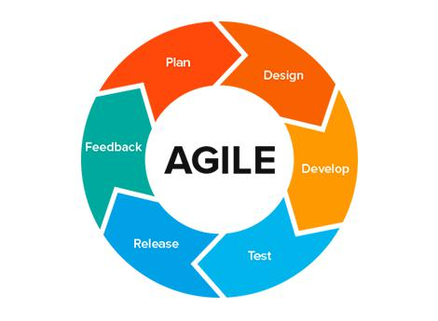

**Figure 1 : Agile-Model**

3

© 2018 Daffodil International University

**1.5. Project Schedule**

In project management, a schedule is a listing of project‟s milestones, activities, and deliverables, usually with intended start and finish dates. A schedule is commonly used in the project planning and project portfolio management parts of project management.

**1.5.1. Gantt Chart**

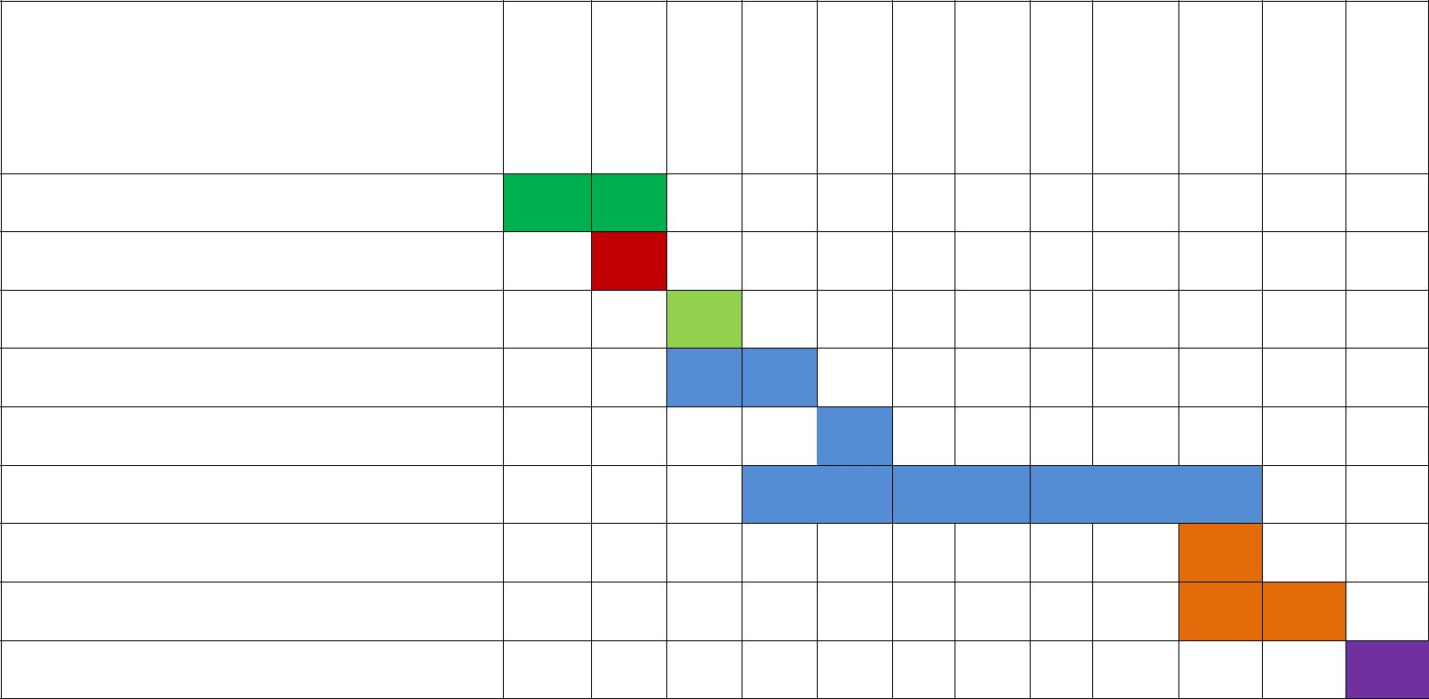

|  |  |  |  |  |  |  |  |  |  |  |  |  |
| --- | --- | --- | --- | --- | --- | --- | --- | --- | --- | --- | --- | --- |
| **Weeks** | 1 | 2 | 3 | 4 | 5 | 6 | 7 | 8 | 9 | 10 | 11 | 12 |

**Works**

**Analysis Phase**

**Feasibility Study**

**Project proposal**

**Project UI**

**Mid**-**term defense**

**Implementation of the project**

**Testing**

**Document of the project**

**Final defense**

**Figure 2: Gantt chart**

4

© 2018 Daffodil International University

**1.5.2. HR Planning for Development Phase**

1. Project plan
2. Analysis
3. Requirement gathering
   * Brainstorming
   * Interview
   * Observation
   * Analysis
4. Design
   * System design
   * Database design
   * System user interface
5. Development
   * User Module
   * Event Module
   * Others
6. Testing
   * Test plan
   * Test Case
   * Test Execution

**1.5.3. Release Plan**

Release 1: beta version 1.0.0 on 15/10/2018

Release 2: beta version 2.0.0 on 30/10/2018

Release 3: version 3.0.0 on 25/11/2018

Release 4: version 4.0.0 on 04/12/2018

5

© 2018 Daffodil International University

**Chapter II**

**Software Requirement Specification**

**2.1. Functional Requirements**

**Table 1: Functional Requirements**

|  |  |  |  |
| --- | --- | --- | --- |
| SRS No. | Name | Description | Priority |
|  |  |  |  |
| #01 | Manage products | Admin can manage product. He can add | High |
|  |  | product category, delete, edit product. |  |
|  |  |  |  |
| #02 | Manage Category | Admin can manage product category. | High |
|  |  |  |  |
| #03 | Manage Orders | Staff will manage orders. He can confirm order | High |
|  |  | and the next process of orders. |  |
|  |  |  |  |
| #04 | Order Product | Customers can place order. Before placing | High |
|  |  | orders he can see products, add to cart pay bill. |  |
|  |  |  |  |
| #04 | Pay Bill | Customer can pay bills after placing order | High |
|  |  |  |  |
| #05 | Track Order | Customer can trace his order status after | High |
|  |  | placement. System will automatically notify by |  |
|  |  | email after completing any process of order. |  |
|  |  |  |  |
| #06 | Add Product to GPS | Staff can update order status and add to GPS | High |
|  | tracking | tracking when shipment starts |  |
|  |  |  |  |

6

© 2018 Daffodil International University

**2.2. Data Requirements**

**Table 2: Data requirements**

|  |  |  |
| --- | --- | --- |
| No | Description | Priority |
|  |  |  |
| #01 | Admin has to insert the login credentials accurately otherwise system | High |
|  | will show an error with message. |  |
|  |  |  |
| #02 | Admin has to insert all product information. | High |
|  |  |  |
| #03 | Staff has to insert login credential to login to the system | Medium |
|  |  |  |
| #04 | Staff has to update orders information. | Medium |
|  |  |  |
| #05 | Customers need to insert login credentials after signup | High |
|  |  |  |
| #06 | Customers have to update all his order address related information | Low |
|  |  |  |

**2.3. Performance Requirements**

**2.3.1. Speed and Latency Requirements**

**Table 3 Speed and Latency Requirements**

|  |  |  |
| --- | --- | --- |
| No | Description | Priority |
|  |  |  |
| #01 | When GPS starts it should send location info to server in real-time | Low |
|  |  |  |
| #02 | The system should update the location in google map without page | Low |
|  | refreshing. |  |
|  |  |  |
| #03 | The system must have a high speed of manipulation data and reply to | Low |
|  | the user request. |  |
|  |  |  |

**2.3.2. Precision or Accuracy Requirements**

**Table 4: Precision or Accuracy Requirements**

|  |  |  |
| --- | --- | --- |
| No | Description | Priority |
|  |  |  |
| #01 | The input data should be validate when Customer or admin provide | Medium |
|  | data to the system |  |
|  |  |  |
| #02 | All data should be in place accurately where it is associated | Medium |
|  |  |  |
| #03 | Need to validate all the collections of Mongodb database. | Medium |
|  |  |  |

7

© 2018 Daffodil International University

**2.3.3. Capacity Requirements**

**Table 5: Capacity Requirements**

|  |  |  |
| --- | --- | --- |
| No | Description | Priority |
|  |  |  |
| #01 | The web application size must able to load at hosting site. | Medium |
|  |  |  |
| #02 | The Mlab or Mongodb atlas database size must be able to store the | Low |
|  | system data |  |
|  |  |  |
| #03 | System should support 100k user at the beginning version | Low |
|  |  |  |
| #04 | System should support 1000 request per second. | Low |
|  |  |  |

**2.4. Dependability Requirements**

**2.4.1. Reliability Requirements**

**Table 6: Reliability Requirements**

|  |  |  |
| --- | --- | --- |
| No | Description | Priority |
|  |  |  |
| #01 | All confidential data must have to be encrypted. | Medium |
|  |  |  |
| #02 | All data should collect from users by permission and by accepting | Low |
|  | privacy policy. |  |
|  |  |  |
| #03 | No one can use customer‟s data for any other purpose except system | Low |
|  | needs. |  |
|  |  |  |

**2.4.2. Availability Requirements**

**Table 7: Availability Requirements**

|  |  |  |
| --- | --- | --- |
| No | Description | Priority |
|  |  |  |
| #01 | The system should work 24 hours a day | Medium |
|  |  |  |
| #02 | The system should provide the desired data to the user in time | Low |
|  |  |  |

8

© 2018 Daffodil International University

**2.4.3. Robustness or Fault-Tolerance Requirements**

**Table 8: Robustness or Fault-Tolerance Requirements**

|  |  |  |
| --- | --- | --- |
| No | Description | Priority |
|  |  |  |
| #01 | If the system has been crashed, it should not be more than an hour. | Low |
|  |  |  |
| #02 | System must be responsible and should be cross browser supported | Low |
|  |  |  |

**2.5. Maintainability and Supportability Requirements**

**2.5.1. Maintenance Requirements**

**Table 9: Maintenance Requirements**

|  |  |  |
| --- | --- | --- |
| No | Description | Priority |
|  |  |  |
| #01 | The system maintenance should be quick. | Low |
|  |  |  |

**2.5.2. Supportability Requirements**

**Table 10: Supportability Requirements**

|  |  |  |
| --- | --- | --- |
| No | Description | Priority |
|  |  |  |
| #01 | The system support latest nodejs and mongodb (mongoose) version. | Medium |
|  |  |  |
| #02 | Should support all the browsers and screen size. | Low |
|  |  |  |
| #03 | Should support latest and popular cloud services. | Low |
|  |  |  |

**2.5.3. Adaptability Requirements**

**Table 11: Adaptability Requirements**

|  |  |  |
| --- | --- | --- |
| No | Description | Priority |
|  |  |  |
| #01 | The system should adapt all upgrading version and time. | Low |
|  |  |  |
| #02 | New version of system should support latest node modules | Low |
|  |  |  |

9

© 2018 Daffodil International University

**2.6. Security Requirements**

**2.6.1. Access Requirements**

**Table 12: Access Requirements**

|  |  |  |
| --- | --- | --- |
| No | Description | Priority |
|  |  |  |
| #01 | All the users access have to be limited with their use case boundaries | Low |
|  |  |  |
| #02 | Users need to be authorized first to access data. | Medium |
|  |  |  |
| #03 | Only SEQURITY Administrator will be able to enter the system to | Low |
|  | make maintenance. |  |
|  |  |  |
| #04 | Customer‟s boundaries should be within the browser. | Low |
|  |  |  |

**2.6.2. Integrity Requirements**

**Table 13: Integrity Requirements**

|  |  |  |
| --- | --- | --- |
| No | Description | Priority |
|  |  |  |
| #01 | Only authorized user can add or delete data with their respective | Low |
|  | accessibility and authorization. |  |
|  |  |  |
| #02 | Only admin can delete products and orders information. | Medium |
|  |  |  |

**2.6.3. Privacy Requirements**

**Table 14: Privacy Requirements**

|  |  |  |
| --- | --- | --- |
| No | Description | Priority |
|  |  |  |
| #01 | The user data must not be visible for public | High |
|  |  |  |
| #02 | The user data should not contain any private issues | Medium |
|  |  |  |
| #03 | All the confidential data should be encrypted. | Medium |
|  |  |  |

**2.7. Usability and Human-Interaction Requirements**

No visible usability and Human-Interaction requirements.

10

© 2018 Daffodil International University

**2.8. Look and Feel Requirements**

**2.8.1. Appearance Requirements**

**Table 15: Appearance Requirements**

|  |  |  |
| --- | --- | --- |
| No | Description | Priority |
|  |  |  |
| #01 | The user interface must be attractive. | High |
|  |  |  |
| #02 | The user interface must be user friendly. | Medium |
|  |  |  |
| #03 | The user interface must be user interactive. | Medium |
|  |  |  |

**2.8.1. Style Requirements**

**Table 16: Style Requirements**

|  |  |  |
| --- | --- | --- |
| No | Description | Priority |
|  |  |  |
| #01 | The interface color should be flat or material. | Medium |
|  |  |  |

11

© 2018 Daffodil International University

**Chapter III**

**System Analysis**

**3.1. Use Case Diagram**

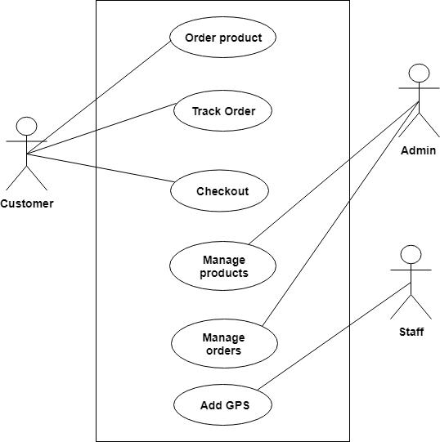

**Figure 3: Use Case Diagram**

12

© 2018 Daffodil International University

**3.2. Use Case Description**

**3.2.1. Order Product**

E-commerce Customer Reorder-Cart Management. From this location, customers can add or remove items from their cart, adjust the quantity, or continue shopping on your e-commerce website to add more products to their order. E-commerce websites make the Customer Reorder function very easy for your customers.

|  |  |  |
| --- | --- | --- |
|  |  | **Table 17: Order Product** |
|  |  | |
| Use Case Name: | Order product | |
|  |  | |
| Scenario : | Customer can browse product select and order. | |
|  |  | |
| Brief Description: | Customer chose product which he want to buy then add the | |
|  | product to cart and then order the product with proper payment | |
|  | method | |
|  |  | |
| Actor: | Customer | |
|  |  | |
| Precondition: | Customer has to sign up or login and products must be available | |
|  | in the system | |
|  |  | |
| Post condition: | Customer must chose a proper payment method | |
|  |  |  |
| Main Success Scenario | 1. | Products must be available |
|  | 2. | Products have to be added to system. |
|  | 3. | After adding product to cart customer can order. |
|  |  |  |
| Scenario Extensions | 1. | If there is no products customer cannot add cart and order |
|  | product. | |
|  | 2. | Proper payment selection must be needed either cannot order |
|  | product. | |
|  |  |  |

13

© 2018 Daffodil International University

**3.2.2. Track Orders**

Registered user can track their order through order id and he/she can see his order status with date and time and he/she can watch his/her product in Google map if the shipment has been start.

|  |  |  |
| --- | --- | --- |
|  |  | **Table 18: Track Orders** |
|  |  | |
| Use Case Name: | Track Orders | |
|  |  | |
| Scenario : | Here customer can track his/her order | |
|  |  | |
| Brief Description: | After finishing order processing an order id will auto generate | |
|  | and customer can track his order through this id. | |
|  |  | |
| Actor: | Customer. | |
|  |  | |
| Precondition: | An order should be taken place before track. | |
|  |  | |
| Post condition: | Admin needs to maintain placed order and confirm. | |
|  |  |  |
| Main Success Scenario | 1. | Order should be confirmed by staff. |
|  | 2. Admin will collect user data properly and provide them to the | |
|  | authority. | |
|  | 3. | For changing any information admin must need to notify users. |
|  |  |  |
| Scenario Extensions | 1. | System user must have an id and password. |
|  | 2. | Admin should provide all the information properly. |
|  | 3. | Admin cannot give any confirmation without the decision of |
|  | the authority. | |
|  |  |  |

14

© 2018 Daffodil International University

**3.2.2. Manage products**

System admin can change any setting through valid username and password either he cannot. He should be login authentic way either he cannot. Whenever he changes any setting he should give password again to make final change either not possible.

|  |  |  |
| --- | --- | --- |
|  |  | **Table 19: Manage Products** |
|  |  | |
| Use Case Name: | Manage products | |
|  |  | |
| Scenario : | Here admin will manage products and products category. | |
|  |  | |
| Brief Description: | Here admin can add product to system, edit delete. | |
|  |  | |
| Actor: | Admin | |
|  |  | |
| Precondition: | Desired information should be available. | |
|  |  | |
| Post condition: | Product information must need available. | |
|  |  |  |
| Main Success Scenario | 1. | System user must be authorized. |
|  | 2. | Authority will give account to the system admin. |
|  |  |  |
| Scenario Extensions | 1. | If system user is not authorized. |
|  | 2. | If user not registered. |
|  | 3. | If the products information does not exist in the system user |
|  | cannot search. | |
|  |  |  |

15

© 2018 Daffodil International University

**3.2.3. Manage Orders**

Staff can manage orders which are taken place by customers. They can confirm orders, delete orders if order seems fake, process orders, check product quality and finally prepare for the shipment. Delivery men then add the product to tracking system and deliver it to customer.

|  |  |
| --- | --- |
|  | **Table 20: Manage Orders** |
|  |  |
| Use Case Name: | Manage Orders |
|  |  |
| Scenario : | After placing orders by customers staff can manage orders. |
|  |  |
| Brief Description: | Proper authorized staff can confirm orders, delete orders, process |
|  | orders, check product quality and prepare for shipment. |
|  |  |
| Actor: | Admin |
|  |  |
| Precondition: | An order needs to be posted by customer. |
|  |  |
| Post condition: | Orders should be confirmed. |
|  |  |
| Scenario Extensions | 1.User should place orders |
|  | 2. Admin should confirm the order |
|  |  |
| Scenario Extensions | 1. If users do not place order how could staff manage orders? So |
|  | first need to place orders |
|  |  |

16

© 2018 Daffodil International University

**3.2.4. Add product to tracking**

After finishing orders management process delivery man adds the product to tracking system so that customer can see the product current status and observe it in Google map.

|  |  |  |
| --- | --- | --- |
|  |  | **Table 21: Add tracking** |
|  |  | |
| Use Case | Add tracking | |
| Name: |  |  |
|  |  | |
| Scenario : | Here staffs can add product to tracking system. | |
|  |  | |
| Brief | Here staff will add product to tracking. Then authority will manage those | |
| Description: | applications. | |
|  |  | |
| Actor: | Staff | |
|  |  | |
| Precondition: | Orders must need to processed and prepare for shipment. | |
|  |  | |
| Post condition: | GPS and location accuracy must be turn on. | |
|  |  |  |
|  | 1. | Staff needs to register. |
|  | 2. | Orders should be confirmed, processed, checked and ready form shipment. |
|  | 3. | Then staff add the product according to its id in tracking system |
|  |  | |
| Scenario | If staff not authorized. | |
| Extensions | If orders not properly place | |
|  |  |  |

17

© 2018 Daffodil International University

**3.3. Activity Diagram**

**3.3.1. Activity Diagram for Customer**

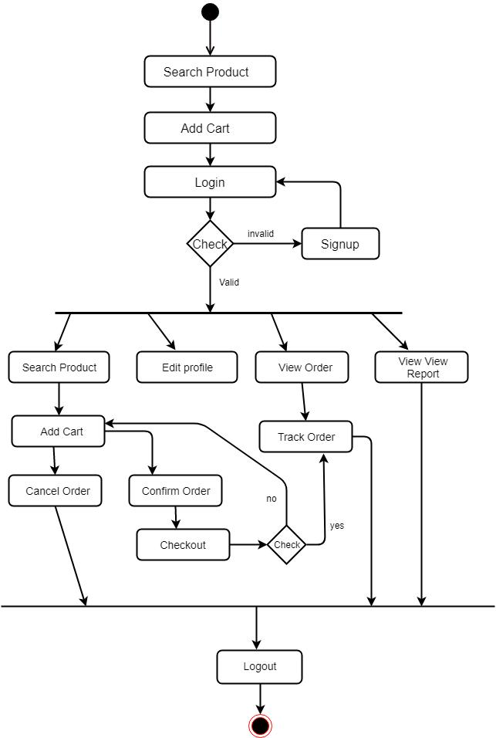

**Figure 4: Activity for customer**

18

© 2018 Daffodil International University

**3.3.2. Activity for Admin**

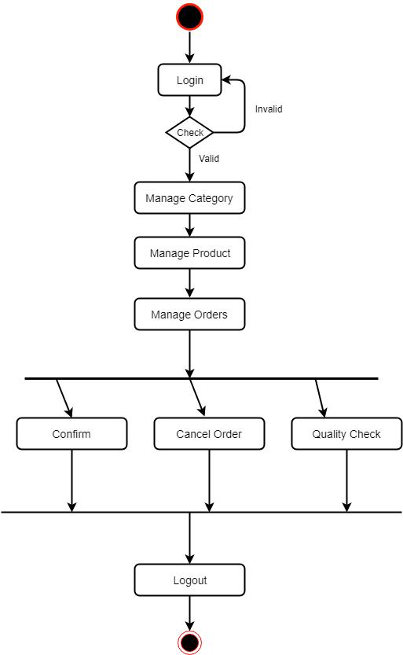

**Figure 5: Activity diagram for admin and staff**

19

© 2018 Daffodil International University

**3.3.3. Activity for Staff**

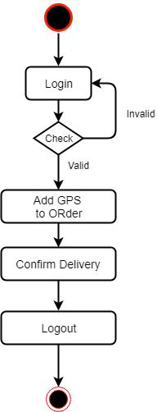

**Figure 6: Activity for staff**

20

© 2018 Daffodil International University

**Chapter IV**

**System Design Specification**

**4.1 Sequence Diagram**

**4.1.1. Order product, Track Product**

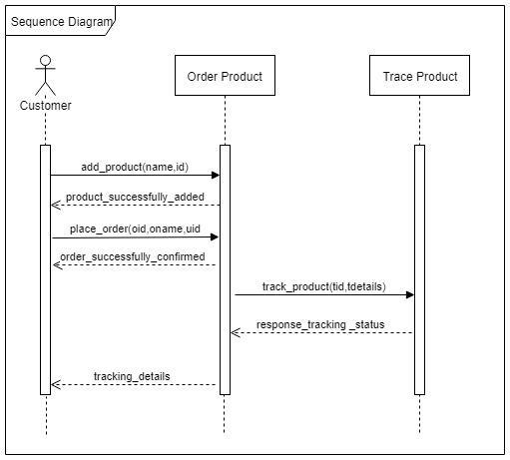

**Figure 7: Sequence 1**

21

© 2018 Daffodil International University

**4.1.2. Manage Orders, Add Tracking**

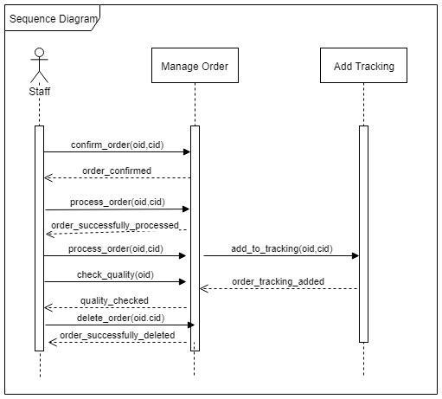

**Figure 8: Sequence 2**

22

© 2018 Daffodil International University

**4.1.3. Manage Orders**

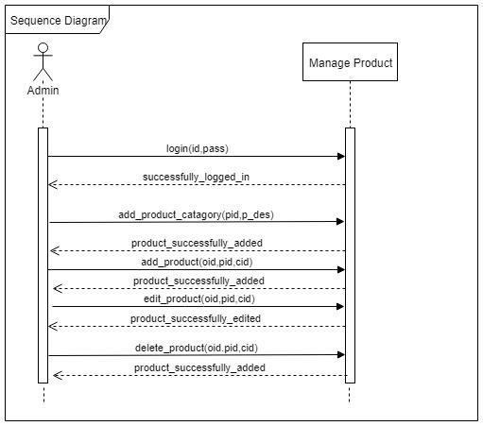

**Figure 9: Sequence 3**

23

© 2018 Daffodil International University

**4.2. Dataflow Diagram**

**4.2.1. DFD Level-0**

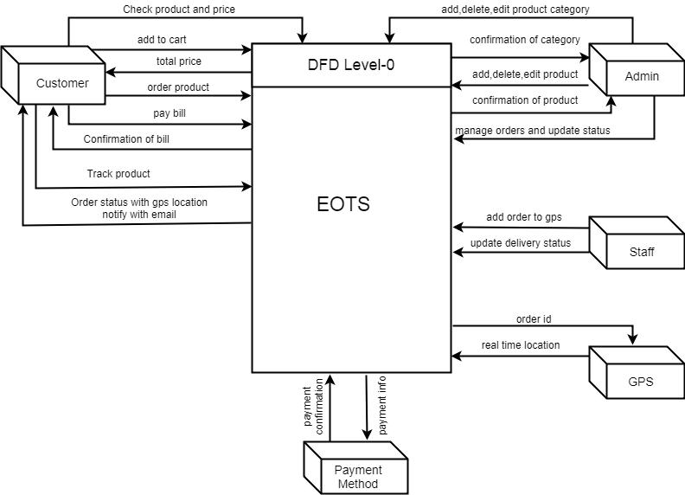

**Figure 10: DFD Level-0**

24

© 2018 Daffodil International University

**4.2.2. DFD Level-1**

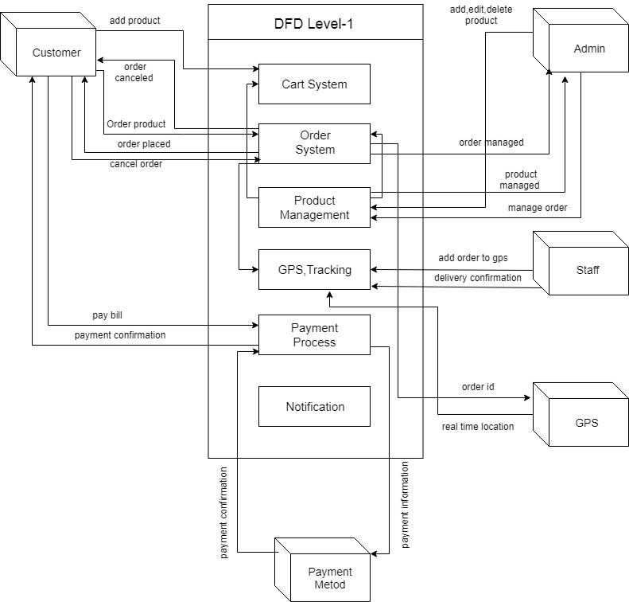

**Figure 11: DFD Level-1**

25

© 2018 Daffodil International University

**4.3. ERD Diagram**

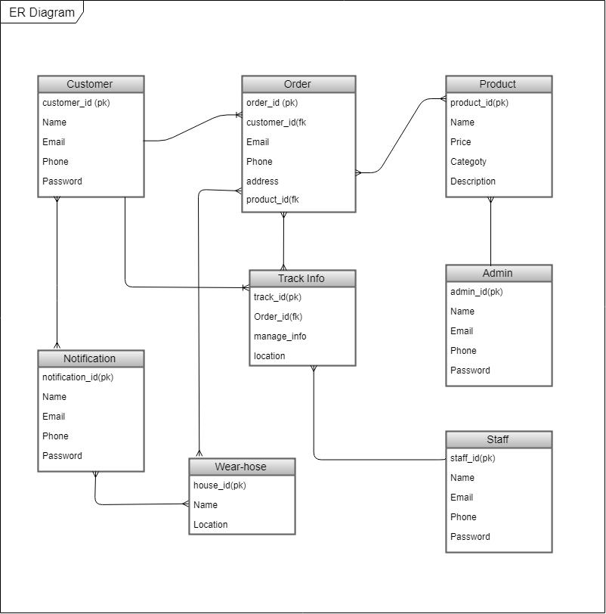

**Figure 12: ERD**

26

© 2018 Daffodil International University

**Chapter V**

**User Interface and Manuals**

5.1. **User Interface**

**5.1.1. Home Page**

After visiting the website url, this is home page. Click **Shop Now** button you will find more products, you can also browsing products by category by clicking **Products** in top navigation bar. At the top right of the navigation bar there is **My Cart**, **Sign** and **Signup**. If you are a existing user can you can login to the system.

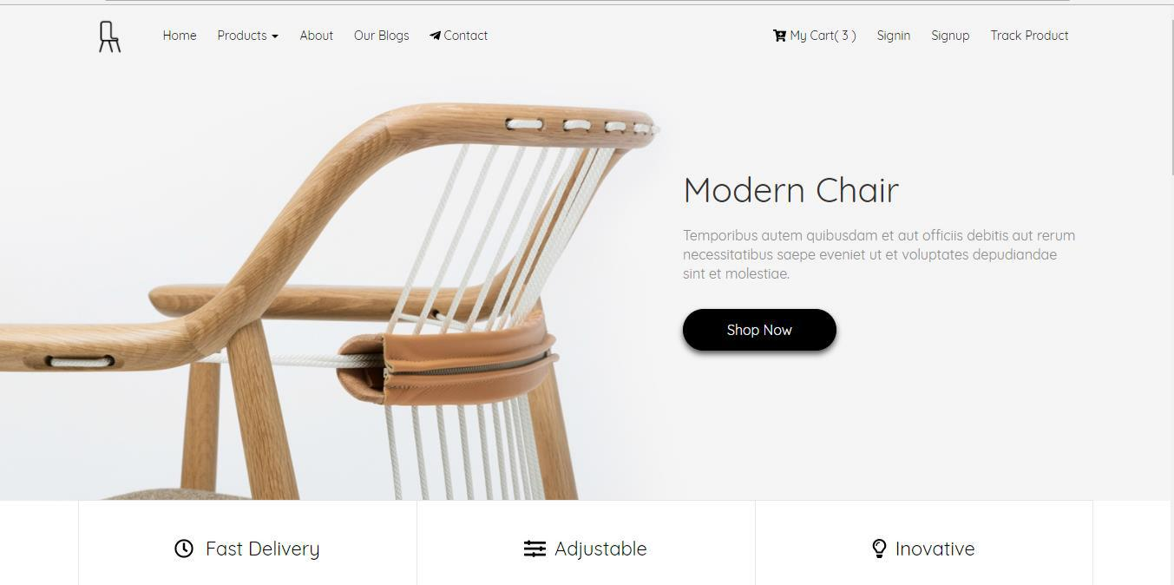

**Figure 13: Home Page**

27

© 2018 Daffodil International University

**5.1.2. Cart**

After choosing products you can find this page. You can update your cart by clicking **Plus** and **Minus** sign button you can also clear a product as well as the whole cart simply clicking the **Clear Cart** button.

If you already login to system you can place a order by clicking the **Buy Now** button otherwise it redirects to **Signin** page

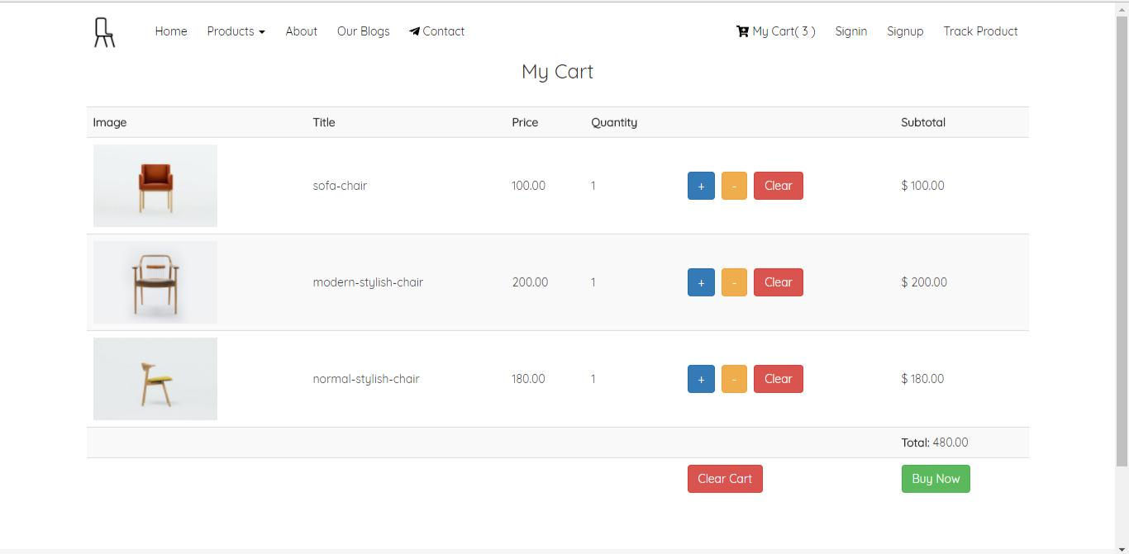

**Figure 14: Cart**

28

© 2018 Daffodil International University

**5.1.3. Sign in Page**

This is customer login page. Existing customer can easily log in to the system simple giving the credentials in the field of email and password.

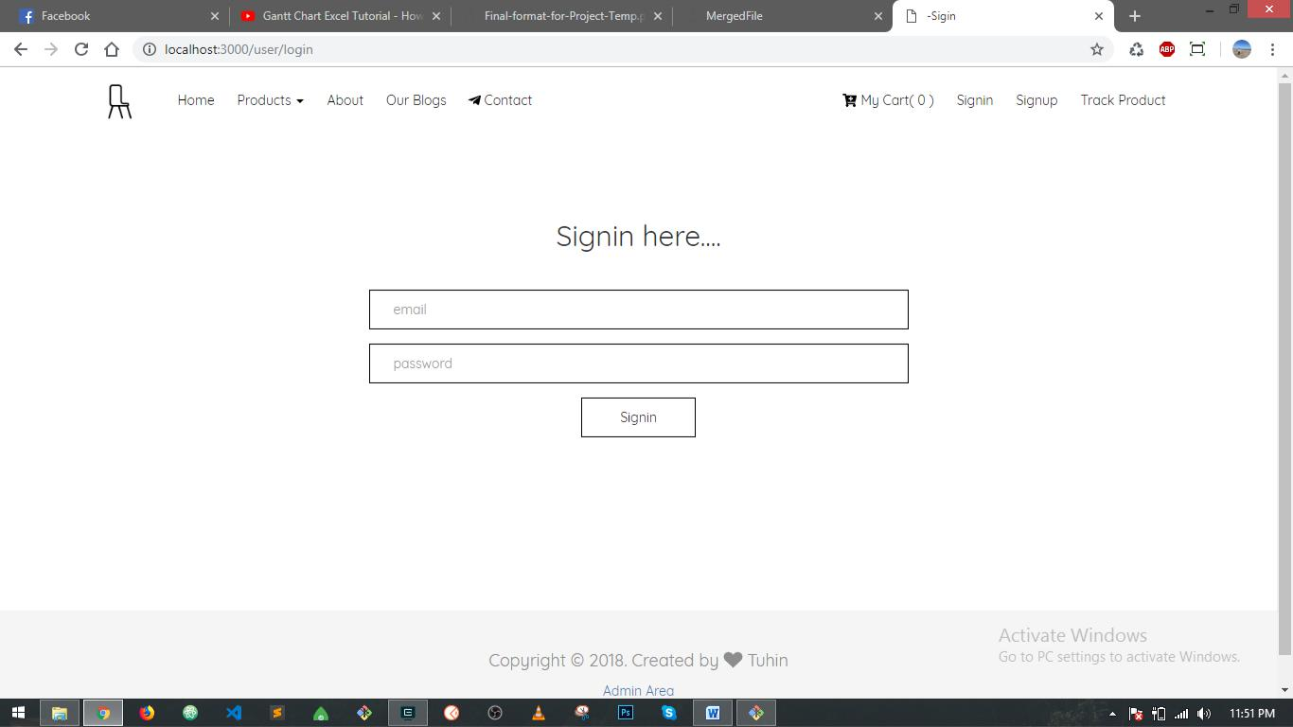

**Figure 15: Sign in page**

29

© 2018 Daffodil International University

**5.1.4. Order Tracking Page**

This is the order tracking page for customer. Order information will auto update against already an order. Customer will notify if any status updates. Customer

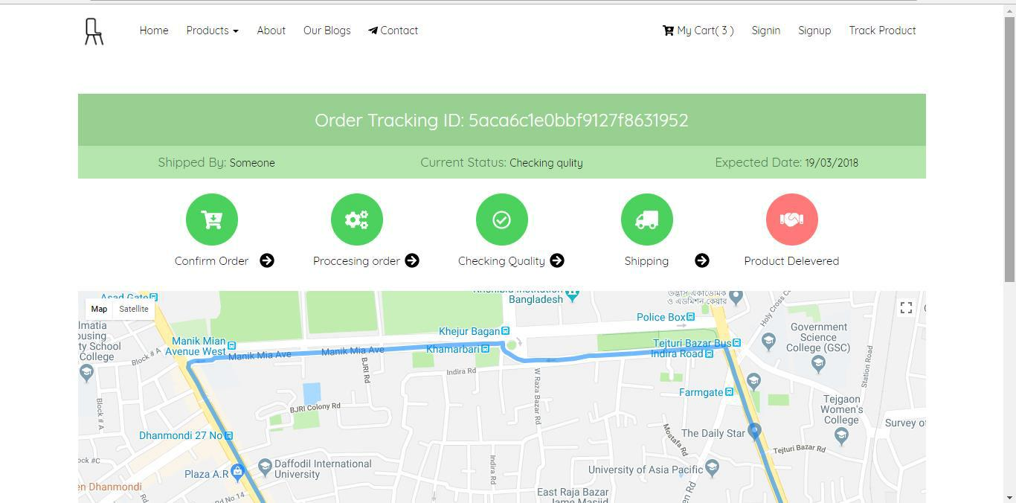

**Figure 16: Order Tracking Page**

30

© 2018 Daffodil International University

**5.1.5. Order Tracking Page**

This is also the above remaining page of map and updated time of order.

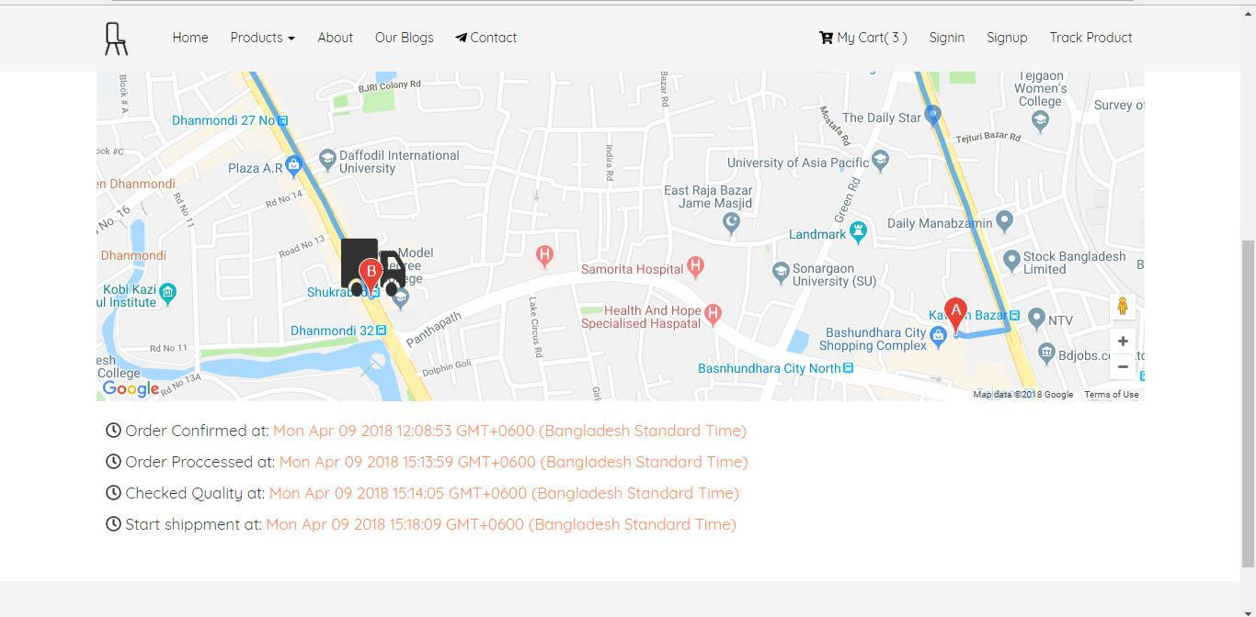

**Figure 17: Order Tracking Page 2**

31

© 2018 Daffodil International University

**5.1.6. Admin Area (Add Product)**

This the admin page after authentication admin can add new product by clicking the **Add New** **Product** button, a form will open and admin can insert the products product related details.Admin also update and delete clicking **Edit** and **Delete** button respectively.

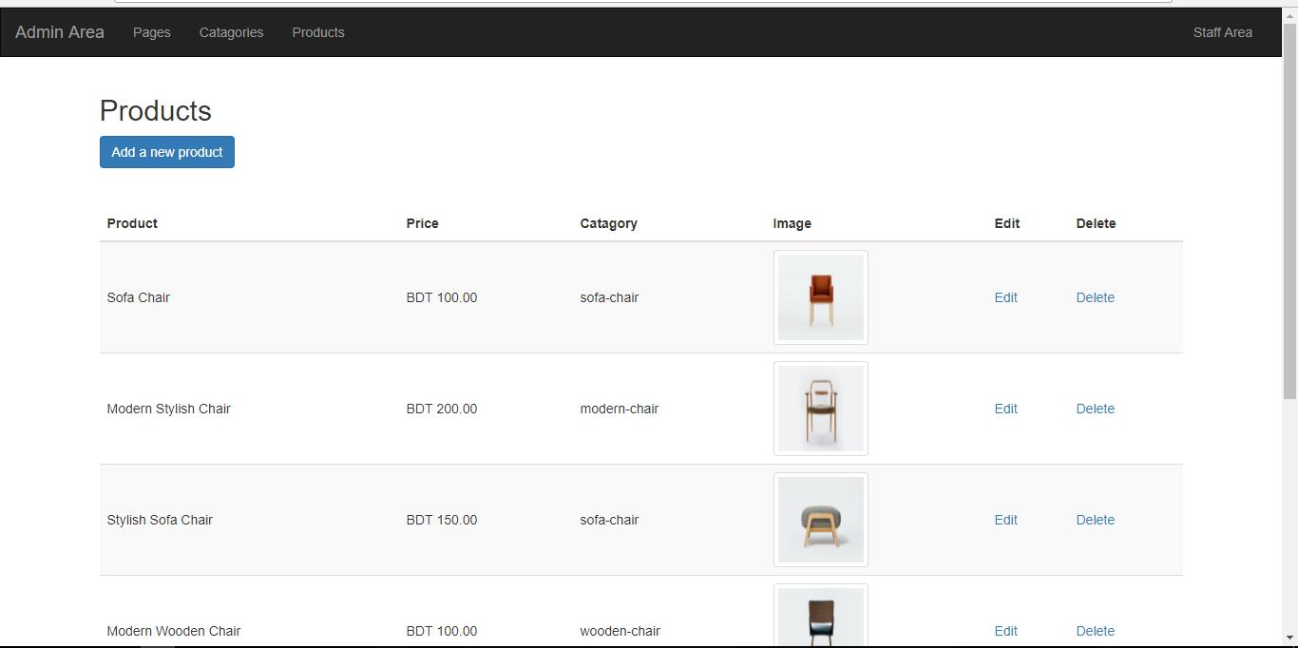

**Figure 18: Add Product (admin)**

32

© 2018 Daffodil International University

**5.1.7. GPS Tracking**

This is the mobile version page for Staff (delivery man) when shipment starts. After insert an order id delivery man can start location tracking buy clicking **Start Tracking** button and this page will open. Real time location will auto update against this order.

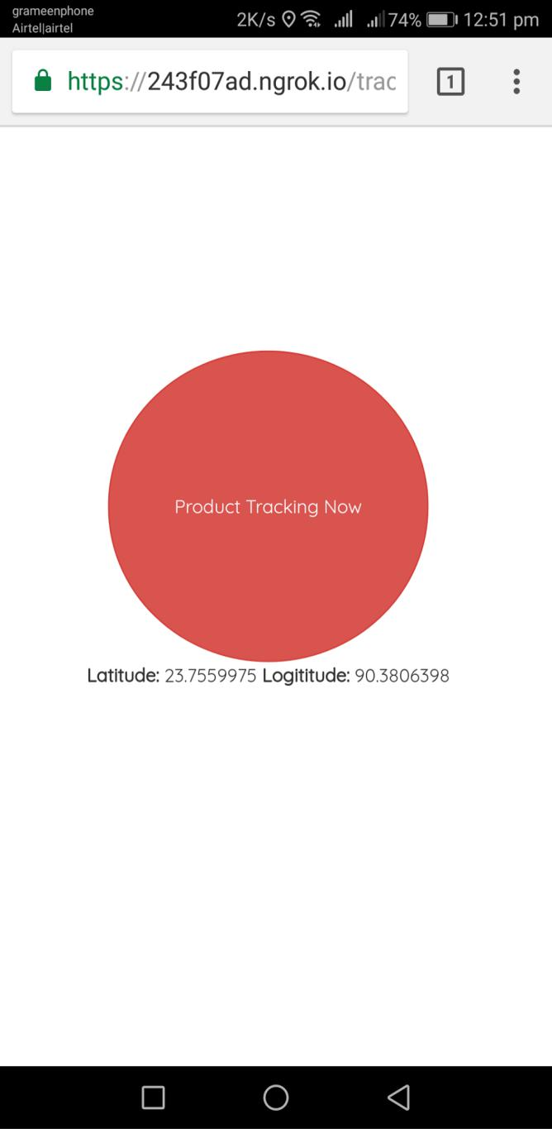

**Figure 19: GPS Tracking**

33

© 2018 Daffodil International University

**Chapter VI**

**Development Tools & Technologies**

**6.1. User Interface Technologies**

* HTML5, CSS3, JavaScript
* JQuery 3.2.1
* EJS (expressJS template engine)
* Twitter Bootstrap
* Font Awesome, Flat Icons

**6.2. Implementation Technologies**

**6.2.1. NodeJS (11.3.0)**

A JavaScript runtime build with chrome‟s v8 JavaScript engine

**6.2.2. NPM (5.7.1)**

NPM is the package manager for JavaScript and the world‟s largest software registry.

Discover packages of reusable code and assemble them in powerful new ways.

**6.2.3. ExpressJS (4.16.4)**

Express.js, or simply Express, is a web application framework for Node.js, released as free and open-source software under the MIT License. It is designed for building web applications and APIs. It has been called the de facto standard server framework for Node.js

**6.2.4. MongoDB (4)**

MongoDB is a free and open-source cross-platform document-oriented database program. Classified as a NoSQL database program, MongoDB uses JSON-like documents with schemata. MongoDB is developed by MongoDB Inc., and is published under a combination of the Server Side Public License and the Apache License.

34

© 2018 Daffodil International University

**6.2.5. Google Map JavaScript API**

Using this API easily can get the real time location of an object and easily able to show the location in google map.

**6.3. Platform & Environment**

**6.3.1. Hardware**

* Processor: Intel Core i3.
* RAM: 4GB.
* Hard drive: 1TB.
* Ubuntu 14.04./ Windows 8.1/Windows 10

**6.3.2. Tools**

* IDE/Editor: Visual Studio Code, Atom, Sublime Text3
* Cmder Terminal
* Robo 3T MongoDB client
* Server: Localhost:3000

**6.3.3. Version Control**

* Git
* Github (a web based version control hosting for software project)

35

© 2018 Daffodil International University

**Chapter VII**

**System Testing**

**7.1. Introduction**

This is aimed at identifying and correcting error. The major objectives of this activity are to ensure that the process done by the application is correct ad meets the objectives of the organization. Test plan aids in effective and systematic testing of the system and it aims at checking the errors of omission and commission that hinders the realization of the objectives.

**7.2. Test Plan Strategy**

The importance of the test plan is to show how the system is to be tested and also gives precise procedure to be followed during test plan. The test data is identified, what is being tested and the expected outcome as well as actual input. Test plan is one of the standard documents that should be produced in most software engineering projects. If the project does not have any test plan this means that the system produced is low quality. This may not be acceptable to the user it will not satisfy their needs. The test plan should be written as soon as requirements have been identified. The system will be tested with sample data to see how it would handle input and output functions as well as extreme data or conditions to determine the system behavior in overloaded situation which will directly slow the system that behaves in failure or extreme situation.

**7.3. Test Case**

A test case is a set of conditions or variables under which a tester will determine whether a system under test satisfies requirements or works properly. The process of developing test case can help find problems in the requirements or design of an application.

* Ensure that logical decisions on their true and false side.
* Practice all the logical decisions on their true and false side.
* Check equivalent partitions and boundary value within their operations bounds.
* Exercise internal data structure to assure their validity.

36

© 2018 Daffodil International University

**7.3.1. Test Case of Login**

|  |  |
| --- | --- |
| Test Case #01 | Test Case Name: Testing the login panel. |
|  |  |
| System: EOTS | Subsystem: Login |
|  |  |
| Designed By: A.U.M. Tuhin | Design date: 25.11.18 |
|  |  |
| Executed By: A.U.M. Tuhin | Execute Date:25.11.18 |
|  |  |

Short Description: This field handle's the login functionality of the website.

Precondition: Go to http://localhost:3000/signin.

**Table 22: Test case of login**

|  |  |  |  |  |
| --- | --- | --- | --- | --- |
| Steps | Action | Action Result | Expected System Response | Pass/Fail |
|  |  |  |  |  |
| 01 | Enter valid email and | Get logged in. | Logged in into the system. | Pass |
|  | valid password |  |  |  |
|  |  |  |  |  |
| 02 | Valid email and invalid | Not logged in | Not logged in and error | Pass |
|  | password | and error | message. |  |
|  |  | message. |  |  |
|  |  |  |  |  |
| 03 | Click login without any | Required | Required message | Fail |
|  | data | message |  |  |
|  |  |  |  |  |

**7.3.2. Test Case of Sign Up**

|  |  |
| --- | --- |
| Test Case #01 | Test Case Name: Testing the signup panel. |
|  |  |
| System: EOTS | Subsystem: Login |
|  |  |
| Designed By: A.U.M. Tuhin | Design date: 26.11.18 |
|  |  |
| Executed By: A.U.M. Tuhin | Execute Date:26.11.18 |
|  |  |

Short Description: This field handle's the login functionality of the website.

Precondition: Go to http://localhost:3000/signup.

37

© 2018 Daffodil International University

**Table 23: Test case of signup**

|  |  |  |  |  |
| --- | --- | --- | --- | --- |
| Steps | Action | Action Result | Expected System Response | Pass/Fail |
|  |  |  |  |  |
| 01 | Click sign up without | Required | Required message | Pass |
|  | any data | message |  |  |
|  |  |  |  |  |
| 02 | Click sign up partially | Not signed up | Not signed up and required | Pass |
|  | filling with data | and required | messages. |  |
|  |  | messages. |  |  |
|  |  |  |  |  |
| 03 | Click sign up with valid | Signed up in and | No Required message | Fail |
|  | data and password less | error message. |  |  |
|  | than 6 characters. |  |  |  |
|  |  |  |  |  |
| 04 | Click sign up with valid | Not signed up in | Not signed up in and error | Pass |
|  | data and password not | and error | message. |  |
|  | matching with confirm | message. |  |  |
|  | password. |  |  |  |
|  |  |  |  |  |
| 05 | Click sign up with valid | Signed up and | Signed up and redirected to | Pass |
|  | data and password. | redirected to | main landing page. |  |
|  |  | main landing |  |  |
|  |  | page. |  |  |
|  |  |  |  |  |

**7.3.2. Test Case of Cart**

|  |  |
| --- | --- |
| Test Case #01 | Test Case Name: Testing the cart panel. |
|  |  |
| System: EOTS | Subsystem: Login |
|  |  |
| Designed By: A.U.M. Tuhin | Design date: 26.11.18 |
|  |  |
| Executed By: A.U.M. Tuhin | Execute Date:26.11.18 |
|  |  |

Short Description: This field handle's the login functionality of the website.

Precondition: Go to http://localhost:3000/cart.

38

© 2018 Daffodil International University

**Table 24: Test case of cart**

|  |  |  |  |  |
| --- | --- | --- | --- | --- |
| Steps | Action | Action Result | Expected System Response | Pass/Fail |
|  |  |  |  |  |
| 01 | Click add to cart on | One product is | One product is added in | Pass |
|  | products. | added in cart | cart. |  |
|  |  | ▪ For registered | • For registered user |  |
|  |  | user cart is | cart is stored in |  |
|  |  | stored in | database. |  |
|  |  | database. | • For guest cart is |  |
|  |  | ▪ For guest cart | stored in session. |  |
|  |  | is stored in |  |  |
|  |  | session. |  |  |
|  |  |  |  |  |
| 02 | Increase/decrease cart | Cart is updated | Cart is updated accordingly | Pass |
|  | item | accordingly | with price. |  |
|  |  |  |  |  |
| 03 | Remove an item from | Product is not | Product is not removed | Fail |
|  | cart | removed. |  |  |
|  |  |  |  |  |

**7.3.3. Test Case of Location Tracking**

|  |  |
| --- | --- |
| Test Case #01 | Test Case Name: Testing the tracking panel. |
|  |  |
| System: EOTS | Subsystem: Login |
|  |  |
| Designed By: A.U.M. Tuhin | Design date: 26.11.18 |
|  |  |
| Executed By: A.U.M. Tuhin | Execute Date:26.11.18 |
|  |  |

Short Description: This field handle's the login functionality of the website.

Precondition: Go to http://localhost:3000/cart.

39

© 2018 Daffodil International University

**Table 25: Test case of location**

|  |  |  |  |  |
| --- | --- | --- | --- | --- |
| Steps | Action | Action Result | Expected System Response | Pass/Fail |
|  |  |  |  |  |
| 01 | Add GPS tracking with | Start tracking | Start tracking | Pass |
|  | order id. |  |  |  |
|  |  |  |  |  |
| 02 | Get latitude and | Get two point | Get two point | Pass |
|  | longitude |  |  |  |
|  |  |  |  |  |
| 03 | Response back to client | Cannot get | Get successfully | Fail |
|  | side of two point |  |  |  |
|  |  |  |  |  |

**7.4. Features yet not tested**

**Table 26: Features yet not tested**

|  |  |  |
| --- | --- | --- |
| No | Name | Users |
|  |  |  |
| 01 | Manage Orders | Admin |
|  |  |  |
| 02 | Manage Category | Admin |
|  |  |  |
| 03 | Barcode code generation | System/ Admin |
|  |  |  |
| 04 | Print order report | System/ Admin |
|  |  |  |

40

© 2018 Daffodil International University

**Chapter VIII**

**Project Summary**

**8.1. GitHub Link**

[**https://github.com/aumtuhin/final-project**](https://github.com/aumtuhin/final-project)

**8.2. Limitations**

* The system is only for Bangladeshi ecommerce perspective.
* The system does not able to track international ecommerce orders.
* The system needs high speed mobile internet.

**8.3. Obstacle & Achievements**

**Obstacle:**

* Learning new technology and environment
* Limited time and budget

**Achievements**

* Learnt new technology
* Successfully build a project for production level

**8.4. Conclusion**

Despite the hardship s encountered in the entire development process the system has been developed for Ecommerce order tracking system thus enabling it improves its efficiency and effectiveness. Maintenance and usage of the system will be easy as the document and user manual of the system will be available to all users. Also there will be room for enhancement as this was considered during development. The system will offer better usability for users to buy products and share their thoughts about these product and process.

41

© 2018 Daffodil International University

**8.5. Future Work**

Though the system was developed as fine but the future work will include some more major changes. Payment gateway will be integrated real time communication media like chat, notification will be introduced.

42

© 2018 Daffodil International University

**Key of Terms**

**A**

Abstract

Acknowledgement

Approval

Associate Review Analysis

**H**

Hardware and Software Specification Html5

**C**

Conclusion

Class Diagram

Context Diagram

**E**

E-commerce Entity Relationship Diagram

**S**

System description

Software Requirement Specification

Software Development Plan

System Design

System Overview

System Scope

Software Specification

**F**

**I**

Implementation

Introduction

**D**

Definition and abbreviations

Design map

Database Name

**J**

JavaScript

JQuery

Future work

Functional Requirements

**T**

Testing

Test case

Tools

Technical Description

**U**

Use case diagrams

**N**

Non-Functional requirements

43

© 2018 Daffodil International University

**References**

**[1].**How Much more traffic should you actually getting,” Available:https://neilpatel.com/blog/e-

commerce-store-should-be-tracking/. [Accessed: 1-December-2018].

**[2].**Canada Post, Why provide ecommerce tracking info to customers, available:https://www.canadapost.ca/web/en/blogs/business/details.page?article=2014/03/12/part_1. [Accessed: 25- November-2018].

1. Wikipedia, “Project Management,” [Online]. Available: https://en.wikipedia.org/wiki/Schedule_(project_management).[Accessed: 25-November-2018].
2. K. Waters, “All About Agile,” All About Agile Agile Development Cycle Comments, 04-December-2011. [Online]. Available: http://www.allaboutagile.com/agile-development-cycle/. [Accessed: 4-December-2018].
3. I. Somerville, Software engineering. Boston: Pearson Education Limited, 2018. [Accessed: 05- December-2018].
4. I. Somerville, Software engineering. Boston: Pearson Education Limited, 2016. [Accessed: 05- December-2018].
5. Is4profit, Order tracking for business, available: http://is4profit.com/order-tracking/2018. [Accessed: 05- December-2018].

44

© 2018 Daffodil International University