IDEA IS need to check iptables rules are configure as per ansible created file “ansible-port-allow “ where it will match two file one is iptables rules and another is ansible-port-allow

Linux firewall check and match with ansible created file

1. import the template
2. insert all ansible allow sorce IP and Port in the **/var/log/ansible-port-allow** location

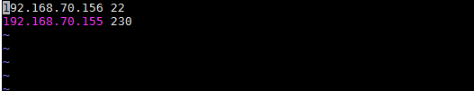

1. give read and write permission in the **/var/log/firewalllist**

3. add the scripts into the zabbix external scripts folder

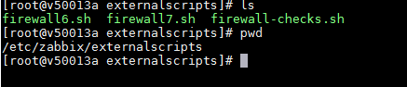

3. add user parameter in the zabbix-agent.conf file



4. give scripts appropriate permission

5. restart the agent