{{signature_record.envelope_id}}

{{signer.email}} Party ID: {{signer.party_id}} IP Address: {{signer.ip_address}}

Multi-Factor
Digital Fingerprint Checksum
{{signer.digital_fingerprint_checksum}}

{{signer_2.full_name}}

Party ID: {{signer_2.party_id}} IP Address: {{signer_2.ip_address}}

Multi-Factor
Digital Fingerprint Checksum
{{signer_2.digital_fingerprint_checksum}}

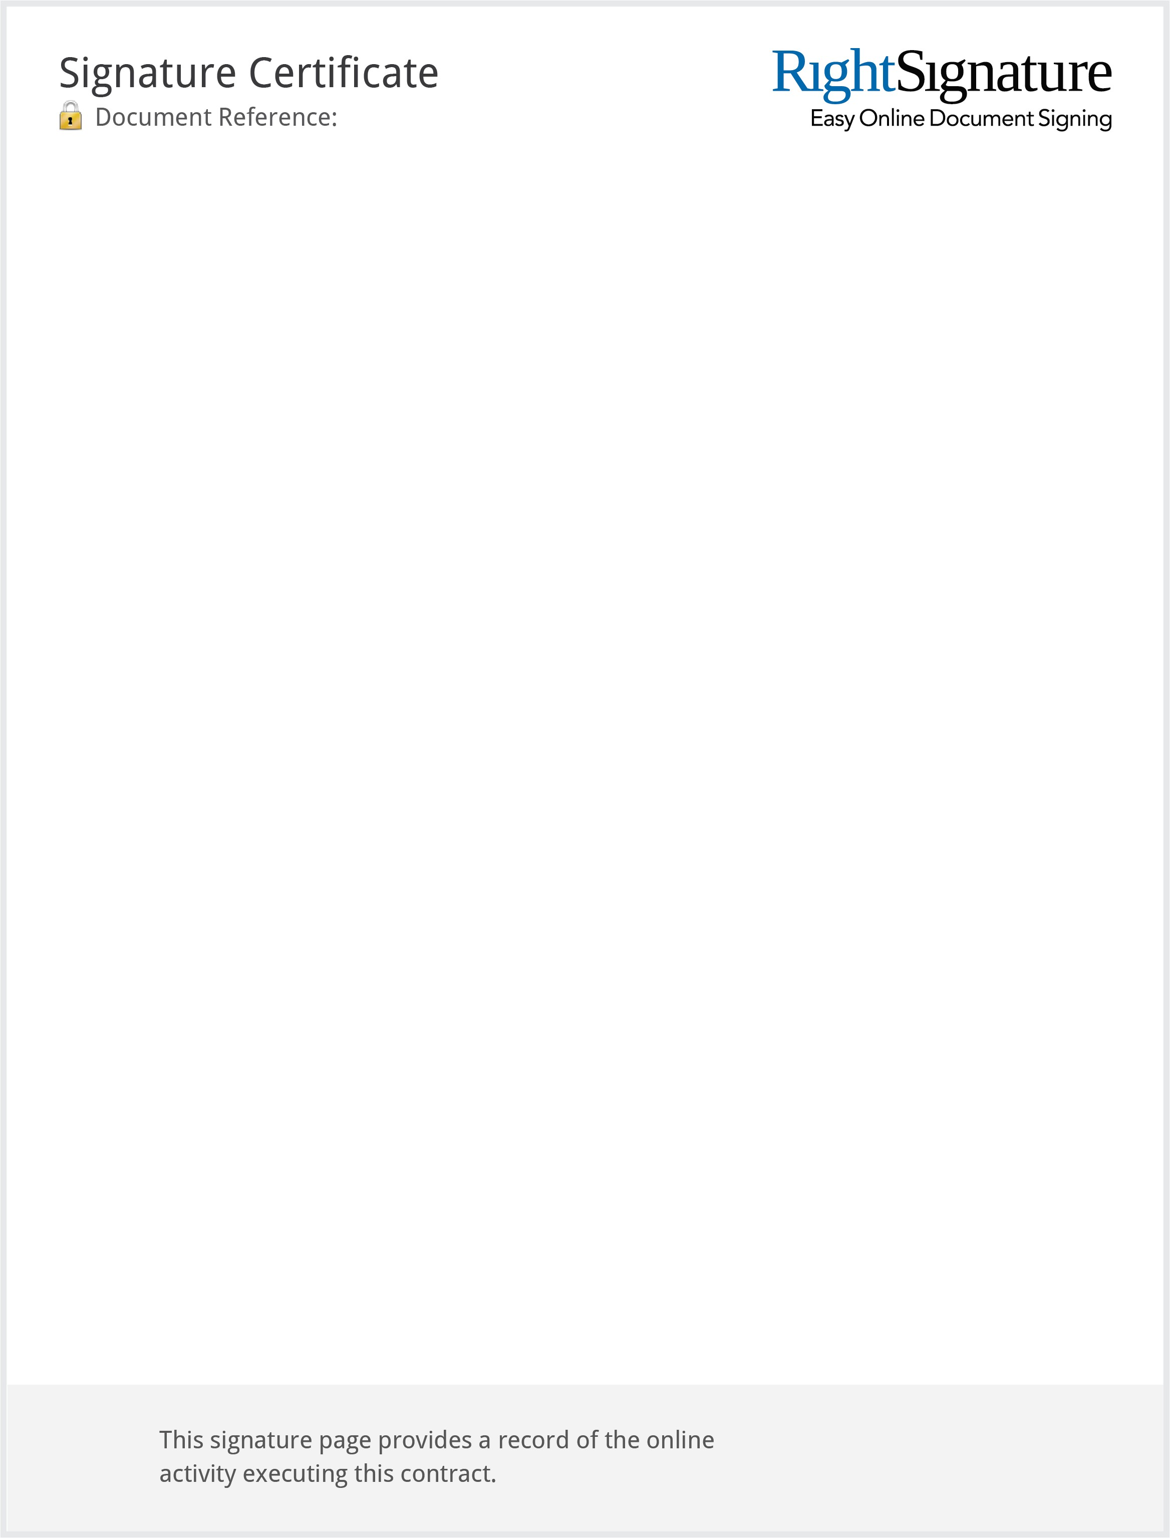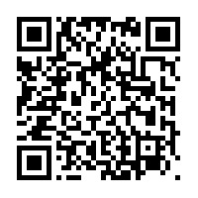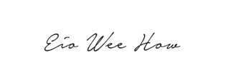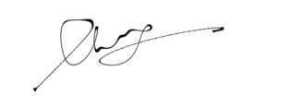

Timestamp Audit
{{signature_record.audit_line_1}}
{{signature_record.audit_line_2}}
{{signature_record.audit_line_3}}
- 202.190.154.18
{{signature_record.audit_line_4}}
2019-02-13 00:05:44 -0800 Document viewed by marcus.angsincgroup.com (noemail@rightsignature.com). -
45.119.153.91
{{signature_record.audit_line_5}}
- 103.11.190.99

Page 1 of 2

{{signature_record.envelope_id_page_2}}

{{signer.full_name}}

Party ID: {{signer.party_id}} IP Address: {{signer.ip_address}}
{{signer.email}}

Multi-Factor
Digital Fingerprint Checksum

{{signer.digital_fingerprint_checksum}}

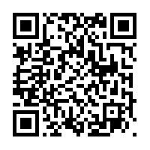

Timestamp Audit
{{signature_record.audit_line_1}}
{{signature_record.audit_line_2}}
{{signature_record.audit_line_3}}
{{signature_record.audit_line_4}}
202.190.154.18

Page 2 of 2

