Não realize nenhuma alteração
nesta página do template
Esta revista é (e sempre foi) eletrônica para ajudar a proteger o meio ambiente, mas, caso deseje imprimir esse artigo, saiba que ele foi editorado com uma fonte mais ecológica, a Eco Sans, que gasta menos tinta.

The Algorithmic Autoregulation

SOFTWARE DEVELOPMENT Methodology

Espaço para incluir os autores, na versão definitiva
(por ora, deixar em branco)

Autor 1
departamento dentro da instituição – nome da instituição (sigla da instituição)
nonono@nonono.edu.br
Autor 2
departamento dentro da instituição – nome da instituição (sigla da instituição)
nonono@nonono.edu.br
Autor 3
departamento dentro da instituição – nome da instituição (sigla da instituição)
nonono@nonono.edu.br
ABSTRACT
We present a new self-regulating methodology for coordinating distributed team work called Algorithmic Autoregulation (AA), based on recent social networking concepts and individual merit. Team members take on an egalitarian role, and stay voluntarily logged into so-called AA sessions for part of their time (e.g. 2 hours per day), during which they create periodical logs — short text sentences — they wish to share about their activity with the team. These logs are publicly aggregated in a Website and are peer-validated after the end of a session, as in code review. A short screencast is ideally recorded at the end of each session to make AA logs more understandable. This methodology has shown to be well-suited for increasing the efficiency of distributed teams working on what is called Global Software Development (GSD), as observed in our experience in actual real-world situations. This efficiency boost is mainly achieved through 1) built-in asynchronous on-demand communication in conjunction with documentation of work products and processes, and 2) reduced need for central management, meetings or time-consuming reports. Hence, the AA methodology legitimizes and facilitates the activities of a distributed software team. It thus enables other entities to have a solid means to fund these activities, allowing for new and concrete business models to emerge for very distributed software development. AA has been proposed, at its core, as a way of sustaining self-replicating hacker initiatives. These claims are discussed in a real case-study of running a distributed free software hacker team called Lab Macambira.
Key-words: AA; GSD; global software development; distributed development; hacking; free software

IntroduCTION
One of the defining features of modern times is the widening geographical distribution of software teams (LAST, 2003) leading to what is called Global Software Development (GSD) (GERMAN, 2003; FRYER, 2013; BEGEL, 2013). Paramount examples stem from the free software movement. Projects and institutions such as Mozilla Foundation have several employees and thousands of voluntary and freelance developers distributed across many countries. The same is true for GNOME (GERMAN, 2003), OpenBSD, MySQL or Apache Software Foundation, to cite a few of the most active projects. Beyond the free and open source software communities, GSD has a growing popularity in every niche of the software industry as a whole, even among those distributing their software solely with proprietary licenses. This phenomenon is attributed to a variety of factors such as the opportunity to harness a much larger labor pool, the massive globalization of software companies at their foundations or even the search for cheaper production costs (KOMI-SIRVIO, 2005).
Despite the clear advantages of GSD, it is often associated to difficult problems as series of qualitatively new situations arise. For intance, the problem of coordinating and funding free software initiatives on an expressively larger scale than currently practiced is widely held as a tough challenge. Distributed teams are highly heterogeneous, comprising not only volunteers and very experienced developers, but also contractors and freelancers from different backgrounds and cultures. These observations are founded on the factors suggested by Carmel (CARMEL, 2001) as main difficulties for GSD: geographic, temporal and cultural differences. In the case of free or open software projects, all such factors are exacerbated, specially given the need to reliably profit in a wildly heterogeneous environment in order to scale up.
Another problem faced by modern software companies and other collectives is the rise of frequent ineffective meetings, which are seldom focused on the particular interest of any attendant. As a result it has become the norm to take part in too many meetings with open laptops and flashing mobile gadgets, which can be unproductive. Software developers have a valuable creative tendency – they find it enjoyable to code, to be hands-on with their project, to do what they are best at. They despise having to forcibly stop for meetings or to do other bureaucratic activities such as writing lengthy reports to justify their funding (THOMPSON, 2012). In GSD, there is a heavier demand on team coordination which, in the abscence of a proper methodology, can lead to excessive and ineffective on-line meetings and bureaucracy. Intrinsic geographic, temporal and cultural differences lead to unavoidable issues such as network latency, calling for a different strategy.
To address these matters is the purpose of the AA methodology reported here and the associated software system for coordinating distributed team work designed to tackle the disadvantages of GSD. Team members take on an egalitarian role, and stay voluntarily logged in the system for part of their time (e.g. 2 hours per day), during which they log a periodical short text sentence or microlog — similar to a ‘tweet’ from Twitter — to sample the status of their activity. Logging is carried out using a series of client UI alternatives: UNIX shell commands, native GUI or Web page, conventional social network posts, or chat messages to a log bot listening to IRC, GTalk, G+, and others. These “microblog sentences” are publicly aggregated and validated by other team members. Through AA, the community has a methodology and an associated system to help implement and validate the activities of a distributed software team. It implicitly legitimizes financial support for scaling up the activity of a distributed development team. The AA methodology is specially useful for coordinating distributed and decentralized team work, providing effective means to asynchronously update different team members without the need for synchronous unproductive meetings, while ensuring baseline productivity.
A brief overview of current work in GSD methodologies related to AA is presented in Section 1. In Section 2 the most relevant characteristics of the AA methodology are outlined; we report an actual use case of AA for coordinating a team of 9 paid developers during the second half of 2011, as well as a broader use case of AA from 2012 to 2014. Section 4 lists overall conclusions and indications of future possibilities for the practical use of AA in other types of teams of software developers or organizations working on non-software distributed activities.

1. RELATED WORK
There has been a large amount of research on methodologies to deal with distributed teams of developers. Although this paper focuses on GSD, many of its principles can be brought back down to the conventional setting of smaller teams of developers working at nearly the same place, timezone and with minor cultural differences, depending on the specific context and demands. Moreover, ‘distributed development’ is generally regarded as being global, which is not always true. For instance, AA has been effectively applied to teams whose members live in the same city but work at different timeframes at different locations, see Section 3. Even smaller groups of developers working on the same building could use GSD methodologies (or an adapted subset) to their benefit, e.g., to account for different work habits, minimize formal meetings, document work process and history, and so on. A thorough survey of distributed GSD methodologies is beyond the scope of this paper; this section presents but a brief overview.
Various methodologies for GSD were built around the factors that affect distributed teamwork. As proposed by Carmel (CARMEL, 1999), these comprise three distances: geographical, cultural and temporal. First, geographical distance handicaps (i) coordination, the act of integrating all the tasks distributed between units (CARMEL, 2001); (ii) control, or the process to maintain specific goals, policies or quality levels; and (iii) communication. All those factors are correlated, e.g., a team needs to have clear communication to work on tasks of a specific problem.
Second, cultural distance encompasses differences in organizational and natural culture. Spoken language, individual and ethnic values are common dimensions impacting such distance. Some companies prefer to allocate development units to foreign locations with minimum cultural variance, e.g., an American company may prefer Ireland due to spoken language similarity (CARMEL, 2001). Third, temporal distance hampers synchronous communications such as telephone or video conferences. Units of developers working on different time-zones are concerned with managing their agenda in the face of temporal dissimilarity.
Targeting geographical distance, Carmel (CARMEL, 2001) suggests a strategy to mitigate reliance on synchronous collaboration. His approach divides the software life-cycle into levels of complexity, each having a degree of collaboration. For example, some developers working on a project with high collaboration demands should use the follow-the-sun approach: when concluding the work day, they pass their work to the team working in another time-zone. Other tactics are suggested by the same author to deal with the three distances, such as separating foreign units of developers in time-zone bands.
Battin et. al. (BATTIN, 2001) propose and discuss their experiments using specific methodologies created for the distributed development centers from Motorola (at the time having 25+ software development centers worldwide). These methodologies included constant communication with critical units, incremental integration and schedules based on time-zones of developers distributed over 6 countries from 3 different continents.
In considering free software projects, similar factors are present and more specialized methodologies arise. German (GERMAN, 2003) provides a concise review of the methodologies used by the GNOME project, one of the most active of all free software projects. The manuscript is centered on software architecture. It begins by explaining that GNOME is separated into modules (76 on version 2.4, to be precise) and each module has one maintainer who divides her modules into separate parts within which other developers can work on independent tasks, along other responsibilities. All development is carried out using modern standard free software engineering tools: a bugtracker for bug and issue management, mailing lists and Internet Relay Chat (IRC) for discussion and communication, and a version control system like Git or Mercurial. Periodic (commonly yearly) conferences like GUADEC are held for face-to-face meetings and are hosted in a different location each time, a common practice on other free and open source projects.
Other major free and open source projects employ similar development strategies and tools, with relatively minor variations. The Scilab team, who needs to tackle a complex software system related to Matlab, employs similar software engineering tools as GNOME but focuses on Git and code reviews. There is also a yearly periodic conference ScilabTEC in addition to adhoc meetings with freelancers. Major development-related modifications to Scilab are proposed by the greater community through Scilab enhancement proposals – SEPs, which are requests for enchancements augmented with design proposals.
We have collaborated with Scilab directly as individual developers, through Google Summer of Code, and through an instance of freelance development funded from France by Scilab Enterprises to our collective Lab Macambira and universities in Brazil. Freelance development was centered on implemented features – main developers set the desired features to be implemented, and the freelancers stipulate a price to be charged per feature. Some payment was anticipated before the work starts, and the other half secured only when the features had been fully implemented. Deadlines were motivated by payment or else set according to milestones for the next release. The development process was otherwise losely managed and undocumented, so that ambitious goals were avoided due to the risk of no payment nor side products of hard work.
Most other major free and open source software such as Blender for 3D modeling, the PureData real-time multimedia programming project and the VXL computer vision libraries, all of which we have helped develop, employ the aforementioned tools except for codereview. Similar to GNOME, these software systems are stable enough to be well organized into conceptual modules and file structure, enabling most changes and communication to be localized to module maintainers or past committers. Collective goals and major changes are coordinated directly via e-mail and IRC with the appropriate module maintainer.
The big problem with the above development approaches is that, to this date, free and open source development models have not managed to consistently scale up production levels to match top quality traditional closed-source software in many important niches. Some challenging examples include producing professional-grade multimedia applications through the current free software development model such as nonlinear video editors, complex videogames, high throughput real-time video applications, interactive music synthesizers, and scientific visualizers (Matlab, Mathematica and Maple). The simple and direct ways in which the proposed methodology improves upon the above approaches as to promote funding and productivity is discussed in Section 3.

2. THE AA METHODOLOGY
Some of the strategies for GSD mentioned in the previous section are based on
complex methodologies and many were built for a specific company or software center. This section describes an alternative methodology based on a simple idea: small working sessions logged by a computational tool. Figure 1 summarizes this methodology.

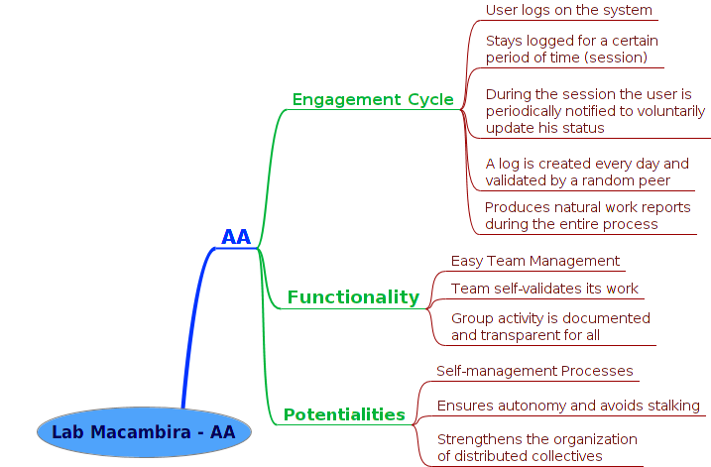
Figure 1: A mindmap of the AA methodology: 1) ‘developer engagement cycle’, i.e., his use of AA; 2) ‘functionality’, i.e., main goals of the system; 3) ‘potentialities’, i.e., enhancements AA delivers to the developer’s context.

2.1 THE AA SESSION
From the developer’s perspective, the AA methodology is based on generating small, high level reports called micrologs or AA shouts of what they are doing in a specific period of time. This timeframe can be between 5 to 15 minutes in our proposed practice, depending on what is most convenient for the developer and the team. An AA Session is a focused period of continuous work, lasting about 2 hours in our proposed regime, in which the developer issues a collection of these short periodical micrologs. The developer can set reminders or alerts to show up when it is time to microlog. The objective of the flexible timeframe and alert scheme is to minimize developer overhead during his AA session. In this way, the developer can issue micrologs while staying maximally focused in his code. Each microlog may be sent directly to an on-line server, or stored locally in a temporarily database for sending/pushing later on. This enables offline micrologging and periodical alerting.
Developers optionally record a brief video screencast at the end of the session summarizing what has been done, explaining his goals and challenges in his own words and showing his most important results. This is very similar to the video logging system in the movie Avatar, although it is clear, from July 2011 git repositories and online wiki, that we have used this powerful concept in AA independently of any major mass media incident. Moreover, screencasting differs from general videologging in that it typically captures actual workflow on the computer screen. Screencasting, combined with the textual log of the AA Session, renders the final report more understandable for the individual developer himself and to other people searching for information about his production.

2.2 THE AA WEBSITE REPORT
All AA reports made by the developers are ultimately sent to a Web server and become publicly aggregated on a Website called pAAnel (Figure 2). It is then possible for a manager or another developer to follow very closely the work of a given developer, nearly real-time, reading each of his small reports or micrologs of what he is working on.
Another possibility is to check older sessions to check when certain tasks were carried out and the comments of the developer about the process. Since each AA microlog happens in a very short timeframe of work, the information about what was done – specially how it was done – becomes very easy to understand, as opposed to having a long report in the end of a session.
In the current version of the AA server infrastructure, the aggregating web-site allows the developer to attach a link for his screencast about each session. Screencasts are specially useful on cases where the small reports were done in a hurry, because the developer did not want to lose his focus on something critical at that moment.
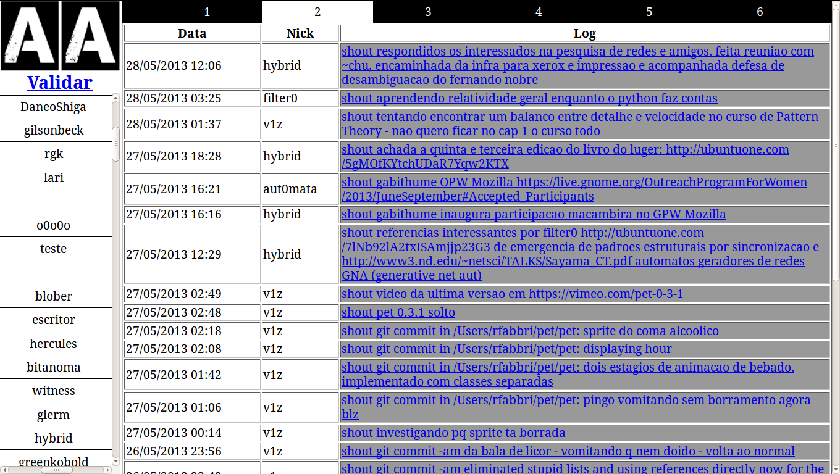
Figure 2: AA Report Agregator Version 0.1. Messages of users hybrid, filter0, v1z e aut0mata about activities of interest for labMacambira.sf.net and a diversity of collaborating entities (IPRJ/UERJ, IFT/UNESP, IFSC/USP, OPW/Mozilla, PulaPirataComics). Each message is a “shout”, which, grouped, forms an AA session.

2.3 PEER VALIDATION
No set bosses or leaders are required in an ideal application the AA methodology; in practice, the role of bosses basically disappears or is greatly alleviated – hence the name Algorithmic Autoregulation and other implicit interpretations to the AA acronym and symbol. The primary mechanism to achieve AA is peer coordination and social behavior, be it deliberate or implicit. In order to prevent spamming and to improve the overall quality of AA reports, each AA session must be validated by another developer. More specifically, all reports are read by someone that will mark them collectively as ‘valid’ or ‘invalid’ and may optionally write commentaries about the specific session and quality of micrologs. The developer in charge of validating any given session is randomly assigned by the AA Web server, which sends an email to the chosen developer with an URL to a validation interface.
Peer validation also helps in making decentralized collaboration more cohesive by encouraging members to be minimally aware of peer activities, even when these are not immediately useful for accomplishing the task at hand. Authors have observed that decentralized teamwork can get so efficient at actual production that the team gets short-sighted in terms of coordination: non-communicating subteams can get formed in practice if care is not taken, causing a fragmentation of the collective. Peer validation is one way to help avoid fragmentation and is an essential mechanism of decentralized team autoregulation.

3. results and discussion
Easy and effective GSD team management is the main purpose of the AA methodology. The proposed methodology was applied to a group of 9 developers in July of 2011, 3 of which are coauthors of the present work, on what was named Lab Macambira.The main objective of the team was to work on an array of strategic free software projects in the broad audiovisual and web categories, contributing directly to their development, submitting bug patches or committing new features to their source code.
The team members had different levels of experience on software development for large and distributed free software projects like Scilab or Mozilla. In this way, one month of training was conducted by three experienced developers (the first authors of the present work), teaching the basics of use of development infrastructure tools like bugtrackers, programming languages, version control systems, and build systems. After this period, a starter project was proposed for new developers: to submit a bugfix or implement a new feature and have an accepted patch or commit to the official repository for a large free software project. Developers passing the starter project would be deemed ‘initiated’ and be called a ‘Macambira’ developer, and be hired for the remainder of the semester. To illustrate the coverage of overall contributions by ‘Macambira’ developers, Table 1 summarizes the effective accepted commits of each successfully initiated developer to free software projects in 2011, which used the AA methodology.

Table 1: Free and open software projects that received contributions from successfully initiated developers or ‘Macambiras’ that worked under the AA methodology. The first column lists applications to which contributions were officially accepted and whose development process was tracked using AA. The second column shows the pseudonym of the “committers”. At Lab Macambira it is common practice to use pseudonyms in AA as identification in order to enhance privacy.
Application | “Commiters”
Mozilla Firefox | daneoshiga, bzum
Evince | hick209, bzum, marcicano, mquasar
BePDF / Xpdf | marcicano
Ekiga | flecha
Empathy | fefo
Lib Folks (Telepathy) | kamiarc
Scilab | v1z, humannoise
VxL | v1z
ImageMagick | v1z
OpenOffice | hick209
Puredata | v1z, automata, greenkobold, gilson, bzum
Puredata OpenCV | v1z
Puredata GEM | v1z, fefo, hick209
Puredata PDP | v1z, fefo, hick209
ChucK | rfabbri, automata
ChucK MiniAudicle | rfabbri, automata
Mozilla Firefox WebRTC | automata
OSC-Web | automata
Live-Processing | automata
Chuck-Wiimote | automata
Audiolet | automata
Extempore | automata

In one month, each developer officially contributed to one or many free software projects. Many developers started the initiation training with no knowledge of what is free software and ended that period becoming a free software developer. During that month, the same team of trainees also developed the first version of the AA system and used AA to manage their activities, even while developing the other aforementioned free software projects. Thus, AA and the associated software system was tested, prototyped, and developed in close contact with actual practice. The source code of AA — both the client that sends the logs and the AA Web server — is public available as free software and all the actual AA log data of the entire team of Lab Macambira from 2011 to the present time is also on-line.
After the initial training period of 1 month, the initiated ‘Macambiras’ worked during 6 additional months on a large range of free software projects, divided into work groups — each work group focusing on a specific theme like video, audio and web — and funded by contracts, freelance, and support of the Pontão Nós Digitais. Table 2 has a list of new free software applications created by ‘Lab Macambira’ since July 2011.

Table 2: Software projects created by Lab Macambira since July 2011 with a short description and the technologies involved (e.g., programming languages or frameworks). It is interesting to note the heterogeneity of projects and their areas of application.
Application | Description | Technologies
AA | Algorithmic Autoregulation | Python, PHP
Ágora Communs | System for online deliberations | PHP
SIP | Scilab Image Processing toolbox | C, Scilab
Animal | An Imaging Library | C
TeDi | Test Framework for Distance Transform Algorithms | C, Shellscript, Scilab
Macambot | Multi-use IRC Bot | Python
Conferência Permanente | Platform for the permanent conference of the rights of minors | PHP, JavaScript
CPC | Center for accounting of the Brazilian culture representation groups | Python, Django
Timeline | Interactive time lines on the Web | JavaScript
Imagemap | Interactive marking for on-line photos | JavaScript
ABT | Program for real-time execution and musical rhythmic analysis | Python
EKP | Emotional Kernel Panic | Python, ChucK
SOS | Aggregation and diffusion of popular and native knowledge about health | Python, Django
Creative Economy | Platform for creative, collaborative and solidarity economy of the culture hubs and cultural entities | Python, Django
OpenID Integration | Adaptations to existing software for unified login through OpenID | PHP
pAAinel | Dashboard for the real-time visualization of Lab Macambira activity | Python, Django
Georef | Collection of scripts to be used as reference, which aims to be a GIS platform to map public data of use to citizens | Python, Django
AirHackTable | Software for an instrument which generates sound from flying origami tracked by webcams | Puredata, C++, Scilab

While using the AA system, developers learned to work asynchronously with others and got used to the habit of periodically updating their status on their projects. Each programmer was given the chance to work with considerable freedom, in any place and time of preference. The strictest required responsibility was that of using AA for at least one session of 2h per day, while working on the agreed tasks. The online pAAnel allowed each developer to quickly grasp activities from others while avoiding interrupting them, a process further aided by the screencasts. Adjustments to the task deadlines and milestones (which were managed in Trac) were done based on verified progress of individuals and labMacambira.sf.net team as a whole. The various newcomers benefited from a fast learning team by the use of AA as a flexible and simple transparency system. Updates from the team were not transmitted in a person-to-person basis, but rather in a person-to-team basis based on the available online progress information.
As of this writing, ‘Lab Macambira’ unites over 15 software developers, and key developers trained in 2011 continue to work voluntarily in the project and as voluntaries and contracted developers on fundations like Mozilla.

4. conclusions
In a scenario where Global Software Development is growing as a popular form of software development across the entire software industry, there is an increasing need for methodologies to deal with its potential disadvantages and at the same time amplify its advantages. This paper has presented the AA methodology, designed for a series of large or small groups of software developers, working on different countries or at the same room. The methodology is built around a simple system where each developer takes note of his work by posting a periodic log of short text sentences or micrologs. The sum of those activity logs, along with an entire session of work, results in a complete unit of report. The report is made publicly available through a Website and is validated by peers that are randomly selected by the AA Web server. Real-world data on practical experience with this approach has been collected and reported, involving a team of paid free software developers, Lab Macambira, which since 2011 has developed new free and open source software for a vast number of high-end applications using AA.
AA is not limited to a work-management tool, but acts as a methodology to improve the temporal sensitivity and sensibility and of individuals, helping divide complex tasks in time into small chunks or sessions, and also reducing the need for extensive reports or unnecessary meetings. By asking users to publish minimal text sentences as a continuous log feed, the proposed methodology avoids disturbing the flow of developers which are heavily concentrated in programming. These developers just have to type a few task-related words and go back to coding; others get updated as needed for their task. Interruption-free communication is achieved – AA interruptions are in context, decentralized and maximally useful.
The AA methodology is not restricted to software development. As of this writing there is an entertainment studio, Pula Pirata, that has been using AA to manage their creative activities. Other people with no software background, like social scientists, musicians and activists also have been using AA and contributing for its broader improvement.
There are many aspects of the work which remain unfinished. Additional ubiquitous client interfaces for micrologging from different interfaces beyond IRC, e.g., web social services and email, would greatly make the use of AA easier and more widespread, turning AA a truly ubiquitous and replicable system, presented on everyday communication channels. Another research direction is that the actual work logs generated by the Lab Macambira and Pula Pirata collectives since July of 2011 could be statistically analyzed to recognize patterns in the behavior of individuals and their creative production process. It would also be desirable to provide more extensive experiments and psychological studies focusing on further backing specific claims made in this paper, in order to refine the methodology, its mechanisms and parameters.

ACKNOWLEDGMENTS
Authors acknowledge the financial support from Pontão Nós Digitais, and Ricardo Fabbri acknowledges support from FAPERJ/Brazil 111.852/2012. Authors also thank AA: the present research and even this manuscript was written using AA. The complete log is on-line at www.pulapirata.com/skills/aa. Finally, authors are also grateful to IFSC/USP, IPRJ/UERJ, IFT/UNESP and all AA users and collaborators, especially those who coded AA hacks for logging through shell and bots, and those who coded the different Web interfaces in use.

REFERENCES

FREYER, K, GOTHE, M. Global software development and delivery: Trends and challenges. http://www.ibm.com/developerworks/rational/library/edge/08/jan08/fryer_gothe/
BEGEL, A., NAGAPPAN, N. Global software development: Who does it? http://research.microsoft.com/apps/pubs/default.aspx?id=76911
BATTIN, R., CROCKER, R., KREIDLER, J., and SUBRAMANIAN, K. Leveraging resources in global software development. Software, IEEE, 18, 2, 70–77, 2001.
CARMEL, E. Global software teams: collaborating across borders and time zones. Prentice Hall PTR, Upper Saddle River, NJ, USA, 1999.
CARMEL, E., and AGARWAL, R. Tactical approaches for alleviating distance in global software development. Software, IEEE, 18, 2, 22–29, 2001.
GERMAN, D. M. The gnome project: a case study of open source, global software development. Software Process: Improvement and Practice, 8, 4 , 201–215, 2003.
GOBBO, F., and VACCARI, M. The pomodoro technique for sustainable pace in extreme programming teams. Agile Processes in Software Engineering and Extreme Programming, 180–184, 2008.
KOMI-SIRVIO, S., and TIHINEN, M. Lessons learned by participants of distributed software development. Knowledge and Process Management, 12, 108–122, 2005.
LAST, M. Understanding the group development process in global software teams. In: Frontiers in Education, 2003. FIE 2003 33rd Annual (2003), vol. 3, IEEE, pp. S1F–20.
REIS, C. R., and DE MATTOS FORTES, R. P. Caracterização de um Processo de Software para Projetos de Software Livre. PhD thesis, University of São Paulo, Brazil, 2003.
THOMPSON, C. Solo performance: shut up and start acting like an introvert. Wired 20.04 (April 2012), 036.

The open source network Ohloh has a more complete and constantly updated list of the most active projects on-line at www.ohloh.net.
LabMacambira.sf.net: http://labmacambira.sf.net.
AA source code: http://labmacambira.git.sourceforge.net/git/gitweb.cgi?p= labmacambira/aa.
Logs of AA sessions: http://labmacambira.git.sourceforge.net/git/gitweb.cgi?p= labmacambira/paainel.
http://nosdigitais.teia.org.br.
http://www.pulapirata.com.

