MATLAB Program for Elbow Segmentation

How to use the program?

- Go to “elbow_segmentation/bin/”
- Type main in the MATLAB command line window to run the program.
- Select the VTK image file you want to segment.
- Then, slices of the 3D volume are displayed. Using the slider, find the first slice containing a bony region. Click the button “First Slice”. Similarly, find the last slice with a bony region and click “Last Slice”. Once you are done, click “Continue”. (In this way, the algorithm will not spend time on slices which do not contain any bony region.)
- Then, the program asks if you want to load an existing edge file (.edg). This saves time if you already have an edge file produced by a previous run of the program. If there is no edge file associated with the image or you want to detect new edges with different settings, then please choose the option “Detect new edges”.
- Next, the program asks you to choose an algorithm. First try the “Edge Clustering” one which runs faster. If it doesn't produce any good results, please try the level-set segmentation option.
- Both algorithms produce an xyz file stored in “elbow_segmentation/oriented_points/”
- Open the xyz file using the program called MeshLab (http://sourceforge.net/projects/meshlab/files/meshlab/MeshLab%20v1.3.1/MeshLab_v131_64bit.exe/download) and run Poisson reconstruction as shown below. This will generate a 3D mesh. You can save the resulting mesh in a format you prefer.

Poisson reconstruction menu location
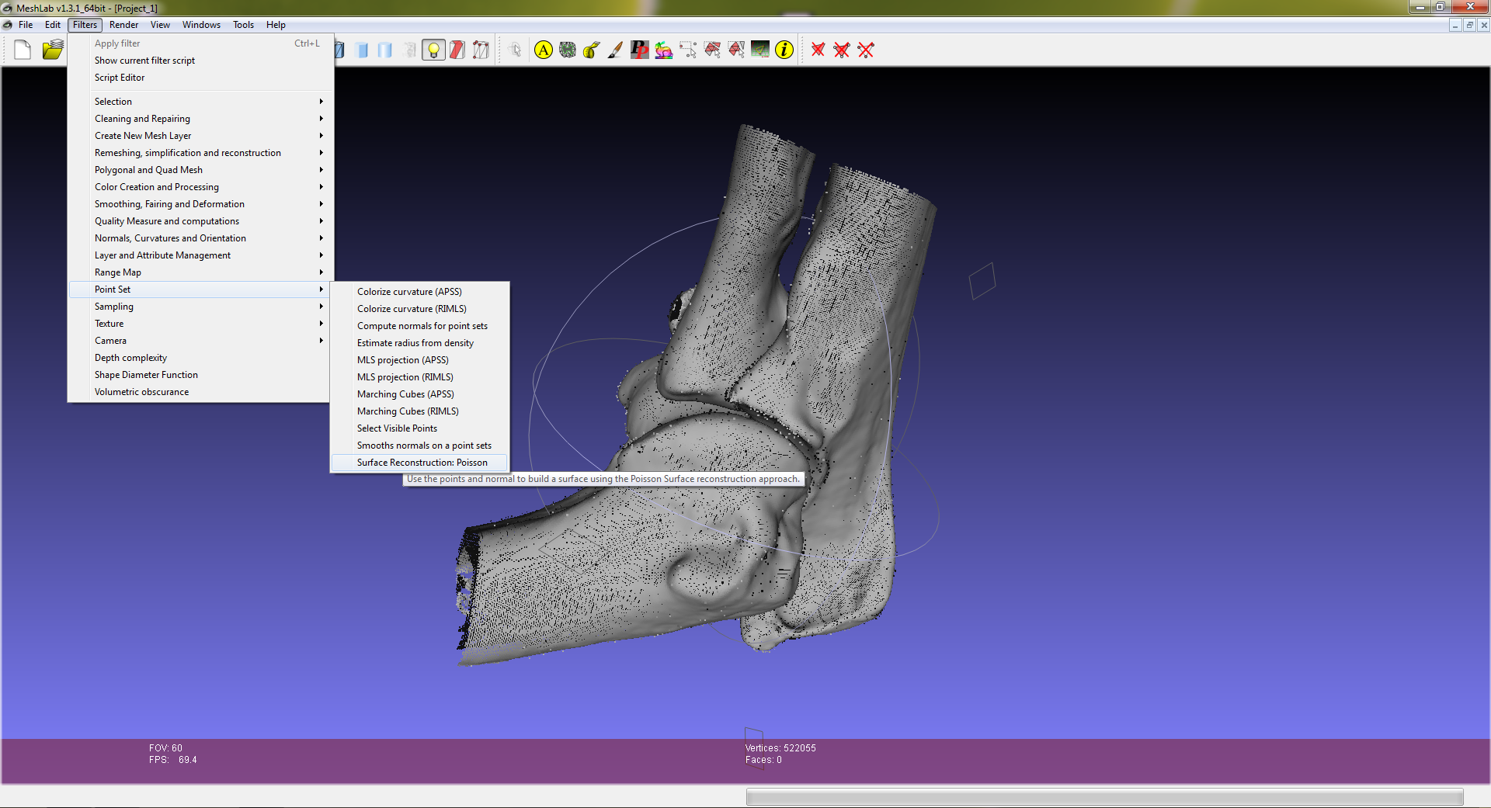

Use the parameters shown below
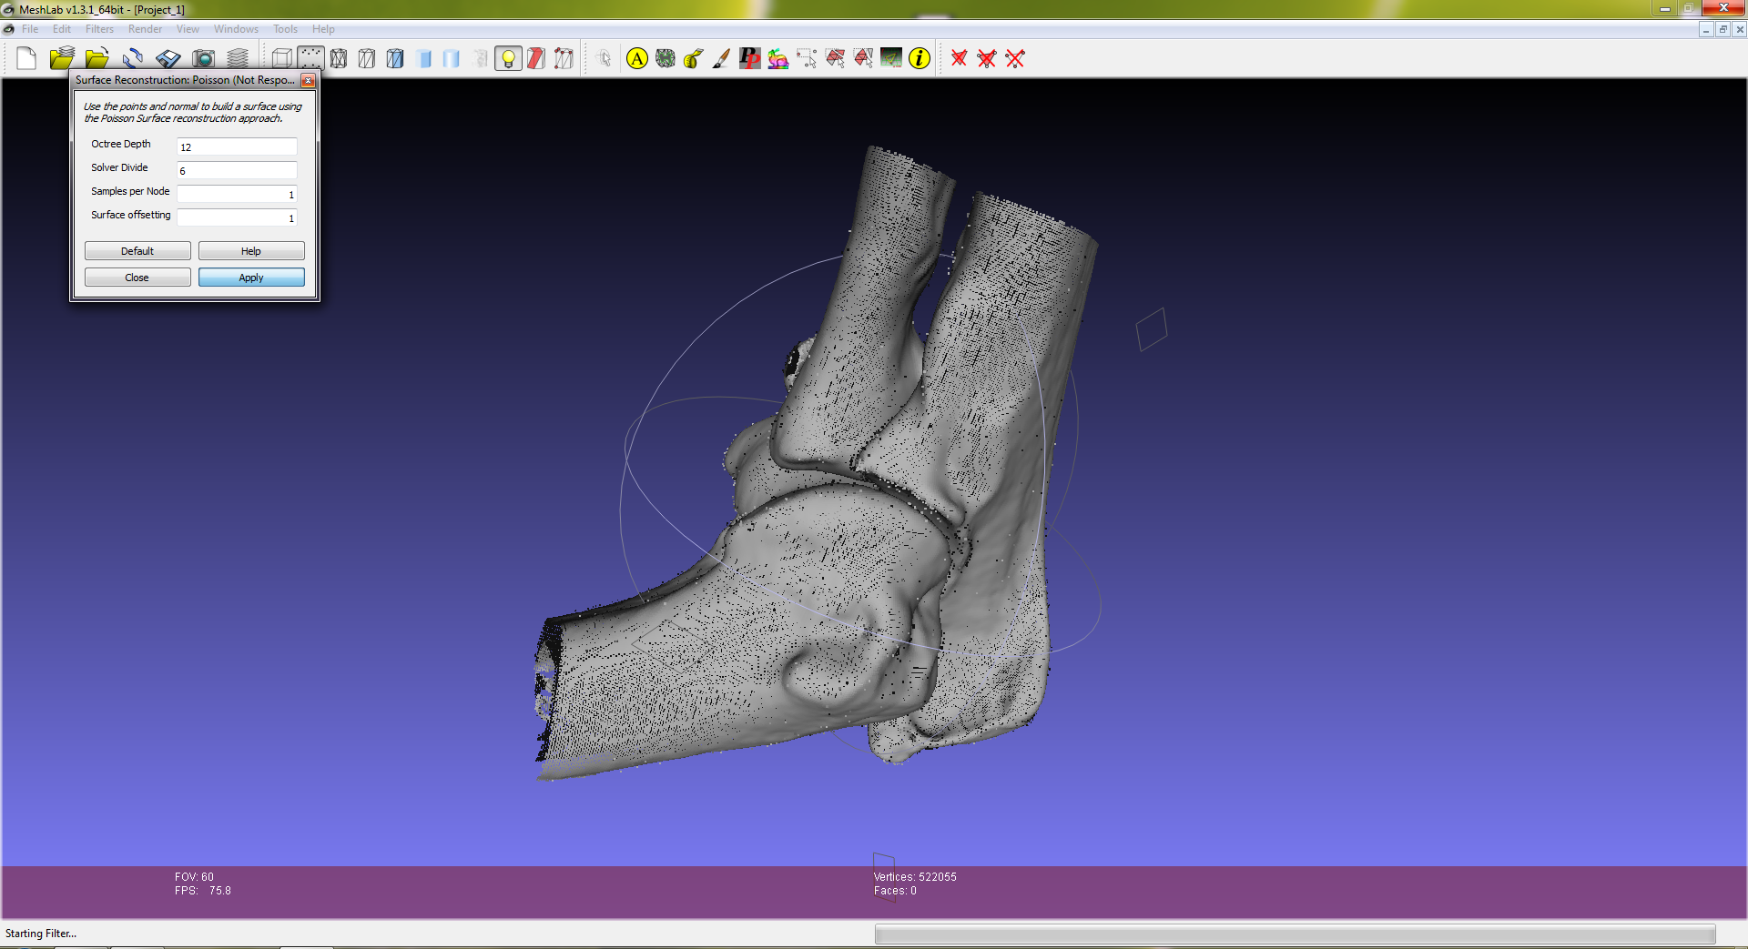

Click the smooth cylinder icon to visualize the mesh.
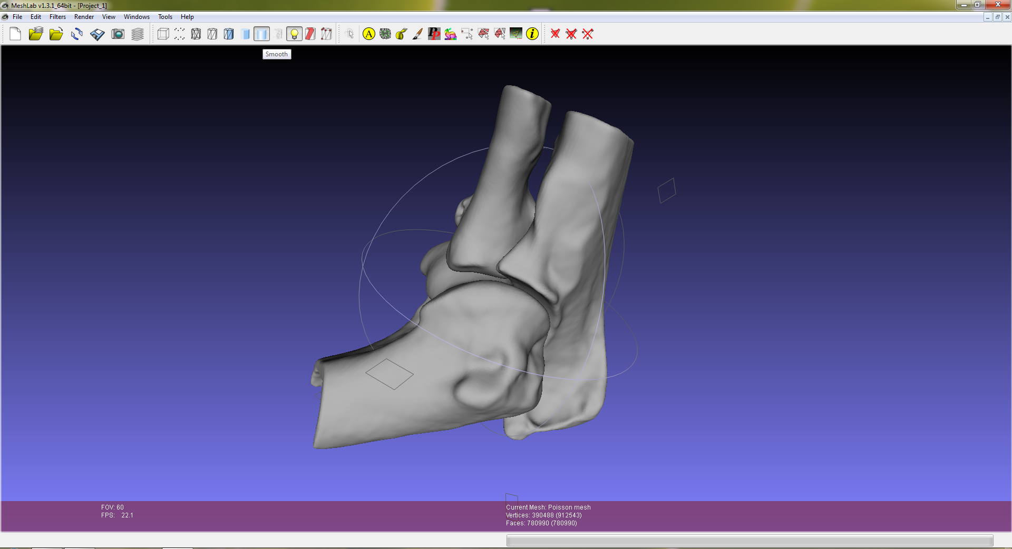
Notes:
- Please use 64 bit MATLAB and MeshLab since you might need more than 4GB of memory.
- Some features may require a recent version of MATLAB.
- Although it has only been tested on Linux, it should also work on 64bit Windows system.

If you have any questions, please contact Firat Kalaycilar (firat_kalaycilar@brown.edu)

