DBMS ASSIGNMENT SERIES

Assignment 3: Database Design Analysis
Campus Sustainability and ESG Assessment System
Student Name | Fabian Brice Rodrigues | Program | Bachelor of Computer Applications
Institution | Alliance University | Date | 23 October 2026
Project Topic | Campus Sustainability and ESG Assessment System | Assignment | Assignment 3

1. Objective
This assignment examines the initial (un-normalised) design of the Campus Sustainability and ESG Assessment System. It identifies data redundancy, explains how it causes insertion, deletion and update anomalies, lists the functional dependencies between attributes, and proposes an improved design that satisfies Third Normal Form (3NF). The improved design is the finalized design implemented in Assignments 5 to 9.

2. System Overview
The system helps a university campus measure its Environmental, Social and Governance (ESG) performance. Trained assessors visit campus facilities (academic blocks, hostels, laboratories, the library, the cafeteria and so on) once per academic year and record the measured value of several ESG indicators such as electricity consumption, waste recycling rate or accessibility compliance. Each measured value is compared with a target to judge whether the facility is compliant. Separately, the campus runs sustainability initiatives (for example rooftop solar) that have budgets and statuses.
The main real-world entities are therefore departments, facilities, assessors, ESG categories, ESG indicators, assessments, assessment results and sustainability initiatives.

3. Initial Design: A Single Flat Table
A common first attempt (and how the data would look in a spreadsheet) is to store everything about an assessment in one wide table. The initial design is called esg_flat. A row records one measured indicator of one assessment, so it repeats all facility, department, assessor and indicator details every time.
INITIAL DESIGN - DDL

CREATE TABLE esg_flat (
assessment_id INT NOT NULL,
assessment_date DATE,
academic_year VARCHAR(7),
facility_id INT,
facility_name VARCHAR(80),
facility_type VARCHAR(30),
floor_area_sqm DECIMAL(10,2),
dept_id INT,
dept_name VARCHAR(80),
building VARCHAR(40),
dept_head VARCHAR(60),
assessor_id INT,
assessor_name VARCHAR(60),
assessor_email VARCHAR(100),
indicator_id INT NOT NULL,
indicator_name VARCHAR(80),
category_name VARCHAR(20),
unit VARCHAR(30),
target_value DECIMAL(10,2),
measured_value DECIMAL(10,2),
PRIMARY KEY (assessment_id, indicator_id)
);

The table was loaded with the same 71 sample measurements that are later stored properly in Assignment 7. A selection of its rows is shown below.
SAMPLE ROWS OF ESG_FLAT
assess_id | facility_name | dept_name | dept_head | assessor_name | indicator_name | category | value
7 | Block A CSE Wing | Computer Science and Engineering | Dr. Meenakshi Rao | Prof. Rohit Sharma | Electricity Consumption | Environmental | 11.21
7 | Block A CSE Wing | Computer Science and Engineering | Dr. Meenakshi Rao | Prof. Rohit Sharma | Solar Energy Share | Environmental | 33.80
7 | Block A CSE Wing | Computer Science and Engineering | Dr. Meenakshi Rao | Prof. Rohit Sharma | Accessibility Compliance | Social | 99.60
7 | Block A CSE Wing | Computer Science and Engineering | Dr. Meenakshi Rao | Prof. Rohit Sharma | Policy Compliance Score | Governance | 99.60
8 | Block B Management Centre | Business Administration | Dr. Arvind Kulkarni | Prof. Rohit Sharma | Electricity Consumption | Environmental | 11.77
8 | Block B Management Centre | Business Administration | Dr. Arvind Kulkarni | Prof. Rohit Sharma | Solar Energy Share | Environmental | 29.88
8 | Block B Management Centre | Business Administration | Dr. Arvind Kulkarni | Prof. Rohit Sharma | Accessibility Compliance | Social | 91.55
8 | Block B Management Centre | Business Administration | Dr. Arvind Kulkarni | Prof. Rohit Sharma | Policy Compliance Score | Governance | 93.11

Even with only two assessments the repetition is obvious: the facility name, department, department head and assessor are stored again on every row.

4. Data Redundancy
Redundancy means that the same fact is stored in more than one place. The query below counts how many times the same department fact is physically stored in esg_flat.
REDUNDANCY OF DEPARTMENT FACTS

SELECT dept_id, dept_name, dept_head, COUNT(*) AS times_stored
FROM esg_flat
WHERE dept_id IS NOT NULL
GROUP BY dept_id, dept_name, dept_head
ORDER BY times_stored DESC, dept_id;

OUTPUT
dept_id | dept_name | dept_head | times_stored
1 | Computer Science and Engineering | Dr. Meenakshi Rao | 11
2 | Business Administration | Dr. Arvind Kulkarni | 8
6 | Physical Education and Sports | Mr. Naveen Prabhu | 8
3 | Environmental Science | Dr. Shalini Menon | 4
4 | Mechanical Engineering | Dr. Harish Gowda | 4
5 | Arts and Humanities | Dr. Farah Siddiqui | 4
7 | Estate and Facilities Management | Mr. Rajesh Hegde | 4

7 rows in set
The department name, building and head of Computer Science and Engineering are repeated on every row of every assessment of its facilities. The same holds for indicator names, units and targets, and for assessor names and e-mail addresses. Redundancy wastes storage, but its real danger is that it makes the data inconsistent when only some copies are changed.

5. Anomalies Caused by the Poor Design

5.1 Update anomaly
If the head of a department changes, the new name has to be updated in every row that mentions the department. If one row is missed (or a transaction stops half-way), the table now says two different things about the same department. The statements below simulate such a partial update (one row only) and then roll the change back.
UPDATE ANOMALY DEMONSTRATION

START TRANSACTION;
UPDATE esg_flat SET dept_head = 'Dr. Ritu Verma'
WHERE assessment_id = 7 AND indicator_id = 1;
SELECT DISTINCT dept_id, dept_name, dept_head
FROM esg_flat WHERE dept_id = 1 ORDER BY dept_head;
ROLLBACK;

OUTPUT
Query OK, 1 row affected
OUTPUT
dept_id | dept_name | dept_head
1 | Computer Science and Engineering | Dr. Meenakshi Rao
1 | Computer Science and Engineering | Dr. Ritu Verma

2 rows in set
Department 1 now has two different heads. To do this correctly the update must touch every one of the rows that carry the department's data.

5.2 Deletion anomaly
Facility and department facts exist only as part of an assessment row. Deleting the only assessment of a facility therefore destroys the facility's own data as well. The Administrative Block was assessed only once (assessment 13).
DELETION ANOMALY DEMONSTRATION

START TRANSACTION;
DELETE FROM esg_flat WHERE assessment_id = 13;
SELECT (SELECT COUNT(*) FROM esg_flat WHERE facility_id = 7) AS admin_block_rows,
(SELECT COUNT(*) FROM esg_flat WHERE dept_id = 7) AS estate_dept_rows;
ROLLBACK;

OUTPUT
Query OK, 4 rows affected
OUTPUT
admin_block_rows | estate_dept_rows
0 | 0

1 row in set
After removing one assessment, the Administrative Block and its owning department, Estate and Facilities Management, have vanished from the database completely, although we only meant to remove an assessment.

5.3 Insertion anomaly
The primary key of esg_flat is (assessment_id, indicator_id). A new facility, department, assessor or indicator cannot be stored until it takes part in an assessment, because the key columns cannot be NULL. For example, the newly built Innovation and Incubation Hub has not been assessed yet:
INSERTION ANOMALY DEMONSTRATION

INSERT INTO esg_flat
(facility_id, facility_name, facility_type, floor_area_sqm, dept_id)
VALUES (13, 'Innovation and Incubation Hub', 'Academic Block', 2400.00, 1);

OUTPUT
ERROR: NOT NULL constraint failed: esg_flat.assessment_id
Note: MySQL reports the same problem as: ERROR 1364 (HY000): Field 'assessment_id' doesn't have a default value. The facility cannot be recorded until an assessment exists for it, which makes it impossible to keep a master list of facilities.

6. Functional Dependencies
A functional dependency X -> Y means that the value of X uniquely determines the value of Y. By studying how the business works, the following dependencies hold in esg_flat:
ID | Determinant (X) | Dependent attributes (Y) | Meaning
FD1 | assessment_id | assessment_date, academic_year, facility_id, assessor_id | Each assessment happens on one date, at one facility, by one assessor
FD2 | facility_id | facility_name, facility_type, floor_area_sqm, dept_id | A facility has fixed descriptive data and belongs to at most one department
FD3 | dept_id | dept_name, building, dept_head | A department has one name, building and head
FD4 | assessor_id | assessor_name, assessor_email | An assessor has one name and one e-mail address
FD5 | indicator_id | indicator_name, category_name, unit, target_value | An indicator has a fixed name, unit and target and belongs to one category
FD6 | (assessment_id, indicator_id) | measured_value | One measurement per indicator in an assessment
FD7 | (facility_id, academic_year) | assessment_id | Business rule: a facility is assessed at most once in an academic year

Candidate key of esg_flat: (assessment_id, indicator_id) because together they determine every other attribute (FD1 to FD6 chained). Only FD6 depends on the whole key. FD1 to FD5 depend on part of the key or on non-key attributes, which is the cause of all the anomalies above.
There are also transitive dependencies, for example assessment_id -> facility_id -> dept_id -> dept_name, and indicator_id -> category_name. A non-key attribute (such as dept_name) is determined through another non-key attribute (dept_id).

7. How Poor Design Leads to the Anomalies
Anomaly | Root cause | Consequence
Update | Partial dependencies (FD1-FD5) copy the same facts into many rows | One real-world change needs many row updates; missing one leaves contradictory data
Deletion | Facility, department and assessor facts depend on assessment rows | Deleting an assessment accidentally erases the only copy of unrelated facts
Insertion | Key columns belong to the assessment and indicator, not to the entity inserted | Entities cannot be added until they take part in an assessment

8. Normalisation to Third Normal Form

8.1 First Normal Form (1NF)
A relation is in 1NF when every attribute holds a single atomic value and there are no repeating groups. esg_flat satisfies this because each row stores exactly one indicator measurement. A design that put several indicators in one cell (for example 'Electricity=11.6; Solar=4.2') would violate 1NF.

8.2 Second Normal Form (2NF)
2NF removes partial dependencies (non-key attributes that depend on only part of a composite key). FD1 to FD5 depend on assessment_id alone or on indicator_id alone, so they are moved out:
Relation after 2NF | Attributes
assessment | assessment_id (PK), assessment_date, academic_year, facility_id, facility_name, facility_type, floor_area_sqm, dept_id, dept_name, building, dept_head, assessor_id, assessor_name, assessor_email
esg_indicator | indicator_id (PK), indicator_name, category_name, unit, target_value
assessment_result | (assessment_id, indicator_id) (PK), measured_value

8.3 Third Normal Form (3NF)
3NF removes transitive dependencies: no non-key attribute may depend on another non-key attribute. In assessment, facility, department and assessor facts depend on facility_id, dept_id and assessor_id rather than directly on assessment_id; in esg_indicator, category_name depends on a category. Each of these groups becomes its own relation, linked by foreign keys:
Relation (3NF) | Primary key | Foreign keys | Other attributes
department | dept_id | - | dept_name, building, head_name
esg_category | category_id | - | category_name, description
facility | facility_id | dept_id -> department | facility_name, facility_type, floor_area_sqm, year_built, status
esg_indicator | indicator_id | category_id -> esg_category | indicator_name, unit, target_value, better_direction
assessor | assessor_id | dept_id -> department | assessor_name, email, designation
assessment | assessment_id | facility_id -> facility; assessor_id -> assessor | assessment_date, academic_year, status
assessment_result | result_id | assessment_id -> assessment; indicator_id -> esg_indicator | measured_value, remarks
sustainability_initiative | initiative_id | category_id -> esg_category; facility_id -> facility | initiative_title, start_date, end_date, budget_inr, status

In every relation each non-key attribute depends on the key, the whole key and nothing but the key. Every determinant of the final relations (dept_id, facility_id, assessor_id, indicator_id, category_id, assessment_id, and the alternate keys such as dept_name and email) is a candidate key, so the design also satisfies Boyce-Codd Normal Form. sustainability_initiative was added as a separate entity and is already in 3NF, since its descriptive attributes depend only on initiative_id.

9. Proposed Improvements to the Design
- Decompose into eight 3NF relations so that each fact is stored once (table above).
- Surrogate primary keys (dept_id, facility_id, ...) replace long text keys, keep foreign keys small and allow names to change without cascading updates.
- Lookup entity esg_category removes the repeated category text and gives a single place to maintain category descriptions.
- dept_id in facility is nullable because hostels, the library and the cafeteria are shared facilities that do not belong to one department.
- better_direction in esg_indicator records whether a higher or a lower value is better, so that compliance can be computed by a query instead of being stored (avoids a derived, redundant column).
- UNIQUE (facility_id, academic_year) implements business rule FD7.
- Constraints (CHECK, DEFAULT, NOT NULL, ON DELETE rules) enforce data quality; they are implemented in Assignments 5 and 6.
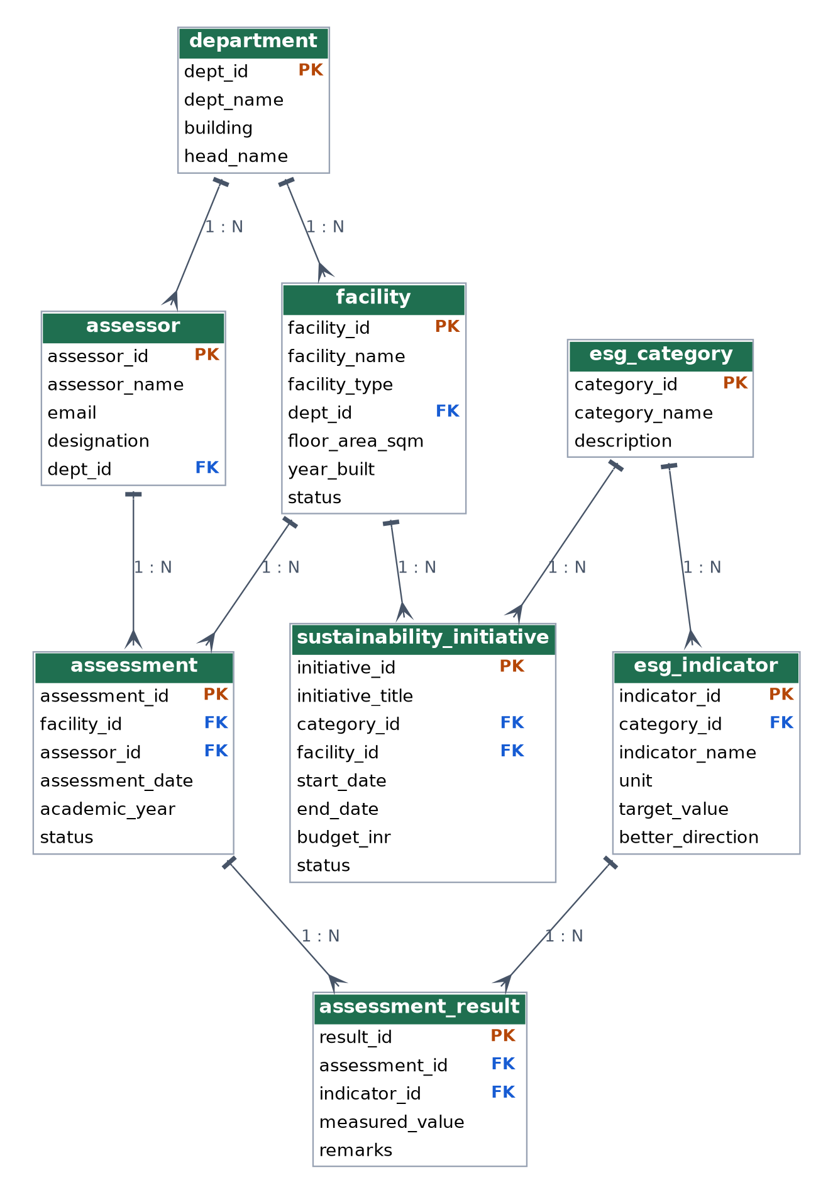
Figure 1: ER diagram of the finalized 3NF design (crow's-foot notation, PK = primary key, FK = foreign key)

10. Anomalies Resolved by the New Design
Anomaly | Before (esg_flat) | After (3NF design)
Update | Department head stored in many rows; one change means many updates | `head_name` stored once in `department`; one UPDATE is enough
Deletion | Deleting an assessment erased the facility and department | Deleting an assessment row only removes that assessment (and its results); facility and department stay
Insertion | A new facility could not be added without an assessment | A facility, department, assessor or indicator can be inserted independently
Redundancy | 71 rows repeated every descriptive attribute | Descriptive attributes stored once; results table holds only keys and the measured value

11. Conclusion
The flat design looks simple but causes redundancy and all three kinds of anomalies. By identifying the functional dependencies and normalising to 3NF (and BCNF), the system is split into eight related tables in which every fact is stored once. This improved design is the basis for the table creation, constraints, sample data and queries in the remaining assignments.
Reproducing: Outputs above were produced by executing the statements on a test database populated with the sample data of Assignment 7. Re-run them in your MySQL client and add screenshots if your submission requires them. The anomaly demonstrations run inside a transaction and are rolled back.

