DBMS ASSIGNMENT SERIES

Assignment 5: Database Creation and Table Implementation
Campus Sustainability and ESG Assessment System
Student Name | Fabian Brice Rodrigues | Program | Bachelor of Computer Applications
Institution | Alliance University | Date | 23 October 2026
Project Topic | Campus Sustainability and ESG Assessment System | Assignment | Assignment 5

1. Objective
This assignment implements the finalized 3NF design of the Campus Sustainability and ESG Assessment System (Assignment 3) in MySQL. It creates the database and all eight tables with SQL DDL commands (CREATE DATABASE, CREATE TABLE) and verifies that the tables and their relationships are correctly defined. The constraints that appear in the statements are explained and tested in Assignment 6.

2. Design Summary
# | Table | Purpose | Parents (FK)
1 | department | Academic and administrative departments of the campus | -
2 | esg_category | The three ESG pillars: Environmental, Social, Governance | -
3 | facility | Buildings and spaces that are assessed (blocks, hostels, library ...) | department
4 | esg_indicator | Measurable ESG indicators with unit, target and preferred direction | esg_category
5 | assessor | Staff members who carry out ESG assessments | department
6 | assessment | One yearly assessment of one facility by one assessor | facility, assessor
7 | assessment_result | Measured value of one indicator within one assessment | assessment, esg_indicator
8 | sustainability_initiative | Projects (e.g. solar) with budget, dates and status | esg_category, facility

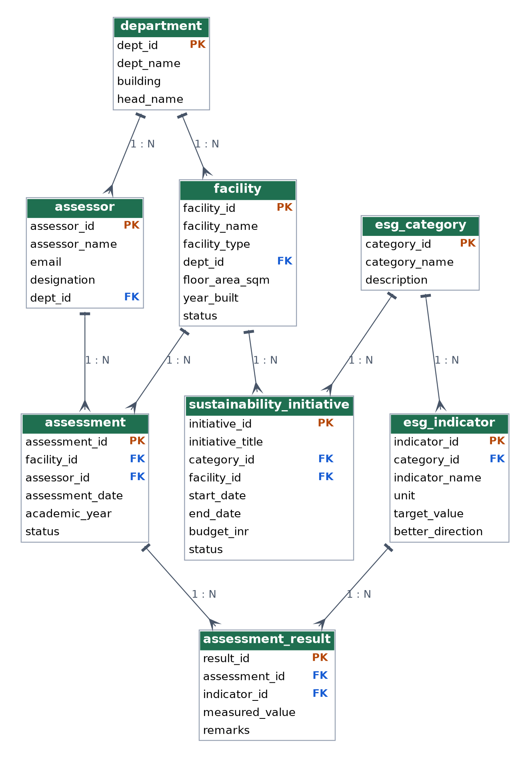
Figure 1: ER diagram of the database implemented in this assignment

3. Implementation Plan
- Environment: MySQL 8.0.16 or later (earlier versions parse but ignore CHECK constraints) with the InnoDB engine, which supports transactions and foreign keys.
- Creation order: parent tables must exist before the child tables that reference them. The order is department, esg_category, facility, esg_indicator, assessor, assessment, assessment_result, sustainability_initiative.
- Naming convention: lower-case snake_case; every constraint is named (pk_, fk_, uq_, chk_) so that error messages are readable and constraints can be dropped by name.
- Primary keys: surrogate INT AUTO_INCREMENT keys.
- Data types: VARCHAR for text, DECIMAL for exact measurements and money (never FLOAT), DATE for calendar dates, INT for years and keys.

4. Creating the Database
CREATE AND SELECT THE DATABASE

CREATE DATABASE IF NOT EXISTS campus_esg_db
CHARACTER SET utf8mb4
COLLATE utf8mb4_unicode_ci;

USE campus_esg_db;

utf8mb4 is used so that any character (including Indian-language names) can be stored. IF NOT EXISTS makes the script safe to re-run.

5. Creating the Tables

5.1 Table: department

CREATE TABLE department (
dept_id INT NOT NULL AUTO_INCREMENT,
dept_name VARCHAR(80) NOT NULL,
building VARCHAR(40) NOT NULL,
head_name VARCHAR(60) NOT NULL,
CONSTRAINT pk_department PRIMARY KEY (dept_id),
CONSTRAINT uq_department_name UNIQUE (dept_name)
) ENGINE = InnoDB;

Stores each department once. dept_name is unique so two departments cannot share a name.

5.2 Table: esg_category

CREATE TABLE esg_category (
category_id INT NOT NULL AUTO_INCREMENT,
category_name VARCHAR(20) NOT NULL,
description VARCHAR(200),
CONSTRAINT pk_esg_category PRIMARY KEY (category_id),
CONSTRAINT uq_esg_category_name UNIQUE (category_name),
CONSTRAINT chk_esg_category_name
CHECK (category_name IN ('Environmental', 'Social', 'Governance'))
) ENGINE = InnoDB;

A small lookup table holding the three ESG pillars; a CHECK restricts the names to those three values.

5.3 Table: facility

CREATE TABLE facility (
facility_id INT NOT NULL AUTO_INCREMENT,
facility_name VARCHAR(80) NOT NULL,
facility_type VARCHAR(30) NOT NULL,
dept_id INT NULL,
floor_area_sqm DECIMAL(10,2) NOT NULL,
year_built INT,
status VARCHAR(20) NOT NULL DEFAULT 'Active',
CONSTRAINT pk_facility PRIMARY KEY (facility_id),
CONSTRAINT uq_facility_name UNIQUE (facility_name),
CONSTRAINT fk_facility_dept FOREIGN KEY (dept_id)
REFERENCES department (dept_id)
ON DELETE SET NULL ON UPDATE CASCADE,
CONSTRAINT chk_facility_type CHECK (facility_type IN
('Academic Block', 'Laboratory', 'Library', 'Sports Complex',
'Administrative Block', 'Hostel', 'Cafeteria')),
CONSTRAINT chk_facility_area CHECK (floor_area_sqm > 0),
CONSTRAINT chk_facility_year CHECK (year_built BETWEEN 1950 AND 2100),
CONSTRAINT chk_facility_status CHECK (status IN
('Active', 'Under Renovation', 'Closed'))
) ENGINE = InnoDB;

Describes every assessable building. dept_id may be NULL because hostels, the library and the cafeteria are shared facilities. floor_area_sqm uses DECIMAL(10,2) for exact area. status defaults to 'Active'.

5.4 Table: esg_indicator

CREATE TABLE esg_indicator (
indicator_id INT NOT NULL AUTO_INCREMENT,
category_id INT NOT NULL,
indicator_name VARCHAR(80) NOT NULL,
unit VARCHAR(30) NOT NULL,
target_value DECIMAL(10,2) NOT NULL,
better_direction VARCHAR(6) NOT NULL DEFAULT 'Higher',
CONSTRAINT pk_esg_indicator PRIMARY KEY (indicator_id),
CONSTRAINT uq_esg_indicator_name UNIQUE (indicator_name),
CONSTRAINT fk_indicator_category FOREIGN KEY (category_id)
REFERENCES esg_category (category_id)
ON DELETE RESTRICT ON UPDATE CASCADE,
CONSTRAINT chk_indicator_target CHECK (target_value >= 0),
CONSTRAINT chk_indicator_direction CHECK (better_direction IN ('Higher', 'Lower'))
) ENGINE = InnoDB;

Each indicator belongs to one category and has a unit, a numeric target and better_direction ('Higher' or 'Lower') telling whether exceeding the target is good or bad.

5.5 Table: assessor

CREATE TABLE assessor (
assessor_id INT NOT NULL AUTO_INCREMENT,
assessor_name VARCHAR(60) NOT NULL,
email VARCHAR(100) NOT NULL,
designation VARCHAR(50) NOT NULL,
dept_id INT NOT NULL,
CONSTRAINT pk_assessor PRIMARY KEY (assessor_id),
CONSTRAINT uq_assessor_email UNIQUE (email),
CONSTRAINT fk_assessor_dept FOREIGN KEY (dept_id)
REFERENCES department (dept_id)
ON DELETE RESTRICT ON UPDATE CASCADE
) ENGINE = InnoDB;

People allowed to perform assessments. email is unique to identify a person unambiguously.

5.6 Table: assessment

CREATE TABLE assessment (
assessment_id INT NOT NULL AUTO_INCREMENT,
facility_id INT NOT NULL,
assessor_id INT NOT NULL,
assessment_date DATE NOT NULL DEFAULT (CURRENT_DATE),
academic_year VARCHAR(7) NOT NULL,
status VARCHAR(15) NOT NULL DEFAULT 'Planned',
CONSTRAINT pk_assessment PRIMARY KEY (assessment_id),
CONSTRAINT uq_assessment_fac_year UNIQUE (facility_id, academic_year),
CONSTRAINT fk_assessment_facility FOREIGN KEY (facility_id)
REFERENCES facility (facility_id)
ON DELETE RESTRICT ON UPDATE CASCADE,
CONSTRAINT fk_assessment_assessor FOREIGN KEY (assessor_id)
REFERENCES assessor (assessor_id)
ON DELETE RESTRICT ON UPDATE CASCADE,
CONSTRAINT chk_assessment_status CHECK (status IN
('Planned', 'In Progress', 'Completed'))
) ENGINE = InnoDB;

One row per facility per academic year (UNIQUE on both columns). assessment_date defaults to the current date and status to 'Planned'.

5.7 Table: assessment_result

CREATE TABLE assessment_result (
result_id INT NOT NULL AUTO_INCREMENT,
assessment_id INT NOT NULL,
indicator_id INT NOT NULL,
measured_value DECIMAL(10,2) NOT NULL,
remarks VARCHAR(150),
CONSTRAINT pk_assessment_result PRIMARY KEY (result_id),
CONSTRAINT uq_result_assess_ind UNIQUE (assessment_id, indicator_id),
CONSTRAINT fk_result_assessment FOREIGN KEY (assessment_id)
REFERENCES assessment (assessment_id)
ON DELETE CASCADE ON UPDATE CASCADE,
CONSTRAINT fk_result_indicator FOREIGN KEY (indicator_id)
REFERENCES esg_indicator (indicator_id)
ON DELETE RESTRICT ON UPDATE CASCADE,
CONSTRAINT chk_result_value CHECK (measured_value >= 0)
) ENGINE = InnoDB;

The bridge between assessments and indicators. UNIQUE (assessment_id, indicator_id) ensures an indicator is measured only once per assessment. Results are deleted automatically with their assessment (ON DELETE CASCADE).

5.8 Table: sustainability_initiative

CREATE TABLE sustainability_initiative (
initiative_id INT NOT NULL AUTO_INCREMENT,
initiative_title VARCHAR(100) NOT NULL,
category_id INT NOT NULL,
facility_id INT NOT NULL,
start_date DATE NOT NULL,
end_date DATE,
budget_inr DECIMAL(12,2) NOT NULL DEFAULT 0.00,
status VARCHAR(15) NOT NULL DEFAULT 'Planned',
CONSTRAINT pk_initiative PRIMARY KEY (initiative_id),
CONSTRAINT fk_initiative_category FOREIGN KEY (category_id)
REFERENCES esg_category (category_id)
ON DELETE RESTRICT ON UPDATE CASCADE,
CONSTRAINT fk_initiative_facility FOREIGN KEY (facility_id)
REFERENCES facility (facility_id)
ON DELETE RESTRICT ON UPDATE CASCADE,
CONSTRAINT chk_initiative_budget CHECK (budget_inr >= 0),
CONSTRAINT chk_initiative_status CHECK (status IN
('Planned', 'Ongoing', 'Completed', 'Cancelled')),
CONSTRAINT chk_initiative_dates CHECK (end_date IS NULL OR end_date >= start_date),
CONSTRAINT chk_initiative_done CHECK (status <> 'Completed' OR end_date IS NOT NULL)
) ENGINE = InnoDB;

Projects that improve ESG performance. Table-level CHECK constraints keep the budget non-negative, the end date after the start date, and require an end date for 'Completed' projects.

6. Verification

6.1 Tables created

SHOW TABLES;

OUTPUT
Tables_in_campus_esg_db
assessment
assessment_result
assessor
department
esg_category
esg_indicator
facility
sustainability_initiative

8 rows in set

6.2 Table structure

DESCRIBE facility;

OUTPUT
Field | Type | Null | Key | Default | Extra
facility_id | int | NO | PRI | NULL | auto_increment
facility_name | varchar(80) | NO | UNI | NULL
facility_type | varchar(30) | NO |  | NULL
dept_id | int | YES | MUL | NULL
floor_area_sqm | decimal(10,2) | NO |  | NULL
year_built | int | YES |  | NULL
status | varchar(20) | NO |  | Active

7 rows in set

DESCRIBE assessment_result;

OUTPUT
Field | Type | Null | Key | Default | Extra
result_id | int | NO | PRI | NULL | auto_increment
assessment_id | int | NO | MUL | NULL
indicator_id | int | NO | MUL | NULL
measured_value | decimal(10,2) | NO |  | NULL
remarks | varchar(150) | YES |  | NULL

5 rows in set
PRI marks the primary key, UNI a unique column and MUL a column that is indexed for a foreign key or as the first column of a composite unique key.

6.3 Relationships between tables
The foreign keys defined in the DDL can be listed from MySQL's information schema:

SELECT constraint_name AS fk_name,
table_name AS child_table,
column_name AS child_column,
referenced_table_name AS parent_table,
referenced_column_name AS parent_column
FROM information_schema.key_column_usage
WHERE table_schema = 'campus_esg_db'
AND referenced_table_name IS NOT NULL
ORDER BY table_name, constraint_name;

OUTPUT
fk_name | child_table | child_column | parent_table | parent_column
fk_assessment_assessor | assessment | assessor_id | assessor | assessor_id
fk_assessment_facility | assessment | facility_id | facility | facility_id
fk_result_assessment | assessment_result | assessment_id | assessment | assessment_id
fk_result_indicator | assessment_result | indicator_id | esg_indicator | indicator_id
fk_assessor_dept | assessor | dept_id | department | dept_id
fk_indicator_category | esg_indicator | category_id | esg_category | category_id
fk_facility_dept | facility | dept_id | department | dept_id
fk_initiative_category | sustainability_initiative | category_id | esg_category | category_id
fk_initiative_facility | sustainability_initiative | facility_id | facility | facility_id

9 rows in set
Parent table | Child table | Rule on parent DELETE | Rule on parent UPDATE | Cardinality
assessment | assessment_result | CASCADE | CASCADE | 1 : N
assessor | assessment | RESTRICT | CASCADE | 1 : N
department | assessor | RESTRICT | CASCADE | 1 : N
department | facility | SET NULL | CASCADE | 1 : N
esg_category | esg_indicator | RESTRICT | CASCADE | 1 : N
esg_category | sustainability_initiative | RESTRICT | CASCADE | 1 : N
esg_indicator | assessment_result | RESTRICT | CASCADE | 1 : N
facility | assessment | RESTRICT | CASCADE | 1 : N
facility | sustainability_initiative | RESTRICT | CASCADE | 1 : N

The database therefore contains 8 tables connected by 9 foreign-key relationships, all one-to-many.

7. Conclusion
The database campus_esg_db and its eight tables were created from the normalised design. Parent tables are created before child tables, every table has a primary key, and all relationships are enforced by named foreign keys. Sample data is inserted in Assignment 7 and queried in Assignments 8 and 9.
Reproducing: The DDL was executed against a test database to confirm it runs without errors. SHOW TABLES, DESCRIBE and the information_schema listing above are shown in MySQL's output format and were generated from that test schema. Run the same commands in MySQL Workbench or the mysql client and add screenshots if required by the submission guidelines.

