|  |  |
| --- | --- |
| Block 2 – BACKEND  BSc Computer Science | **Rodrigo Facchin**  **Student ID: L38544296** |

Contents

INTRODUCTION 1

The “SPACE PROJECT” 2

What is back-end 2

ER DIAGRAM 1

FUNCTIONALITY 2

STEP-BY-STEP (insert/create button) 2

VALIDATION 2

DEVELOPMENT PROCESS 2

TECHNOLOGIES USED 2

Frontend 3

Backend 3

W3_VALIDATOR 3

REFERENCES 3

# INTRODUCTION

## The “SPACE PROJECT”

The “space project” is a backend (server-side) solution for a space agency to control their astronauts, mission, targets, and attends. With the use of the correct technology, this application will cover all the daily tasks.

## What is back-end

As its name suggests, comes from the idea of ​​what's behind an application. It can get a little abstract at first but think that to be able to use major of the websites, a bunch of personal details needs to be saved somewhere, this place being a database and processed from there. The Backend works in most cases bridging the data that comes from the browser to the database and vice versa, always applying the appropriate business rules, validations, and guarantees in an environment where the end-user does not have access and can manipulate something.Diagram

# ER DIAGRAM

The ER (Entity Relationship) is one of the first steps to be performed is the study and survey of the requirements for the construction of the final product. During this analysis, the main parties and objects involved are identified, their possible actions and responsibilities, their characteristics, and how they interact with each other.

From the information obtained, a conceptual model can be developed that will be used to guide the development itself, providing information on aspects related to the domain of the project in question.

# FUNCTIONALITY

The main functionality of the application is the possibility to create, update, delete and create relations between all relevant parts of a Space Mission (astronauts, mission, targets, and attends).

To simplify the management of the data a friendly and clean frontend interface (HTML, CSS, JavaScript) has been created.

The top menu has been divided into 4 parts (1- Astronaut, 2 – Targets, 3 – Missions, and 4 – Attends) and in tab a button group is available (insert, select, manage (update/delete)).

# STEP-BY-STEP (insert/create button)

Every main tab has been divided into buttons relevant to the task (insert, list, manage) and a common tab for every task is the possibility of inserting data into the database (example: INSERT A NEW ASTRONAUT).

The user must fill all the fields for the form to be processed.

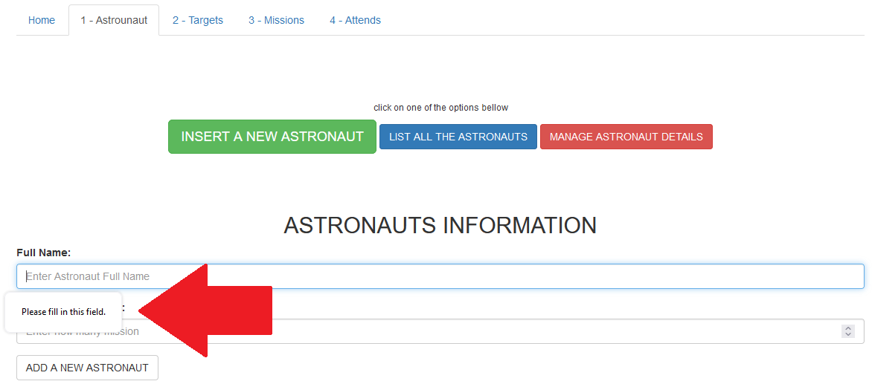

Once the form is fulfilled (first validation) and the button “ADD A NEW ASTRONAUT” has been pressed a PHP code will be responsible for cleaning the inserted data (second validation) and inserting the data into a MySQL database (third validation)

As a result of this process, the system will return two possible outcomes.

**1º)** Entry successfully created

or

**2º)** Error - Display the query (first line) and the reason for not inserting (second line).

# VALIDATION

To maintain the integrity of the database and to deliver, a good level of security 3 validation step has been used in this project.

**First_Validation**

The first validation happens on the frontend when the user will be able only to send the form if all the fields have been filled and match the field type.

**Second_Validation**

After passing the first validation, the PHP will clean the data (based on validation), and only after that it will execute the query sending to the database the “clean” data

**Third_Validation**

To finish the validation process, before touching the database, the database will verify the integrity of the data. By verifying if it matches the attribute type and foreign key to confirm if it’s valid.

# DEVELOPMENT PROCESS

The whole project has been written using Visual Studio Code and tested locally using XAMPP (Apache / MySQL).

The project has been divided into 5 parts:

1º) Layout (tabs, buttons, forms).

2º) PHP / MySQL (database (creation (AI, Primary and foreign key), code (validation, queries, and comments)).

3º) Brief/checklist verification.

4º) Commit to GitHub / Pull to Azure VM.

5º) Final test on completion.

# TECHNOLOGIES USED

## Frontend

For a faster development frontend interface, the Bootstrap framework (HTML, CSS, JavaScript) has is recommended and has been used.

## Backend

The model adopted for the creation of this project is the LAMP (Linux, Apache, MySQL, PHP). The combination of these 4 technologies is one of the most used models for web development.

**PHP -** Use Along with ease of learning, scalability, great support, and ease of use. This makes PHP one of the most popular programming languages ​​worldwide. Since it was introduced to the world of web development it has become one of the most popular languages. It’s estimated that over 80% of websites that use a server language are using PHP including Facebook and Wikipedia.

* **Open-source** - This means that no worrying about licensing.
* **Easy to learn** - it’s easy to break the project down into smaller tasks for each of the developers involved.
* **It doesn't depend on the system** - PHP is highly portable. Start coding with PHP on one system, transfer the code to another system, and continue the code without having to make any changes.
* **Many frameworks to choose from** - PHP is one of the languages ​​with the most frameworks to choose from. The frameworks make web application development easier and faster.
* **Simple integration with other technologies** - On the client-side, PHP can be used alongside HTML, CSS, JavaScript, and other available technologies. On the server side, PHP can be used on all servers.
* **The way PHP works** - PHP runs in separate processes, unlike languages ​​that run as a single process. PHP can take care of various requests without causing server problems.

**MySQL -** MySQL has become the most popular open-source database in the world because it has consistency, high performance, reliability, and is easy to use. It’s currently used in more than 6 million installations on all continents (including Antarctica), ranging from installations in large corporations to specific embedded applications. Furthermore, MySQL has become the choice of a new generation of applications, which use the LAMP model (Linux, Apache, MySQL, PHP).

**GitHub -** GitHub is an essential tool for software engineers, with an unbeatable popularity. GitHub is a cloud-based service that hosts a version control system called Git. It allows developers to collaborate and make changes to shared projects while keeping a detailed record of their progress.

**Linux –** Well known for being secure, consistent, and flexible. Linux servers and the applications they run generally use fewer computer resources.

**Apache –** In May 2012, Apache was found to serve approximately 54.68% of all websites and 66% of the world's busiest millions of websites.

# W3_VALIDATOR

Before

# REFERENCES

01 – PHP - <https://en.wikipedia.org/wiki/PHP> - Accessed on 06/12/2021

02 – BACK END - <https://careerfoundry.com/en/blog/web-development/whats-the-difference-between-frontend-and-backend/> - Accessed on 07/12/2021

03 – ER Diagram - <https://www.smartdraw.com/entity-relationship-diagram/> - Accessed on 07/12/2021

04 – PHP - <https://www.w3schools.com/php/> - Accessed 01/12/021

05 – DEVELOPMENT PROCESS - <https://xbsoftware.com/blog/website-development-process-full-guide/> - Accessed – 28/11/2021

WEBSITE LINK: [SPACE PROJECT (rodrigofacchin.com)](http://block2.rodrigofacchin.com/)

GITHUB LINK: [rfacchin/block2 (github.com)](https://github.com/rfacchin/block2)