CYB-0103 – Quiz2-B

|  |  |
| --- | --- |
| **Student Name (in English):** |  |
| **Student ID:** |  |
| **Section No.:** | 322 |

**Q1: Choose the correct answer:**

|  |  |
| --- | --- |
| 1. Difficult to determine which subjects are able to access specific objects by looking at the object itself in ______________. | |
| 1. A model | 1. Verification techniques |
| 1. Security policy | 1. Capabilities list |

|  |  |
| --- | --- |
| 2. Clark Wilson model deals with two types of transactions named _____________________. | |
| 1. CDIs | 1. UDIs |
| 1. TPs and IVPs | 1. CDIs and UDIs |

|  |  |
| --- | --- |
| 3. It can be used to show that a policy is satisfied by a system. | |
| 1. A model | 1. Verification techniques |
| 1. Security policy | 1. Capabilities list |

|  |  |
| --- | --- |
| 4. ____________can be implemented via an Access Control List or via a Capabilities list. | |
| 1. HRU model | 1. Chinese Wall model |
| 1. BLP model | 1. Clark Wilson model |

|  |  |
| --- | --- |
| 5. The phase/phases of incident response are | |
| 1. Preparation phase. | 1. Post-event activity phase. |
| 1. Detection and analysis phase. | 1. All of the above |

|  |  |
| --- | --- |
| 6. The difference between security and functional safety can be summed up in one word. | |
| 1. Safety | 1. Security |
| 1. Clearance | 1. Intent |

|  |  |
| --- | --- |
| 7. The state of being away from hazards caused by natural forces or human errors randomly. | |
| 1. Safety | 1. Security |
| 1. Clearance | 1. Classification |

|  |  |
| --- | --- |
| 8. Bell-LaPadula (BLP) Model is a _____________________________ | |
| 1. Confidentiality model | 1. Traceability model |
| 1. Integrity model | 1. Availability model |

|  |  |
| --- | --- |
| 9. Security levels arranged from lowest to highest. | |
| 1. Top secret-secret-confidential-unclassified | 1. Unclassified- confidential- secret- top secret |
| 1. Top secret-secret- unclassified -confidential | 1. Confidential-unclassified- secret- top secret |

|  |  |
| --- | --- |
| 10. The state of being away from hazards caused by deliberate intention of human to cause harm. | |
| 1. Safety | 1. Security |
| 1. Clearance | 1. Classification |

**Q2: Answer the following question:**

Using Biba model Example add the arrows and fill the table by read (R) or write (W):

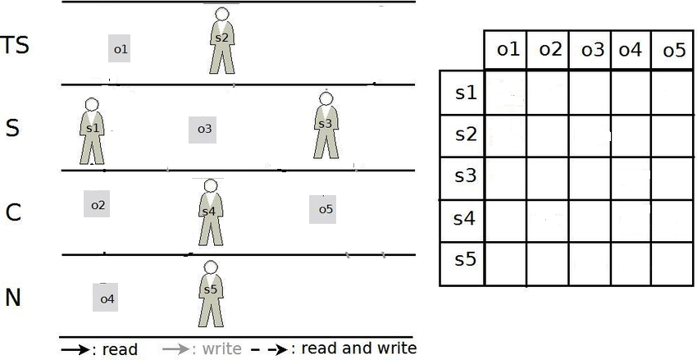

**R**

**R**

**R**

**R**

**RW**

**RW**

**RW**

**RW**

**RW**

**W**

**R**

**R**

**R**

**W**

**W**

**W**

**W**

**W**

**W**

**W**

**RW**

**W**

**W**

**W**

**R**

Good Luck 