**Inflation Expectations in the Euro Area**

The aim of this report is to model and forecast the inflation expectations in the euro area. The dataset includes the pre-Covid observations on consumer confidence and inflation expectations (measured by the European Commission), as well as some macroeconomic and financial variables. The data is available since the establishment of the euro area – January 1999.

***Variables:***

**- date:** date in dd.mm.yyyy. format. Corresponds to the monthly frequency starting from January 1999

**- infl_exp:** inflation expectations in the euro area: balances (in percentage points) of the answers to the following question "By comparison with the past 12 months, how do you expect that consumer prices will develop in the next 12 months?". Higher number denotes higher inflation expectations in comparison to the current inflation

**- conf:** consumer confidence indicator: arithmetic average of the balances (in percentage points) of the answers to the questions on the financial situation of households, the general economic situation, unemployment expectations (with inverted sign) and savings, all over the next 12 months. Higher number denotes higher optimism of consumers about the economic situation in the near future

**- euribor:** overnight interest rate on the euro area interbank market (EURIBOR), %

**- hicp:** harmonized index of consumer prices (HICP), 100 = 2015

**- eurusd:** EUR/USD exchange rate, shows how many USD you should pay to get 1 EUR

***The level of inflation expectations and consumer confidence?***

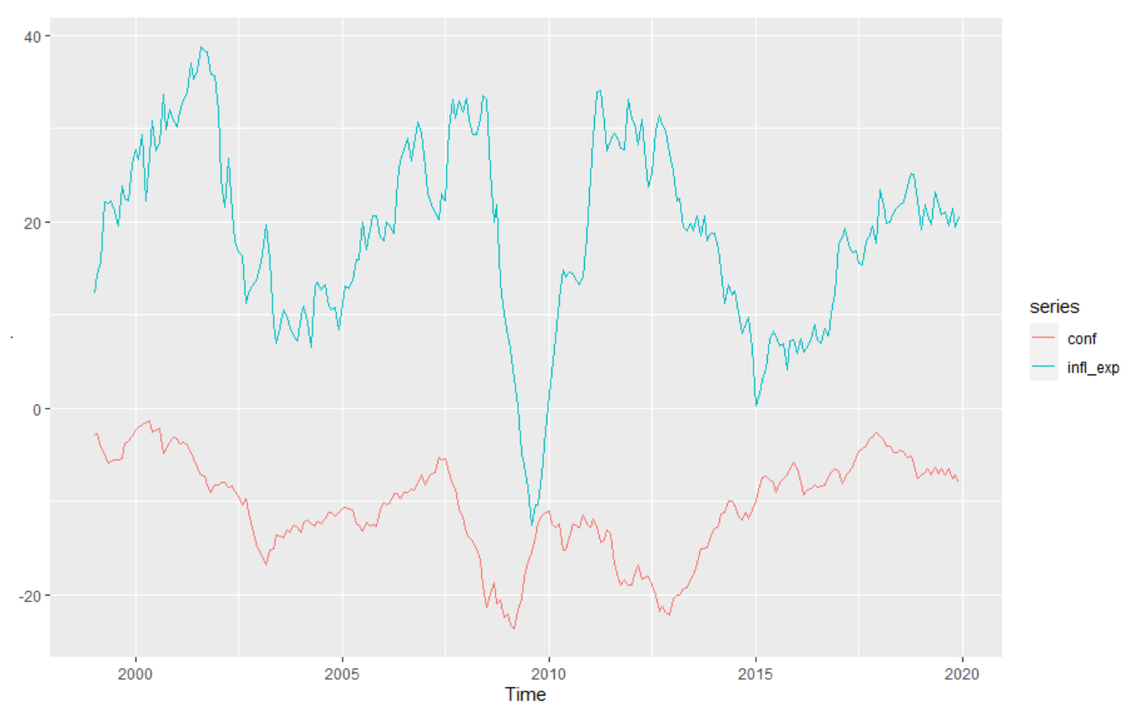

Inflation expectations and confidence seem to move together - perhaps they have a common trend. It seems like confidence moves before inflation expectations. Both have periods of growth and decline at about the same time, though the changes are not as large for confidence. This makes economic sense as well, because if consumers have high inflation expectations (like around 2010), then they are likely to also have more optimism about the economic situation in the future. If people are optimistic about the future of the economic situation, they are likely to buy more and also ask for higher wages (which then is likely to make firms increase prices), thus creating an expectation for higher inflation.

**Autocorrelation functions**

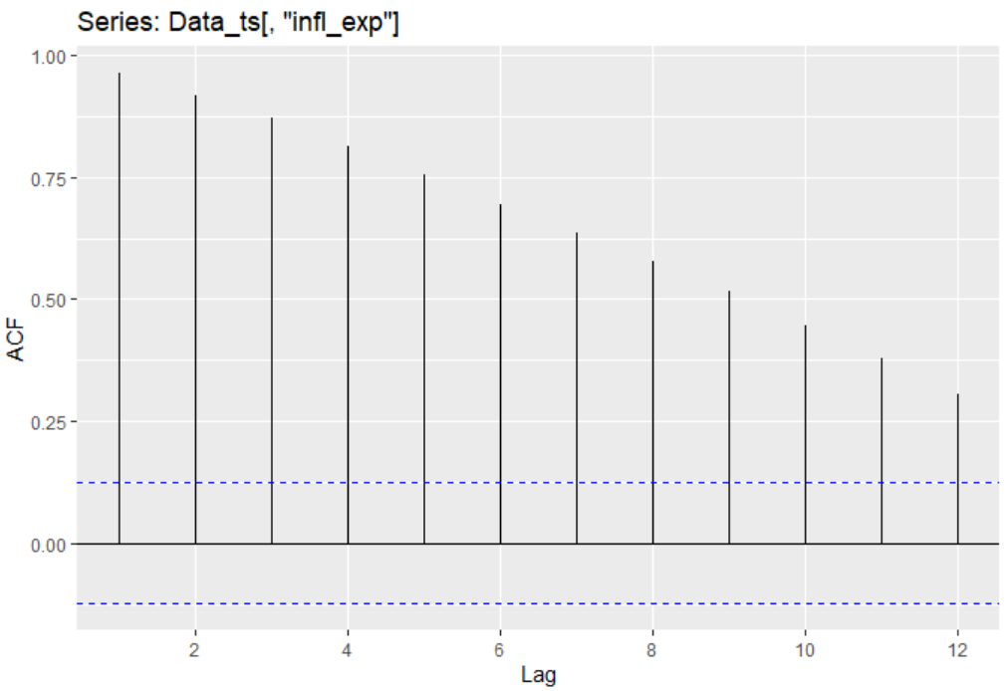

People tend to expect the same inflation in the upcoming period as they expected in the last period, 2 periods ago, 3 periods ago, etc. Meaning that the level of inflation expectations is driven by the previous period's level of inflation expectations. If we use levels, this is also driven by the fact that inflation expectations generally are positive in roughly the same range of percentages, therefore it makes more sense to check the ACF of changes in inflation expectations.

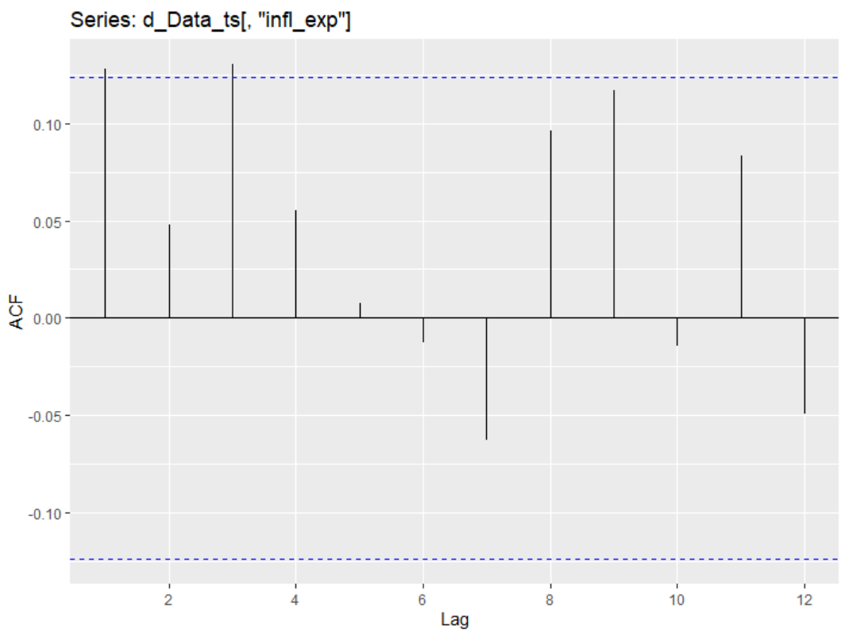

Here we use the first difference in inflation expectations instead of levels. When we do so we see far smaller autocorrelation. It goes out of bounds ever so slightly in the first and third lag, but it is still statistically significant. If their expectations rose in the previous period then their expectations will be high in this period as well, and vice versa - if they were falling in the previous period, then they will be low this period too.

***What is the integration order of the inflation expectations?***

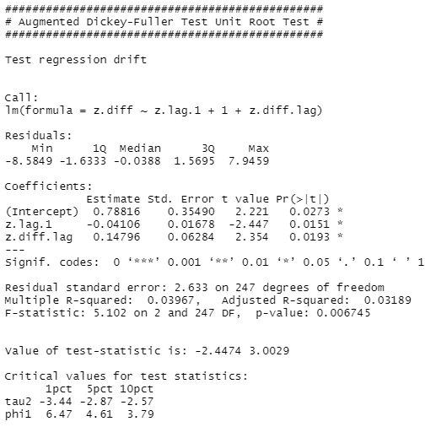

When we do the augmented Dickey-Fuller test for inflation expectations in levels, we see that it is non-stationary as the t-value is higher than the critical values in all confidence intervals. Thus, we next take the first difference and run the ADF test again.

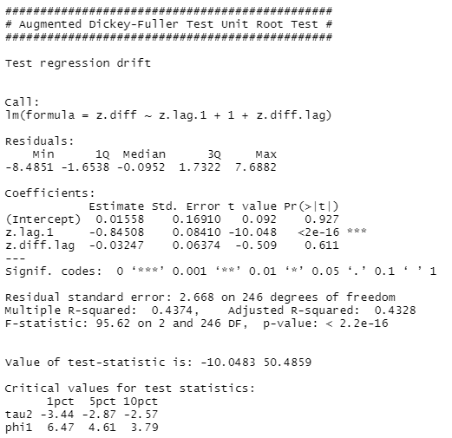

After running ADF test for the first difference of inflation expectations, we can safely say that inflation expectations are integrated of order one and the data is now stationary, and this is true for a 99% confidence interval.

Thus we can conclude that it is better to use changes in inflation expectations not levels for the AR model.

Then we run three BIC tests to determine how many lags we should use for the AR model:

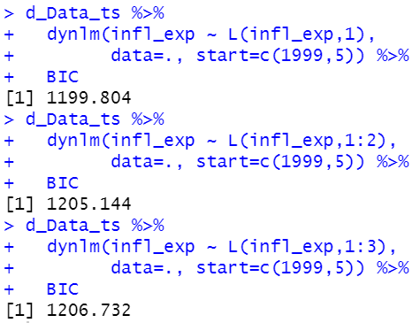

The smallest BIC value is for one lag, therefore that is what we will be using.

We create an AR(1) model regressing changes in inflation expectations on its first lag:

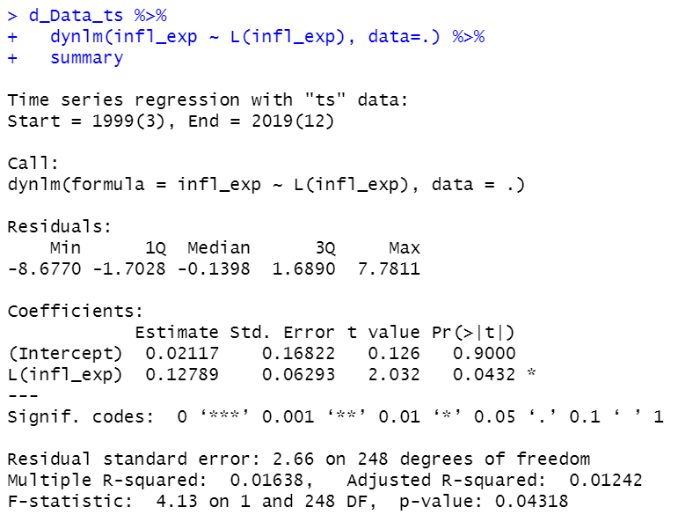

Intercept is not statistically significant. The coefficient before the first lag of inflation expectations is statistically significant.

A 1pp increase in inflation expectations in the previous period will increase the inflation expectations in this period by an estimated 0.13pp, all other things held constant.

The adjusted R squared for this model is 0.01242, meaning that we explain only 1.24% of the variance of the changes in inflation expectations. It is not a good fit of the model.

***ADL model that explains the changes in inflation expectations by its own lags and by the monthly log-changes in consumer prices***

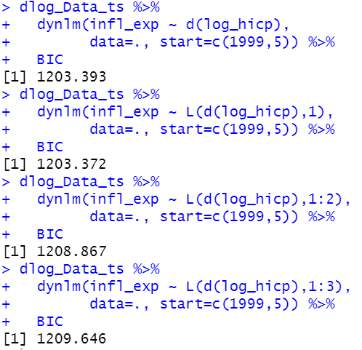

We run BIC tests for various lags of log_hicp, and what we get is that it is best to use only the first lag of log_hicp. Thus, log_hicp is I(1).

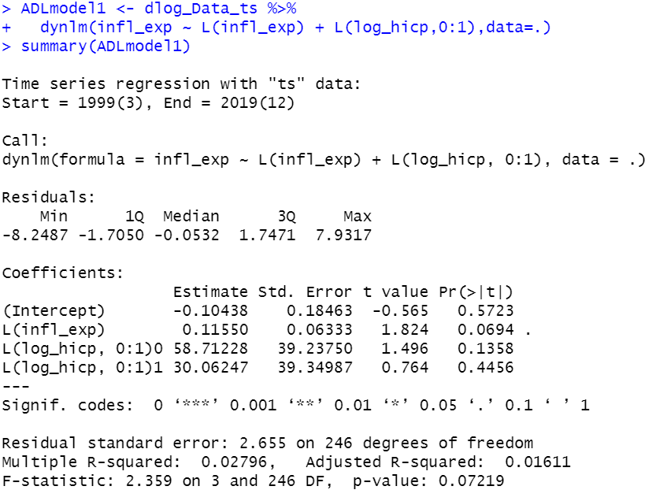

The estimates of the intercept and both lags of log-changes in consumer prices are not statistically significant.

The first lag of difference in inflation expectations is statistically significant. A 1pp increase in inflation expectations in the previous period is expected to increase the inflation expectations in the current period by 0.115pp, all other things held constant.



One percentage point increase in actual inflation is estimated to increase inflation expectations by 100.3671 percentage points in the long run.

***VAR model + Granger-causality test***

We first run the VAR model:

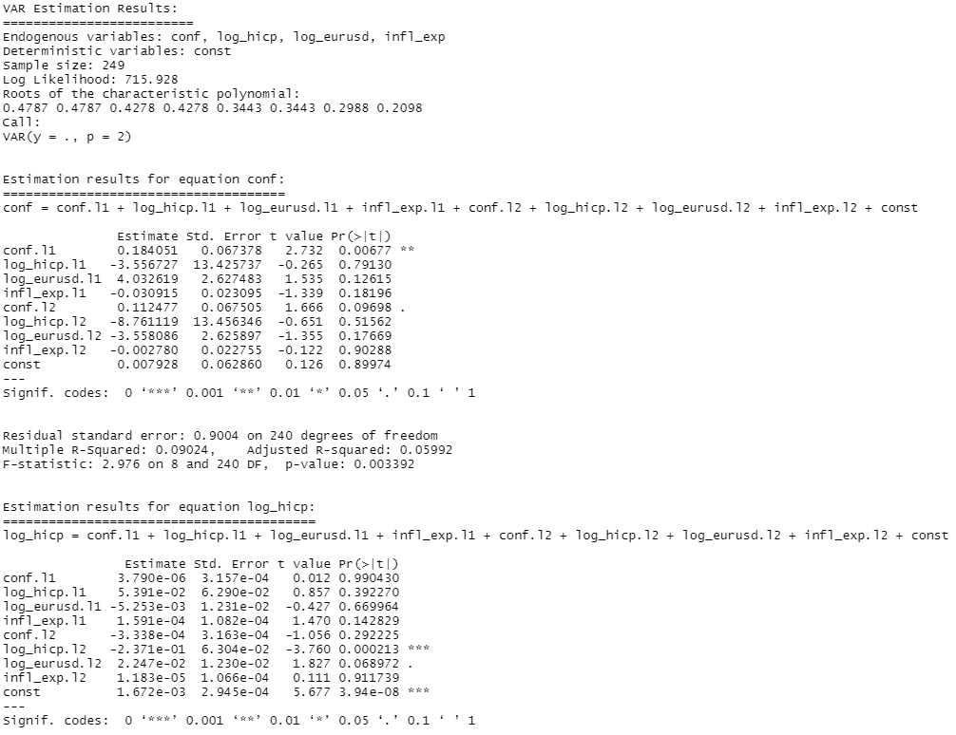

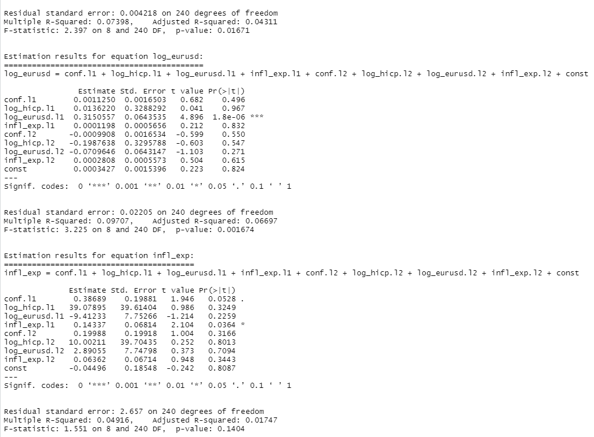

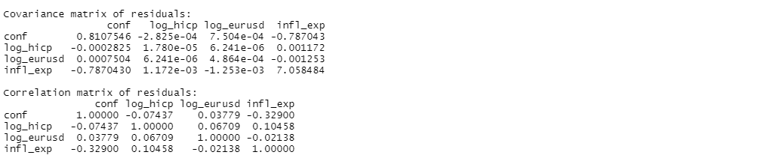

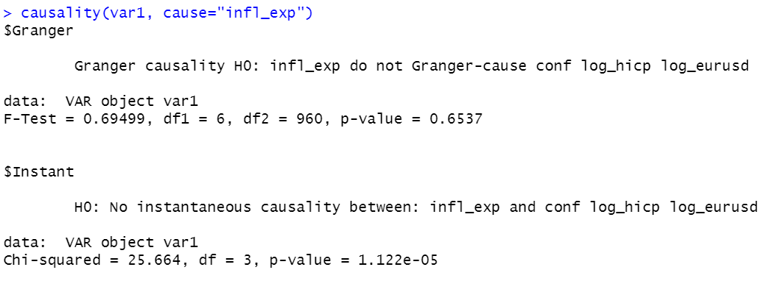

Inflation expectations is not a useful estimator for confidence, log_hicp or log_eurusd.

***Predicting monthly changes in inflation expectations until March 2020 using the VAR model developed before***

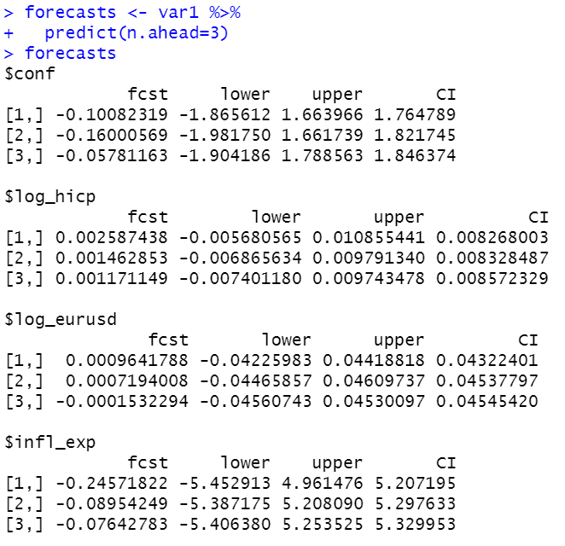

Inflation expectations are forecasted to decrease by 0.246pp in January 2020 compared to December 2019. They will decrease by 0.0895pp in February 2020 compared to January 2020. They will decrease by 0.0764pp in March 2020 compared to February 2020.

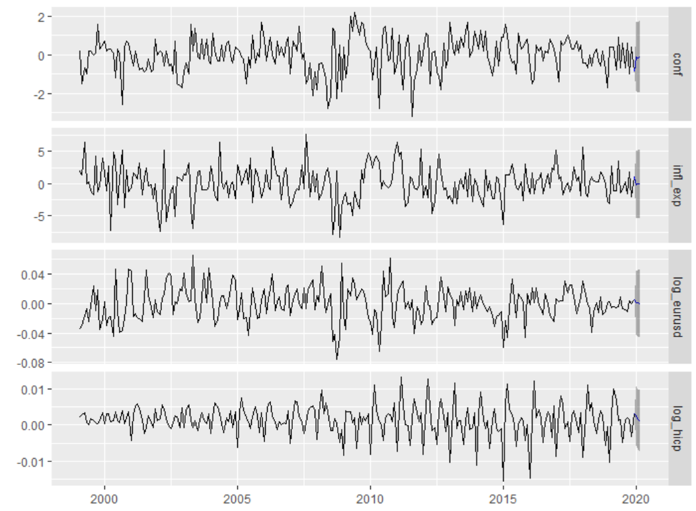

Here we also plotted the forecast. The forecast gives a pretty large confidence range, meaning that the usefulness of our forecast is questionable.

***GARCH(1,1) model that explains the volatility of monthly changes in consumer confidence in the euro area***

Run GARCH(1,1) model that explains the volatility of monthly changes in consumer confidence in the euro area. Interpret the coefficients of the model (when possible). Plot the residual of the model and comment.

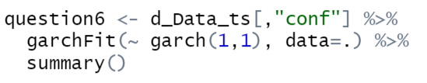

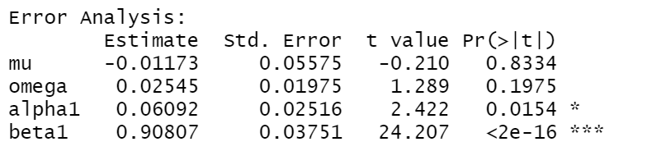

Mu is constant in the mean equation. Here it is not statistically significant.

Omega is constant in the variance equation, but it is not statistically significant here either.

Alpha1 is statistically significant and it shows the effect of shocks in the previous period on this period’s volatility. The previous period’s shock positively affects the volatility in the current period.

Beta1 is also statistically significant and can be interpreted as such: 91% of last period’s volatility remains in the current period.

***OLS that explains the level of inflation expectations by two variables: the level of consumer confidence and the level of the overnight EURIBOR***

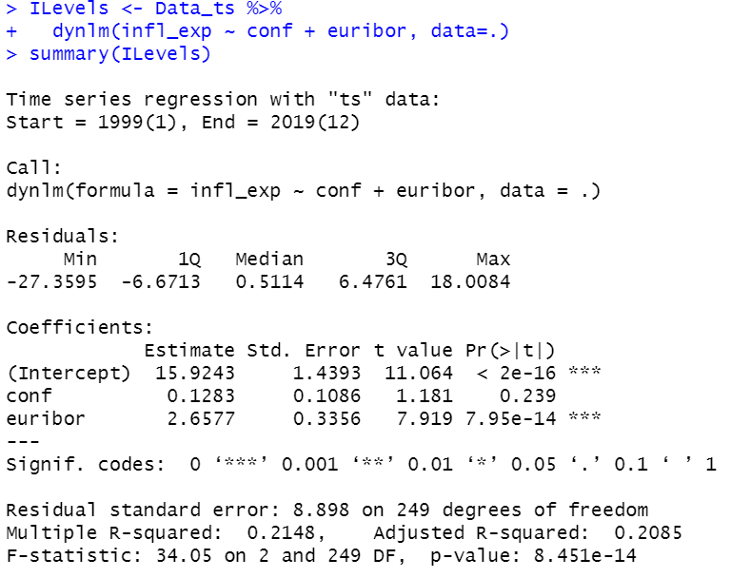

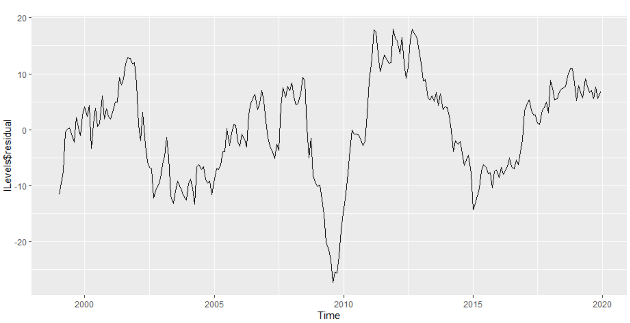

We can test the cointegration of these variables. If they are cointegrated, they can be non-stationary. We run an E-G ADF test.

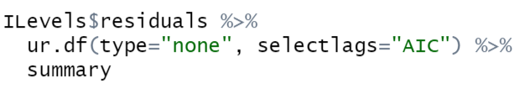

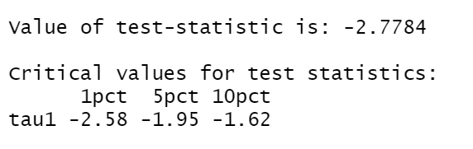

Here we can’t use the critical values provided by R, instead we use the values from the Stock & Watson book’s table 16.2. The t-value of -2.7784 is bigger than the value needed for it to be cointegrated. For us to reject the null hypothesis we would need a t-value of at least -3.52 (at a 90% confidence interval), thus we conclude that these variables are not cointegrated.

Next, since these variables are not cointegrated, they have to be stationary to be usable. We check the stationarity for each variable:

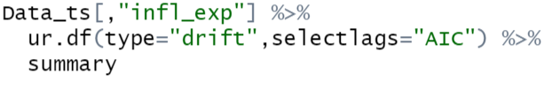

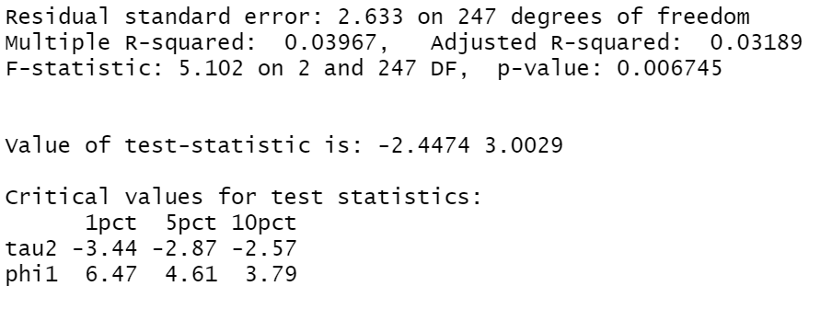

The value of the ADF test-statistic is higher than the critical value for a 90% confidence interval. This means that inflation expectations are non-stationary and follow random walk. This can cause a spurious regression. In fact, euribor and conf are both non-stationary too:

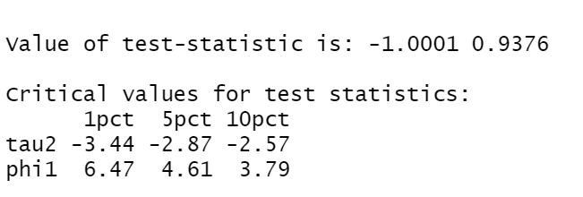

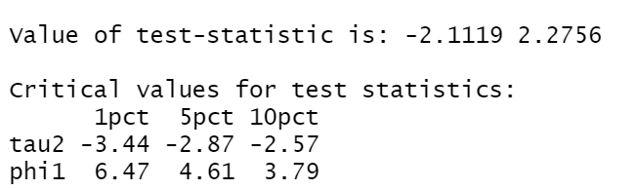

A fix for this is to transform this into a first difference model, and checking whether these variables are integrated of order 1. If not, one should add another difference and repeat the process.

***The active phase of the financial crisis started with the bankruptcy of the Lehman Brothers (in September 2008). Therefore, we should run the same model as in the section above, only for the pre-crisis period.***

We run the ILevels model again, but now only for the period before the crisis. We create a subsample of the data from 1999 January - 2008 January, assuming that the crisis began at the start of 2008. We get the regression output, but before jumping to interpretations we should test for cointegration to avoid interpreting a spurious regression.

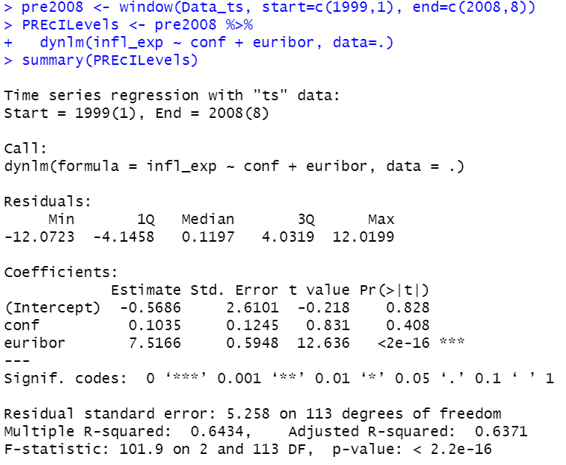

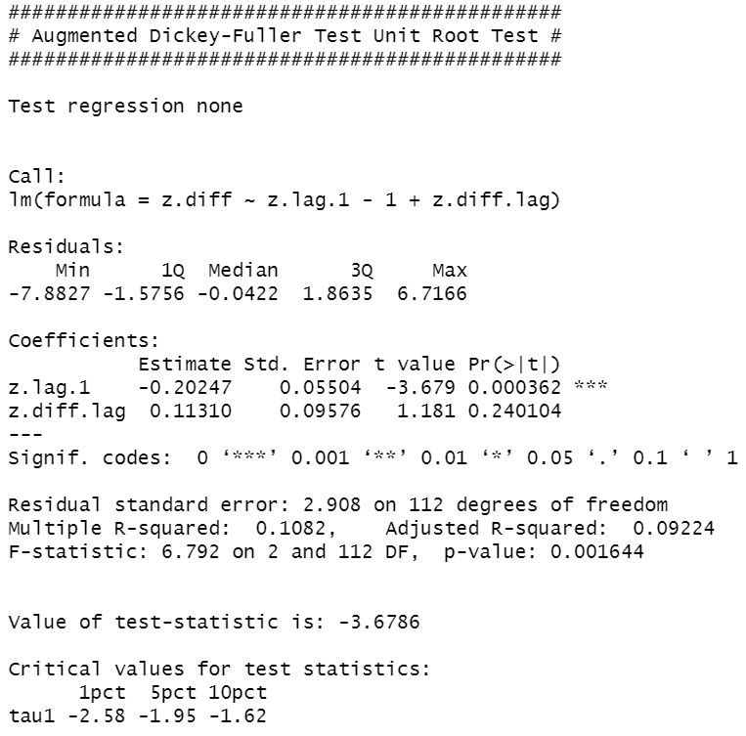

We do not compare the value of t- to the critical values suggested by R, we take them from the beautiful table below.

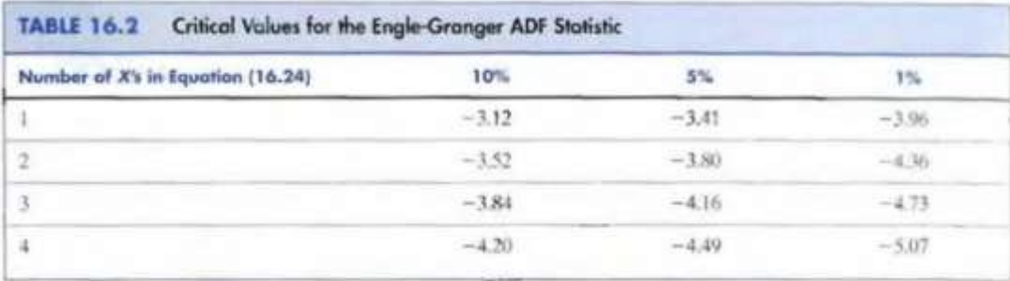

For 2 x’s we can reject the null hypothesis of no cointegration at 10% level of significance as -3.67<-3.52. We conclude that we have cointegration.

Now we can interpret the coefficient of the previous regression according to macroeconomic theory.

Returning to our time series regression, we can see that the only statistically significant coefficient is the coefficient before euribor. Increase in euribor by 1% increases the inflation expectations by 7.51 pp, all other factors held constant. While this model only has 1 statistically significant B value, it can still be used for forecasting as both R squared and adjusted R squared is rather high, explaining 64,34% and 63,71% of the variance respectively.