Foundations of Statistics – Rafael Martins Guimarães

Part 1

|  |  |  |  |
| --- | --- | --- | --- |
|  | The price of the house | The Yard sizes | The house sizes (sqft) |
| Mean | 228.6294 | 7472.72 | 1991.525 |
| Median | 195 | 6400 | 1900 |
| SD | 111.9543 | 5356.904 | 614.5461 |
| Variance | 12533.77 | 2.87e+07 | 377666.9 |
| Smallest | 110 | 1530 | 950 |
| Largest | 590 | 36304 | 3775 |
| Skewness | 1.364798 | 3.055515 | .4732681 |
| Kurtosis | 4.604902 | 15.58248 | 2.792214 |

Part 2

1. As we can see, the correlation between the size of the house and price is .60. Although there is a correlation, these two variables are not highly correlated.
2. Also in this case, the correlation between the size of yard and price is .46. Although there is a correlation, these two variables are not highly correlated, meaning that there are other variables that affect even more the price of the house. Another hypothesis is that maybe the group of variables might affect more the price than only one variable.

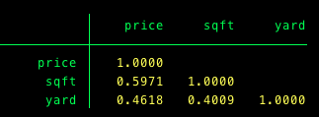

Part 3

We can see that every time the sqft of the house increases by 1, the price will be increase by .109. The coefficient for sqft is significantly different from zero, because his p-value is 000. His constant (_cons) is not significant, because the p-value(.672) is higher than 0.005.

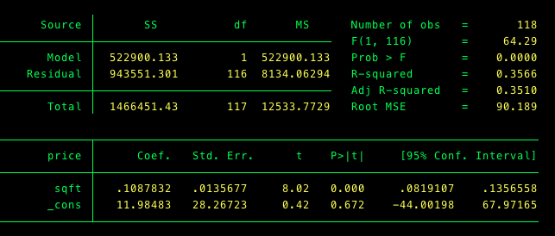

Part 4

1. The difference in the mean is 120.849, showing that house s without fence have a higher price and that range difference could be between 30.216 and 211.4815.
2. The difference in the mean is 41.222, showing that houses with a swimming pool have a higher price, but it is lower than the difference from houses with a fence, and that range difference could be between 7.6 up to 90.09997.
3. The TTest shows that the difference in the mean is 74.75814, showing that houses with law-sprinkler system have a higher price, but it is lower than the difference from houses with a fence, and that range difference could be between 31.631 up to 117.886.
4. Again, we can see that the difference in the mean is 81.59998, showing that houses with view have a higher price, but it is lower than the difference from houses with a fence, and that range difference could be between 43.386 up to 119.814.
5. In this case we can see that the difference in the mean is 155.1926, the largest mean, showing that houses with In LaJolla have a higher price, and that range difference could be between 125.746 up to 184.639.
6. Finally, the difference in the mean is 34.829, showing that houses on the corner lot have a higher price, and that range difference could be between 32.695 up to 102.353.

One important factor that can explain why houses in La Jotta have the highest increase on prices, is because of the variables analyzed, this one is more correlated whit price than the others. That means when you add one point in La Jotta it will affect more price than the others, 155.102 to make a point. The correlation is .67.

