## **Introduction**

## The growth of wireless networking has generated many commercial and research interests in statistical methods to tack people and things. The ability to locate these devices based on statistical models that create an Indoor Positioning System (IPS) hold many applications in factories, hospitals, warehouses, businesses and even smart connected cities [1].

While GPS has become a ubiquitous solution for outdoor real-time locating, RTLS technology has evolved and become much more prevalent for indoor tracking. The RTLS data set used in this exercise is comprised of MAC addresses from recorded connections made to routers within a location. Signal strength is measured at every router (network access point) via a mobile scanning device. Measuring signal strength for these routers at various locations enable us to create a reference dataset on which to base device position predictions.

Nolan and Lang try to predict the location of devices using different access points in a building. They use K nearest neighbor algorithm. In this case study, we initially investigate the Nolan and Lang code and analyze the impact of an extra access point that they dropped from the dataset. We will ask ourselves if it was a good decision. We will also analyze if retaining the access point will lead to a more accurate result. Finally, we will use a weighted Euclidean distance technique to predict the location. Initially we analyze the Nolan and Lang code line by line and then we will try to answer the mentioned questions.

The steps used for this analysis are: exploratory data analysis, data cleansing, signal strength and time analysis, analysis of accuracy of the model with certain features, implementation of kNN with different distance, and comparison of kNN approaches to determine the best location prediction method.

Our code includes modified versions examples found in Data Science in R: A Case Studies Approach to Computational Reasoning and Problem Solving, Chapter 1, pages 3-40 as well as from an R notebook from class.

## **Background**

Two data sets from CRAWDAD (A Community Resource for Archiving Wireless data at Dartmouth) [3] are used for developing an IPS. The first dataset “offline” contains signal strengths measured using a hand-held device on a grid of 166 points spaced 1 meter apart in the hallways of one floor of a building at the university of Mannheim.

**Figure 1: Floor Plan of the Test Environment.** *In this ﬂoor plan, the 6 ﬁxed access points are denoted by black square markers, the oﬄine/training data were collected at the locations marked by grey dots, and the online measurements were recorded at randomly selected points indicated with black dots. The grey dots are spaced one meter apart.*

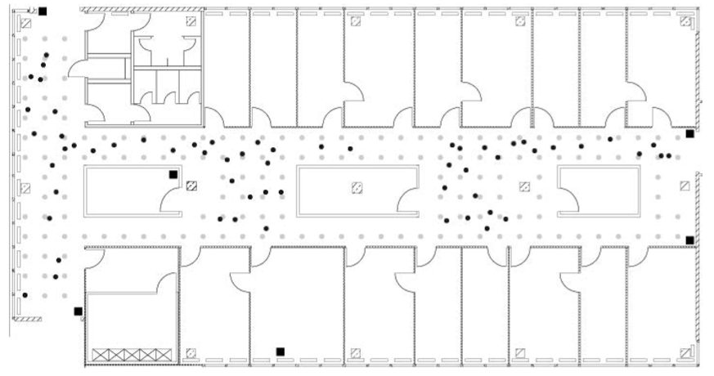

The ﬂoor plan, which measures about 15 meters by 36 meters, is displayed in Figure 1. The grey circles on the plan mark the locations where the oﬄine measurements were taken and the black squares mark 6 access points. These reference locations give us a calibration set of signal strengths for the building, and we use them to build our model to predict the locations of the hand-held device when its position is unknown. In addition to the (x,y) coordinates of the hand-held device, the orientation of the device was also provided. Signal strengths were recorded at 8 orientations in 45 degree increments (i.e., 0, 45, 90, and so on). Further, the documentation for the data indicates that 110 signal strength measurements were recorded to each of the 6 access points for every location-orientation combination [2].

In addition to the oﬄine data, a second set of recordings, called the “online” data, is available for testing models for predicting location. In these data, 60 locations and orientations are chosen at random and 110 signals are measured from them to each access point. The test locations are marked by black dots in Figure 1.1. In both the oﬄine and online data some of these 110 signal strength values were not recorded. Additionally, measurements from other hand-held devices, e.g., phone or laptop, in the vicinity of the experimental unit appear in some oﬄine records [2].

The format of the data for both files are viewed through a plaintext editor has the same basic format:

# timestamp=2006-02-11 08:31:58   
# usec=250   
# minReadings=110   
t=1139643118358;id=00:02:2D:21:0F:33;pos=0.0,0.0,0.0;degree=0.0;\ 00:14:bf:b1:97:8a=-38,2437000000,3;\   
00:14:bf:b1:97:90=-56,2427000000,3;\   
00:0f:a3:39:e1:c0=-53,2462000000,3;\   
00:14:bf:b1:97:8d=-65,2442000000,3;\   
00:14:bf:b1:97:81=-65,2422000000,3;\   
00:14:bf:3b:c7:c6=-66,2432000000,3;\   
00:0f:a3:39:dd:cd=-75,2412000000,3;\   
00:0f:a3:39:e0:4b=-78,2462000000,3;\   
00:0f:a3:39:e2:10=-87,2437000000,3;\   
02:64:fb:68:52:e6=-88,2447000000,1;\   
02:00:42:55:31:00=-84,2457000000,1

The values of the dataset are:

t="Timestamp";   
id="MACofScanDevice";   
pos="RealPosition";   
degree="orientation";   
MACofResponse1="SignalStrengthValue,Frequency,Mode"; ...   
MACofResponseN="SignalStrengthValue,Frequency,Mode"

We notice several things: this record has 8 readings; the MACa ddresses appear in a diﬀerent order than in the ﬁrst record; there are 2 readings from the same access point (the 8a access point); and one of the 8 addresses belongs to an adhoc device because, according to the variable units, , the mode digit indicates whether the recording is for an adhoc device (1) or access point (3). If we look at the ﬁrst observation again, we notice that there are more than 6 MAC addresses with a mode of 3. The “extras” are from other ﬂoors in the building [2].

**Exploratory Data Analysis**

We use R to prepare the data for analysis. We must first format the dataset by having the same initial variables describing the hand-held device, i.e., time, MAC address, location, and orientation. After this, we have just 4 other variables: the MAC address of the device from which we received a signal, the signal, the channel and the type of the device.

t(timestamp), id(MAC), pos(Real Position), degree, sender signal, signal, channel, device type

We will split the 4th column which is a composite column based on semicolon, equal and comma. Then we make sure to choose the rows with valid columns and then focus on the types of numeric columns. Now the data is ready to be used as a dataframe. The dimension of the data indicates that all 1181628 rows have 10 columns and we can check the types of the variables in the data frame and verify that they are correct. The "rawTime" will also be converted into milliseconds as "time".

**Table 1. List of values now contained in the “offline” dataset after applying data processing steps.**

|  |  |  |  |  |  |  |  |  |  |  |
| --- | --- | --- | --- | --- | --- | --- | --- | --- | --- | --- |
| **Time1** | **Time2** | **scanMac** | **posX** | **PosY** | **PosZ** | **orientation** | **mac** | **signal** | **channel** | **rawtime** |
| **POSIXT** | **POSIXCt** | **character** | **numeric** | **numeric** | **numeric** | **numeric** | **character** | **numeric** | **character** | **numeric** |

**Table 2. Summary of “offline” dataset after applying data processing steps.**

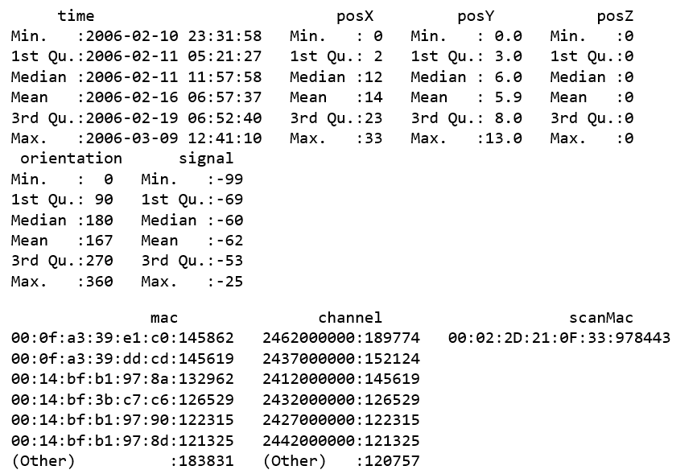

When viewing the orientation data, we see that the empirical distribution function of orientation shows that there are 8 basic orientations that are 45 degrees apart. We observe from the steps in the function that these orientations are not exactly 45, 90, 135, etc. Also, the 0 orientation is split into the two groups, one near 0 and the other near 360 as they both refer to the same orientation as seen in Figure 3. Nolan and Lang use “roundOrientation” function to address this issue and introduce a new variable called angle.

**Figure 2: Orientation data of offline dataset.**

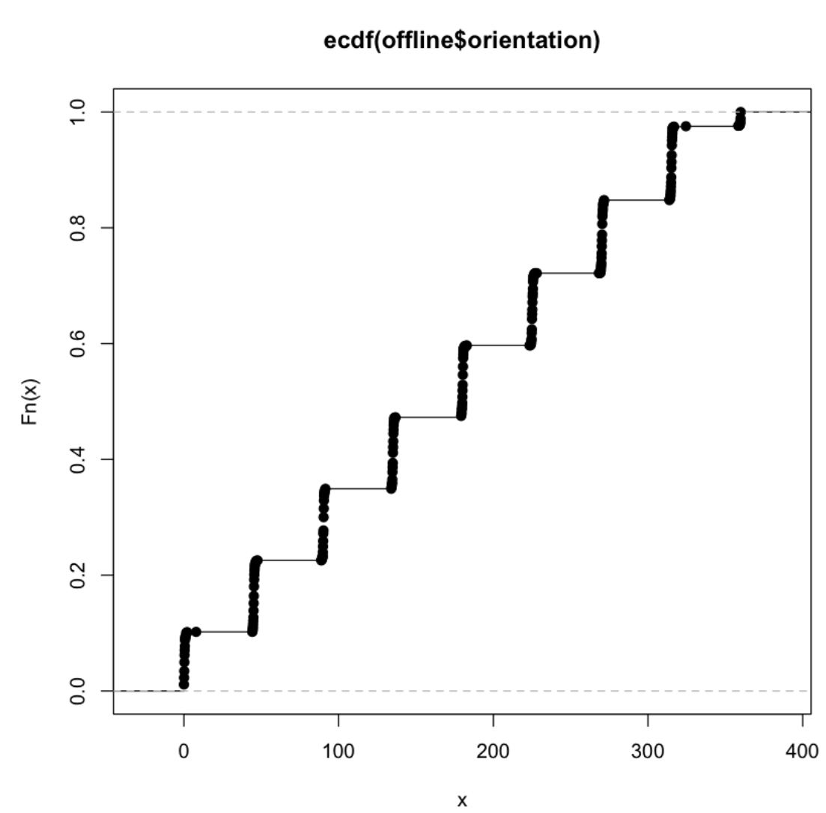

**Figure 3: Density vs. Orientation.**

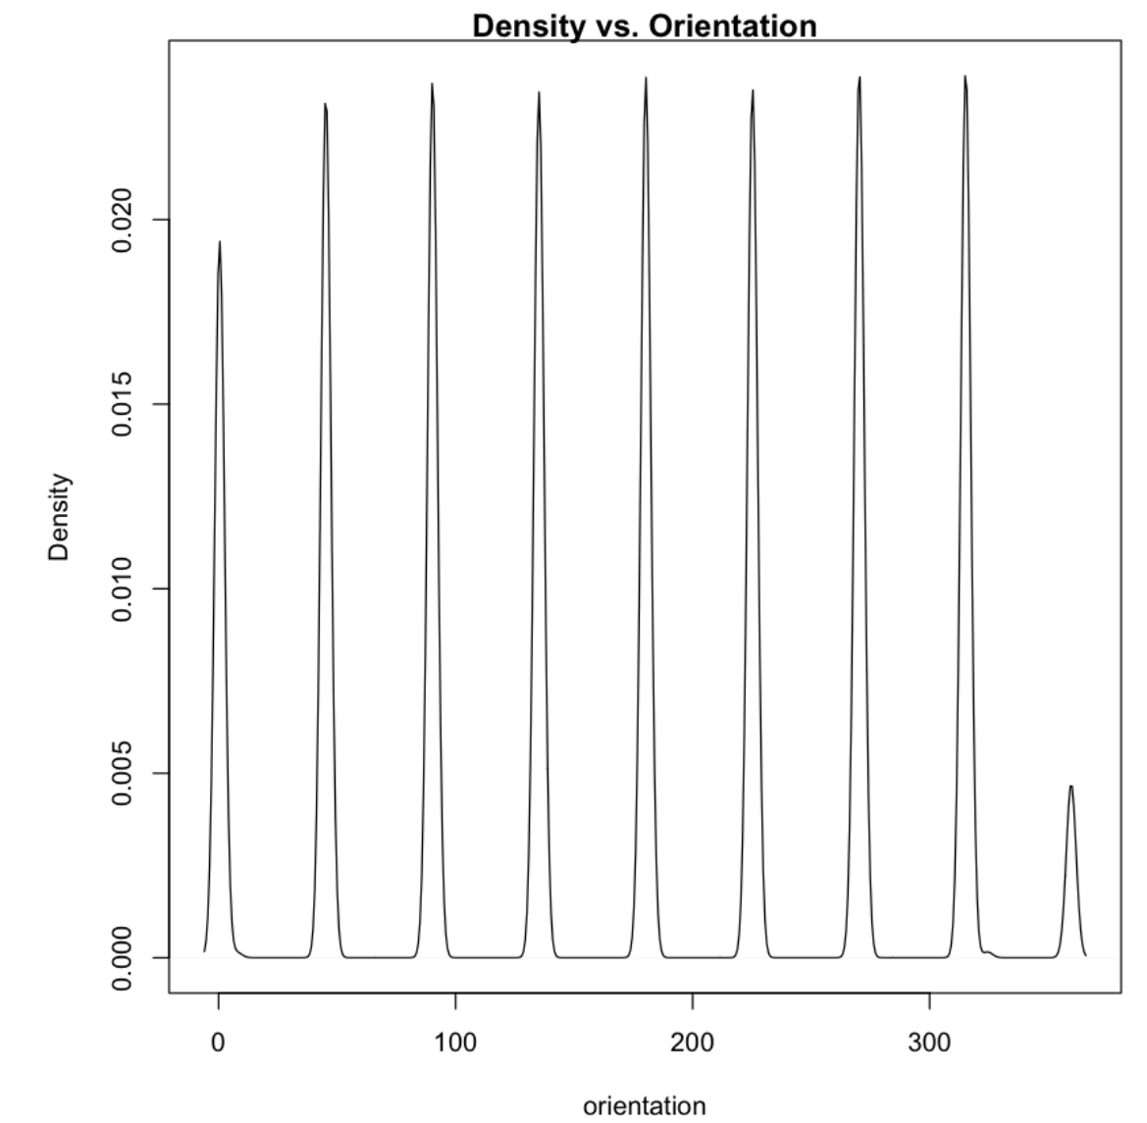

From the summary() information, it seems that there may be a one-to-one mapping between the MAC address of the access points and channel. For example, the summary statistics show there are 126,529 occurrences of the address 00:14:bf:3b:c7:c6 and the same number of occurrences of channel 2432000000. To help us ascertain if we do have a one- to-one mapping, we look at the relationship between the MAC address and channel. How many unique addresses and channels do we have? There should be the same number, if there is a one-to-one mapping.

There are 12 MAC addresses and 8 channels. We were given the impression from the building plan that there are only 6 access points. Why are there 8 channels and 12 MAC addresses? Rereading the documentation we find that there are additional access points that are not part of the testing area and so not seen on the floor plan.

According to the documentation, the access points consist of 5 Linksys/Cisco and one Lancom L-54g routers. We look up these MAC addresses at the http://coffer.com/mac_find/ site to find the vendor addresses that begin with 00:14:bf belong to Linksys devices, those beginning with 00:0f:a3 belong to Alpha Networks, and Lancom devices start with 00:a0:57 (see Figure 1.4). We do have 5 devices with an address that begins 00:14:bf, which matches with the Linksys count from the documentation. However, none of our MAC addresses begin with 00:a0:57 so there is a discrepancy with the documentation. Please recall that there are potentially signals recorded at 166 grid points, 8 orientations, and 110 replications.

The third and fifth above addresses are not among the access points displayed on the map because they have much lower counts than the others and these are far lower than the possible 146,080 recordings. For now, we keep records of our top 7 devices.

**Table 3: Count of MAC addresses**

|  |  |  |  |  |  |  |
| --- | --- | --- | --- | --- | --- | --- |
| Access Point | 00:0f:a3:39:e1:c0 | 00:14:bf:3b:c7:c6 | 00:14:bf:b1:97:81 | 00:14:bf:b1:97:8a | 00:14:bf:b1:97:8d | 00:14:bf:b1:97:90 |
| # MAC Ad | 145862 | 126529 | 120339 | 132962 | 121325 | 122315 |
| Access Point | 00:0f:a3:39:e2:10 | 00:0f:a3:39:dd:cd | 00:0f:a3:39:e0:4b | 00:04:0e:5c:23:fc | 00:30:bd:f8:7f:c5 | 00:e0:63:82:8b:a9 |
| # MAC Ad | 19162 | 154619 | 43508 | 418 | 301 | 103 |

Due to one to one correspondence of channel and MAC address of our top 7 devices, we eliminate the channel.

**Table 4: 1 to 1 correspondence of MAC channel**

|  |  |
| --- | --- |
| **Access Point** | **# Correspondence Channel** |
| 00:0f:a3:39:e1:c0 | 1 |
| 00:14:bf:b1:97:8a | 1 |
| 00:14:bf:3b:c7:c6 | 1 |
| 00:14:bf:b1:97:90 | 1 |
| 00:0f:a3:39:dd:cd | 1 |
| 00:14:bf:b1:97:8d | 1 |
| 00:14:bf:b1:97:81 | 1 |

We now consider the position variables, posX and posY. For how many different locations do we have data? The by() function can tally up the numbers of rows in our data frame for each unique (x, y) combination. We begin by creating a list containing a data frame for each location as follows and remove the 310 null elements to arrive at 166 data frames.

We can now operate on all 166 data frames to determine the number of observations recorded at each location. The next sapply function will keep the position information with the location and then we can confirm that "locCounts" is a matrix with 3 rows. Examining a few of the location data indicates that we have about 5500 records per position. With 7 access points in place and the 8 orientations that we cleansed, there are 110 replications of the data. This becomes 6,160 signal strength measurements. This matrix can be plotted and it gives us a very good overview of the presence of devices on different locations. The following code illustrates this data and as you can see, not all signals were detected, so there are about 5500 recordings at each location.

**Figure 4: Plotted matrix of signals.**

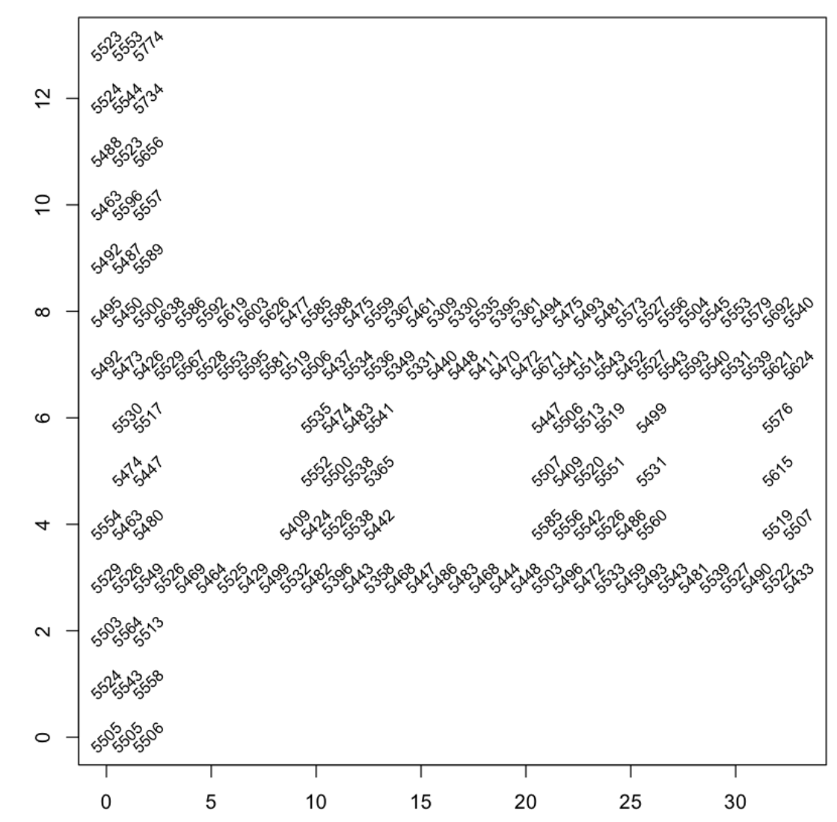

Now, we try to detect any time related bias in the data as Nolan and Lang examined all variables except "time" and "signal". By plotting variable against the time, we observe that data has been captured in three dates in February and March. These plots indicate that we have less data in March compared to February. Channels and orientations are very limited (which may reflect certain behavior of handheld device users in March). Posx, posY and posZ indicate that handheld device users did not show up in different locations (Unlike what we observed in Fig. 1) in March. This may cause a bias in predicting location. We will consider this as part of our analysis.

**Figure 5: Signal and Orientation vs. time**

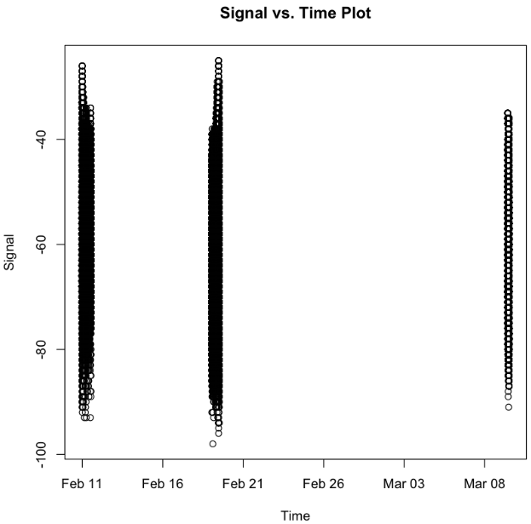 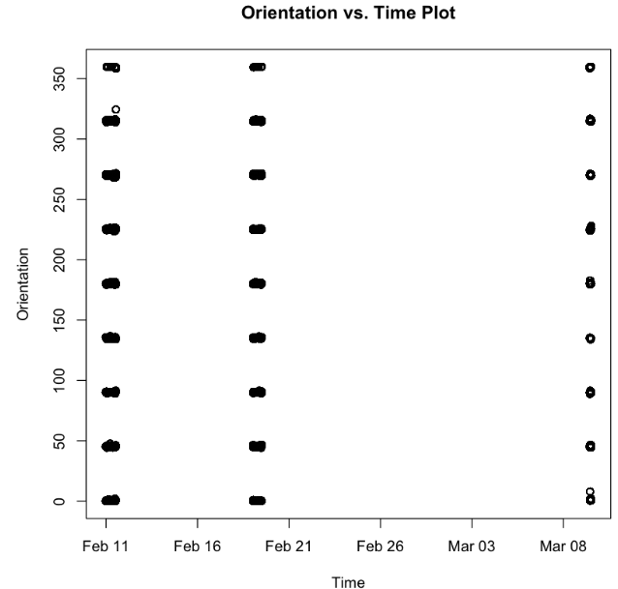

**Figure 6: Channel and ScanMac vs. time**

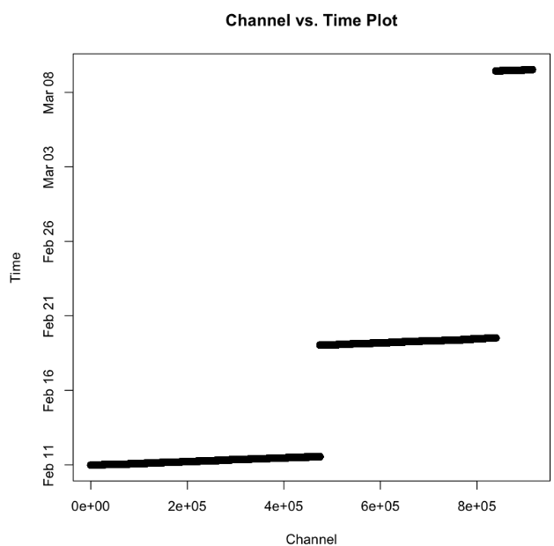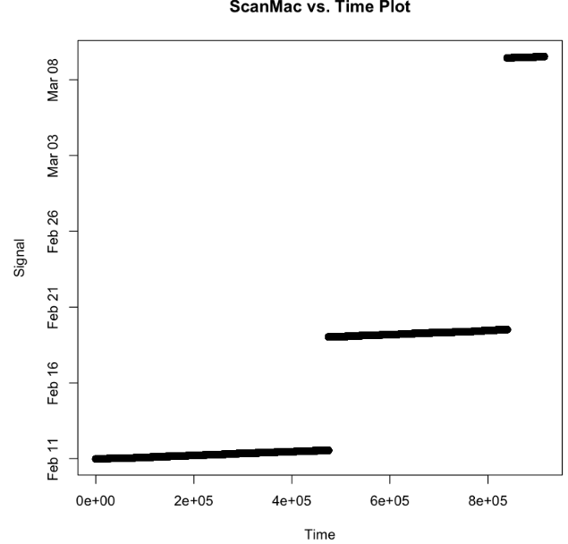

**Figure 7: PosX and PosY vs. time**

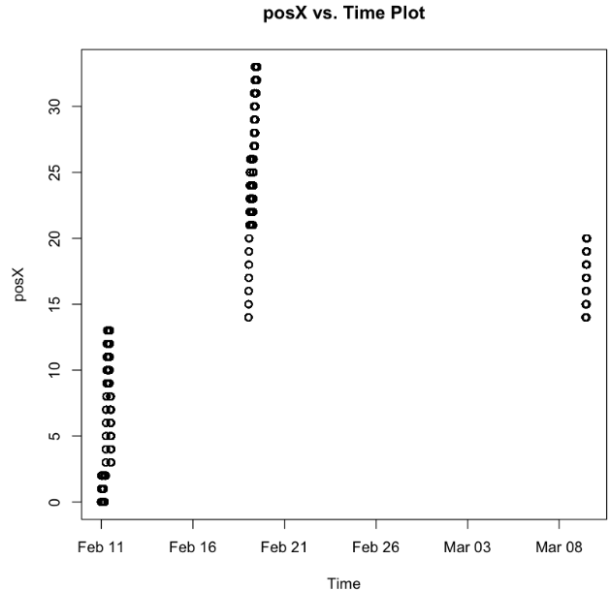 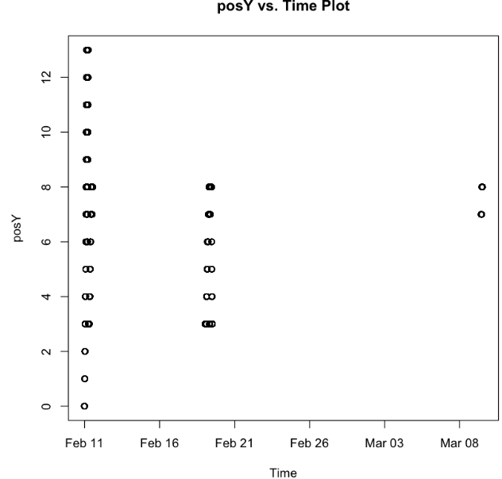

Now we need to cleanse the signal data. As explained in Section 1.3.4 of Data Science in R, the following process introduces a function to redo all cleansing we have done in "readData" function. It reuses the roundRotation and processLine functionality that we have globally shared in the R session. Then we use the idential functionality to verify that the output of "readData" function is identical to the existing "offline" variable.

We have measured the signal strength to an access point multiple times at each location and orientation. How do these signal strengths behave? That is, what is the distribution of the repeated measurements at each location and orientation? Does signal strength behave similarly at all locations? Or does, the location, orientation, and access point affect this distribution?

In practice, physical characteristics of a building and human activity can add significant noise to signal strength measurements. How can we characterize the relationship between the signal strength and the distance from the device to the access point? How does the orientation affect this relationship? Is this relationship the same for all access points?

We will try to find answer for these questions.

## **Results**

We want to compare the distribution of signal strength at different orientations and for different access points, so we need to subdivide our data. We are interested in seeing if these distributions are normal or skewed. We also want to look at their variances.

We would like to consider the impact of orientation on signal strength by fixing a location on the map to see how the signal changes as the experimenter rotates through the 8 angles. We also separately examine the MAC addresses because, for example, at an orientation of 90 degrees the experimenter may be facing toward one access point and away from another. As part of the work, we summarize the signal values. The more negative the signal value is, the weaker it becomes.

**Figure 8: Distribution of Signal Strength for each selected MAC address based on orientations.**

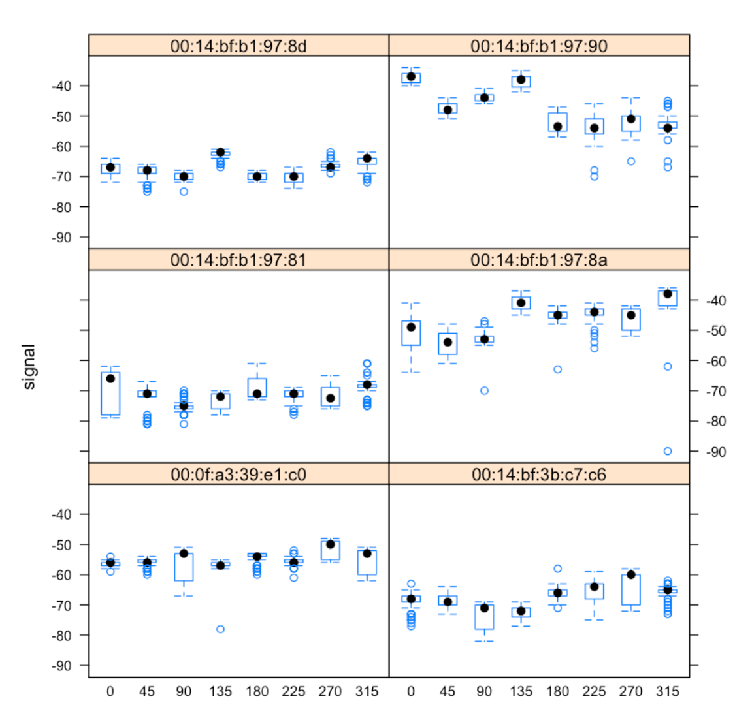

We observe in the previous plot that the signal strength varies with the orientation for bothclose and distant access points. Note we have dropped the records for the MAC address of 00:0f:a3:39:dd:cd because it is identified as the extra address in the next section.

We compare the distributions of signal strength for different angles and MAC addresses at the central location of x = 23 and y = 4. Lack of normal distribution in the following plot illustrates that conditioning on angle and MAC address is warranted. If the distributions were normal, we could conclude that signal can be received from different angles but that does not seem to be the case.

**Figure 9: Comparison of distributions of signal strength by angle**

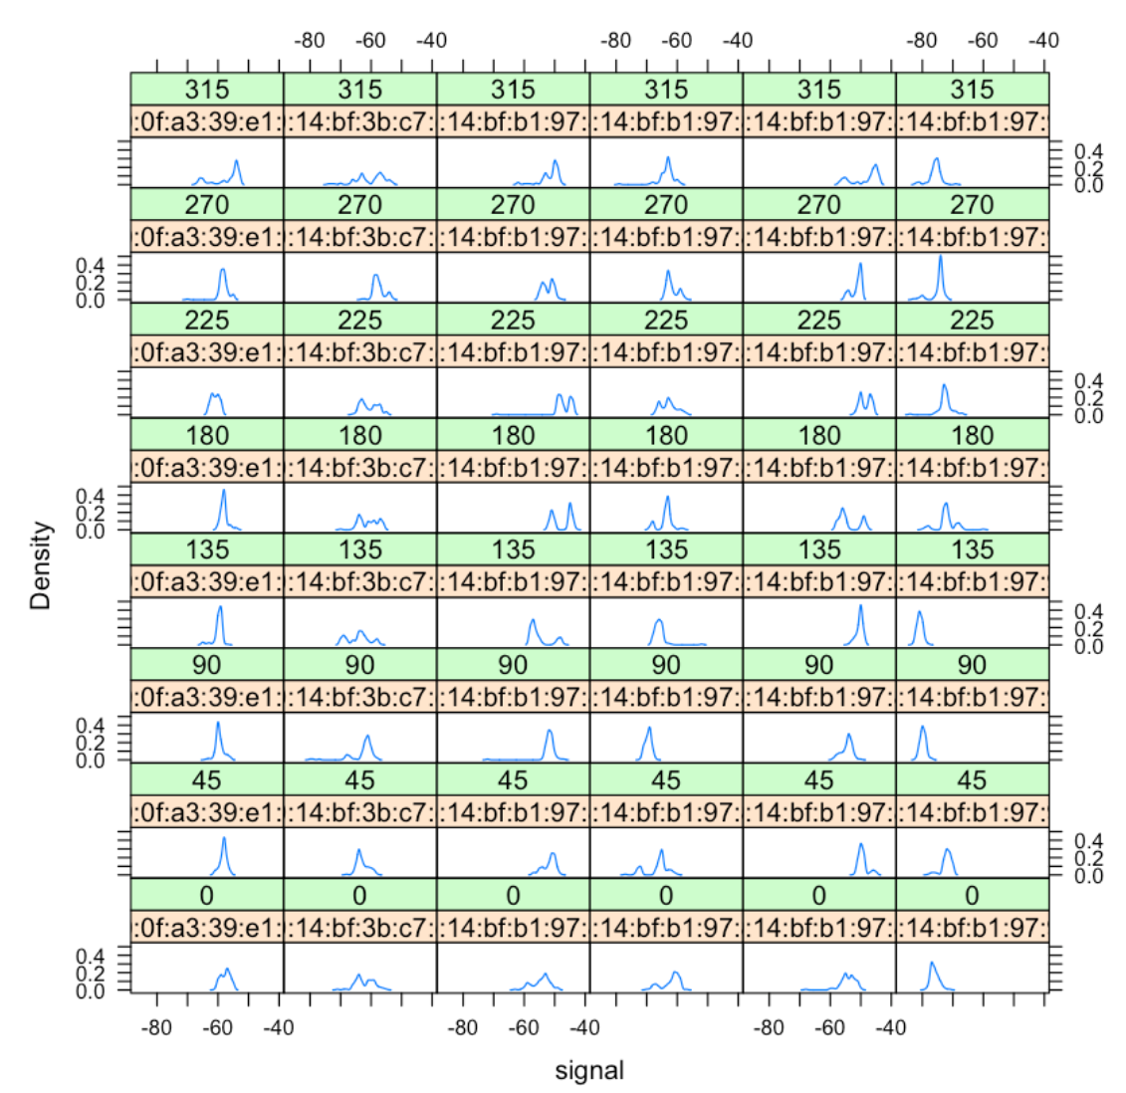

If we want to examine the distribution of signal strength for all 166 locations, 8 angles, and 6 access points, we need to create thousands of boxplots or density curves. We can, instead, examine summary statistics such as the mean and SD or the median and IQR of signal strength for all location–orientation–access point combinations. For each combination, we have roughly 100 observations. To compute summary statistics for these various combinations, we first create a special factor that contains all of the unique combinations of the observed (x, y) pairs for the 166 locations.

We plot the offlineSummary data and observe that the weakest signals have small standard deviations and that it appears that the SD increases with the average signal strength. If we plan to model the behavior of signal strength, then we want to take these features into consideration. The weak signals have low variability and the stronger signals have greater variability.

**Figure 10: Boxplot of SD signal against Mean Signal**

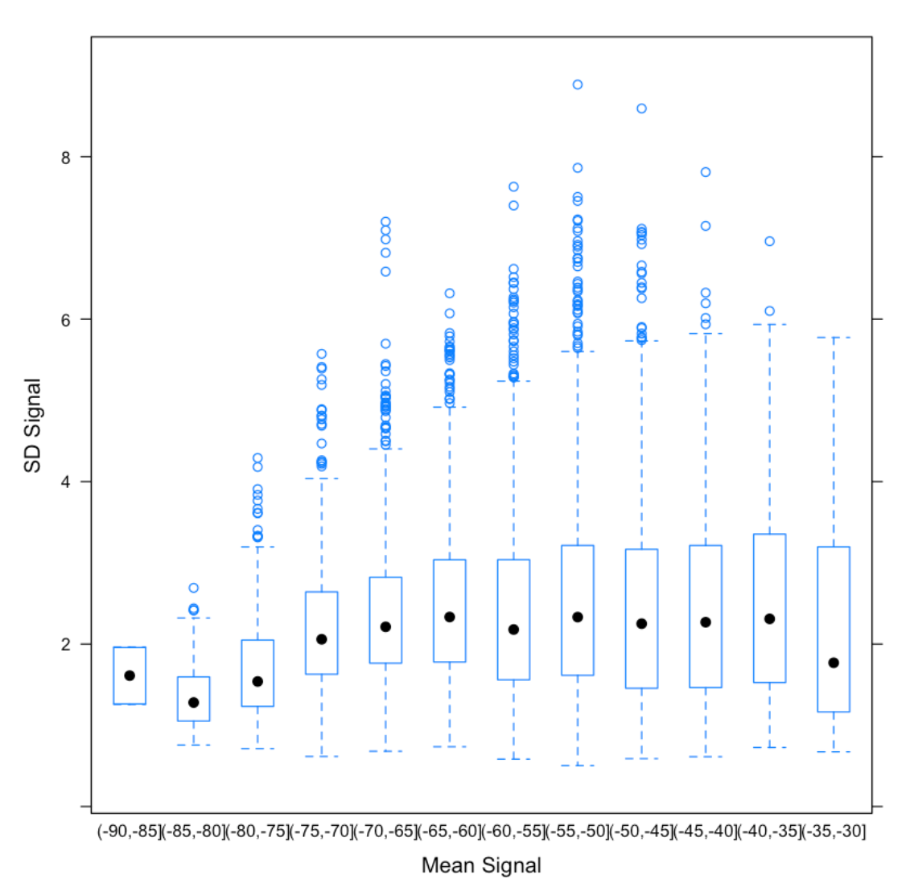

We examine the skewness of signal strength by plotting the difference, avgSignal - medSignal, against the number of observations. Then we use the fitted model to predict the difference for each value of num and add these predictions to the scatter plot. We see that these two measures of centrality are similar to each other; they typically differ by less than 1 to 2 dBm.

**Figure 11: Difference of Signal Strength minus Average Signal Strength**

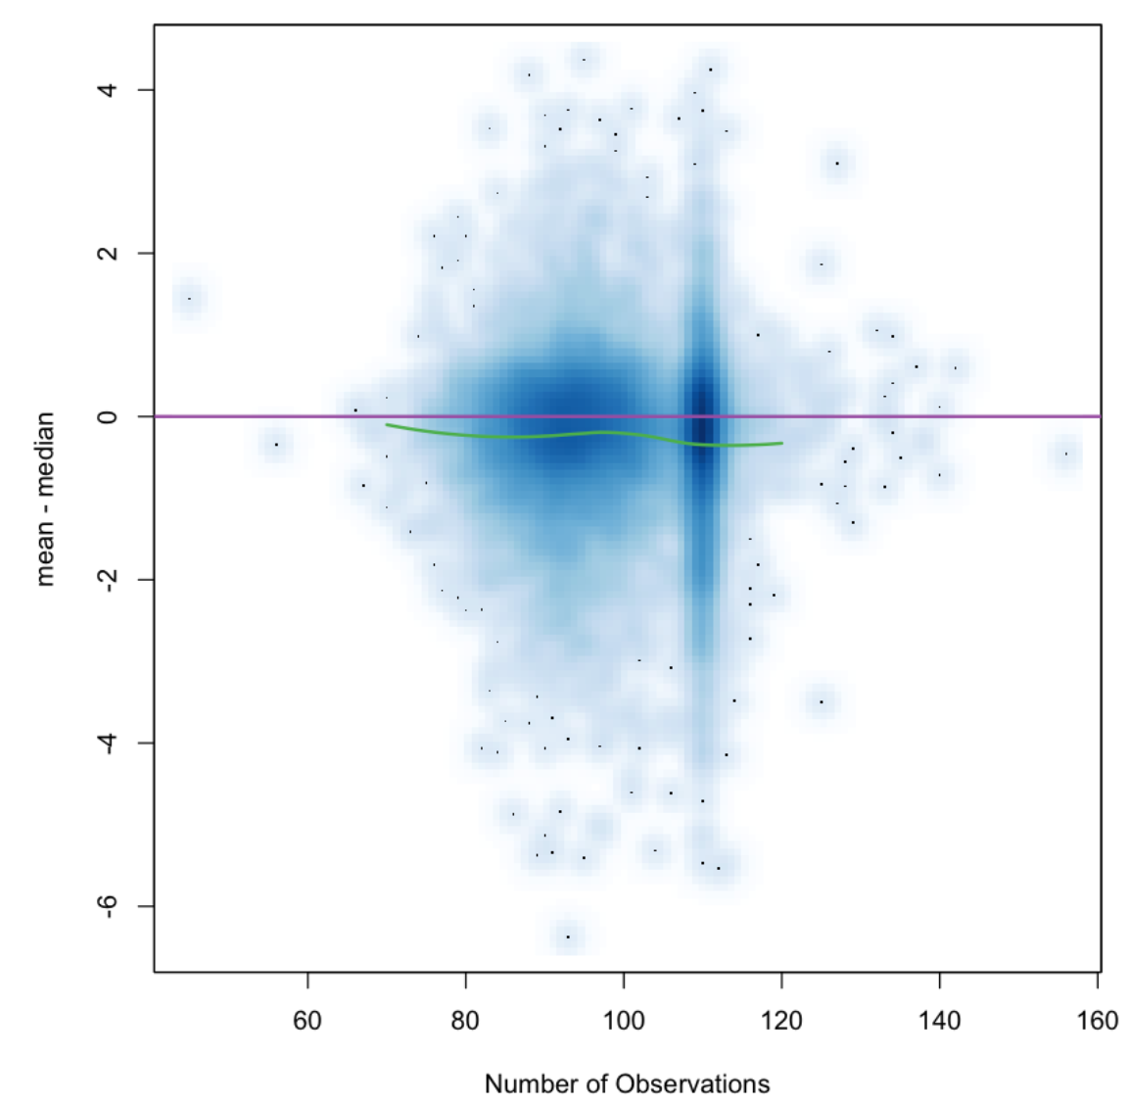

## **Results**

We see that we can easily identify the location of the access point as the dark red region at the top of the “mountain.” We also confirm the effect of the orientation on signal strength. Additionally, a corridor effect emerges.

**Figure 12: Heat map of signal strength plotted on posX and posY.**

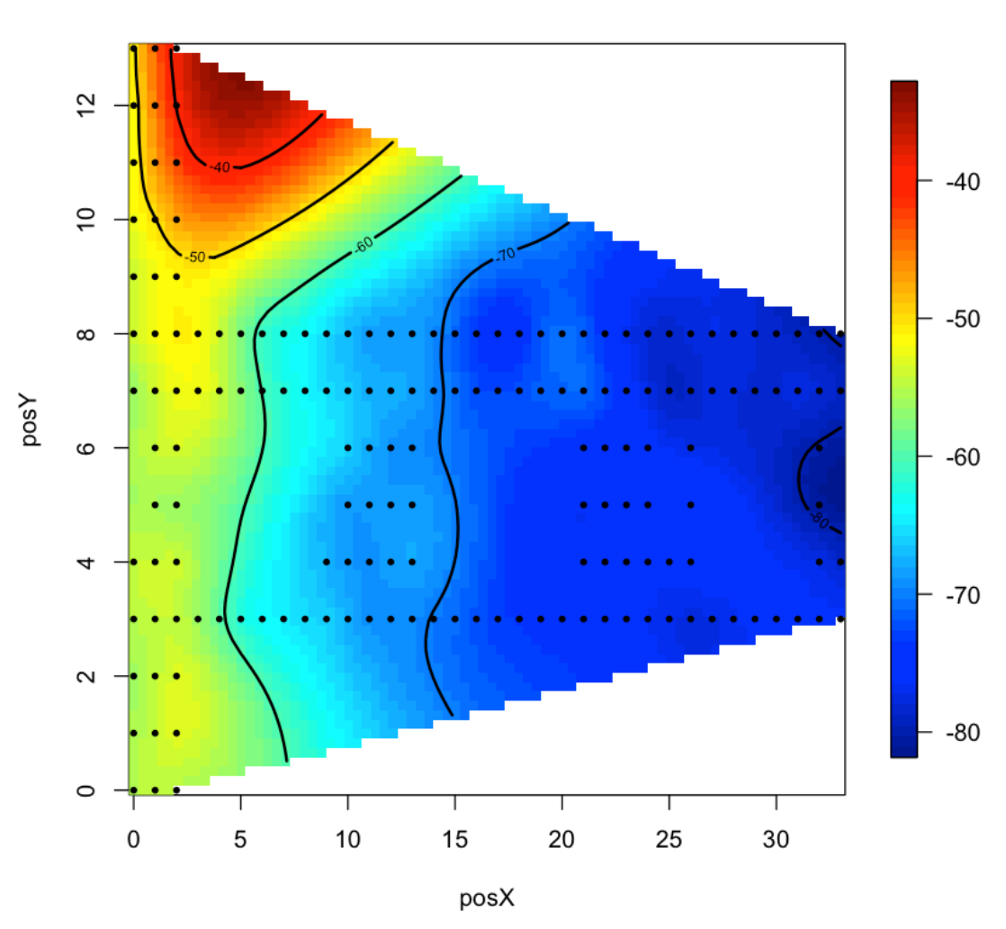

The signal is stronger relative to distance along the corridors where the signals are not blocked by walls. We know the locations of the access points based on the floor plan of the building, but we have not been given their exact location and we do not know the mapping between MAC address and access point. Fortunately, the contour maps that we just created make it easy to connect the MAC address to the access point marked on the floor plan in figure 1.

For example, the signals appearing in the top row of the plot clearly correspond to the access point in the top left corner of the building. Also, according to the documentation, the training data were measured at 1 meter intervals in the building so we can use the grey dots on the plan to estimate the location of the access points. We find that two MAC addresses have similar heat maps and these both correspond to the access point near the center of the building (i.e., x = 7.5 and y = 6.3).

**Table 5: X and Y locations corresponds to individual access points**

|  |  |  |
| --- | --- | --- |
| **Access Point** | **X** | **Y** |
| 00:0f:a3:39:e1:c0 | 7.5 | 6.3 |
| 00:14:bf:b1:97:8a | 2.5 | -0.8 |
| 00:14:bf:3b:c7:c6 | 12.8 | -2.8 |
| 00:14:bf:b1:97:90 | 1.0 | 14.0 |
| 00:14:bf:b1:97:8d | 33.5 | 9.3 |
| 00:14:bf:b1:97:81 | 33.5 | 2.8 |

**Figure 13: Heat map of median signal strength at two access points and two angles.**

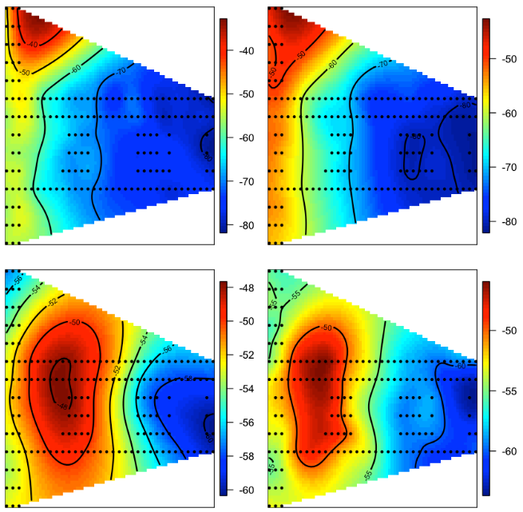

Due to heat map similiarity, one of the Mac addresses that is located at the center of the building is removed from the dataset. This decision will have an impact on location prediction. Although it seems that there is a multicolinearity between two Mac addresses and the strength of the signal, the prediction model might have other influencing factors and missing data of a particular location might bias the model in a certain way. We already know that the March data is very limited in volume and variance and choosing either of these two Mac address can cause a bias. Ideally we should compute the accuracy of the model, with the first, second and both Mac addresses separately.

**Figure 14: Scatter plot of signal strength versus distance to access point for each individual orientation and access points.**

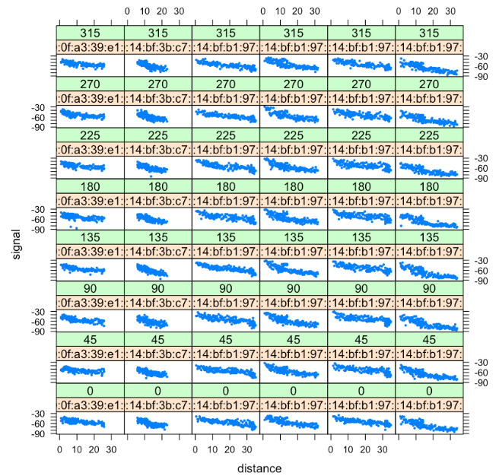

As there appears to be a curvature in the scatter plots of signal strength vs. distance for each access points and orientation angle, we can do a log transformation to improve the performance. As there are negative numbers for signal strengths, we needed to shift the signal values by at least 89 in order to have positive numbers for signal values.

As illustrated in figure 12, the log transformation was successful and the curvature almost disappeared. Then we decided to add logSignal and logDist to the offlineSummary. If we use it in the model later, we should remember to reverse log transformation in the conclusion phase.

**Figure 15: Scatter plot of log signal strength versus log distance to access point for each individual orientation and access points.**

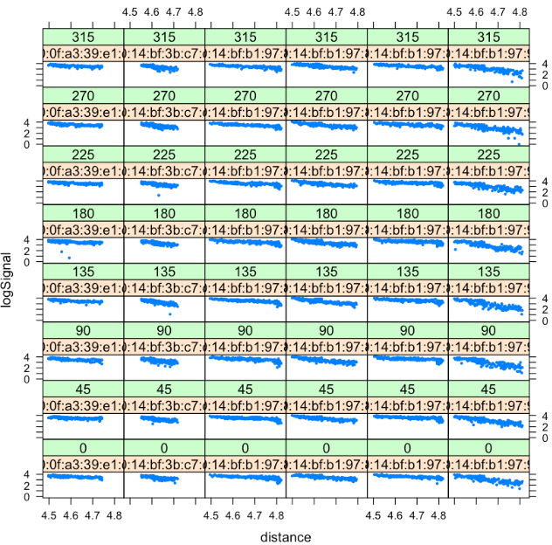

At this point, we have a set of training data that we can use to predict the location of our new point. We want to look at the distance in terms of signal strengths from these training data to the new point. If we would like to use the nearest neighbor or the 3 nearest neighbors, we need to calculate the distance from the new point to all observations in the training set. The following code prepares the test data by tallying the number of signal strengths recorded at each location, keeping the data variables that are being used in assessing prediction. This new data frame will have 60 rows and 11 variables, including 6 average signal strengths at the corresponding MAC addresses. The dimension of onlineSummary will verify the result.

**Table 6: Number of Signal strengths recorded at each orientation.**

|  |  |  |  |  |  |  |  |  |
| --- | --- | --- | --- | --- | --- | --- | --- | --- |
|  | 0 | 45 | 90 | 135 | 180 | 225 | 270 | 315 |
| 0-0.05 | 0 | 0 | 0 | 593 | 0 | 0 | 0 | 0 |
| 0.15-9.42 | 0 | 0 | 660 | 0 | 0 | 0 | 0 | 0 |
| 0.31-11.09 | 0 | 0 | 0 | 0 | 0 | 573 | 0 | 0 |
| 0.47-8.2 | 590 | 0 | 0 | 0 | 0 | 0 | 0 | 0 |
| 0.78-10.94 | 586 | 0 | 0 | 0 | 0 | 0 | 0 | 0 |
| 0.93-11.69 | 0 | 0 | 0 | 0 | 583 | 0 | 0 | 0 |

In the nearest neighbor model, we would like to find records in our offline data that have similiar orientations to our new observation as orientation can impact the strength of the signal. That is why we consider using all records with an orientation that is within a specified range of the new point's orientation.

Since the observations were recorded in 45 degree increments, we can simply specify the number of neighboring angles to include from the training data. For example, if we want only one orientation, then we only include training data with angles that match the rounded orientation value of the new observation. If we want two orientations then we pick those two multiples of 45 degrees that flank the new observation’s orientation; for three, we choose the closest 45 degree increment and one on either side of it, and so on.

We used the SelectTrain() function to average the signal strengths for different orientations in order to create just a set of signals for each of individual 166 locations in our training data.

**Table 7: Average Signal strengths for angle of 130 in each location.**

|  |  |  |  |  |  |  |
| --- | --- | --- | --- | --- | --- | --- |
| PosXY | 00:0f:a3:39:e1:c0 | 00:14:bf:3b:c7:c6 | 00:14:bf:b1:97:81 | 00:14:bf:b1:97:8a | 00:14:bf:b1:97:8d | 00:14:bf:b1:97:90 |
| 0-0 | -52 | -66 | -63 | -36 | -64 | -59 |
| 0-1 | -53 | -65 | -64 | -39 | -65 | -59 |
| 0-10 | -56 | -66 | -69 | -45 | -67 | -50 |
| 0-11 | -55 | -67 | -70 | -48 | -67 | -55 |
| 0-12 | -56 | -70 | -72 | -45 | -67 | -50 |
| 0-13 | -55 | -71 | -73 | -43 | -69 | -54 |

We now have a set of training data that we can use to predict the location of our new point. We want to look at the distance in terms of signal strength from these training data to the new point. So we need to calculate the distance from the new point to all observations in the training set. The findNN function will help us to do the calculation. It will return the locations of the training observations in order of closeness to the new observation's signal strength. Later, you will see that a subset of this result can be used to estimate the location of the new observation (For k value of nearest neighbors, we can simply average the first k locations).

We can predict the location for all dataset by reusing trainSelect and findNN functions. Please consider that we calculate the average of k neighbor distance using anonymous function using Euclidean distance. This function can later be imporved to be passed as a parameter to calculate the predicted location.

The "predXY" is then invoked using 1 and 3 nearest neighbors and 3 orientations. We will later calculate the accuracy of our predictions with different number of neighbors.

The results shows the average error for 1 and 3 nearest neighbors as 411.6 and 270.5 respectively. This indicates that the root mean square error of the predicted result with 3 nearest neighbor is considerably more accurate. But we might still do better with different number of nearest neighbors.

While figure 13 visualizes the error, the calcError function calculates the value of root mean square error (RMSE).

**Figure 16: Floor plan with actual (dots) and predicted (asterisks) locations with 3 nearest neighbors.**

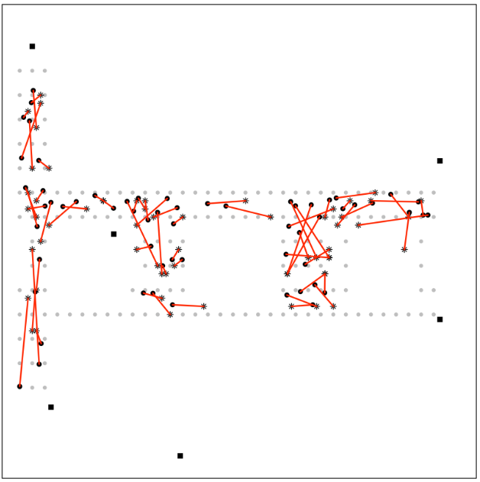

In performing the v fold cross validation process, if we create v fold of subset of offline data as test data and use a subset of corresponding online data, we can find the K-NN estimate for a large K number for a certain number of angles with average signal strength. This will help us avoid overfitting. We created the essential subset data with v =11 to create roughly equal folds across.

Using "reshapeSS" function, we will prepare the offline vs. online data and predict the result in "estFold" for 3 neighbors and 3 angles and predict the result with different number of (k) neighbors, and calculate the error size per scenario. This data will help us find the best possible K using a brute force approach and as we hope the cross validation reduces the chance of overfitting.

We expect that the estimate of many sensors that are far away from each other will not lead to accurate location. That is why a small K is expected to have the minimum root mean square error.

We predicted location for each fold. We observe that root mean square error is minimized for k =5 and k=7 which stand somewhere between 1 and 20. As expected, the error rate will increase with too many neighbors contributing to the calculation of the location and the "calcError" function yields smaller value (275.92).

We also observe that the calculation of one or two sensors leads to inaccurate results, but as closest neighbors contribute more to the calculation, the rate of error drastically decrease.

**Figure 17: Linear plot of sum of square errors vs. number of neighbors.**

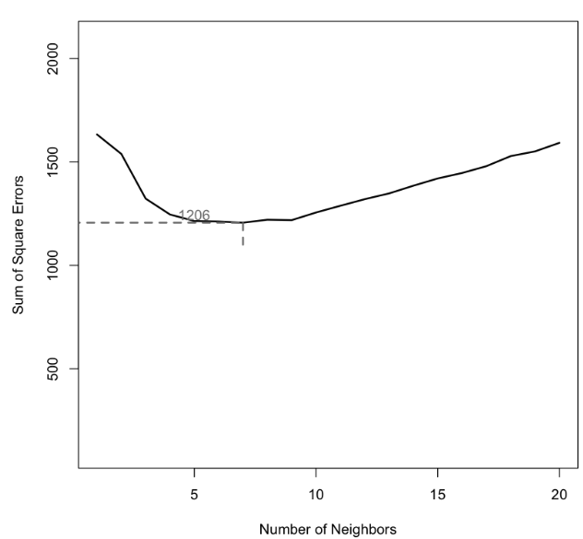

## **Two Access Point Data Analysis**

Here, we are going to conduct a more thorough data analysis into two MAC addresses including determining locations by using data corresponding to both MAC addresses (with MAC address "00:0f:a3:39:e1:c0" and "00:0f:a3:39:dd:cd") and the goal is to find out which of these two MAC addresses should be used and which should not be used for RTLS.

Table 8 shows the number of existing data for "00:0f:a3:39:e1:c0" and "00:0f:a3:39:dd:cd" access points. We observe that the size of the data is very close. Plotting the data of both access points indicates that "00:0f:a3:39:dd:cd" data has lower signal strength, and we know that the signal strength has an impact on the location prediction.

**Table 8: Number of existing data for two access points.**

|  |  |  |
| --- | --- | --- |
| Access Point | 00:0f:a3:39:dd:cd | 00:0f:a3:39:e1:c0 |
| # of Records | 145619 | 145862 |

**Figure 18: Box plot of signal strengths for each orientation of two access points.**

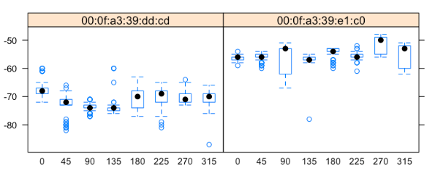

Nolan and Temple Lang did not use one of the seven access points that exists in the offline data set. The access point "00:0f:a3:39:dd:cd" was removed by them in the analysis as it was roughly in the same location as "00:0f:a3:39:e1:c0". We will rerun all the steps again with "00:0f:a3:39:dd:cd" and without "00:0f:a3:39:e1:c0". We will observe the results with the requested access points data. Then we will do KNN with both data in the model and compare the root mean square error between predicted and actual locations.

We performed the same process as above and visualized the results that help to find out with which access points we have a less error in our RTLS.

**Predicting the location with new access point data**

We prepared the essential folds of offline data (with the new access point data) so that we can predict the location and calculate the root mean square error rate for different number of neighbors in the range of 1 to 20. This will help us plot the root mean square error vs. the number of neighbors and analyze the way new access point contributes to our prediction model.

When we compare figure 19 with Nolan and Lang code, we observe that our access point ("00:0f:a3:39:dd:cd") leads to a smaller root mean square error rate with the same number of neighbors(k=5) and the "calcError" function yields smaller value (249.92). We conclude that the access point "00:0f:a3:39:dd:cd" has a better contribution to the model.

**Figure 19: Linear plot of sum of square errors vs. number of neighbors.**

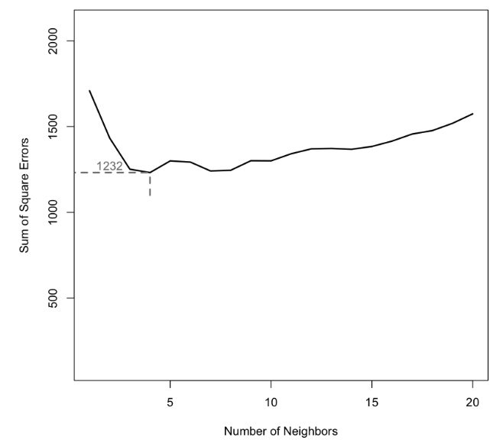

Now we would like to know whether we can have a better model with both access points in the data. As they are roughly in the same location, the result might not differ as much. But we try to find an answer for the question.

Figure 20 illustrates a similar trend. Very few access points and too many of them contribute to the root mean square error of predicted location. When we compare this plot with the corresponding previous plots , we observe that having both access points as part of the model will lead to a lower root mean square error (229) compared to the original approach, therefore our model has higher accuracy than having only "00:0f:a3:39:dd:cd" or "00:0f:a3:39:e1:c0" access points. Thus, combination of two access points caused to have a better location prediction.

**Figure 20: Linear plot of sum of square errors vs. number of neighbors with both access points.**

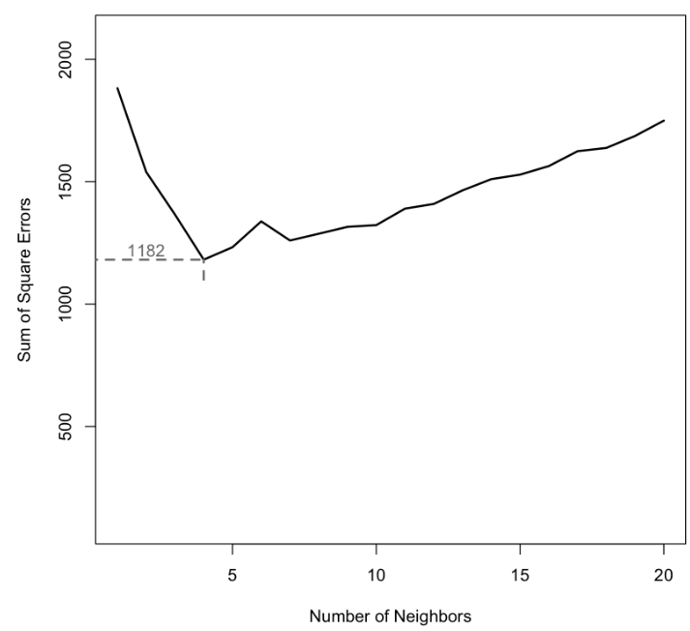

**KNN Distance Weighting**

Now that we have chosen the combination of both access points, we estimate positions by average X-Y location across k nearest points. The distance of the points may influence the accuracy of the model. We apply weights to the XY positions of each k closest locations to evaluate the influence. Rather than averaging the values, we will take the sum of those results. With the below formula, we are able to compute weights for each k closest observations.

The findNN function has been modified from the previous version to return the distance metrics as well(It is used in determining the closest k points). Moreover, predXY function is improved to conduct weight computation (with the mentioned formula). These weights are each multiplied against each k nearest observation, and then summed to compute weighted estimation by distance. These new calculations might allow locations of closer distances to be more impactful than those further away (instead of equal weighting among the k points).

With our optimal k value (equal to 4) selected for number of nearest points, we compute predictions using the weighted distance estimation method, storing the RMSE values for comparison to the average location methods. RMSE in this case is 204.5 which is less than the RMSE in our previous approaches.

**Figure 19: Linear plot of sum of square errors vs. number of neighbors.**

## 

## **Conclusions**

Estimations are compared using RMSE values. Visually, errors in Nolan and Lang original model and KNN with distance weighting both seem to show more errors in the narrow hallways. This large error makes sense due to density of observations. Overall, differences in these outputs show very similar results with some errors being largely minimized by the weighted distance strategy and adding the new access point to the model. Using different K values and distance methods, the error rate gradually decreased from 659.4 to 306.7 to 275.5 to 228.3, and finally to 204.5. We wish we had more time to improve our model using log transformed and time features and other distance methods to minimize the RMSE even more.

## **References**

1. Madigan et al, “Location Estimation in Wireless Networks: a Bayesian Approach.” Statistica Sinica 16(2006)
2. Nolan, D. and Lang, D. T. “Data Science in R.” CRC Press, 2015 (Chapter 1)
3. <https://github.com/rfarhanian/qtw/tree/master/week2>

## **Appendix – R Code**

### RTLS Project R code

seed <- 763

set.seed(seed = seed)

library(data.table)

options(digits = 2)

txt <- readLines('data/offline.final.trace.txt')

head(txt)

sum(substr(txt, 1, 1) == "#")

length(txt)

strsplit(txt[4], ";")[[1]]

tokens = strsplit(txt[4], "[;=,]")[[1]]

tokens[1:10]

tokens[c(2, 4, 6:8, 10)]

tokens[ -( 1:10 ) ]

tmp = matrix(tokens[ - (1:10) ], ncol = 4, byrow = TRUE)

mat = cbind(matrix(tokens[c(2, 4, 6:8, 10)], nrow = nrow(tmp), ncol = 6, byrow = TRUE), tmp)

dim(mat)

processLine = function(x)

{

tokens = strsplit(x, "[;=,]")[[1]]

tmp = matrix(tokens[ - (1:10) ], ncol = 4, byrow = TRUE)

cbind(matrix(tokens[c(2, 4, 6:8, 10)], nrow = nrow(tmp),

ncol = 6, byrow = TRUE), tmp)

}

tmp = lapply(txt[4:20], processLine)

sapply(tmp, nrow)

offline = as.data.frame(do.call("rbind", tmp))

dim(offline)

lines = txt[ substr(txt, 1, 1) != "#" ]

tmp = lapply(lines, processLine)

processLine = function(x)

{

tokens = strsplit(x, "[;=,]")[[1]]

if (length(tokens) == 10)

return(NULL)

tmp = matrix(tokens[ - (1:10) ], , 4, byrow = TRUE)

cbind(matrix(tokens[c(2, 4, 6:8, 10)], nrow(tmp), 6,

byrow = TRUE), tmp)

}

options(error = recover, warn = 1)

tmp = lapply(lines, processLine)

offline = as.data.frame(do.call("rbind", tmp), stringsAsFactors = FALSE)

dim(offline)

# head(offline)

names(offline) = c("time", "scanMac", "posX", "posY", "posZ",

"orientation", "mac", "signal",

"channel", "type")

numVars = c("time", "posX", "posY", "posZ",

"orientation", "signal")

offline[ numVars ] = lapply(offline[ numVars ], as.numeric)

offline = offline[ offline$type == "3", ]

offline = offline[ , "type" != names(offline) ]

#offline[1:2]

dim(offline)

offline$rawTime = offline$time

offline$time = offline$time/1000

class(offline$time) = c("POSIXt", "POSIXct")

unlist(lapply(offline, class))

summary(offline[, numVars])

summary(sapply(offline[ , c("mac", "channel", "scanMac")], as.factor))

offline = offline[ , !(names(offline) %in% c("scanMac", "posZ"))]

length(unique(offline$orientation))

plot(ecdf(offline$orientation), main="8 equi-spaced angles", sub="Emperical cumulative distribution function transforms orientations into 8 segments.")

#pdf(file = "Geo_ECDFOrientation.pdf", width = 10, height = 7)

oldPar = par(mar = c(4, 4, 1, 1))

plot(ecdf(offline$orientation), pch = 19, cex = 0.3,

xlim = c(-5, 365), axes = FALSE,

xlab = "orientation", ylab = "Empirical CDF", main = "")

box()

axis(2)

axis(side = 1, at = seq(0, 360, by = 45))

par(oldPar)

dev.off()

#pdf(file = "Geo_DensityOrientation.pdf", width = 10, height = 5)

oldPar = par(mar = c(4, 4, 1, 1))

plot(density(offline$orientation, bw = 2),

xlab = "orientation", main = "")

title("Density vs. Orientation")

par(oldPar)

dev.off()

roundOrientation = function(angles) {

refs = seq(0, by = 45, length = 9)

q = sapply(angles, function(o) which.min(abs(o - refs)))

c(refs[1:8], 0)[q]

}

offline$angle = roundOrientation(offline$orientation)

#pdf(file = "Geo_BoxplotAngle.pdf", width = 10)

oldPar = par(mar = c(4, 4, 1, 1))

par(oldPar)

dev.off()

c(length(unique(offline$mac)), length(unique(offline$channel)))

table(offline$mac)

subMacs = names(sort(table(offline$mac), decreasing = TRUE))[1:7]

offline = offline[ offline$mac %in% subMacs, ]

macChannel = with(offline, table(mac, channel))

apply(macChannel, 1, function(x) sum(x > 0))

offline = offline[ , "channel" != names(offline)]

locDF = with(offline,

by(offline, list(posX, posY), function(x) x))

length(locDF)

sum(sapply(locDF, is.null))

locDF = locDF[ !sapply(locDF, is.null) ]

length(locDF)

locCounts = sapply(locDF, nrow)

locCounts = sapply(locDF,

function(df)

c(df[1, c("posX", "posY")], count = nrow(df)))

class(locCounts)

dim(locCounts)

plot(offline$time, offline$signal, xlab="Time", ylab="Signal",

main="Signal vs. Time Plot", sub="Signal is less dense and less variant in March.")

plot(offline$time, offline$orientation, xlab="Time", ylab="Orientation",

main="Orientation vs. Time Plot", , sub="Orientation is less dense and less variant in March.")

plot(offline$time, offline$channel, ylab="Time", xlab="Channel",

main="Channel vs. Time Plot", sub="Channel is less variant in March.")

plot(offline$time, offline$scanMac, xlab="Signal", ylab="Time",

main="ScanMac vs. Time Plot", sub="ScanMac is less variant in March.")

plot(offline$time, offline$posX, ylab="posX", xlab="Time",

main="posX vs. Time Plot",

sub="posX seems to be very limited in variance and volume in March.")

plot(offline$time, offline$posY, ylab="posY", xlab="Time",

main="posY vs. Time Plot",

sub="posY seems to be very limited in variance and volume in March.")

plot(offline$time, offline$posZ, ylab="Time", xlab="posZ",

main="posZ vs. Time Plot",

sub="posZ seems to be very limited in variance and volume in March.")

#pdf(file = "Geo_XYByCount.pdf", width = 10)

oldPar = par(mar = c(3.1, 3.1, 1, 1))

locCounts = t(locCounts)

plot(locCounts, type = "n", xlab = "", ylab = "")

text(locCounts, labels = locCounts[,3], cex = .8, srt = 45)

par(oldPar)

dev.off()

subMacCollection <- c("00:0f:a3:39:e1:c0", "00:0f:a3:39:dd:cd", "00:14:bf:b1:97:8a",

"00:14:bf:3b:c7:c6", "00:14:bf:b1:97:90", "00:14:bf:b1:97:8d",

"00:14:bf:b1:97:81")

readData = function(filename = 'data/offline.final.trace.txt', subMacs = subMacCollection)

{

txt = readLines(filename)

lines = txt[ substr(txt, 1, 1) != "#" ]

tmp = lapply(lines, processLine)

offline = as.data.frame(do.call("rbind", tmp),

stringsAsFactors= FALSE)

names(offline) = c("time", "scanMac",

"posX", "posY", "posZ", "orientation",

"mac", "signal", "channel", "type")

# keep only signals from access points

offline = offline[ offline$type == "3", ]

# drop scanMac, posZ, channel, and type - no info in them

dropVars = c("scanMac", "posZ", "channel", "type")

offline = offline[ , !( names(offline) %in% dropVars ) ]

# drop more unwanted access points

offline = offline[ offline$mac %in% subMacs, ]

offline

# convert numeric values

numVars = c("time", "posX", "posY", "orientation", "signal")

offline[ numVars ] = lapply(offline[ numVars ], as.numeric)

# convert time to POSIX

offline$rawTime = offline$time

offline$time = offline$time/1000

class(offline$time) = c("POSIXt", "POSIXct")

# round orientations to nearest 45

offline$angle = roundOrientation(offline$orientation)

return(offline)

}

offlineRedo = readData()

identical(offline, offlineRedo)

#pdf(file = "Geo_BoxplotSignalByMacAngle.pdf", width = 7)

oldPar = par(mar = c(3.1, 3, 1, 1))

library(lattice)

bwplot(signal ~ factor(angle) | mac, data = offline,

subset = posX == 2 & posY == 12

& mac != "00:0f:a3:39:dd:cd",

layout = c(2,3))

par(oldPar)

dev.off()

summary(offline$signal)

#pdf(file = "Geo_DensitySignalByMacAngle.pdf", width = 8, height = 12)

oldPar = par(mar = c(3.1, 3, 1, 1))

densityplot( ~ signal | mac + factor(angle), data = offline,

subset = posX == 24 & posY == 4 &

mac != "00:0f:a3:39:dd:cd",

bw = 0.5, plot.points = FALSE)

par(oldPar)

dev.off()

offline$posXY = paste(offline$posX, offline$posY, sep = "-")

byLocAngleAP = with(offline,

by(offline, list(posXY, angle, mac),

function(x) x))

signalSummary =

lapply(byLocAngleAP,

function(oneLoc) {

ans = oneLoc[1, ]

ans$medSignal = median(oneLoc$signal)

ans$avgSignal = mean(oneLoc$signal)

ans$num = length(oneLoc$signal)

ans$sdSignal = sd(oneLoc$signal)

ans$iqrSignal = IQR(oneLoc$signal)

ans

})

offlineSummary = do.call("rbind", signalSummary)

#pdf(file = "Geo_BoxplotSignalSDByAvg.pdf", width = 10)

oldPar = par(mar = c(3.1, 3, 1, 1))

breaks = seq(-90, -30, by = 5)

bwplot(sdSignal ~ cut(avgSignal, breaks = breaks),

data = offlineSummary,

subset = mac != "00:0f:a3:39:dd:cd",

xlab = "Mean Signal", ylab = "SD Signal")

par(oldPar)

dev.off()

#pdf(file = "Geo_ScatterMean-Median.pdf", width = 10)

oldPar = par(mar = c(4.1, 4.1, 1, 1))

with(offlineSummary,

smoothScatter((avgSignal - medSignal) ~ num,

xlab = "Number of Observations",

ylab = "mean - median"))

abline(h = 0, col = "#984ea3", lwd = 2)

lo.obj =

with(offlineSummary,

loess(diff ~ num,

data = data.frame(diff = (avgSignal - medSignal),

num = num)))

lo.obj.pr = predict(lo.obj, newdata = data.frame(num = (70:120)))

lines(x = 70:120, y = lo.obj.pr, col = "#4daf4a", lwd = 2)

par(oldPar)

dev.off()

oneAPAngle = subset(offlineSummary,

mac == subMacs[5] & angle == 0)

list.of.packages <- c("fields")

new.packages <- list.of.packages[!(list.of.packages %in% installed.packages()[,"Package"])]

if(length(new.packages)) install.packages(new.packages)

library(fields)

smoothSS = Tps(oneAPAngle[, c("posX","posY")],

oneAPAngle$avgSignal)

vizSmooth = predictSurface(smoothSS)

plot.surface(vizSmooth, type = "C")

points(oneAPAngle$posX, oneAPAngle$posY, pch=19, cex = 0.5)

unique(offlineSummary$mac)

surfaceSS = function(data, mac, angle = 45) {

require(fields)

oneAPAngle = data[ data$mac == mac & data$angle == angle, ]

smoothSS = Tps(oneAPAngle[, c("posX","posY")],

oneAPAngle$avgSignal)

vizSmooth = predictSurface(smoothSS)

plot.surface(vizSmooth, type = "C",

xlab = "", ylab = "", xaxt = "n", yaxt = "n")

points(oneAPAngle$posX, oneAPAngle$posY, pch=19, cex = 0.5)

}

parCur = par(mfrow = c(2,2), mar = rep(1, 4))

mapply(surfaceSS, mac = subMacs[ rep(c(5, 1), each = 2) ],

angle = rep(c(0, 135), 2),

data = list(data = offlineSummary))

par(parCur)

offlineSummary = subset(offlineSummary, mac != subMacs[2])

AP = matrix( c( 7.5, 6.3, 2.5, -.8, 12.8, -2.8,

1, 14, 33.5, 9.3, 33.5, 2.8),

ncol = 2, byrow = TRUE,

dimnames = list(subMacs[ -2 ], c("x", "y") ))

AP

diffs = offlineSummary[ , c("posX", "posY")] -

AP[ offlineSummary$mac, ]

offlineSummary$dist = sqrt(diffs[ , 1]^2 + diffs[ , 2]^2)

xyplot(signal ~ dist | factor(mac) + factor(angle),

data = offlineSummary, pch = 19, cex = 0.3,

xlab ="distance")

#pdf(file="Geo_ScatterSignalDist.pdf", width = 7, height = 10)

oldPar = par(mar = c(3.1, 3.1, 1, 1))

library(lattice)

xyplot(signal ~ dist | factor(mac) + factor(angle),

data = offlineSummary, pch = 19, cex = 0.3,

xlab ="distance")

par(oldPar)

dev.off()

macs = unique(offlineSummary$mac)

summary(offlineSummary$signal)

summary(offlineSummary$dist)

offset <- 89

logSignal <- log(offlineSummary$signal + offset)

logDist <- log(offlineSummary$dist + offset)

xyplot(logSignal ~ logDist| factor(mac) + factor(angle),

data = offlineSummary, pch = 19, cex = 0.3,

xlab ="logDistance")

#pdf(file="Geo_ScatterSignalDist.pdf", width = 7, height = 10)

oldPar = par(mar = c(3.1, 3.1, 1, 1))

library(lattice)

xyplot(logSignal ~ logDist | factor(mac) + factor(angle),

data = offlineSummary, pch = 19, cex = 0.3,

xlab ="logDistance")

par(oldPar)

dev.off()

offlineSummary$logSignal = logSignal

offlineSummary$logDist = logDist

macs = unique(offlineSummary$mac)

online = readData("data/online.final.trace.txt", subMacs = macs)

online$posXY = paste(online$posX, online$posY, sep = "-")

length(unique(online$posXY))

tabonlineXYA = table(online$posXY, online$angle)

tabonlineXYA[1:6, ]

keepVars = c("posXY", "posX","posY", "orientation", "angle")

byLoc = with(online,

by(online, list(posXY),

function(x) {

ans = x[1, keepVars]

avgSS = tapply(x$signal, x$mac, mean)

y = matrix(avgSS, nrow = 1, ncol = 6,

dimnames = list(ans$posXY, names(avgSS)))

cbind(ans, y)

}))

onlineSummary = do.call("rbind", byLoc)

dim(onlineSummary)

names(onlineSummary)

m = 3; angleNewObs = 230

refs = seq(0, by = 45, length = 8)

nearestAngle = roundOrientation(angleNewObs)

if (m %% 2 == 1) {

angles = seq(-45 * (m - 1) /2, 45 * (m - 1) /2, length = m)

} else {

m = m + 1

angles = seq(-45 * (m - 1) /2, 45 * (m - 1) /2, length = m)

if (sign(angleNewObs - nearestAngle) > -1)

angles = angles[ -1 ]

else

angles = angles[ -m ]

}

angles = angles + nearestAngle

angles[angles < 0] = angles[ angles < 0 ] + 360

angles[angles > 360] = angles[ angles > 360 ] - 360

offlineSubset =

offlineSummary[ offlineSummary$angle %in% angles, ]

reshapeSS = function(data, varSignal = "signal",

keepVars = c("posXY", "posX","posY")) {

byLocation =

with(data, by(data, list(posXY),

function(x) {

ans = x[1, keepVars]

avgSS = tapply(x[ , varSignal ], x$mac, mean)

y = matrix(avgSS, nrow = 1, ncol = 6,

dimnames = list(ans$posXY,

names(avgSS)))

cbind(ans, y)

}))

newDataSS = do.call("rbind", byLocation)

return(newDataSS)

}

trainSS = reshapeSS(offlineSubset, varSignal = "avgSignal")

selectTrain = function(angleNewObs, signals = NULL, m = 1){

# m is the number of angles to keep between 1 and 5

refs = seq(0, by = 45, length = 8)

nearestAngle = roundOrientation(angleNewObs)

if (m %% 2 == 1)

angles = seq(-45 * (m - 1) /2, 45 * (m - 1) /2, length = m)

else {

m = m + 1

angles = seq(-45 * (m - 1) /2, 45 * (m - 1) /2, length = m)

if (sign(angleNewObs - nearestAngle) > -1)

angles = angles[ -1 ]

else

angles = angles[ -m ]

}

angles = angles + nearestAngle

angles[angles < 0] = angles[ angles < 0 ] + 360

angles[angles > 360] = angles[ angles > 360 ] - 360

angles = sort(angles)

offlineSubset = signals[ signals$angle %in% angles, ]

reshapeSS(offlineSubset, varSignal = "avgSignal")

}

train130 = selectTrain(130, offlineSummary, m = 3)

head(train130)

length(train130[[1]])

findNN = function(newSignal, trainSubset) {

diffs = apply(trainSubset[ , 4:9], 1,

function(x) x - newSignal)

dists = apply(diffs, 2, function(x) sqrt(sum(x^2)) )

closest = order(dists)

return(trainSubset[closest, 1:3])

}

predXY = function(newSignals, newAngles, trainData, numAngles = 1, k = 3) {

closeXY = list(length = nrow(newSignals))

for (i in 1:nrow(newSignals)) {

trainSS = selectTrain(newAngles[i], trainData, m = numAngles)

closeXY[[i]] =

findNN(newSignal = as.numeric(newSignals[i, ]), trainSS)

}

estXY = lapply(closeXY,

function(x) sapply(x[ , 2:3],

function(x) mean(x[1:k])))

estXY = do.call("rbind", estXY)

return(estXY)

}

estXYk3 = predXY(newSignals = onlineSummary[ , 6:11],

newAngles = onlineSummary[ , 4],

offlineSummary, numAngles = 3, k = 3)

estXYk1 = predXY(newSignals = onlineSummary[ , 6:11],

newAngles = onlineSummary[ , 4],

offlineSummary, numAngles = 3, k = 1)

floorErrorMap = function(estXY, actualXY, trainPoints = NULL, AP = NULL) {

plot(0, 0, xlim = c(0, 35), ylim = c(-3, 15), type = "n",

xlab = "", ylab = "", axes = FALSE)

box()

if ( !is.null(AP) ) points(AP, pch = 15)

if ( !is.null(trainPoints) )

points(trainPoints, pch = 19, col="grey", cex = 0.6)

points(x = actualXY[, 1], y = actualXY[, 2],

pch = 19, cex = 0.8 )

points(x = estXY[, 1], y = estXY[, 2],

pch = 8, cex = 0.8 )

segments(x0 = estXY[, 1], y0 = estXY[, 2],

x1 = actualXY[, 1], y1 = actualXY[ , 2],

lwd = 2, col = "red")

}

trainPoints = offlineSummary[ offlineSummary$angle == 0 &

offlineSummary$mac == "00:0f:a3:39:e1:c0" ,

c("posX", "posY")]

#pdf(file="GEO_FloorPlanK3Errors.pdf", width = 10, height = 7)

oldPar = par(mar = c(1, 1, 1, 1))

floorErrorMap(estXYk3, onlineSummary[ , c("posX","posY")],

trainPoints = trainPoints, AP = AP)

par(oldPar)

dev.off()

#pdf(file="GEO_FloorPlanK1Errors.pdf", width = 10, height = 7)

oldPar = par(mar = c(1, 1, 1, 1))

floorErrorMap(estXYk1, onlineSummary[ , c("posX","posY")],

trainPoints = trainPoints, AP = AP)

par(oldPar)

dev.off()

calcError =

function(estXY, actualXY)

sum( rowSums( (estXY - actualXY)^2) )

actualXY = onlineSummary[ , c("posX", "posY")]

sapply(list(estXYk1, estXYk3), calcError, actualXY)

v = 11

permuteLocs = sample(unique(offlineSummary$posXY))

permuteLocs = matrix(permuteLocs, ncol = v,

nrow = floor(length(permuteLocs)/v))

onlineFold = subset(offlineSummary, posXY %in% permuteLocs[ , 1])

reshapeSS = function(data, varSignal = "signal",

keepVars = c("posXY", "posX","posY"),

sampleAngle = FALSE,

refs = seq(0, 315, by = 45)) {

byLocation =

with(data, by(data, list(posXY),

function(x) {

if (sampleAngle) {

x = x[x$angle == sample(refs, size = 1), ]}

ans = x[1, keepVars]

avgSS = tapply(x[ , varSignal ], x$mac, mean)

y = matrix(avgSS, nrow = 1, ncol = 6,

dimnames = list(ans$posXY,

names(avgSS)))

cbind(ans, y)

}))

newDataSS = do.call("rbind", byLocation)

return(newDataSS)

}

offline = offline[ offline$mac != "00:0f:a3:39:dd:cd", ]

keepVars = c("posXY", "posX","posY", "orientation", "angle")

onlineCVSummary = reshapeSS(offline, keepVars = keepVars,

sampleAngle = TRUE)

onlineFold = subset(onlineCVSummary,

posXY %in% permuteLocs[ , 1])

offlineFold = subset(offlineSummary,

posXY %in% permuteLocs[ , -1])

estFold = predXY(newSignals = onlineFold[ , 6:11],

newAngles = onlineFold[ , 4],

offlineFold, numAngles = 3, k = 3)

actualFold = onlineFold[ , c("posX", "posY")]

calcError(estFold, actualFold)

K = 20

err = rep(0, K)

for (j in 1:v) {

onlineFold = subset(onlineCVSummary,

posXY %in% permuteLocs[ , j])

offlineFold = subset(offlineSummary,

posXY %in% permuteLocs[ , -j])

actualFold = onlineFold[ , c("posX", "posY")]

for (k in 1:K) {

estFold = predXY(newSignals = onlineFold[ , 6:11],

newAngles = onlineFold[ , 4],

offlineFold, numAngles = 3, k = k)

err[k] = err[k] + calcError(estFold, actualFold)

}

}

#pdf(file = "Geo_CVChoiceOfK.pdf", width = 10, height = 6)

#oldPar = par(mar = c(4, 3, 1, 1))

plot(y = err, x = (1:K), type = "l", lwd= 2,

ylim = c(100, 2100),

xlab = "Number of Neighbors",

ylab = "Sum of Square Errors")

rmseMin = min(err)

kMin = which(err == rmseMin)[1]

segments(x0 = 0, x1 = kMin, y0 = rmseMin, col = gray(0.4),

lty = 2, lwd = 2)

segments(x0 = kMin, x1 = kMin, y0 = 1100, y1 = rmseMin,

col = grey(0.4), lty = 2, lwd = 2)

text(x = kMin - 2, y = rmseMin + 40,

label = as.character(round(rmseMin)), col = grey(0.4))

#par(oldPar)

#dev.off()

#mtext(kMin, side = 1, line = 1, at = kMin, col = grey(0.4))

estXYk5 = predXY(newSignals = onlineSummary[ , 6:11],

newAngles = onlineSummary[ , 4],

offlineSummary, numAngles = 3, k = 5)

calcError(estXYk5, actualXY)

predXY = function(newSignals, newAngles, trainData,

numAngles = 1, k = 3){

closeXY = list(length = nrow(newSignals))

for (i in 1:nrow(newSignals)) {

trainSS = selectTrain(newAngles[i], trainData, m = numAngles)

closeXY[[i]] = findNN(newSignal = as.numeric(newSignals[i, ]),

trainSS)

}

estXY = lapply(closeXY, function(x)

sapply(x[ , 2:3],

function(x) mean(x[1:k])))

estXY = do.call("rbind", estXY)

return(estXY)

}

comparedAccessPoints = c("00:0f:a3:39:e1:c0", "00:0f:a3:39:dd:cd")

originalOffline = readData(subMacs = comparedAccessPoints)

oldPar = par(mar = c(3.1, 3, 1, 1))

library(lattice)

bwplot(signal ~ factor(angle) | mac, data = originalOffline,

subset = posX == 2 & posY == 12,

layout = c(2,3))

par(oldPar)

dev.off()

table(originalOffline$mac)

subMacs = names(sort(table(originalOffline$mac), decreasing = TRUE))[1:7]

subMacs = c("00:0f:a3:39:e1:c0", "00:0f:a3:39:dd:cd", "00:14:bf:b1:97:8a",

"00:14:bf:3b:c7:c6", "00:14:bf:b1:97:90", "00:14:bf:b1:97:8d", "00:14:bf:b1:97:81")

filteredAccessPoint = "00:0f:a3:39:e1:c0"

usedAccessPoints = subMacs[subMacs != filteredAccessPoint]

offlineRedo = readData(subMacs = usedAccessPoints)

oldPar = par(mar = c(3.1, 3, 1, 1))

library(lattice)

bwplot(signal ~ factor(angle) | mac, data = offlineRedo,

subset = posX == 2 & posY == 12

& mac != filteredAccessPoint

,

layout = c(2,3))

par(oldPar)

dev.off()

#-----------------------------------------

# In the following code, we compare the distributions of signal strength for different angles and MAC addresses

# at the central location of x = 23 and y = 4. Lack of normal distribution in the following plot illustrates that

# conditioning on angle and MAC address is warranted. If the distributions were normal, we could conclude that

# signal can be received from different angles but that does not seem to be the case.

#-----------------------------------------

summary(offlineRedo$signal)

oldPar = par(mar = c(3.1, 3, 1, 1))

densityplot( ~ signal | mac + factor(angle), data = offlineRedo,

subset = posX == 24 & posY == 4

& mac != filteredAccessPoint

,bw = 0.5, plot.points = FALSE)

par(oldPar)

dev.off()

#-----------------------------------------

# If we want to examine the distribution of signal strength for all 166 locations, 8 angles, and 6 access points,

# we need to create thousands of boxplots or density curves. We can, instead, examine summary statistics such as

# the mean and SD or the median and IQR of signal strength for all location–orientation–access point combinations.

# For each combination, we have roughly 100 observations. To compute summary statistics for these various

# combinations, we first create a special factor that contains all of the unique combinations of the observed (x, y)

# pairs for the 166 locations.

#-----------------------------------------

# offline = offline[ offline$mac != "00:0f:a3:39:dd:cd", ]

offlineRedo$posXY = paste(offlineRedo$posX, offlineRedo$posY, sep = "-")

byLocAngleAP = with(offlineRedo,

by(offlineRedo, list(posXY, angle, mac),

function(x) x))

signalSummary =

lapply(byLocAngleAP,

function(oneLoc) {

ans = oneLoc[1, ]

ans$medSignal = median(oneLoc$signal)

ans$avgSignal = mean(oneLoc$signal)

ans$num = length(oneLoc$signal)

ans$sdSignal = sd(oneLoc$signal)

ans$iqrSignal = IQR(oneLoc$signal)

ans

})

offlineSummary = do.call("rbind", signalSummary)

oldPar = par(mar = c(3.1, 3, 1, 1))

breaks = seq(-90, -30, by = 5)

bwplot(sdSignal ~ cut(avgSignal, breaks = breaks),

data = offlineSummary,

subset = mac != filteredAccessPoint,

xlab = "Mean Signal", ylab = "SD Signal")

par(oldPar)

dev.off()

oldPar = par(mar = c(4.1, 4.1, 1, 1))

with(offlineSummary,

smoothScatter((avgSignal - medSignal) ~ num,

xlab = "Number of Observations",

ylab = "mean - median"))

abline(h = 0, col = "#984ea3", lwd = 2)

lo.obj =

with(offlineSummary,

loess(diff ~ num, data = data.frame(diff = (avgSignal - medSignal), num = num)))

lo.obj.pr = predict(lo.obj, newdata = data.frame(num = (70:120)))

lines(x = 70:120, y = lo.obj.pr, col = "#4daf4a", lwd = 2)

par(oldPar)

dev.off()

oneAPAngle = subset(offlineSummary, mac == subMacs[5] & angle == 0)

#-----------------------------------------

#-----------------------------------------

list.of.packages <- c("fields")

new.packages <- list.of.packages[!(list.of.packages %in% installed.packages()[,"Package"])]

if(length(new.packages)) install.packages(new.packages)

library(fields)

smoothSS = Tps(oneAPAngle[, c("posX","posY")], oneAPAngle$avgSignal)

vizSmooth = predictSurface(smoothSS)

plot.surface(vizSmooth, type = "C")

points(oneAPAngle$posX, oneAPAngle$posY, pch=19, cex = 0.5)

unique(offlineSummary$mac)

surfaceSS = function(data, mac, angle = 45) {

require(fields)

oneAPAngle = data[ data$mac == mac & data$angle == angle, ]

smoothSS = Tps(oneAPAngle[, c("posX","posY")], oneAPAngle$avgSignal)

vizSmooth = predictSurface(smoothSS)

plot.surface(vizSmooth, type = "C", xlab = "", ylab = "", xaxt = "n", yaxt = "n")

points(oneAPAngle$posX, oneAPAngle$posY, pch=19, cex = 0.5)

}

parCur = par(mfrow = c(2,2), mar = rep(1, 4))

mapply(surfaceSS, mac = usedAccessPoints[ rep(c(5, 2), each = 2) ],

angle = rep(c(0, 135), 2),

data = list(data = offlineSummary))

par(parCur)

offlineSummary = subset(offlineSummary, mac != filteredAccessPoint)

AP = matrix( c( 7.5, 6.3, 2.5, -.8, 12.8, -2.8,

1, 14, 33.5, 9.3, 33.5, 2.8),

ncol = 2, byrow = TRUE,

dimnames = list(usedAccessPoints, c("x", "y") ))

diffs = offlineSummary[ , c("posX", "posY")] - AP[ offlineSummary$mac, ]

offlineSummary$dist = sqrt(diffs[ , 1]^2 + diffs[ , 2]^2)

xyplot(signal ~ dist | factor(mac) + factor(angle),

data = offlineSummary, pch = 19, cex = 0.3,

xlab ="distance")

oldPar = par(mar = c(3.1, 3.1, 1, 1))

library(lattice)

xyplot(signal ~ dist | factor(mac) + factor(angle),

data = offlineSummary, pch = 19, cex = 0.3,

xlab ="distance")

par(oldPar)

dev.off()

macs = unique(offlineSummary$mac)

online = readData("data/online.final.trace.txt", subMacs = macs)

online$posXY = paste(online$posX, online$posY, sep = "-")

length(unique(online$posXY))

tabonlineXYA = table(online$posXY, online$angle)

tabonlineXYA[1:6, ]

keepVars = c("posXY", "posX","posY", "orientation", "angle")

byLoc = with(online,

by(online, list(posXY),

function(x) {

ans = x[1, keepVars]

avgSS = tapply(x$signal, x$mac, mean)

y = matrix(avgSS, nrow = 1, ncol = 6,

dimnames = list(ans$posXY, names(avgSS)))

cbind(ans, y)

}))

onlineSummary = do.call("rbind", byLoc)

dim(onlineSummary)

names(onlineSummary)

m = 3; angleNewObs = 230

refs = seq(0, by = 45, length = 8)

nearestAngle = roundOrientation(angleNewObs)

if (m %% 2 == 1) {

angles = seq(-45 * (m - 1) /2, 45 * (m - 1) /2, length = m)

} else {

m = m + 1

angles = seq(-45 * (m - 1) /2, 45 * (m - 1) /2, length = m)

if (sign(angleNewObs - nearestAngle) > -1)

angles = angles[ -1 ]

else

angles = angles[ -m ]

}

angles = angles + nearestAngle

angles[angles < 0] = angles[ angles < 0 ] + 360

angles[angles > 360] = angles[ angles > 360 ] - 360

offlineSubset =

offlineSummary[ offlineSummary$angle %in% angles, ]

reshapeSS = function(data, varSignal = "signal",

keepVars = c("posXY", "posX","posY")) {

byLocation =

with(data, by(data, list(posXY),

function(x) {

ans = x[1, keepVars]

avgSS = tapply(x[ , varSignal ], x$mac, mean)

y = matrix(avgSS, nrow = 1, ncol = 6,

dimnames = list(ans$posXY,

names(avgSS)))

cbind(ans, y)

}))

newDataSS = do.call("rbind", byLocation)

return(newDataSS)

}

trainSS = reshapeSS(offlineSubset, varSignal = "avgSignal")

selectTrain = function(angleNewObs, signals = NULL, m = 1) {

# m is the number of angles to keep between 1 and 5

refs = seq(0, by = 45, length = 8)

nearestAngle = roundOrientation(angleNewObs)

if (m %% 2 == 1)

angles = seq(-45 * (m - 1) /2, 45 * (m - 1) /2, length = m)

else {

m = m + 1

angles = seq(-45 * (m - 1) /2, 45 * (m - 1) /2, length = m)

if (sign(angleNewObs - nearestAngle) > -1)

angles = angles[ -1 ]

else

angles = angles[ -m ]

}

angles = angles + nearestAngle

angles[angles < 0] = angles[ angles < 0 ] + 360

angles[angles > 360] = angles[ angles > 360 ] - 360

angles = sort(angles)

offlineSubset = signals[ signals$angle %in% angles, ]

reshapeSS(offlineSubset, varSignal = "avgSignal")

}

train130 = selectTrain(130, offlineSummary, m = 3)

#head(train130)

#length(train130[[1]])

findNN = function(newSignal, trainSubset) {

diffs = apply(trainSubset[ , 4:9], 1,

function(x) x - newSignal)

dists = apply(diffs, 2, function(x) sqrt(sum(x^2)) )

closest = order(dists)

return(trainSubset[closest, 1:3 ])

}

predXY = function(newSignals, newAngles, trainData, numAngles = 1, k = 3) {

closeXY = list(length = nrow(newSignals))

for (i in 1:nrow(newSignals)) {

trainSS = selectTrain(newAngles[i], trainData, m = numAngles)

closeXY[[i]] =

findNN(newSignal = as.numeric(newSignals[i, ]), trainSS)

}

estXY = lapply(closeXY,

function(x) sapply(x[ , 2:3],

function(x) mean(x[1:k])))

estXY = do.call("rbind", estXY)

return(estXY)

}

estXYk3 = predXY(newSignals = onlineSummary[ , 6:11],

newAngles = onlineSummary[ , 4],

offlineSummary, numAngles = 3, k = 3)

estXYk1 = predXY(newSignals = onlineSummary[ , 6:11],

newAngles = onlineSummary[ , 4],

offlineSummary, numAngles = 3, k = 1)

floorErrorMap = function(estXY, actualXY, trainPoints = NULL, AP = NULL) {

plot(0, 0, xlim = c(0, 35), ylim = c(-3, 15), type = "n",

xlab = "", ylab = "", axes = FALSE)

cap <- "Figure x: Prediction vs. Real Location"

box()

if ( !is.null(AP) ) points(AP, pch = 15)

if ( !is.null(trainPoints) )

points(trainPoints, pch = 19, col="grey", cex = 0.6)

points(x = actualXY[, 1], y = actualXY[, 2],

pch = 19, cex = 0.8 )

points(x = estXY[, 1], y = estXY[, 2],

pch = 8, cex = 0.8 )

segments(x0 = estXY[, 1], y0 = estXY[, 2],

x1 = actualXY[, 1], y1 = actualXY[ , 2],

lwd = 2, col = "red")

}

trainPoints = offlineSummary[ offlineSummary$angle == 0 &

offlineSummary$mac == "00:0f:a3:39:dd:cd" ,

c("posX", "posY")]

# pdf(file="GEO_FloorPlanK3Errors.pdf", width = 10, height = 7)

oldPar = par(mar = c(1, 1, 1, 1))

floorErrorMap(estXYk3, onlineSummary[ , c("posX","posY")],

trainPoints = trainPoints, AP = AP)

par(oldPar)

dev.off()

#pdf(file="GEO_FloorPlanK1Errors.pdf", width = 10, height = 7)

oldPar = par(mar = c(1, 1, 1, 1))

floorErrorMap(estXYk1, onlineSummary[ , c("posX","posY")],

trainPoints = trainPoints, AP = AP)

par(oldPar)

dev.off()

calcError =

function(estXY, actualXY)

sum( rowSums( (estXY - actualXY)^2) )

actualXY = onlineSummary[ , c("posX", "posY")]

sapply(list(estXYk1, estXYk3), calcError, actualXY)

set.seed(seed = seed)

v = 11

permuteLocs = sample(unique(offlineSummary$posXY))

permuteLocs = matrix(permuteLocs, ncol = v,

nrow = floor(length(permuteLocs)/v))

onlineFold = subset(offlineSummary, posXY %in% permuteLocs[ , 1])

reshapeSS = function(data, varSignal = "signal",

keepVars = c("posXY", "posX","posY"),

sampleAngle = FALSE,

refs = seq(0, 315, by = 45)) {

byLocation =

with(data, by(data, list(posXY),

function(x) {

if (sampleAngle) {

x = x[x$angle == sample(refs, size = 1), ]}

ans = x[1, keepVars]

avgSS = tapply(x[ , varSignal ], x$mac, mean)

y = matrix(avgSS, nrow = 1, ncol = 6,

dimnames = list(ans$posXY,

names(avgSS)))

cbind(ans, y)

}))

newDataSS = do.call("rbind", byLocation)

return(newDataSS)

}

offlineRedo = offlineRedo[ offlineRedo$mac != filteredAccessPoint, ]

keepVars = c("posXY", "posX","posY", "orientation", "angle")

onlineCVSummary = reshapeSS(offlineRedo, keepVars = keepVars,

sampleAngle = TRUE)

onlineFold = subset(onlineCVSummary,

posXY %in% permuteLocs[ , 1])

offlineFold = subset(offlineSummary,

posXY %in% permuteLocs[ , -1])

estFold = predXY(newSignals = onlineFold[ , 6:11],

newAngles = onlineFold[ , 4],

offlineFold, numAngles = 3, k = 3)

actualFold = onlineFold[ , c("posX", "posY")]

calcError(estFold, actualFold)

K = 20

err = rep(0, K)

for (j in 1:v) {

onlineFold = subset(onlineCVSummary,

posXY %in% permuteLocs[ , j])

offlineFold = subset(offlineSummary,

posXY %in% permuteLocs[ , -j])

actualFold = onlineFold[ , c("posX", "posY")]

for (k in 1:K) {

estFold = predXY(newSignals = onlineFold[ , 6:11],

newAngles = onlineFold[ , 4],

offlineFold, numAngles = 3, k = k)

err[k] = err[k] + calcError(estFold, actualFold)

}

}

set.seed(seed = seed)

plot(y = err, x = (1:K), type = "l", lwd= 2,

ylim = c(100, 2100),

xlab = "Number of Neighbors",

ylab = "Sum of Square Errors")

rmseMin = min(err)

rmseMin

kMin = which(err == rmseMin)[1]

segments(x0 = 0, x1 = kMin, y0 = rmseMin, col = gray(0.4),

lty = 2, lwd = 2)

segments(x0 = kMin, x1 = kMin, y0 = 1100, y1 = rmseMin,

col = grey(0.4), lty = 2, lwd = 2)

text(x = kMin - 2, y = rmseMin + 40,

label = as.character(round(rmseMin)), col = grey(0.4))

estXYk5 = predXY(newSignals = onlineSummary[ , 6:11],

newAngles = onlineSummary[ , 4],

offlineSummary, numAngles = 3, k = 5)

calcError(estXYk5, actualXY)

set.seed(seed = seed)

subMacs = c("00:0f:a3:39:e1:c0", "00:0f:a3:39:dd:cd", "00:14:bf:b1:97:8a",

"00:14:bf:3b:c7:c6", "00:14:bf:b1:97:90", "00:14:bf:b1:97:8d",

"00:14:bf:b1:97:81")

filteredAccessPoint = ""

usedAccessPoints = subMacs

offlineRedo = readData()

oldPar = par(mar = c(3.1, 3, 1, 1))

offlineRedo$posXY = paste(offlineRedo$posX, offlineRedo$posY, sep = "-")

byLocAngleAP = with(offlineRedo,

by(offlineRedo, list(posXY, angle, mac),

function(x) x))

signalSummary =

lapply(byLocAngleAP,

function(oneLoc) {

ans = oneLoc[1, ]

ans$medSignal = median(oneLoc$signal)

ans$avgSignal = mean(oneLoc$signal)

ans$num = length(oneLoc$signal)

ans$sdSignal = sd(oneLoc$signal)

ans$iqrSignal = IQR(oneLoc$signal)

ans

})

offlineSummary = do.call("rbind", signalSummary)

macs = unique(offlineSummary$mac)

macs

online = readData("data/online.final.trace.txt", subMacs = macs)

online$posXY = paste(online$posX, online$posY, sep = "-")

length(unique(online$posXY))

tabonlineXYA = table(online$posXY, online$angle)

tabonlineXYA[1:7, ]

keepVars = c("posXY", "posX","posY", "orientation", "angle")

byLoc = with(online,

by(online, list(posXY),

function(x) {

ans = x[1, keepVars]

avgSS = tapply(x$signal, x$mac, mean)

y = matrix(avgSS, nrow = 1, ncol = 7,

dimnames = list(ans$posXY, names(avgSS)))

cbind(ans, y)

}))

onlineSummary = do.call("rbind", byLoc)

names(onlineSummary)

m = 3; angleNewObs = 230

refs = seq(0, by = 45, length = 8)

nearestAngle = roundOrientation(angleNewObs)

if (m %% 2 == 1) {

angles = seq(-45 * (m - 1) /2, 45 * (m - 1) /2, length = m)

} else {

m = m + 1

angles = seq(-45 * (m - 1) /2, 45 * (m - 1) /2, length = m)

if (sign(angleNewObs - nearestAngle) > -1)

angles = angles[ -1 ]

else

angles = angles[ -m ]

}

angles = angles + nearestAngle

angles[angles < 0] = angles[ angles < 0 ] + 360

angles[angles > 360] = angles[ angles > 360 ] - 360

offlineSubset =

offlineSummary[ offlineSummary$angle %in% angles, ]

reshapeSS = function(data, varSignal = "signal",

keepVars = c("posXY", "posX","posY")) {

byLocation =

with(data, by(data, list(posXY),

function(x) {

ans = x[1, keepVars]

avgSS = tapply(x[ , varSignal ], x$mac, mean)

y = matrix(avgSS, nrow = 1, ncol = 7,

dimnames = list(ans$posXY,

names(avgSS)))

cbind(ans, y)

}))

newDataSS = do.call("rbind", byLocation)

return(newDataSS)

}

trainSS = reshapeSS(offlineSubset, varSignal = "avgSignal")

selectTrain = function(angleNewObs, signals = NULL, m = 1) {

# m is the number of angles to keep between 1 and 5

refs = seq(0, by = 45, length = 8)

nearestAngle = roundOrientation(angleNewObs)

if (m %% 2 == 1)

angles = seq(-45 * (m - 1) /2, 45 * (m - 1) /2, length = m)

else {

m = m + 1

angles = seq(-45 * (m - 1) /2, 45 * (m - 1) /2, length = m)

if (sign(angleNewObs - nearestAngle) > -1)

angles = angles[ -1 ]

else

angles = angles[ -m ]

}

angles = angles + nearestAngle

angles[angles < 0] = angles[ angles < 0 ] + 360

angles[angles > 360] = angles[ angles > 360 ] - 360

angles = sort(angles)

offlineSubset = signals[ signals$angle %in% angles, ]

reshapeSS(offlineSubset, varSignal = "avgSignal")

}

train130 = selectTrain(130, offlineSummary, m = 3)

findNN = function(newSignal, trainSubset) {

diffs = apply(trainSubset[ , 4:9], 1,

function(x) x - newSignal)

dists = apply(diffs, 2, function(x) sqrt(sum(x^2)) )

closest = order(dists)

return(trainSubset[closest, 1:3 ])

}

predXY = function(newSignals, newAngles, trainData, numAngles = 1, k = 3) {

closeXY = list(length = nrow(newSignals))

for (i in 1:nrow(newSignals)) {

trainSS = selectTrain(newAngles[i], trainData, m = numAngles)

closeXY[[i]] =

findNN(newSignal = as.numeric(newSignals[i, ]), trainSS)

}

estXY = lapply(closeXY,

function(x) sapply(x[ , 2:3],

function(x) mean(x[1:k])))

estXY = do.call("rbind", estXY)

return(estXY)

}

estXYk3 = predXY(newSignals = onlineSummary[ , 6:11],

newAngles = onlineSummary[ , 4],

offlineSummary, numAngles = 3, k = 3)

estXYk1 = predXY(newSignals = onlineSummary[ , 6:11],

newAngles = onlineSummary[ , 4],

offlineSummary, numAngles = 3, k = 1)

calcError =

function(estXY, actualXY)

sum( rowSums( (estXY - actualXY)^2) )

actualXY = onlineSummary[ , c("posX", "posY")]

sapply(list(estXYk1, estXYk3), calcError, actualXY)

v = 11

permuteLocs = sample(unique(offlineSummary$posXY))

permuteLocs = matrix(permuteLocs, ncol = v,

nrow = floor(length(permuteLocs)/v))

onlineFold = subset(offlineSummary, posXY %in% permuteLocs[ , 1])

reshapeSS = function(data, varSignal = "signal",

keepVars = c("posXY", "posX","posY"),

sampleAngle = FALSE,

refs = seq(0, 315, by = 45)) {

byLocation =

with(data, by(data, list(posXY),

function(x) {

if (sampleAngle) {

x = x[x$angle == sample(refs, size = 1), ]}

ans = x[1, keepVars]

avgSS = tapply(x[ , varSignal ], x$mac, mean)

y = matrix(avgSS, nrow = 1, ncol = 7,

dimnames = list(ans$posXY,

names(avgSS)))

cbind(ans, y)

}))

newDataSS = do.call("rbind", byLocation)

return(newDataSS)

}

keepVars = c("posXY", "posX","posY", "orientation", "angle")

onlineCVSummary = reshapeSS(offlineRedo, keepVars = keepVars,

sampleAngle = TRUE)

onlineFold = subset(onlineCVSummary,

posXY %in% permuteLocs[ , 1])

offlineFold = subset(offlineSummary,

posXY %in% permuteLocs[ , -1])

estFold = predXY(newSignals = onlineFold[ , 6:11],

newAngles = onlineFold[ , 4],

offlineFold, numAngles = 3, k = 3)

actualFold = onlineFold[ , c("posX", "posY")]

calcError(estFold, actualFold)

K = 20

err = rep(0, K)

for (j in 1:v) {

onlineFold = subset(onlineCVSummary,

posXY %in% permuteLocs[ , j])

offlineFold = subset(offlineSummary,

posXY %in% permuteLocs[ , -j])

actualFold = onlineFold[ , c("posX", "posY")]

for (k in 1:K) {

estFold = predXY(newSignals = onlineFold[ , 6:11],

newAngles = onlineFold[ , 4],

offlineFold, numAngles = 3, k = k)

err[k] = err[k] + calcError(estFold, actualFold)

}

}

set.seed(seed = seed)

plot(y = err, x = (1:K), type = "l", lwd= 2,

ylim = c(100, 2100),

xlab = "Number of Neighbors",

ylab = "Sum of Square Errors")

rmseMin = min(err)

rmseMin

kMin = which(err == rmseMin)[1]

segments(x0 = 0, x1 = kMin, y0 = rmseMin, col = gray(0.4),

lty = 2, lwd = 2)

segments(x0 = kMin, x1 = kMin, y0 = 1100, y1 = rmseMin,

col = grey(0.4), lty = 2, lwd = 2)

text(x = kMin - 2, y = rmseMin + 40,

label = as.character(round(rmseMin)), col = grey(0.4))

estXYk5 = predXY(newSignals = onlineSummary[ , 6:11],

newAngles = onlineSummary[ , 4],

offlineSummary, numAngles = 3, k = 5)

calcError(estXYk5, actualXY)

set.seed(seed = seed)

subMacs = c("00:0f:a3:39:e1:c0", "00:0f:a3:39:dd:cd", "00:14:bf:b1:97:8a",

"00:14:bf:3b:c7:c6", "00:14:bf:b1:97:90", "00:14:bf:b1:97:8d",

"00:14:bf:b1:97:81")

filteredAccessPoint = "00:0f:a3:39:e1:c0"

usedAccessPoints = subMacs[subMacs != filteredAccessPoint]

offlineRedo = readData()

oldPar = par(mar = c(3.1, 3, 1, 1))

offlineRedo$posXY = paste(offlineRedo$posX, offlineRedo$posY, sep = "-")

byLocAngleAP = with(offlineRedo,

by(offlineRedo, list(posXY, angle, mac),

function(x) x))

signalSummary =

lapply(byLocAngleAP,

function(oneLoc) {

ans = oneLoc[1, ]

ans$medSignal = median(oneLoc$signal)

ans$avgSignal = mean(oneLoc$signal)

ans$num = length(oneLoc$signal)

ans$sdSignal = sd(oneLoc$signal)

ans$iqrSignal = IQR(oneLoc$signal)

ans

})

offlineSummary = do.call("rbind", signalSummary)

keepVars = c("posXY", "posX","posY", "orientation", "angle")

onlineCVSummary = reshapeSS(offlineRedo, keepVars = keepVars,

sampleAngle = TRUE)

onlineFold = subset(onlineCVSummary,

posXY %in% permuteLocs[ , 1])

offlineFold = subset(offlineSummary,

posXY %in% permuteLocs[ , -1])

estFold = predXY(newSignals = onlineFold[ , 6:11],

newAngles = onlineFold[ , 4],

offlineFold, numAngles = 3, k = 3)

actualFold = onlineFold[ , c("posX", "posY")]

calcError(estFold, actualFold)

K = 20

err = rep(0, K)

for (j in 1:v) {

onlineFold = subset(onlineCVSummary,

posXY %in% permuteLocs[ , j])

offlineFold = subset(offlineSummary,

posXY %in% permuteLocs[ , -j])

actualFold = onlineFold[ , c("posX", "posY")]

for (k in 1:K) {

estFold = predXY(newSignals = onlineFold[ , 6:11],

newAngles = onlineFold[ , 4],

offlineFold, numAngles = 3, k = k)

err[k] = err[k] + calcError(estFold, actualFold)

}

}

macs = unique(offlineSummary$mac)

macs

findNN = function(newSignal, trainSubset) {

diffs = apply(trainSubset[ , 4:9], 1,

function(x) x - newSignal)

dists = apply(diffs, 2, function(x) sqrt(sum(x^2)) )

closest = order(dists)

return(list(trainSubset[closest, 1:3 ], dists[order(dists)]))

}

set.seed(seed = seed)

predXY = function(newSignals, newAngles, trainData, numAngles = 1, k = 3){

closeXY = list(length = nrow(newSignals))

closeDist = list(length = nrow(newSignals))

for (i in 1:nrow(newSignals)) {

trainSS = selectTrain(newAngles[i], trainData, m = numAngles)

fnnResult = findNN(newSignal = as.numeric(newSignals[i, ]), trainSS)

closeXY[[i]] = fnnResult[[1]]

closeDist[[i]] = fnnResult[[2]]

}

distWeight = list(length = length(closeDist))

for (i in 1:length(closeDist)){

distW = list(length = k)

for (j in 1:k){

distW[j] = (1/closeDist[[i]][j])/sum(1/closeDist[[i]][1:k])

}

distWeight[[i]] = distW

}

estXYDetails = list(length=length(closeXY))

for(i in 1:length(closeXY)){

estXYDetails[[i]] = as.matrix(closeXY[[i]][1:k,2:3]) * unlist(distWeight[[i]])

}

estXY = lapply(estXYDetails,

function(x) apply(x, 2,

function(x) sum(x)))

estXY = do.call("rbind", estXY)

return(estXY)

}

K = 20

err = rep(0, K)

for (j in 1:v) {

onlineFold = subset(onlineCVSummary,

posXY %in% permuteLocs[ , j])

offlineFold = subset(offlineSummary,

posXY %in% permuteLocs[ , -j])

actualFold = onlineFold[ , c("posX", "posY")]

for (k in 1:K) {

estFold = predXY(newSignals = onlineFold[ , 6:11],

newAngles = onlineFold[ , 4],

offlineFold, numAngles = 3, k = k)

err[k] = err[k] + calcError(estFold, actualFold)

}

}

oldPar = par(mar = c(4, 5, 1, 1))

plot(y = err, x = (1:K), type = "l", lwd= 2,

ylim = c(1200, 1800),

xlab = "Number of Neighbors",

ylab = "Sum of Square Errors")

rmseMin = min(err)

kMin2 = which(err == rmseMin)[1]

segments(x0 = 0, x1 = kMin2, y0 = rmseMin, col = gray(0.4),

lty = 2, lwd = 2)

segments(x0 = kMin2, x1 = kMin2, y0 = 900, y1 = rmseMin,

col = grey(0.4), lty = 2, lwd = 2)

mtext(kMin2, side = 1, line = 1, at = kMin2, col = grey(0.4))

text(x = kMin2 - 2, y = rmseMin + 40,

label = as.character(round(rmseMin)), col = grey(0.4))

par(oldPar)

set.seed(seed = seed)

estXYk8 = predXY(newSignals = onlineSummary[ , 6:11],

newAngles = onlineSummary[ , 4],

offlineSummary, numAngles = 4, k = 4)

calcError(estXYk8, actualXY)

oldPar = par(mar = c(1, 1, 1, 1))

par(oldPar)

floorErrorMap(estXYk8, onlineSummary[ , c("posX","posY")], trainPoints = trainPoints, AP = AP)