Fall 2025
Ryaan Farrukh
Kencho Lodhen
Anand Krishna Anil Kumar
Jasmine
Github:
https://github.com/rfarrukh0/Sentra
Sentra

Software Requirements Specification

Executive Summary

0.1 Background
The proposal introduces a centralized fraud detection platform designed to empower smaller fintech firms and startups to collectively combat rising fraud and scams in the digital finance sector, with features for collaborative intelligence-sharing, machine learning-based detection, and secure integration. Fraud losses in the U.S. financial sector reach as much as $20 billion annually, with smaller fintech firms and startups disproportionately affected due to lack of advanced tools. Isolated systems allow fraudsters to repeat their methods across companies, making collaboration essential.

0.2 Description

0.3 Company Value Add
Participating companies gain enhanced fraud detection capabilities without the need to individually invest in advanced infrastructure. The system also reduces operational and reputational risk by blocking fraudsters more quickly and efficiently.

0.4 End-User Value Add
Customers experience a reduced risk of financial loss and identity theft, as well as higher overall confidence in digital banking platforms, thanks to enhanced fraud prevention and industry-wide protections.

0.5 Scope

0.5.1 What is Included
- Collaborative fraud intelligence sharing
- Real-time monitoring and alerting
- Machine learning-powered anomaly detection
- Secure APIs for onboarding fintech partners
- Web dashboard for reporting and visualization

0.5.2 What is Not Included
- Direct access to raw customer data between firms
- Out-of-industry use cases (e.g., non-financial industries)
- Legacy integration with non-digital banking tools
- On-premises deployment (cloud-based only)

0.6 Justification
The two-semester scope is justified by the project’s complexity: integrating diverse data sources, designing robust ML and API solutions, ensuring security and privacy compliance, and creating operational front/back-end components. The platform delivers significant value by reducing fraud, safeguarding customers, and elevating industry standards for trust and security.

Table of Contents
Executive Summary 1
Background 1
Description 1
Company Value Add 1
End-User Value Add 1
Scope 1
What is Included 1
What is Not Included 1
Justification 2
Section 1 5
1.1 Document Authors 5
1.2 Document Revision History 5
1.3 Document Purpose 6
1.4 Audience 6
1.5 Group Agreement 6
Team # 6
Project Title 6
Project Time Frame 6
Team Members 6
Team Leadership 6
Team Functions/Roles 6
Team Meetings 6
Team Problems 6
Team Commitment 6
Section 2 7
2.1 Project Proposal 7
2.1.1 Project Background 7
2.1.2 Problem Statement 7
2.1.3 Product Vision 7
2.2 Stakeholders and Users 7
2.3 Project Scope 7
2.4 System Rosks 7
2.5 Operating Environment 7
2.6 Functional Requirements 7
2.7 Nonfunctional Requirements 7
2.8 UI/UX Interface Mock-ups 7
Section 3 8
3.1 Data Flow Diagrams 8
3.2 Iser Stories and related Use Case Scenarios 8
3.3 Activity Diagrams 8
3.4 Business Rules 8
Section 4 – Domain Class 8
Section 5 – Database 9
Section 6 – Project Management 9
6.1 Work Breakdown Structure 9
6.2 Milestones & Acceptance Criteria 9
Section 7 – Product Backlog & Implementation Schedule 9
Section 8 – Client/Faculty Sign-off 9

Section 1

Document Authors

Ryaan Farrukh
Kencho Lodhen
Anand Krishna Anil Kumar
Jasmine

1.2 Document Revision History

WEEK | DATE | Revisions
1 | September 10 - 11, 2025 | - Made the business proposal
2 | September 17 – 18, 2025 | - Entire SRS section 1 and section 2.1
3 | Sept 24, 2025 | - SRS Section 2.2-2.5 draft + revision of previous sections, Finished up SRS section 2
4 | Oct 1, 2025 | - Began function requirements and NFR draft
5 | Oct 4, 2025 | - Finished sections 2.6, and 2.7
6 | Oct 9, 2025 | - Revised the non-functional requirements
7 | Oct 11,2025 | - Made the UI draft
8 | Oct 12, 2025 | - Completed section 2.8
9 | Oct 29, 2025 | - Discussion on section 3
11 | Oct 30, 2025 | - Completed the diagrams
12
13
14

1.3 Document Purpose
This Software Requirements Specification (SRS) defines the purpose, scope and objectives of Sentra. Sentra is a centralized fraud detection platform, and this document provides a shared reference for the team, instructors and shareholders guiding development over PRJ566 + PRJ666

1.4 Audience

The audience includes:
- Course Instructor
- Team Members
- Industry Stakeholders

1.5 Group Agreement

Team #: Group 7

Project Title: Sentra – Centralized Fraud Detection Platform

Project Time Frame: September 2025 - April 2026 2 Semesters (8 months)

Team Members
Ryaan Farrukh
Kencho Lodhen
Anand Krishna Anil Kumar

Team Leadership
Ryaan Farrukh (Project Lead)

Team Functions/Roles
Ryaan Farrukh – Project Manager and Machine Learning developer
Kencho Lodhen – Backend development and API integration
Anand Krishna Anil Kumar – UI + UX Designer and Documentation

Team Meetings
Weekly online via MS Teams (Saturday 3pm) + bi-weekly in-class check-ins.

Team Problems
Limited team size increases workload between members.

Team Commitment
The undersigned members agree to work together on the project until the end of the PRJ666 next Semester. They recognize that as a team and individually they are equally responsible for the quality of all deliverables.
Name | Date | Signature
Ryaan Farrukh | September 18, 2025 | R.F
Kencho Lodhen | September 18, 2025 | K.L
Anand Krishna Anil Kumar | September 18, 2025 | A.K

Section 2

2.1 Project Proposal

2.1.1 Project Background
As financial services are rapidly digitized, such rapid digitization opens a broader attack surface for fraud. In 2024, consumers reported $12.5B worth of fraud losses to the U.S. Federal Trade Commission, which is up 25% YoY-and the FBI's IC3 has recorded more than $16 billion in cybercrime-related losses [1][2]; this figure is the highest ever reported. Such figures are likely to be underestimations because they are based on voluntary reporting.
Reports within the financial service industry have also shown increases, for example, 1 in 20 verification attempts are flagged as fake and a 21% rise in fraud attempts [3][4]. This highlights just how quickly fraudulent tactics-such as synthetic IDs, credential stuffing, and deepfakes have evolved.
Existing Solutions (what and who they’re for):
- FICO Falcon Fraud Manager - An enterprise-grade platform providing real-time monitoring across transaction types, blending AI/ML models trained with insights gained from the Falcon Intelligence Network, which pulls information from 10,000+ institutions to improve detection whilst reducing false positives. Very powerful, but usually only adopted by large financial institutions. [5]
- SAS Fraud Management - A comprehensive fraud platform that features machine learning, cross payments and events, real-time scoring and decisioning and alert/case management. Strong capabilities, usually placed in enterprise environments. [6]
- Kount (An Equifax Company) - AI/ML risk scoring and millisecond decisions. Leverages the Identity Trust Global Network (tens of billions of annual interactions) to assess risk using device, identity, and behavioral signals. More common in e-commerce/fintech onboarding and payments. [7]
- NICE Actimize (Enterprise Fraud Management / IFM-X) - Real-time cross-channel fraud prevention with AI-driven analytics and end-to-end case management with widespread adoption through mid-to-large financial institutions. [8]

Feature Comparison: focus on beneficial features
Product | Target Users | Cost/  Accessibility | Ease of Intergration | Intelligence pool | Typical deployment | Intergration with small FinTech
FICO Falcon | Huge firms | High | Complex | Yes | Enterprise | None
SAS Fraud Mgmt | Large enterprise | High | Complex | Not stated | Enterprise | Limited
Kount | Large Fintech | Medium | Moderate | Minimal | Cloud | Moderate
NICE Actimize | Mid-large banks | High | Complex | Not stated | Enterprise | Limited
Sentra | Small fintech | Low, Startup friendly | Easy, Simple APIS | Yes, Open cross firm sharding | Cloud | Strong
The existing offerings are all very effective, but they are mostly enterprise centric. Some of them use vendor-run networks (FICO, Kount) for sharing, but access is tied to purchasing their entire enterprise platforms, making them quite costly and complicated for small firms. There is little that pertains to open, collaborative sharing geared toward small fintech. Sentra fills this very gap with simple, privacy-respecting, cross-firm intelligence sharing and right-sized integrations for startups and small institutions. [5][7]

2.1.2 Problem Statement
Who has the problem?
- Primary: Smaller fintechs/startups that do not have the advantage of large bank budgets, data network effects and operational manpower.
- Secondary: Their customers (in terms of identity theft and direct financial loss) and regulators/industry (systemic risk and reputational loss). Record-level national loss figures and sector-specific spikes show the burden is meaningful and rising. [1][2][3]
Why is it important?
Losses keep increasing and the attacks are becoming increasingly sophisticated (synthetic identities, deepfakes, real-time payment scams), eroding customer confidence and increasing operational and regulatory pressure on smaller providers. [4]

Why existing solutions don’t solve it for small fintech?
- Fit and complexity: These platforms are built for very large enterprise deployment.[6][8]
- Access to pool: Where networks do exist (e.g., Falcon Intelligence Network; Kount’s Identity Trust Global Network), they are tied to those vendors’ stacks, creating a barrier for small teams trying to build an open, cross-firm hub. [5][7]
- Isolation in practice: Many solutions still stress single-institution monitoring; vendor pages say nothing about shared, peer-to-peer intelligence exchanges designed for small fintech participation. [6][8]

2.1.3 Product Vision

Sentra is a cloud-based centralized fraud detection platform for smaller fintech firms that:

- Allows for a collaborative intelligence regarding fraud (preservation of the privacy of patterns, entities, and behavior/device fingerprints) so repeated attacks will be blocked among participants.
- Provides ML-based anomaly detection in real time together with risk scores through secure APIs, along with a dashboard for analysts/compliance to investigate the alerts and trends.
- Emphasizes integration as well as security and compliance (encryption in transit/at rest, audit trails, and data minimization).

Vision: The most trusted fraud-intelligence hub for small fintech that turns an isolated defense into collective defense and reduces time-to-signal from weeks to minutes.

Main value: Losses and false negatives are reduced through pooled network effects, while costs/complexities lessen for smaller teams, improving customer protection and customer trust.

2.2 Stakeholders and Users
Internal:
- Project Lead (Ryaan Farrukh): Manages team activities, coordinates project timelines, ensures all deliverables meet QA standards and communicates with faculty.
- Backend Developer (Kencho Lodhen): Develops the fraud detection engine, handles integration with APIs and manages backend infra.
- UI/UX Designer (Anand Krishna Anil Kumar): Designs web dashboards, ensures user friendly interfaces and maintains clear project documentation.
- Testing and QA (shared): Each team member is responsible for individual and shared testing including unit and integration testing. Each member will also contribute to the validation and training of ML models.
External:
- Partner Fintech businesses: Benefits directly from shared fraud intelligence by reducing losses and risk.
- Incubators/Accelerators: Interested in supporting and innovative fraud prevention solution that can strengthen future fintech startups allowing higher success rates.
- Developers at Partner Firms: Intergration with our solution with existing fintech systems.
- Regulators: Ensures that platform complies with financial regulations and standards.
- End customers (indirect): Customers experience safer transactions and reduced risk of theft.

2.3 Project Scope
In Scope
- Development of Sentra’s centralized fraud detection platform.
- Design and implementation of ML models for detection and risk scores.
- Creation of secure APIs for fintech firms to integrate with.
- Development of a web dashboard to monitor, report and visualize anomalies and data.
- Incorporation of encryption and data minimizations to reduce overall risk.
- Full system documentation from system design, architecture and usage guides.
Out of Scope
- On premises deployment (Our solution will be cloud based).
- Legacy systems integration beyond APIs.
- Development of any mobile application for end consumers.
- Services for non-financial industries.

2.4 System Risks
Privacy Risk
- Exposure of sensitive financial and customer data if encryption or access controls are not properly developed and implemented.
Integration Risk
- Partner fintech firms may use different data forms or incompatible APIs causing onboarding and integration issues, furthering workloads and possibly delayed deadlines.
Model Risk
- ML models may produce false positives/negatives reducing reliability and accuracy to determine real fraud attempts.
Adoption Risk
- Small fintechs may hesitate to share sensitive information due to competition, cost or uncertainty in solution.
Scalability Risk
- Large volumes of data processing could overwhelm resources if cloud services and scaling are not properly optimized or configured resulting in high latency or system downtimes.
Security Risk
- Potential for breaches or exploitation by attackers in attempts to manipulate fraud signals and/or to bypass detection systems
Regulatory Risk
- Lack of compliance with global and national stands could result in fines, reputation damage or at worse consequences such as being shut down altogether

2.5 Operating Environment
Hosting Environment
- Sentra will be deployed on a secure cloud infra (AWD, Azure or GCP) to maintain scalability requirements and uptime
Client Access
- End users will access the system through a web-based dashboard that runs on standard browsers (Chrome, Edge, Firefox, Safari)

Integration
- Partner firms will connect through a REST API secured with TLS encryption and OAuth authentication
Supported Platforms
- Platform APIs will be designed to integrate with modern tech stacks (Python, Node.js Java)
Security
- The development and operating environment must comply with the financial security requirements such as PCI DSS (Payment Card Industry Data Security Standard) and data regulations such as GDPR (General Data Protection Regulation)
Data Managment
- Logs, fraud alerts and models will all be secured in an encrypted large-scale database hosted in the cloud with automated backups.

2.6 Functional Requirements

2.6.1 Requirements Gathering Process
To identify all the functional and nonfunctional requirements for our solution, we simulated interviews with key personnel. These personas reflect real users who will interact or benefit from the system we create.
Person 1: Fraud Analyst (External User)

- Role: Reviews alert and investigates them
- Goal: Needs accurate and quick alerts to act quickly
- Frustrations: Current systems produce too many false alerts and too cluttered
Sample Interview Q&A
- Q: How quickly do you need alerts?
A: “Within seconds, otherwise the fraudster can get away”
- Q: What information do you need in an alert
A: “Transaction details, risk scores and why it was flagged”
- Q: What is frustrating in dashboards
A: “Too many extra screens, I need a clean and simple dashboard”

Keywords -> Requirements
- “Within seconds” -> NFR1: System should return fraud risk scores within 2 seconds
- “Risk score and reasons” -> FR6: APIs should return risk scores and reasons
- “Clean and simple” -> FR8: Dashboard should show alert simple with summary

Person 2: Compliance Officer (External User)

- Role: Makes sure fraud reporting meets legal and regulatory requirements
- Goal: Needs accurate and exportable reports and full audit trails.
- Frustrations: Manual reporting wastes time and the logs are incomplete
Sample Interview Q&A
- Q: What do you need most for compliance?
A: “Exportable reports with timestamps.”
- Q: What helps with audits?
A: “Complete logs of every fraud event and action.”

Keywords -> Requirements
- “Exportable reports” -> FR10: Generate compliance reports
- “Complete logs” ->FR4: Store all alerts and logs in a secure database with audit trails.
- “Compliance” -> NFR5: Comply with PCI DSS and GDPR.

Person 3: Fintech Developer (External User)

- Role: Integrates our APIs into partner systems
- Goal: Needs simple and secure APIs
- Frustrations: Enterprise systems are too complex and difficult to integrate
Sample Interview Q&A
- Q: What matters most when integrating APIs?
A: “They must be secure and return info fast”
- Q: What slows you down?
A: “Inconsistencies in code and poor documentation”

Keywords -> Requirements
- “Secure and fast” -> FR7: APIs should use OAuth 2.0/TLS and respond within 2 seconds.
- “Poor documentation” -> NFR8: Dashboard and APIs should be intuitive and consistent.

Person 4: Project Lead (Internal User)

- Role: Oversees the project and ensures the stability of our system
- Goal: Needs to be scalable and reliable for multiple partners
- Frustrations: Downtime reduces partner trust and scaling issues increases cost
Sample Interview Q&A
- Q: What is critical for system stability?
A: “The system must be scalable for lots of partners”
- Q: How much downtime is allowed?
A: “Almost none, we aim for 99.9% uptime”

Keywords -> Requirements
- “Scale for lots of partners” -> NFR6: System should scale to support 50+ partners.
- “99.9% uptime” -> NFR3: System should provide 99.9% uptime excluding maintenance.
- “Without crashing” -> NFR2: Cloud environment should scale to handle load.

2.6.2 Functional Requirements (FR)
FR1 – Real-Time Fraud Detection
The system shall analyze incoming transaction data in real time to identify potentially fraudulent activities. Using predefined rules and trained machine-learning models, the platform must process transaction payloads (including transaction ID, user ID, amount, device fingerprint, and time) and return a risk score within seconds.
Purpose: Enables immediate action by fintech partners before fraudulent transactions are completed.
Benefit: Reduces the time window available to fraudsters and helps minimize financial losses.
FR2 – Alert Generation and Case Management
Whenever a transaction exceeds a defined risk threshold, the system shall automatically create a fraud alert entry. Each alert must include details such as the transaction ID, risk score, partner firm, timestamp, and detection reason. Alerts will be stored in a secure database and made viewable through the analyst dashboard.
Purpose: Provides analysts and compliance officers with centralized visibility over flagged events.
Benefit: Streamlines investigations, ensures traceability, and supports audit requirements.
FR3 – Cross-Firm Intelligence Sharing
The platform shall allow participating fintech firms to share anonymized fraud intelligence through a secure data exchange layer. Shared insights may include device fingerprints, behavioral anomalies, or transaction pattern identifiers without exposing personal customer data.
Purpose: Creates a collective defense network where detection in one firm benefits all participants.
Benefit: Enhances overall fraud detection accuracy while maintaining strict data privacy.
FR4 – Secure Partner API Integration
Sentra shall provide RESTful APIs for partner fintech systems to submit transaction data, request risk scores, and retrieve alerts. The APIs must require OAuth 2.0 authentication and TLS 1.3 encryption for all communications.
Purpose: Ensures partners can safely and easily integrate their applications without compromising security.
Benefit: Simplifies onboarding and promotes adoption by small fintech firms.

FR5 – Centralized Logging and Audit Trails
All system activities, including API calls, alerts, data exchanges, and administrative actions, shall be logged automatically. Logs must include timestamps, actor IDs, and action details. Audit logs shall be immutable and retained for regulatory review.
Purpose: Maintains transparency and traceability of every event for compliance and troubleshooting.
Benefit: Supports legal audits, meets PCI DSS and GDPR obligations, and enhances platform trust.
FR6 – Analyst Dashboard
The system shall include a secure web-based dashboard for analysts and administrators. The dashboard will display alerts, fraud trends, partner statistics, and ML performance summaries through charts and tables. Users shall be able to filter results by partner name, date, transaction type, or risk score.
Purpose: Provides an intuitive interface for users to monitor fraud activity and act efficiently.
Benefit: Improves productivity and reduces analyst fatigue caused by cluttered interfaces.
FR7 – Role-Based Access Control
Sentra shall implement user roles (Admin, Analyst, Partner Developer) to restrict access based on privileges.
Purpose: Protects sensitive data and ensures users only access the functions relevant to their responsibilities.
Benefit: Enhances system security and regulatory compliance.
FR8 – Reporting and Export Features
Authorized users shall be able to generate downloadable compliance and performance reports in PDF or CSV format. Reports will summarize fraud cases, model accuracy, and incident resolution status.
Purpose: Assists compliance officers in meeting reporting requirements.
Benefit: Saves manual effort and ensures documentation consistency across partner organizations.
FR9 – System Administration
The system shall provide administrative tools to register new partner fintech firms, manage user accounts, update ML models, and configure thresholds for fraud detection.
Purpose: Gives system administrators full control of operational management.
Benefit: Simplifies maintenance and supports scalability as more partners onboard.

2.7 Nonfunctional Requirements
NFR1 - Performance and Reliability
The platform must provide near-instantaneous detection and high system uptime:
- Average API response time for fraud risk scoring shall be ≤ 2 seconds under normal load (up to 500 requests per minute).
- The cloud infrastructure must ensure 99.9 % uptime, excluding scheduled maintenance.
- Automated health checks and logging mechanisms must restart failed services and alert the admin when downtime is detected.
Purpose: Guarantees users receive timely, uninterrupted service during fraud detection operations.
Benefit: Builds partner confidence and prevents financial losses caused by delayed responses.

NFR2 – Security and Compliance
- All system data—both in transit and at rest—must be encrypted using TLS 1.3 and AES-256 standards. The system shall adhere to recognized data protection frameworks such as PCI DSS v4.0 for payment security and GDPR Article 32 for data privacy. Multi-factor authentication must be implemented for all admin and partner accounts.
Purpose: Ensures regulatory compliance and protects sensitive financial information from unauthorized access or leakage.
Benefit: Prevents reputational damage, legal penalties, and loss of trust among partner fintech firms.

NFR3 – Scalability and Maintainability
- The system architecture must be modular, containerized, and deployable on scalable cloud services such as AWS Elastic Beanstalk or GCP Compute Engine. The backend should be designed to handle a growing number of partner integrations without major reconfiguration.
Purpose: Allows the platform to grow from a few initial fintech partners to 50+ organizations.
Benefit: Ensures long-term sustainability, easier updates, and reduced maintenance cost.

2.8 UI/UX Interface Mock-ups
Login page:
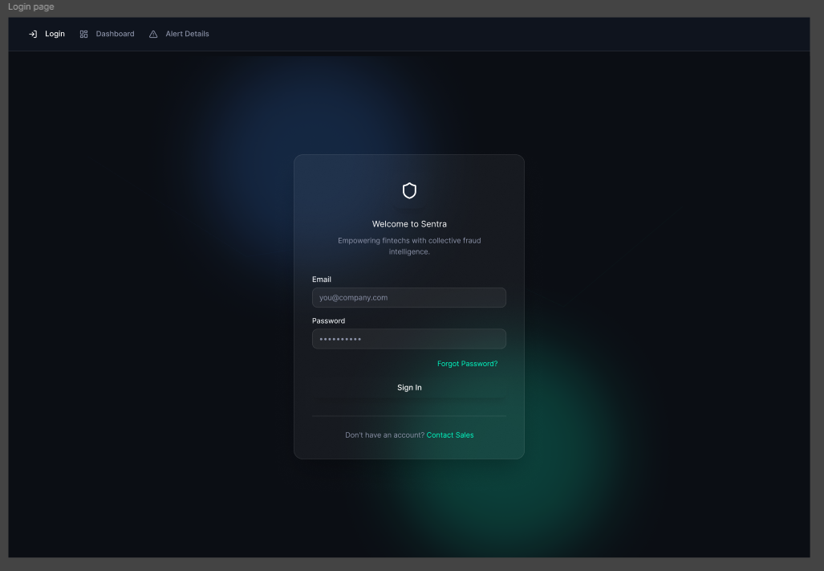
Dashboard: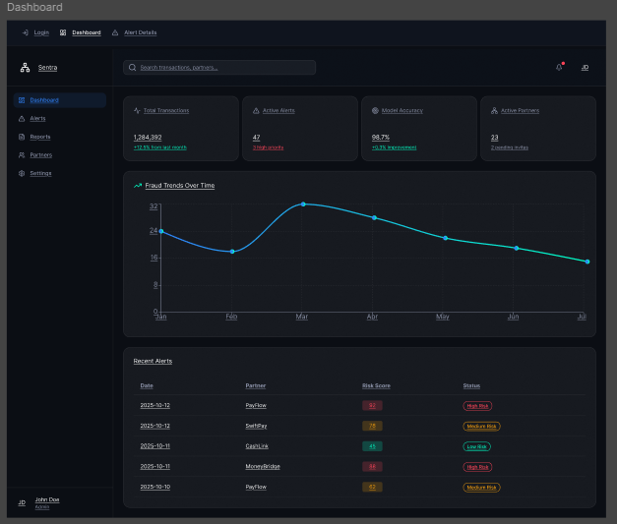
Alerts page: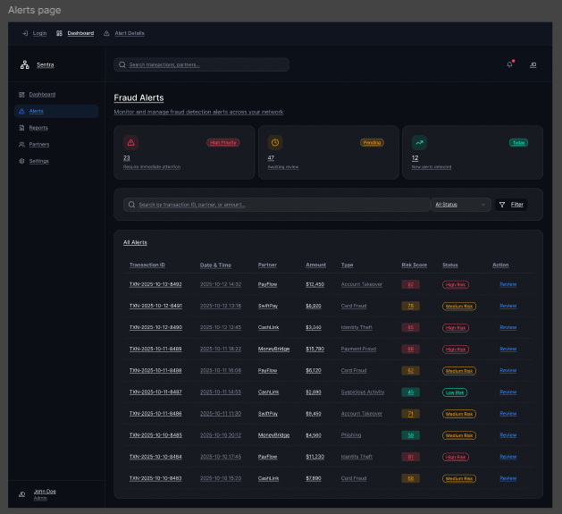

Alert details: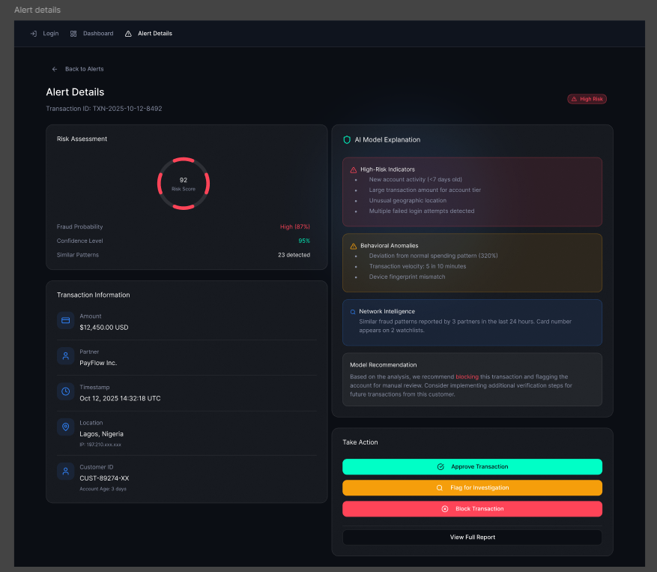

Reports page: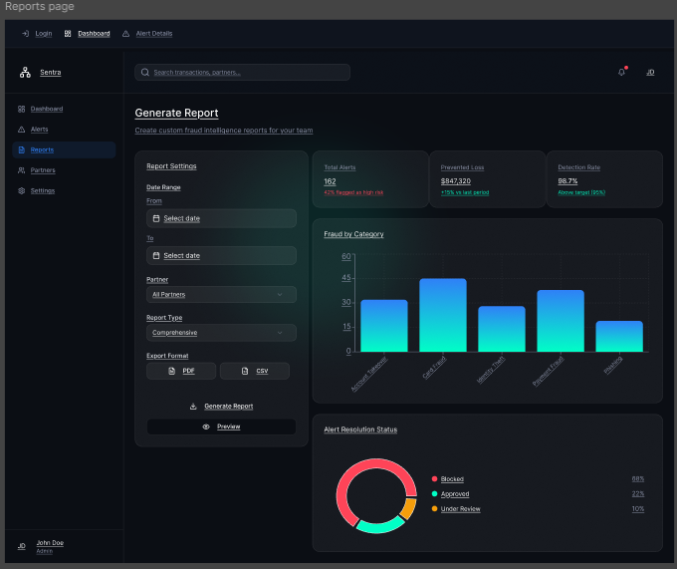

Partners page: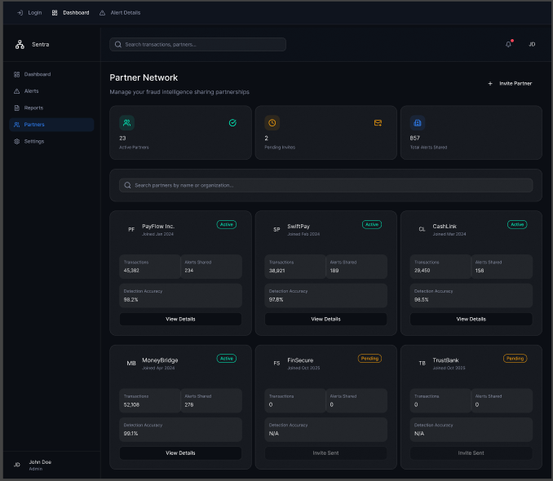

Settings page:
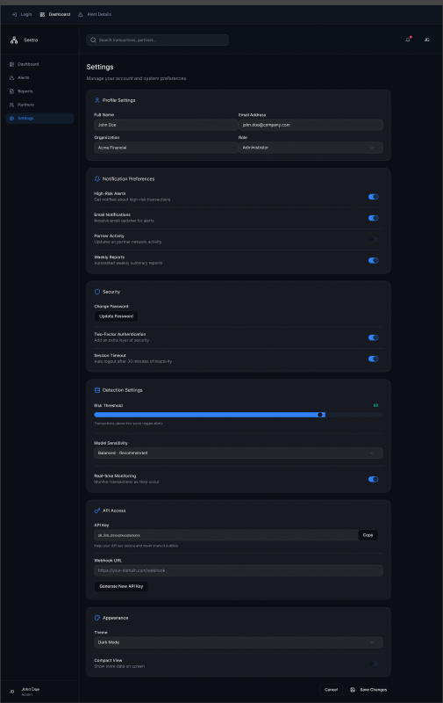

References (Section 2)

[1] Federal Trade Commission, “New FTC Data Show a Big Jump in Reported Losses to Fraud to $12.5 Billion in 2024,” Mar. 10, 2025. [Online]. Available: https://www.ftc.gov/news-events/news/press-releases/2025/03/new-ftc-data-show-big-jump-reported-losses-fraud-125-billion-2024
[2] Federal Bureau of Investigation, “FBI Releases Annual Internet Crime Report,” Apr. 23, 2025. [Online]. Available: https://www.fbi.gov/news/press-releases/fbi-releases-annual-internet-crime-report
[3] Veriff, “Top fraud trends in digital banking for 2025 – and how to stay one step ahead,” Jul. 30, 2025. [Online]. Available: https://www.veriff.com/fraud/learn/top-fraud-trends-in-digital-banking-for-2025-and-how-to-stay-one-step-ahead
[4] Veriff, “The growing threat of deepfakes in financial services and why a trust infrastructure is the future,” Aug. 20, 2025. [Online]. Available: https://www.veriff.com/identity-verification/the-growing-threat-of-deepfakes-in-financial-services-and-why-a-trust-infrastructure-is-the-future
[5] FICO, “FICO® Falcon® Fraud Manager,” [Online]. Available: https://www.fico.com/en/products/fico-falcon-fraud-manager
[6] SAS, “SAS Fraud Management,” [Online]. Available: https://www.sas.com/en_us/software/fraud-management.html
[7] Kount (Equifax), “Fraud Detection Software / Identity Trust Platform,” [Online]. Available: https://kount.com/fraud-detection-software
[8] NICE Actimize, “Enterprise Fraud Management,” [Online]. Available: https://www.niceactimize.com/fraud-management

Section 3

3.1 Data Flow Diagrams
3.1.1 Context Diagram (Level 0)
The context diagram shows Sentra's interactions with external entities:
External Entities:
- Partner Fintech Systems
- Fraud Analysts
- Compliance Officers
- System Administrators
- Partner Developers
Major Data Flows:
- Transaction Data → Sentra Platform
- Risk Scores & Alerts → Partner Systems
- Fraud Intelligence (anonymized) → Shared Intelligence Pool
- Dashboard Access → Analysts/Officers
- Configuration & Management → Administrators
3.1.2 Level 1 DFD - Core System Processes
Process 1.0: Authenticate & Authorize
- Input: Login credentials, OAuth tokens
- Output: Session tokens, access permissions
- Data Store: User Accounts DB
Process 2.0: Process Transaction Data
- Input: Transaction payloads from Partner APIs
- Output: Validated transaction records
- Data Store: Transaction Log DB
Process 3.0: Analyze Fraud Risk
- Input: Transaction data, historical patterns, ML models
- Output: Risk scores, detection reasons
- Data Store: ML Models DB, Fraud Patterns DB
Process 4.0: Generate Alerts
- Input: High-risk transactions (score > threshold)
- Output: Fraud alerts with details
- Data Store: Alerts DB, Audit Logs
Process 5.0: Share Intelligence
- Input: Anonymized fraud patterns
- Output: Shared intelligence indicators
- Data Store: Shared Intelligence Pool
Process 6.0: Display Dashboard
- Input: Alert queries, filter parameters
- Output: Visualizations, reports, trends
- Data Store: Alerts DB, Partner DB, Analytics DB
Process 7.0: Manage System
- Input: Admin commands, configuration changes
- Output: Updated settings, new partners, user accounts
- Data Store: Configuration DB, Partner DB, User Accounts DB
3.1.3 Level 2 DFD - Fraud Analysis Subsystem (Process 3.0)
Process 3.1: Validate Input
- Checks data completeness and format.
- Filters out malformed requests
Process 3.2: Extract Features
- Extracts transaction amount, time, location
- Generates device fingerprint hash.
- Calculates velocity metrics (transactions/hour)
Process 3.3: Apply Rule Engine
- Checks predefined fraud rules (e.g., amount > $10,000)
- Flags suspicious patterns (e.g., multiple failed attempts)
Process 3.4: Run ML Model
- Passes features to trained ML model.
- Generates probability score (0-100)
Process 3.5: Calculate Risk Score
- Combines rule engine and ML outputs.
- Normalizes to final risk score.
- Determines detection reasons.
Process 3.6: Check Shared Intelligence
- Queries shared pool for matching device/behavior patterns.
- Adjusts risk score based on cross-firm data.

3.2 User Stories and related Use Case Scenarios
User Story 1: Real-Time Fraud Detection
As a Partner Fintech System
I want to submit transaction data and receive instant risk scores
So that I can block fraudulent transactions before they complete
Related Use Case: UC1 - Submit Transaction for Analysis
Actors: Partner System (Primary), Sentra API (System)
Preconditions:
- Partner has valid OAuth token.
- API endpoint is operational.
Main Flow:
- Partner system sends POST request with transaction payload (ID, user_id, amount, device_fingerprint, timestamp)
- Sentra validates authentication token.
- Sentra validates transaction data format.
- Sentra processes transaction through fraud detection engine
- Sentra returns JSON response with risk_score, transaction_id, and detection_reason
- Partner system receives response within 2 seconds.
Postconditions:
- Transaction logged in database
- Risk score returned to partner
- Alert generated if score > threshold
Alternative Flows:
- 2a. Invalid token → Return 401 Unauthorized
- 3a. Malformed data → Return 400 Bad Request with error details
- 6a. Timeout → Partner retries with exponential backoff.

User Story 2: Alert Investigation
As a Fraud Analyst
I want to view and investigate fraud alerts in a dashboard
So that I can act on suspicious transactions quickly
Related Use Case: UC2 - View Fraud Alerts
Actors: Fraud Analyst (Primary), Dashboard UI (System)
Preconditions:
- Analyst has logged in with valid credentials.
- Alerts exist in the system.
Main Flow:
- Analyst navigates to Alerts page.
- System displays list of alerts sorted by timestamp (newest first)
- Each alert shows: Transaction ID, Partner Name, Risk Score, Timestamp, Status
- Analyst applies filters (date range, partner, risk score range)
- System updates alert list based on filters.
- Analyst clicks on an alert to view details.
- System displays full alert details including transaction data, detection reason, device fingerprint.
Postconditions:
- Analyst has visibility into flagged transactions.
- Alert status can be updated (e.g., "Under Review")
Alternative Flows:
- 2a. No alerts found → Display "No alerts to show" message.
- 4a. Invalid filter → Show validation error
Related Use Case: UC3 - Update Alert Status
Main Flow:
- Analyst is viewing alert details (from UC2)
- Analyst selects new status from dropdown (Under Review, False Positive, Confirmed Fraud, Resolved)
- Analyst optionally adds investigation notes.
- Analyst clicks "Update Status."
- System validates analyst permissions.
- System updates alert status in database
- System logs action in audit trail
- System displays success message.

User Story 3: Cross-Firm Intelligence Sharing
As a Partner Fintech
I want to contribute anonymized fraud patterns to a shared pool
So that all participants can benefit from collective detection
Related Use Case: UC4 - Share Fraud Intelligence
Actors: Sentra Platform (Primary), Partner Systems (Secondary)
Preconditions:
- Fraud confirmed by partner
- Pattern meets sharing criteria (severity, confidence level)
Main Flow:
- Sentra identifies confirmed fraud case.
- System anonymizes sensitive data (removes user_id, transaction details)
- System extracts shareable indicators (device fingerprint hash, behavioral patterns, IP geolocation)
- System adds indicators to Shared Intelligence Pool
- System notifies other partners of new intelligence (optional)
- Future transactions are checked against shared pool.
Postconditions:
- Anonymized fraud pattern stored in shared pool.
- All partners benefit from updated detection rules.

User Story 4: Partner Onboarding
As a System Administrator
I want to register new fintech partners
So that they can integrate with the platform securely
Related Use Case: UC5 - Register New Partner
Actors: Administrator (Primary), Registration System (System)
Preconditions:
- Administrator logged in
- Partner has completed registration form.
Main Flow:
- Admin navigates to Partners page.
- Admin clicks "Add New Partner."
- Admin enters partner details (Company Name, Contact Email, Industry Type)
- System validates input.
- System generates unique API credentials (Client ID, Client Secret)
- System stores partner record in database
- System displays API credentials (one-time view)
- Admin securely shares credentials with partner.
Postconditions:
- Partner registered in system
- API credentials generated
- Partner can begin integration.
Alternative Flows:
- 4a. Duplicate partner name → Show error and suggest modification.

User Story 5: Compliance Reporting
As a Compliance Officer
I want to generate and export fraud reports
So that I can meet regulatory requirements
Related Use Case: UC6 - Generate Compliance Report
Actors: Compliance Officer (Primary), Reporting System (System)
Preconditions:
- Officer logged in with appropriate permissions
- Data exists for selected period.
Main Flow:
- Officer navigates to Reports page.
- Officer selects report type (Fraud Summary, Alert Resolution, Partner Activity)
- Officer specifies date range and filters (partner, status)
- Officer clicks "Generate Report."
- System queries database for relevant records
- System compiles report data
- System generates PDF/CSV file.
- System displays download link.
- Officer downloads report
Postconditions:
- Report generated and logged.
- Officer has exportable documentation.

User Story 6: Dashboard Monitoring
As a Fraud Analyst
I want to view real-time fraud trends and statistics
So that I can identify patterns and respond proactively
Related Use Case: UC7 - View Dashboard Metrics
Actors: Analyst (Primary), Dashboard System (System)
Preconditions:
- Analyst logged in
- System has collected transaction and alert data.
Main Flow:
- Analyst accesses main Dashboard page
- System displays key metrics:
  - Total transactions today
  - Fraud alerts today
  - Detection rate (%)
  - Top fraud types
- System shows visualizations:
  - Alerts over time (line chart)
  - Risk score distribution (histogram)
  - Alerts by partner (pie chart)
- System auto-refreshes data every 30 seconds
- Analyst can click on chart elements to drill down.
Postconditions:
- Analyst has current visibility into fraud activity.

User Story 7: API Integration
As a Partner Developer
I want to integrate Sentra's API into our system
So that we can submit transactions and receive risk scores
Related Use Case: UC8 - Integrate Partner System
Actors: Developer (Primary), Sentra API (System)
Preconditions:
- Partner has API credentials.
- Developer has access to API documentation.
Main Flow:
- Developer implements OAuth 2.0 authentication flow.
- Developer obtains access token.
- Developer sends test transaction via POST /api/v1/analyze.
- System validates request format.
- System returns risk assessment response.
- Developer handles response in application logic
- Developer implements error handling for timeouts, invalid responses.
- Developer completes integration testing.
Postconditions:
- Partner system successfully integrated.
- Transactions flow to Sentra for analysis

3.3 Activity Diagrams
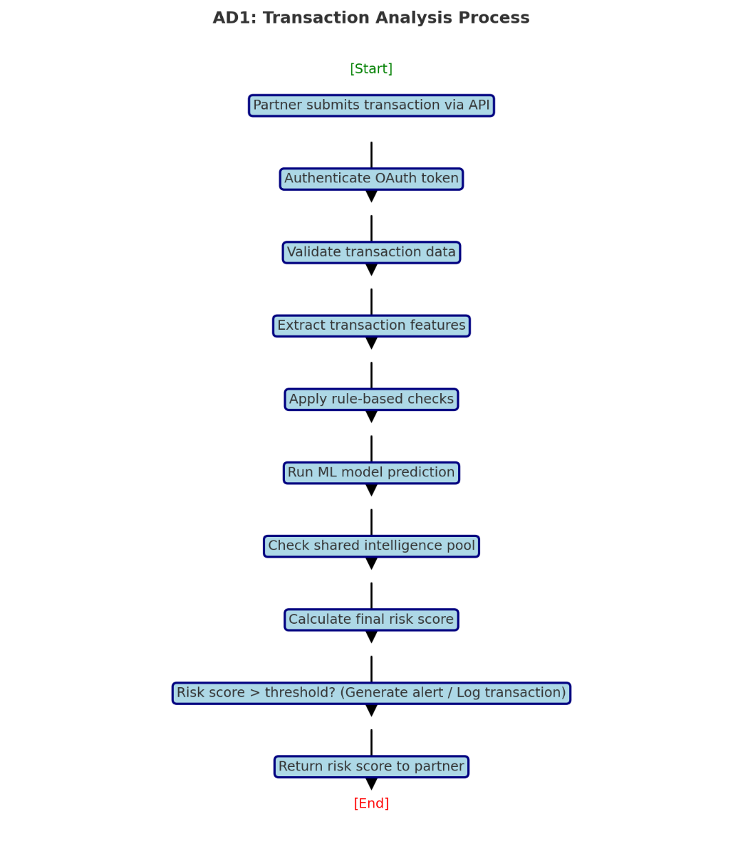
Description: This diagram shows the complete flow from transaction submission to risk score delivery, including validation, analysis, and alert generation steps.

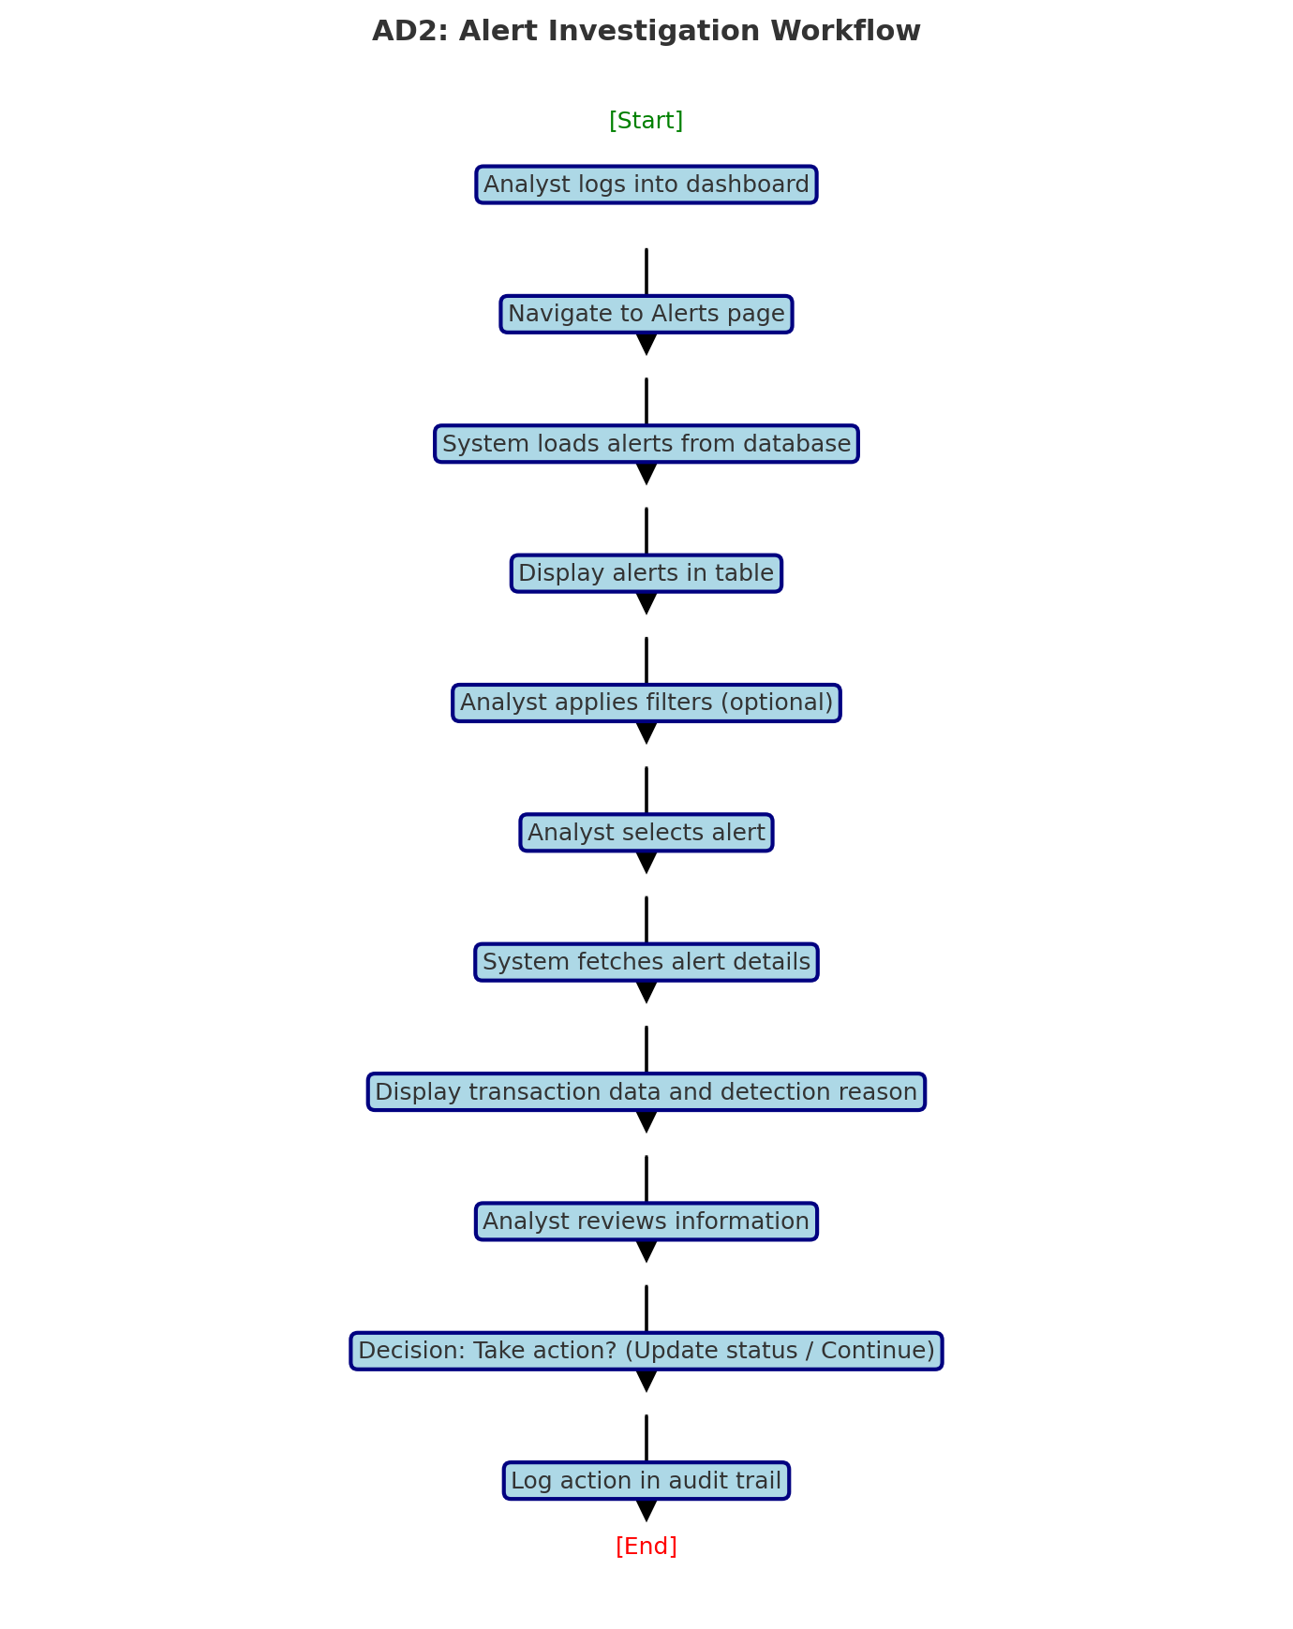

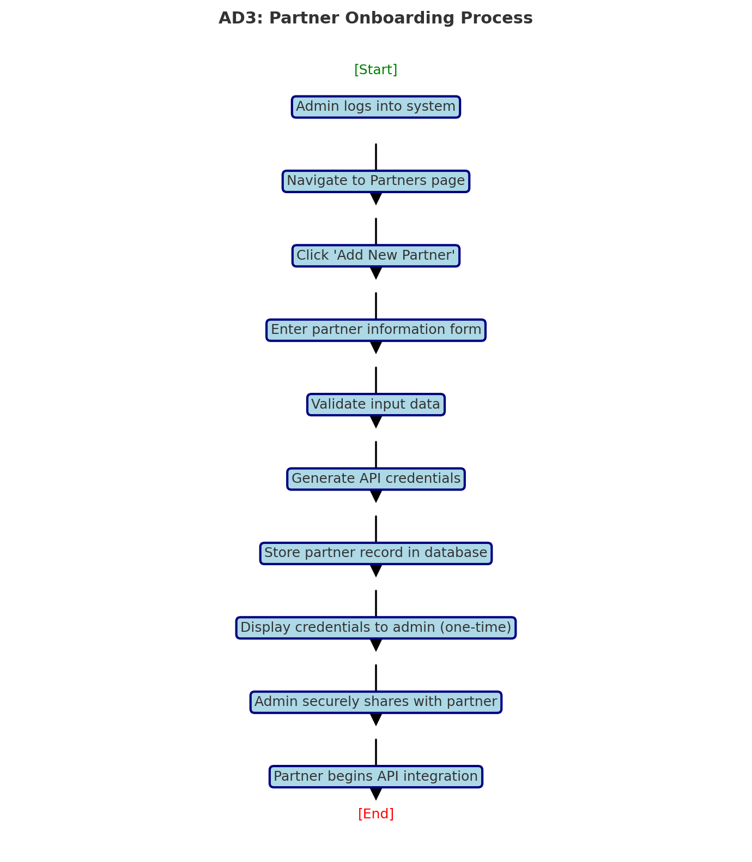

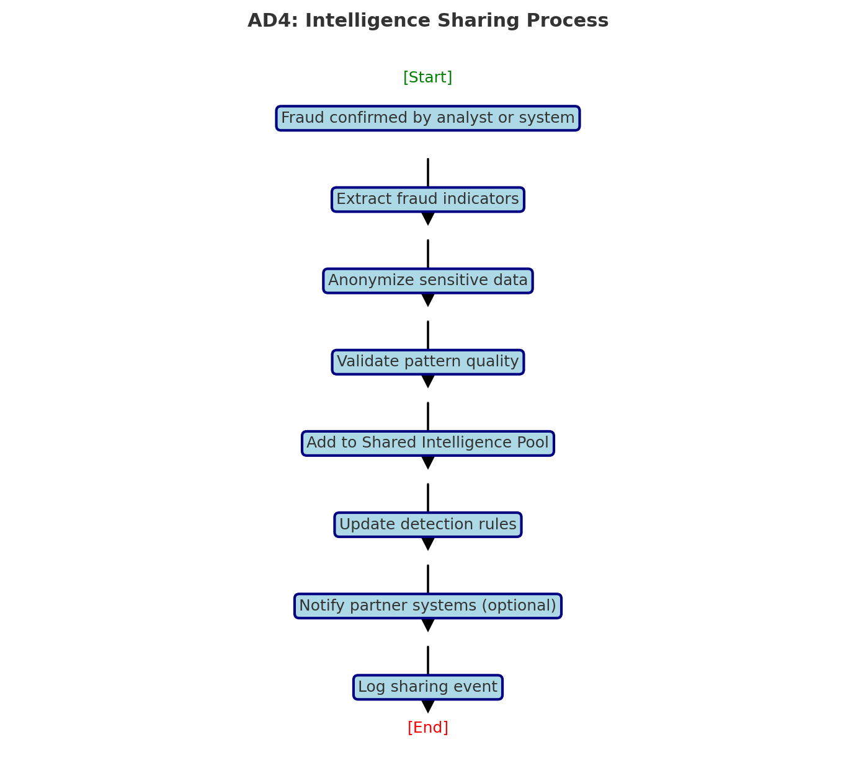

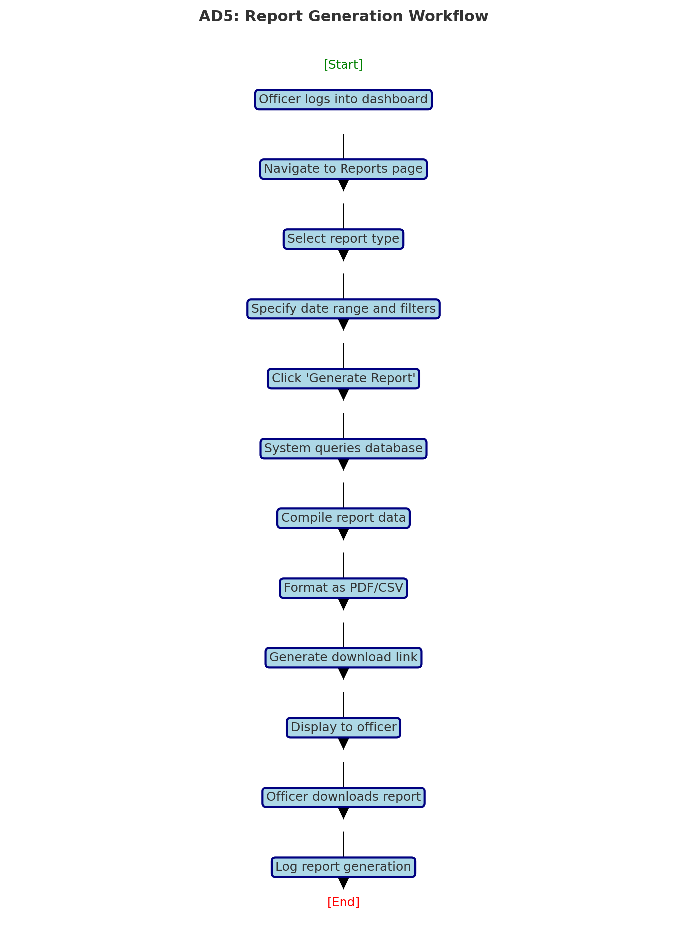

3.4 Business Rules

Business Rule # | Description | Activity Diagram | Related UCS | UI Mock-up
BR1 | All API requests must include valid OAuth 2.0 token | AD1 | UC1, UC8 | N/A (API)
BR2 | Risk scores must be calculated within 2 seconds | AD1 | UC1 | N/A
BR3 | Alerts are automatically generated when risk score > 75 | AD1 | UC1, UC2 | UI 2.8 (Alerts)
BR4 | Only Admin and Analyst roles can update alert status | AD2 | UC3 | UI 2.8 (Alert Details)
BR5 | Transaction data must include transaction id, user id, amount, timestamp, device fingerprint | AD1 | UC1 | N/A (API)
BR6 | Shared intelligence must be anonymized before storage | AD4 | UC4 | N/A
BR7 | Only Admins can register new partners | AD3 | UC5 | UI 2.8 (Partners)
BR8 | API credentials are displayed only once during partner creation | AD3 | UC5 | UI 2.8 (Partners)
BR9 | Compliance Officers or Admins can only generate compliance reports | AD5 | UC6 | UI 2.8 (Reports)
BR10 | All system actions must be logged in audit trail with timestamp and actor id | AD1, AD2, AD3, AD4, AD5 | All | N/A
BR11 | Dashboard metrics auto-refresh every 30 seconds | N/A | UC7 | UI 2.8 (Dashboard)
BR12 | Users must authenticate with username and password; Admins require MFA | N/A | All | UI 2.8 (Login)
BR13 | Failed login attempts are limited to 5 within 15 minutes | N/A | All | UI 2.8 (Login)
BR14 | Alert statuses: Pending, Under Review, False Positive, Confirmed Fraud, Resolved | AD2 | UC2, UC3 | UI 2.8 (Alert Details)
BR15 | Reports are retained for 7 years to meet regulatory requirements | AD5 | UC6 | N/A
BR16 | All data at rest must be encrypted using AES-256 | N/A | All | N/A
BR17 | All data in transit must use TLS 1.3 | AD1 | UC1, UC8 | N/A
BR18 | System must support minimum 50 concurrent partner connections | N/A | UC1 | N/A
BR19 | ML models must be retrained monthly with new fraud data | N/A | N/A | N/A
BR20 | Partners can only view their own transaction data and alerts | AD2 | UC2 | UI 2.8 (Alerts)
BR21 | Risk score scale: 0-25 (Low), 26-50 (Medium), 51-75 (High), 76-100 (Critical) | AD1 | UC1 | UI 2.8 (Dashboard)
BR22 | Device fingerprints are hashed before storage | AD1, AD4 | UC1, UC4 | N/A
BR23 | System must maintain 99.9% uptime (excluding scheduled maintenance) | N/A | All | N/A
BR24 | API rate limiting: 500 requests per minute per partner | AD1 | UC1 | N/A

Section 4 – Domain Class

Section 5 – Database

Section 6 – Project Management

6.1 Work Breakdown Structure

6.2 Milestones & Acceptance Criteria

Section 7 – Product Backlog & Implementation Schedule

Section 8 – Client/Faculty Sign-off

