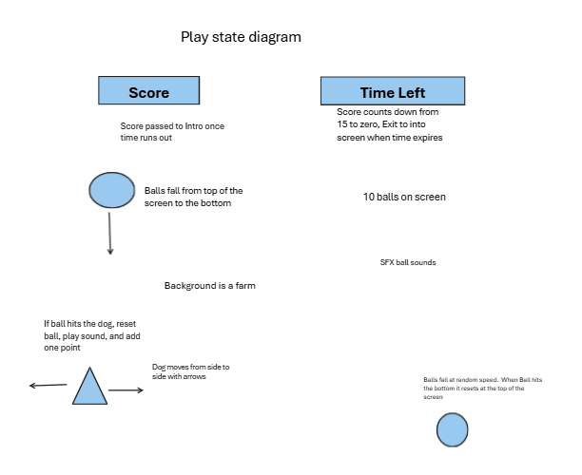

import pygame, simpleGE, random

class Ball(simpleGE.Sprite): def **init**(self, scene): super().**init**(scene) self.setImage("ball.png") self.setSize(25, 25) self.minSpeed = 2 self.maxSpeed = 8 self.reset()

def reset(self):  
 self.y = 10  
 self.x = random.randint(0, self.screenWidth)  
 self.dy = random.randint(self.minSpeed, self.maxSpeed)  
   
def checkBounds(self):  
 if self.bottom > self.screenHeight:  
 self.reset()

class Lenny(simpleGE.Sprite): def **init**(self, scene): super().**init**(scene) self.setImage("dog.png") self.setSize(50, 50) self.position =(320, 400) self.moveSpeed = 5

def process(self):  
 if self.isKeyPressed(pygame.K_LEFT):  
 self.x-=self.moveSpeed  
 if self.isKeyPressed(pygame.K_RIGHT):  
 self.x += self.moveSpeed

class Game(simpleGE.Scene): def **init**(self): super().**init**() self.setImage("farm.png")

self.sndBall = simpleGE.Sound("ball.ogg")  
 self.numBalls = 10  
   
 self.lenny = Lenny(self)  
   
 self.balls = []  
 for i in range(self.numBalls):  
 self.balls.append(Ball(self))  
   
 self.sprites = [self.lenny,  
 self.balls]  
   
def process(self):  
 for ball in self.balls:  
 if ball.collidesWith(self.lenny):  
 ball.reset()  
 self.sndBall.play()

def main(): game = Game() game.start()

if **name** == "**main**": main()