**Comms Board / Software**

* LEDs turn on
  + work!
* Can program ATMEGA through header pins
  + works!
* can talk to Xbee
  + probably ok
* can talk through SPI
  + untested
* add silk screenshowing programmer orientation
* IMU
  + holes too small
  + outline is on bottom, not top
  + pushbutton is too close
* Make RESET button cut power to XBee as well as ATMEGA
* programmers on all other boards are not hooked up right
  + SCK from programmer is not hooked up to microcontroller

**Kicker Board**

* discharge
  + manual works!
  + MC works
* kick (works for now, but needs to be revized. kicks if you generate a level lower than the cap voltage
  + works from output of the and gate
  + And gate connected incorrectly
    - we crossed our kicker and chipper channels in the AND gate so that chip = kick_ena AND chip_ena, while kick = comp AND comp
    - fix this for next run
  + Comparator works
    - Works!
    - feeding in a sin wave and comparing to cap voltage, and I see on and off spikes in the correct proportion
  + PWM filter
    - works, but should be replaced with 100k to reduce peak to peak noise
    - cap has some resistance along side it, so we never actually get to 100% pass at DC. Can’t figure this out, ask avi about it
      * FIXED! had burned out the comparator
* chip
  + untested
* cap voltage sensor
  + Does not work. output is shorted to ground with ~70 ohms, instead of 10k
  + works when clamps are disconnected. 20mV PP noise -> 2V resolution on cap.
    - clamps are backwards? nope, were correct the first time
  + when diodes are connected, middle floats at 1.6V, and signal goes on top of that
  + Oh well, works without clamps...
* dribbler
  + works!
* fluorescent light
  + works
* 3.3V generation
  + untested
* 5V generation
  + untested
* on / off switch and battery
  + untested
* charging circuit
  + 47uF too big by charger, change layout
  + Big caps are only rated for 250V, should be higher for safety margin
  + switching trans gets really hot. get higher current package
  + caps charging really slowly
    - charging at ~.293A very consistently
    - maybe calculations were off with the current limiting sense resistor?
    - R = .020 ohms nominally, ~.080 measured
    - Fixed!
      * wasn’t a problem with the current limit. We need both a higher current mosfet, and a high frequency switching diode, instead of a regular diode. I pulled both off of a Gen 2 board, and now it’s working.
      * there’s still a weird pattern where it charges slowly at first, and then picks up speed
      * 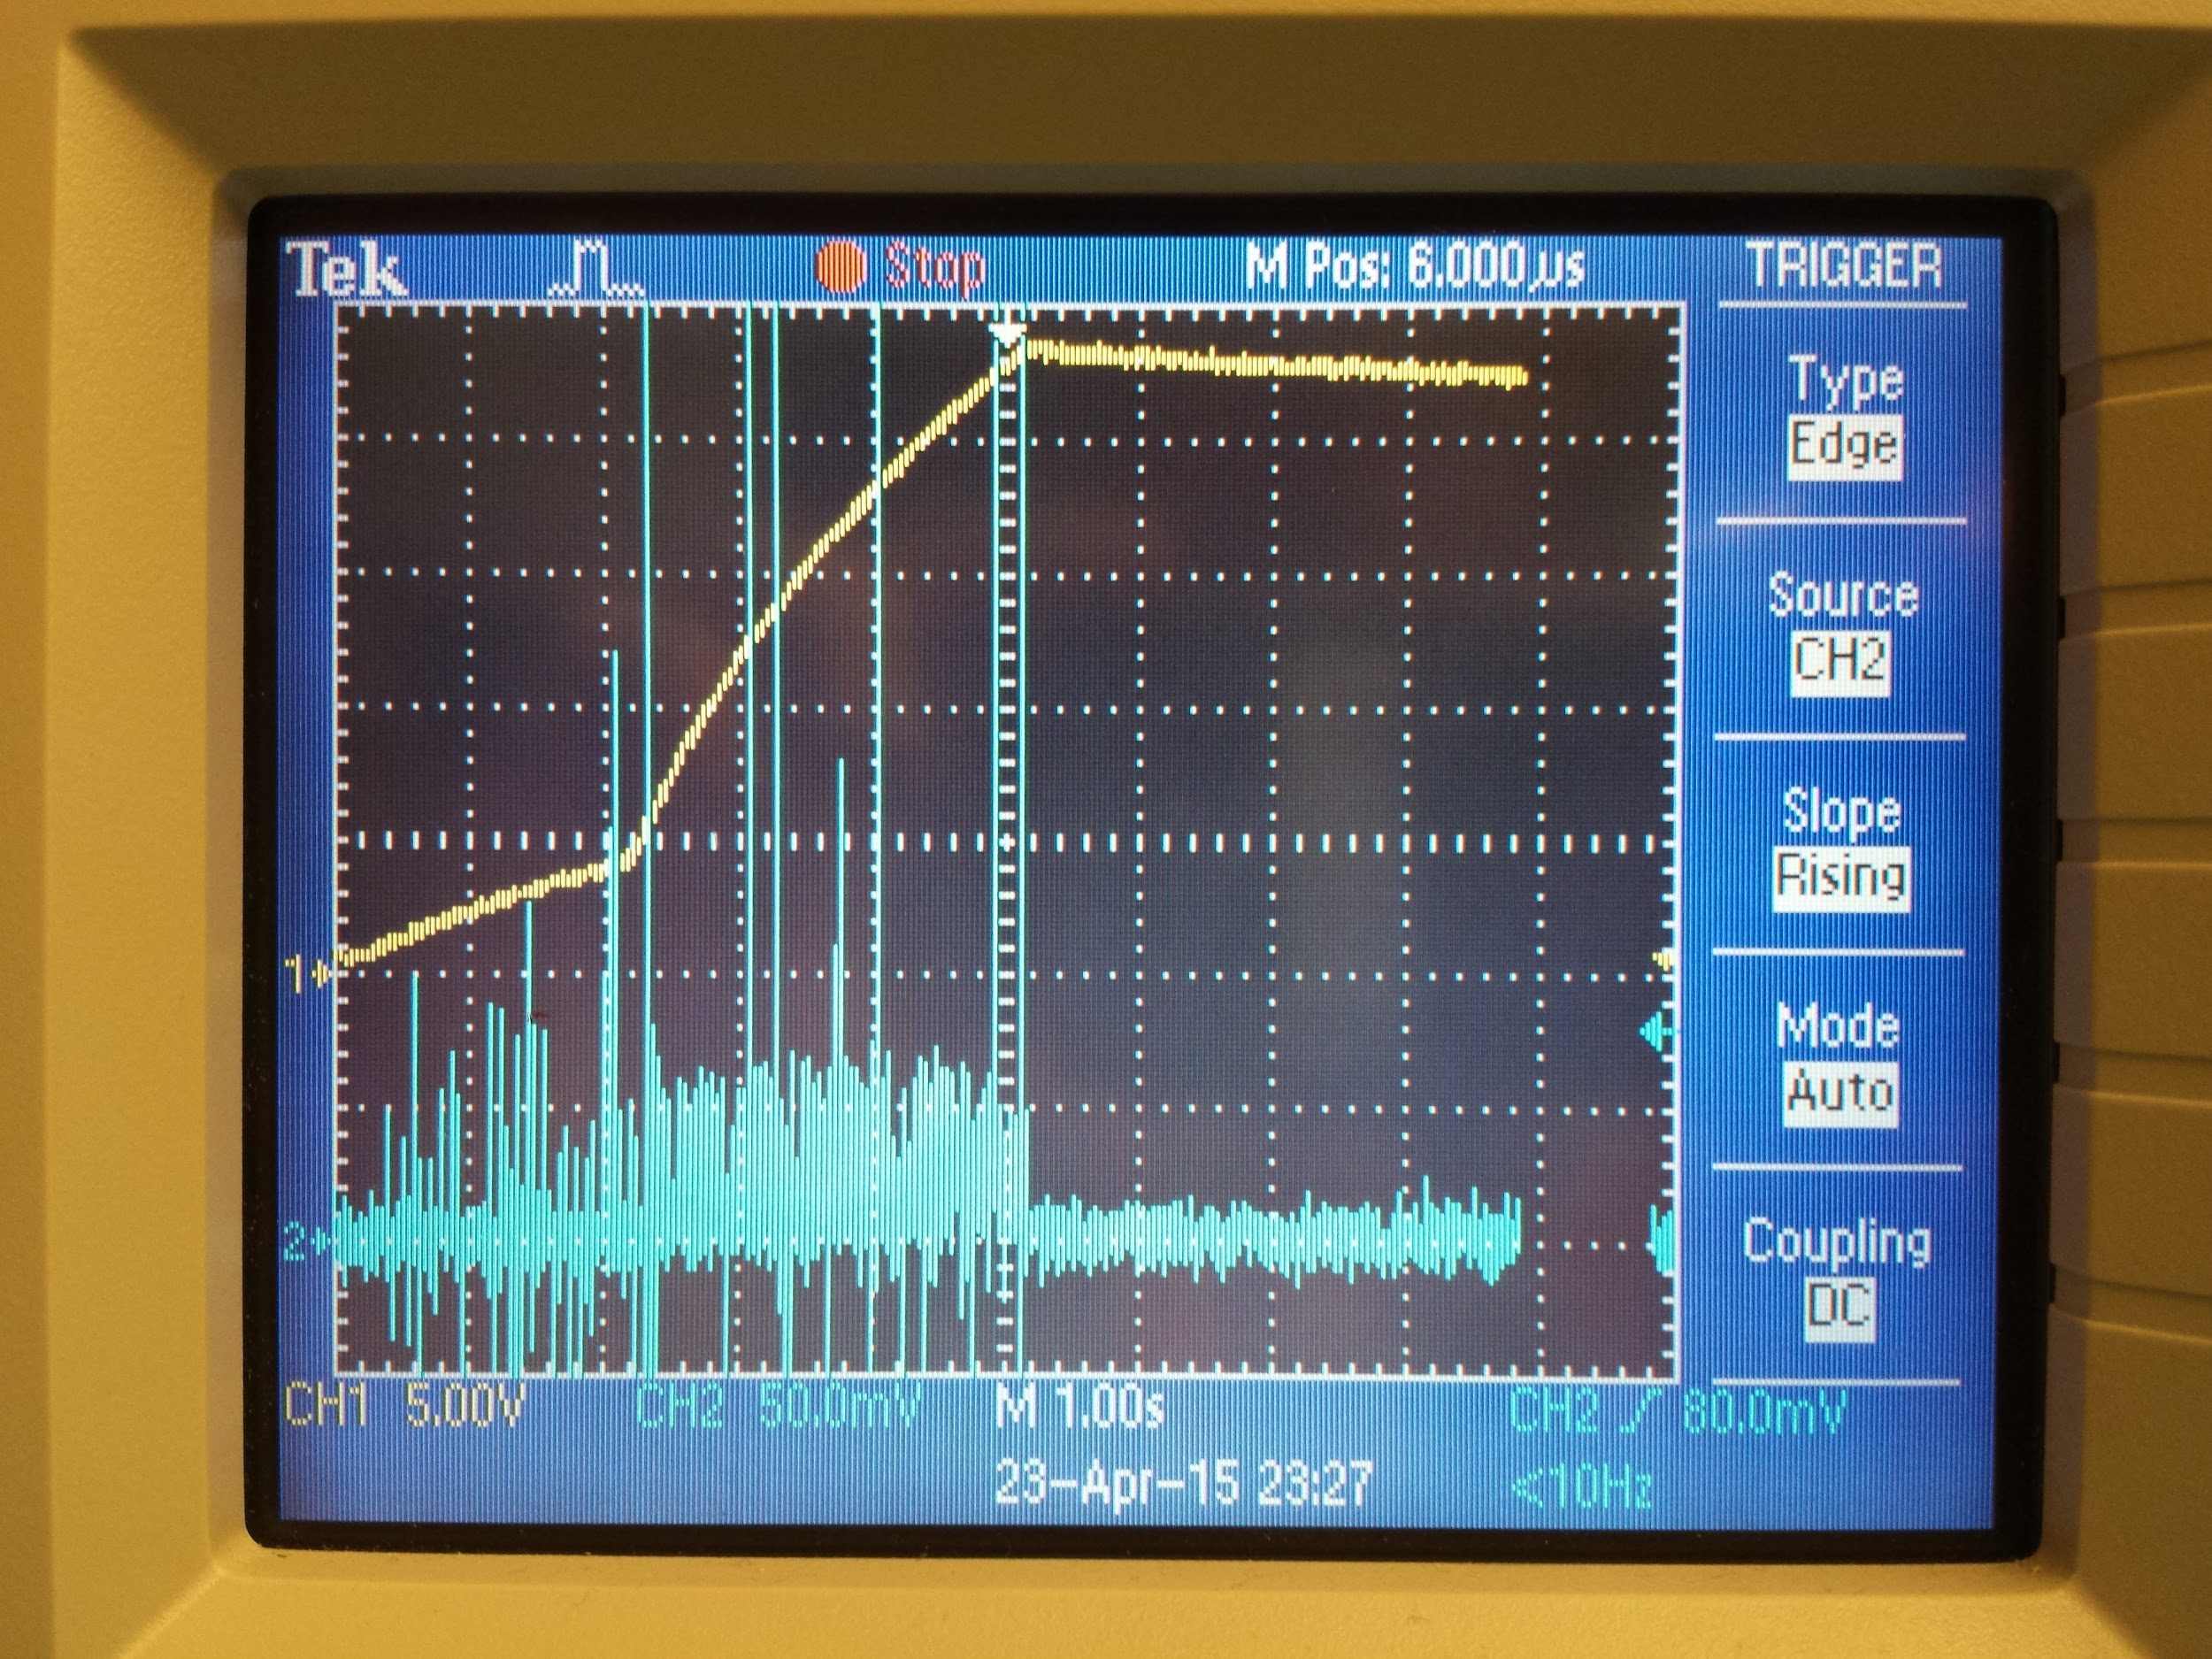
    - caps set target voltage to 400. We should change this down to 250 for safety, but make sure all parts are rated for 400V in case we ever need to kick harder
* voltage protection circuitry
  + untested
* Gen2 comparison
  + gen2 charges in ~2.5 seconds for a single cap, and looks like it’s going much higher than 250 volts, but is stopped early
  + draws 2.5A at 12V
* order normal female headers, not long ones
* add silkscreen to label kick vs chip vs drib

**Motor Board**

* ground lines are pretty noisy
* Motor driving Works!
  + h[ttps://drive.google.com/open?id=0B0-MRdEJpC5-SExmSV9naUVOLTg&authuser=0](https://drive.google.com/open?id=0B0-MRdEJpC5-SExmSV9naUVOLTg&authuser=0)
* Heat dissipation
  + doesn’t get too hot, and allegro seems to be worse than mosfets
  + 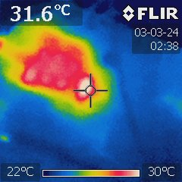
* Current sensing
  + low pass filter isn’t working
  + 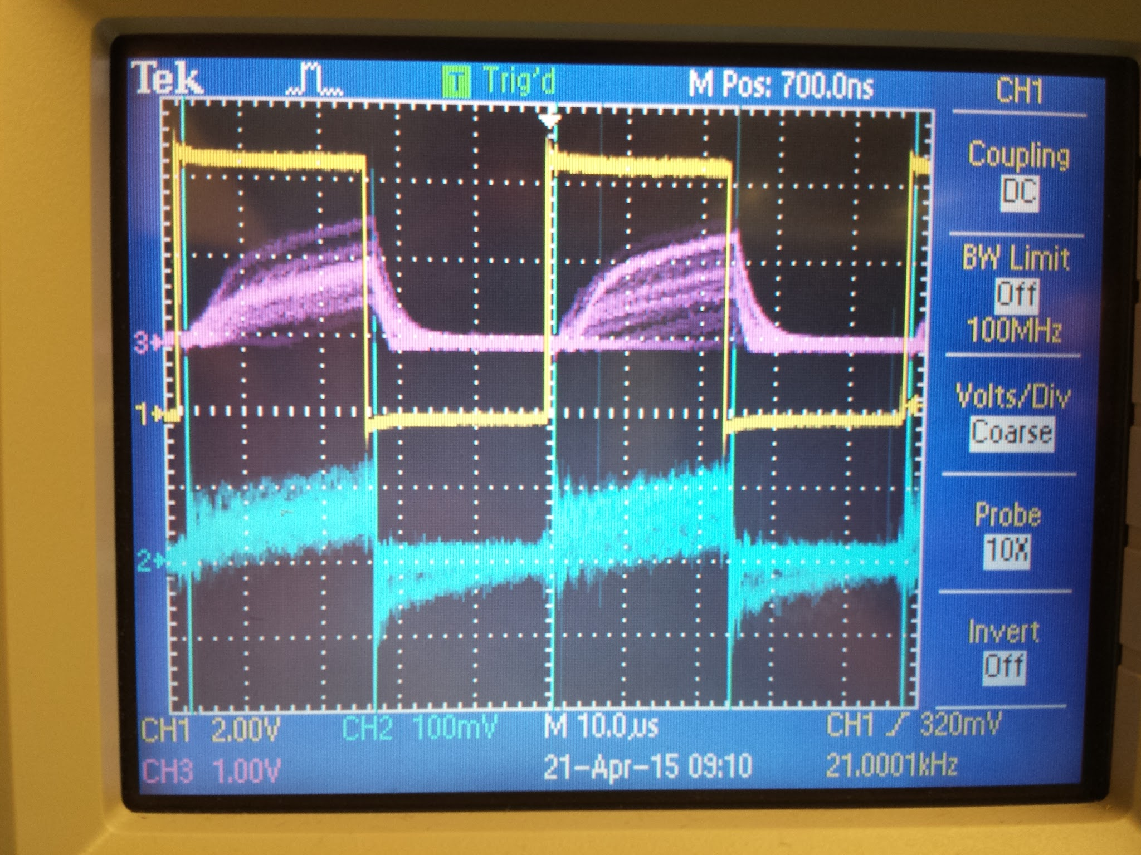
    - yellow = PWM input
    - blue = LSS
    - red = SENSE1 (supposedly low passed x15
  + Gain looks ok, resistance is different going each way
  + after adding 2nd cap
    - current .65A, 50% duty cycle
    - LSS peaks at 200mV / .1 ohm = 2A average = ~ 1A
    - SENSE1 is roughly 1V
  + TODO:
    - add 2nd cap in parallel with resistor to make symmetric
    - caps 10x
    - decoupling everywhere, our ground lines are a mess
    - add silkscreen everywhere
    - add hot glue dots to plugs so they can’t go in backwards
* Current limiting
  + working remarkably well, although triggering too early because low pass isn’t working
  + 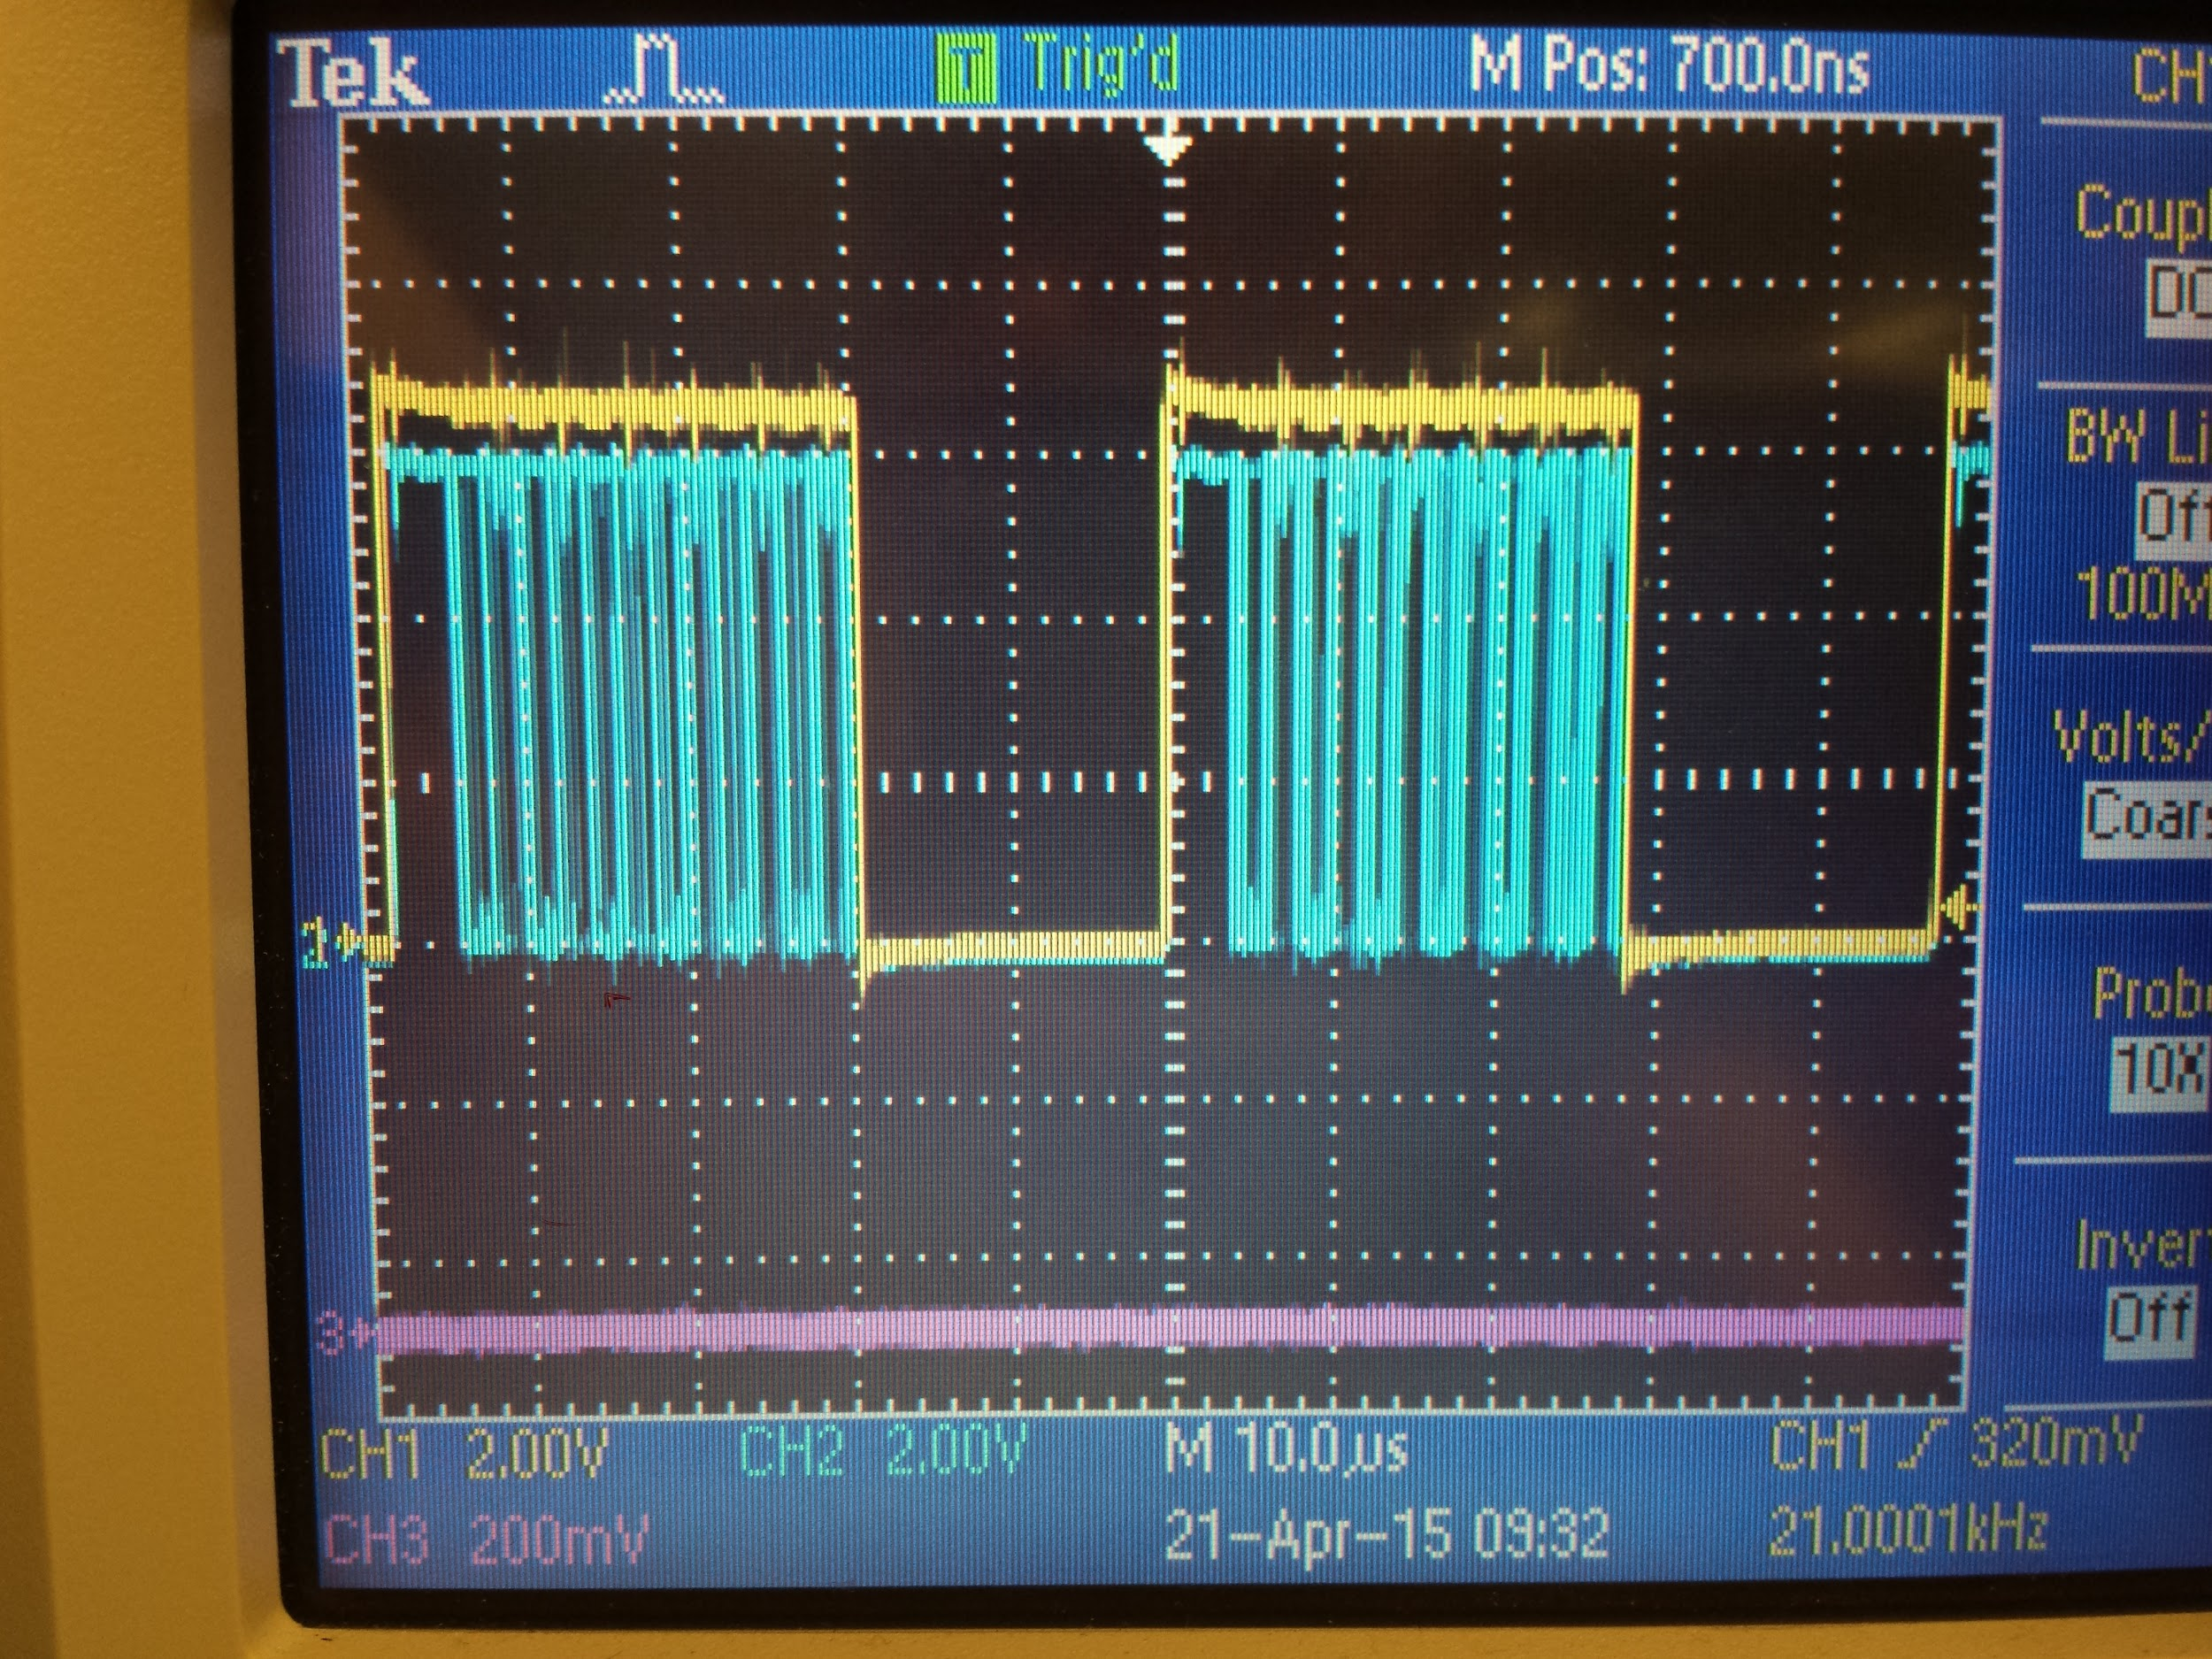
  + 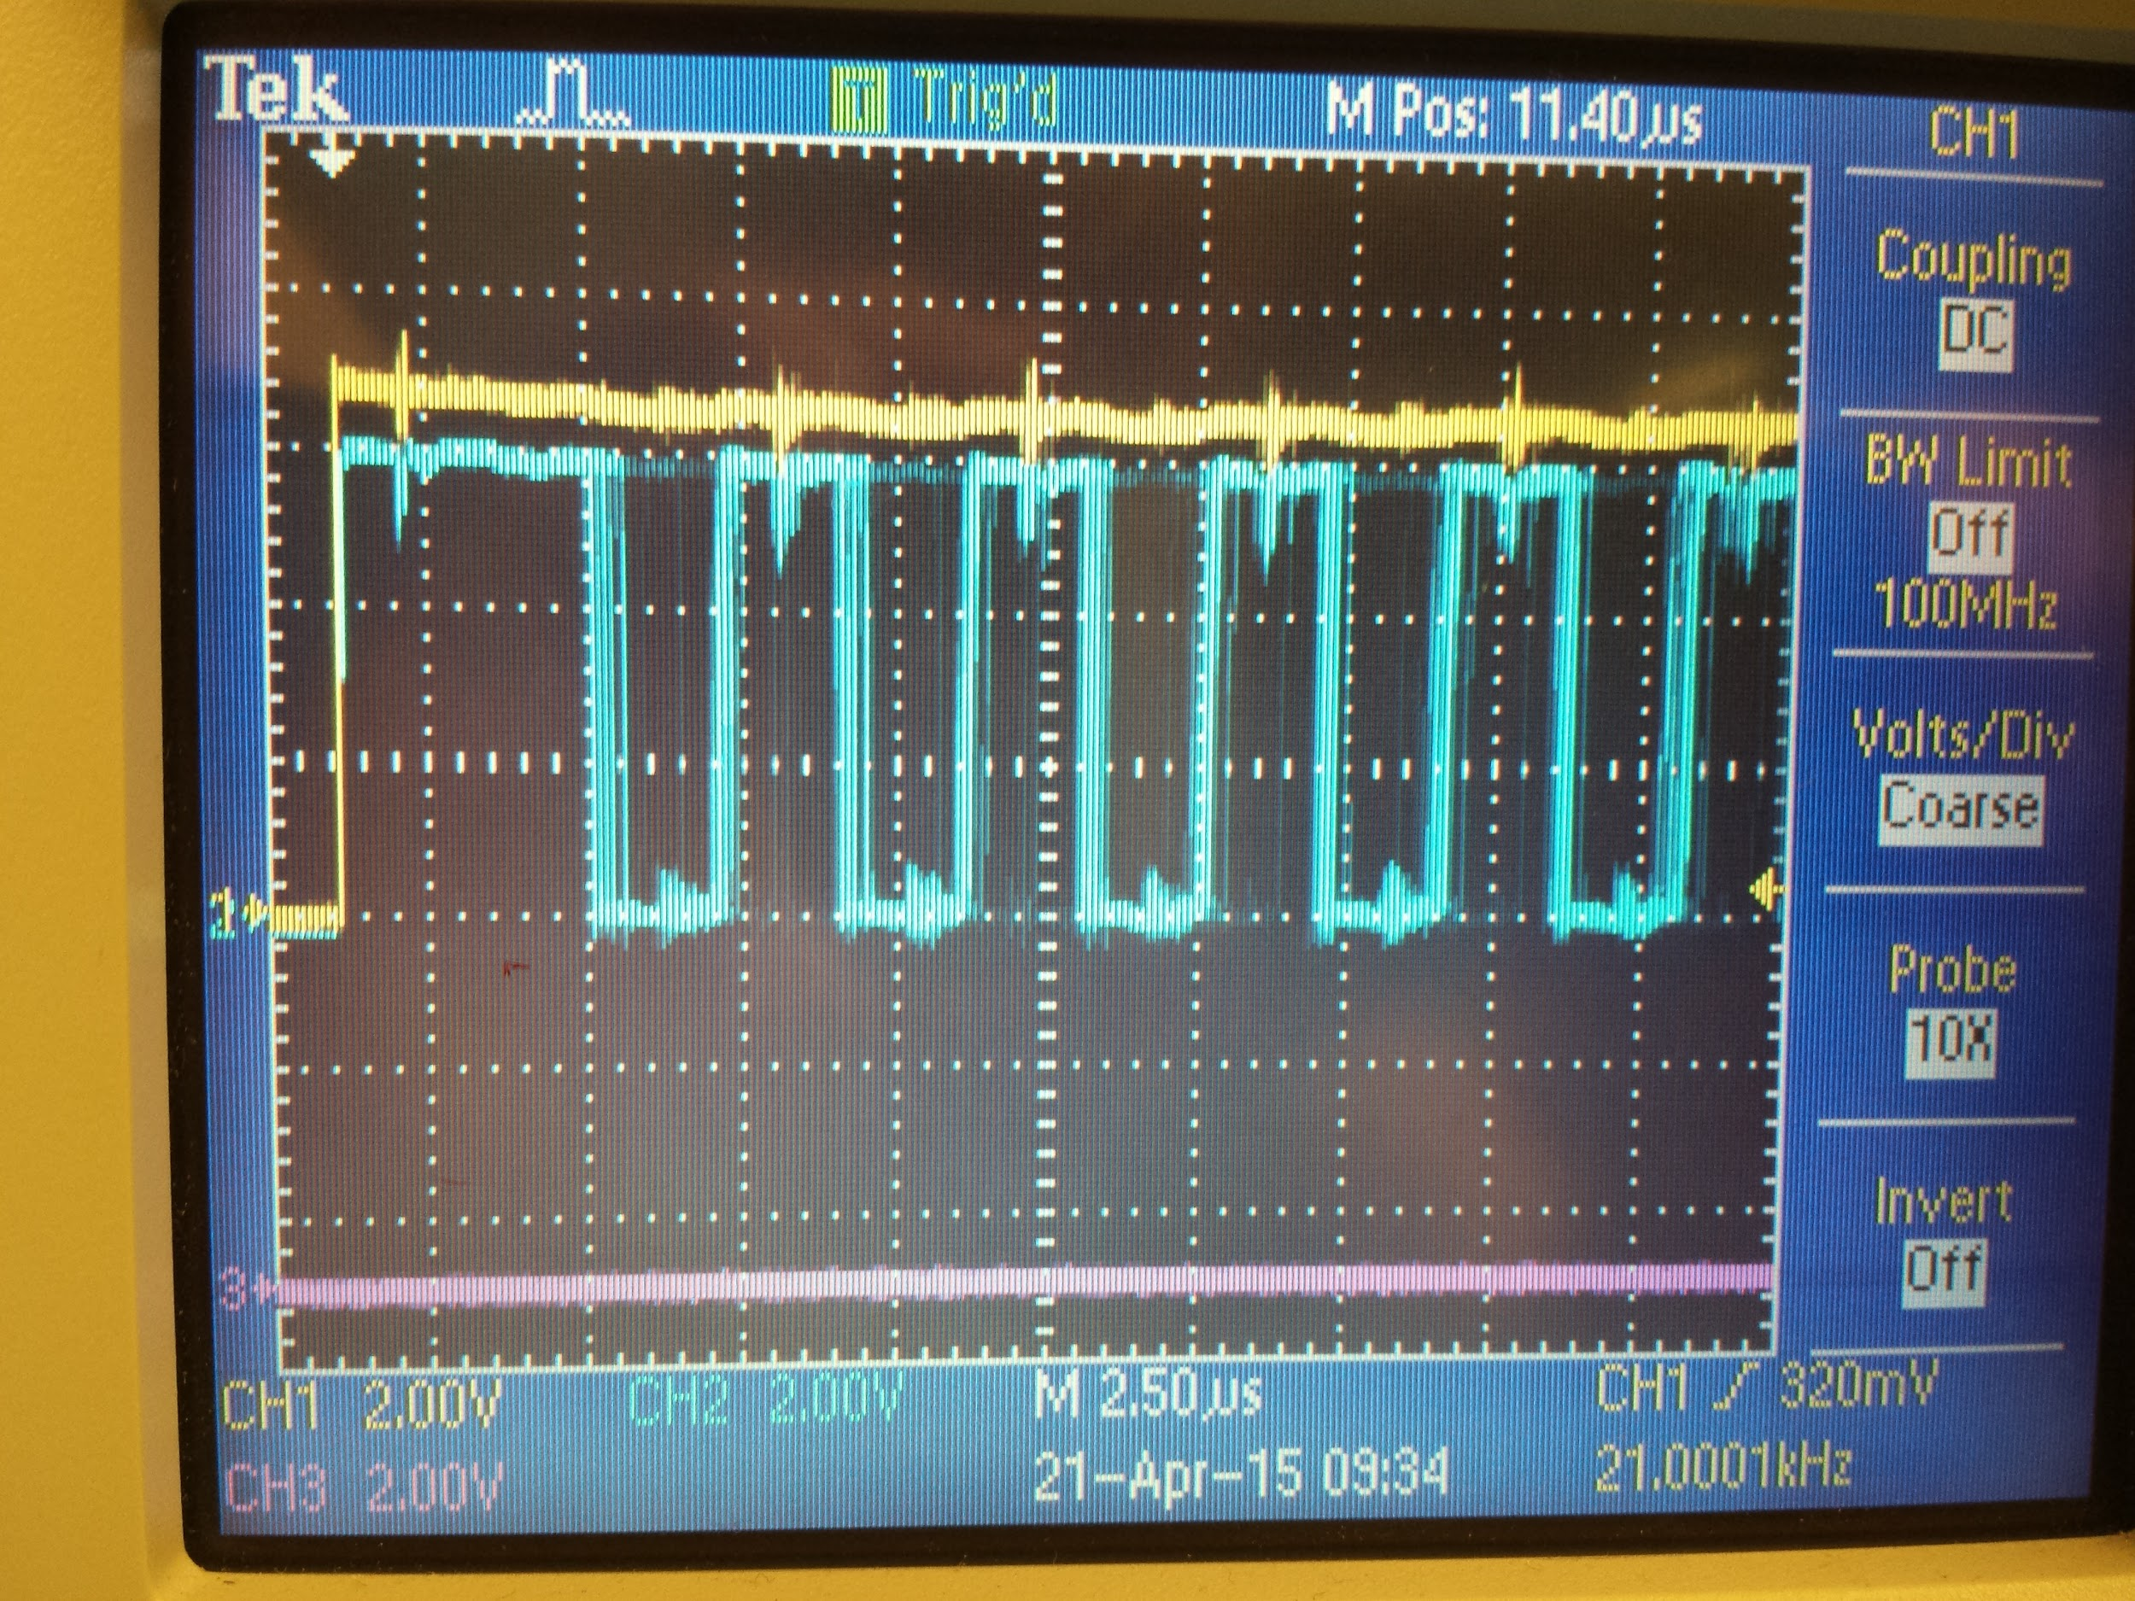
    - Blue = allegro input
    - yellow = microcontroller output
  + system is PWMing the PWM signal!
  + You can see this sort of happening to the current
  + period = 4uS

**Integration Test**

* header pins between boards fit togehter
* nothing is too tall
  + transformer collides with mosfets on motor board. push into middle of board
  + screw terminals are really tall and collide with mosfets
  + header pins won’t plug all the way in. maybe how we soldered them?
* total stack fits inside robot
* battery connector is accessible
  + nope, right behind some caps on the motor board
* motor cables are accessible and not flipped
* header cables are accessible