Abstract:

1 Introduction:

The ecosystem of high-end computing applications and the high performance machine is complimentary, in that the need for resolution and scale (at the same time) with which such problems are to be handled constantly push the technology. Traditionally the performance increases have been provided by Intel Pentium and AMD Opteron families but are hitting the limits of flops/watt. Multi-core architectures are a mainstay of throughput computing, in the sense that rather than increasing the single-thread performance efforts will continue to concentrate on adding more cores. An interesting architecture is the Cell Broadband engine which is a heterogeneous nine-core processor. On the other hand, with the highly parallel graphics processing units (GPUs) gaining maturity as a powerful engine, the advances in computational throughput is being driven by such GPUs, a path which is being adopted by the mainstream microprocessor manufacturers as well (AMD/ATI's – Fusion, Intel's Larabee). A GPU can be viewed as a parallel SIMD machine with limited instruction set. Modern GPUs allow for user-programmable pixel and vertex shaders, thereby transforming the GPU into a general-purpose parallel computing device. While early programmable shaders featured assembly-like language for manipulating the data as it is pushed through the GPU pipe, with the introduction of NVIDIA's CUDA the implementation-specific details of shader programming are almost fully hidden behind a high-level abstraction.

As can be seen in the graph [Figure 1], the performance of such applications on the GPUs is rapid (roughly doubling every year), given that current generation use massive multithreading, fast context switching, and high memory bandwidth. It is the powerful scheduler/context manager that plays an instrumental role by overlapping long-latency memory requests in stalled threads with useful computation in other threads to hide the inevitable yet ever-increasing latencies to main memory. Any new processor architecture is rolled out with a bet from the manufacturers that consumers would find a way to program on these chips to exploit their capabilities. The GPGPU computing on Nvidia graphics cards has enjoyed widespread popularity owing to the cost to performance ratio [~$250 for 500Gflops] and more importantly the enhanced programmability on these devices (programmable with CUDA tools – which manifest as a simple parallel programming model providing C like constructs).

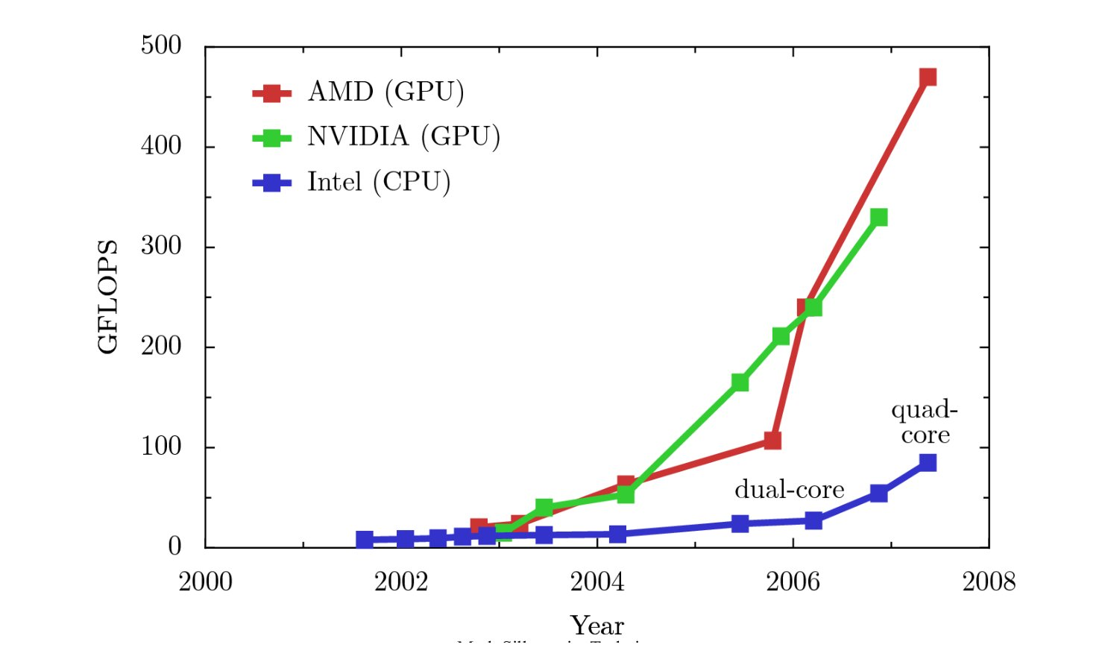

Nvidia’s Tesla scalable parallel computing solution facilitates the use of GPU processor to deliver performance for not only graphics applications but also in other realms throughput computing and scientific applications, unmatched by any of the current general purpose processor. The GPUs are best suited for application having the following characteristics [Nvidia Tesla reference]:
- extensive data parallelism—thousands of computations on independent data elements;
- modest task parallelism—groups of threads execute the same program, and different groups can run different programs;
- intensive floating-point arithmetic;
- latency tolerance—performance is the amount of work completed in a given time;
- streaming data flow—requires high memory bandwidth with relatively little data reuse;
- modest inter-thread synchronization and communication—parallel computing applications require limited synchronization and communication.

2 Overview of GPU architecture
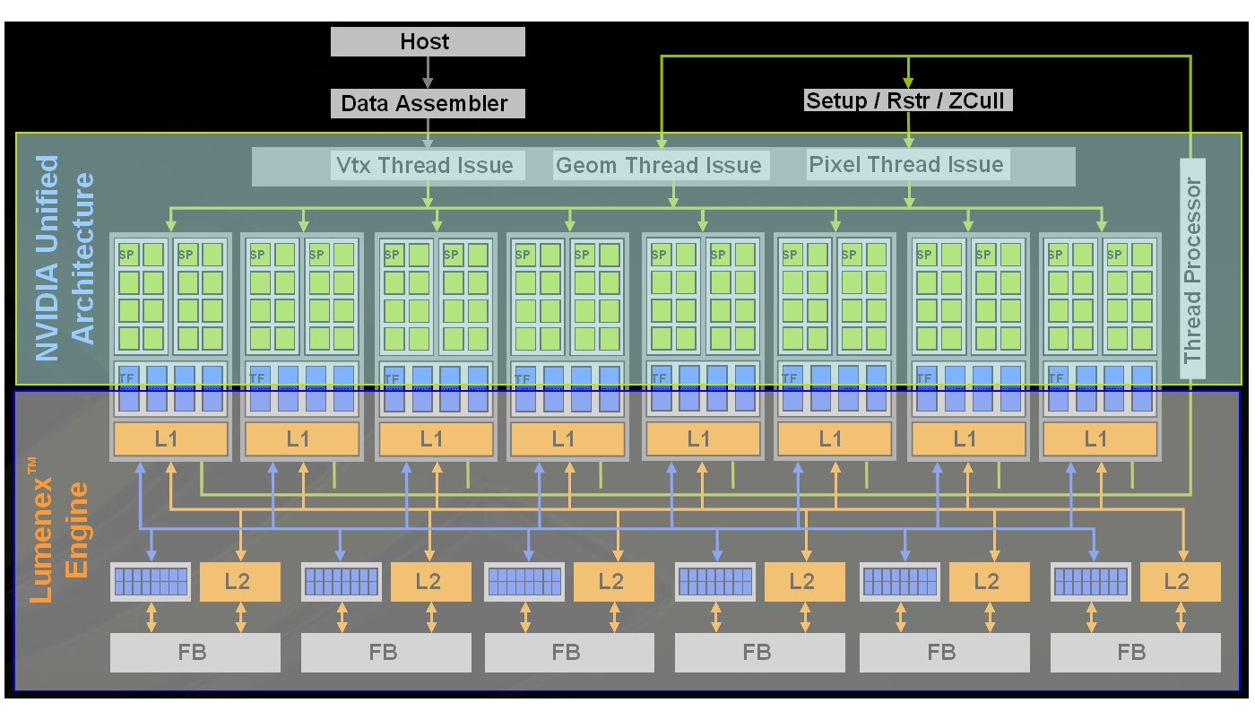
GPUs are basically massively multithreaded many-core chips capable of concurrently executing thousands of concurrent light weight threads. The GPU consists of independent processing units called texture/processor clusters (TPCs) each housing a geometry controller, an SM controller (SMC), two streaming multiprocessors (SMs), and a texture unit. The GPU basically houses of a group of streaming multi-processors (the number varies across different cards - 16 for GT 8800) each containing eight streaming processors (SP) (running at 1.5Ghz for GT 8800). Each streaming multi-processor (SM) has two fully pipelined special functional units (SFU) specialized to perform complex operations such as inverse square root and trigonometric operations; and has 8192 registers available to all the threads that are assigned to it. Each core has a single functional unit (fully pipelined) that performs the single-precision floating point arithmetic and 32-bit integer math, resulting in a theoretical peak of 432 GFlops for GTX 8800 (16 SP + 2 SFU ops per clock cycle = 18 Flops * 16 * 1.5Ghz = 432GFlops).

From the standpoint of programming on this device, it is done with CUDA programming model which has a low learning curve owing to its C-like interface. In the model the GPU is a compute device which has its own device memory on the card and serves as a coprocessor to the host CPU capable of executing large number of threads in parallel (batched a single kernel of execution by the host CPU). The developer supplies a single source program encompassing both host (CPU) and kernel (GPU) code. The data required for the kernel to work on is shuttled to and from the GPU's global memory via API calls from the host code.

Apart from 8192 registers, each SM has 16Kb of low latency software managed shared memory. This shared memory facilitated threads within a block to cooperate and share their data. For computing, the load/store instructions access three read/write memory spaces – a) private local memory for per-thread b) shared memory for low-latency access to data shared by threads within a single block and c) global memory for data shared by all threads of a computing application (implemented in external DRAM). The read-only texture memory is the only cached memory in the architecture and hence data pinned under texture memory accessed with texture fetches are much faster than normal global memory access (although the programming guide says that the texture memory is read-only, it is also writable but the texture cache is not coherent with the texture memory which does not guarantee correctness with respect to reusing the stored/written data).

The execution of the threads on the cores takes place in a SIMD fashion. The computation kernel is batched in blocks of threads, with each block mapped onto one SM. By virtue of a mapping a block of threads onto the same SM, the threads can interact with each other through the low latency shared memory space. The global memory is uncached and hence each access is very costly, but inorder to to improve memory bandwidth and reduce overhead, thread accesses could be orchestrated such that DMA coalescing of the group of accesses from the same warp would result in fewer memory block accesses; the addresses requested must fall in the same block and meet alignment criteria. This would potentially boost the performance over single requests to exploit the on-chip 78Gbps bandwidth.

Mapping the problem effectively onto the GPU involves that the programmer decomposes the problem into many small problems that can be solved in parallel. The GPU compute work distribution unit generates a stream of cooperative threads arrays [give nvidia tesla reference] and distributes them to available SMs to compute each independent block. This is a key feature of CUDA programming model - the program however does not care about the number of processors its eventually going to execute on, thus being able to execute without recompiling to any size of GPU. Thus, the GPU computing architecture “transparently” scales parallel application performance with the number of SMs and SP cores.

The performance gains that the GPU has to offer is attributed to the large thread count, coupled with fast context switches to support outstanding memory access requests that helps amortize the latency of reaching the external DRAM.

3 dSim Background and Implementation

The MR Diffusion Simulator is a code written with CUDA programming model to exploit the power of GPUs to accelerate the simulation i.e. for running the simulation on CUDA enabled Nvidia graphics cards. However the same package also has the provision to run the same simulation on CPUs which do not have Nvidia graphics cards, but must have the NVCC compiler installed (NOTE: Separate code exists to execute the particle interaction and computation on the CPU hence the simulation does not run on device emulation mode).

The simulation models the the hindered and restricted motion of water molecules in the presence of neuronal fibers. The effects of user-specified magnetic gradients on the nuclear magnetic resonance (MR) spin evolution is also computed and the resulting bulk MR signal is estimated.

The existing CUDA example code for “particles” has been adopted in developing our simulation. Hence most of the object oriented framework and graphics functions remain very similar to the CUDA sdk example. The simulation is instantiated in 'diffusion.cpp' which also contains all the visualization modules to render the simulation. The other main modules are a) 'particleSystem' - contains the variable and functions that support the simulation and b) 'particles_kernel' (.cu is the GPU version and Cpu.cpp the corresponding CPU version) – contains the function that performs the actual computation modeling the motion of the molecules.

4.1 Modeling the random motion of the water molecules
We know that Brownian motion is the scaling limit of random walk in 1 dimension. We would get an approximation to Brownian motion if we take a random walk with very small steps i.e. if the step size is ε, one needs to take a walk of length L/ε² to approximate a Brownian motion of length L. As the step size tends to 0 (and the number of steps increased comparatively) random walk converges to Brownian motion in an appropriate sense [give the wiki brownian motion/random walk reference]. We simulate the brownian motion (free diffusion) with a random walk of the molecules every time step. In 3-D, the variance corresponding to the Green’s function of the diffusion equation is given by:
σ² = 6 x ADC x δt

where
ADC – is the apparent diffusion co-efficient
δt – is the time step
σ² – is the variance corresponding to the distribution associated with the vector R that links the two ends of the random walk in the 3D space. Hence the standard deviation of each component would be given by:

σ = √(2 x ADC x δt)

In each time step, we need three random numbers to generate the random walk and a fourth random number as a coin flip for permeating through the fibers when required. Hence, we require three random numbers from the normal distribution and the fourth from uniform distribution. The random number generation we have employed is a combination of multiply-with-carry pseudo random generation followed by a box muller transform. The random number generation module thus takes two seeds and passes them onto the first stage which returns a single random number generated by a simple multiply-with-carry pseudo-random number generation algorithm from George Marsaglia. This is used to generate four such random numbers, and on each pair the box muller transforms is performed.
[give the graph of the random walks/positions of the particles x,y,z over a time slice just to illustrate – show validation]

4.2 Modeling the interaction with the neuronal fibers

The heart of the simulation is to find the valid new position of the molecule every time step. The presence of the neuronal fibers affect the perfectly random motion of the water molecules. This interaction is to be accounted for while computing the new position of the molecule. It is however important to identify all the possible fibers with which the molecule could potentially interact with each random step taken. If not done carefully this could be the major source of overhead and the simulation would become ridiculously memory bound.

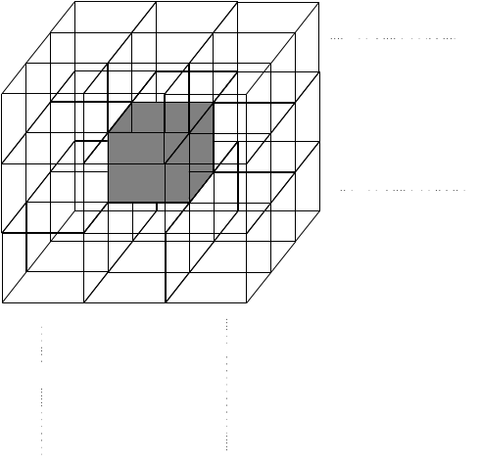

Figure 1: Space grid into cubes
As a result of the above mentioned notion, the space is grid into cubes such that each cube holds the information of the fiber that it contains. The cube to which the particle belongs to is to be identifies so that only those fibers need be retrieved to compute the new position (i.e. its interaction only with the fibers in the vicinity). A list is first created which holds the indices to the tubes that are present in the given cube in the space.
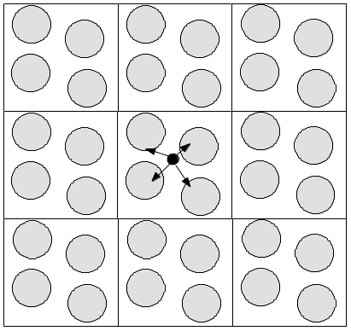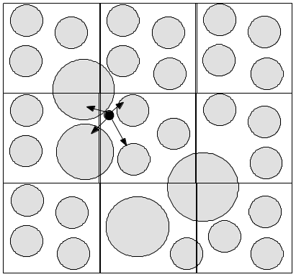

Figure 2: (a), (b) Scenarios to illustrate the molecule-fiber interaction
Hence during simulation the particles position is used to determine which cube the particle currently resides (this index gives the starting location of the cube level list which holds the indices to the tube list which contains the tube positions and their radii) :-
cubePos.x = (pos.x – worldOrigin.x ) / cubeSize
cubeListIndex = cubePos.z x gridSize.y x gridSize.x + cubePos.y x gridSize.x + cubePos.x

However, as depicted by Figure 2 (b) it is not enough to only consider the cube in which the molecule resides but also its neighboring cubes for accurate simulation. The main simulation kernel executes as follows:
- First compute the new position as a random step taken
- Find if the new position is valid as restricted by the presence of neighboring fibers and governed by the permeability of the medium [curDis/preDis - distance of position of molecule to center of fiber]
- If curDis <= radius && prevDis > radius – the particle is trying to move from outside to inside of the fiber
- If curDis > radius && prevDis <= radius – the particle is trying to move from inside to outside of the fiber
- Final position : either bounce back or remain in the new calculated position, determined by the permeability

5 Evaluation of different Implementation strategies
Method 1
Since the first
- Naïve implementation of griding into cubes but single list of fiber positions and checking for all 26 neighboring cubes every time – 0.588 gbps
Method 2
- Creating separate cube level list containing the actual fiber positions within each cube, performed repacking of the particles - radix sort based on position for coalesced DMA access, with float4 texture fetches (without radix – 1.75Gbps, with radix 2.16gbps)
Method 3
- Texture fetch, halo, increased iteration per kernel batch, maintaining track of which tube it is in. (12.207Gbps)
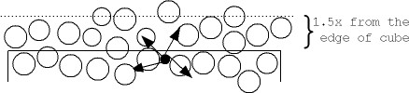
In a more realistic situation the packing of the fibers will be so dense that there would potentially be more molecules residing inside a fiber at a given instant of time than outside to the extent that keeping track of the tubes within which it resides would obviate the need to consider all the other fibers in the vicinity.

(a)

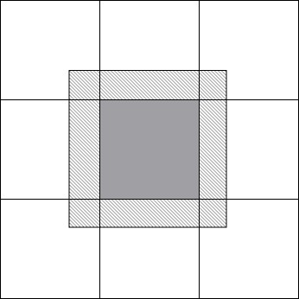

(b)

Figure 3: Illustration of another optimization
Yet another optimization in order to reduce the number of fibers to be considered for each molecule, that was incorporated was to consider only those fibers from the neighboring cubes which lie within 1.5 times the maximum radius of the fibers present in the space. This would yield accurate results under the assumption that the step size for the motion of the molecule is much smaller than the radius of the fiber.

GPU Specific Optimization :
The first optimization made was to pin the list containing the position & radius of each fiber to texture memory and retrieve them through texture fetches
The other optimization incorporated was an effort to support DMA coalescing by sorting the particles based on there new position in the space so that access pattern of the tube positions by threads of molecules close in the space would support DMA coalescing.

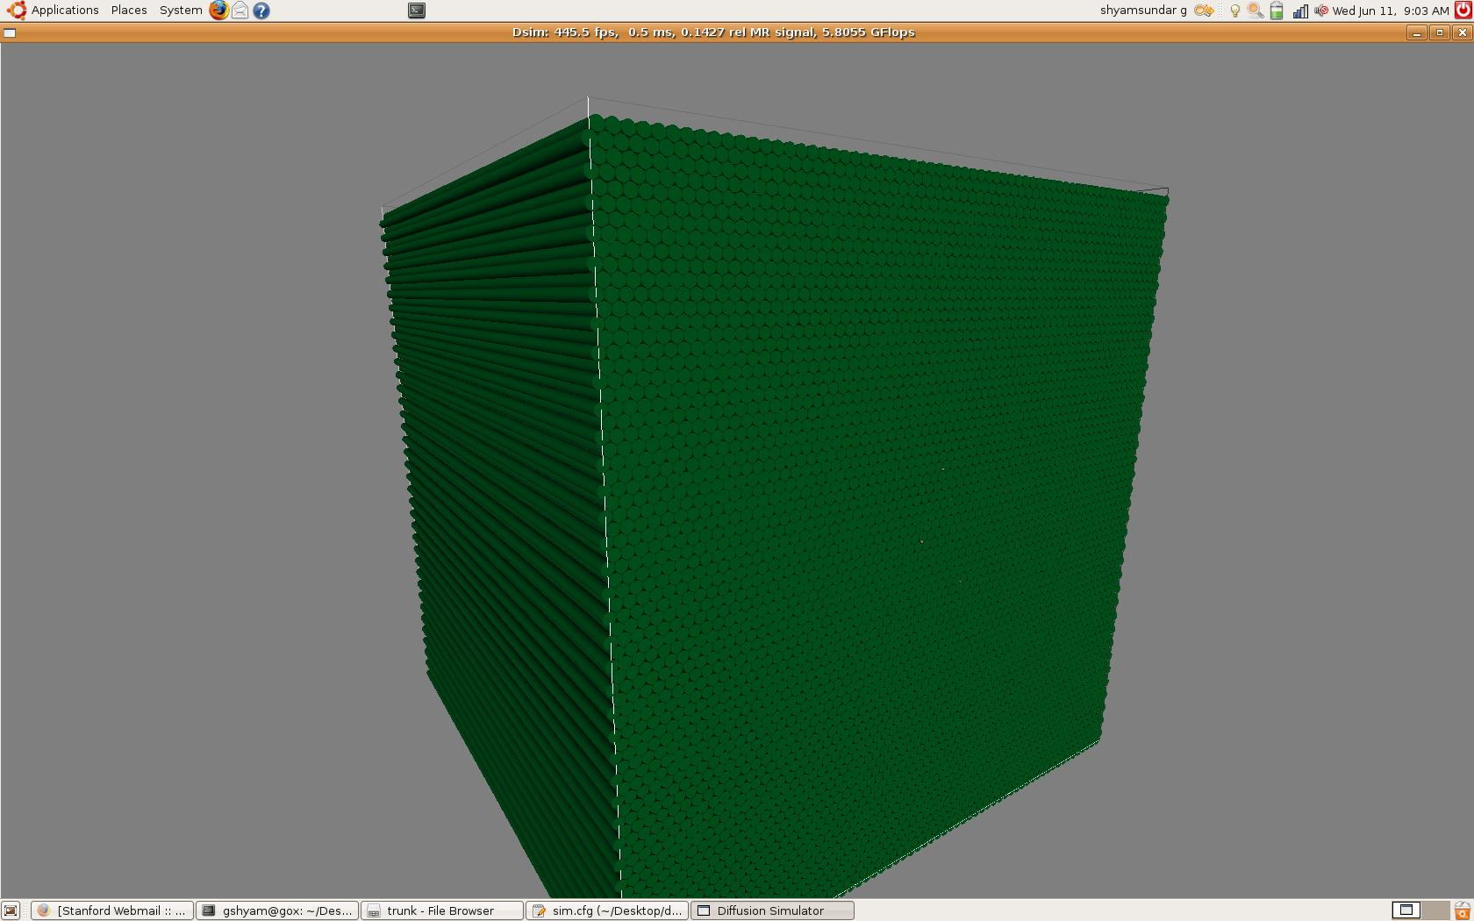
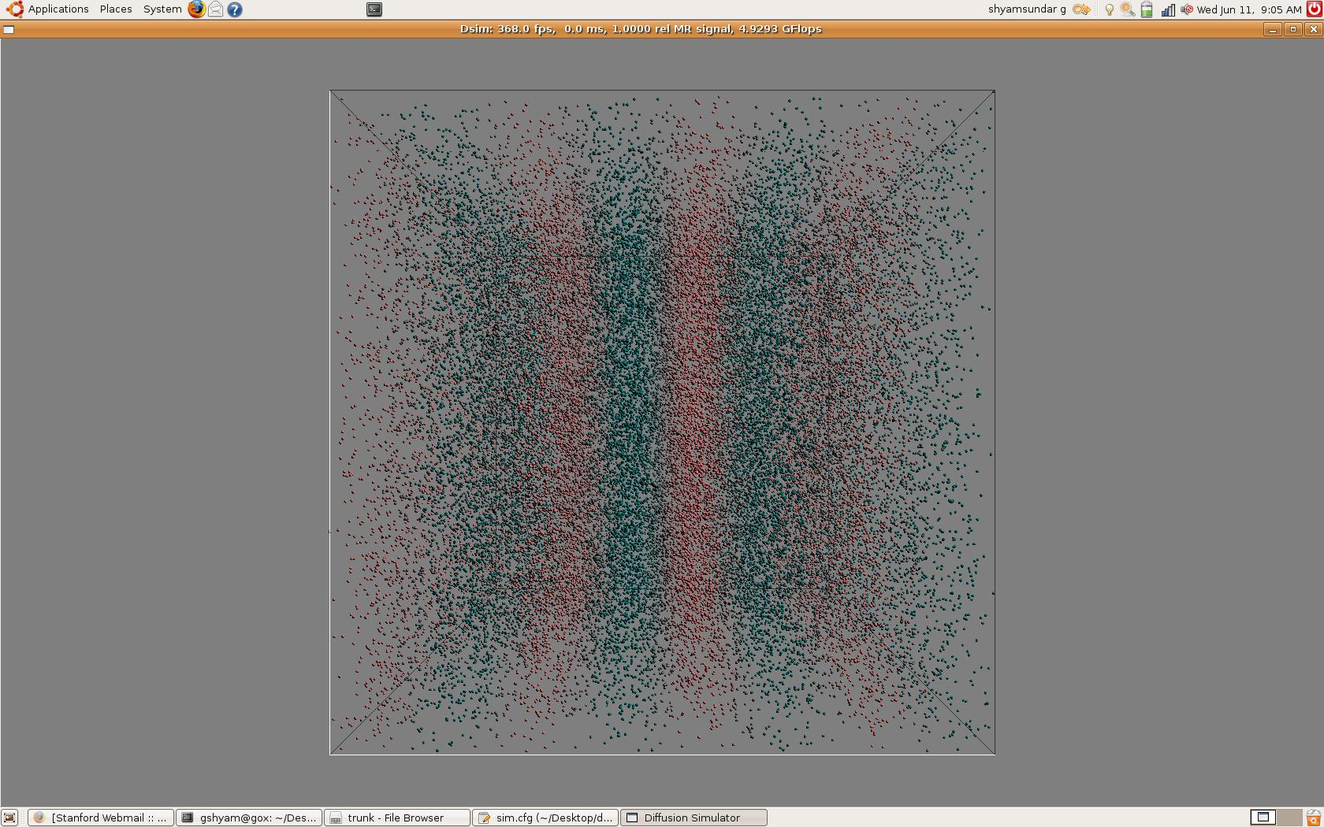

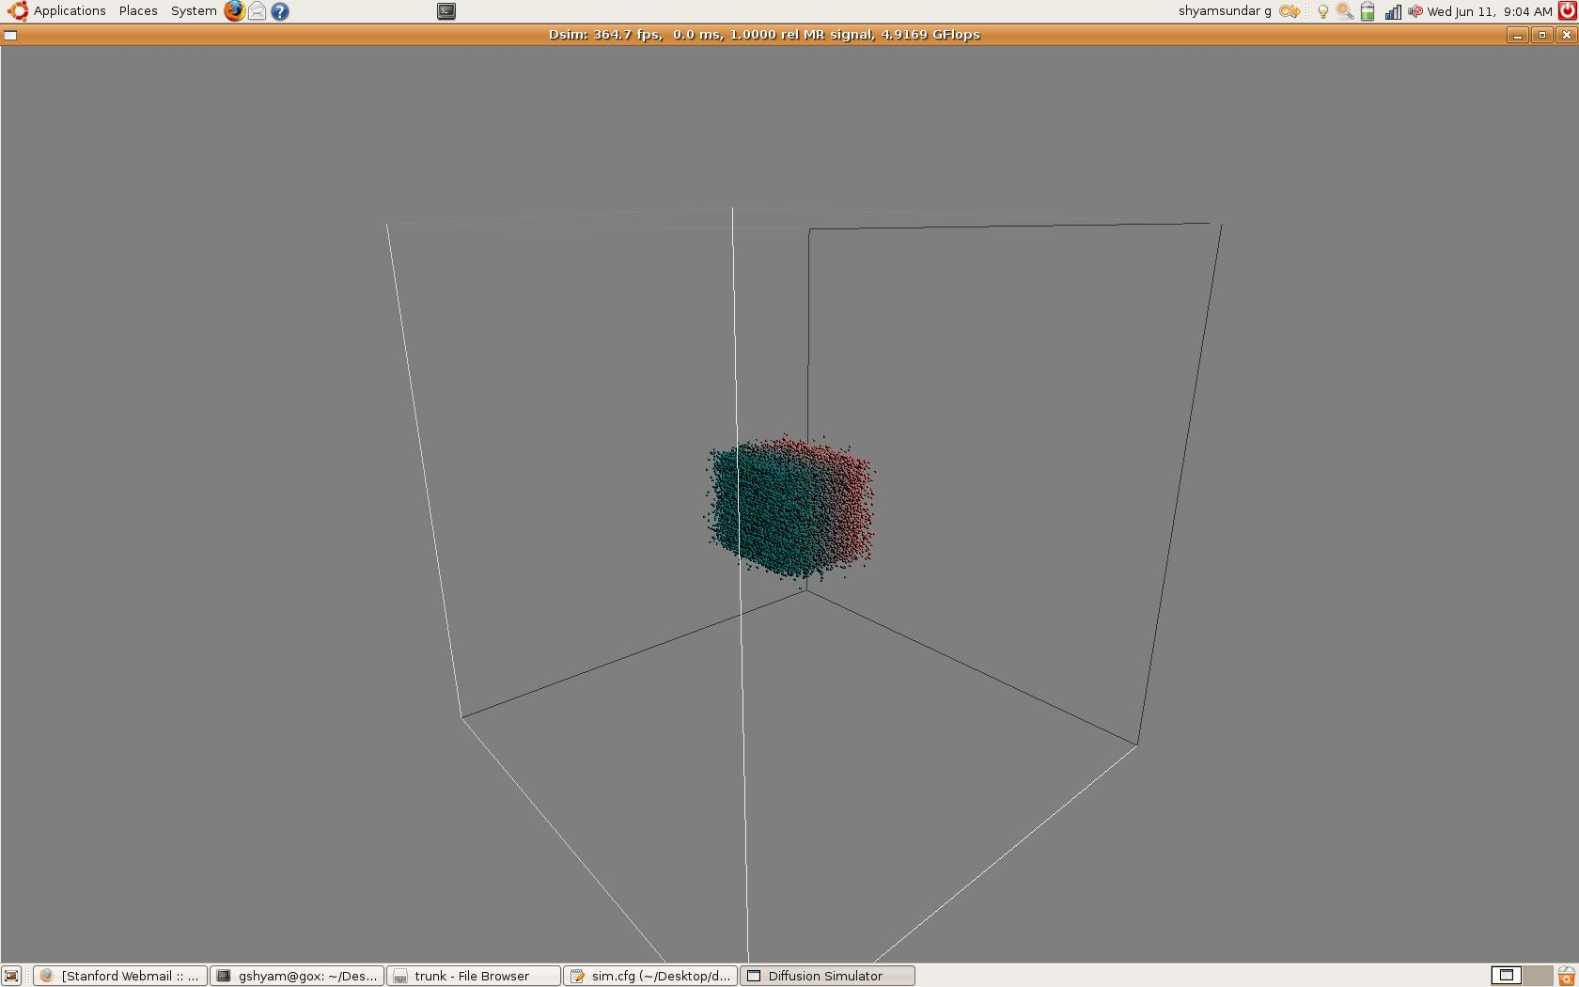
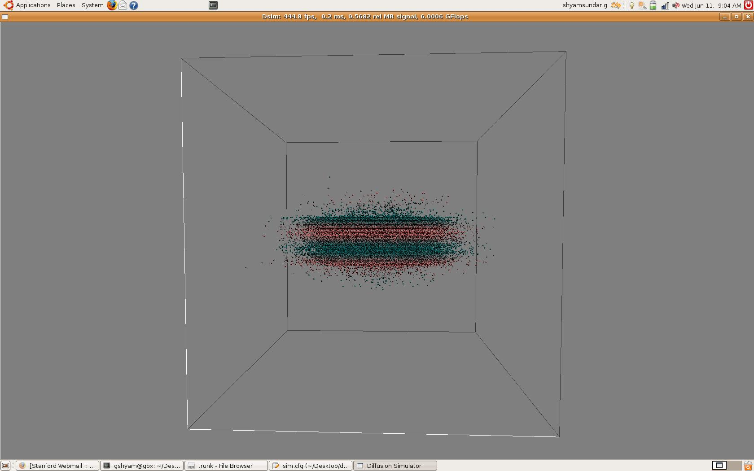
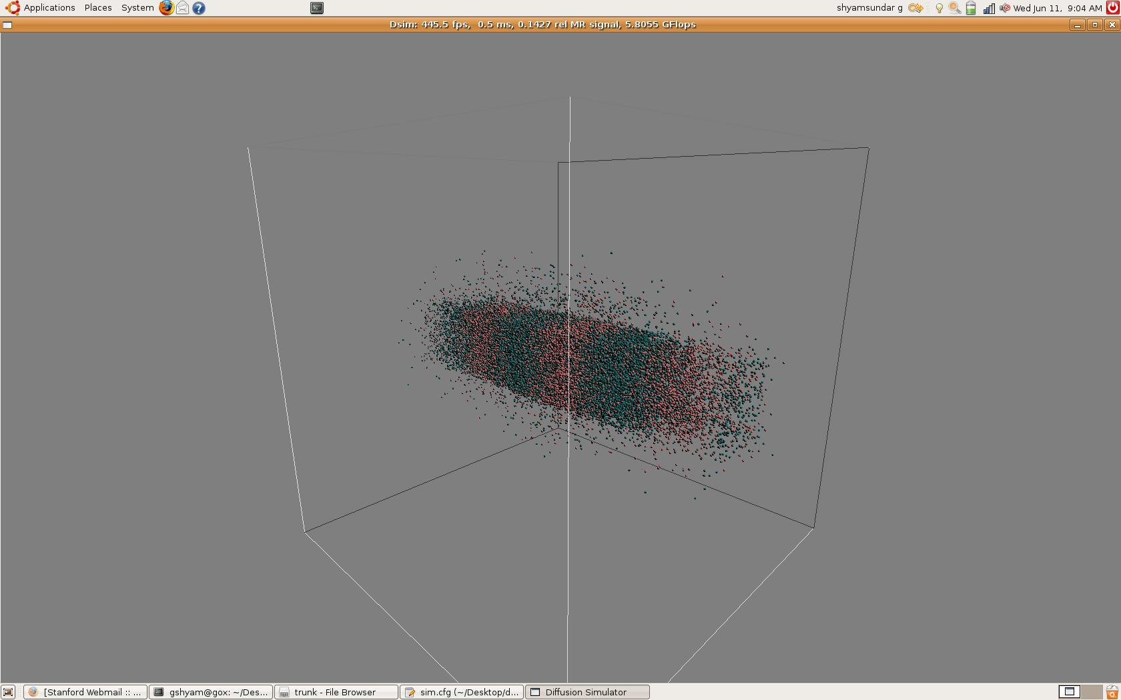

Run-time execution graphs (simulations run on Quadro FX 570M)
Runtime graph of Different implementation strategies adopted...(what were the various other methods adopted, why and which version is most apt) must include not only the run-time on (3 machines – mine, bob, tony) but also the comment on the compiled code (registers etc.), memory/network bandwidth utilization ... graphs must be a normalized version,

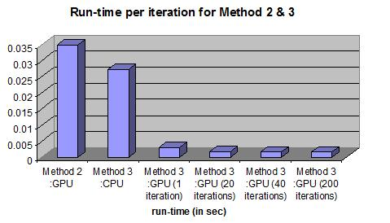

Method 1 : GPU: 0.0373299
CPU: not implemented
Method 2 : CPU: 0.132922
GPU: 0.034734
Method 3 : CPU: 0.02723
GPU: 0.00300312 (1 iteration )
GPU: 0.00168996 (20 iterations)
GPU: 0.0016566 (40 iterations)
GPU: 0.00162788 (200 iterations)
6 Future works
1.separate kernels for x,y,z
2.exploiting the use of shared memory
7 Conclusion

