CIC
$$H\left(z\right)=1+z^{-1}+z^{-2}+z^{-3}$$

$$\sum_{n=0}^{3}{z^{n}}=\frac{1-z^{4}}{1-z}$$
$$H\left(z\right)=\frac{z^{3}+z^{2}+z+1}{z^{3}}=\frac{\left(1-z^{4}\right)}{z^{4}\left(1-z\right)}$$

$$z^{4}=1=e^{j2πk}→z=e^{\frac{j2πk}{4}}, k=0…3$$
The zero at $z=1$ ($k=0$) cancels out so you’re left with zeros at
$$e^{\frac{j2πk}{4}},k=1…3$$
$$H\left(z\right)=\frac{\left(z-e^{\frac{jπ}{2}}\right)\left(z-e^{jπ}\right)\left(z-e^{\frac{j3π}{2}}\right)}{z^{3}}=\frac{\left(z-j\right)\left(z+1\right)\left(z+j\right)}{z^{3}}$$

$$x\left(n\right)=e^{\frac{jπ}{2}n}u\left(n\right)$$
$$X\left(z\right)=\frac{1}{1-e^{\frac{jπ}{2}}z^{-1}}=\frac{z}{z-e^{\frac{jπ}{2}}}=\frac{z}{z-j}$$
$$Y\left(z\right)=H\left(z\right)X\left(z\right)=\frac{\left(z+1\right)\left(z+j\right)}{z^{2}}=\frac{z^{2}+\left(1+j\right)z+j}{z^{2}}=1+\left(1+j\right)z^{-1}+jz^{-2}$$
$$y\left(n\right)=\left[1, \left(1+j\right), j\right]$$

CORDIC

Summary
This can be used to convert from rectangular to polar coordinates. The final rotated vector lies along the real axis (envelope), and you’re calculating the angle of the original coordinates. The plus-minus decision is based on the sign of the y coordinate.
The reverse is used to convert from polar to rectangular. You calculate sine and cosine of the angle, which gives you the x and y coordinates. The plus-minus decision is based on the sign of the difference between desired angle and accumulated rotation.
There is no (mathematical) downside to increasing the number of iterations since the CORDIC algorithm always converges. Each subsequent rotation is always $≥\frac{1}{2}$ of the previous rotation.

Background
CORDIC Algorithm (YouTube)
How can we compute $\cos{θ}$ and $\sin{θ}$ in fixed-point arithmetic?
One way is Taylor series:
$$\cos{x}=1-\frac{x^{2}}{2!}+\frac{x^{4}}{4!}-\frac{x^{6}}{6!}+…$$
$$\sin{x}=x-\frac{x^{3}}{3!}+\frac{x^{5}}{5!}-…$$
These infinite series are valid for any values of $x$, but the approximation of truncating the series to the first desired terms is more accurate for smaller $x$. However, this requires multiplications for $x^{2},x^{3},$ etc.
Another way is using a lookup table (LUT), e.g.
$$x$$ | $$\cos{x}$$
0 | $$\cos{0}$$
0.25 | $$\cos{0.25}$$
0.5 | $$\cos{0.5}$$
… | …

The outputs are precomputed. Outputs for values not in the table are interpolated. However, accuracy is limited by the size of the LUT, and interpolation itself may require difficult computations.
Another way is by using a CORDIC, or Coordinate Rotation Digital Computer, invented in 1959 by Jack Volder, which involves these core ideas:
- Binary (or similar) search
- Strength reduction (replacing multiplication by shift-and-add)
CORDIC (Wikipedia)
- Simple and efficient algorithm to calculate trigonometric functions, hyperbolic functions, square roots, multiplications, divisions, and exponentials and logarithms with arbitrary base
- Iterative algorithm that typically converges with one digit (or bit) per iteration
- Only requires addition, subtraction, bitshift, and LUTs
- Belongs in the categories of digit-by-digit algorithm and shift-and-add algorithm

For DSP
A CORDIC is used to rotate a 2-dimensional coordinate vector $\left(x,y\right)$ by an angle that is anywhere within $\left[-π/2,+π/2\right]$.
In DSP, this is useful for converting between rectangular and polar representations of a complex baseband signal. Let the “coordinate” be $\left(I,Q\right)$ corresponding to the real and imaginary parts of the signal.
A CORDIC has two modes: vectoring mode and rotation mode.
Vectoring mode:
Given $\left(I,Q\right)$, we compute the angle $ϕ=∠\left(I+jQ\right)$.
A CORDIC calculates $ϕ$, and along the way, rotates $\left(I, Q\right)$ to $\left(\sqrt{I^{2}+Q^{2}},0\right)$. You can think of that rotation as $\left(I+jQ\right)e^{-jϕ}$. Since the angle of rotation must be within $\left[-π/2,+π/2\right]$, $\left(I,Q\right)$ must be in the first or fourth quadrants.
This means we’ve transformed $I+jQ$ to $\sqrt{I^{2}+Q^{2}}e^{jϕ}$, or rectangular-to-polar conversion.
Rotation mode:
In rotation mode, the CORDIC rotates $\left(x,y\right)$ by any angle within $\left[-π/2,+π/2\right]$.
Let’s assume our initial coordinates are $\left(\sqrt{I^{2}+Q^{2}},0\right)$ and the angle of rotation is $ϕ=∠\left(I+jQ\right)$.
The rotated coordinates are $\sqrt{I^{2}+Q^{2}}e^{jϕ}=\left(\sqrt{I^{2}+Q^{2}}\cos{ϕ},\sqrt{I^{2}+Q^{2}}\sin{ϕ}\right)$. This is polar-to-rectangular conversion.
In other words, the CORDIC in rotation mode calculates $\cos{ϕ}$ and $\sin{ϕ}$.

Binary search algorithm
Why should we use CORDIC? After all, we can achieve the same rotations via a complex multiplier.
We use CORDIC because it avoids the use of multipliers. It is a shift-and-add algorithm.
The binary search algorithm iteratively rotates the coordinates by $θ_{i}$ until the sum of the rotations is close enough to the desired rotation $θ$.
$$\lim_{N→∞}{\sum_{i=0}^{N}{θ_{i}}}=θ$$
For this limit to converge, we need $\left|θ_{i}\right|≥\left|θ_{i-1}\right|/2$. 1/2 + 1/4 + 1/8 + 1/6 + ...
First, let’s calculate how to rotate the coordinates by an angle $θ$.
We can treat the coordinates as being in the complex z-plane, i.e. $\left(x,y\right)=x+jy$.
Then rotating by an angle $θ$ is equal to
$$\left(x+jy\right)e^{jθ}=\left(x_{i}+jy_{i}\right)\left(\cos{θ}+j\sin{θ}\right)=x\cos{θ}-y\sin{θ}+j\left(x\sin{θ}+y\cos{θ}\right)$$
The new coordinates are
$$x^{'}=x\cos{θ}-y\sin{θ}$$
$$y^{'}=x\sin{θ}+y\cos{θ}$$
In matrix form, the rotation is
$$\left(\begin{matrix}x^{'} \\ x^{'}\end{matrix}\right)=\left(\begin{matrix}\cos{θ} & -\sin{θ} \\ \sin{θ} & \cos{θ}\end{matrix}\right)\left(\begin{matrix}x \\ y\end{matrix}\right)$$
Which we will simplify to
$$\left(\begin{matrix}x^{'} \\ y^{'}\end{matrix}\right)=\cos{θ}\left(\begin{matrix}1 & -\tan{θ} \\ \tan{θ} & 1\end{matrix}\right)\left(\begin{matrix}x \\ y\end{matrix}\right)=\frac{1}{\sqrt{1+\tan^{2}{θ}}}\left(\begin{matrix}1 & -\tan{θ} \\ \tan{θ} & 1\end{matrix}\right)\left(\begin{matrix}x \\ y\end{matrix}\right)$$
If we restrict $θ∈\left[-π/2,+π/2\right]$, then one way of converging to $θ$ would be
$$\left|θ_{i}\right|=\left|θ_{i-1}\right|/2$$
$$θ_{0}=±π/4$$
For example, let’s say we want to rotate by $θ=70°$. Then the search would proceed as
- Total rotation = $0°$. Error = $70°$.
- Rotate by $θ_{0}=\text{sign}\left(\text{error}\right)⋅45°$
- Total rotation = $45°$. Error = $25°$.
- Rotate by $θ_{1}=\text{sign}\left(\text{error}\right)⋅22.5°$
- Total rotation = $67.5°$. Error = $2.5°$.
- Rotate by $θ_{2}=\text{sign}\left(\text{error}\right)⋅11.25°$
- Total rotation = $78.75°$. Error = $-8.75°$.
- Rotate by $θ_{3}=\text{sign}\left(\text{error}\right)⋅5.625°$
- Total rotation = $73.125°$. Error = $-3.125°$.
- Rotate by $θ_{4}=\text{sign}\left(\text{error}\right)⋅2.8125°$
- Total rotation = $70.3125°$. Error = $-0.3125°$.
Choose $N$ s.t. error is less than your requirement.

Strength reduction
The binary search algorithm on its own does not avoid the use of multipliers since the coefficients require multiplying by ${\tan{θ}}_{i}$.
We fix that with strength reduction. Instead of $θ_{i}=\left(\begin{matrix}±π/4 \\ ±π/8 \\ ±π/16 \\ ⋮\end{matrix}\right)$, pick $θ_{i}$ s.t. the coefficients are bitshifts, i.e.
$$\tan{θ_{i}}=\left(\begin{matrix}2^{0} \\ 2^{-1} \\ 2^{-2} \\ ⋮\end{matrix}\right)$$
Or
$$\left|θ_{i}\right| \left(\text{degrees}\right)=\left(\begin{matrix}45° \\ 26.56° \\ 14.03° \\ ⋮\end{matrix}\right)$$
The rotation is given by
$$\left(\begin{matrix}x^{'} \\ y^{'}\end{matrix}\right)=\frac{1}{\sqrt{1+\tan^{2}{θ}}}\left(\begin{matrix}1 & -\tan{θ} \\ \tan{θ} & 1\end{matrix}\right)\left(\begin{matrix}x \\ y\end{matrix}\right)$$
Then the first and second rotation matrices are
$$\left(\begin{matrix}1 & ∓1 \\ ±1 & 1\end{matrix}\right)$$
$$\left(\begin{matrix}1 & ∓1/2 \\ ±1/2 & 1\end{matrix}\right)$$
In general, after the $N$th rotation, the coordinate is
$$\left(\begin{matrix}x_{N} \\ y_{N}\end{matrix}\right)=K\left(N\right)\left(\begin{matrix}1 & ∓2^{-\left(N-1\right)} \\ ±2^{-\left(N-1\right)} & 1\end{matrix}\right)…\left(\begin{matrix}1 & ∓1/2 \\ ±1/2 & 1\end{matrix}\right)\left(\begin{matrix}1 & ∓1 \\ ±1 & 1\end{matrix}\right)\left(\begin{matrix}x_{0} \\ y_{0}\end{matrix}\right)$$
$$K\left(N\right)=\prod_{i=0}^{N-1}{K_{i}}=\prod_{i=0}^{N-1}{\frac{1}{\sqrt{1+\tan^{2}{θ_{i}}}}}=\prod_{i=0}^{N-1}{\frac{1}{\sqrt{1+2^{-2i}}} }$$
$$\lim_{N→∞}{K\left(N\right)}≈0.60725$$
For a fixed $N$, $K\left(N\right)$ is known and is precomputed (and stored into a LUT).

Modes of operation
Let’s put it all together.

Rotation mode
The goal of rotation mode is to rotate a vector – nominally, the vector $\left(1,0\right)$ – by $θ∈\left[-π/2,+π/2\right]$.
For $N$ iterations ($N$ is a fixed number that you must calculate or simulate based on your desired error limit), each rotation by $θ_{i}$ is given by
$$\left(\begin{matrix}x_{i+1} \\ y_{i+1}\end{matrix}\right)=\left(\begin{matrix}1 & -σ_{i}2^{-i} \\ σ_{i}2^{-i} & 1\end{matrix}\right)\left(\begin{matrix}x_{i} \\ y_{i}\end{matrix}\right)$$
$$σ_{i}=\left\{\begin{aligned}1, θ_{i}>0 \\ -1, θ_{i}<0\end{aligned}\right.=\left\{\begin{aligned}1, e_{i}>0 \\ -1,e_{i}<0\end{aligned}\right.$$
$$e_{i+1}=e_{i}-σ_{i}θ_{i}$$
$σ_{i}$ depends on the sign of the error, $e_{i}$. Initialize the error as $e_{0}=θ$. Update the error after each iteration. This requires storing $θ_{i}$ in a LUT.
If magnitude matters, the final vector must be multiplied by $K\left(N\right)$.
If the desired $θ$ is outside of $\left[-π/2,+π/2\right]$, then you must rotate to $θ±π$ and then multiply the final coordinates by $-1$.
Rotation mode can rotate any vector by $\left[-π/2,+π/2\right]$. This is a phase shift. To perform a frequency shift, simply accumulate the desired phase shift per sample.

Vectoring mode
This is the inverse of rotation mode. Instead of rotating $\left(1,0\right)$ by $θ$, we want to rotate $\left(x,y\right)$ to $\left(1,0\right)$. If $θ$ is the angle of $\left(x,y\right)$, we want to rotate $\left(x,y\right)$ by $-θ$.
The rotation operation is the same, i.e. $θ∈\left[-π/2,+π/2\right]$. This means $\left(x,y\right)$ must be in quadrants 1 or 4 (positive $x$ coordinate).
However, the control/logic is slightly different per iteration.
$$\left(\begin{matrix}x_{i+1} \\ y_{i+1}\end{matrix}\right)=\left(\begin{matrix}1 & -σ_{i}2^{-i} \\ σ_{i}2^{-i} & 1\end{matrix}\right)\left(\begin{matrix}x_{i} \\ y_{i}\end{matrix}\right)$$
$$σ_{i}=\left\{\begin{aligned}1, θ_{i}>0 \\ -1, θ_{i}<0\end{aligned}\right.=\left\{\begin{aligned}1, y_{i}<0 \\ -1,y_{i}>0\end{aligned}\right.$$
$$Θ_{i+1}=Θ_{i}+σ_{i}θ_{i}$$
$σ_{i}$ depends on the sign of $y_{i}$ instead of the sign of the error, and instead of tracking the error, we track the accumulated phase.
If $x_{0}$ is positive, initialize $Θ_{0}=0$. If $x_{0}$ is negative, multiply the coordinates by $-1$ and initialize $Θ_{0}=π$.

The effect of $N$ on EVM and spectrum
Reducing $N$ will of course impact EVM, but it also adds out-of-band noise. The noise spectrum looks different depending on the application. For rectangular-to-polar conversion and vice versa, the noise is relatively smooth. For frequency shifting, the noise spectrum depends on the signal. For low occupied bandwidth, the noise spectrum has ugly artifacts.
These are simulation results using floating-point arithmetic.
Constellation due to low $N$:
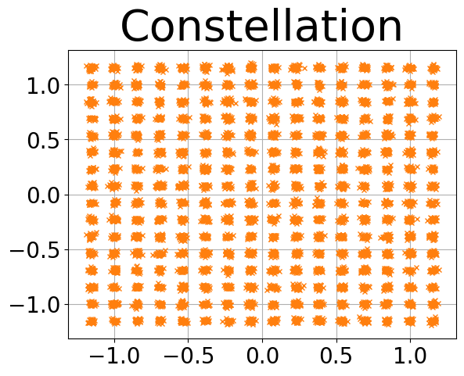
Rectangular-to-polar conversion PSD, high occupied BW:
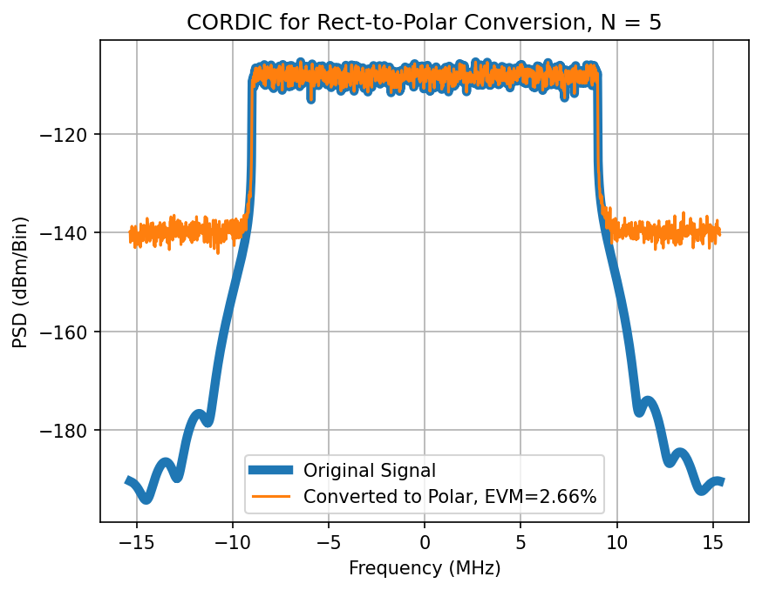
Rectangular-to-polar conversion PSD, low occupied BW:
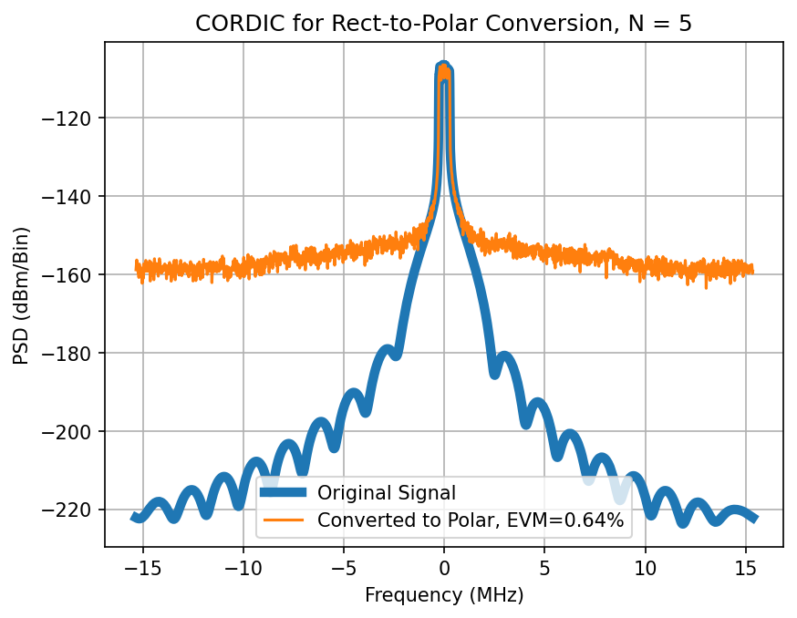
Frequency shift PSD, high occupied BW:
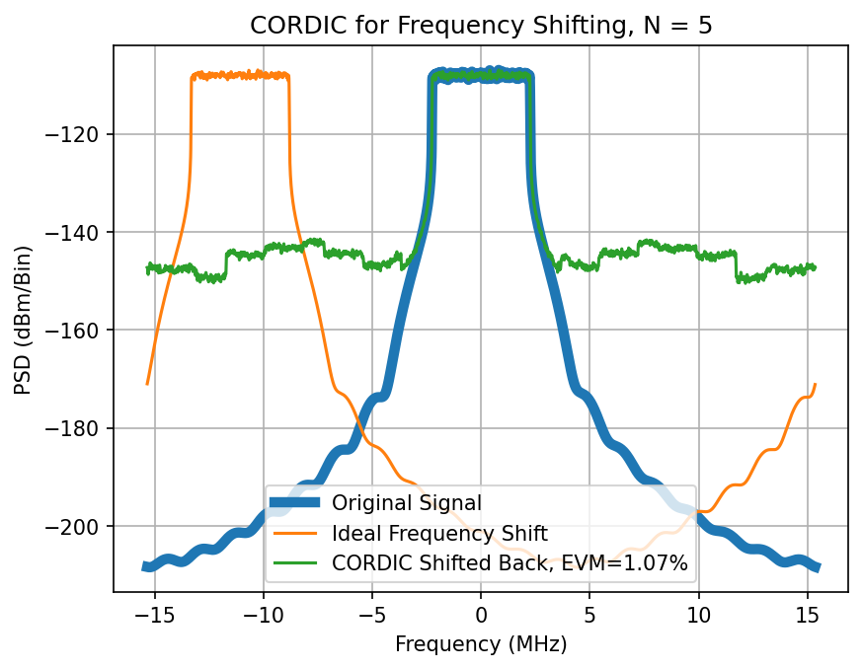
Frequency shift PSD, low occupied BW:
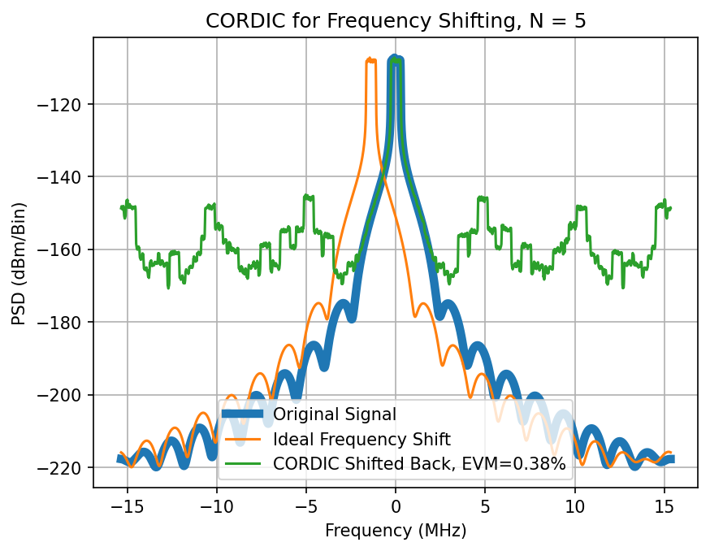

Pipelining
For $N$ iterations of the CORDIC, there are a corresponding $N$ stages. At the simplest level, each sample completes one iteration per clock cycle. At each clock cycle, you must
- Determine the sign of the next rotation
- Update the error or accumulated phase
For each sample, track the error or accumulated phase.

Digital biquad

Multirate processing

CIC filters

Halfband filters

Polyphase FIR filters
Symmetric coefficients

Upsampling chains

Downsampling chains

Notch filter
$$H\left(z\right)=\frac{1-e^{jω_{0}}z^{-1}}{1-re^{jω_{0}}z^{-1}}, \left|z\right|>r$$
$$x\left(n\right)=e^{jω_{0}n}u\left(n\right)$$
$$X\left(z\right)=\sum_{n=0}^{∞}{x\left(n\right)z^{-n}}=\sum_{n=0}^{∞}{e^{jω_{0}n}z^{-n}}=\sum_{n=0}^{∞}{{\left(e^{jω_{0}}z^{-1}\right)}^{n}}=\frac{1}{1-e^{jω_{0}}z^{-1}}, \left|z\right|>1$$
$$Y\left(z\right)=X\left(z\right)H\left(z\right)=\frac{1}{1-re^{jω_{0}}z^{-1}}, \left|z\right|>r$$
$$y\left(n\right)=r^{n}e^{jω_{0}n}u\left(n\right)$$

$$x\left(n\right)=e^{jω_{1}n}u\left(n\right)$$
$$X\left(z\right)=\frac{1}{1-e^{jω_{1}}z^{-1}}, \left|z\right|>1$$
$$Y\left(z\right)=X\left(z\right)H\left(z\right)=\frac{1-e^{jω_{0}}z^{-1}}{\left(1-e^{jω_{1}}z^{-1}\right)\left(1-re^{jω_{0}}z^{-1}\right)}, \left|z\right|>1$$
$$Y\left(z\right)=\frac{A}{1-e^{jω_{1}}z^{-1}}+\frac{B}{1-re^{jω_{0}}z^{-1}}=\frac{1-e^{jω_{0}}z^{-1}}{\left(1-e^{jω_{1}}z^{-1}\right)\left(1-re^{jω_{0}}z^{-1}\right)}$$
$$y\left(n\right)=A⋅e^{jω_{1}n}u\left(n\right)+B⋅r^{n}e^{jω_{0}n}u\left(n\right)$$

$$A={\left.\frac{1-e^{jω_{0}}z^{-1}}{1-re^{jω_{0}}z^{-1}}\right|}_{z=e^{jω_{1}}}=\frac{1-e^{j\left(ω_{0}-ω_{1}\right)}}{1-re^{j\left(ω_{0}-ω_{1}\right)}}$$
$$B={\left.\frac{1-e^{jω_{0}}z^{-1}}{1-e^{jω_{1}}z^{-1}}\right|}_{z=re^{jω_{0}}}=\frac{1-\frac{1}{r}}{1-\frac{e^{j\left(ω_{1}-ω_{0}\right)}}{r}}$$
$${\left.A\right|}_{ω_{1}=ω_{0}}=0$$
$${\left.B\right|}_{ω_{1}=ω_{0}}=1$$

$${\left.A\right|}_{ω_{1}=ω_{0}-π}=\frac{1-e^{jπ}}{1-re^{jπ}}=\frac{2}{1+r}≈1$$
$${\left.B\right|}_{ω_{1}=ω_{0}-π}=\frac{1-\frac{1}{r}}{1-\frac{e^{jπ}}{r}}=\frac{1-\frac{1}{r}}{1+\frac{1}{r}}≈0$$

SPDFT

