# Topics

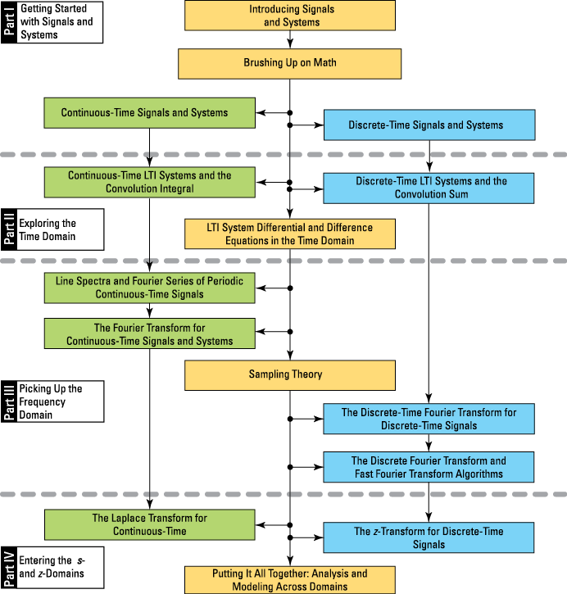

# Math review

## Partial fraction expansion (PFE)

Important for inverse Laplace and z-transforms. PFE allows you to split up a ratio of polynomials into a sum of fractions, with each denominator containing a single or repeated root.

Consider Nth and Mth-order polynomials

For , is a proper rational function. If you assume has no repeated roots, then the PFE of is

If you don’t assume no repeated roots, and each of roots has multiplicity such that , then

When (improper rational function), you need to use long division to reduce the numerator order to be less than the denominator order. You need to first put your ratio of polynomials in the form

Where is a proper rational function.

For distinct (no repeats) roots, the coefficients are given by

For repeated roots, the coefficients are given by

## Trigonometry

Useful trig identities:

## Complex arithmetic

Rectangular form (x-y coordinates):

Polar form (magnitude/envelope and phase):

Rectangular to polar conversion:

Polar to rectangular conversion:

Let .

Euler’s identity:

Example:

### Phasor analysis

Phasor analysis: when sinusoidal signals of the same frequency are added together (superimposed), the result is a single sinusoidal signal having a composite amplitude and phase. Mathematically,

The composite amplitude and phase are given by the vector addition of the individual amplitudes and phases.

Proof:

## Calculus

Formally, has derivative at if this limit exists:

Differentiation formulas ( is constant and and are functions of ):

* (chain rule)

Indefinite integrals are also known as antiderivatives, i.e. if

Then

Useful indefinite integrals:

Useful definite integrals:

When a closed-form solution for integration is not available, use numerical integration (e.g. SciPy integrate module, quad function).

To find the minimum or maximum of a function , find

(As long as there is only one global minimum or maximum).

* If minimum,
* If maximum,

### Geometric series

Geometric series are often found in discrete-time signals and systems.

A finite geometric series, aka the sum of a finite initial segment of an infinite geometric series:

The convergence of the infinite sequence of partial sums of the infinite geometric series depends on , where may be complex.

When , the series converges:

When , the series diverges.

When , if , grows to infinity. When , the partial sums oscillate between . More generally, when for any integer , the series will circulate indefinitely with a period of .

Derivation of partial sum closed form:

Derivation of infinite series closed form for :

## Finding polynomial roots

For performing stability analysis of systems.

For 2nd-order polynomial, you can use the quadratic formula:

For higher-order, you will likely want to use numerical methods.

A special Nth-degree polynomial that occurs in discrete-time systems:

To find the roots, .

The roots equally spaced around the unit circle in the complex plane at separation angle .

If where is a real number, then the roots instead have magnitude .

# Intro to continuous-time signals and systems

## Complex exponential

General complex exponential (4 parameters):

The general complex exponential encompasses several important and special cases.

**Real exponential:**  and are real.

controls the amplitude and controls the decay rate.

In practice, we usually work with real exponentials that “turn on” after a certain point. We model this with the unit step function .

**Complex and real sinusoids:**  is complex and is imaginary.

is the signal amplitude, is frequency in rad/s, and is the phase.

, is frequency in Hz. is period in seconds.

**Damped complex and real sinusoids:** and are complex.

for damping.

## Singularity and other special signals

These signals are piecewise continuous – a formal derivative does not exist everywhere, and the signal may contain jumps.

**Rectangle pulse and triangle pulse:**

The width of the rectangle pulse is , but the width of the triangle pulse is . This is not an accident – the triangle pulse is the result of the rectangle pulse convolved with itself.

**Unit impulse (Dirac delta):**

Test waveform to find the impulse response of systems.

You can define this signal only in an operational sense, as in how it behaves. It is a spike with zero width and unity area, i.e.

It’s a function with unit area located at .

Sifting property of the Dirac delta:

Approximation of Dirac delta:

Dirac delta is drawn as a vertical line with an arrow at the top, with height equal to area.

**Unit step function:**

Model signals with on/off gates.

Derivative of rectangle pulse:

For derivative of triangle pulse, ignore the discontinuities at and define the derivative elsewhere.

A real-world step function doesn’t suddenly jump from 0 to 1 – it smoothly transitions over a period of time, which you can see when you zoom in. When you zoom out, it looks like a true mathematical step function. When you differentiate the real-world step, its derivative is defined everywhere, and the result is a pulse-like signal that looks like an impulse when viewed from a distance.

## Types of signals

**Deterministic vs. random:**

A deterministic signal is a completely specified function of time.

A random signal takes on values by chance according to a probabilistic model.

For example, is deterministic. However, if you make any of the parameters random, then it becomes a random signal.

**Periodic vs. aperiodic:**

A periodic signal satisfies , where is the period of the signal.

is an integer. For ,

**Power and energy signals:**

A signal has power and energy. Energy (joules) may be finite or infinite; power (watts) may be zero, finite, or infinite.

Circuit theory:

When or are functions of time (signals), then instantaneous power is a function of time.

In signals and systems, we typically normalize .

Average power and energy are defined as

is for complex signals.

For a periodic signal, power becomes

For a **power signal**, and .

For an **energy signal**, and .

For signals that are neither (unbounded power and energy), .

Mathematically, a signal can have infinite power but this isn’t a practical reality. Infinite energy usually means signal duration is infinite, so it makes more sense to deal with power rather than energy.

**Single real sinusoid**: power signal with and .

because you’re integrating over two full periods.

**Two real sinusoids at different frequencies**: power signal with and . does not need to be periodic.

In the equation of power, as , the cosine terms are vanishingly small (the constant terms dominate). So

For to be periodic, and must be commensurate – you need to be able to find integers and s.t.

The ratio of the two periods/frequencies must be a rational number, and the fundamental period is . In algebraic terms, is the least common multiple (LCM) of the periods or is the greatest common divisor (GCD) of the frequencies.

Periodicity among multiple sinusoids is essential to Fourier series.

**In short, sinusoidal signals are power signals. For sinusoids at distinct frequencies, . If the sinusoids have the same frequency, you need to combine them using phasor addition before calculating power.**

**Real exponential:**

Energy signal if , power signal if , and neither if .

**Even and odd signals:**

Symmetry along the time axis relative to the origin, .

Even:

Odd:

(Or neither.)

is even, is odd.

## Signal transformations

Time shifting:

Time reversal:

Shift and reverse:

For , shifts to the right, but shifts to the left.

Superimposing signals:

## System properties

**Linear and nonlinear:**

A system is linear if superposition holds.

If the system is linear, then

In general,

If this isn’t true, then the system is nonlinear.

For example, you want a karaoke system to be linear so that the singer’s voice and the track can merge together in the audio amplifier without distortion. On the other hand, hard rock guitarists may intentionally send their signal through a nonlinear amplifier to get some distortion.

**Time-invariant and time-varying:**

A system is time-invariant if its properties or characteristics don’t change with time:

A system that doesn’t obey this condition is time-varying. For example, twisting the volume control on your car stereo means that the gain of your system is time varying.

Noise-removing filters are typically designed to be time-invariant – assuming the noise characteristics and desired signal characteristics are fixed, the filter design should be time-invariant.

A time-varying filter – aka an adaptive filter – is needed when the noise signal characteristics change over time, like in noise-canceling headphones.

**Causal and noncausal:**

A system is causal if all output values, , depend only on input values for . The current output depends only on past and current inputs.

A non-causal system can use future input values to generate the current output – essentially, it can predict the future because it’s anticipating future inputs. A causal system is also called non-anticipative.

A non-causal system is more of a mathematical concept than a practical reality (and is physically impossible for real-time processing). With discrete-time signals and systems, it’s possible to store a signal in memory and then process it later using a non-causal system, but in reality, you’re still using past input values because you’re working with a recorded signal.

**Memory and memoryless:**

In a memoryless system, each output depends only on the current input .

A system with memory (a filter) uses current and past values of the input to form the current output. For example, systems described by linear constant coefficient differential/difference equations, or an electronic circuit composed of resistors, capacitors, and inductors. The capacitors and inductors are the memory elements; a resistor-only network has no memory.

**Bounded-input bounded-output (BIBO):**

A signal that is bounded has magnitude less than infinity over all time. A signal is bounded if there exists a constant s.t. .

A system is BIBO-stable if every bounded input produces a bounded output.

**Choosing linear and time-invariant systems (LTI):**

Typically, we’re most interested in LTI systems because they are the easiest to analyze for system performance.

Consider