IIS hosted Web API with OWIN

1. Create an ASP.Net Project

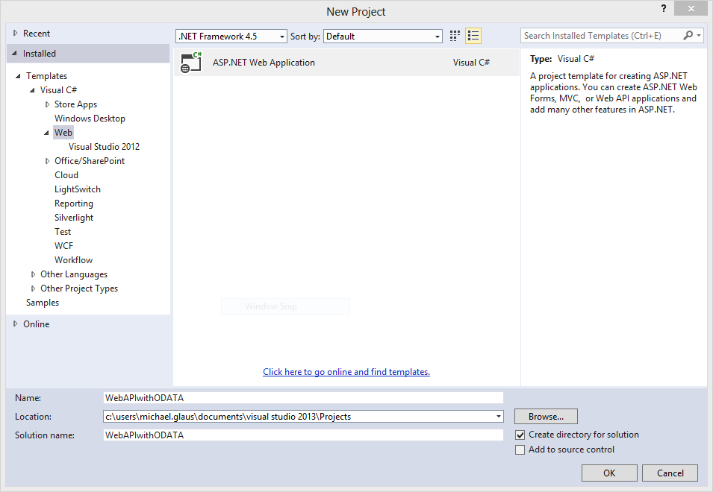

1. Choose Web API without Authentication and no remote resources

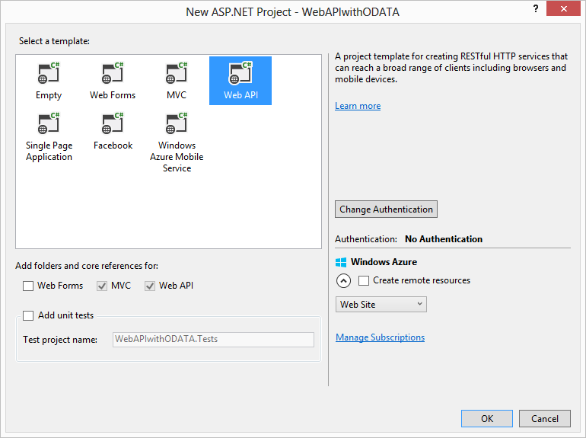

1. Update all NuGet Packages of the Project to be sure to get the newest WebAPI Templates

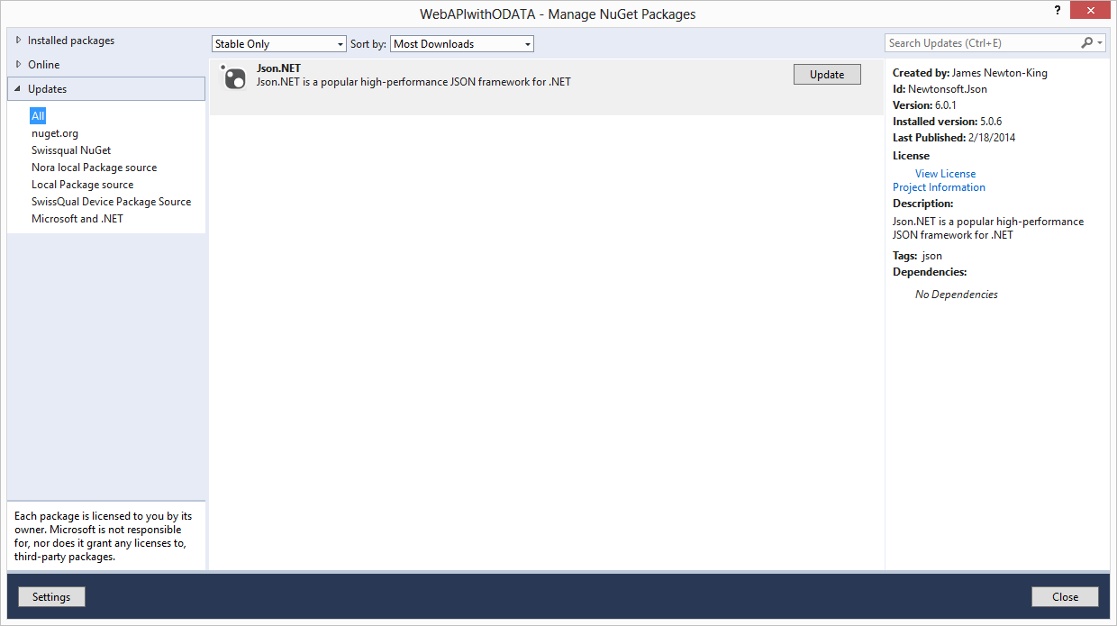

1. Add Routing information: <http://localhost:port/anything/number> and <http://localhost:port/anything/number/number>

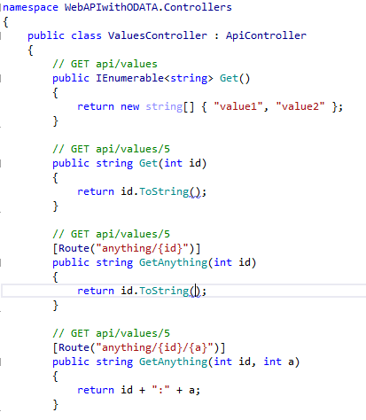

1. Add http result types

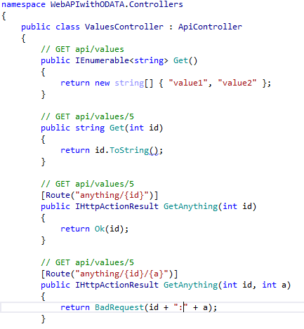

1. Define Data Model Classes

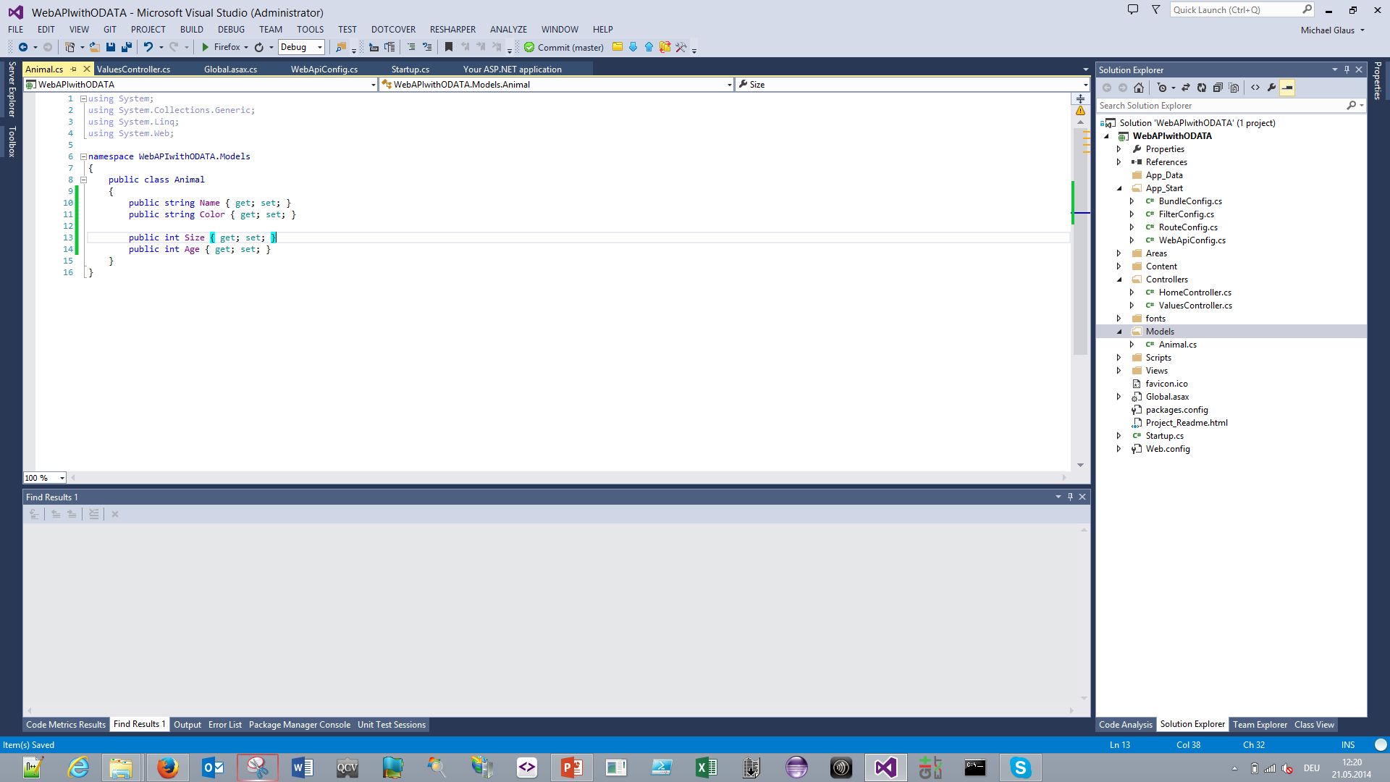

1. Add Model Classes to controller

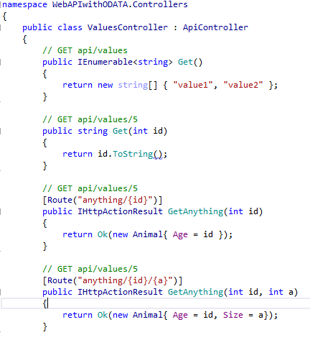

1. Create List of data and add Queryable attribute and IQueryable return type to be able to query the data structure

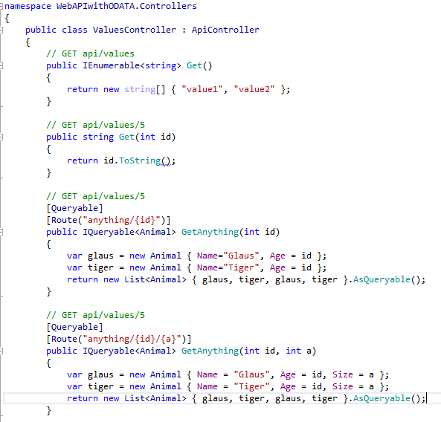

1. Run Application and negative test ODATA in browser

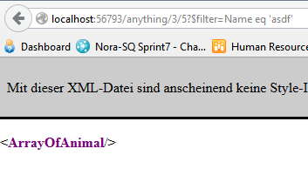

1. Do positive test

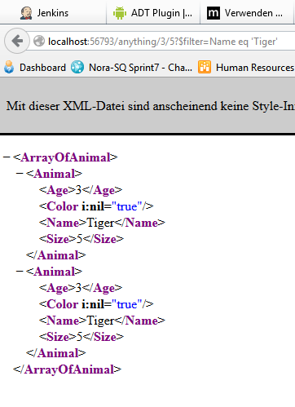

1. Create complex data structure

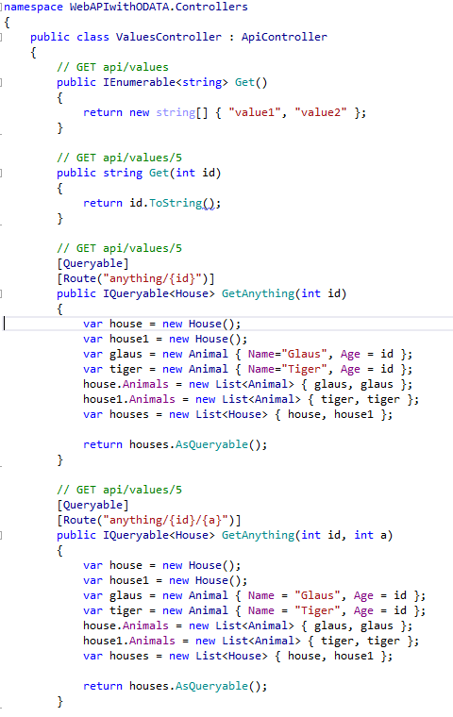

1. Test complex data structure with a complex filter

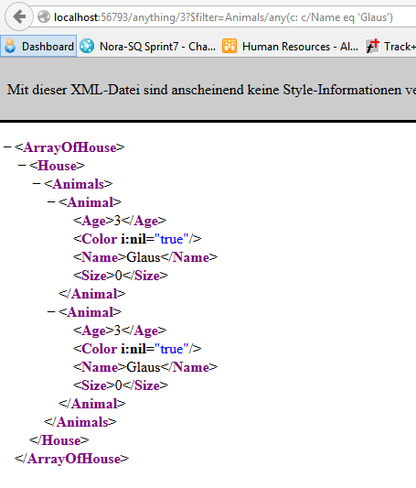

1. Adapt WebApiConfig to get json output

