Self-Hosted Web API with OWIN

1. Create Console Application

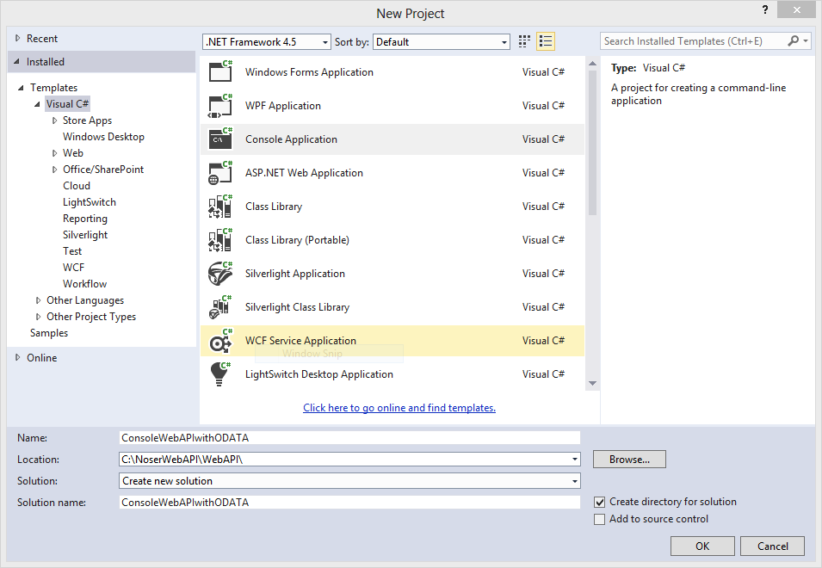

1. Add necessary NuGet Packages to the project

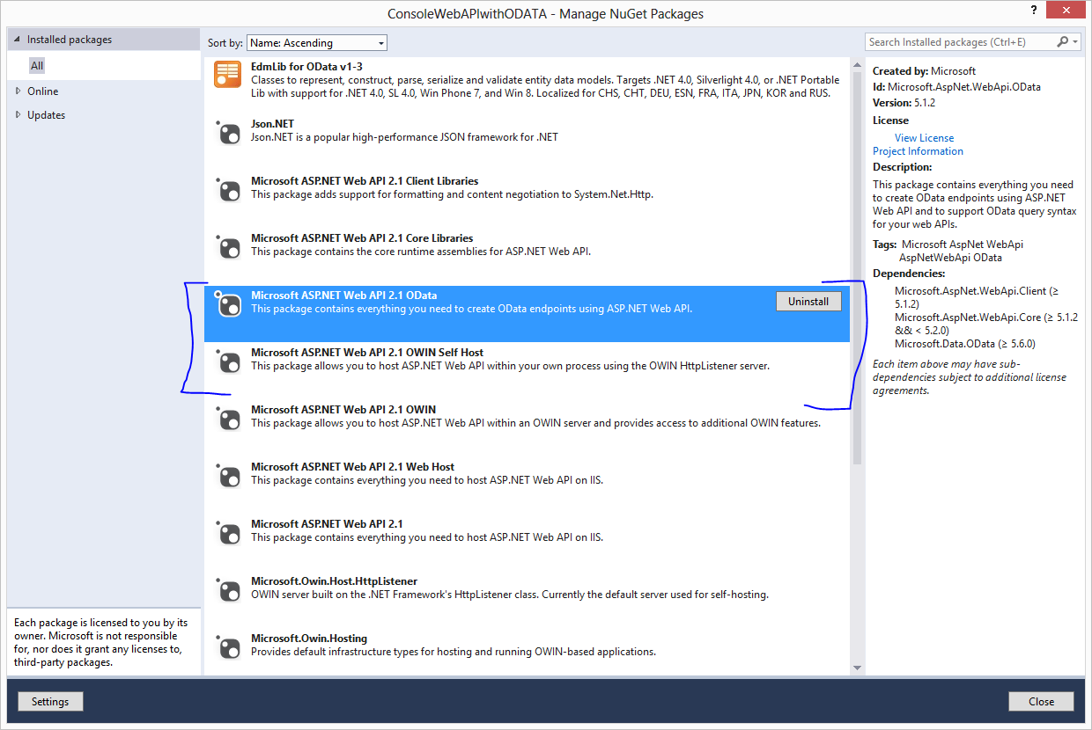

1. Add the following Startup Class to the project

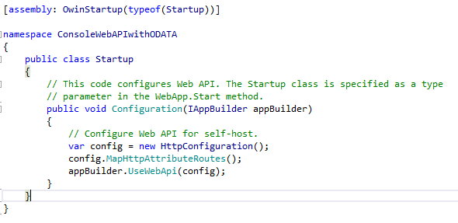

1. Add OWIN startup logic to the Main method

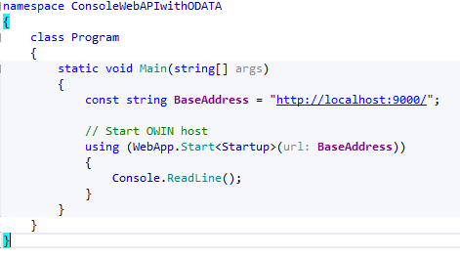

1. Move the model to a shared project (from IIS hosted application)

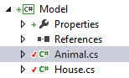

1. Copy the controller (from IIS hosted application)

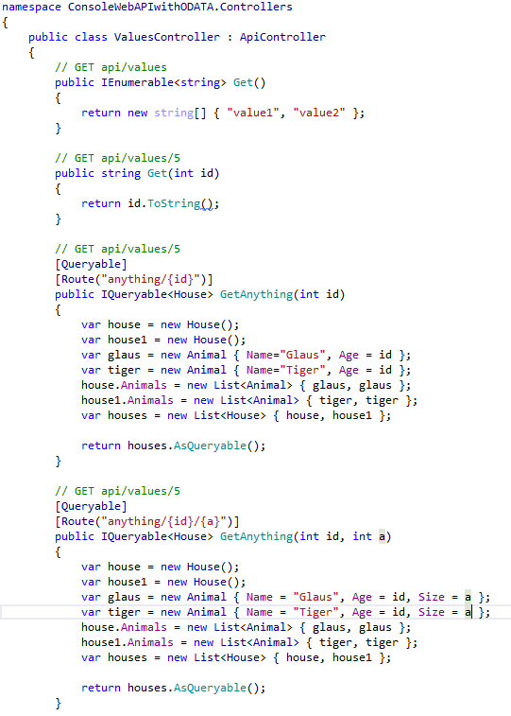

1. Test with complex filter

