Ryan Cox  
[ryancox@us.ibm.com](mailto:ryancox@us.ibm.com)  
March 2017

**Contents**

Template: IBM BPM 8.5.7 RHEL 7.2 - 03-07-2017 (3 VMs) 2

BPM Topology 3

System Details 4

DB2 4

BPM 5

Process Center on rhel7bpm1 5

Process Server on rhel7bpm2 and rhel7bpm3 6

BPM users configured in all BPM environments 7

**Template: IBM BPM 8.5.7 RHEL 7.2 - 03-07-2017 (3 VMs)**

[https://cloud.skytap.com/templates/1011241?project_id=90814#](https://cloud.skytap.com/templates/1011241?project_id=90814)

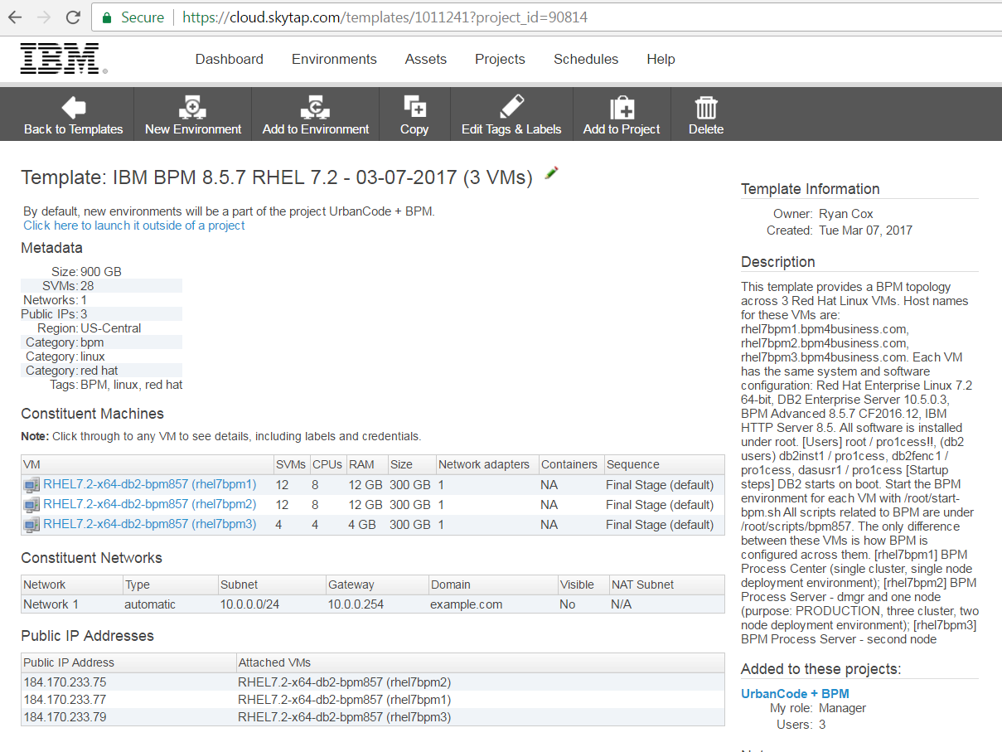

This template provides a BPM topology across 3 Red Hat Linux VMs.

Host names for these VMs are:

* rhel7bpm1.bpm4business.com
* rhel7bpm2.bpm4business.com
* rhel7bpm3.bpm4business.com

Each VM has the same system and software configuration:

* Red Hat Enterprise Linux 7.2, 64-bit
* DB2 Enterprise Server 10.5.0.3
* BPM Advanced 8.5.7 CF2016.12
* IBM HTTP Server 8.5

All software is installed under root.

System users:

root / pro1cess!!

(db2 users)

db2inst1 / pro1cess

db2fenc1 / pro1cess

dasusr1 / pro1cess

Startup steps:

1. DB2 is configured to startup automatically on boot.
2. Start the BPM environment for each VM with /root/start-bpm.sh
3. If needed, all other scripts for starting/stopping specific BPM servers are under /root/scripts/bpm857/control

The only difference between these VMs is how BPM is configured across them.

* rhel7bpm1: BPM Process Center   
  (single cluster, single node deployment environment)
* rhel7bpm2: BPM Process Server - dmgr and one node   
  (purpose: PRODUCTION, three cluster, two node deployment environment)
* rhel7bpm3: BPM Process Server - second node, managed by the dmgr on rhel7bpm2

## **BPM Topology**

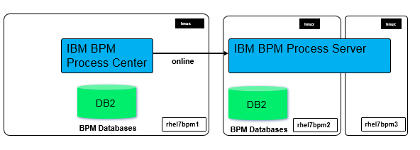

Figure : BPM Topology

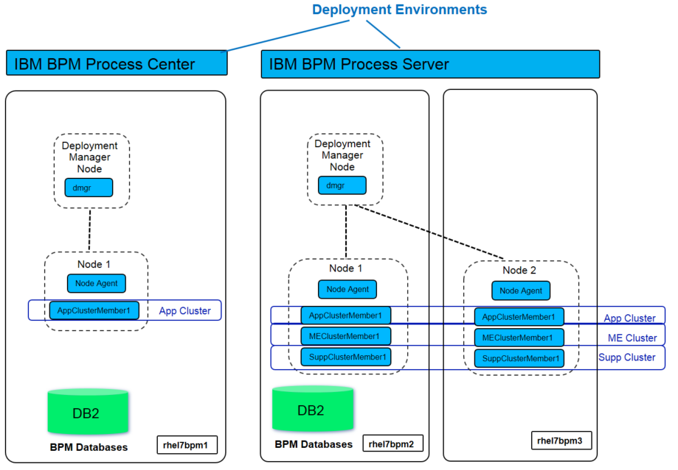

Figure : BPM Topology Details

## **System Details**

### **DB2**

DB2 Enterprise Server 10.5.0.3

DB2 system users:

db2inst1 / pro1cess

db2fenc1 / pro1cess

dasusr1 / pro1cess

DB2 install home: /app/ibm/db2/V10.5/bin

The db2 instance is running under the user **db2inst1**.

The SQL for creating the BPM schemas are under /home/db2inst1/scripts/bpm857

### **BPM**

BPM Advanced 8.5.7 CF2016.12

Installation Manager install home: /app/ibm/InstallationManager/eclipse

Installation Manager shared eclipse folder: /app/ibm/IMShared

BPM install home: /app/ibm/BPM/v8.57

#### **Process Center on rhel7bpm1**

Process Center single cluster, single node deployment environment.

**cell: pcCell**

nodes: pcDmgr, pcNode1

databases: PC857CMN, PC857BPM, PC857PDW  (login w/ db2inst1 / pro1cess)

database configuration files: /app/ibm/BPM/v8.57/profiles/pcDmgr/dbscripts/pcCell

**node: pcDmgr**

admin console:40000/ 40001

bootstrap: 40002

soap: 40003

WAS admin console -> <https://rhel7bpm1.bpm4business.com:40001/admin>

cell admin: celladmin / pro1cess

bpm deployment environment admin: bpmadmin / pro1cess

**node: pcNode1**

default host:40218/ 40219

bootstrap: 40200

soap: 40215

Process Center -> <http://rhel7bpm1.bpm4business.com:40218/ProcessCenter>

Process Portal -> <https://rhel7bpm1.bpm4business.com:40219/ProcessPortal>

Process Admin -> <http://rhel7bpm1.bpm4business.com:40218/ProcessAdmin>

Heritage Process Portal -> <https://rhel7bpm1.bpm4business.com:40219/HeritagePortal>

BPM REST API Tester -> <http://rhel7bpm1.bpm4business.com:40218/bpmrest-ui>

#### **Process Server on rhel7bpm2 and rhel7bpm3**

Process Server three cluster, two node deployment environment.

**(on rhel7bpm2)**

**cell: psCell**

nodes: ps2Dmgr, ps2Node1, ps2Node2

databases: PS857CM2, PS857BP2, PS857PD2  (login w/ db2inst1 / pro1cess)

database configuration files: /app/ibm/BPM/v8.57/profiles/ps2Dmgr/dbscripts/psCell

**node: ps2Dmgr**

admin console:51000/ 51001

bootstrap: 51002

soap: 51003

WAS admin console -> <https://rhel7bpm2.bpm4business.com:51001/admin>

cell admin: celladmin / pro1cess

bpm deployment environment admin: bpmadmin / pro1cess

**node: ps2Node1**

default host:51218/ 51219

bootstrap: 51200

soap: 51215

Process Center ->[http://rhel7bpm2.bpm4business.com:51218/ProcessCenter](http://rhel7bpm1.bpm4business.com:40218/ProcessCenter)

Process Portal -> <https://rhel7bpm2.bpm4business.com:51219/ProcessPortal>

Process Admin -> <http://rhel7bpm2.bpm4business.com:51218/ProcessAdmin>

Heritage Process Portal -> <https://rhel7bpm2.bpm4business.com:51219/HeritagePortal>

BPM REST API Tester -> <http://rhel7bpm2.bpm4business.com:51218/bpmrest-ui>

**(on rhel7bpm3)**

**node: ps2Node2**

 default host: 51218 / 51219

bootstrap: 51200

soap: 51215

Process Center -> <http://rhel7bpm3.bpm4business.com:51218/ProcessCenter>

Process Portal -> <https://rhel7bpm3.bpm4business.com:51219/ProcessPortal>

Process Admin -> <http://rhel7bpm3.bpm4business.com:51218/ProcessAdmin>

Heritage Process Portal -> <https://rhel7bpm3.bpm4business.com:51219/HeritagePortal>

BPM REST API Tester -><http://rhel7bpm3.bpm4business.com:51218/bpmrest-ui>

#### **BPM users configured in all BPM environments**

admins:

     cell admin: celladmin / pro1cess

     bpm deployment environment admin: bpmadmin / pro1cess

demo users:

     group: developers

          ryan / bpmdemo

          dev1 / password

          dev2 / password

     group: demoUsers

          demo1 / password

          demo2 / password

     group: demoManagers

          manager1 / password