Ass 5:

Task 1

Country (CountryName, GrossProduct, Geometry)
State (StateCode, StateName, CountryName, Geometry)
County (CountyCode, CountyName, StateCode, Population, Geometry)
ParcelLandUse (RegionCode, CountyCode, Owner, TypeOfUse, Geometry)
River (RiverName, AverageFlow, Geometry)

Q1. List all the rivers that run through farmland (Use predicate intersectLR between lines
and regions).
Select rivername from River r
where exists
(select ST_Intersects (r.geometry, p.geometry) from ParcelLandUse p
where p.TypeOfUse='farmland')
Q2. List all the rivers that do not run through farmland.
Select rivername from River r
where not exists
(select ST_Intersects (r.geometry, p.geometry) from ParcelLandUse p
where p.TypeOfUse='farmland')
Q3. Give the length of “The Spree” (Use function length (geometry)).
Select ST_Length(r.geometry) from river where RiverName='Spree';
Q4. What are the States located south of Saxony-Anhalt? (Use predicate
south-of (geometry1, geometry2).)
select s2.StateName from State s1, State s2
where s1.stateName='Saxony-Anhalt' and south-of(s1.geometry,s2.geometry)

Task 2
a) How can we express a polygon in the constraint model? Give an example.
Create polygon via half planes. Calculate line plane with 2 points: (y2-y1)/(x2-x1)

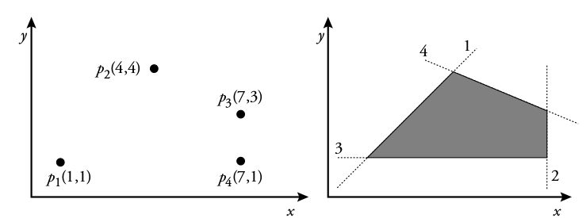
y ≤ x ∧ x ≤ 7 ∧ y ≥ 1 ∧ x + 3y − 16 ≤ 0

b) Is it possible to express a non-convex polygon in the constraint model?
Yes, split the non-convex polygon into convex polygons and union the convex components.
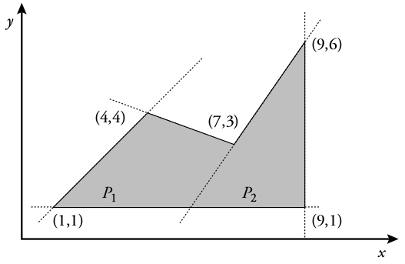
(y ≤ x ∧ y ≥ 1 ∧ x + 3y − 16 ≤ 0 ∧ 3x − 2y − 15 ≤ 0) ∨ (x ≤ 9 ∧ y ≥ 1 ∧ 3x − 2y − 15 ≥ 0)

Task 3
Implement an algorithm that calculates the convex hull of the following polygon: p i are vertices
of the polygon.

a) Calculate the convex hull of the following list:

p 1 (240, 297)
p 2 (499, 424)
p 3 (413, 49)
p 4 (99, 348)
p 5 (428, 363)
p 6 (424, 212)
p 7 (80, 4)
p 8 (394, 348)
p 9 (451, 364)
p 10 (271, 228)

b) Calculate the convex hull of the list of points given in points.csv.

https://en.wikibooks.org/wiki/Algorithm_Implementation/Geometry/Convex_hull/Monotone_chain
http://www.sanfoundry.com/java-program-implement-quick-hull-algorithm-find-convex-hull/

Code (Python):

import csv
from _csv import reader, Dialect

def cross(o, a, b):
return (a[0] - o[0]) * (b[1] - o[1]) - (a[1] - o[1]) * (b[0] - o[0])

def convex_hull(points):

points = sorted(set(points))

if len(points) <= 1:
return points

lower = []
for p in points:
while len(lower) >= 2 and cross(lower[-2], lower[-1], p) <= 0:
lower.pop()
lower.append(p)

upper = []
for p in reversed(points):
while len(upper) >= 2 and cross(upper[-2], upper[-1], p) <= 0:
upper.pop()
upper.append(p)

return lower[:-1] + upper[:-1]

pointList= []
pointList.append((240,297))
pointList.append((499, 424))
pointList.append((413, 49))
pointList.append((99, 348))
pointList.append((428, 363))
pointList.append((424, 212))
pointList.append((80, 4))
pointList.append((394, 348))
pointList.append((451, 364))
pointList.append((271, 228))

print "Task 3 a) :" + str(convex_hull(pointList))

# count rows
fileName= 'points.csv'
with open(fileName,'rU') as csvFile:
reader= csv.reader(csvFile,delimiter=';')
row_count = sum(1 for row in reader)
#skip first line
#line = reader.next();
#or line in reader:

csvPoints = []
with open(fileName,'rU') as csvFile:
reader= csv.reader(csvFile,delimiter=';')
line=reader.next()
while reader.line_num<row_count:
line=reader.next()
csvPoints.append((int(line[1]),int(line[2])))

print "Task 3 b) :" + str(convex_hull(csvPoints))
---------------------------------------------------
Results:
Task 3 a) :[(80, 4), (413, 49), (499, 424), (99, 348)]
Task 3 b) :[(0, 124), (4, 42), (9, 22), (40, 10), (59, 4), (76, 3), (154, 1), (248, 2), (416, 13), (488, 22), (500, 36), (500, 273), (493, 453), (489, 480), (470, 498), (42, 498), (26, 478), (5, 414)]

