Quantifying the Impact of Downscaling Algorithms on Vegetation Biophysical Parameter Retrieval from Sentinel 2 Multispectral Instrument

Richard Fernandesª, Detang Zhong^{b}, Francis Canisius^{c}, Rasim Latifovic^{d}, Darrent Pouliot^{e}, Lixin Sun^{f}

ªCanada Centre for Remote Sensing, 560 Rochester Street, Ottawa, Ontario, Canada, K1A 0Y7 richard.fernandes@canada.ca , corresponding Author

^{b}Canada Centre for Remote Sensing, 560 Rochester Street, Ottawa, Ontario, Canada, K1A 0Y7
^{c}Canada Centre for Remote Sensing, 560 Rochester Street, Ottawa, Ontario, Canada, K1A 0Y7 francis.canisius@canada.ca
^{d}Canada Centre for Remote Sensing, 560 Rochester Street, Ottawa, Ontario, Canada, K1A 0Y7 rasim.latifovic@canada.ca
ªEnvironment and Climate Change Canada, 1125 Colonel By Drive, K1A 0H3, darren.pouliot@canada.ca
^{f}Canada Centre for Remote Sensing, 560 Rochester Street, Ottawa, Ontario, Canada, K1A 0Y7 Lixin.Sun@canada.ca

Abstract

The Sentinel 2 mission was developed to provide systematic global mapping of vegetation biophysical parameters such as the fraction of cover (fCOVER), fraction of absorbed photosynthetically active radiation (fAPAR), leaf area index (LAI) and canopy water content (CWC) using 10m and 20m resolution bands on the Multispectral Instrument (MSI). Spatial downscaling algorithms, coupled with the baseline Simplified Level 2 Prototype Processor (SL2P), can generate 10m resolution products. However, applicable downscaling algorithms have yet to be validated in terms of the uncertainty and spatial appearance of vegetation parameter maps. In this paper, we evaluated four super-resolution and two resampling downscaling algorithms coupled to SL2P and applied to MSI data at 10 sites across Canada to produce 10m parameter maps. Reference maps for validation were produced using a new transfer function approach applied to co-incident high-resolution imagery. The algorithm with the lowest thematic uncertainty (SupReMe for fCOVER, fAPAR and LAI and Nearest Neighbour resampling for CWC) resulted in an average increase in uncertainty equivalent to ~50% of Global Climate Observing System threshold user requirement; with some sites approaching 100%. However, all of the super-resolution algorithms had much better qualitative spatial similarity to reference maps in comparison to nearest neighbour resampling. These results suggest that super-resolution downscaling algorithms are useful to improve the qualitative appearance of vegetation patterns at 10m resolution but at the price of a substantial increase in thematic uncertainty.

Key Words

Spatial downscaling, Sentinel 2, leaf area index, canopy water content, canopy cover, fAPAR, validation

Introduction

The Sentinel 2 (S2) mission provides satellite data records for global mapping of vegetation biophysical variables (Level 2b or L2b products) (Drusch et al., 2012). The S2 Multispectral Instrument (MSI) on Sentinel 2A and Sentinel 2B satellites has 10 spectral bands for land mapping, six at 20m spatial resolution (hereafter ‘resolution’) and four at 10m (Table 1), that satisfy resolution requirements for global mapping of many L2b products (Table 2). Nevertheless, the thematic uncertainty of L2b products derived from MSI data using the baseline Simplified Level 2 Prototype Processor (SL2P, Weiss and Baret, 2016) does not consistently satisfy threshold user requirements over heterogeneous natural landscapes (Brown et al, 2019; Hu et al., 2020; Brown et al., 2021).

Increasing the resolution of MSI surface reflectance imagery (Level 2a or L2a products) used as input to algorithms such as SL2P may decrease thematic uncertainty due to the non-linear relationship between reflectance and canopy variables (Baret and Guyot, 1991). Zhang et al. (2019) observed a ~25% increase in coefficient of determination (r²) and 0.18 decrease in root mean square error (RMSE) for predicting leaf area index over corn fields when using 10m downscaled versus 20m original L2a products as input to an algorithm similar to SL2P. Increasing resolution also increases the number of pixels falling within narrow or small disturbances such as exploration corridors and well-heads, vegetation harvest and regeneration, and (sub)urban infrastructure (Delangre et al., 2017).

Two general approaches for increasing the resolution of MSI L2b products are: i) using retrieval algorithms that only use 10m bands (‘feature selection’), and ii) estimating higher resolution input bands or products from their 20m resolution counterparts (‘downscaling’) (Thomas et al., 2008). Feature selection may be sufficient to meet thematic uncertainty requirements if local algorithm calibration is used (Clevers et al., 2017, Cohrs et al., 2020). However, globally applicable algorithms generally require spectral sampling that includes 20m resolution S2 bands to minimize uncertainty (Verger et al. 2011; Richter et al., 2012; Verrelst et al., 2012). Downscaling requires spatially and temporally co-located auxiliary data at finer resolution. The S2 mission requirement for systematic global mapping in a free and open manner currently constrains the choice of such auxiliary data to the 10m bands from either S2a or S2b instead of other high resolution imagers.

There are many downscaling methods applicable to MSI data (Wang et al., 2016; Brodu, 2017; Lanaras et al., 2018; Zheng et al., 2017; Zhang et al., 2019). Again, global application indicates a preference for downscaling approaches based on a single S2 acquisition to simplify computation. Two such approaches are spatial resampling and super-resolution downscaling. Spatial resampling makes use of only auxiliary geolocation information to downscale either inputs of products (Wolf et al., 2014). Resampling of 20m products to 10m resolution requires non-linear algorithms to handle missing or invalid product retrievals. Here nearest neighbour resampling using valid 20m product pixels is implemented (‘R1’ in Table 3). Resampling of L2a products can be performed using smoother spatial interpolators. Here, cubic spline interpolation is implemented (SEN2COR v2.5.5, Müller-Wilm, 2018; ‘R2’ in Table 3). Both algorithms were selected as they are also implemented in the SNAP software provided by the European Space Agency for MSI processing (https://github.com/mundialis/esa-snap, accessed on August 19, 2021). Super-resolution uses spectral bands in addition to geolocation information to perform downscaling (Alparone, et al., 2015). A number of super-resolution algorithms have been tested for downscaling MSI reflectance imagery and a subset of openly available algorithms are considered in this study (algorithms abbreviated with prefix ‘D’ in Table 3).

Table 1. MSI band specifications (Clerc and MPC Team, 2020). Point spread function (PSF), full width half maximum (FWHM).
Band Name | Sentinel-2A |  | Sentinel-2B |  | Spatial Definition
Band Name | Central  wavelength  (nm) | Bandwidth  (nm) | Central  Wavelength  (nm) | Bandwidth  (nm) | Pixel  resolution  (m) | PSF  FWHM  (m)
1 – Coastal aerosol | 442.7 | 21 | 442.2 | 21 | 60 | 58.5
2 – Blue | 492.4 | 66 | 492.1 | 66 | 10 | 10.5
3 – Green | 559.8 | 36 | 559.0 | 36 | 10 | 10.2
4 – Red | 664.6 | 31 | 664.9 | 31 | 10 | 10.8
5 – Red edge I | 704.1 | 15 | 703.8 | 16 | 20 | 17.7
6 – Red edge II | 740.5 | 15 | 739.1 | 15 | 20 | 18.7
7 – Red edge III | 782.8 | 20 | 779.7 | 20 | 20 | 18.6
8 – NIR | 832.8 | 106 | 832.9 | 106 | 10 | 10.5
8A – Narrow NIR | 864.7 | 21 | 864.0 | 22 | 20 | 18.8
9 – Water vapour | 945.1 | 20 | 943.2 | 21 | 60 | 62.7
10 – SWIR–Cirrus | 1373.5 | 31 | 1376.9 | 30 | 60 | N/A
11 – SWIR I | 1613.7 | 91 | 1610.4 | 94 | 20 | 22.2
12 – SWIR II | 2202.4 | 175 | 2185.7 | 185 | 20 | 21.8

Table 2. MSI vegetation biophysical variable Level 2b products and their user requirements including goal (GCOS, 2016) and threshold (Lang and Tychon, 2015) thematic uncertainty.
Product | Acronym | Units | Resolution |  | Uncertainty
Product | Acronym | Units | Spatial | Temporal | Goal | Threshold
Canopy Water Content | CWC | kg/m² | N/A | N/A | 1kg/m² | 5kg/m²
Fraction Absorbed Photosynthetically Active Radiation | FAPAR | 0-1 | <50m | <10d | 10%,0.05 | 20%,0.1
Fraction canopy cover | FCOVER | 0-1 | <50m | 1d | 5% | 20%,0.1
Leaf area index | LAI | m^{2/}m² | <50m | <10d | 15% | 25%,0.75

Table 3. Downscaling algorithms applied to MSI imagery and available for free and open use.
Name | Algorithm | Reference | Accessed on August 19, 2021
R1 | Nearest neighbour | ESA, SNAP. | https://github.com/senbox-org/snap-desktop/blob/master/ReleaseNotes.md
R2 | Bi-cubic resampling | ESA, SNAP. | https://github.com/senbox-org/snap-desktop/blob/master/ReleaseNotes.md
D0 | SEN2RES | Brodu, 2017 | https://step.esa.int/main/third-party-plugins-2/sen2res/
D1 | ATPRK-PAN | Wang et al., 2015. | https://qunmingwang.github.io/
D2 | ATPRK-MS | Wang et al., 2016. | https://qunmingwang.github.io/
D3 | SupReMe | Lanaras et al., 2017 | https://github.com/lanha/SupReMe/
D4 | DSEN2 | Lanaras et al., 2018 | https://github.com/lanha/DSEN2/

The majority of studies evaluate downscaling algorithms using metrics related to the thematic uncertainty of downscaled reflectance (Vivone et al., 2021). Such metrics are a necessary rather than sufficient condition for meeting L2b product uncertainty requirements due to the non-linear relationship between reflectance and product retrievals. Rather, downscaling should be assessed using thematic uncertainty metrics and protocols developed for L2b product validation (Fernandes et al., 2014, Duncanson et al., 2021). These protocols recommend comparisons of L2b products to available reference estimates of known uncertainty (‘reference uncertainty’) traceable to standards and sampled over representative spatial and temporal extents for their intended use.

Zheng et al. (2017) and Zhang et al. (2019) validated L2b products derived from downscaled L2a inputs used in-situ reference estimates for elementary sampling units (ESUs) corresponding to plots within homogenous vegetation patches. This approach has three limitations: i) the spatial footprint of in-situ measurements may vary with canopy height and could easily exceed 10m (Fernandes et al., 2014), ii) the number of validation samples typically considered sufficient for pixel-based algorithms (e.g. >20 per land cover class in a local region) is likely insufficient considering that downscaling algorithms are spatially adaptive, iii) and most importantly, downscaling algorithms target mapping in spatially heterogeneous landscape where in-situ measurements may have large uncertainty or may not even be possible.

In circumstances where spatial matching of in-situ measurements and products is not feasible, good practices recommend the production of reference maps using a transfer function, of known uncertainty relative to a reference standard, applied to auxiliary high resolution multi-spectral imagery (Fernandes et al., 2014). Normally, the transfer function is calibrated using local in-situ measurements. However, as the goal of this study was to quantify the change in uncertainty due to downscaling, the SL2P algorithm are used for calibration. SL2P is globally applicable and, when compared to in-situ measurements over homogenous plots, generally performs within threshold uncertainty requirements for crops (Djamai et al., 2019) and is precise, but linearly biased, over heterogeneous forests (Brown et al., 2021). High (<2m) resolution multispectral imagery, spatially matched to 20m L2b product pixels, was used to calibrate site specific transfer functions. These transfer functions were then reapplied to the high resolution imagery at 10m resolution to generate reference maps. In this case, differences between matching downscaled product and reference 10m pixels correspond to a ‘total uncertainty’ that includes both product uncertainty and the reference uncertainty with the latter ideally being much smaller than the former.

The purpose of this study was to:

1. quantify the thematic uncertainty of downscaled S2 maps of canopy variables at regional extents

2. compare downscaling methods previously applied to S2 MSI data (Table 3) in terms of the thematic uncertainty of derived products.

We hypothesized that

- The reference uncertainty will be substantially less than total uncertainty. If true, then total uncertainty will have sufficient precision to quantify the impact of each downscaling algorithm on product uncertainty.

- Products relying on super-resolution downscaling will have lower total uncertainty and higher qualitative and quantitative agreement with the spatial pattern in corresponding reference products in comparison to products relying on resampling downscaling. If true, then super-resolution downscaling approaches would be recommended in preference to the spatial resampling offered within ESA toolboxes.

Datasets

Reference Imagery

WorldView-3 Imagery

WorldView-3 (WV3) satellite imagery (Table 4) was selected for making reference maps as it has i) a spatial resolution <2m, deemed sufficient to ignore the impact of varying projected instantaneous field of view (PIFOV) when upscaling to co-located 10m MSI pixels, ii) visible and near infrared (VNIR) bands similar to MSI, and iii) radiometric uncertainty similar to the MSI specification.

WV3 Standard top-of-atmosphere radiance products in GEOTIFF format were acquired from the Government of Canada’s archive of images purchased for geoscience and environmental monitoring applications; bring the advantage of sampling regions where downscaling if of relevance to users. The products were at 2m (0.5m) multispectral (panchromatic) resolution although their acquired resolution was significantly higher (Table 4). Standard products have a 3.5m (90% circular error probablechr) planimetric accuracy but are not ortho-rectified. One hundred and seven WV3 VNIR images within +/-1d of cloud free MSI imagery were visually assessed and ten cloud free WV3 images, excluding mountainous terrain, were selected (Figure 1,Table 5). Mountainous terrain was avoided to simplify co-registration of WV3 and MSI imagery, to reduce shadowing within WV3 imagery, and to reduce uncertainty in L2a products (Djamai and Fernandes, 2018).

Figure 1. Location of study sites corresponding to WV3 image footprints.

Table 4. WV3 Standard Imagery specifications (Digital Globe, 2020; Maxar, 2020; Longbotham et al., 2015).
Band | Wavelength |  | Spatial Resolution |  | Radiometric Uncertainty | Geometric Uncertainty
Band | Min (nm) | Max (nm) | Actual  (nm) | Provided  (nm) | 1 standard deviation relative error | 90% circular error probable
Coastal | 400 | 450 | 1.24 | 2.0 | 5% | 3.5
Blue | 450 | 510 | 1.24 | 2.0 | 6% | 3.5
Green | 510 | 580 | 1.24 | 2.0 | 6% | 3.5
Yellow | 585 | 625 | 1.24 | 2.0 | 7% | 3.5
Red | 630 | 690 | 1.24 | 2.0 | 8% | 3.5
Red-Edge | 705 | 745 | 1.24 | 2.0 | 7% | 3.5
NIR-1 | 770 | 995 | 1.24 | 2.0 | 6% | 3.5
NIR-2 | 960 | 1040 | 1.24 | 2.0 | 7% | 3.5
Pan | 450 | 900 | 0.30 | 0.50 | - | 3.5

S2 MSI Imagery

Level 1C (L1c) orthorectified Top-Of-Atmosphere (TOA) S2a and S2b MSI reflectance data produced by the European Space Agency (doi: /10.5066/F76W992G) were accessed from the United States Geological Survey mirror archive (https://www.usgs.gov/centers/eros/science/usgs-eros-archive-sentinel-2?qt-science_center_objects=0#qt-science_center_objects accessed on August 19, 2021). The data correspond to the original Standard Archive Format for Europe data format with a radiometric uncertainty of <5% (+/-2%) excluding Band 10 (Gascon et al., 2017). The geolocation uncertainty is <11m at 95.5% confidence with a band-to-band co-registration uncertainty of <0.3 pixels at 99.7% confidence (Clerc et al., 2020). However, there is a bias in spatial uncertainty of ~5m South/North for northern/southern latitudes (Vajsová and Aastrand, 2015).

Table 5. Study site data (Ecozone taken from Ecological Stratification Working Group, 1996, Landcover taken from Commission for Environmental Cooperation, 2020)
Site | Area  km² | WV3 ID | MSI ID | WV3 View Zenith° | Ecozone | Land Cover
Wabush | 170 | wv3_20170612_N5310W06629 | 20170612T153911_20170612T153906_T19UFU | 6.7 | Taiga Shield | Temperate/sub-polar needleleaf forest
Attawap-  iskat | 221 | wv3_20180605_N5282W08399 | 20180605T163941_20180605T164352_T16UFD | 30.9 | Hudson Plain | Sub-polar taiga needleleaf forest
Fox Creek South | 239 | wv3_20170811_N5433W11722 | 20170811T185921_20170811T190305_T11UMA | 17.7 | Boreal Plains | Temperate/sub-polar broadleaf deciduous forest
Fox Creek North | 82 | wv3_20170811_N5448W11728 | 20170811T185921_20170811T190305_T11UMA | 5.9 | Boreal Plains | Temperate/sub-polar broadleaf deciduous forest
Eastmain | 67 | wv3_20180817_N5208W07770 | 20180818T161901_20180818T162518_T17UQT | 28 | Hudson Plain | Temperate/sub-polar shrubland
Charlettown | 140 | wv3_20170921_N4641W06315 | 20170921T151651_20170921T151646_T20TMS | 16.9 | Atlantic Maritime | Cropland
Kouchi-bouguac | 52 | wv3_20200926_N4669W06491 | 20200925T151701_20200925T151656_T20TLT | 17.2 | Atlantic Maritime | Mixed forest
Kitchener | 120 | wv3_20160924_N4340W08044 | 20160924T161342_20160924T211747_T17TNJ | 7 | Mixedwood Plains | Cropland/Urban
Red Bay | 10 | wv3_20170713_N5171W05643 | 20170715T150719_20170715T150716_T21UWT | 33.1 | Boreal Shield | Sub-polar/polar grassland-lichen-moss
Eagle Plain | 9 | wv3_20170806_N6649W13635 | 20170807T210021_20170807T210157_T08WMU | 18.9 | Taiga Cordillera | Temperate/ sub-polar grassland

Methods

The same method (Figure 2) was applied for each site listed in Table 5. Source code other than that available from the European Space Agency is available at https://github.com/rfernand387/downscaling (DOI: 10.5281/zenodo.5227592 Accessed August 19, 2021).
Figure 2. Method used at each site (lettered dashed boxes corresponding to sub-sections in text).

S2 MSI L1C Co-Registration

AROSICS (Scheffler et. al, 2017) was used to automatically co-register and resample WV3 imagery to corresponding MSI images. AROSICS finds matching tie points between an input and target single band image with differing spatial resolutions using local spatial frequency similarity. Input pixels are geolocated in the target image using local rational polynomials robustly fitted to local tie points. Bi-cubic resampling is used to estimate the co-registered input WV3 image, still at 2m resolution. For each site, AROSICS was separately applied to the WV3 and MSI green bands and the WV3 and 10m MSI near infrared (NIR) bands. The solution with the maximum matching tie point density was selected. The WV3 pan-chromatic band was not selected as synthesizing the MSI spectral equivalent would be non-trivial.

Co-registration uncertainty was not measured quantitatively. Comparisons to reference geospatial layers would not be relevant as the MSI geolocation uncertainty implies that the co-registered 2m resolution WV3 image will still have an absolute geolocation uncertainty (bias) of up to 11m (5m) with 95.5% confidence. Quantitative assessment of spatial shifts between WV3 and MSI features was also not performed since there are few features that can be visually matched at <10m resolution considering the ~10m FHWM PSF of MSI bands used for co-registration. Even if this was feasible, the 1/3 pixel MSI band to band misregistration implies that a perfect single band co-registration would still imply additional uncertainty for other bands. Instead, co-registration was visually assessed for each WV3-MSI image pair by sampling 10 mixed MSI pixels at non-shadowed edges of water bodies or buildings and visually verifying that an edge between cover types was clearly indicated in the co-registered WV3 pixels using a true colour WV3 image. This evaluation at least confirms a co-registration uncertainty of less than 10m over the assessed samples. The 10 images used in this study satisfied this requirement at all ten sampled pixels.

MSI Level 1c to MSI Level 2a Processing

MSI L1c products were processed to L2a bottom-of-atmosphere reflectance using the SEN2COR v2.5.5 with default settings (Müller-Wilm, 2018). SEN2COR uses spatially variable estimates of atmosphere parameters - water vapour from the L1C image, tropospheric ozone from the auxiliary data acquired automatically from the European Centre for Midrange Weather Forecasting, and aerosol optical depth at 550nm from a dense dark vegetation approach – to perform atmospheric correction. It also identifies clear sky land pixels using ancillary land/water masks and a combination of heuristics and geometric processing to map clouds and cloud shadows. The uncertainty of using SEN2COR bottom-of-atmosphere reflectance to estimate surface reflectance ($ρ$) is $0.05ρ+0.005$ , 67.5% confidence interval, for relatively clear sky conditions (Doxani et al., 2018) except over mountainous terrain where it can exceed 0.10 in near-infrared bands (Djamai and Fernandes, 2018).

c. Downscaled MSI L2b Products

SL2P was used to generate L2b products from downscaled 10m resolution L2a MSI images. SL2P was applied in MATLAB (Mathworks, 2020) using single hidden layer field forward networks for each parameter in Table 2, calibrated with radiative transfer model simulations as specified in Weiss and Baret (2016). A per pixel flag indicates if the inputs (outputs) are outside the domain (range) of the calibration data. Only unflagged pixels over clear sky land were considered valid.

Downscaled 10m resolution L2a products were generated using the algorithms indicated in Table 3 with the exception of SEN2RES. SEN2RES was not applied due to software issues related to processing speed and execution errors that could not be addressed within the time frame of our study (Nicholas Brodu, personal communication). R1 and R2 were implemented using SNAP while D1, D2, D3 and D4 were implemented using code provided by their authors (see sub-sections below for details). A numeric suffix (e.g., ‘10’) is attached to each algorithm to specify the output resolution. SL2P was used to process 10m downscaled MSI L2a products to L2b.

R1-10 Nearest neighbour resampling

R1-10 interpolates L2a 20m products to the 10m resolution L1b grid using nearest neighbour interpolation of valid retrievals unless all of the 9 nearest neighbours were invalid, in which case the R1-10 product was also flagged as invalid.

R2-10 Bi-Cubic Spline Resampling

R2-10 interpolates L2a 20m bands and acquisition geometry layers to the 10m resolution L1b grid using bicubic spline resampling (as implemented in SEN2COR v2.5.5) of valid clear sky L2A 20m pixels. SL2P was applied to each 10m pixel of the interpolated data.

D1-10 ATPRK-PAN Super Resolution

D1-10 interpolates L2a 20m bands and acquisition geometry layers to the 10m resolution L1b grid using Area-To-Point Regression Kriging (ATPRK) (Wang et al., 2015). For each 20m MSI band, a generalized least squares regression, calibrated using the 10m band having the highest correlation when upscaled to 20m, is used to produce an initial 10m resolution estimate. The residuals for this initial estimate are then modelled using kriging and added to the initial estimate. ATPRK-PAN assumes i) the regression relationship is scale invariant and ii) residuals due to spectral differences of the 20m and 10m bands can be modelled using a stationary covariance matrix for the image.

D2-10 ATPRK-MS Super Resolution

D2-10 corresponds to ATPRK with the initial estimate based on a multivariate regression between the 20m MSI band being downscaled and all MSI 10m bands, upscaled to 20m (Wang et al., 2016). In principle, multivariate regression help address spectral differences between the band being downscaled and each of the available 10m MSI bands. All other steps and assumptions are similar to ATPRK-PAN. ATPRK-MS has not been previously validated although a more sophisticated version, Spectral-Spatially Adaptive Area to Point Kriging (SSAATPRK), that extends ATPRK-MS by using a spatially variable covariance matrix for the kriging of residuals has been found to improve on ATPRK for downscaling Moderate Resolution Imager Spectrometer (MODIS) imagery from 250m to 30m using Landsat Operational Line Imager data (Zhang et al., 2017). SSAATPRK code was not openly available at the time of our study but we note that our sites are chosen to have spatially consistent land cover patterns so its improvement over ATPRK-MS may not be substantial.

D3-10 SupReME Super Resolution

D3-10, SupReME, downscales L2a 20m bands and acquisition geometry layers to the 10m resolution L1b grid using a regularized inversion of the linear blurring and downsampling operators relating to original resolution MSI bands and the 10m counterparts (Lanaras et al., 2017). MSI PSFs are used to specify the blurring operator. Two regularization strategies are employed: i) inversion performed in a linear subspace corresponding to dominant singular vectors of input bands, and ii) a penalty term is added to the inversion objective function corresponding to horizontal and vertical derivatives of the resampled images. SupReME assumes i) a linear upscaling process, ii) the pixel PIFOV is adequately modelled using the PSF, and iii) heuristic settings for the size of edges and the Lagrange multiplier for the penalty term. Comparison of SupReME with R2-10 and D2-10 for MSI data over mixed land cover scenes indicates it provides the least uncertainty in terms of the estimated spectral angle of downscaled bands in comparison to reference hyperspectral imagery (Lanaras et al., 2017). This suggests SupReME best preserves relative spectral magnitudes between bands of downscaled estimates of the three compared algorithms. However, SL2P products depend on both accurate spectral magnitudes and shapes so such tests are not sufficient for evaluating the impact of downscaling on thematic uncertainty of L2b products. As noted in the introduction, MSI data downscaled to 10m with SupReME has been shown to produce modest reductions in LAI and canopy chlorophyll content uncertainty, in comparison to original 20m data, when validated over relatively homogenous corn fields (Zhang et al., 2019). However, it is not clear how well SupReME performs over more heterogeneous targets.

D4-10 DSen2 Super Resolution

D4-10, DSen2, used a deep convolution neural network (DCNN) to downscale MSI 20m bands to 10m (Lanaras et al., 2018). The DCNN is calibrated using all 10m resolution and 20m resolution MSI bands upscaled to 40m resolution as independent variables and all original 20m resolution and 10m resolution bands, upscaled to 20m, as dependent variables. Calibration is performed using 45 training and 15 test L2a products stratified by global biomes and sampled over cloud free growing season acquisitions. DSen2 assumes i) scale invariance in relationship between 40m and 20m L2a data and the relationship between 20m and 10m L2a data, ii) representative and adequate calibration sampling, and iii) the DCNN is capable of finding a globally acceptable inverse solution. DSen2 performed significantly better in terms of thematic uncertainty, spectral angle reproduction and spatial similarity indices when compared to R1, D2 and D3 over test sites (Lanaras et al., 2018). However, these comparisons were limited to test the estimation of 20m MSI bands given linearly upscaled 40m equivalents. Moreover, these tests did not consider the impact of uncertainties of downscaled L2a estimates on SL2P products.

WV3 Transfer Function Calibration

For each site, the WV3 Standard image was smoothed using a point spread function of the 20m MSI band nearest in terms of centre-wavelength (Table 1) and resampled to 20m using R2 to produce a WV3 Standard 20m resolution image with a co-registration error of <10m. For each product, matching WV3 standard 20m pixels and valid 20m MSI Level 2m pixels were used for calibration of a site-specific ensemble regression tree using the MATLAB ‘fitreensemble’ function with default parameters (https://www.mathworks.com/help/stats/fitrensemble.html accessed August 19, 2021).

WV3 L2b product generation

Oversampled WV3 reference products were generated by smoothing the 2m resolution co-registered WV3 standard image using a moving window 10m x 10m boxcar filter. The site-specific regression tree ensemble for each product was applied to the smoothed WV3 image using the MATLAB ‘predict’ function (https://www.mathworks.com/help/stats/linearmodel.predict.html accessed August 19, 2021) to produce an oversampled WV3 L2b product where each 2m pixel’s value has a spatial scale corresponding to a 10m x 10m square.

Validation

Validation was performed by comparing each downscaled 10m MSI L2b product with the 2m grid resolution pixel in the upscaled WV3 L2b reference maps. Note that the WV3 pixel had a spatial scale of 10m resolution due to the oversampled smoothing filter previously applied. Following good practices, total and reference uncertainty metrics based on residuals of matching product and reference pixels were reported after minimizing the impact of geolocation error (Fernandes et al., 2014). These uncertainty metrics were used to quantify the likely change in product uncertainty due to downscaling and to rank downscaling algorithms. A quantitative metric of local spatial similarity between product and corresponding reference map was used to rank algorithms based on their ability to preserve spatial patterns.

Uncertainty Metrics

Thematic uncertainty metrics (bias, RMSE and r²) were quantified for all variables and downscaling treatments at each site. Both total and reference uncertainty were also summarized for each variable across all sites by using the unweighted average of the uncertainty at each site. The average was not weighted since i) site area varied substantially as WV3 images were originally acquired for other mapping purposes, and ii) all sites had sufficient (>20000) comparisons such that the confidence interval of comparison statistics was negligible compared to uncertainty due to spatial matching. For each variable, reference uncertainty was quantified for each site using the RMSE of the site-specific regression tree calibration residuals.

Total uncertainty metrics were computed for each unique site, variable and downscaling treatment by comparing the downscaled L2b product with the matching L2b reference estimate. Normally, such comparison are performed after smoothing product and reference maps so the contribution of geolocation uncertainty to the observed difference of a match up can be assumed negligible (Fernandes et al., 2014). Smoothing is not acceptable here since we need quantify uncertainty at 10m resolution. Even though care was taken to ensure a geolocation uncertainty of <10m such an error can still lead to large differences between the product and reference in areas with fine scale heterogeneity. A naïve approach to minimize reference uncertainty due to geolocation error is to select the reference estimate that minimizes the absolute residual amongst all reference estimates falling within a radius of the product pixel being matched. While this approach is feasible as the reference is oversampled to 2m resolution, it would underestimate uncertainty in areas without geolocation error but with random downscaling errors. To ensure unbiased estimate of the residual in areas without geolocation error, the minimum residual is replaced by the median residual. A further complication was that the local geolocation uncertainty was only known to be sub-pixel (<10m). Here, we used the minimum median magnitude residual over windows of size 1x1, 2x2, 3x3, 4x4, and 5x5 2m reference pixels centred on each 10m product pixel. This strategy will not always find the minimum geolocation error uncertainty but will at least avoid matchups with very large residuals caused by geolocation errors over heterogeneous terrain.

Spatial Similarity

The Structural Similarity Index (SSI, Zhou et al. 2004) as implemented using the MATLAB ‘ssim’ function (https://www.mathworks.com/help/images/ref/ssim.html accessed August 19, 2021) was used to quantify the similarity between treatments and reference 10m product maps for each site. The SSI combines local image structure, luminance, and contrast into a metric using a weighting designed to correspond to human perception of image similarity. SSI is sensitive to spatial smoothing of the reference image. However, here the same reference image is used to evaluate the SSI for each downscaling treatment so the observed SSI can be used to rank treatments. Spatial similarity was also evaluated qualitatively over subsets of sites corresponding to unique landscapes.

Results

Reference and Total Uncertainty

For brevity, reference and product metrics were summarized in terms of the average and range across sites (Figure 3) and in terms of the average and range across sites relative to the metric for the best performing treatment (‘relative metric’, Figure 4). Site specific results are provided at https://github.com/rfernand387/downscaling (DOI: 10.5281/zenodo.5227592 Accessed August 19, 2021). The relationship between thematic uncertainty and spatial similarity was also examined by comparing RMSE and SSI across sites (Figure 5). Unless otherwise indicated, values in parentheses correspond to the interval spanning observed the range between sites.

Reference Uncertainty

The site average reference RMSE of 0.023 (+0.015/-0.012) for fCOVER, 0.023 (+0.014/-0.011) for fAPAR, 0.005 (+0.06/-0.05) for LAI and 0.18 kg/m² (+0.02 kg/m² / -0.02 kg/m²) for CWC were under GCOS threshold user requirements (Figure 3). Irrespective of variable, site average reference r² was ~0.96 (+0.02/-0.03), bias was 0 (+1%/-1%) and relative RMSE was ~32% (+6%/-14%) (Figure 3 and Figure 4). The average SSI was 0.60 (+0.27/-0.28) for fAPAR, 0.59 (+0.27/-0.31) for fCOVER, 0.56 (+0.27/-0.32) for LAI and 0.66 (+0.23/-0.33) for CWC (Figure 3).

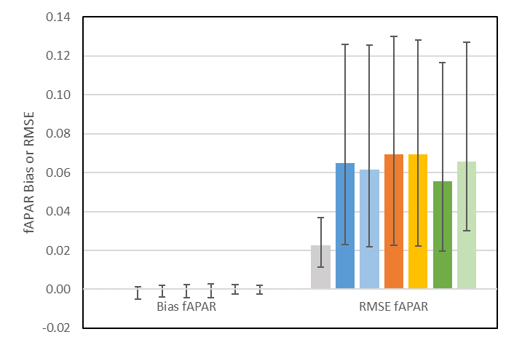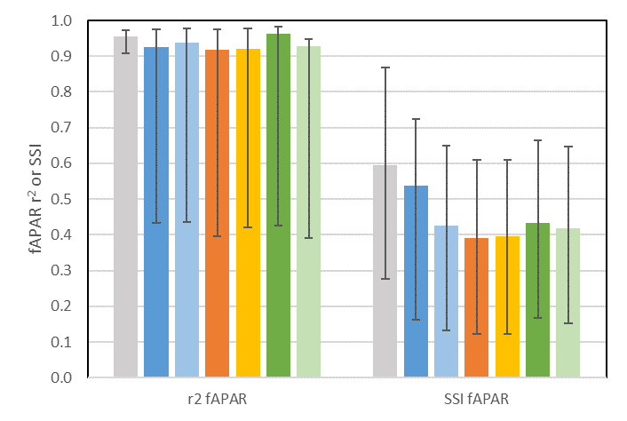
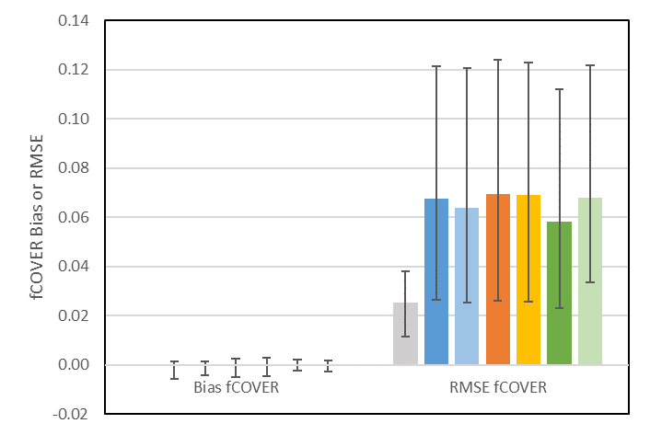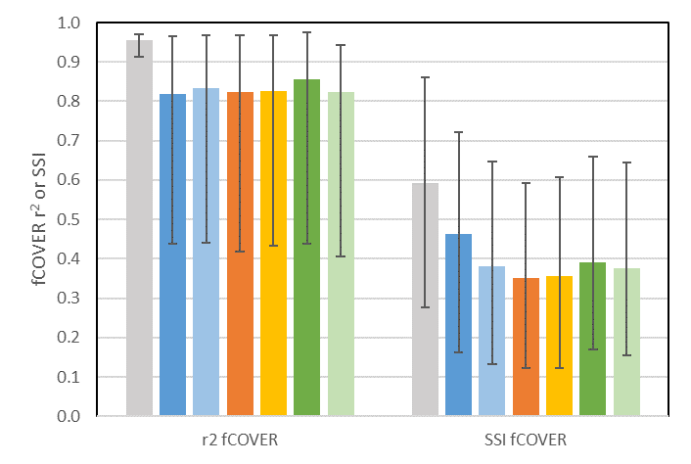
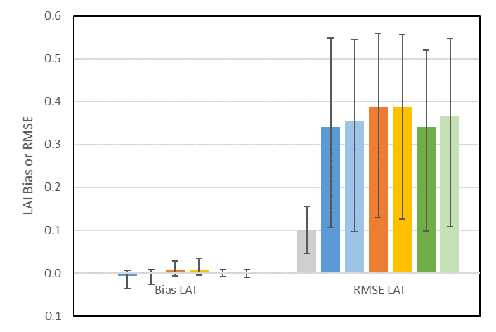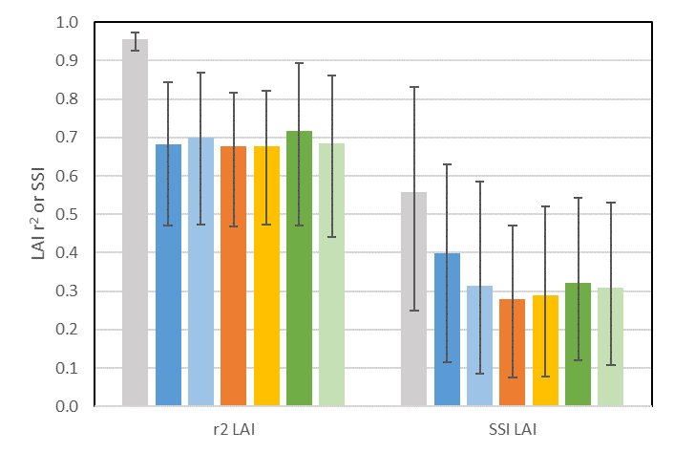
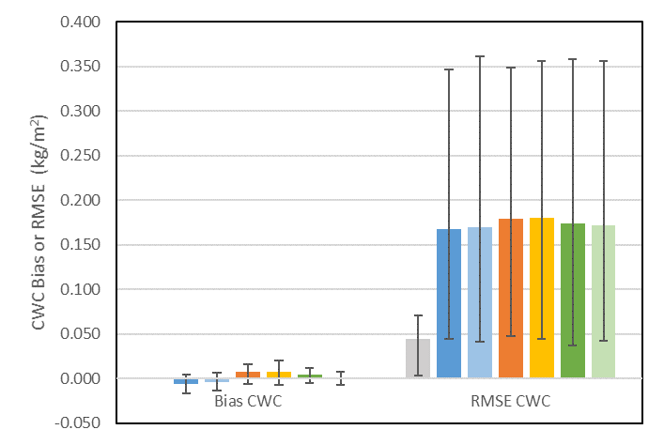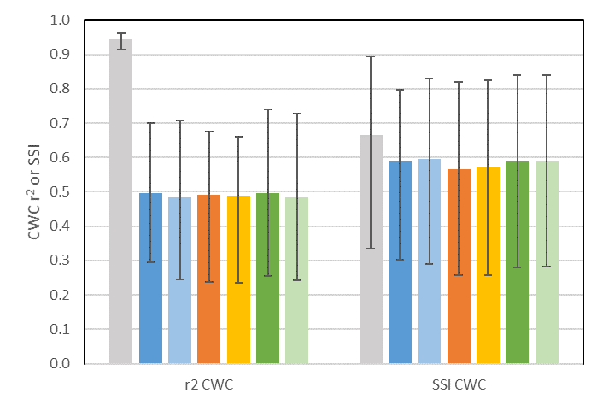

Figure 3. Average uncertainty metrics for reference and treatments across sites. Whiskers indicate range.

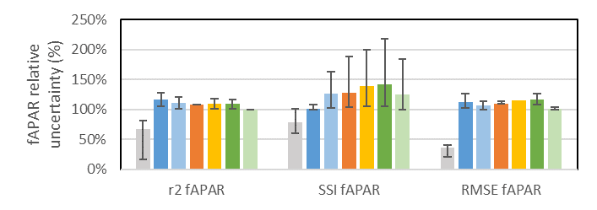
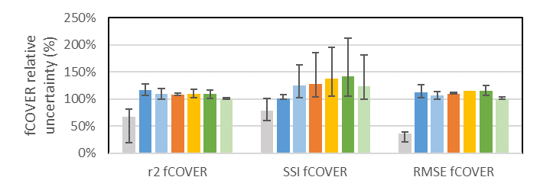

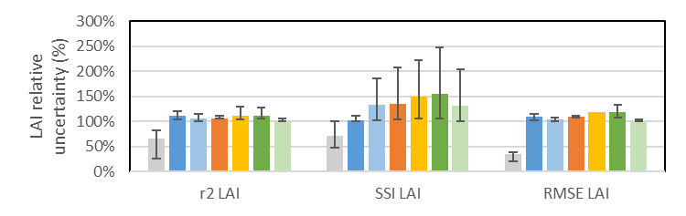

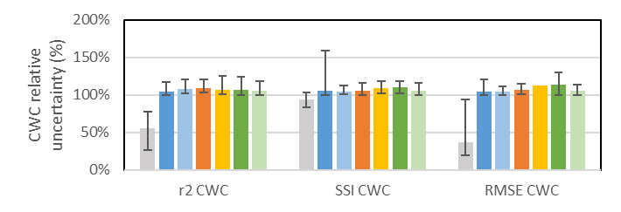
Figure 4 Relative uncertainty metrics for baseline and treatments as a percentage of the best treatment. Whiskers indicate range across sites.

Product Uncertainty

For all treatments, absolute bias for products was <.001 for fCOVER and fAPAR, <0.035 for LAI and <0.02 kg/m² for CWC (Figure 3). Bias was below 5% RMSE. As such, bias was not used to rank treatments in terms of thematic uncertainty.

D3-10 products had the lowest site average RMSE and highest site average r² amongst treatments for most variables; with RMSE of 0.05 (+0.06/-0.03) for both fAPAR and fCOVER and 0.29 (+0.27/-0.20) for LAI (Figure 3). These RMSE levels fall between goal and threshold user requirements for fAPAR and, on average, satisfy goal LAI uncertainty requirements for LAI>2. However, the same can be said for all downscaling treatments as the worst case treatment had a site average RMSE no more than 10% greater than D3-10 for these three variables. For CWC, R1-10 had the lowest RMSE of 0.172 (+0.02 kg/m² /-0.06 kg/m²) although all other treatments were within 10% of this figure. D1-10 and D2-10 shared the highest site average RMSE, and lowest site average r² for all variables.

R1-10 also has the highest site average SSI for all treatments. However, site averages are not ideal for ranking downscaling treatments as the between site range for SSI, RMSE and r² was similar in magnitude to the site average for each metric and at least twice the between difference in site average metrics across treatments. The large between site range was chiefly due to some difficult sites where all treatments performed poorly. For example, the LAI RMSE ranged from 0.12 for Wabush to 0.51 for Kitchener and LAI SSIM ranged from 0.09 at Fox Creek South to 0.55 at Red Bay (Figure 5).

The effect of either treatment or site on variability in metrics decreases by approximately 50% for relative metrics (Figure 4) in comparison to absolute metrics (Figure 3). D3-10 is consistently the best performing algorithm in terms of site average relative metrics for all variables. However, even the relative metrics still indicate a between site variation of similar or greater magnitude than treatment effects.

Site specific metrics were considered to ensure that D3-10 was indeed the best algorithm. Considering site specific metrics, D3-10 had the lowest RMSE and highest r² at most sites for fCOVER, fAPAR and LAI (Table 6) but D4-10 and R1-10 performed equally well for these metrics for CWC. As with site average metrics, R1-10 was almost always the treatment resulting in the best SSI. In terms of site specific RMSE, the best performing treatment resulted in an RMSE between sites ranging from 0.03 to 0.12 for fCOVER, 0.02 to 0.13 for fAPAR, 0.09 to 0.55 for LAI and 0.004 to 0.035 for CWC.

Table 6. Best performing treatment per site and metric. Colour corresponds to treatment indicated in legend below. All metrics are dimensionless except RMSE for CWC (kg/m²).
Site |  | fCOVER |  |  | fAPAR |  |  | LAI |  |  | CWC
 | RMSE | r² | SSI | RMSE | r² | SSI | RMSE | r² | SSI | RMSE | r² | SSI
Wabush | 0.023 | 0.97 | 0.72 | 0.020 | 0.98 | 0.72 | 0.305 | 0.65 | 0.52 | 0.04 | 0.58 | 0.84
Attapixk. | 0.031 | 0.89 | 0.71 | 0.028 | 0.96 | 0.72 | 0.234 | 0.76 | 0.62 | 0.16 | 0.56 | 0.80
Fox Creek S. | 0.036 | 0.93 | 0.17 | 0.035 | 0.93 | 0.12 | 0.162 | 0.89 | 0.12 | 0.12 | 0.30 | 0.30
Fox Creek N. | 0.045 | 0.93 | 0.38 | 0.030 | 0.97 | 0.38 | 0.266 | 0.72 | 0.27 | 0.18 | 0.48 | 0.60
Eastmain | 0.083 | 0.71 | 0.29 | 0.081 | 0.72 | 0.30 | 0.306 | 0.66 | 0.26 | 0.13 | 0.53 | 0.53
Charlettown | 0.044 | 0.98 | 0.60 | 0.042 | 0.98 | 0.60 | 0.405 | 0.78 | 0.56 | 0.23 | 0.63 | 0.69
Kouchibou. | 0.047 | 0.05 | 0.30 | 0.047 | 0.05 | 0.30 | 0.545 | 0.53 | 0.29 | 0.35 | 0.46 | 0.35
Kitchener | 0.089 | 0.09 | 0.51 | 0.089 | 0.09 | 0.51 | 0.089 | 0.09 | 0.51 | 0.89 | 0.09 | 0.51
Red Bay | 0.122 | 0.44 | 0.67 | 0.126 | 0.44 | 0.67 | 0.499 | 0.47 | 0.63 | 0.25 | 0.63 | 0.72
Eagle Plain | 0.031 | 0.88 | 0.32 | 0.030 | 0.88 | 0.32 | 0.099 | 0.88 | 0.27 | 0.49 | 0.30 | 0.63

 | R1-10 | R2-10 | D1-10 | D2-10 | D3-10 | D4-10

Relationship between Spatial Similarity and Thematic Uncertainty

The relationship between spatial similarity of the downscaled and reference maps and the thematic uncertainty of the downscaled maps was explored by comparing SSI and RMSE averaged over treatments for each site (Figure 5). Averaging over treatments was justified by the fact that treatment effects were almost always much smaller than between site variation in either SSI or RMSE. Scatter plots of SSI vs RMSE indicate little evidence of a systematic relationship between treatment average SSI and RMSE (coefficient of determination between SSI and RMSE of ~0, +/-0.2 at 95% confidence interval, for fAPAR, fCOVER and CWC and ~0.43, +/-0.16 at 95% confidence interval, for LAI. Figure 5 also indicates that certain sites typically fall at extremes of the relationship between these metrics irrespective of parameter. Red Bay had both the largest or second largest RMSE and SSI amongst sites; while Wabush had the lowest RMSE and highest SSI for all variables except LAI, where it fell in the middle of sites. Fox Creek had the lowest SSI for all variables and generally ranked low in RMSE.

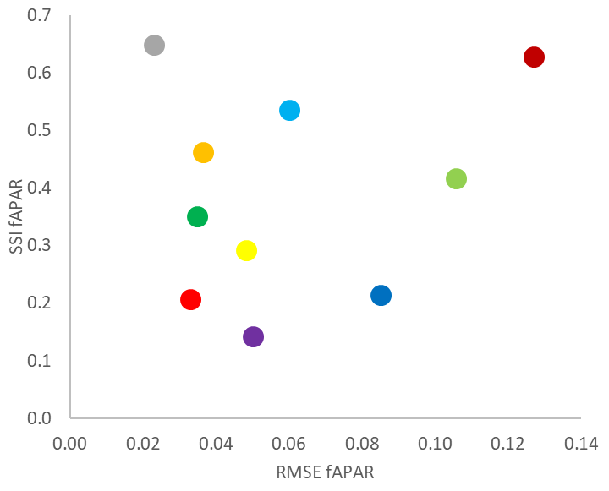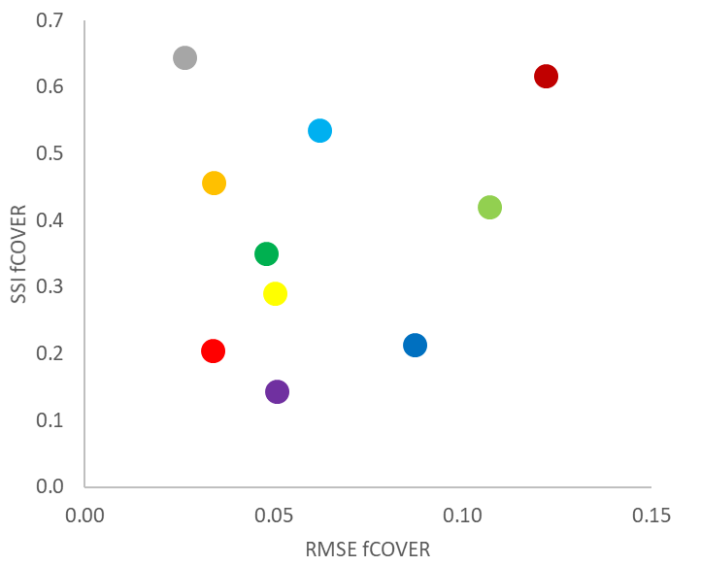
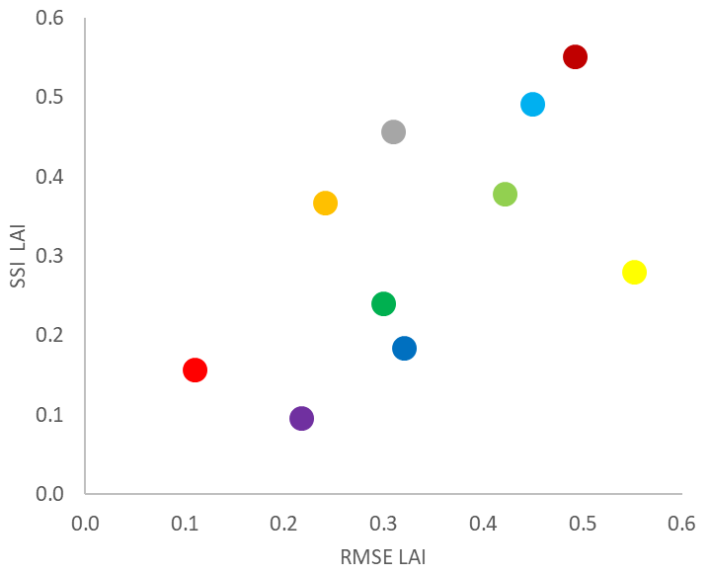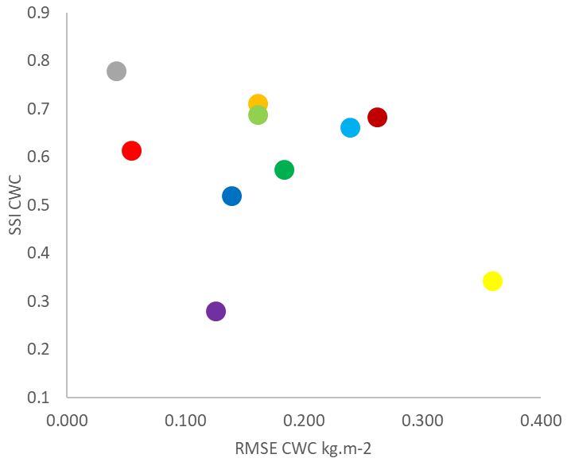

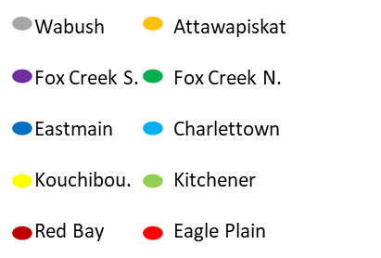
Figure 5. Relationship between average RMSE and SSI over treatments for each site and parameter.

Case Studies

Red Bay and Fox Creek South were selected for qualitative case studies as they corresponded to the lowest SSI and largest RMSE respectively for the majority of variables. Kitchener was also included as it was the site with the most built-up areas. A representative subset of approximately 5km x 5km is considered here chiefly for ease of reading corresponding to landscapes depicted in Figure 6. Geotiff layers corresponding to all reference and treatment maps are available upon request.
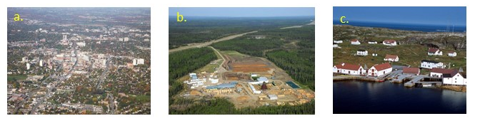
Figure 6. Air-photos of study sites: a. Kitchener (license Wikipedia Commons), b. Fox Creek South (license Wikipedia Commons), c. Red Bay (copyright Government of Canada).

Kitchener

Kitchener corresponds to a built-up landscape with residential, institutional and industrial development together with road infrastructure. A subarea surrounding a golf course was selected since SL2P retrievals are normally masked over pixels mapped as urban or non-vegetated (Figure 7).

As expected, the reference fCOVER is highest (>0.5) over the golf course and more moderate in built-up areas (0.2 to 0.5). There are patches of invalid reference retrievals over the golf course corresponding to shadow dominated pixels. There are also large built-up industrial areas with zero fCOVER.

All of the downscaling methods blur detail over the golf course and at edges of vegetated and non-vegetated patches in built-up areas; with increasing blurring in order of D3-10, D2-10, D4-10 and finally R1-10. D2-10 and D3-10 are similar over vegetated areas and are able to resolve variations in fCOVER along linear forested patches bordering golf greens. This ranking is in contrast to the SSI ranking for the subregion where R1-10 has the highest SSI (0.51); although D3-10 appears as the second best SSI (0.46). All methods have a similar RMSE (range 0.09 to 0.11) and retrieve non-zero fCOVER over the industrial areas where the reference fCOVER is mapped as zero.
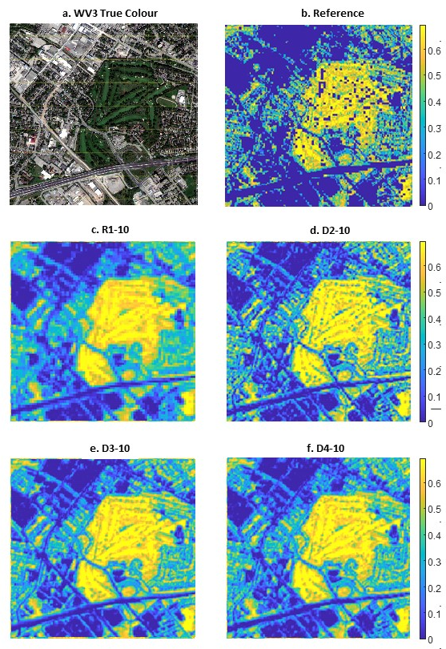
Figure 7. Comparison of 10m fCOVER for 5kmx5km Kitchener subset using (b) reference and (c, d, e, f) selected downscaling treatments using common color scale. Panel a. shows true colour WV3 radiance image. Invalid pixels mapped dark purple in reference image.

Fox Creek South

Fox Creek South is a natural boreal forest landscape with multiple disturbances with a range of spatial footprints including forest harvest blocks, seismic lines, oil extraction sites, and transportation corridors. A subarea containing all of these disturbances was selected (Figure 8).

The reference fCOVER map captures patches and linear features with relative constant within patch fCOVER typical of boreal forests (>0.5) and more moderate fCOVER over harvest blocks with shrubs and grasses (between 0.2 and 0.5). There are more frequent invalid retrievals compared to Kitchener as expected given the greater likelihood of cast shows from forests onto disturbed areas with shorter vegetation.

As with Kitchener, R1-10 shows the greatest blurring, followed by D4-10. While D2-10 and D3-10 are similar within large patches, D2-10 captures more detail within the fragmented forested areas at the left border of the site. However, D2-10 also tends to overestimate fCOVER over forested pixels in comparison to reference resulting in the highest RMSE (0.06) and lowest SSI (0.12). In contrast, D3-10 had the lowest RMSE (0.035) and highest SSI (0.017) of all treatments. It is noteworthy that R-10 also had a high SSI (0.016) but at the cost of also a high RMSE (0.05) (Figure 3).

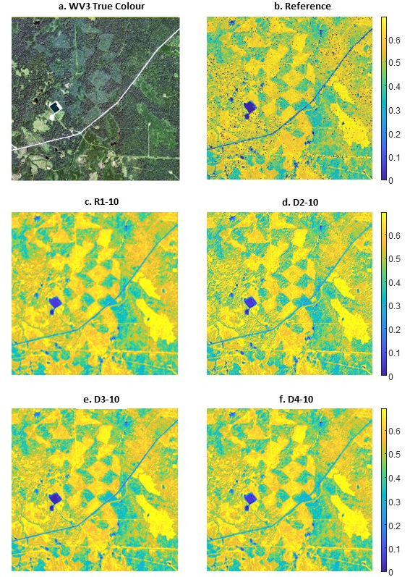
Figure 8. Comparison of 10m fCOVER for 5kmx5km Fox Creek South subset using (b) reference and (c, d, e, f) selected downscaling treatments using common color scale. Panel a. shows true colour WV3 radiance image. Invalid pixels mapped dark purple in reference image.

Red Bay

The Red Bay site corresponds to a natural tundra landscape with low density residential development, a sparse dirt road network, and an airport. A subarea containing all of these features was selected (Figure 9).

The reference fCOVER map shows more gradual variations within vegetated and disturbed or barren patches in comparison to either Kitchener or Fox Creek. These are expected as the area is covered by low shrubs and grasses rather than trees with larger crowns and gaps. The site also has the greatest frequency of invalid retrievals. This was also expected since SL2P is not specifically trained with barren landscapes or bare rock outcrops so both the calibration database spectral domain and the resulting retrievals are likely not representative of many areas of Red Bay.

As with the other sites, R1-10 shows the greatest blurring while the D2-10, D3-10 and D4-10 have a similar level of blurring over vegetated patched. The RMSE is essentially constant, at 0.12, across treatments but the SSI for R1-10 is slightly higher (0.67) compared to the other methods (0.59 to 0.61). In contrast to Fox Creek South where SSI and visual matching are not in correspondence, the SSI for Red Bay is indicative of qualitative matching of the reference and estimated maps.

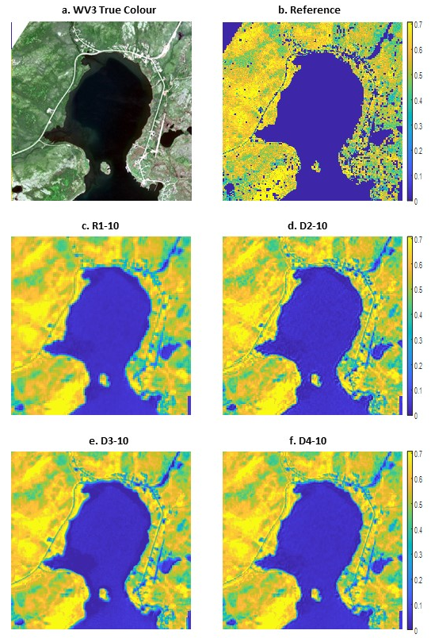
Figure 9. Comparison of 10m fCOVER for 5kx5km Red Bay subset using (b) reference and (c, d, e, f) selected downscaling treatments using common color scale. Panel a. shows true colour WV3 radiance image. Invalid pixels mapped dark purple in reference image.

Discussion

The goal of this study was to determine the downstream impact of downscaling algorithms applied to MSI L2a data on L2b thematic uncertainty. This goal is relevant to users seeking to reduce thematic uncertainty in comparison to 20m resolution L2b products or requiring 10m resolution products. The first objective of our study was to quantify the additional thematic uncertainty (the ‘product uncertainty’) due to downscaling. The second objective was to rank the different downscaling algorithms (‘treatments’). The second objective also quantified the impact of super-resolution methods on thematic uncertainty in comparison to treatment R1-10, nearest neighbour downscaling, that is equivalent to simply resampling the original 20m resolution L2b products.

Our experiment, in contrast to the majority of previous downscaling validation studies, used the thematic uncertainty of L2b rather than L2a products to evaluate algorithms. This is critical to determine the impact of downscaling on user requirements since the relationship between L2a and L2b products is, in general, non-linear. Some studies have used in-situ L2b reference measurements but these are limited to homogenous local regions either due to survey methodology or in-situ networks that generally place plots within homogeneous land cover patches. The transfer function approach developed originally for validating coarse resolution L2b products offered three benefits essential to our study. Firstly, the local regression predictors provided associated reference uncertainty estimates. Secondly, the predictors were applied directly to WV3 radiance imagery without having to resort to physics based approaches for atmospheric correction and product estimation that could increase reference uncertainty and especially bias. Thirdly, using 20m resolution L2b products for calibration provided large (>20,000 per site) representative calibration datasets without having to resort to in-situ sampling.

The transfer function approach was not without limitations. The reference uncertainty of ~30% of the total uncertainty of the best treatment was not negligible and was included when modelling the precision of product uncertainty estimates. We hypothesize that using hyperspectral imagery or additional SWIR bands may reduce reference uncertainty in certain landscapes based on previous studies on optimal band selection (Verger et al., 2011). However, the large between site variation in uncertainty (~100% of total uncertainty) suggests that having access to many reference sites with multispectral VNIR imagery is more important than a few sites with high spectral sampling. The transfer function relies on SL2P to calibrate reference estimates even though SL2P is often linearly biased in excess of user requirements when mapping heterogeneous landscapes (Brown et al., 2020). This is not a major issue when comparing downscaling methods but remains a concern for quantifying the product uncertainty with respect to in-situ measurements. In this regard, our product uncertainty estimates are likely underestimates. A second validation stage using in-situ measurements would be required to quantify this potential bias but was beyond the scope of our experiment.

Co-registration uncertainty between upscaled reference maps and L2b maps produced by downscaling was another limitation of our experiment. Previous studies avoided this uncertainty by using upscaled versions of the reference imagery as the input to downscaling algorithms ('upscaling approach'). The problem with the upscaling approach is that the applied upscaling corresponds to a linear spatial filter followed by spatial sampling below the Nyquist frequency. This is a carry-over from the computer vision field where scaling behavior of synthetic targets may follow this approach. In reality, the relationship between top of canopy radiance at scales shorter than the length of multiple cast shadows, is generally non-linear (Chen and Leblanc, 2001). The upscaling approach to generation of coarse resolution input imagery also ignores artifacts such as band-to-band co-registration, detector cross-talk, and acquisition geometry variation that are generally not considered in downscaling algorithms and are as such sources of noise. Our use of a statistical approach to estimate the residual for each match-up is new but not intrinsically different from applying summary statistics such as the RMSE to all the residuals at a site. By using an unbiased estimator (i.e., median residual in a local window), we accept a lower precision estimate of a single residual in comparison to the case where we have single match-up for perfectly co-registered data. However, this decrease in precision has negligible impact of statistics for each site given that they used at least 20,000 match-ups.

Product uncertainty (RMSE) for all variables varied substantially more between sites than between treatments. As such, we focus our discussion on the median and extreme RMSE of the best case treatment for all sites (Table 7). Incorporating a 30% decrease in precision due to reference uncertainty (Figure 6) gives best case estimates of product uncertainty of 0.05 (+0.10/-0.027) for fCOVER, 0.04 (+0.11/-0.025) for fAPAR, 0.29 (+0.34/-0.26) for LAI and 0.17 kg/m²(+0.95 kg/m² /-0.17 kg/m²) for CWC. Comparison of these uncertainty estimates with user requirements (Table 2) indicate that the product uncertainty due to downscaling reduces the acceptable threshold uncertainty of the retrieval algorithm by ~50%. This tradeoff between spatial resolution and thematic uncertainty is not surprising considering that, assuming spatially uncorrelated error, it approximately balances the potential decrease in uncertainty by a factor of two if the downscaled 10m L2b products were subsequently upscaled to 20m.

SupReMe (treatment D3-10) resulted in the lowest RMSE and highest r² for most sites for fCOVER, fAPAR and LAI. SupReMe implements a regularized inverse PSF filter solution that is optimal in terms of reconstructing higher resolution L2a products assuming a linear upscaling process with regular sampling. It is likely that this is indeed the case when relating the 10m and 20m VNIR MSI bands. The absence of an original 10m SWIR band may explain why nearest neighbour resampling (R1-10) performed better in terms of RMSE and r² for CWC at many sites: the super-resolution methods did not have a finer resolution SWIR band to calibrate their downscaled SWIR L2a estimates. This could be tested using data with a 10m resolution SWIR band (e.g., WV3 full band imagery) or hyperspectral VNIR and SWIR imagery. Even so, the difference between all treatments, including nearest neighbour resampling, in terms of RMSE and r² was less than 10% when averaged across all sites. This suggests that the tested super-resolution algorithms do not substantially reduce product uncertainty in comparison to the 20m resolution product.

Considering the similarity in thematic uncertainty between treatments, the spatial similarity between downscaled products and reference maps becomes an important criterion for algorithm selection. Unfortunately, our results were contradictory and equivocal. The contradiction arises in that the SSI clearly indicated that nearest neighbour resampling provided the best spatial similarity between downscaled and reference maps but qualitative assessment indicated this treatment produced significant blurring at two sites (Fox Creek South and Kitchener). The SSI seems to be of limited use for quantitative assessment of downscaled patterns when dealing with medium resolution (5m to 30m) reference imagery since it is based on ratios of local cross and auto correlations of the compared maps and not the actual spatial arrangement of features at fine resolution. At the same time, qualitative assessments of spatial similarity when using super-resolution was equivocal. All super-resolution algorithms provided similar levels of feature matching to reference maps notwithstanding the aforementioned finding that they also resulted in a substantial increase in product uncertainty at 10m resolution. More study is required to determine appropriate quantitative similarity metrics such as those based on texture matching.

We initially embarked upon this study with the intent of finding a downscaling algorithm suitable for systematic production of 10m resolution vegetation biophysical variables from MSI data. While SupReMe was a clear winner for fCOVER, fAPAR and LAI we feel that its computational cost, the increased product uncertainty at 10m resolution and the large between site variability in uncertainty does not warrant its implementation in a systematic processing chain. However, in developing the transfer function approach we came to realize that in many circumstances VNIR bands are sufficient for accurate estimate of vegetation biophysical variables given sufficient local calibration data. This was noted by Clevers et al. (2017) using in-situ calibration data but there is no reason why it cannot be implemented systematically using 20m SL2P retrievals and the MSI bands available at 10m resolution for calibration. Assuming the transfer function could be calibrated efficiently this approach would allow for both 10m resolution estimates and associated prediction uncertainties.

Conclusions

Spatial downscaling offers the potential for simultaneously decreasing thematic uncertainty and increasing the applicability of maps of vegetation biophysical variables derived from satellite imagery. Downscaling is especially attractive for sensors, such as the MSI on S2a and S2b, with co-located bands at different resolutions. Many downscaling algorithms have been developed for such multispectral imagery but previous validation has been limited to the uncertainty of L1b radiance or L2a surface reflectance products. A new methodology, adapted from the transfer function approach used for validation of maps from coarse scale satellite imagery, was developed to quantify the thematic uncertainty of downscaled S2 maps of canopy variables at regional extents and to compare available downscaling algorithms.

The bias of both reference maps and downscaled products was negligible compared to their uncertainty (i.e., RMSE) and user requirements. Additionally, irrespective of variable or site, the reference maps uncertainty, corresponding to the precision of the estimated product uncertainty, was ~30% of total uncertainty between downscaled products and reference maps. This supports our hypothesis that reference maps have sufficient precision to quantify product uncertainty.

The uncertainty of the best algorithm at a site was, on average, ~50% of the threshold user requirements. Problematic sites with best algorithm uncertainties approaching 100% of threshold user requirements were observed for all variables. This suggests that downscaled maps will not likely meet user requirements for uncertainty if evaluated at 10m resolution considering current levels of uncertainty for retrieval algorithms such as SL2P when applied at 20m resolution.

SupReMe was consistently the algorithm with lowest RMSE and highest r² for fCOVER, LAI and fAPAR at most sites and nearest neighbour resolution was frequently the best in all three metrics for CWC. However, differences between the best algorithm and nearest neighbour were typically less than 10% for all metrics and always less than reference uncertainty.

The SSI metric provided independent information compared to the RMSE but its lack of agreement with qualitative assessments of spatial similarity case doubt on its relevance for evaluating downscaled 10m resolution MSI products. Qualitative assessment of spatial similarity between downscaled and reference maps indicated that all of the super-resolution algorithms (ATPRK, AATPRK, DSen2 and SupReMe) showed more detail and less smoothing than the resampling algorithms (nearest neighbour and cubic convolution). These results suggest that super-resolution downscaling algorithms are useful to improve the qualitative appearance of vegetation patterns at 10m resolution but at the price of a substantial increase in product uncertainty.

Considering the large between site variability in product uncertainty none of the spatial downscaling algorithms are recommended for systematic application without additional reference measurements to quantify local uncertainty. Instead, considering the relative low uncertainty of the transfer functions applied using VNIR data, the use of feature selection to calibrate local algorithms using only the 10m resolution MSI bands should be investigated.

Acknowledgements

The authors acknowledge the following providers of algorithms: European Space Agency (SEN2COR), Q. Wang (ATPRK-PAN and ATPRK-MS), C. Lanaras (SuPreMe and DSEN2), M. Weiss (SL2P).

This work was supported by the Government of Canada’s Cumulative Effects Monitoring programme and by the Canada Centre for Mapping and Earth Observation’s remote sensing science programme.

References

Alparone, L., Aiazzi, B., Baronti, S. and Garzelli, A., 2015. Remote Sensing Image Fusion. Boca Raton, FL: CRC Press, copyright 2015.

Baret, F. and Guyot, G., 1991. Potentials and limits of vegetation indices for LAI and APAR assessment, Remote Sensing of Environment, 35, 161-173, https://doi.org/10.1016/0034-4257(91)90009-U.

Brodu, N., 2017. Super-resolving multiresolution images with band independent geometry of multispectral pixels. IEEE Transactions on Geoscience and Remote Sensing, 55 , 4610–4617.

Brown, L.A., Ogutu, B.O., Dash, J., 2019. Estimating Forest Leaf Area Index and Canopy Chlorophyll Content with Sentinel-2: An Evaluation of Two Hybrid Retrieval Algorithms. Remote Sens. 11, 1752. https://doi.org/10.3390/rs11151752

Brown, L.A., Fernandes, R., Djamai, N., Meier, C., Gobron, N., Morris, H., Canisius, F., Bai, G., Lerebourg, C., Lanconelli, C., Clerici, M., Dash, J., 2021. Validation of baseline and modified Sentinel-2 Level 2 Prototype Processor leaf area index retrievals over the United States. ISPRS Journal of Photogrammetry and Remote Sensing,175, 71-87, https://doi.org/10.1016/j.isprsjprs.2021.02.020.

Chen, J.M. and Leblanc, S.G., 2001. A Geometrical multiple scattering scheme to be used in geometrical optical models. IEEE TGARS, 39, 1061-1071.

Clerc, S. and MPC Team, 2020. S2 MPC L1C Data Quality Report. Ref. S2-PDGS-MPC-DQR, European Space Agency, https://sentinels.copernicus.eu/documents/247904/685211/Sentinel-2_L1C_Data_Quality_Report on January 20, 2021 (Accessed August 19, 2021).

Clevers, J.G.P.W., Kooistra, L., Van den Brande, M.M.M., 2017. Using Sentinel-2 Data for Retrieving LAI and Leaf and Canopy Chlorophyll Content of a Potato Crop. Remote Sens, 9, 405, https://doi.org/10.3390/rs9050405

Cohrs, C.W., Cook, R.L., Gray, J.M., Albaugh, T.J., 2020. Sentinel-2 Leaf Area Index Estimation for Pine Plantations in the Southeastern United States. Remote Sens., 12, 1406, https://doi.org/10.3390/rs12091406.

Commission for Environmental Cooperation, 2020. 2015 Land Cover of North America at 30 Meters, North American Land Change Monitoring System, Ed. 2.0. http://www.cec.org/wp-content/uploads/wpallimport/files/Atlas/Files/2010nalcms30m/north_america_2015_v2.zip (Accessed August 19, 2021).

Copernicus Sentinel Hub, 2021, ttps://docs.sentinel-hub.com/api/latest/data/sentinel-2-l2a/#about-sentinel-2-l2a-data, (Accessed on August 19, 2021).

Delangre, J., Radoux, J., Dufrene, M., 2017. Landscape delineation strategy and size of mapping units influence the performance of habitat suitability models. Ecological Informatics , 47, 55-60, 10.1016/j.ecoinf.2017.08.005

Digital Globe, 2020. https://earth.esa.int/eogateway/documents/20142/37627/DigitalGlobe-Standard-Imagery.pdf (Accessed August 19, 2021).

Djamai, N. and Fernandes, R., 2018. Comparison of SNAP-Derived Sentinel-2A L2A Product to ESA Product over Europe. Remote Sens. 10, 926. https://doi.org/10.3390/rs10060926.

Djamai, N., Fernandes, R., Weiss, M., McNairn, H., Goïta, K., 2019. Validation of the Sentinel Simplified Level 2 Product Prototype Processor (SL2P) for mapping cropland biophysical variables using Sentinel-2/MSI and Landsat-8/OLI data. Remote Sens. Environ. 225, 416–430. https://doi.org/10.1016/j.rse.2019.03.020.

Doxani, G., Vermote, E., Roger, J.C., Gascon, F., Adriaensen, S., Frantz, D., Hagolle, O., Hollstein, A., Kirches, G., Li, F, Louis, J., Mangin, A., Pahlevan, N., Pflug, B., Vanhellemont, Q. 2018. Atmospheric Correction Inter-Comparison Exercise. Remote Sens.10, 352.

Drusch, M., Del Bello, U., Carlier, S., Colin, O., Fernandez, V., Gascon, F., Hoersch, B., Isola, C., Laberinti, P., Martimort, P., Meygret, A., Spoto, F., Sy, O., Marchese, F., Bargellini, P., 2012. Sentinel-2: ESA's Optical High-Resolution Mission for GMES Operational Services. Remote Sensing of Environment, 120, 25-36, https://doi.org/10.1016/j.rse.2011.11.026.

Duncanson, L., Armston, J., Disney, M., Avitabile, V., Barbier, N., Calders, K., Carter, S., Chave, J., Herold, M., MacBean, N., McRoberts, R., Minor, D., Paul, K., Réjou-Méchain, M., Roxburgh, S., Williams, M., Albinet, C., Baker, T., Bartholomeus, H., Bastin, J.F., Coomes, D., Crowther, T., Davies, S., de Bruin, S., De Kauwe, M., Domke, G., Dubayah, R., Falkowski, M., Fatoyinbo, L., Goetz, S., Jantz, P., Jonckheere, I., Jucker, T., Kay, H., Kellner, J., Labriere, N., Lucas, R., Mitchard, E., Morsdorf, F., Næsset, E., Park, T., Phillips, O.L., Ploton, P., Puliti, S., Quegan, S., Saatchi, S., Schaaf, C., Schepaschenko, D., Scipal, K., Stovall, A., Thiel, C., Wulder, M.A., Camacho, F., Nickeson, J., Román, M., Margolis, H., 2021. Aboveground Woody Biomass Product Validation Good Practices Protocol. Version 1.0. In L. Duncanson, M. Disney, J. Armston, J. Nickeson, D. Minor, and F. Camacho (Eds.), Good Practices for Satellite-
Derived and Product Validation, (p. 236): Land Product Validation Subgroup (WGCV/CEOS), doi:10.5067/doc/ceoswgcv/lpv/agb.001.

Ecological Stratification Working Group, 1996. A National Ecological Framework for Canada. Agriculture and Agri-Food Canada, Research Branch, Centre for Land and Biological Resources Research, and Environment Canada, State of the Environment Directorate, Ecozone Analysis Branch, Ottawa/Hull. Report and national map at 1:7,500,000 scale.

Fernandes, R., Plummer, S., Nightingale, J., Baret, F., Camacho, F., Fang, H., Garrigues, S., Gobron, N., Lang, M., Lacaze, R., Leblanc, S., Meroni, M., Martinez, B., Nilson, T., Pinty, B., Pisek, J., Sonnentag, O., Verger, A., Welles, J., Weiss, M., Widlowski, J.-L., Schaepman-Strub, G., Roman, M., Nickeson, J., 2014. Global Leaf Area Index Product Validation Good Practices, in: Fernandes, R., Plummer, S., Nightingale, J. (Eds.), Best Practice for Satellite-Derived Land Product Validation. Land Product Validation Subgroup (Committee on Earth Observation Satellites Working Group on Calibration and Validation), doi: 10.5067/doc/ceoswgcv/lpv/lai.002.

Gascon, F., Bouzinac, C., Thépaut, O., Jung, M., Francesconi, B., Louis, J., Lonjou, V., Lafrance, B., Massera, S., Gaudel-Vacaresse, A., Languille, F., Alhammoud, B., Viallefont, F., Pflug, B., Bieniarz, J., Clerc, S., Pessiot, L., Trémas, T., Cadau, E., De Bonis, R., Isola, C., Martimort, P., Fernandez, V., 2017. Copernicus Sentinel-2A Calibration and Products Validation Status. Remote Sens., 9, 584,. https://doi.org/10.3390/rs9060584.

GCOS, 2016. The global observing system for climate: implementation needs. GCOS-200, World Meteorological Organization. https://library.wmo.int/opac/doc_num.php?explnum_id=3417 (Accessed August 19, 2021).

Hu, Q., Yang, J., Xu, B., Huang, J., Memon, M.S., Yin, G., Zeng, Y., Zhao, J., Liu, K. 2020. Evaluation of Global Decametric-Resolution LAI, FAPAR and FVC Estimates Derived from Sentinel-2 Imagery. Remote Sens., 12, 912, https://doi.org/10.3390/rs12060912.

Lanaras, C., Bioucas-Dias, J., Baltsavias, E., Schindler, K., 2017. Superresolution of multispectral multiresolution images from a single sensor. IEEE Conference on Computer Vision and Pattern Recognition Workshops (CVPRW). pp. 1505–1513.

Lanaras, C., Bioucas-Dias, J., Galliania, S., Baltsaviasa, E., Schindlera, K., 2018. Super-resolution of Sentinel-2 images: Learning a globally applicable deep neural network. ISPRS Journal of Photogrammetry and Remote Sensing, 146, 305–319.

Lang, M. and Tychon, B., 2015. GIO Copernicus Global Land – Technical User Group – Service Specification and Product Requirements Proposal – SPB-GIO-3017-TUG-SS-004 – Issue I1.0 – 26 May 2015. https://land.copernicus.eu/global/sites/cgls.vito.be/files/service/EN-SPB-GIO-307-TUG-SS-004%20-%201.0%20-%20Service%20Specification%20and%20Product%20Requirements%20Proposal%20Final%20Report.pdf (Accessed August 19, 2021).

Longbotham, N., Pacifici, F., Malitz, S., Baugh, W., Camps-Valls, G. 2015. Measuring the Spatial and Spectral Performance of WorldView-3, in Fourier Transform Spectroscopy and Hyperspectral Imaging and Sounding of the Environment, OSA Technical Digest (online) (Optical Society of America, 2015), paper HW3B.2.

Maxar, 2020. https://blog.maxar.com/tech-and-tradecraft/2020/absolute-radiometric-calibration-is-an-essential-tool-to-imagery-science-but-what-is-it (Accessed August 19, 2021)

Müller-Wilm, U., 2018. Sen2Cor Configuration and User Manual, 2nd ed. CS, Toulouse, France.

Richter, K.,Hank, T.B., Vuolo, F., Mauser, W., D’Urso, G., 2012. Optimal Exploitation of the Sentinel-2 Spectral Capabilities for Crop Leaf Area Index Mapping. Remote Sens., 4, 561-582. https://doi.org/10.3390/rs4030561.

Scheffler, D., Hollstein, A., Diedrich, H., Segl, K., Hostert, P., 2017. AROSICS: An Automated and Robust Open-Source Image Co-Registration Software for Multi-Sensor Satellite Data. Remote Sens., 9, 676. https://doi.org/10.3390/rs9070676

Thomas, C., Ranchin, T., Wald, L.,Chanussot, J., 2008. Synthesis of multispectral images to high spatialresolution: A critical review of fusion methods based on remote sensing physics. IEEE Transactions on Geoscience and Remote Sensing, 46, 1301-1312.

Vajsová B and Aastrand P, 2015.New sensors benchmark report on Sentinel-2A; EUR 27674 EN; doi:10.2788/544302 European Union, https://publications.jrc.ec.europa.eu/repository/bitstream/JRC99517/lb-na-27674-en-n%20.pdf ( Accessed August 19, 2021.

Verger, A., Baret, F., Camacho, F., 2011. Optimal modalities for radiative transfer-neural network estimation of canopy biophysical characteristics: Evaluation over an agricultural area with CHRIS/PROBA observations, Remote Sensing of Environment, 2011, 115, 415-426, https://doi.org/10.1016/j.rse.2010.09.012.

Verrelst, J., Muñoz, J., Alonso, L., Delegido, J., Rivera, J.P., Camps-Valls, G., Moreno, J., 2012. Machine learning regression algorithms for biophysical parameter retrieval: Opportunities for Sentinel-2 and -3. Remote Sens. Environ., 118,127-139, https://doi.org/10.1016/j.rse.2011.11.002.

Vivone, G., Dalla Mura, M., Garzelli, A., Restaino, R., Scarpa, G., Ulfarsson, M., Alparone, L., Chanussot, J.,2021. A New Benchmark Based on Recent Advances in Multispectral Pansharpening: Revisiting Pansharpening With Classical and Emerging Pansharpening Methods. IEEE Geoscience and Remote Sensing Magazine, 9, 53-81, doi: 10.1109/MGRS.2020.3019315.

Wang, Q.; Shi, W.; Atkinson, P.M.; Zhao, Y., 2015. Downscaling MODIS images with area-to-point regression kriging. Remote Sens. Environ.,166, 191–204.

Wang, Q., Shi, W., Li, Z., Atkinson, P. M., 2016. Fusion of Sentinel-2 images. Remote Sensing of Environment 187, 241–252.

Weiss, M., Baret, F., 2016. S2ToolBox Level 2 Products: LAI, FAPAR, FCOVER, 1.1. ed. Institut National de la Recherche Agronomique, Avignon, France. https://step.esa.int/docs/extra/ATBD_S2ToolBox_L2B_V1.1.pdf ( Accessed August 19, 2021.

Wolf, P.R., Dewitt, B.A., and Wilkinson, B.E., 2014. Elements of Photogrammetry with Applications in GIS, Fourth Edition, McGraw-Hill Education, copyright 2014. ISBN: 9780071761123, https://www.accessengineeringlibrary.com/content/book/9780071761123 ( Accessed August 19, 2021.

Zhang, Y., Atkinson, P.M., Ling, F., Wang, Q., Li, X., Shi, L., Du, Y., 2017. Spectral–Spatial Adaptive Area-to-Point Regression Kriging for MODIS Image Downscaling, IEEE Journal of Selected Topics in Applied Earth Observations and Remote Sensing, vol. 10, 1883-1896, doi: 10.1109/JSTARS.2017.2650260.

Zhang, M, Su, W., Fu, Y., Zhu, D. Xue, J., Huang, J., Wang, W., Wu, J., Yao, C. 2019. Super-resolution enhancement of Sentinel-2 image for retrieving LAI and chlorophyll content of summer corn. European Journal of Agronomy, 111, 10.1016/j.eja.2019.125938.

Zheng, H., Du, P., Chen, J., Xia, J., Li, E., Xu, Z., Li, X., Yokoya, N., 2017. Performance Evaluation of Downscaling Sentinel-2 Imagery for Land Use and Land Cover Classification by Spectral-Spatial Features. Remote Sens. 2017, 9, 1274, https://doi.org/10.3390/rs9121274.

Zhou, W., Bovik, A.C., Sheikh, H.R., Simoncelli, E.P., 2004. Image quality assessment: from error visibility to structural similarity. IEEE Transactions on Image Processing. 13, 600–612.

