**Team Members:**

1. Brian Zick
2. Randall Ferrance
3. Chris Mccarty
4. Annie Wong

**Requirements:**

Chris

1. Processing sensor data to control the mouse and keyboard
2. Desktop emulator UI: Basically a display of the actual desktop (considered streaming going to try this out first)
   1. If streaming does not work (too difficult after trying this for a couple of days) will switch to view hierarchy
   2. If view hierarchy, will only do Swing-based UI (**ENTIRE TEAM WILL HELP CREATE)**
      1. Will have access to main programs (such as web browser) and file systems
   3. Will give deliverables for this
3. Server talking back and forth (working with Annie)
   1. Mainly in charge of sharing mouse/keyboard data back and forth
   2. Mainly in charge with sharing desktop data back and forth

Randall

1. Create the application UI skeleton (fragments different pages)
2. Enable encryption: Transmission & Password
3. File Browser (working with Brian on this, will be doing more of the gui portion)
4. Help emulator UI

Brian

1. Enable chatting between computer and application
2. Detect unauthorized access
   1. When someone logs on, server will log it, User can check all logs (user can see if someone logged on and it wasn’t them), also will see unsuccessful logon attempts (like incorrect password)
3. File Browser (working with Randall on this, will be doing more of the networking portion)
4. Help emulator UI

Annie

1. Enable communication between application and command line interface of PC
   1. Possibly will not support commands that require interaction
   2. Supported commands:
      1. Creating files and directories
      2. Traversing folders
      3. Delete files and directories
      4. Etc.
2. Create server GUI
3. Server talking back and forth (working with Chris)
   1. Mainly responsible for sending terminal commands to the server for execution and reading the responses
4. Help emulator UI

**Interface Mock-Ups:**

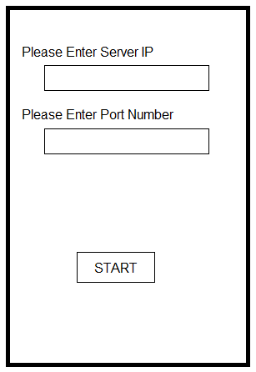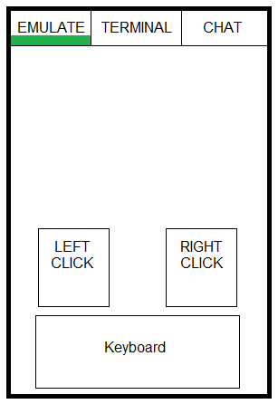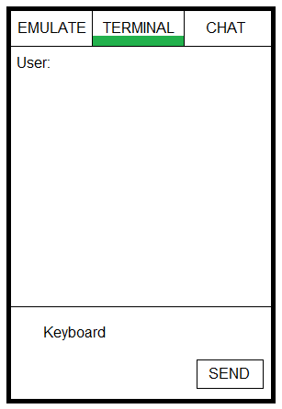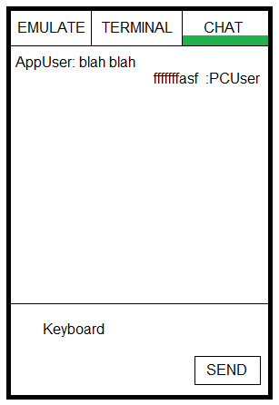

**Features:**

DataBridge is an application that links users to their personal computer s. The user can interact with their computer to accomplish tasks on the go either through a GUI interface of the command line interface. Also they can chat with users that are currently on their computer and give them directions on how to accomplish tasks.

**Schedule:**

Some Features (if we run into many issues)

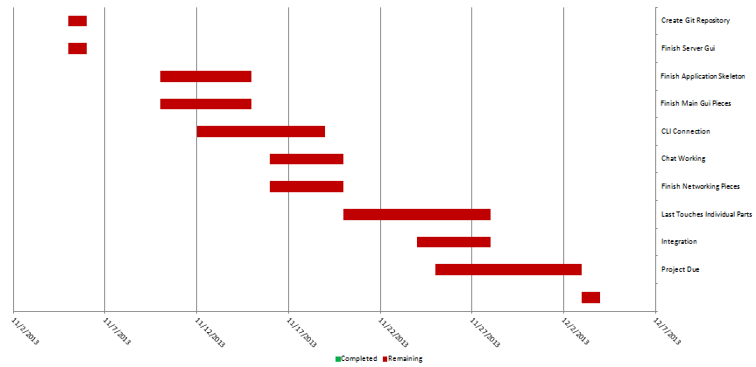

Features If All Goes Smoothly