
Online-Reservierung der Kegelbahn Haus St. Kunigund in Schnaittach
Admin Manual
BBS Bowling System
Version 0.3
BBS Bowling Booking System – Admin Manual
Ausgabe: November 2025
Institut für Nachhaltigkeit
Kunigundenring 17
91220 Schnaittach
Peter Tyrach
Tel.: +49 170 573 4381
E-Mail: office@institutnachhaltigkeit.de
Internet: www.institutnachhaltigkeit.de
Georg Hofrichter, 29646 Nürnberg, 241/129/294339
© Copyright 2025 Institut für Nachhaltigkeit
Das BBS Bowling Booking System ist eine eingetragene Marke von Institut der Nachhaltigkeit. Alle anderen Marken sind Eigentum ihrer jeweiligen Inhaber.
Dieses Werk ist urheberrechtlich geschützt. Seine Verwendung außerhalb der durch das Urheberrecht gesetzten Grenzen ist ohne Zustimmung des Herausgebers nicht gestattet und stellt eine strafbare Handlung dar. Dies gilt insbesondere für das Kopieren, Übersetzen, Mikroverfilmen sowie das Speichern und Verarbeiten in elektronischen Systemen. Alle Rechte vorbehalten.

Inhaltsverzeichnis
1 Einleitung 5
2 Das HostEurope Web Hosting System 6
2.1 Anmeldung 7
Login 7
2.2 Character styles 8
Product name 8
Element 9
Parameter 10
Term 10
Emphasis 11
Strong 12
Input 13
Code 14
Link / cross-reference 14
2.3 Numbering styles 16
2.4 Internal styles 17
2.5 Tables 19
2.6 Images 20
3 Keyboard shortcuts 21

Einleitung
Das BBS-Administrationshandbuch soll den Administrator bei den folgenden Aufgaben unterstützen:
- Anmeldung an das HostEurope Web Hosting System
- Parametrierung der Tage, an denen die Kegelbahn nicht zur Verfügung steht
- Pflege der Web-Seite mit den aktuellen Informationen
- Anpassung der Getränke-Preise und Kegelbahn Gebühren
- Bearbeitung von Rechnungen
- Grober Überblick über die Software-Architektur
- Löschen von fehlerhaften oder nicht mehr genutzten Daten in der BBS-Datenbank
- Neustart des BBS-Web-Servers
- Erste Analysen bei Problemen mit der BBS-Homepage mit Hilfe von Log-Dateien

Das HostEurope Web Hosting System
Man hat sich entschieden als Provider das Web-Hosting System von HostEurope zu verwenden
Folgende Softwarepakete sind Bestandteil des aktuellen Vertrages:
- Die Domäne kv-sankt-kunigund.de
https://kv-sankt-kunigund.de/index.html
- Microsoft 365 Email Essentials mit der E-Mail-Adresse
schnaittach@kv-sankt-kunigund.de
- Virtual Server 10.0 - 1vCPU | 2GB RAM - Linux - Plesk - WebAdmin

Anmeldung
Der Zugang zum Web Hosting HostEurope Kunden Informations-System erfolgt über den Link https://kis.hosteurope.de/

Login

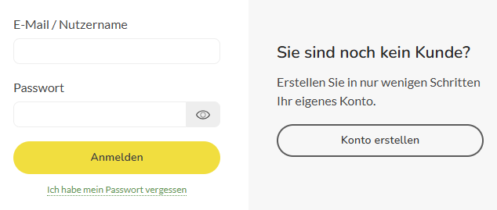

Character styles
Character styles format single words or phrases. They determine the used typeface and color.
When setting up character styles:
- Create as few character styles as possible. Users aren’t able to distinguish among more than 3 or 4 distinct visual styles (see also Fehler! Verweisquelle konnte nicht gefunden werden. on page Fehler! Textmarke nicht definiert.).
- Create styles only for tagging particular types of information (see Fehler! Verweisquelle konnte nicht gefunden werden. on page Fehler! Textmarke nicht definiert.).
- When possible, define styles that adhere to general conventions so that readers don’t have to learn a new meaning of a known style. For example, it’s most common to use:
  - bold font style for controls
  - underlined text for hyperlinks
  - italic font style for special terms and for emphasis
When applying character styles:
- Don’t include surrounding spaces and punctuation.
- Don’t use character styles in headings and subheadings.

Product name
Style
cp_product
Use
You can use this style to set off the name of the documented product. Having this style is optional. It’s purely a matter of design and corporate identity. You can just as well write your product’s name as regular body text without any special markup.
Don’t use quotation marks around product names, regardless of whether you use any special character style.
Example
With DemoSoft you can print reports.
Possible modifications
If your product uses special colors or fonts, you can also use these colors and fonts for the product name.

Element
Style
ce_element
Use
Apply this style to mark all user interface and interaction elements, such as window titles, menu items, buttons, keys, switches, levers, and so on.
Example
From the File menu, choose Print.
Possible modifications
If you want to use color, preferably choose either your corporate color or the predominant color of your product logo.

Parameter
Style
ca_parameter
Use
Apply this style to mark parameters, such as parameters of function calls, formulas, and so on.
Example
When you set the temperature to cool, energy consumption is slightly higher.
Possible modifications
You can also use a monospaced font (such as Courier) if users can’t select parameters from a given set but must type them.
If parameters are important landmarks for which readers will skim your document, make the parameter style bold or add some color.

Term
Style
ct_term
Use
This style is optional. You can use it to mark product-specific technical terms. Often, these terms follow words such as “called,” “known as,” “labeled,” “stands for,” and so on.
Don’t use quotation marks instead of setting up the ct_term character style, and don’t use quotation marks around this style. Quotation marks make your text longer than necessary and add clutter that you can avoid.
Example
Several fonts that share the same typeface are called a font family.
Possible modifications
If product-specific technical terms are important landmarks for which readers will skim your document, make ct_term bold+italic.

Emphasis
Style
cm_emphasis
Use
You sometimes need this style to emphasize words and expressions to avoid misinterpretation or confusion.
Important: Don’t use this style to highlight important information. For this purpose, use the cs_strong character style.
When writing texts, apply the cm_emphasis character style sparingly to avoid dulling the impact on the reader. Only use this style when it really makes a sentence clearer. As a decision aid, read the sentence aloud: Use the cm_emphasis style only if you have actually emphasized the word.
Example
This character style is not dispensable.
Possible modifications
None.
Don’t make the emphasis bold and don’t use color. It’s sufficient if readers notice the emphasis while reading. The style shouldn’t attract attention on its own because it doesn’t mark any information that needs to be accessed in a targeted way.
Don’t use ALL CAPS. This style was common for emphases on mechanical typewriters, which didn’t have any italic font style. However, like bold or colored text, ALL CAPS is actually too strong for a simple emphasis. In addition, ALL CAPS slows readers down because the words don’t have their characteristic shapes.

Strong
Style
cs_strong
Use
You can add this style to highlight important keywords that help readers skim a document for specific information.
Important: Don’t use this style if you want to emphasize a word to avoid misinterpretation or confusion. In this case, use the cm_emphasis character style.
When writing texts, apply the cs_strong character style sparingly. If you use it too often, it loses its power.
Example
If you want to write a letter, lorem ipsum dolor sit amet, consectetur adipiscing elit. Morbi erat nunc, auctor eget condimentum eget, viverra a ante.
If you want to write a report, praesent sollicitudin, nisl vel elementum pellentesque, dolor libero elementum nunc, sit amet auctor massa turpis ut ipsum. Praesent blandit vestibulum nisl mollis gravida.
Possible modifications
None.
Don’t use ALL CAPS or Small Caps. These styles slow readers down because the words don’t have their characteristic shapes.

Input
Style
ci_input
Use
Use this style to mark input that users must type.
Example
Into the Password field, type: demo
Possible modifications
Instead of blue color, which resembles the ink of a pen, you can also use a shade of gray or black.

Code
Style
cc_code
Use
Use this style to mark:
- quotes from program source code
- examples of program source code
- computer-language elements such as reserved words, variables, procedures, and so on
- commands in configuration files
Example
This is an HTML snippet: <p>Hello world.</p>
Possible modifications
None.

Link / cross-reference
Style
cl_link
Use
Use this style to mark links and cross-references to other topics within the document, as well as to mark links to external documents and web sites.
Don’t add quotation marks instead of using this character style because this would make your text longer and less clearly laid out.
Example
For detailed information, see Working with Dummies on page 26.
Possible modifications
In printed documents, don’t underline cross-references as you would underline links in online help. This would put too much visual weight on them.
To distinguish cross-references from other italic text elements (such as parameters, terms, and emphases) you can use a shade of gray.

Numbering styles
The template defines a few numbering styles for lists, procedures, and headings. With most authoring tools, you don’t have to assign these styles manually when formatting a text. Only assign the corresponding paragraph styles.
However, if you wish to change the look of bullets and numbers, you need to change the linked numbering styles:
- list_list is linked to the paragraph styles l1_list_level1_bullet and l2_list_level2_bullet
- list_procedure is linked to the paragraph style ps_procedure_step
- list_heading is linked to the paragraph styles h1 and h2.

Internal styles
In addition to the paragraph styles, character styles, and numbering styles that you can assign when writing a text, the template includes some internal styles that are used for automatically generated elements, such as the table of contents, headers, footers, and the alphabetical index. Normally, you only need to edit these styles if you want to change the look of the corresponding element.
Important: In Microsoft Word, the names of several of these styles depend on the language of your Microsoft Word installation. If you don’t find one of the listed styles in your style catalog, look for a corresponding style name in your specific language.
In the English version of Microsoft Word, the used styles are:
- TD Character Styles
Common parent style of all custom character styles.
- TD Paragraph Styles
Common parent style of all custom paragraph styles.
- Footer
Used for the page numbers.
- hx
Used for the main heading of the table of contents and for the main heading of the index.
- TD index 1
Used for level 1 index entries.
- TD index 2
Used for level 2 index entries.
- Header
Used for the running header.
- Index Heading
Used for the subheadings (the letters) within the index.
- TD toc 1
Used for level 1 entries within the table of contents.
- TD toc 2
Used for level 2 entries within the table of contents.
- TD toc 3
Used for level 3 entries within the table of contents.

Tables
The table styles function in Word can be difficult to use and has some drawbacks. For this reason, this template does not use the table styles function. However, you can copy one of following sample tables and edit it freely as needed.
Horizontal lines only; no column titles:
xxx | xxx
xxx | xxx
xxx | xxx
xxx | xxx
xxx | xxx
Light colors:
Column title | Column title
xxx
xxx
xxx
xxx
Classic gray:
Column title | Column title
xxx
xxx
xxx
xxx

Images
For adding images to your document, use the standard functions of Word.
Typically, it is best to add an empty paragraph and then to add the image there as an inline image. This way, the image will move along with the text properly if you add or delete some content.
Here is an example of an image. You can copy it and then replace its contents. Or look at the image properties and add these to your own images.
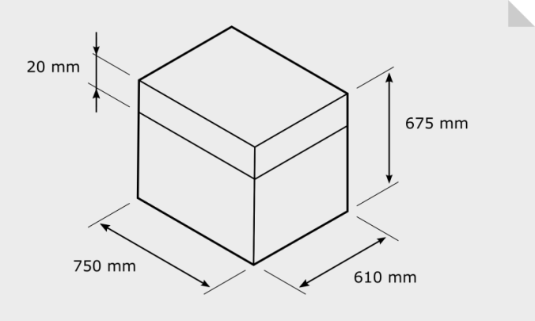
Here is a wider image:
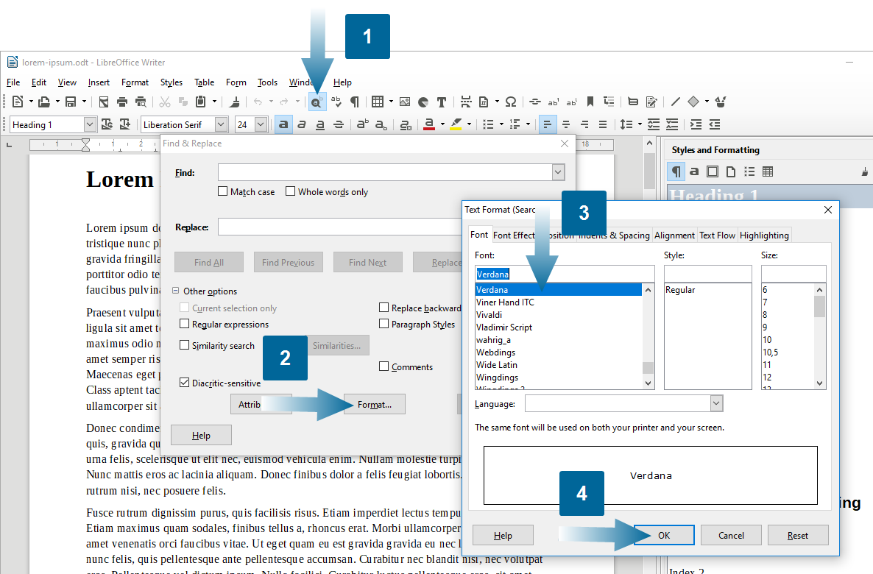

Keyboard shortcuts
The following tables list all styles and their corresponding keyboard shortcuts. All paragraph styles use key combination with the keys Alt+Shift. All character styles use key combinations with the keys Ctrl+Shift.
Paragraph styles
Purpose | Style name | Keyboard shortcut
Headings:  heading level 1  heading level 2  heading level 3 | h1  h2  h3 | Alt+Shift+1  Alt+Shift+2  Alt+Shift+3
Subheadings:  subheading that introduces a static section (always visible)  subheading that introduces an expandable section (toggle) | ss_subhead_static  se_subhead_expandable | Alt+Shift+u  Alt+Shift+e
Body text:  standard paragraph  standard paragraph with some extra space before paragraph  standard paragraph within tables | bo_body  bor_body_resume  boa_body_table | Alt+Shift+o  Alt+Shift+r–  Alt+Shift+a–
Procedures:  paragraph that introduces a procedure  step of a procedure  (with number)  indented first-level paragraph in a procedure  (without number) | pi_procedure_intro  ps_procedure_step  pp_procedure_plain | Alt+Shift+p  Alt+Shift+s  –
Lists:  paragraph that introduces a  list  first-level item of a list  (with bullet)  indented first-level paragraph in a list (without bullet)  second-level item of a list  (with bullet)  indented second-level paragraph in a list (without bullet) | li_list_intro  l1_list_level1_bullet  l1p_list_level1_plain  l2_list_level2_bullet  l2p_list_level2_plain | Alt+Shift+l  Alt+Shift+b  –  –  –
Annotations: Tips  standard tip | at_tip | Alt+Shift+t
Annotations: Notes  annotation  important note | aa_annotation  ai_important | Alt+Shift+a  Alt+Shift+i
Annotations: Warnings  caution  warning  danger | ac_caution  aw_warning  ad_danger | Alt+Shift+c  Alt+Shift+w  Alt+Shift+d
Character styles
Purpose | Style name | Keyboard shortcut
To highlight the name of the documented product (optional). | cp_product | Ctrl+Shift+p
To highlight all user interface and interaction elements, such as window titles, menu items, buttons, keys, levers, and so on. | ce_element | Ctrl+Shift+e
To mark parameters, such as parameters of function calls, formulas, and so on. | ca_parameter | Ctrl+Shift+a
To mark product-specific technical terms (optional). | ct_term | Ctrl+Shift+t
To emphasize words and expressions if this is necessary to avoid confusion. | cm_emphasis | Ctrl+Shift+m
To highlight important keywords that help readers to skim the text (optional). | cs_strong | Ctrl+Shift+s
To mark input that users must type. | ci_input | Ctrl+Shift+i
To mark quotes of source code and configuration files. | cc_code | Ctrl+Shift+c
To mark links / cross-references to other topics within the document as well as links to external web sites and documents. | cl_link | Ctrl+Shift+l

Index

C
ca_parameter 10
cc_code 14
ce_element 9
character styles 8
ca_parameter 10
cc_code 14
ce_element 9
ci_input 13
cl_link 14
cm_emphasis 11
cp_product 8
cs_strong 12
ct_term 10
ci_input 13
cl_link 14
cm_emphasis 11
code
style 14
cp_product 8
cross-reference
style 14
cs_strong 12
ct_term 10
E
element
style 9
emphasis
style 11
F
Footer
paragraph style 17
H
Header
paragraph style 17
hotkeys 21
hx 17
I
Index Heading
paragraph style 17
input
style 13
K
key combinations 21
keyboard shortcuts 21
L
link
style 14
list_heading 16
list_list 16
list_procedure 16
N
numbering styles 16
list_heading 16
list_list 16
list_procedure 16
P
paragraph styles
Footer 17
Header 17
hx 17
Index Heading 17
keyboard shortcuts 21
TD index 17
TD toc 17
parameter
style 10
product name
style 8
S
strong
style 12
styles
character styles 8
keyboard shortcuts 21
numbering styles 16
overview table 21
tables 19
T
tables
styles 19
TD index 17
TD toc 17
technical term
style 10
term
style 10

