**Capital Asset Pricing Model: Does an International Exposure Factor Effect A Security’s Excess Returns?**

By: Ryan Finegan

Advisor: Professor Luo

Table of Contents

Abstract: 3

Overview: 4

Data and Calculations: 5

VEMAX (2009-2019) 5

VEA (2009-2019) 6

Comparing the Two Regressions: 7

Beta-Sorted Portfolios Checking CAPM on Present Day Stock Market: 8

VEMAX (2015-2019) 9

VEA (2015-2019) 10

SMB - Double Sorted Portfolios with an International Component: 11

Conclusion and Future Work: 13

Acknowledgements: 13

References: 14

# Abstract:

With the inspiration of the Fama and French Three Factor Model, we decided to observe the Capital Asset Pricing Model with an emphasis on three main factors: the size of the firm based on market capitalization, their security’s average annual excess returns, and the international exposure the firm has on two separate indices (VEA and VEMAX). We did this by running regressions on thousands of stocks listed on the NYSE, NASDAQ, and AMEX exchanges. These regressions were used to calculate beta and gamma coefficients of all the stocks with security price data from two distinct time windows: 2015 to 2019 and 2009 to 2019. All the data was recovered using pandas datareader through yahoo finance’s API. Using python and statsmodels API, we ran a regression for all the stocks to find their beta and gamma coefficients. Beta was the stock’s market risk to the S&P 500 and the gamma coefficient was the international exposure using Vanguard’s FTSE Developed Markets Index (VEA) and Vanguard’s Emerging Markets Stock Index (VEMAX). VEA has holdings primarily in European and Pacific-based companies while VEMAX has Alibaba and Tencent Holdings as their two highest in terms of percentage of total assets. We wanted to examine if more exposure to the international markets would lead to more average annual excess returns to the risk-free rate. The beta and gamma of each security was calculated monthly over a seven-year period (2009-2015) for the first backtest and a three-year period (2015-2017) for the second backtest. Before we put the stocks into ten different portfolios, we decided to pursue a market capitalization weighted portfolio taken from December 2015 (first backtest) and December of 2017 (second backtest). The gamma of each stock was then sorted based on the market cap weighted gammas into ten portfolios. Portfolio 0 had the highest weighted gammas and Portfolio 9 had the lowest weighted gammas. We also made separate backtests for portfolios based on their weighted beta coefficients to compare with the studies of Fama and French. We also explored the size factor of firms and their exposure to the international markets. For this, the portfolios were equally weighted and there were 15 portfolios. The stocks were double sorted, first based on market cap size (small, medium, big), then sorted by their respective gammas or international exposure to the VEA or VEMAX index.

# Overview:

The Capital Asset Pricing Model is a formula used in finance to calculate the expected returns of securities given their risk to the overall market, usually using the S&P 500 index. The coefficient that measures a security’s risk to the market is called the beta. When a beta is over one, the security is said to be riskier than the market. When the beta of a security is below one and above zero, it is supposed to lower the systemic risk of the portfolio. Previous research studies have been performed to examine if the model is a good indicator to excess returns of stocks here in the United States. One of these studies was the Fama and French Three Factor Model. This was an expansion to the asset pricing model, CAPM. Its factors were the overall size of the companies, the book to market values and the excess returns to the market. Fama and French believed that two main portfolio characteristics would lead to an alpha greater than zero. To have an alpha greater than zero, returns must be greater than that of what the CAPM suggests. These two characteristics were included in their three-factor model. They were stocks that had a relatively small market cap and stocks with high book to market ratios (value stocks). Basically, this study in 1992 uncovered that value stocks outperform growth stocks and smaller companies’ stocks outperform larger companies. Their study determined that a good strategy would require a long-short strategy. They would be long on portfolios with high book to market values and short on portfolios that had low book to market values. Also, a long position would be held on portfolios made up of small cap stocks and short positions on portfolios with large cap stocks. In our study we check if this still exists today as well as looking at companies’ exposure to international markets. We explore if an international exposure factor or the size of the firm, with any respect to the volatility of the entire market (VIX), has any effect on average annual excess returns. Companies with high international reach are normally companies that have been around for a long time with enough resources to provide their products or services globally. International reach also provides a firm with diversification to different systemic risks and political conflicts which could benefit a firm long term with sustainability and consistency.

# Data and Calculations:

There were three places where data was pulled from: Wharton Research Data Services, Yahoo Finance API, and the Kenneth R. French Data Library. All calculations were used in python’s libraries with the regressions run in statsmodels paired with a for loop to find the beta and gamma coefficients from the year 2009 to 2015 and the annual excess returns were pulled from the years of 2016 to 2019. Market capitalization of all the stocks was calculated by multiplying the stock’s price in December 31, 2015 by their total shares outstanding from that same date. The ten portfolios were sorted by market-cap weighted gamma values. The higher gammas were placed into portfolio 0 and the lowest gammas were placed into portfolio 9. 10 new portfolios were created based on market-cap weighted betas. These are represented as the red dots in the scatter plot. The blue line is representing the excess return of the S&P 500 index. The color bar in the graph shows that the portfolios with an average gamma that is highest is colored yellow while the portfolio with the lowest average gamma is colored purple. The regression formula is below.

$$r_{jt}=α_{j}+ β_{j}* r_{m,t }+ γ_{j}* r_{intl, t }+ ε_{jt}$$

## VEMAX (2009-2019)

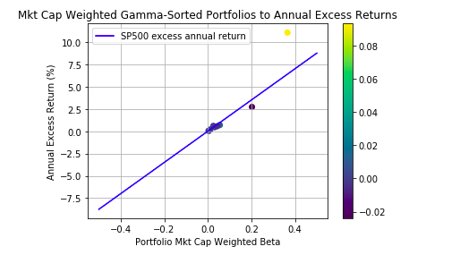

The emerging markets index (VEMAX) is shown above. The yellow dot is the portfolio with the highest weighted gamma. The purple dot that is below the blue S&P 500 annual return line is the lowest gamma portfolio. This scatterplot shows that the portfolio with the higher exposure to an international emerging market index experienced higher average annual returns when compared to portfolios with lower weighted gammas. The highest gamma portfolio also experienced higher returns than what the Capital Asset Pricing Model suggests. CAPM suggests that Portfolio 0 had a beta of 0.366, so the expected return should have been 6.40%. Portfolio 0 had a 11.05% return which is a 4.66% weighted return in excess of CAPM.

## VEA (2009-2019)

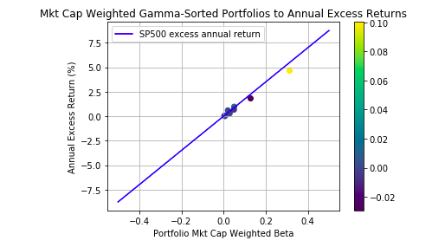

The developed international market regression was less deviating from the Capital Asset Pricing Model. The portfolios were around the same returns as the CAPM suggested. The highest gamma portfolio in this scenario was below what the CAPM suggests. In this scenario, a portfolio with higher international exposure to a developed economy did not produce returns greater than that of what the CAPM suggests. Furthermore, this relates to a realization in our data that will be touched on later; when the gammas of stocks are more deviating in a specific time window or given a certain index, then the expected weighted returns show more deviation in excess on what the capital asset pricing model suggests. This trend will be more pronounced in the backtests that that have a three-year coefficient portfolio time window.

## Comparing the Two Regressions:

For this ten year backtest, the emerging market index (VEMAX) was better in terms average annual returns. A portfolio with higher exposure to this emerging market index saw returns that beat the market and the Capital Asset Pricing Model.

This chart was created to better visualize the results of this regression. The portfolios sorted by gamma were then compared to the CAPM expected return based on the S&P’s returns. According to the VEMAX regression, the portfolio with the highest market-cap weighted gamma saw a return that was over 400 basis points higher than what the Capital Asset Pricing Model suggests.

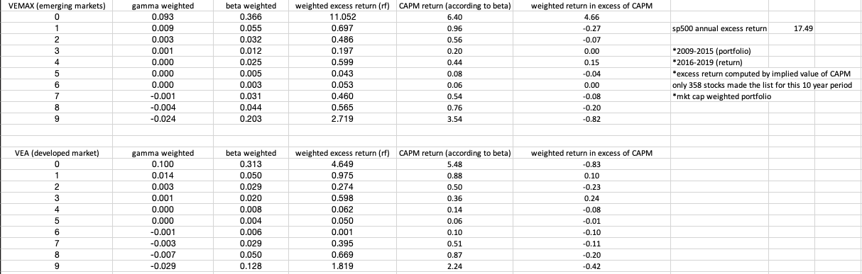

For this time period (2009-2019), the results seen in the VEMAX regression are very promising showing that high gamma portfolios beat the market while low gamma portfolios underperform the market and the Capital Asset Pricing Model. Using this backtest, a long/short equity strategy would work well. We would short the stocks with low gammas and be long on stocks that are more exposed to the emerging markets, mainly that of China (Alibaba and Tencent).

## 

## Beta-Sorted Portfolios Checking CAPM on Present Day Stock Market:

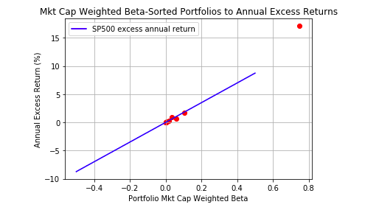

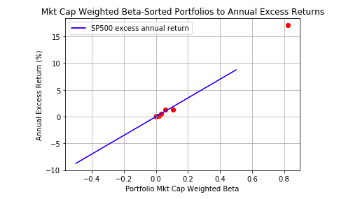

The scatterplots above are regressions run just to see the Capital Asset Pricing Model and the effects of a portfolio’s weighted beta and excess returns. The blue line is again representing the excess return of the S&P 500 index from 2016 to 2019. The scatterplot on top is the emerging markets portfolio and the one underneath is the scatterplot for the developed international index. Both are very similar in results. The ten portfolios that were separately sorted based on the weighted beta are seen to be almost exactly on the blue line which represents the average annual excess return of the market. These portfolios were created using a market capitalization weighted formula. Initially, we created equally weighted portfolios after running the regression and the results actually showed a negative relationship between the portfolio betas and excess returns. A weighted portfolio construction based on market capitalization seemed like the best idea after Dr. Scott Weisbenner of Illinois suggested that the CAPM should be studied based on more asset classes, such as real estate and fixed income securities along with equities, to get stronger results. To better account for the assets while we were mainly observing CAPM in the United States’ stock exchanges, we decided to add a factor based on a firm’s size to weight the returns and beta and gamma coefficients of each stock security before sorting them into the portfolios. The results above are what resulted in accounting for the market capitalization of each firm.

## VEMAX (2015-2019)

The next regression we ran was based on a shorter time window. The time window for the beta and gamma calculation was from 2015 to 2017. The returns data was taken from 2018 to 2019. Market capitalization was taken by retrieving the stock’s data from December 29, 2017 and multiplying by its total number of shares outstanding from the same date. The same formula was used for these backtests.

$$r_{jt}=α_{j}+ β_{j}* r_{m,t }+ γ_{j}* r_{intl, t }+ ε_{jt}$$

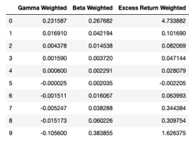

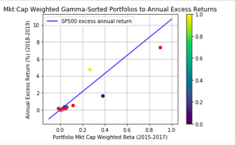

The red points were the weighted beta portfolios and the blue points are the 1-8 gamma weighted portfolios in the table above. The yellow point on the scatterplot represents Portfolio 0 made up of the highest weighted gamma stocks. The portfolio beats CAPM experiencing higher returns with less systemic risk. Portfolio 9 made up of the lowest weighted gammas fell below CAPM experiencing less returns than that of CAPM. Market weighted portfolios with higher exposure to the emerging markets saw excess returns to CAPM while also performing better than Portfolio 9 in terms of less systemic risk and higher average annual returns.

## VEA (2015-2019)

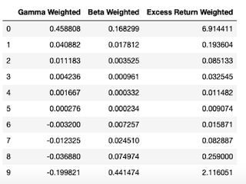

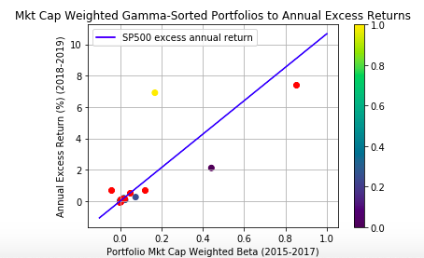

For the weighted gamma sorted portfolioswith respect to the VEA or developed markets index, Portfolio 0 with the highest gamma compared to the Portfolio 9 with the lowest gamma saw higher returns by about 4.8% while also showing less systemic risk with a lower beta. Portfolio 0 also experienced excess returns to CAPM by about 510 basis points. Similar to the emerging markets backtest, the portfolio with the highest exposure to the international developed markets faced higher average annual returns and less systemic risk when compared to the portfolio with the lowest exposure to the international markets.

# SMB - Double Sorted Portfolios with an International Component:

With the same data as the first backtest from the years of 2009 to 2019, we decided to look into forming portfolios by double sorting. 15 portfolios were created with respect to each of the indices, VEA and VEMAX. The first component was size. So, stocks that were in the 33rd percentile of market capitalization were placed in the S subset. For the M subset, the median stocks with 66th to 33rd percentile market capitalization were grouped together. The B subset were the stocks that were the biggest in terms of market capitalization, 66th percentile and above. Once these three groups were formed, the next sorting was based on five groups of gamma exposure. The smallest gammas, given market capitalization sorting, were sorted into their own portfolio. The chart below will give a better representation on how these portfolios were created. Based on the size of the firm’s stock, portfolios were created by first examining size, then grouping by the international exposure to the respective index. The formula for the regression we used displayed in the chart below is as follows.

$$r_{jt}=α_{j}+ β_{j}* r_{m,t }+ γ_{j}* r_{intl, t }+ δ_{j}* r_{SMB,t} + ε_{jt}$$

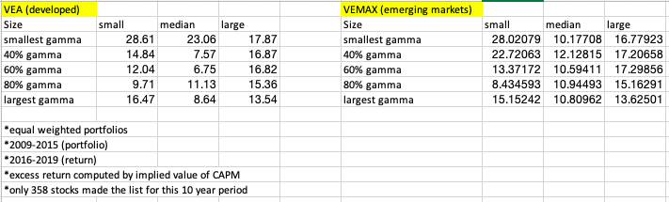

Unlike the other backtests, we made this equally weighted portfolios due to the fact that we already accounted for the size of the firm during are first part of the double sort. The portfolios made up of the smallest firms, based on market capitalization, performed best when compared to other portfolios. We can conclude that small firms with the least amount of international exposure, whether that be in the emerging or developed markets, see the highest returns out of any other portfolio. This is in line with the results many years ago from the Fama French Three Factor Model where the smaller firms beat larger firms on average. The smallest firms having the least international exposure can be explained by the fact that small firms in their earlier stages still growing performed better by focusing on improving operations in the nation’s borders to better profits instead of stretching their resources too thin and prematurely expanding into international markets.

# Conclusion and Future Work:

In this study we found that companies listed on US stock exchanges from 2015 to 2019 followed closely with the Capital Asset Pricing Model when the securities were accounted for their total market capitalization. Portfolios with higher weighted gamma coefficients saw better returns than the portfolios with lower gammas or international exposure. We decided to account for companies’ sizes in each portfolio on inspiration of the Fama and French study in 1992. Future studies can look into other asset classes such as fixed income securities to see if other securities follow the CAPM model closer or to see if international exposure is a good factor to pair with this asset pricing model. This SMB portion of the research project was an 11 year backtest from 2009 to 2019 where the portfolios were equally weighted and mainly sorted on the size of the stock’s market capitalization. The results here showed that smaller sized firms outperform the market and larger firms no matter their exposure to international markets. Smaller firms’ stocks have more room for growth while also don’t have a big presence overseas yet due to the fact that the company is still expanding and in the early stage of business development. Another finding in our study was the fact that the backtests that found the most profound results were those years that were high in volatility. When the VIX was at a high point, the portfolios had deviating gamma and beta coefficients where real returns could have been realized. To expand on this study further, one can incorporate a volatility factor and see any pattern between the market’s overall volatility and the average annual excess returns of these securities. One factor I am going to expand upon in the future given more time is sentiment analysis and the patterns between beta and gamma coefficients. I would like to look at scraping data off twitter for their cashtags and also scraping data off of a reliable new source heavily used by investing professionals. Given this extra information, we would look at the macroeconomic news sentiment and whether or not it plays a big role in an equity’s return based on international exposure and beta coefficients.

# Acknowledgements:

I would like to thank my advisor, Professor Luo. He helped me overcome many problems I ran into during this project.

# References:

Black, F.; Jensen, M.; Scholes, M. “The Capital Asset Pricing Model: Some

Empirical Results.” In *Studies in the Theory of Capital Markets,* edited by Michael Jensen. New York: Praeger, 1972.

Blitz, David and Vidojevic, Milan, The Characteristics of Factor Investing (July 2,

2018). Available at SSRN: <https://ssrn.com/abstract=3206798>.

Fama, E., French, K., Booth, D., & Sinquefield, R. (1993). Differences in the risks

and returns of NYSE and NASD stocks. Financial Analysts Journal, 49(1), 37-41.

Fama, E., & French, K. (1995). Size and book-to-market factors in earnings and

returns. Journal of Finance, 50(1), 131-155.

Fama, E., & French, K. (1996). Multifactor explanations of asset pricing

anomalies. Journal of Finance, 51(1), 55-84.

Nartea, G.V., Ward, B.D. and Djajadikerta, H.G. (2009), "Size, BM, and

momentum effects and the robustness of the Fama‐French three‐factor model: Evidence from New Zealand", *International Journal of Managerial Finance,* Vol. 5 No. 2, pp. 179-200.

Sharpe, W. (1964). Capital asset prices: A theory of market equilibrium under

conditions of risk. Journal of Finance, 19(3), 425-442.

Womack, Kent L. and Zhang, Ying, Understanding Risk and Return, the CAPM,

and the Fama-French Three-Factor Model. Tuck Case No. 03-111. Available at SSRN: <https://ssrn.com/abstract=481881>

# GitHub Repository:

https://github.com/rfinegan1/CAPM_Intl_Factor_Research_Project