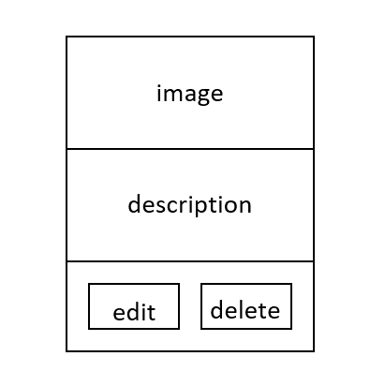

footer

Add images

**All images**

imagify