|  |  |  |
| --- | --- | --- |
| **IRSA_Logo_200.png** | **Infrared Processing and Analysis Center**  Caltech, MS 314-6, Pasadena, CA 91125  desai@ipac.caltech.edu, (626) 395-6254 | **IPAC_Small.png** |

Nov 15, 2016

I have read the proposal titled “RUI: Collaborative Research: The Effect of Filaments on the Gas in Galaxies” with Co-PIs Rudnick and Finn and agree to my role as described therein.

IRSA routinely ingests contributed sets of enhanced data products from research projects such as the one proposed here. The proposed data products are of reasonable size, and could be served through existing IRSA services. With appropriate formatting by the team, they could be ingested using standard procedures. We agree to include them in IRSA if the proposal were successful.

Sincerely,

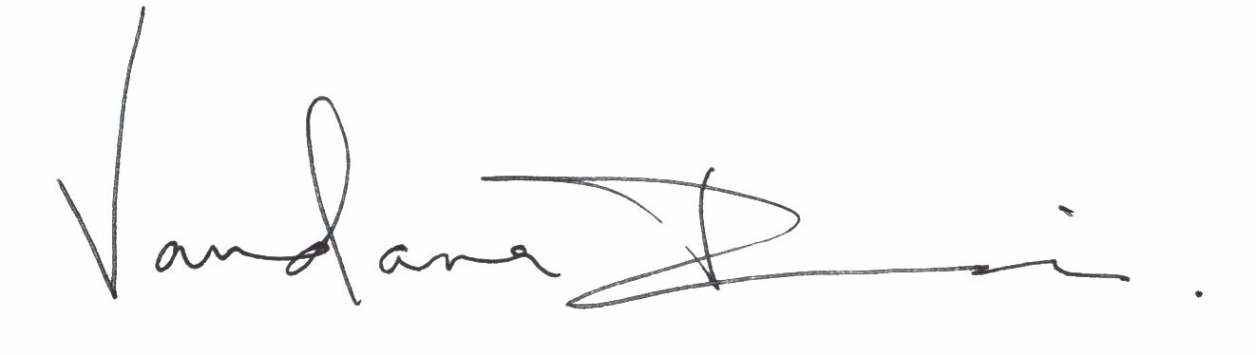

Vandana Desai

Science User Support Lead, NASA/IPAC Infrared Science Archive